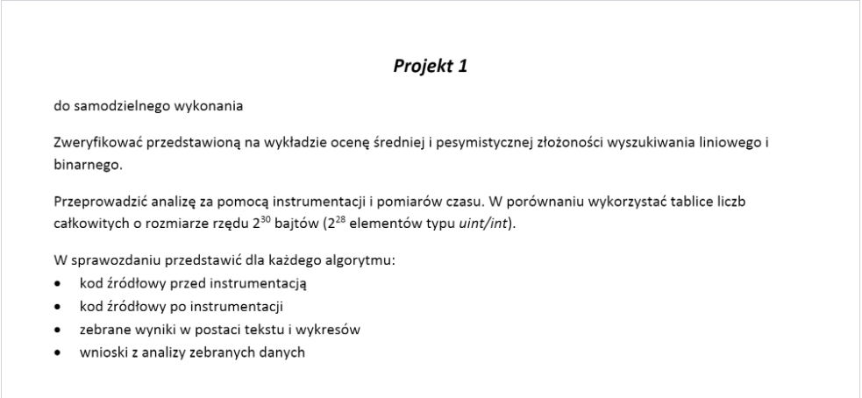

**Wyszukiwanie Liniowe Średnie**

Funkcja wyszukiwania liniowego średniego przed Instrumentacją

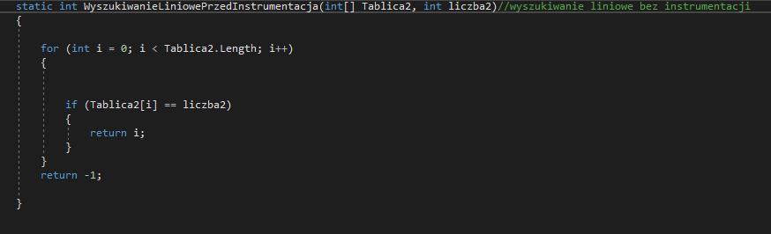

Funkcja wyszukiwania liniowego średniego z instrumentacją

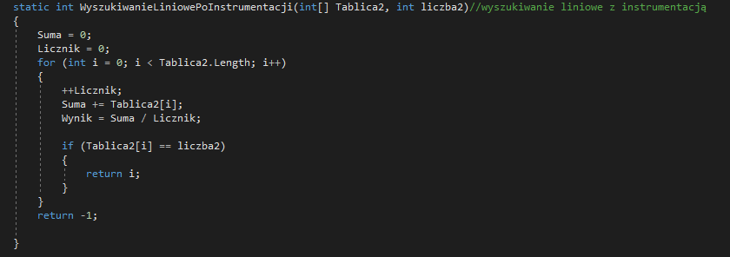

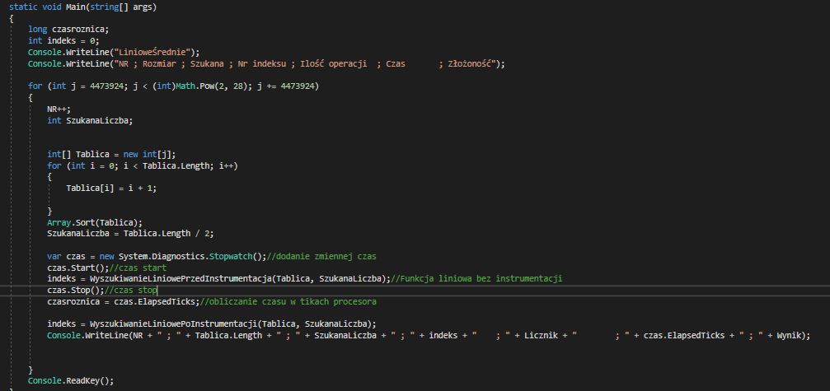Funkcje zaimplementowane w Main

Obliczanie czasu operacji bez instrumentacji

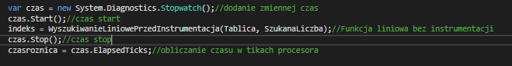

Pomiary:

|  |  |  |  |  |  |  |
| --- | --- | --- | --- | --- | --- | --- |
| NR | Rozmiar | Szukana | Nr indeksu | Ilość operacji | Czas | Złożoność |
| 1 | 4473924 | 2236962 | 2236961 | 2236962 | 84071 | 1118481 |
| 2 | 8947848 | 4473924 | 4473923 | 4473924 | 153208 | 2236962 |
| 3 | 13421772 | 6710886 | 6710885 | 6710886 | 224946 | 3355443 |
| 4 | 17895696 | 8947848 | 8947847 | 8947848 | 302507 | 4473924 |
| 5 | 22369620 | 11184810 | 11184809 | 11184810 | 387927 | 5592405 |
| 6 | 26843544 | 13421772 | 13421771 | 13421772 | 458514 | 6710886 |
| 7 | 31317468 | 15658734 | 15658733 | 15658734 | 534922 | 7829367 |
| 8 | 35791392 | 17895696 | 17895695 | 17895696 | 616865 | 8947848 |
| 9 | 40265316 | 20132658 | 20132657 | 20132658 | 659479 | 10066329 |
| 10 | 44739240 | 22369620 | 22369619 | 22369620 | 725585 | 11184810 |
| 11 | 49213164 | 24606582 | 24606581 | 24606582 | 800541 | 12303291 |
| 12 | 53687088 | 26843544 | 26843543 | 26843544 | 917244 | 13421772 |
| 13 | 58161012 | 29080506 | 29080505 | 29080506 | 994772 | 14540253 |
| 14 | 62634936 | 31317468 | 31317467 | 31317468 | 1071876 | 15658734 |
| 15 | 67108860 | 33554430 | 33554429 | 33554430 | 1156217 | 16777215 |
| 16 | 71582784 | 35791392 | 35791391 | 35791392 | 1172003 | 17895696 |
| 17 | 76056708 | 38028354 | 38028353 | 38028354 | 1232830 | 19014177 |
| 18 | 80530632 | 40265316 | 40265315 | 40265316 | 1377344 | 20132658 |
| 19 | 85004556 | 42502278 | 42502277 | 42502278 | 1460809 | 21251139 |
| 20 | 89478480 | 44739240 | 44739239 | 44739240 | 1530706 | 22369620 |
| 21 | 93952404 | 46976202 | 46976201 | 46976202 | 1611939 | 23488101 |
| 22 | 98426328 | 49213164 | 49213163 | 49213164 | 1688282 | 24606582 |
| 23 | 102900252 | 51450126 | 51450125 | 51450126 | 1759476 | 25725063 |
| 24 | 107374176 | 53687088 | 53687087 | 53687088 | 1747806 | 26843544 |
| 25 | 111848100 | 55924050 | 55924049 | 55924050 | 1917792 | 27962025 |
| 26 | 116322024 | 58161012 | 58161011 | 58161012 | 1908196 | 29080506 |
| 27 | 120795948 | 60397974 | 60397973 | 60397974 | 2075961 | 30198987 |
| 28 | 125269872 | 62634936 | 62634935 | 62634936 | 2142552 | 31317468 |
| 29 | 129743796 | 64871898 | 64871897 | 64871898 | 2122083 | 32435949 |
| 30 | 134217720 | 67108860 | 67108859 | 67108860 | 2294875 | 33554430 |
| 31 | 138691644 | 69345822 | 69345821 | 69345822 | 2456279 | 34672911 |
| 32 | 143165568 | 71582784 | 71582783 | 71582784 | 2440885 | 35791392 |
| 33 | 147639492 | 73819746 | 73819745 | 73819746 | 2517165 | 36909873 |
| 34 | 152113416 | 76056708 | 76056707 | 76056708 | 2602834 | 38028354 |
| 35 | 156587340 | 78293670 | 78293669 | 78293670 | 2567591 | 39146835 |
| 36 | 161061264 | 80530632 | 80530631 | 80530632 | 2678530 | 40265316 |
| 37 | 165535188 | 82767594 | 82767593 | 82767594 | 2835536 | 41383797 |
| 38 | 170009112 | 85004556 | 85004555 | 85004556 | 2882814 | 42502278 |
| 39 | 174483036 | 87241518 | 87241517 | 87241518 | 3030714 | 43620759 |
| 40 | 178956960 | 89478480 | 89478479 | 89478480 | 3068865 | 44739240 |
| 41 | 183430884 | 91715442 | 91715441 | 91715442 | 3151713 | 45857721 |
| 42 | 187904808 | 93952404 | 93952403 | 93952404 | 3211389 | 46976202 |
| 43 | 192378732 | 96189366 | 96189365 | 96189366 | 3291947 | 48094683 |
| 44 | 196852656 | 98426328 | 98426327 | 98426328 | 3367371 | 49213164 |
| 45 | 201326580 | 100663290 | 100663289 | 100663290 | 3441194 | 50331645 |
| 46 | 205800504 | 102900252 | 102900251 | 102900252 | 3431239 | 51450126 |
| 47 | 210274428 | 105137214 | 105137213 | 105137214 | 3446040 | 52568607 |
| 48 | 214748352 | 107374176 | 107374175 | 107374176 | 3752690 | 53687088 |
| 49 | 219222276 | 109611138 | 109611137 | 109611138 | 3622335 | 54805569 |
| 50 | 223696200 | 111848100 | 111848099 | 111848100 | 3762779 | 55924050 |
| 51 | 228170124 | 114085062 | 114085061 | 114085062 | 3905937 | 57042531 |
| 52 | 232644048 | 116322024 | 116322023 | 116322024 | 3988458 | 58161012 |
| 53 | 237117972 | 118558986 | 118558985 | 118558986 | 4070132 | 59279493 |
| 54 | 241591896 | 120795948 | 120795947 | 120795948 | 4120492 | 60397974 |
| 55 | 246065820 | 123032910 | 123032909 | 123032910 | 4171824 | 61516455 |
| 56 | 250539744 | 125269872 | 125269871 | 125269872 | 4997758 | 62634936 |
| 57 | 255013668 | 127506834 | 127506833 | 127506834 | 4371993 | 63753417 |
| 58 | 259487592 | 129743796 | 129743795 | 129743796 | 4459418 | 64871898 |
| 59 | 263961516 | 131980758 | 131980757 | 131980758 | 4378913 | 65990379 |
| 60 | 268435440 | 134217720 | 134217719 | 134217720 | 4601452 | 67108860 |

Wykresy:

**Wyszukiwanie Liniowe Pesymistyczne**

Funkcja wyszukiwania liniowego pesymistycznego przed Instrumentacją

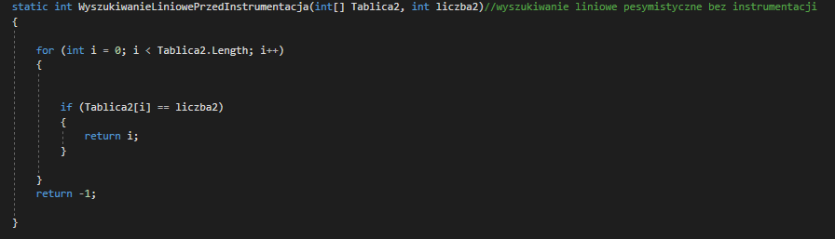

Funkcja wyszukiwania liniowego pesymistycznego z instrumentacją

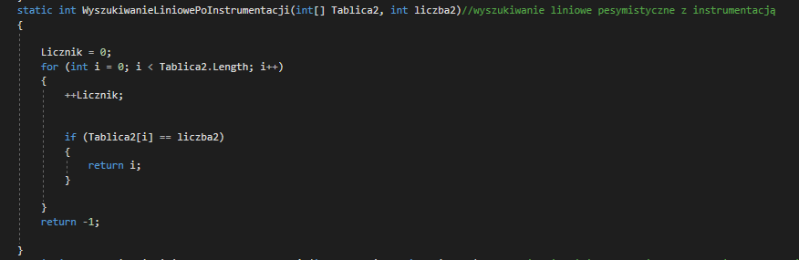

Funkcje zaimplementowane w Main

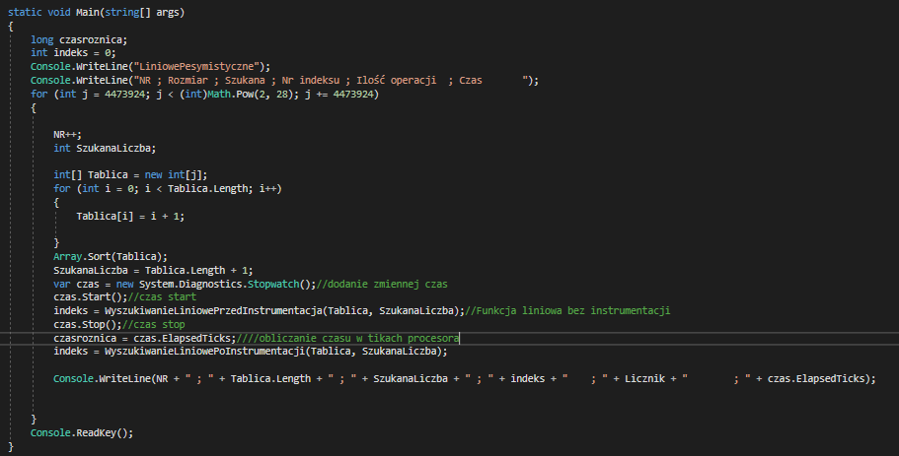

Obliczanie czasu

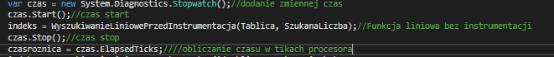

Pomiary:

|  |  |  |  |  |  |
| --- | --- | --- | --- | --- | --- |
| NR | Rozmiar | Szukana | Nr indeksu | Ilość operacji | Czas |
| 1 | 4473924 | 4473925 | -1 | 4473924 | 178879 |
| 2 | 8947848 | 8947849 | -1 | 8947848 | 306250 |
| 3 | 13421772 | 13421773 | -1 | 13421772 | 458037 |
| 4 | 17895696 | 17895697 | -1 | 17895696 | 629588 |
| 5 | 22369620 | 22369621 | -1 | 22369620 | 773552 |
| 6 | 26843544 | 26843545 | -1 | 26843544 | 898807 |
| 7 | 31317468 | 31317469 | -1 | 31317468 | 1076377 |
| 8 | 35791392 | 35791393 | -1 | 35791392 | 1221776 |
| 9 | 40265316 | 40265317 | -1 | 40265316 | 1374157 |
| 10 | 44739240 | 44739241 | -1 | 44739240 | 1528132 |
| 11 | 49213164 | 49213165 | -1 | 49213164 | 1689403 |
| 12 | 53687088 | 53687089 | -1 | 53687088 | 1838227 |
| 13 | 58161012 | 58161013 | -1 | 58161012 | 1896641 |
| 14 | 62634936 | 62634937 | -1 | 62634936 | 2039650 |
| 15 | 67108860 | 67108861 | -1 | 67108860 | 2378919 |
| 16 | 71582784 | 71582785 | -1 | 71582784 | 2341098 |
| 17 | 76056708 | 76056709 | -1 | 76056708 | 2718505 |
| 18 | 80530632 | 80530633 | -1 | 80530632 | 2644964 |
| 19 | 85004556 | 85004557 | -1 | 85004556 | 2908303 |
| 20 | 89478480 | 89478481 | -1 | 89478480 | 3185731 |
| 21 | 93952404 | 93952405 | -1 | 93952404 | 3209407 |
| 22 | 98426328 | 98426329 | -1 | 98426328 | 3291252 |
| 23 | 102900252 | 102900253 | -1 | 102900252 | 3457292 |
| 24 | 107374176 | 107374177 | -1 | 107374176 | 3520912 |
| 25 | 111848100 | 111848101 | -1 | 111848100 | 3825596 |
| 26 | 116322024 | 116322025 | -1 | 116322024 | 3936055 |
| 27 | 120795948 | 120795949 | -1 | 120795948 | 4391849 |
| 28 | 125269872 | 125269873 | -1 | 125269872 | 4150086 |
| 29 | 129743796 | 129743797 | -1 | 129743796 | 4268183 |
| 30 | 134217720 | 134217721 | -1 | 134217720 | 4533435 |
| 31 | 138691644 | 138691645 | -1 | 138691644 | 4688682 |
| 32 | 143165568 | 143165569 | -1 | 143165568 | 4667834 |
| 33 | 147639492 | 147639493 | -1 | 147639492 | 5045539 |
| 34 | 152113416 | 152113417 | -1 | 152113416 | 5198009 |
| 35 | 156587340 | 156587341 | -1 | 156587340 | 5346487 |
| 36 | 161061264 | 161061265 | -1 | 161061264 | 5280129 |
| 37 | 165535188 | 165535189 | -1 | 165535188 | 5520467 |
| 38 | 170009112 | 170009113 | -1 | 170009112 | 5792505 |
| 39 | 174483036 | 174483037 | -1 | 174483036 | 5831578 |
| 40 | 178956960 | 178956961 | -1 | 178956960 | 5823167 |
| 41 | 183430884 | 183430885 | -1 | 183430884 | 6022161 |
| 42 | 187904808 | 187904809 | -1 | 187904808 | 6419352 |
| 43 | 192378732 | 192378733 | -1 | 192378732 | 6327047 |
| 44 | 196852656 | 196852657 | -1 | 196852656 | 6433674 |
| 45 | 201326580 | 201326581 | -1 | 201326580 | 6859754 |
| 46 | 205800504 | 205800505 | -1 | 205800504 | 6906855 |
| 47 | 210274428 | 210274429 | -1 | 210274428 | 7204026 |
| 48 | 214748352 | 214748353 | -1 | 214748352 | 7139178 |
| 49 | 219222276 | 219222277 | -1 | 219222276 | 7217678 |
| 50 | 223696200 | 223696201 | -1 | 223696200 | 7415098 |
| 51 | 228170124 | 228170125 | -1 | 228170124 | 7796106 |
| 52 | 232644048 | 232644049 | -1 | 232644048 | 7615421 |
| 53 | 237117972 | 237117973 | -1 | 237117972 | 8036391 |
| 54 | 241591896 | 241591897 | -1 | 241591896 | 8145492 |
| 55 | 246065820 | 246065821 | -1 | 246065820 | 8292486 |
| 56 | 250539744 | 250539745 | -1 | 250539744 | 8316607 |
| 57 | 255013668 | 255013669 | -1 | 255013668 | 8479149 |
| 58 | 259487592 | 259487593 | -1 | 259487592 | 8837938 |
| 59 | 263961516 | 263961517 | -1 | 263961516 | 9020698 |
| 60 | 268435440 | 268435441 | -1 | 268435440 | 9206948 |

Wykresy:

**Wyszukiwanie Binarne Średnie**

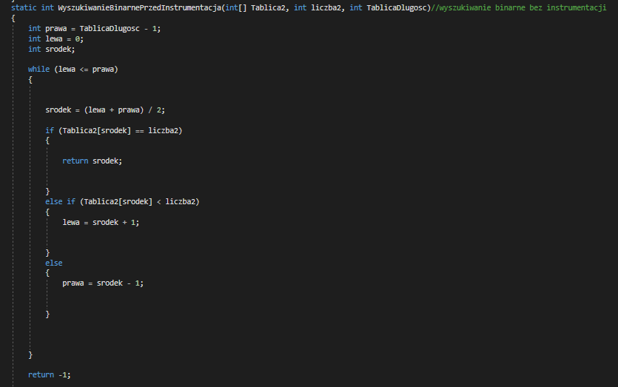Funkcja wyszukiwania binarnego średniego przed instrumentacją

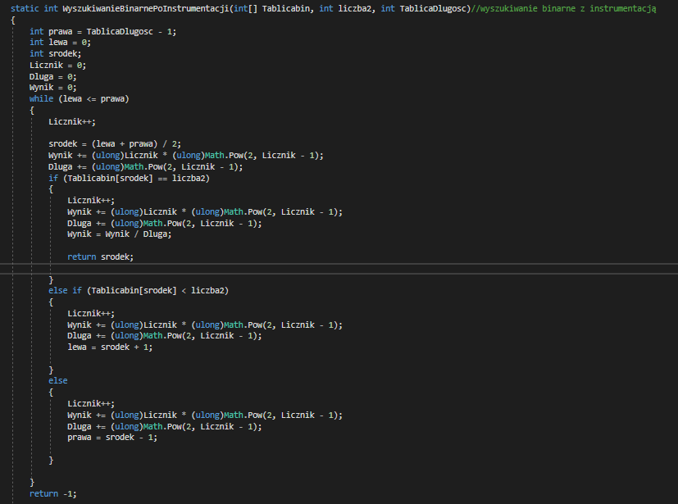Funkcja wyszukiwania binarnego średniego z instrumentacją

Funkcje zaimplementowane w Main

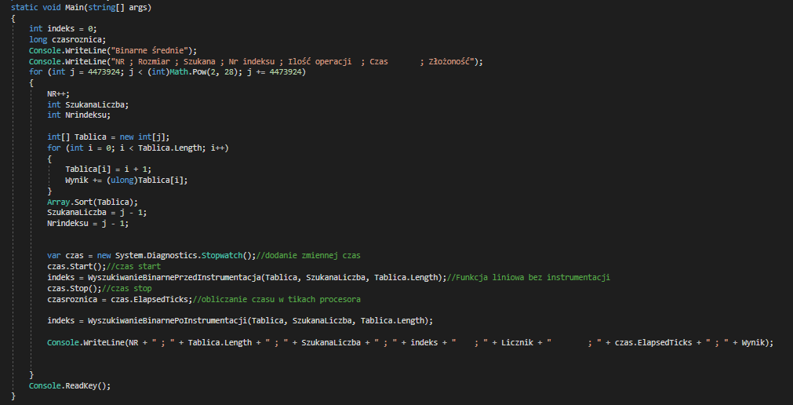

Obliczanie czasu

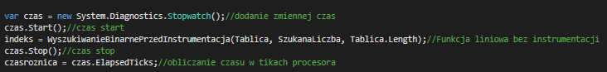

Pomiary:

|  |  |  |  |  |  |  |
| --- | --- | --- | --- | --- | --- | --- |
| NR | Rozmiar | Szukana | Nr indeksu | Ilość operacji | Czas | Złożoność |
| 1 | 4473924 | 4473923 | 4473922 | 44 | 564 | 43 |
| 2 | 8947848 | 8947847 | 8947846 | 46 | 17 | 45 |
| 3 | 13421772 | 13421771 | 13421770 | 46 | 19 | 45 |
| 4 | 17895696 | 17895695 | 17895694 | 48 | 19 | 47 |
| 5 | 22369620 | 22369619 | 22369618 | 48 | 20 | 47 |
| 6 | 26843544 | 26843543 | 26843542 | 48 | 19 | 47 |
| 7 | 31317468 | 31317467 | 31317466 | 48 | 22 | 47 |
| 8 | 35791392 | 35791391 | 35791390 | 50 | 20 | 49 |
| 9 | 40265316 | 40265315 | 40265314 | 50 | 16 | 49 |
| 10 | 44739240 | 44739239 | 44739238 | 50 | 21 | 49 |
| 11 | 49213164 | 49213163 | 49213162 | 50 | 20 | 49 |
| 12 | 53687088 | 53687087 | 53687086 | 50 | 16 | 49 |
| 13 | 58161012 | 58161011 | 58161010 | 50 | 20 | 49 |
| 14 | 62634936 | 62634935 | 62634934 | 50 | 21 | 49 |
| 15 | 67108860 | 67108859 | 67108858 | 50 | 22 | 49 |
| 16 | 71582784 | 71582783 | 71582782 | 52 | 18 | 51 |
| 17 | 76056708 | 76056707 | 76056706 | 52 | 22 | 51 |
| 18 | 80530632 | 80530631 | 80530630 | 52 | 21 | 51 |
| 19 | 85004556 | 85004555 | 85004554 | 52 | 23 | 51 |
| 20 | 89478480 | 89478479 | 89478478 | 52 | 19 | 51 |
| 21 | 93952404 | 93952403 | 93952402 | 52 | 21 | 51 |
| 22 | 98426328 | 98426327 | 98426326 | 52 | 28 | 51 |
| 23 | 102900252 | 102900251 | 102900250 | 52 | 20 | 51 |
| 24 | 107374176 | 107374175 | 107374174 | 52 | 23 | 51 |
| 25 | 111848100 | 111848099 | 111848098 | 52 | 24 | 51 |
| 26 | 116322024 | 116322023 | 116322022 | 52 | 28 | 51 |
| 27 | 120795948 | 120795947 | 120795946 | 52 | 22 | 51 |
| 28 | 125269872 | 125269871 | 125269870 | 52 | 28 | 51 |
| 29 | 129743796 | 129743795 | 129743794 | 52 | 26 | 51 |
| 30 | 134217720 | 134217719 | 134217718 | 52 | 22 | 51 |
| 31 | 138691644 | 138691643 | 138691642 | 54 | 28 | 53 |
| 32 | 143165568 | 143165567 | 143165566 | 54 | 21 | 53 |
| 33 | 147639492 | 147639491 | 147639490 | 54 | 20 | 53 |
| 34 | 152113416 | 152113415 | 152113414 | 54 | 22 | 53 |
| 35 | 156587340 | 156587339 | 156587338 | 54 | 20 | 53 |
| 36 | 161061264 | 161061263 | 161061262 | 54 | 24 | 53 |
| 37 | 165535188 | 165535187 | 165535186 | 54 | 22 | 53 |
| 38 | 170009112 | 170009111 | 170009110 | 54 | 22 | 53 |
| 39 | 174483036 | 174483035 | 174483034 | 54 | 26 | 53 |
| 40 | 178956960 | 178956959 | 178956958 | 54 | 24 | 53 |
| 41 | 183430884 | 183430883 | 183430882 | 54 | 27 | 53 |
| 42 | 187904808 | 187904807 | 187904806 | 54 | 19 | 53 |
| 43 | 192378732 | 192378731 | 192378730 | 54 | 25 | 53 |
| 44 | 196852656 | 196852655 | 196852654 | 54 | 22 | 53 |
| 45 | 201326580 | 201326579 | 201326578 | 54 | 24 | 53 |
| 46 | 205800504 | 205800503 | 205800502 | 54 | 22 | 53 |
| 47 | 210274428 | 210274427 | 210274426 | 54 | 25 | 53 |
| 48 | 214748352 | 214748351 | 214748350 | 54 | 21 | 53 |
| 49 | 219222276 | 219222275 | 219222274 | 54 | 25 | 53 |
| 50 | 223696200 | 223696199 | 223696198 | 54 | 28 | 53 |
| 51 | 228170124 | 228170123 | 228170122 | 54 | 23 | 53 |
| 52 | 232644048 | 232644047 | 232644046 | 54 | 22 | 53 |
| 53 | 237117972 | 237117971 | 237117970 | 54 | 26 | 53 |
| 54 | 241591896 | 241591895 | 241591894 | 54 | 23 | 53 |
| 55 | 246065820 | 246065819 | 246065818 | 54 | 24 | 53 |
| 56 | 250539744 | 250539743 | 250539742 | 54 | 24 | 53 |
| 57 | 255013668 | 255013667 | 255013666 | 54 | 24 | 53 |
| 58 | 259487592 | 259487591 | 259487590 | 54 | 20 | 53 |
| 59 | 263961516 | 263961515 | 263961514 | 54 | 26 | 53 |
| 60 | 268435440 | 268435439 | 268435438 | 54 | 24 | 53 |

Wykresy:

**Wyszukiwanie Binarne Pesymistyczne**

Funkcja wyszukiwania binarnego pesymistycznego przed instrumentacją

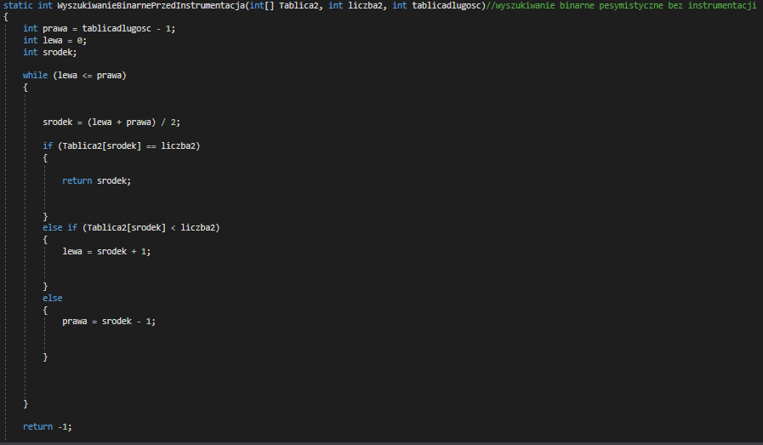

Funkcja wyszukiwania binarnego pesymistycznego z instrumentacją

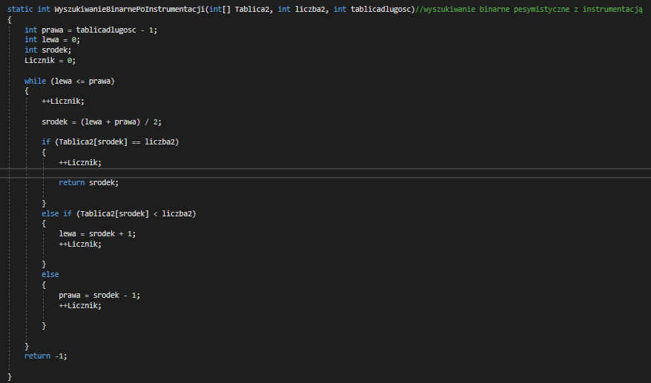

Funkcje zaimplementowane w Main

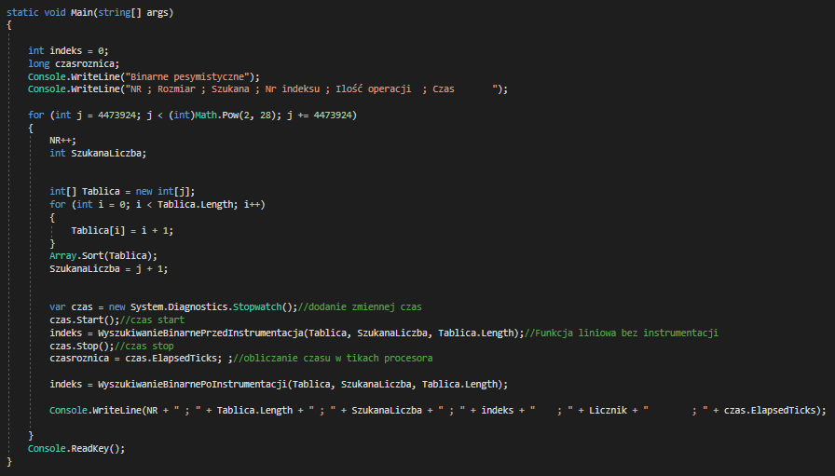

Obliczanie czasu

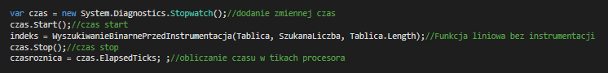

Pomiary:

|  |  |  |  |  |  |
| --- | --- | --- | --- | --- | --- |
| NR | Rozmiar | Szukana | Nr indeksu | Ilość operacji | Czas |
| 1 | 4473924 | 4473925 | -1 | 46 | 569 |
| 2 | 8947848 | 8947849 | -1 | 48 | 17 |
| 3 | 13421772 | 13421773 | -1 | 48 | 17 |
| 4 | 17895696 | 17895697 | -1 | 50 | 16 |
| 5 | 22369620 | 22369621 | -1 | 50 | 19 |
| 6 | 26843544 | 26843545 | -1 | 50 | 15 |
| 7 | 31317468 | 31317469 | -1 | 50 | 18 |
| 8 | 35791392 | 35791393 | -1 | 52 | 18 |
| 9 | 40265316 | 40265317 | -1 | 52 | 21 |
| 10 | 44739240 | 44739241 | -1 | 52 | 17 |
| 11 | 49213164 | 49213165 | -1 | 52 | 21 |
| 12 | 53687088 | 53687089 | -1 | 52 | 19 |
| 13 | 58161012 | 58161013 | -1 | 52 | 20 |
| 14 | 62634936 | 62634937 | -1 | 52 | 23 |
| 15 | 67108860 | 67108861 | -1 | 52 | 22 |
| 16 | 71582784 | 71582785 | -1 | 54 | 19 |
| 17 | 76056708 | 76056709 | -1 | 54 | 24 |
| 18 | 80530632 | 80530633 | -1 | 54 | 20 |
| 19 | 85004556 | 85004557 | -1 | 54 | 26 |
| 20 | 89478480 | 89478481 | -1 | 54 | 22 |
| 21 | 93952404 | 93952405 | -1 | 54 | 25 |
| 22 | 98426328 | 98426329 | -1 | 54 | 35 |
| 23 | 102900252 | 102900253 | -1 | 54 | 21 |
| 24 | 107374176 | 107374177 | -1 | 54 | 19 |
| 25 | 111848100 | 111848101 | -1 | 54 | 23 |
| 26 | 116322024 | 116322025 | -1 | 54 | 25 |
| 27 | 120795948 | 120795949 | -1 | 54 | 26 |
| 28 | 125269872 | 125269873 | -1 | 54 | 22 |
| 29 | 129743796 | 129743797 | -1 | 54 | 26 |
| 30 | 134217720 | 134217721 | -1 | 54 | 23 |
| 31 | 138691644 | 138691645 | -1 | 56 | 27 |
| 32 | 143165568 | 143165569 | -1 | 56 | 23 |
| 33 | 147639492 | 147639493 | -1 | 56 | 22 |
| 34 | 152113416 | 152113417 | -1 | 56 | 26 |
| 35 | 156587340 | 156587341 | -1 | 56 | 17 |
| 36 | 161061264 | 161061265 | -1 | 56 | 25 |
| 37 | 165535188 | 165535189 | -1 | 56 | 24 |
| 38 | 170009112 | 170009113 | -1 | 56 | 19 |
| 39 | 174483036 | 174483037 | -1 | 56 | 23 |
| 40 | 178956960 | 178956961 | -1 | 56 | 20 |
| 41 | 183430884 | 183430885 | -1 | 56 | 23 |
| 42 | 187904808 | 187904809 | -1 | 56 | 29 |
| 43 | 192378732 | 192378733 | -1 | 56 | 26 |
| 44 | 196852656 | 196852657 | -1 | 56 | 19 |
| 45 | 201326580 | 201326581 | -1 | 56 | 26 |
| 46 | 205800504 | 205800505 | -1 | 56 | 25 |
| 47 | 210274428 | 210274429 | -1 | 56 | 21 |
| 48 | 214748352 | 214748353 | -1 | 56 | 22 |
| 49 | 219222276 | 219222277 | -1 | 56 | 28 |
| 50 | 223696200 | 223696201 | -1 | 56 | 23 |
| 51 | 228170124 | 228170125 | -1 | 56 | 24 |
| 52 | 232644048 | 232644049 | -1 | 56 | 20 |
| 53 | 237117972 | 237117973 | -1 | 56 | 22 |
| 54 | 241591896 | 241591897 | -1 | 56 | 21 |
| 55 | 246065820 | 246065821 | -1 | 56 | 36 |
| 56 | 250539744 | 250539745 | -1 | 56 | 21 |
| 57 | 255013668 | 255013669 | -1 | 56 | 37 |
| 58 | 259487592 | 259487593 | -1 | 56 | 20 |
| 59 | 263961516 | 263961517 | -1 | 56 | 28 |
| 60 | 268435440 | 268435441 | -1 | 56 | 28 |

Wykresy:

Podsumowanie:

Wyszukiwanie liniowe polega na przeglądaniu kolejnych elementów tablicy. W przypadku pesymistycznym, gdy poszukiwanego zbioru nie ma w zbiorze lub znajduje się on na samym końcu zbioru, algorytm musi wykonać przynajmniej *n* obiegów pętli sprawdzającej poszczególne elementy. Wynika z tego że pesymistyczna złożoność obliczeniowa jest równa O(n), czyli jest liniowa.

Wyszukiwanie binarne algorytm szuka danego elementu w tablicy uporządkowanej (posortowanej). Złożoność obliczeniowa tego sposobu wyszukiwania jest rzędu O(log).  Oznacza to, że metoda jest znaczenie szybsza niż algorytm przeszukiwania liniowego.

Czas potrzebny na wykonanie wyszukiwania liniowego jest dłuższy niż wyszukiwania binarnego.

Komputer na którym wykonywano pomiary:

