CSCI4315 Advanced Software Development with .NET and C#

Programming Assignment No. 2

Wednesday July 15th, 2020

Name: Ravitheja Vodapally

ID: 18265807

**Objective:** Build a console application that modify the existing Time2 Case study to show time added (as integer or char) correctly according to the Universal representation. Build another console application to add milliseconds and represent in universal format in increasing order.

**Project Includes:** Three Library files and Two console applications.

**CODE**:

**LibraryOne:**

Used already existing code from Test5 case study 10.5, add methods with different parameters, one with full parameters and other with Time2 object.

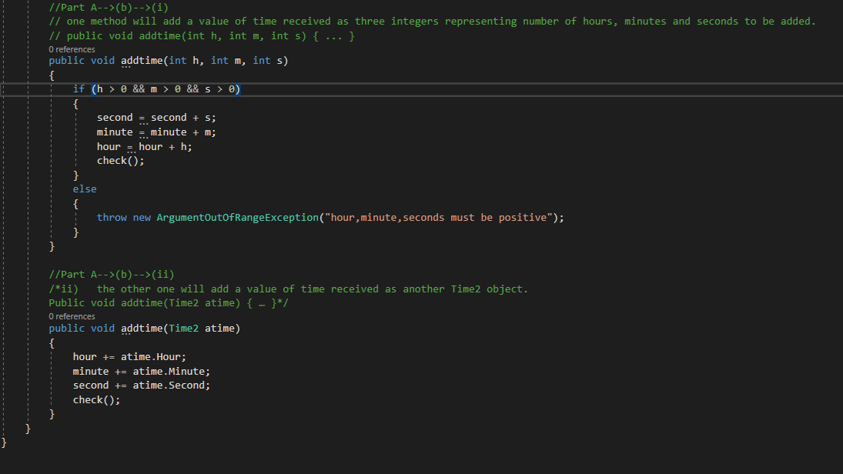

**LibraryTwoArray:**

Create char array and assign first two char as hours

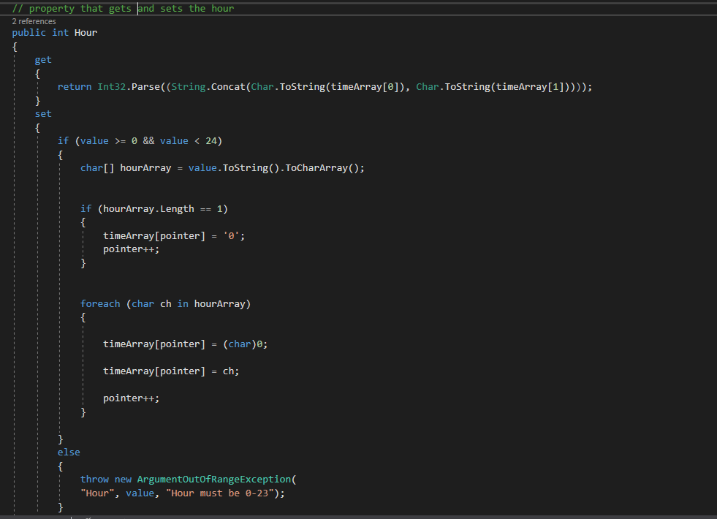

Second two char as Minutes

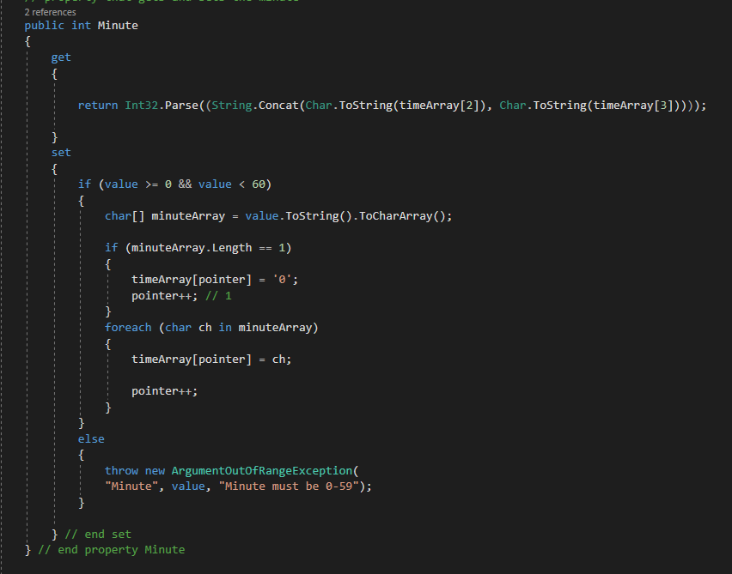

Third two char as Seconds

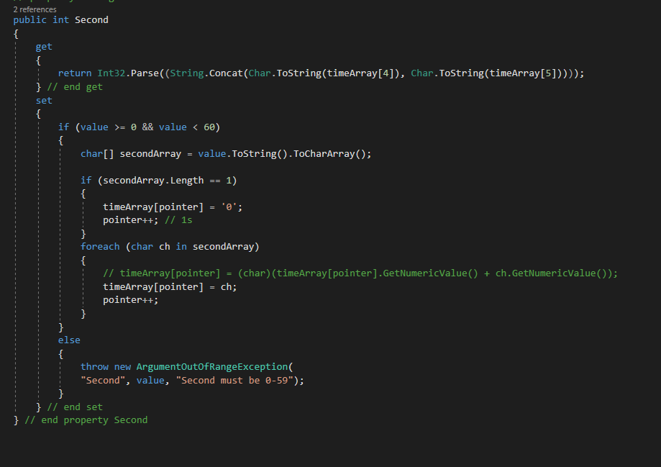

**Console Application One**

Create 6 Test Cases,

Test case-1 without parameters: It will assign zero values to hours, minutes, seconds

Test case-2 with single parameter hour. Minute and seconds are assigned zero

Test case-3 with two parameters hours, minutes. Seconds is assigned zero

Test case-4 with three parameters

Test case-5 assign parameter as test case 4 object

Test case-6 with invalid values for hours, minutes, seconds

By taking the parameter values and represent them in Universal format.

**Library Three:**

Add milliseconds along with hour, minute, seconds.

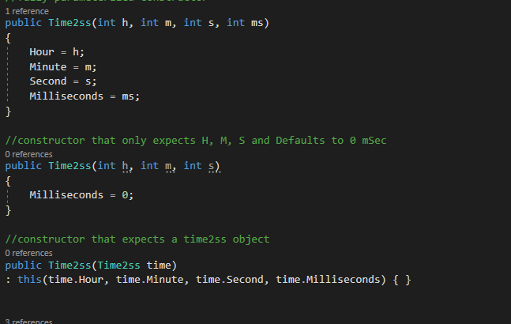

Adding three parameters with all parameters, three parameters and assign default 0 to milliseconds and Time2ss object as parameter.

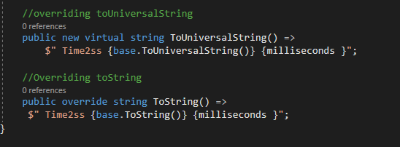

**Override ToUniversalString and ToString methods from Time2 from LibraryOne.**

**OUTPUT:**

**Console Application 2**

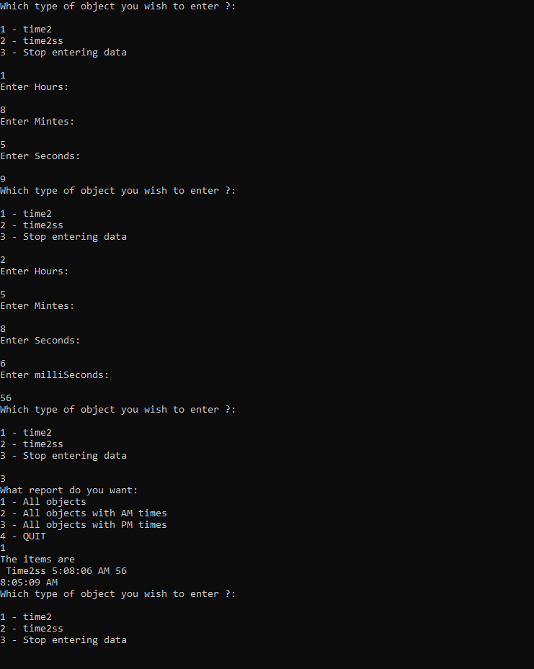

**Console Application 1:**

Output with new library

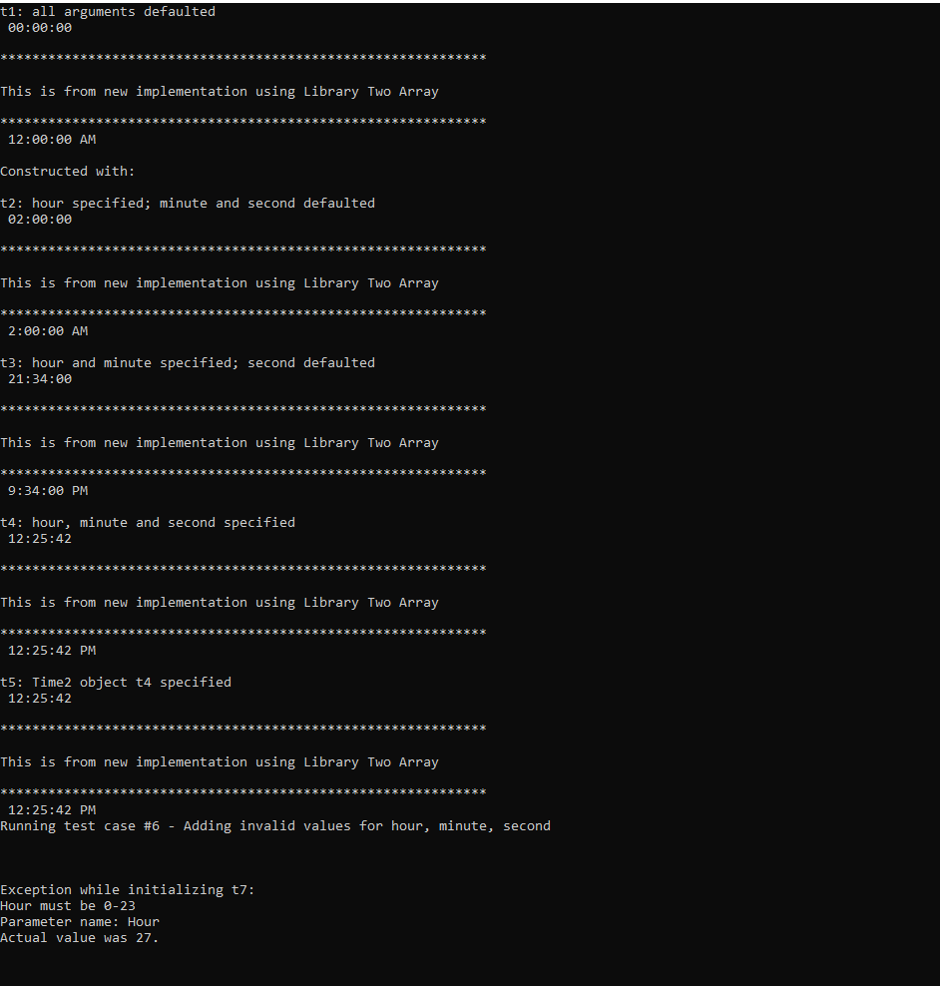

Output with Old Library

