CSCI4315 Advanced Software Development with .NET and C#

Programming Assignment No. 3

Saturday Aug 1, 2020

Name: Ravitheja Vodapally

ID: 18265807

**Objective:** Create a Windows Application to keep track of Running Athletes performance while running laps. This application should able to add Any number of Athletes and should be able to run the timer for each athlete separately and should be able to record the laps and thus finally provide the final report of all the athletes.

**Project Includes:** Assignment 2 module for Hours, Minutes and Seconds and extra class created for an added feature for milliseconds called PreciseTime.cs. Main application for Athlete and TimeTrackerForm application for creating the forms.

**CODE**:

PreciseTime.cs

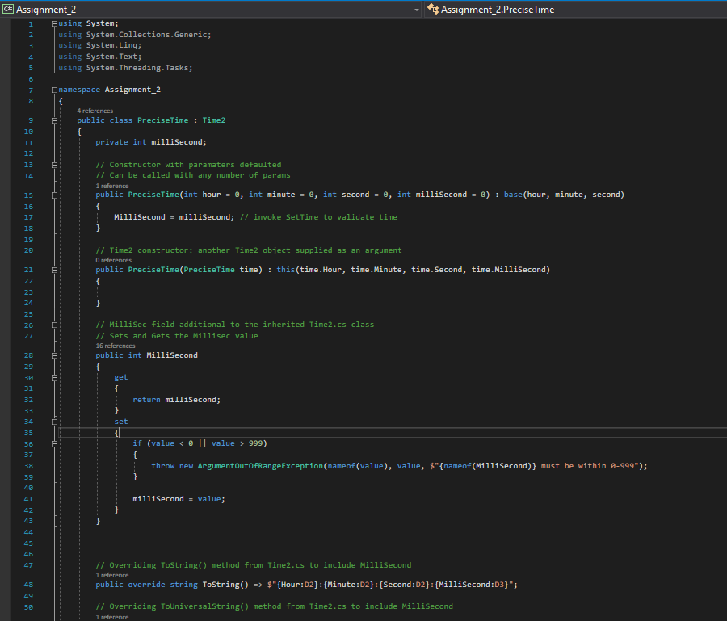

An Extra feature called Milliseconds has been added to this class file by utilizing all the Hours, Minutes and Seconds from the Assignment 2.

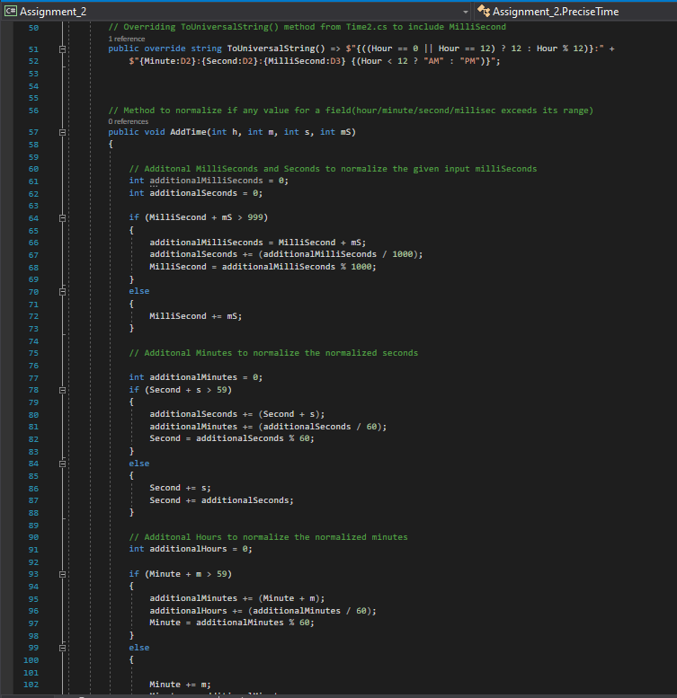

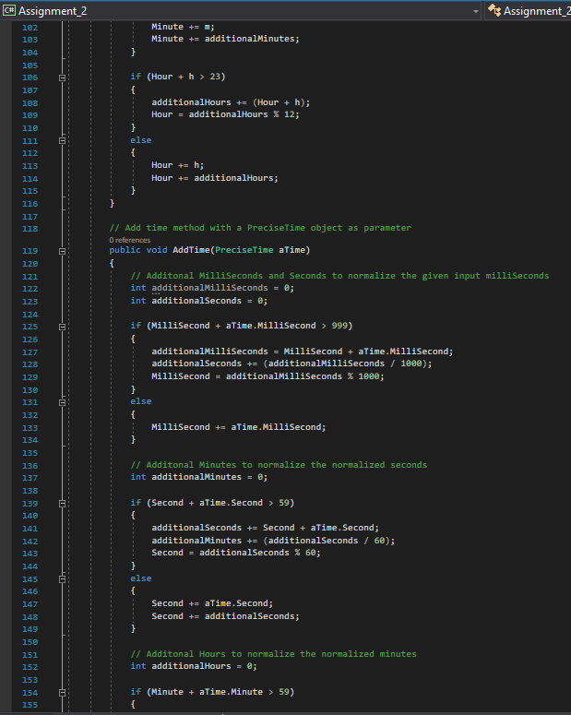

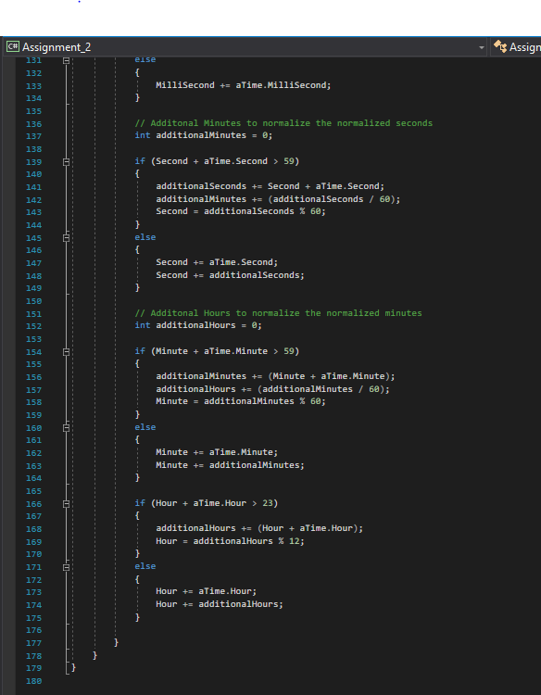

Athlete.cs

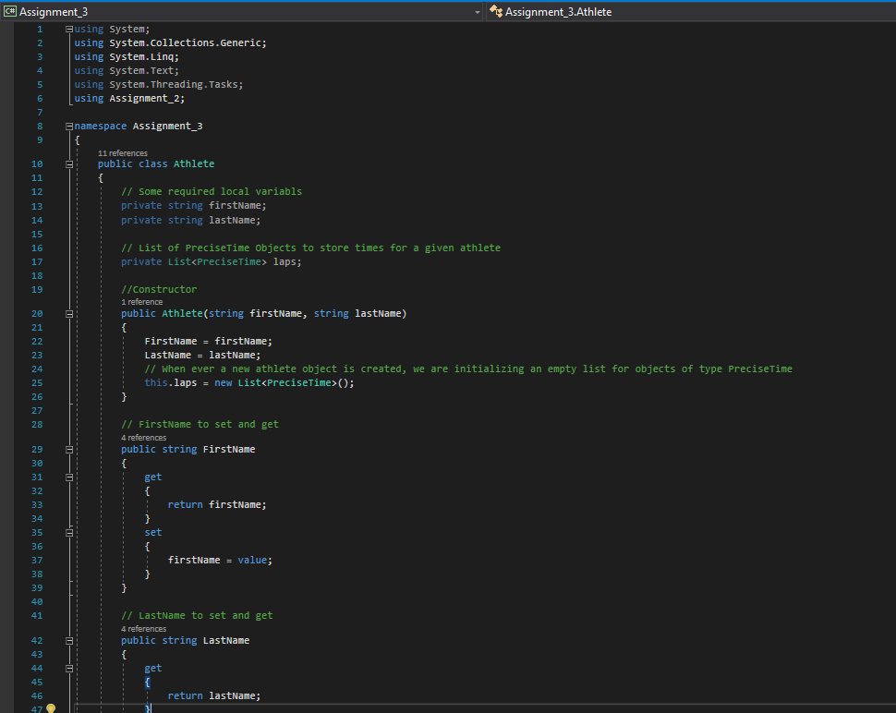

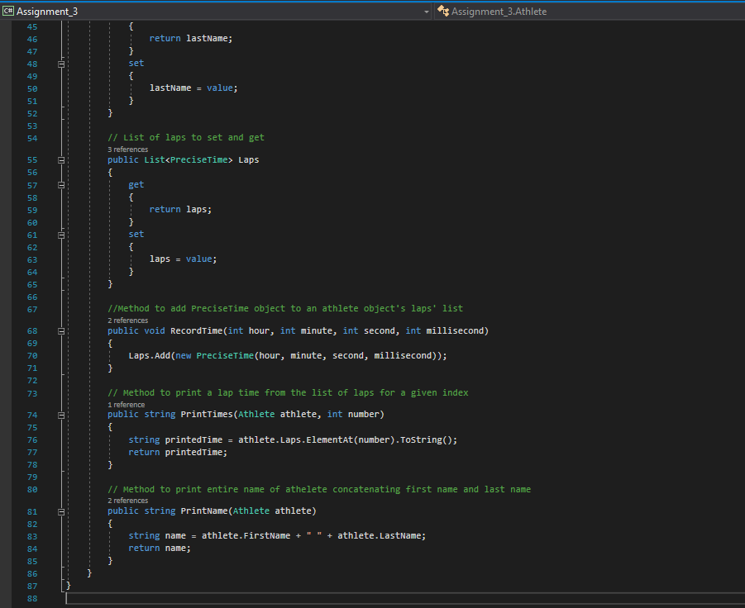

AthleteNames.cs

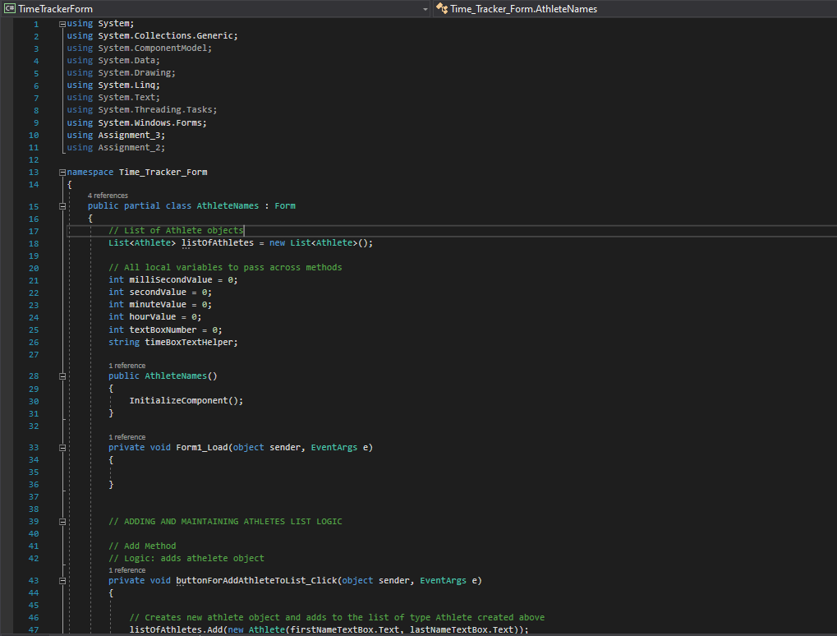

Please refer to Assignment_3/TimeTrackerForm/AthleteName.cs for full length code

AthleteLaps.cs

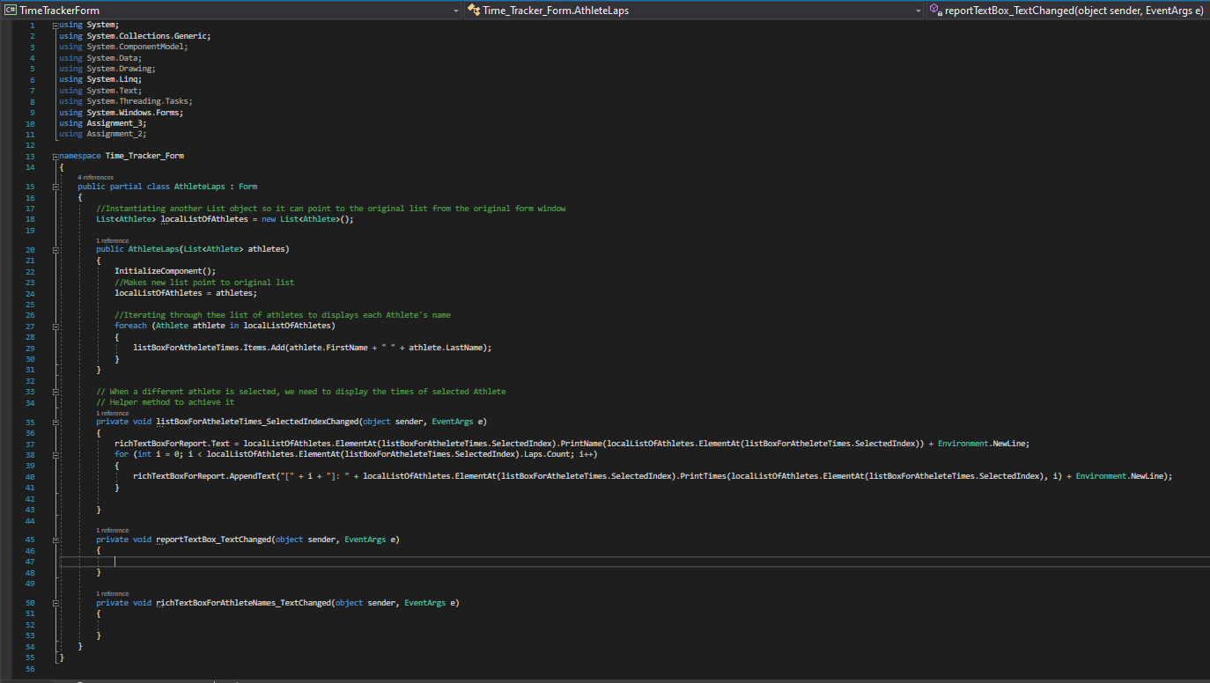

Form:1

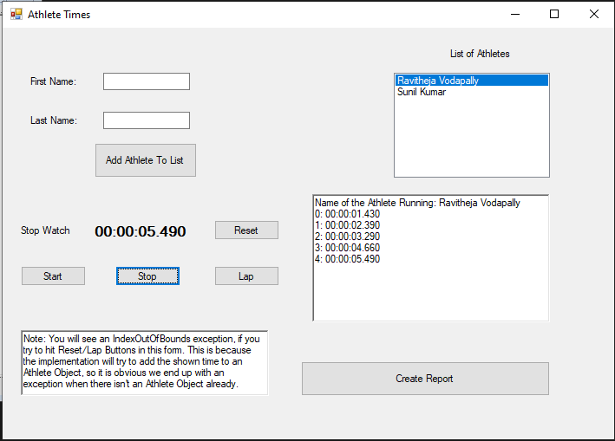

In Form:1- The user can input the first name, last name of the athlete.

* It receives as an object in the Listbox for athletes.
* Whenever the user inputs the second athlete name, then it adds as a second object in the Listbox for athletes.
* By selecting a user the application is able to produce the timer and it saves the times and laps as shown.
* When user press the create report button then it redirects to Athlete Times form

Form:2

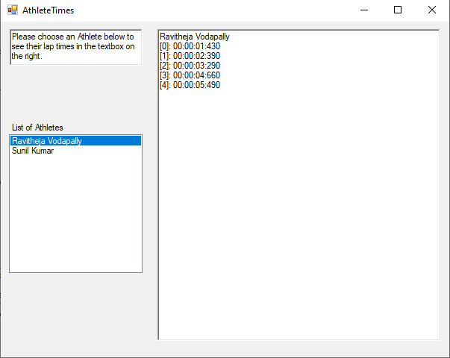

When user press create report button it redirects to the Athlete Times form

It displays the List of Athletes as shown and thus generating the lap time records.