ASCENT

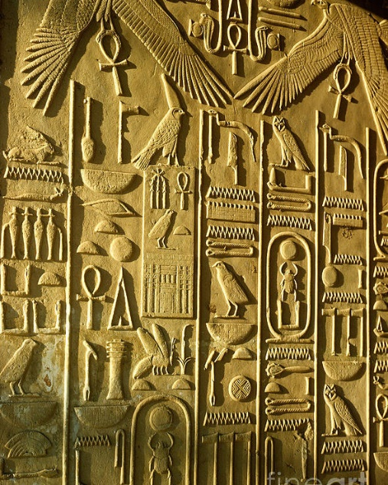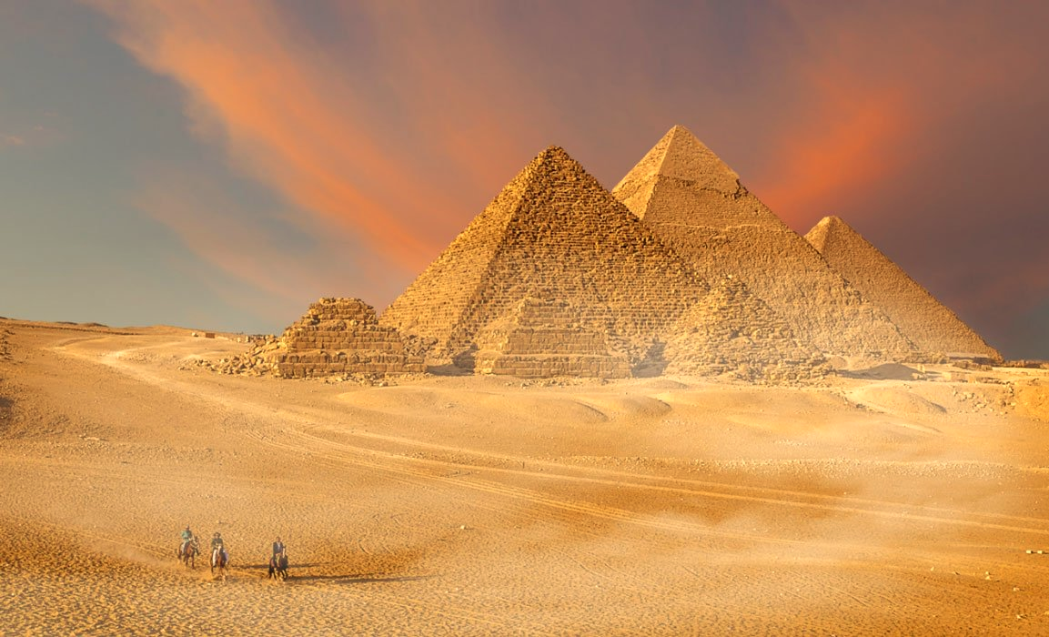 **Ascent** is a deckbuilding rogue-like game in which you play as a divine group of Egyptian creatures trying to ascend to Godhood. There are two main game modes, Ascent and Create a religion, which are different but influence each other’s gameplay.

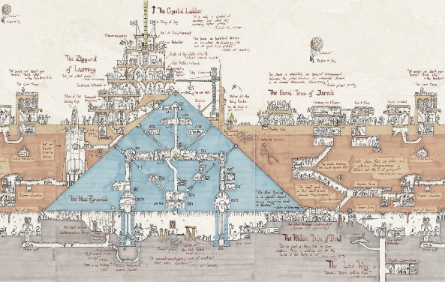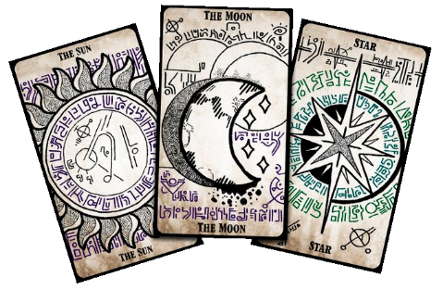Resultado de imagen de eye of horus pngResultado de imagen de eye of horus pngResultado de imagen de eye of horus png

**Unique Selling Points:**

**Ancient Egypt**: This is an underused setting with a lot of mythology and mysteries that can be introduced and explored in different aspects of the game. Has not been used before in this kind of games.

**Three deck card-based combat:** Having three characters (instead of the usual 1) at the same time gives combat more variety in gameplay and combos and an extra level of strategy.

**Status System:** Adding a system in which you can combo status effects on the different characters to create a different one will add even more variety, strategy and dynamism to the combat.

**Ascent**

Explore the interior never seen before parts of the Pyramids to find out their secrets and obtain powers that will help you reach Godhood.

When you explore all three pyramids you will have to face the Ancient Reanimation Rite to be reborn into Godhood.

**Create a religion**

Between Ascent trials players will be able to increase their powers using the objects and power obtained during the Ascent by performing miracles, sending plagues or basically acting like a God so that the people of Egypt accept you as such and adore you, giving you strength and new godlike abilities.