DecodeLabs Internship Program
Cybersecurity Analyst Track
PROJECT 2 REPORT
Basic Encryption & Decryption
Extended Caesar Cipher with Full ASCII Support
Submitted By
Adnan Iqbal
Cybersecurity Analyst Intern — DecodeLabs Internship Program
Computer System Engineering
Mirpur University of Science and Technology (MUST), AJK

Project Information
Item | Details
Internship | DecodeLabs Internship
Track | Cybersecurity Analyst
Project | Project 2
Project Title | Basic Encryption & Decryption
Programming Language | Python 3
Development Environment | Visual Studio Code
Cipher Type | Extended Caesar Cipher
Character Support | 95 Printable ASCII Characters
1. Introduction
Cryptography plays a fundamental role in modern cybersecurity by protecting information from unauthorized access. Before understanding advanced encryption algorithms such as AES or RSA, it is important to learn the basic principles behind data encryption.
One of the earliest and simplest encryption techniques is the Caesar Cipher, where each character is shifted by a fixed number of positions. Although it is no longer considered secure for real-world applications, it provides an excellent foundation for understanding concepts such as character encoding, modular arithmetic, and symmetric encryption.
This project extends the traditional Caesar Cipher by supporting all printable ASCII characters instead of only alphabetic letters. As a result, letters, digits, punctuation marks, symbols, and spaces are encrypted using the same mathematical approach.
The project was developed in Python with a focus on clean code, input validation, modular programming, and practical implementation of basic cryptographic concepts.

2. Project Overview
The objective of this project is to implement an Extended Caesar Cipher capable of encrypting and decrypting all printable ASCII characters.
Unlike the traditional Caesar Cipher, which operates only on letters (A–Z or a–z), this implementation applies the shift operation across the complete printable ASCII range (ASCII values 32 to 126). This enables the program to encrypt:
- Uppercase letters
- Lowercase letters
- Numbers
- Symbols
- Punctuation marks
- Spaces
The application accepts a plaintext message and a user-defined shift key. Each printable character is transformed mathematically into its encrypted equivalent. The encrypted text is then decrypted using the same key to verify that the original message is recovered successfully.
The project also incorporates input validation to prevent invalid entries and includes a verification mechanism that confirms whether the decrypted text exactly matches the original plaintext.

3. Objectives
The primary objectives of this project are:
- To understand the working principle of the Caesar Cipher.
- To extend the algorithm from alphabet-only encryption to full printable ASCII support.
- To implement encryption and decryption using Python.
- To apply modular arithmetic in cryptographic operations.
- To practice writing modular and reusable Python functions.
- To validate user input and handle invalid cases gracefully.
- To demonstrate the Input–Process–Output (IPO) programming model.
- To strengthen the understanding of fundamental cryptographic concepts.

4. Features
The application provides the following functionality:
- Encrypts all 95 printable ASCII characters.
- Supports uppercase and lowercase letters.
- Encrypts digits (0–9).
- Encrypts punctuation marks and symbols.
- Encrypts spaces.
- Supports user-defined shift values.
- Automatically decrypts the ciphertext for verification.
- Validates empty messages and invalid shift values.
- Displays original, encrypted, and decrypted messages.
- Provides a character mapping preview.
- Uses modular Python functions for improved readability and maintenance.

5. Technologies Used
The project was developed using standard Python libraries and does not rely on any third-party packages. The following tools and technologies were used during development.
Technology | Purpose
Python 3 | Core programming language used to implement the cipher algorithm.
Visual Studio Code | Integrated Development Environment (IDE) used for writing, testing, and debugging the code.
ASCII Character Set | Represents printable characters that are encrypted and decrypted by the algorithm.
GitHub | Used for version control and project documentation.
Markdown (README.md) | Used to document the project for the GitHub repository.

6. Mathematical Background
Encryption is based on converting characters into numerical values, performing mathematical operations on those values, and converting the results back into characters.
Python provides two built-in functions that make this process straightforward:
- ord() — Converts a character into its ASCII value.
- chr() — Converts an ASCII value back into a character.
For example:
Character | ASCII Value
A | 65
B | 66
@ | 64
0 | 48
Space | 32
Since the printable ASCII range begins at 32 (space) and ends at 126 (~), the algorithm operates within a total range of 95 printable characters.
To ensure that characters remain within this range after shifting, the modulo (%) operator is used. This allows the algorithm to wrap around to the beginning of the printable range whenever the shift exceeds the upper limit.

7. Encryption & Decryption Formula
The Extended Caesar Cipher uses modular arithmetic to transform each printable ASCII character.

Encryption Formula
E(x) = (x − 32 + shift) % 95 + 32

Decryption Formula
D(x) = (x − 32 − shift) % 95 + 32
Where:
Symbol | Description
x | ASCII value of the current character
32 | Starting value of the printable ASCII range
95 | Total number of printable ASCII characters
shift | User-defined encryption key
These formulas ensure that every printable character remains within the valid ASCII range after encryption and can be correctly restored during decryption.

8. Algorithm Explanation
The overall workflow of the program is straightforward and follows the Input–Process–Output (IPO) model.

Step 1 — Read User Input
The program prompts the user to enter a plaintext message and a shift key. Input validation ensures that:
- The message is not empty.
- The shift value is a valid integer.
- The shift key is greater than zero.

Step 2 — Convert Characters to ASCII
Each character in the plaintext is converted into its corresponding ASCII value using the ord() function.
Character : A
ASCII : 65

Step 3 — Apply the Encryption Formula
The ASCII value is shifted mathematically using the encryption formula. Example:
Character : @
ASCII Value : 64
64 − 32 = 32
32 + Shift (3) = 35
35 % 95 = 35
35 + 32 = 67
ASCII 67 = C
The resulting character (C) becomes the encrypted version of the original character (@).

Step 4 — Build the Ciphertext
The encryption process is repeated for every character in the input message. The encrypted characters are combined to produce the final ciphertext.

Step 5 — Decrypt the Ciphertext
The ciphertext is processed using the decryption formula. Each encrypted character is shifted back by the same key, restoring the original plaintext.

Step 6 — Verification
After decryption, the recovered plaintext is compared with the original input. If both strings are identical, the program displays a successful verification message.
Verification
[✓] PASSED — Decryption perfectly matches the original.
This verification step confirms that the encryption and decryption processes are functioning correctly.

9. Project Structure
The project follows a simple and modular directory structure, making the source code easy to understand and maintain.
decodelabs-project2/
│
├── assets/
│ └── output.png
│
├── docs/
│ └── Project2_Report.docx
│
├── project2_cipher.py
├── README.md
└── LICENSE

Folder Description
File / Folder | Description
project2_cipher.py | Main Python program containing the encryption and decryption logic.
README.md | Project documentation for the GitHub repository.
Project2_Report.docx | Detailed internship report describing the project.
assets/output.png | Screenshot showing successful execution of the program.
LICENSE | MIT License for project usage and distribution.

The project structure separates documentation, source code, and supporting resources, making the repository organized and easier to navigate.

10. Source Code Explanation
The application is designed using modular programming, where each function performs a single responsibility. This approach improves readability, maintainability, and code reuse. The following functions are implemented in the project.

encrypt_char(character, shift)
Encrypts a single printable ASCII character. It converts the character into its ASCII value using ord(), applies the encryption formula, and converts the result back into a character using chr().
- Encrypt one character at a time.
- Keep the logic reusable.

decrypt_char(character, shift)
Performs the reverse operation by applying the decryption formula to recover the original character.
- Restore encrypted characters.
- Reverse the encryption process.

encrypt(text, shift)
Processes the complete plaintext. Each character is passed to encrypt_char(), and the encrypted characters are combined into a single ciphertext string.
- Encrypt the complete message.
- Return the ciphertext.

decrypt(ciphertext, shift)
Decrypts the complete encrypted message. Each encrypted character is processed through decrypt_char() until the original plaintext is reconstructed.
- Recover the original message.
- Verify encryption correctness.

get_valid_message()
Validates user input and ensures that the entered message is not empty before encryption begins.
- Prevent empty input.
- Improve program reliability.

get_valid_shift()
Validates the encryption key entered by the user, checking that the value is an integer greater than zero. If an invalid value is entered, the program requests input again.
- Prevent invalid shift values.
- Improve user experience.

display_results()
Formats and displays the program output, including the original text, encrypted text, decrypted text, character mapping, and verification result. Using a separate display function keeps the code organized and easier to maintain.

main()
Controls the complete execution of the program, coordinating user input, encryption, decryption, and output display.

11. Program Execution
The application was executed successfully using Visual Studio Code. During testing, the user entered a sample plaintext message along with a shift key. The application encrypted the message, decrypted it using the same key, and verified that the recovered plaintext exactly matched the original input.
The output also displays a character mapping preview to demonstrate how selected characters are transformed during encryption.

Program Output
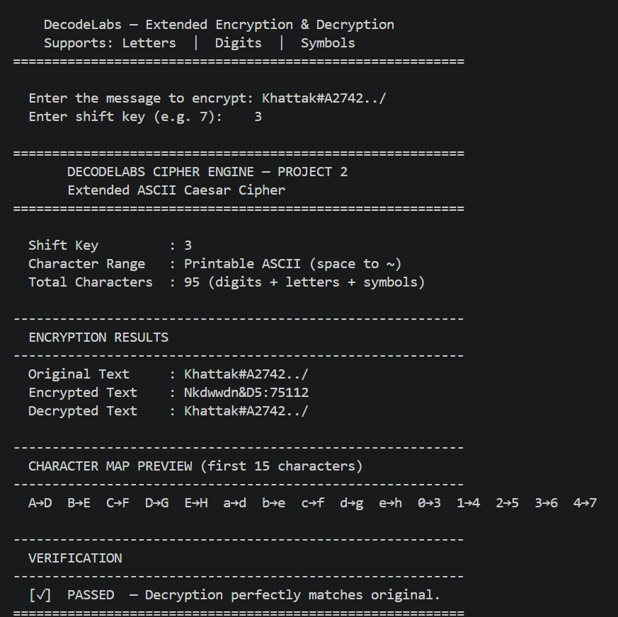
Figure 1: Successful execution of the Extended Caesar Cipher in Visual Studio Code.
Figure 1 demonstrates the successful execution of the application. The output includes:
- User input
- Shift key
- Encrypted text
- Decrypted text
- Character mapping preview
- Verification status
The verification result confirms that the decrypted text matches the original plaintext, demonstrating that both the encryption and decryption algorithms operate correctly.

Key Observations
The execution output confirms the following:
- The application successfully encrypts uppercase and lowercase letters.
- Numeric characters are encrypted correctly.
- Symbols and punctuation are also transformed.
- The original plaintext is accurately recovered after decryption.
- The verification mechanism confirms the correctness of the algorithm.
These results demonstrate that the Extended Caesar Cipher implementation behaves as expected for printable ASCII characters.

12. Testing
To ensure the correctness and reliability of the application, the Extended Caesar Cipher was tested using different input scenarios. Each test case verified that the encryption and decryption processes produced the expected results.
Test Case | Description | Result
Uppercase Letters | Encrypt and decrypt uppercase alphabets | Passed
Lowercase Letters | Encrypt and decrypt lowercase alphabets | Passed
Numeric Characters | Encrypt digits (0–9) | Passed
Symbols | Encrypt punctuation and special characters | Passed
Spaces | Encrypt and decrypt spaces correctly | Passed
Mixed Input | Combination of letters, numbers, and symbols | Passed
Empty Message | Reject empty input | Passed
Invalid Shift Value | Reject non-integer values | Passed
Zero Shift Key | Prevent zero shift | Passed
Verification | Confirm decrypted text matches original | Passed
Testing Summary: All test cases were executed successfully. The application consistently produced the correct ciphertext and accurately recovered the original plaintext after decryption. The verification mechanism confirmed that the encryption and decryption algorithms functioned correctly for every tested scenario.

13. Edge Cases
In addition to normal test cases, several edge cases were considered during development to improve the robustness of the application.

Empty Message
If the user submits an empty message, the program displays an error message and requests a valid input.

Invalid Shift Key
The application accepts only integer values. If the user enters alphabetic characters or other invalid input, the program prompts the user to enter a valid integer.

Zero Shift
A shift value of zero would leave the message unchanged. Therefore, the program rejects zero and requests another value.

Large Shift Values
Large shift values are handled correctly using modular arithmetic. Regardless of the shift size, the resulting character always remains within the printable ASCII range.

Printable ASCII Range
Only printable ASCII characters (ASCII 32–126) are processed by the encryption algorithm, ensuring consistent behavior throughout the application.

14. Complexity Analysis
The algorithm processes each character of the input message exactly once during encryption and once during decryption. Therefore, the computational complexity grows linearly with the size of the input.
Operation | Complexity
Encryption | O(n)
Decryption | O(n)
Space Complexity | O(n)
Where n represents the number of characters in the input message. Since each character is processed independently, the algorithm is efficient for educational purposes and small text inputs.

15. Security Analysis
The Extended Caesar Cipher improves upon the traditional Caesar Cipher by encrypting all printable ASCII characters instead of only alphabetic letters. This enhancement provides broader character coverage and produces ciphertext that is less predictable than the classical version.
However, despite this improvement, the algorithm remains a classical educational cipher and should not be used to protect sensitive or confidential information.

Security Limitations
Small Key Space: The cipher relies on a single shift value, resulting in a very limited number of possible keys. An attacker can try every possible shift value within a short period of time.
Brute-Force Attack: Because the key space is small, the cipher is highly vulnerable to brute-force attacks. Every possible key can be tested automatically until the correct plaintext is recovered.
Frequency Analysis: Although all printable ASCII characters are encrypted, the algorithm still preserves character frequency patterns. These statistical patterns can be analyzed to recover the original message without knowing the key.

Educational Value
Despite its security limitations, the Extended Caesar Cipher is valuable for learning fundamental cryptographic concepts, including:
- Symmetric Encryption
- Character Encoding (ASCII)
- Modular Arithmetic
- Encryption and Decryption Processes
- Input Validation
- Function-Based Programming
These concepts provide a solid foundation before studying modern cryptographic algorithms such as AES, RSA, and ECC.

16. Future Improvements
Although the current implementation successfully demonstrates the principles of the Extended Caesar Cipher, several enhancements can be introduced to improve both functionality and learning outcomes.
- Develop a Graphical User Interface (GUI) using Tkinter or PyQt.
- Add file encryption and decryption support for text files.
- Generate random shift keys automatically.
- Allow users to save encrypted and decrypted output to a file.
- Support batch encryption of multiple files.
- Implement password-based key generation.
- Add logging to record encryption and decryption activities.
- Write unit tests using Python's pytest framework.
- Implement more advanced classical ciphers such as the Vigenère Cipher.
- Explore modern encryption standards, including AES-256, to understand practical cryptography.
These improvements would make the project more feature-rich while providing a gradual transition from classical cryptography to modern encryption techniques.

17. Conclusion
This project successfully demonstrates the implementation of an Extended Caesar Cipher using Python. Unlike the traditional Caesar Cipher, which operates only on alphabetic characters, this implementation supports all 95 printable ASCII characters, including letters, numbers, symbols, punctuation marks, and spaces.
Throughout the development process, several important programming and cybersecurity concepts were applied, including:
- ASCII character encoding
- Modular arithmetic
- Symmetric encryption
- Input validation
- Function-based programming
- Input–Process–Output (IPO) model
The application was tested using multiple input scenarios, and all test cases produced the expected results. The verification mechanism confirmed that the decrypted message always matched the original plaintext when the correct shift key was used.
Although the Extended Caesar Cipher is not suitable for protecting sensitive information due to its vulnerability to brute-force and frequency analysis attacks, it serves as an effective educational project for understanding the core principles of encryption and decryption.
Overall, this project provides a strong foundation for learning modern cryptographic algorithms such as AES, RSA, and other secure encryption techniques used in real-world cybersecurity.

18. References
- Python Software Foundation. Python 3 Documentation. https://docs.python.org/3/
- ASCII Character Set Reference Table. https://www.ascii-code.com/
- Stallings, W. Cryptography and Network Security: Principles and Practice.
- Microsoft. Visual Studio Code Documentation. https://code.visualstudio.com/docs
- GitHub Docs. About READMEs. https://docs.github.com/

Appendix

Program Output
The following screenshot shows the successful execution of the program in Visual Studio Code.

Figure 1. Program execution demonstrating encryption, decryption, character mapping, and successful verification.

Project Summary
Item | Details
Project Title | Extended Caesar Cipher
Language | Python 3
IDE | Visual Studio Code
Encryption Type | Symmetric Encryption
Algorithm | Extended Caesar Cipher
Character Set | 95 Printable ASCII Characters
Time Complexity | O(n)
Space Complexity | O(n)
Status | Successfully Completed

Acknowledgements
I would like to express my sincere gratitude to DecodeLabs for providing practical cybersecurity projects that encourage hands-on learning and strengthen problem-solving skills.
This project was completed as Project 2 of the Cybersecurity Analyst Internship Track and has significantly improved my understanding of classical cryptography, Python programming, and secure software development practices.

Author
Adnan Iqbal
Cybersecurity Analyst Intern — DecodeLabs
Computer System Engineering Student
Mirpur University of Science and Technology (MUST), AJK

Areas of Interest
- Cybersecurity
- Penetration Testing
- Red Teaming
- Python Programming
- Computer Networking

Contact
GitHub: https://github.com/adnaniqbal
LinkedIn: www.linkedin.com/in/addan-iqbal-4186ab247

