[Computational Materials Science 50 (2011) 811–819](http://dx.doi.org/10.1016/j.commatsci.2010.10.006)

Contents lists available at [ScienceDirect](http://www.sciencedirect.com/science/journal/09270256)

Computational Materials Science

journal homepage: [www.elsevier.com/locate/commatsci](http://www.elsevier.com/locate/commatsci)

Kinetic modeling of high temperature oxidation of Ni-base alloys

a,⇑

a

a

a

a

b

A. Chatterjee , S. Srikanth , S. Sanyal , L. Krishna , K. Anand , P.R. Subramanian

a GE Global Research Center, Bangalore, India

b GE Global Research Center, Niskayuna, NY, USA

a r t i c l e i n f o

a b s t r a c t

Article history:

Received 5 May 2010

Received in revised form 28 September

The rates of isothermal and cyclic oxidation and the elemental concentration proﬁles as a function of time

of oxidation for few Ni-base superalloys were determined through modiﬁed Wagner’s oxidation

a

a

model and the solution of coupled elemental diffusion equations. Thermodynamically calculated interfa-

cial elemental concentrations and oxygen partial pressures for the multi-component Ni-base alloys were

used as boundary conditions for the solution of Wagner’s equation and the elemental coupled diffusion

equations (for Cr, Al and O). The multiple elemental diffusion and mass conservation equations were

solved using a numerical procedure. The dependence of self/tracer-diffusivities of Cr, Al and O in the

corundum phase on the oxygen partial pressures was deduced using a genetic algorithm based optimi-

zation procedure incorporating the experimental parabolic rate constants for several Ni-base alloys. Rates

of cyclic oxidation were then deduced from the deterministic interfacial cyclic oxidation spalling model

(DICOSM) developed by Smialek [1]. The calculated oxidation rates were in reasonable agreement with

the experimental values for a range of multi-component Ni-base alloys.

2

010

Accepted 4 October 2010

Available online 9 November 2010

Keywords:

Ni-based superalloy

Thermodynamic model

Oxidation kinetics

Genetic algorithm based optimization

Wagner’s equation

Ó 2010 Elsevier B.V. All rights reserved.

1

. Introduction

Further improvement in the development of Ni-base superalloys

The elemental concentrations at the alloy/oxide and oxide/gas

interfaces are independent of the scale thickness.

Oxidation occurs at steady state.

for higher temperature applications in gas turbines and aero-en-

gines to improve the energy efﬁciency is constrained by their high

temperature corrosion. Knowledge of the rates of oxidation of these

alloys as a function of temperature and gas composition is essential

for this purpose. Since high temperature isothermal or cyclic corro-

sion experiments under simulated gas atmospheres are both time

consuming and expensive, modeling the rates of isothermal and

cyclic oxidation of multi-component multiphase alloys is essential

for the design of Ni-base superalloys and bond coat alloys. The oxi-

dation rate of alloys is determined both by thermodynamic and ki-

The rate of oxide layer growth is given as:

dLðtÞ VoxideD½Cð0Þ CðLÞ

¼

ð1Þ

dt

LðtÞ

Integration of the above equation, yields the parabolic law i.e.,

L t

ð Þ

2kt

2

¼

k ¼ VoxideD½Cð0Þ CðLÞ

netic considerations.

A

rigorous thermodynamic analysis of the

where Voxide is the molar volume of the oxide, L(t) is the thickness of

the oxide scale at time t, C(0) and C(L) are the concentration of the

diffusing species at the alloy/oxide and oxide/air interfaces respec-

tively, k is the rate constant and D is the intrinsic diffusivity of the

diffusing species. Subsequently, Wagner [3] postulated that the oxi-

dation of metals occurs by the transport of charged defects in oxides

and developed a theory based on the theoretical treatment of ionic

diffusion in electrolytes. Wagner’s equation is essentially based on

the linear diffusion equation for charged particles:

oxidation of multi-component multiphase Ni-base alloys was re-

ported in an earlier study [2]. In this paper, we would restrict to

the analysis of the kinetics of oxidation of these alloys.

The early theories on the kinetics of oxidation were based on

the Tammann–Pilling–Bedworth (TPB) parabolic law derived from

Fick’s law of diffusion under various assumptions. The basic

assumptions of the TPB parabolic law are the following:

The growth of the oxide phase is by atomic/molecular diffusion.

The diffusion coefﬁcient is independent of the concentration.

þ qiE

DiCi

kT

dli

dx

Ji

¼

ð2

Þ

where Ji is the ﬂux of the ith species, li is the chemical potential, Ci

is the concentration (number of particles per unit volume) of the

diffusing charged defect, qi is the effective charge on the defect, E

⇑

Corresponding author. Tel.: +91 80 4088 3927; fax: +91 80 2841 2111.

E-mail address: [aveek.chatterjee@ge.com](mailto:aveek.chatterjee@ge.com) (A. Chatterjee).

0927-0256/$ - see front matter Ó 2010 Elsevier B.V. All rights reserved.

doi:[10.1016/j.commatsci.2010.10.006](http://dx.doi.org/10.1016/j.commatsci.2010.10.006)

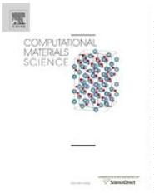

8

12

A. Chatterjee et al. / Computational Materials Science 50 (2011) 811–819

the electric ﬁeld, k is the Boltzmann constant, and T is the temper-

ature. For each diffusing species, ﬂux equations similar to Eq. (2)

can be given. Eq. (2) is based on the validity of the Nernst–Einstein

relationship and is therefore applicable only for thick oxide scales

(>1 lm) and at temperatures greater than 500 °C. By assuming

the magnitude of the electric ﬁeld to be small and assuming charge

neutrality and local equilibrium at all points within the oxide phase,

we can eliminate from the coupled transport equations, the electric

ﬁeld and all the chemical potentials, except that of oxygen and cor-

relate the parabolic rate constant (kp) to the tracer diffusion coefﬁ-

cients of the cations [D(M)] and anions [D(O)]:

literature on the modeling of oxidation of multi-component Ni-

base alloys.

In the present work, mathematical models based on genetic

algorithm (GA) were developed to extract the diffusivities of mul-

ti-component alloys. The diffusivities were then used in a cyclic

oxidation model for analysis of high temperature oxidation of Ni-

base alloys. The predicted oxidation rates were compared with

experimental data.

2

. Mathematical models and computational methods

2

.1. 2A. Modeling of oxidation of multi-component alloys

Z

ðOÞ

p

aD

ðM

D

f

O2 ðIIÞ

Þ

kp

¼

þ

d ln pO2

ð3Þ

f

In the present study on the modeling of the kinetics of oxidation

pO2ðIÞ

M

O

of multi-component alloys, two approaches were considered: (i) a

modiﬁed Wagner’s ionic approach and (ii) simultaneous solution of

multiple elemental diffusion equations. In an earlier paper on the

thermodynamics of oxidation of multi-component Ni-base alloys,

it was observed that three different oxide phases formed, i.e.,

corundum (solid solution of Al2O3 and Cr O ) formed adjacent to

where a = a/b is the stoichiometric ratio of the oxide phase (M O ),

a

b

fM and fO are the correlation factors for the metal and oxygen ions

for self diffusion and is of the order of unity, p(O2)I and p(O2)II are

the oxygen partial pressures at the metal/oxide and oxide/gas inter-

faces respectively. To evaluate the parabolic rate constants using Eq.

(3), a knowledge of the cation and anion tracer diffusion coefﬁcients

as a function of the oxygen partial pressure is essential. The func-

tional relationship between tracer diffusion coefﬁcients and oxygen

partial pressure depends on the defect chemistry of the oxide [4].

Tretjakow and Schmalzreid [4], Gesmundo and coworkers [5] and

Dieckmann [6] give a detailed treatise on the effect of defect chem-

istry of various oxides on metal oxidation. If the oxide formation is

controlled purely by oxygen ion diffusion, the D(M) term can be ne-

glected and if it is controlled by cation interstitials diffusion, the

D(O) term can be neglected. The main difﬁculties with the applica-

tion of Wagner’s theory are:

2

3

the alloy at low pO followed by the alloy-corundum-spinel (solu-

2

tion of NiCr O –NiAl O ) equilibria as p is increased and then

2

4

2

4

O

2

the spinel–bunsenite (NiO) equilibrium up to the oxide/air inter-

face. Also, there is ample literature evidence [8,43] that highlight

the co-existence of multiple oxides, viz. Cr2O3 and NiO above

Al2O3 scale. This is also reinstated by the XRD analyses reported

in literature [30]. However, consideration of all the elements and

all the oxide phases makes the kinetic treatment mathematically

unwieldy. Further, diffusivity data of all the elements in the differ-

ent oxide phases and their temperature and oxygen partial pres-

sure dependence are not available in the literature. Keeping this

in mind, our approach has been to extract D from Kp, which was

experimentally available. We also established a method using ge-

1

.

Knowledge of defect chemistry and transport mechanism in the

oxide scale is essential.

netic algorithm to extract a unique value of diffusivity from several

2

.

Defect chemistry and the diffusivities of the mobile species are

a function of oxygen partial pressure and therefore pO depen-

dence of D in the oxide may be different at metal/oxide and

oxide/air interface.

sets of experimental Kp. Besides, the dependence of Kp on pO has

2

2

been incorporated in the optimization model. Further details of

the optimization method used has been presented in Section 2.5.

For simplicity, we have made the following assumptions:

3

4

.

.

Gets complicated when more than one oxide phase forms – e.g.,

corundum, spinel, rocksalt/monoxide, etc.

1

.

Diffusion in the oxide product phase is the rate-controlling

step.

Diffusivity along grain boundaries and dislocations may have

different pO dependence and coupling them in Wagner’s equa-

2

2.

The diffusivity of Al in alloy, as quoted from DICTRA [44], is of

the order of 10 13–10 14 cm2/s at 1100 °C, whereas, diffusivity

of Al and O in the oxide (Al O ) is of the order of 10 17 cm2/s.

tion may be difﬁcult.

Application of Wagner’s theory to complex oxide growth is ren-

2

3

Since the elemental diffusivities in the alloy phase are two to

three orders of magnitude greater than their corresponding dif-

fusivities in the oxide phase, the existence of a concentration

proﬁle within the alloy is neglected.

dered difﬁcult because of the uncertainties concerning the defect

and transport properties of multi-component oxide solutions.

Some papers on the modeling of oxidation of ternary Ni-base al-

loys have been reported in the literature. Nijdam et al. [7,8] re-

3

.

The formation of only the corundum oxide phase is considered.

The subsequent formation of the spinel and bunsenite (NiO)

phases is ignored for oxide growth. However, the co-existence

of the corundum phase with the spinel phase is considered

for the determination of elemental concentration proﬁles in

the corundum oxide phase.

ported

a coupled thermodynamic–kinetic oxidation model to

describe the thermal oxidation of a c-phase Ni–27Cr–9Al (at.%) al-

loy at 1373 K. They have used the THERMOCALC™ software [9] and

the TTNI7 [9] database for the determination of the activities of the

constituents in the alloy phase. For

a given oxide layer growth

kinetics (i.e., using experimental growth rates), the model com-

putes composition–depth proﬁles in the alloy as well as the

amount of each oxide phase developed as a function of oxidation

time. In their kinetic approach, elemental diffusion equations have

been formulated for the alloy phase. Whereas, diffusion of mobile

charged species within the oxide phase is not implicitly considered

(experimental parabolic rate constants in the oxide phase is di-

rectly used). The chemical diffusion coefﬁcients as a function of

composition in the alloy phase have also been taken from the

mobility database of DICTRA™ [9]. We are not aware of any paper

in the literature where the activities in the oxide phase are also

considered in the modeling of oxidation. Further there is no

4

5

.

.

Diffusion of only the major species i.e. Cr, Al and O in the oxide

phase is considered. The diffusion model does not specify the

nature of the diffusion process (e.g. grain boundary diffusion,

bulk diffusion, etc.).

The solubility of oxygen in the alloy is considered to be

negligible.

2.2. Modiﬁed Wagner’s equation for multi-component alloys

Wagner’s approach can be adopted for

a multi-component

oxide and an equation can be derived (assuming charge neutrality



A. Chatterjee et al. / Computational Materials Science 50 (2011) 811–819

813

cor

Cr

@X

and local equilibrium at all points within the oxide phase) for the

parabolic rate constant in terms of the diffusivities of all the

charged defects (oxygen ion, all the cation interstitials and elec-

trons). The modiﬁed Wagner equation correlating the parabolic

rate constant to the ionic diffusivities for a multi-component (com-

prising of N cations) oxide phase can be given as:

@C

@C

valloy=cor Calloy=cor;int  Ccor ¼ DcCorr

ð9Þ

Cr

Cr

cor

Al

@X

valloy=cor Calloy=cor;int  Ccor ¼ DcAolr

ð10Þ

ð11Þ

Al

Al

cor

O

"

D ðMiÞ D ðOÞ#

cor @C

Z

alloy=cor;int

O

cor

p00

X

N

valloy=cor

C

CO ¼ DO

O

i eff

f

O eff

fO

@X

kp

¼

2

a

;

þ

;

dln pO2

ð4Þ

p0

mi

i¼1

where

= dXalloy/cor/dt is the velocity of the alloy/corundum

O

valloy/cor

2

interface i.e., rate of growth of the corundum phase. It is appropriate

to mention that since the interface position is determined by the

fastest diffusing species, mass conservation equation will apply only

for this species. Therefore, among Eqs. (9)–(11) for the alloy/corun-

dum interface, only one of them is relevant and the remaining equa-

tions are redundant. The initial conditions at t = 0 is given as:

where a = b/a is the stoichiometric factor for oxide M O , f and fO

a

b

mi

are the correlation factors for the individual cations and oxygen ion

self-diffusion mechanisms and are of the order of unity. D(Mi) and

D(O) are the effective cation and oxygen ion self-diffusion coefﬁ-

cients and are a function of both oxygen partial pressure and tem-

perature. The effective diffusion coefﬁcients accounts for diffusion

through the lattice, grain boundaries and defects and is given by:

Calloy=cor;int ¼ C0 ;

Calloy=cor;int ¼ C0 ;

Cr

Cr

Al

Al

ð12Þ

D ¼ D p1=ni

Ccor

¼

0

;

Ccor

¼

0;

i;eff

eff

O

Cr

Al

2

At all times t, the alloy/corundum (1st interface) and the corundum/

spinel interfaces (2nd interface) are at thermodynamic equilibrium

and therefore, the boundary conditions at the interfaces at any gi-

ven time t are given by:

Deff ¼ ð1 fÞDL þ f:Dgb

2

l

d

f ¼

ð5Þ

CaClrloy;int1

¼

Calloy=cor;eq

;

CaAllloy;int1

¼

Calloy=cor;eq

;

CaOlloy;int1

¼

Calloy=cor;eq

;

O

Cr

Al

where ni is the functional dependence on pO2 depending on defect

structure and can be positive or negative depending on the defect,

f is the effective volume fraction of grain boundaries; d is the grain

boundary width andl is the grain size. In this study, we have con-

sidered only the effect of pO on diffusivity and assumed that the

concentration of other elements in the oxide phase alters the diffu-

sivity by altering the pO2

Ccor;int1 ¼ Ccor=alloy;eq;

Ccor;int1 ¼ Ccor=alloy;eq;

Ccor;int1 ¼ Ccor=alloy;eq;

Cr

Cr

Al

Al

O

O

2

C

cor;int2

Cr

¼

CcCor r=spinel;eq;

CcAolr;int2

¼

CcAol r=spinel;eq;

CcOor;int2

¼

CcOor=spinel;eq

.

ð13Þ

The equilibrium concentrations of Cr, Al and

O at the alloy/

2

.3. Formulation of diffusion equations in the alloy and oxide phases

corundum and corundum/spinel interfaces are deduced from free

energy minimization techniques using THERMOCALC™ and its

associated databases (TTNI7). The details of the thermodynamic

calculation are given in an earlier study [2]. In principle, Eqs.

(6)–(11) can be solved simultaneously under the initial and bound-

ary conditions given by Eqs. (12) and (13) to determine the ele-

Similar to the Tammann–Pilling–Bedworth approach, diffusion

and mass conservation equations can be formulated for all the ele-

ments and for each of these phases, assuming mass transport in the

alloy and oxide phases to occur through atomic transport. How-

ever, as mentioned earlier, consideration of all the elements and

all the oxide phases makes the kinetic treatment mathematically

unwieldy and therefore, the same assumptions as mentioned ear-

lier were made for formulating the diffusion equations.

mental concentration proﬁles of Cr, Al and

O in the alloy,

corundum and spinel phases as a function of time as well as the

rate of growth of the oxide phase. The diffusion equations were

solved using a ﬁnite difference method (FDM). A second order spa-

tial discretization and an explicit temporal discretization scheme

were used to implement the FDM based approach. Utilizing the ini-

tial and boundary conditions and explicit time stepping, the ele-

mental concentration proﬁle for the next time step was

computed. Based on the elemental concentration proﬁle and ther-

modynamic estimate of equilibrium concentration at the interface,

the boundary position was updated and based on the new bound-

ary position, the diffusivities were updated. Although the compu-

tational algorithm can be scaled to handle multiple oxide phases

this was not done in the present study because of the absence of

experimental diffusivity data for the various elements and para-

bolic rate constants for the growth of spinel and monoxide (NiO)

phases in multi-component Ni-base alloys.

Based on Fick’s 2nd law, the concentration proﬁles for Cr, Al and

O in the corundum phase as a function of time can be given as:

@

@

@

C

cor

Cr

t

@

@X

@

@X

Ccor

Cr

¼

¼

¼

Dcor

ð6Þ

ð7Þ

ð8Þ

Cr

@

C

cor

Al

t

@

@X

@

@X

Ccor

Dcor

Al

Al

@

C

cor

O

t

@

@X

@

@X

Ccor

Dcor

O

O

@

In Eqs. (6)–(8), Dcor, Dcor, and Dcor are intrinsic diffusion coefﬁcients

Cr

Al

O

of Cr, Al, and O respectively in the corundum phase and are func-

tions of the oxide composition and temperature. Eqs. (6)–(8) can

also be written in terms of the elemental chemical potential gradi-

ents and self-diffusion coefﬁcients rather than concentration gradi-

ents and chemical diffusion coefﬁcients. The concentration

mentioned in Eqs. (6)–(8) refer to the active and mobile species,

which participate in the oxidation process. Thermodynamic model-

ing can be used to generate either the interfacial chemical poten-

tials or concentrations for a multi-component multiphase system

for the solution of the diffusion equations. The elemental mass con-

servation equations at the alloy/corundum interface are:

2.4. Cyclic oxidation model

Since both gas turbines and aero-engines undergo periodic

start-ups involving heating cycles and shutdowns involving cool-

ing cycles, Ni-base superalloys used in these applications undergo

cyclic oxidation. In cyclic oxidation, some spalling of the scale oc-

curs during the cooling cycle. Several cyclic oxidation spalling

models have been reported in the literature [1,10–13]. Typically,



8

14

A. Chatterjee et al. / Computational Materials Science 50 (2011) 811–819

in all these models, a scale growth law with a ﬁxed rate constant is

postulated for each heating cycle and spalling formalism is

knowledge of the defect chemistry as a function of oxygen partial

pressure and temperature of the various oxide phases is essential

to estimate the diffusivities of the charged defects and correlation

to the parabolic rate constant. The defect structure of pure Cr2O3

has been reviewed by Kroger [14]. It is suggested that pure Cr2O3

a

deﬁned, which governs the type and amount of spalling that occurs

in each cooling cycle. Two types of cyclic spalling formalisms have

been reported in the literature. In the ﬁrst method, a discrete and

constant area fraction of each portion of the scale spalls in each cy-

cle [10]. In the second method, a uniform external layer of speciﬁed

thickness spalls off the entire area [11–13]. The entire cyclic oxida-

tion curve is then generated from the resultant effect of all the cy-

cles either by series summation or by using iterative procedures. A

consolidated cyclic oxidation spalling computer program (COSP),

which allows the selection of various scale growth laws, spalling

functions, and spalling conﬁgurations is available [12,13]. More re-

cently, Smialek [1] has modiﬁed the interfacial spallation model

(deterministic interfacial cyclic oxidation spallation model) stipu-

is

a p-type conductor at high pO and low temperatures and is

2

‘‘intrinsic” at temperatures above 1200 °C. Several researchers

have reported diffusivities of Cr3+ cations and oxygen anions in

pure Cr O . However, the results vary by 4–7 orders of magnitude.

2

3

The above-mentioned results are summarized in the review papers

by Hindam and Whittle [15] and Atkinson [16]. The large differ-

ence in the reported diffusivities is attributed to the domination

of dislocation and grain boundary effects in many of the earlier

measurements.

The variation of self-diffusivity of Cr (DCr) with oxygen partial

lating that the spallation occurs from

a constant area fraction

pressure shows a p 3=16 dependence at low p as would be ex-

O

2

O

2

biased towards the thickest oxide regions that is yet to spall, but

does not stipulate that a critical oxide thickness be attained before

spallation. Smialek [1] has also simpliﬁed the mathematics of the

treatment to describe the total cyclic oxidation curve through sim-

ple algebraic functions. In his model (DICOSM), the expression for

weight change (DW) per unit area (A) as a function of time for cyc-

lic oxidation is given as:

pected from a Cr3+ interstitials diffusion mechanism. We initially

adopted the Cr interstitials diffusivity reported by Hagel and

Seybolt [17] for the corundum phase. Oxygen anion diffusion in

pure Cr2O3 has been reported by Hagel [18] and Oishi and Kingery

[19] to be three orders of magnitude slower than Cr interstitials.

Oxygen anion diffusion in Cr2O3 reported by Hagel was initially

used in the present calculations for the corundum phase. Cation

and anionic diffusivities in Cr2O3 scale formed on alloys may be dif-

ferent because of the formation of oxide solid solution. Tsai and

coworkers [20] report the bulk and grain boundary diffusivities

of Cr interstitials and oxygen ions in Cr2O3 scale formed on Ni-Cr

alloys and conclude that the scale growth is controlled by counter-

2ScÞðjÞ1=2

DW

A

pﬃﬃﬃﬃﬃﬃﬃﬃﬃﬃ

1

2

1

3

¼

FA k Dt ð2n0  ScÞðjÞ1=2

þ

ð1

P

Case

A

DW

A

pﬃﬃﬃﬃﬃﬃﬃﬃﬃﬃ

1

2

current diffusion of both Cr3+ and O2

ions and that the diffusion is

¼

FA k Dt ð1 ScÞj Sc ðn0Þ1=2

P

predominantly along grain boundaries. Lobnig et al. [21] have also

measured and reported lattice and grain boundary diffusivities at

1173 K of some cations (Fe, Mn, Cr and Ni) in Cr2O3 scales of Fe–

Cr and Fe–Cr–Ni alloys. Although they did not observe any signiﬁ-

cant difference in the lattice diffusivities of these cations, they ob-

served that the grain boundary diffusion of Mn is the fastest and Ni

is the slowest.

Case

B

1

3

3=2

ð14

Þ

þ

ð1 þ S Þðn Þ

c

0

where kp is the parabolic growth rate constant for isothermal oxida-

tion, FA is the spall area fraction (also known as spall constant), Sc is

the weight of the oxide relative to oxygen and is constant for a given

oxide and Dt is the cycle duration. Case A corresponds to the situa-

tion where the number of cycles j 6 N0, where N0 = 1/FA, and Case B

corresponds to a situation when number of cycles j > N0. It is to be

noted that the spall constant will be different for different alloys.

We have provided a method to simulate the cyclic oxidation pro-

cess. However, it is imperative for a user to utilize the experimental

spall constant for a speciﬁc alloy to predict the cyclic oxidation rate.

The simpliﬁed DICOSM model of Smialek [1] has been used in the

present study for the prediction of cyclic oxidation of multi-compo-

nent Ni-base alloys using the isothermal oxidation rates determined

from the modiﬁed Wagner’s equation and the coupled diffusion

equations.

In the case of oxidation of corundum Al O , since Al melts at a

2

3

relatively low temperature, the oxidation studies reported in the

literature are essentially on alloys. Pure a-Al2O3 has a low concen-

tration of ionic and electronic defects and the defect chemistry of

pure a-Al2O3 as a function of oxygen partial pressure and temper-

ature is still not well understood [14]. It is reported that for

a-Al O , the concentration of intrinsic point defects is very small

2

3

and that transport properties are dominated by solute ions present

as impurities. The diffusivities of O2 in a-Al O measured and re-

2

3

ported by several researchers and that of Al3+ in a-Al O measured

2

3

by Paladino and Kingery [22] have been critically reviewed and

compiled by Atkinson [16]. The reported anion diffusivities vary

by 3–4 orders of magnitude. Atkinson concluded that D(Al) is al-

ways greater than D(O) in the Al2O3 lattice. Despite the higher dif-

fusivities of Al, they inferred from studies on scale morphology and

marker diffusion experiments that Al2O3 grows by inward diffusion

of oxygen. They suggest that the diffusion paths of oxygen in Al2O3

are the grain boundaries and ﬁssures. However, more recently,

Tolpygo and Clark [23] have produced microstructural evidence

to indicate that Al2O3 scales grow by counter-diffusion of alumi-

num and oxygen in Fe–Cr–Al alloys and nickel aluminides. It is

therefore clear that the diffusivities, concentration, and mobility

of the mobile species in pure Cr2O3 and Al2O3 oxide are a complex

function of alloy composition, oxygen partial pressure, and tem-

perature. No experimental measurements are reported in the liter-

ature on the corundum solid solution phase involving more than

one oxide.

2

.5. Evaluation of diffusivities of Cr, Al and O in the corundum phase

The mobility of most elements in Ni-base superalloys and their

temperature dependence are available and included in the DIC-

TRA™ [9] database. The chemical diffusion coefﬁcients in any

phase are determined from the mobility and activity coefﬁcients

of the respective element in the relevant phase, which is derived

from THERMOCALC™ [9]. In this study, we have considered the

oxide phase to be a solid solution of Al2O3 and Cr O . Hence, diffu-

2

3

sivities of elements in both Chromia and Alumina have been

considered.

The diffusivities of elements in oxides are not by atomic mobil-

ity but by ionic mobility and occur through the presence of charged

defects (typically, cation interstitials, cation vacancies, anion

vacancies, electrons, and holes). The nature, concentration, and

mobility of these charged defects are a function of chemical com-

position, oxygen partial pressure, and temperature. Therefore,

There is much less information on the defect structure and dif-

fusivities of Cr, Al, Ni and O in the spinel phase. Armijo [24] and

Schmalzried [25] have reviewed diffusion in the spinel phase. Since



A. Chatterjee et al. / Computational Materials Science 50 (2011) 811–819

815

Table 1

Alloy compositions and corresponding experimental parabolic rate constants for datasets used in the optimization process.

Alloy composition atom percent

Temperature of oxidation (°C)

Parabolic rate constant (mg2 cm 4 s 1)

Ni–24.7Cr–14.6Al [29]

Ni–25.34Cr–14.1Al–0.59Y [29]

Ni–10.0Cr–10.95Al–7.8Ti [30]

Pure Ni3Al [31]

Pure Ni3Al [15]

Ni–16Cr–6Al–0.1Y [15]

1100

1100

1000

1100

1100

1100

1100

0.7 10

1.6 10

5.0 10

6

6

7

log kP = 1.8996–9978.3/T

8.987 10

6

4.25 10

7

Ni–5Cr–1Al [27]

Ni–30Cr–2Al [27]

log kP = 7.1682–13,474/T

log kP = 5.4043–13,314/T

Ni–5Cr–6Al [27]

Ni–27Cr–9Al [8]

Ni–27Cr–9Al [8]

1.373 10

4.862 10

5.835 10

6

6

6

at 1100 °C

1100

1100

1100

1100

1100

1100

1100

1100

1100

1100

1100

900 and 1000

1000

1100

1100

1050

1050

1050

1050

1200

900

Ni–31Cr–20.7Al [32]

Ni–36.4Cr–14.1Al [32]

Ni–24.8Cr–24.6Al [32]

Ni–37.6Cr–19.0Al [32]

Ni–24.2Cr–21.7Al [32]

Ni–35.6Cr–18.0Al [32]

Ni–24.3Cr–22.3Al [32]

Ni–31.3Cr–14.7Al [32]

Ni–29.5Cr–24.0Al [32]

Ni–32.4Cr–15.35Al–0.44Y [33]

Ni–19.8Cr–19.05Al–0.29Y [34]

Ni–15Cr–5Al–5Pd [35]

Ni–7.10Al–10.0Cr [33]

Ni–27.33Cr [36]

Ni–28.62Cr–0.07Y [36]

Ni–25.21Cr–0.47Mn [36]

Ni–26.92Cr–0.096Y–0.51Mn [36]

b–NiAl + 0.1 at.% Hf [37]

Ni–22Cr–3Si [38]

Ni–32.6Cr [39]

Ni–32.6Cr [39]

Ni–32.6Cr [39]

Ni–30.5Cr [40]

Ni–30.18Cr–22.08Fe [40]

Ni–30.54Cr–26.94Co [41]

Ni–29.66Cr–5.30Si [41]

Ni–29.35Cr–21.47Fe–5.24Si [41]

Ni–29.7Cr–26.2Co–5.30Si [41]

Ni–27.33Cr–0.1Ti [42]

Ni–27.33Cr–0.1Cr [42]

Ni–27.33Cr–0.1Mn [42]

Ni–27.33Cr–0.1Sc [42]

Ni–27.33Cr–0.1Nb [42]

Ni–27.33Cr–0.1 Mg [42]

Ni–27.33Cr–0.1Hf [42]

Ni–27.33Cr–0.1Zr [42]

Ni–27.33Cr–0.1Ca [42]

Ni–27.33Cr–0.1Y [42]

Ni–27.33Cr–0.1Ce [42]

Ni–27.33Cr–0.1 Tb [42]

Ni–27.33Cr–0.1Gd [42]

Ni–27.33Cr–0.1Sm [42]

Ni–27.33Cr–0.1Nd [42]

Ni–27.33Cr–0.1La [42]

0.7 10

0.6 10

1.0 10

0.8 10

0.9 10

0.3 10

0.5 10

1.0 10

1.4 10

6

6

6

6

6

6

6

6

6

7.583 10

7

6

at 900 °C and 1.228 10

6

at 1000 °C

1.04 10

6

3.0 10

6

1.18 10

6

1.478 10

7.09 10

7.21 10

5.07 10

7

6

6

0.76–1.0 10

6

7.2 10

1.4 10

2.4 10

6.4 10

8

7

7

7

900

900

900

9 10

6

1000

1000

1000

1000

1000

1000

1000

1000

1000

1000

1000

1000

1000

1000

1000

1000

1000

1000

1000

1000

1000

1.1 10

1.9 10

2.9 10

2.6 10

3.2 10

5

5

6

6

6

5.338 10

4.185 10

7.809 10

8.328 10

5.990 10

4.684 10

2.979 10

1.634 10

8.918 10

6.167 10

1.471 10

3.310 10

1.764 10

1.921 10

1.921 10

2.002 10

6

6

6

6

6

6

6

6

6

7

7

7

7

7

7

7

sufﬁcient experimental information on the growth rates of Ni-base

spinel oxide layers is not available, the growth of the spinel phase

could not be considered in the present study and the growth of

only the corundum phase is considered. However, the formation

of spinel phase in equilibrium with corundum as thermodynami-

cally predicted is acknowledged.

The defect chemistry and consequently the transport mecha-

nism and their oxygen partial pressure dependence in oxide solu-

tions (corundum, spinel etc.) will differ considerably. Since no

measurements exist in the literature on the diffusivities in oxide

solid solutions, an attempt was made to estimate the effective dif-

fusivities of Cr, Al and O in the corundum solid solution and their

temperature and oxygen partial pressure dependence from the

experimental parabolic rate constants for several ternary Ni–Cr–

Al and quaternary Ni–Cr–Al–X alloys by applying the Wagner’s

equation (Eq. (4)) through an optimization procedure. A genetic

algorithm (GA) based optimization scheme has been used to esti-

mate the effective diffusivities (Deff ) and the pressure dependence

parameters (ni) of the three diffusing species (Cr, Al and O). The

algorithm implemented in the present study is a modiﬁed version

of a differential evolution type GA [26] that can handle both con-

strained and unconstrained optimization problems. No initial

guesses are required for this optimization method. Thirty-seven

experimental data sets of parabolic rate constants for Ni-base ter-

nary and quaternary alloys at 1373 K were used to extract the opti-

mum value of the six unknown parameters (Deff , Deff , Deff at 1373 K

Cr

Al

O

and their individual pO dependences). The Arrhenius energies for

2

these diffusivities were then deduced from the experimental tem-

perature dependent parabolic rate constants for some of these

alloys available in the literature. These parameters were then used

to compute the oxidation rate of the multi-component Ni-base

superalloys (viz. Ni–5Cr–6Al, Ni–20Cr–6Al, CMSX-4, and Rene’



8

16

A. Chatterjee et al. / Computational Materials Science 50 (2011) 811–819

N5). The equilibrium oxygen partial pressures at the alloy/corun-

dum and corundum/spinel interface for all these alloys required

for application of Wagner’s equation (Eq. (4)) to the optimization

process were obtained from thermodynamic modeling through

the procedure described earlier [2]. It needs to be emphasized that

in the estimation of optimized diffusivities of Cr, Al and O in the

corundum solid solution at 1373 K and their pO dependence, no

experimental information on multi-component Ni-base alloys

were used. The estimated diffusivities as a function of temperature

and oxygen partial pressure were then used to calculate the oxide

growth rates in multi-component Ni-base superalloys using the

Wagner’s model (Eq. (4)). Solving the diffusion equations also

yields the elemental concentration proﬁle in the corundum solu-

tion as a function of time of oxidation.

3. Results and discussion

The datasets of alloy compositions, the corresponding experi-

mental parabolic rate constants, and the equilibrium oxygen par-

tial pressures at the alloy-corundum and corundum-spinel

interface determined from THERMOCALC™ used for the optimiza-

tion process are summarized in Table 1. The optimized self-diffu-

sivities of Cr, Al and O in corundum phase, their oxygen partial

pressure, and temperature dependences are summarized in Table

2. The results indicate that the diffusivities of Cr interstitials and

oxygen ions at 1373 K are of the same order of magnitude and that

of aluminum interstitials are two orders of magnitude smaller.

However, the diffusivity of Cr interstitials is the fastest among

the three species. It is also interesting to note that the optimized

2

p

dependence of the diffusivities of all the three species is very

O

2

similar ( 1/5) to what would be expected if Cr3+ interstitials were

the main diffusing species (self-diffusivity of Cr with oxygen par-

tial pressure shows a p 3=16 dependence in pure Cr2O3 [17].

O

2

The agreement between the experimental parabolic rate con-

stants at 1373 K and those calculated from the optimized diffusiv-

ities are shown in Fig. 1. It is seen that the agreement between the

two is very good. The rates of the corundum phase formation were

determined for four multi-component Ni-base alloys (Ni–5Cr–6Al,

Ni–26Cr–4.5Al, CMSX-4 and Rene’ N5) using the optimized diffu-

sivities. The equilibrium oxygen partial pressures, the elemental

Table 2

Optimized self-diffusivities of Cr, Al and O in the corundum phase and their oxygen

partial pressure dependencies.

Element

D (cm2/s)

n

Cr

Al

O

6.86224 10 19

4.99438

4.838524

4.998994

8.60143 10 21

2.60328 10

1

9

Fig. 1. Comparison of the experimental and optimized parabolic rate constants for several ternary Ni–Cr–Al and quaternary Ni–Cr–Al–X alloys at 1373 K (for the alloy

classiﬁcations see Table 1).

Table 3

Thermodynamic modeling of equilibrium pO2 and elemental concentrations at interfaces of oxidized Ni-base alloys.

Temp. (K)

Alloy–corundum interface

ln pO2 (atm)

XNi XCr

Ni–27Cr–9Al (at.%) i.e., Ni–25.98Cr–4.49Al (wt.%) alloy

Alloy–corundum–spinel interface

Spinel–bunsenite_NiO interface

XAl

XO

ln pO2 (atm)

XNi

XCr

XAl

XO

ln pO2 (atm)

XNi

XCr

XAl

XO

1

373

43.23

0.64

0.27

0.09

1.1e-6

27.30

0.10

0.27

0.09

0.54

Ni–5Cr–6Al (wt.%) alloy

1

1

373

473

42.30

39.62

0.826

0.826

0.052

0.052

0.121

0.121

8.8e-7

9.3e-7

27.29

25.86

0.635

0.635

0.044

0.044

0.102

0.102

0.219

0.219

24.08

22.82

0.583

0.583

0.042

0.042

0.097

0.097

0.279

0.278

Ni–20Cr–6Al (wt.%) alloy

1

473

40.58

0.675

0.206

0.119

9.5e-7

25.91

0.400

0.152

0.088

0.360

22.85

0.337

0.140

0.081

0.443

CMSX-4 alloy (Ni–9Co–6.5Cr–0.6Mo–6.0W–5.6Al–1.0Ti–6.5Ta–0.1Hf–3Re)

1

1

373

450

43.16

0.638

0.638

0.076

0.076

0.126

0.126

1.0e-6

1.14e-6

26.81

0.446

0.446

0.061

0.061

0.102

0.102

0.261

0.261

23.64

22.67

0.400

0.400

0.058

0.058

0.096

0.096

0.323

0.323

41.16

25.70

Rene’ N5 alloy (Ni–7.5Co–7Cr–1.5Mo–5W–6.2Al–7Ta–0.15Hf–3Re)

366 0.644 0.081 0.139 9.6e-7 27.00

43.28

1

0.447

0.065

0.112

0.266

23.65

0.397

0.061

0.105

0.333

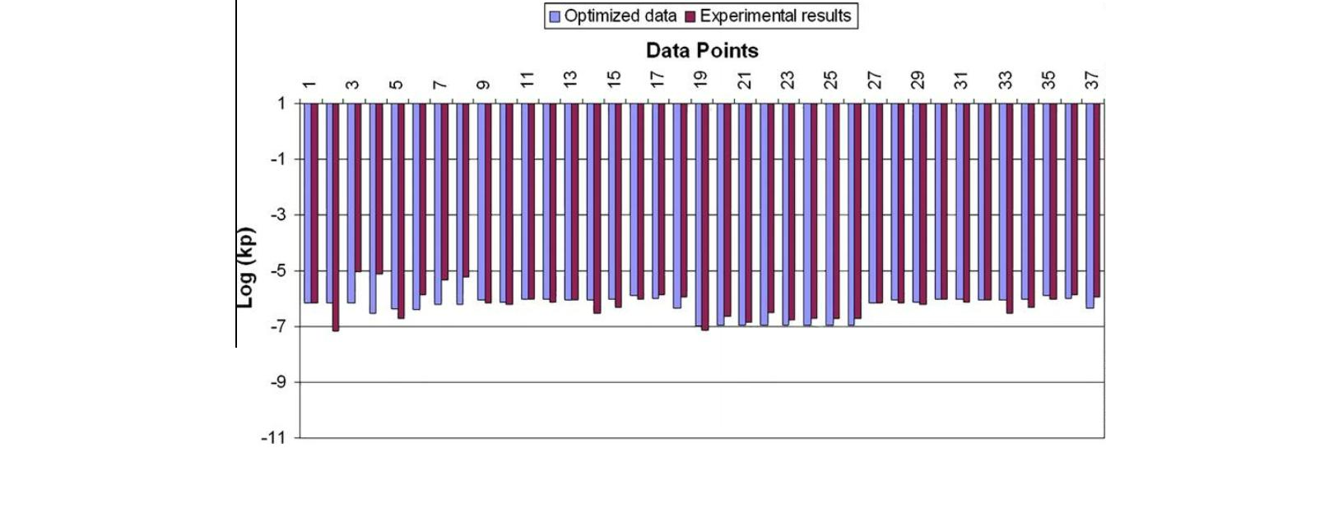

A. Chatterjee et al. / Computational Materials Science 50 (2011) 811–819

817

chemical potentials, and concentrations at the alloy-corundum and

corundum-spinel interface computed by thermodynamic modeling

for all these alloys are listed in Table 3. For simplicity, only the

corundum phase was assumed to form and the formation of other

oxide phases (spinel and monoxide) were neglected.

The rates of oxidation of ternary Ni–5Cr–6Al wt.% and Ni–20Cr–

6

Al alloy at 1373 K computed from Wagner’s equation are shown

in Fig. 2a and b and are compared with the experimental results

of Giggins and Pettit [27] for these alloys. It is seen that for both

these alloys, the agreement between the predicted and experimen-

tal isothermal oxidation rates is excellent. The experimental results

were not used for the optimization process.

The isothermal oxidation rates of a commercial alloy CMSX-4 at

1

373 K determined using the present approaches is compared with

the experimental results of Mu et al. [28] in Fig. 2c. Similarly the

oxidation rate of Rene’ N5 determined from Wagner’s model is

shown in Fig. 2d and compared with the experimental results

Fig. 3. Oxidation thickness vs. time, as predicted by the kinetic diffusion model.

[

45]. The predicted results for Rene’ N5 are in very good agreement

with the experimental data. However, for CMSX-4, the model un-

der-predicts the oxidation rate.

sion coefﬁcient in corundum to be identical for solving the diffu-

sion equations. The oxidation rate or the rate of corundum phase

formation calculated using this approach overestimates the oxida-

tion rate considerably. For example in 250 h, the oxide scale thick-

ness predicted by Wagner theory is 2 lm in comparison to 7 lm

predicted by the diffusion model. The prediction of oxidation rates

using the diffusion model can be improved by altering the atomic

diffusivities of Cr, Al and O. This has not been carried out in the

present study because atomic diffusion is inconsistent with the

generally accepted mechanism of defect diffusion in oxide scales.

The cyclic oxidation rates for these alloys (Rene’ N5 and CMSX-

4) determined from the DICOSM model (Eq. (14)) using the isother-

mal parabolic rate constants determined through Wagner’s

The isothermal oxidation rate of Rene’ N5 alloy at 1373 K, deter-

mined independently by solution of the elemental diffusion and

mass balance equations using the initial and boundary conditions,

is shown in Fig. 3. Although we do not have any direct evidence

about the mechanism of defect migration, our optimization proce-

dure yielded a pO dependence of n = 3/16 for all the three diffusiv-

2

ities. This value is very close to that expected for Cr interstitial

diffusion (n = 1/5) in pure Cr2O3 [17]. In this case, the oxidation

rate is determined purely by the fastest diffusing species i.e., Cr

(see Table 2) and therefore among the mass balance equations for-

mulated, only the one corresponding to Cr is applied. Further we

have assumed the atomic diffusion coefﬁcient and the ionic diffu-

Fig. 2. (a) Comparison of the predicted and experimental rates of oxidation of Ni–5Cr–6Al alloy at 1373 K. (b). Predicted vs. experimental isothermal oxidation rates of Ni–

0Cr–6Al (wt.%) alloys at 1373 K. (c). Isothermal oxidation of Ni-base superalloy CMSX-4 – comparison of prediction with experimental results at 1373 K. (d) Comparison of

the predicted and experimental rates of isothermal oxidation of Rene’ N5 at 1373 K.

2

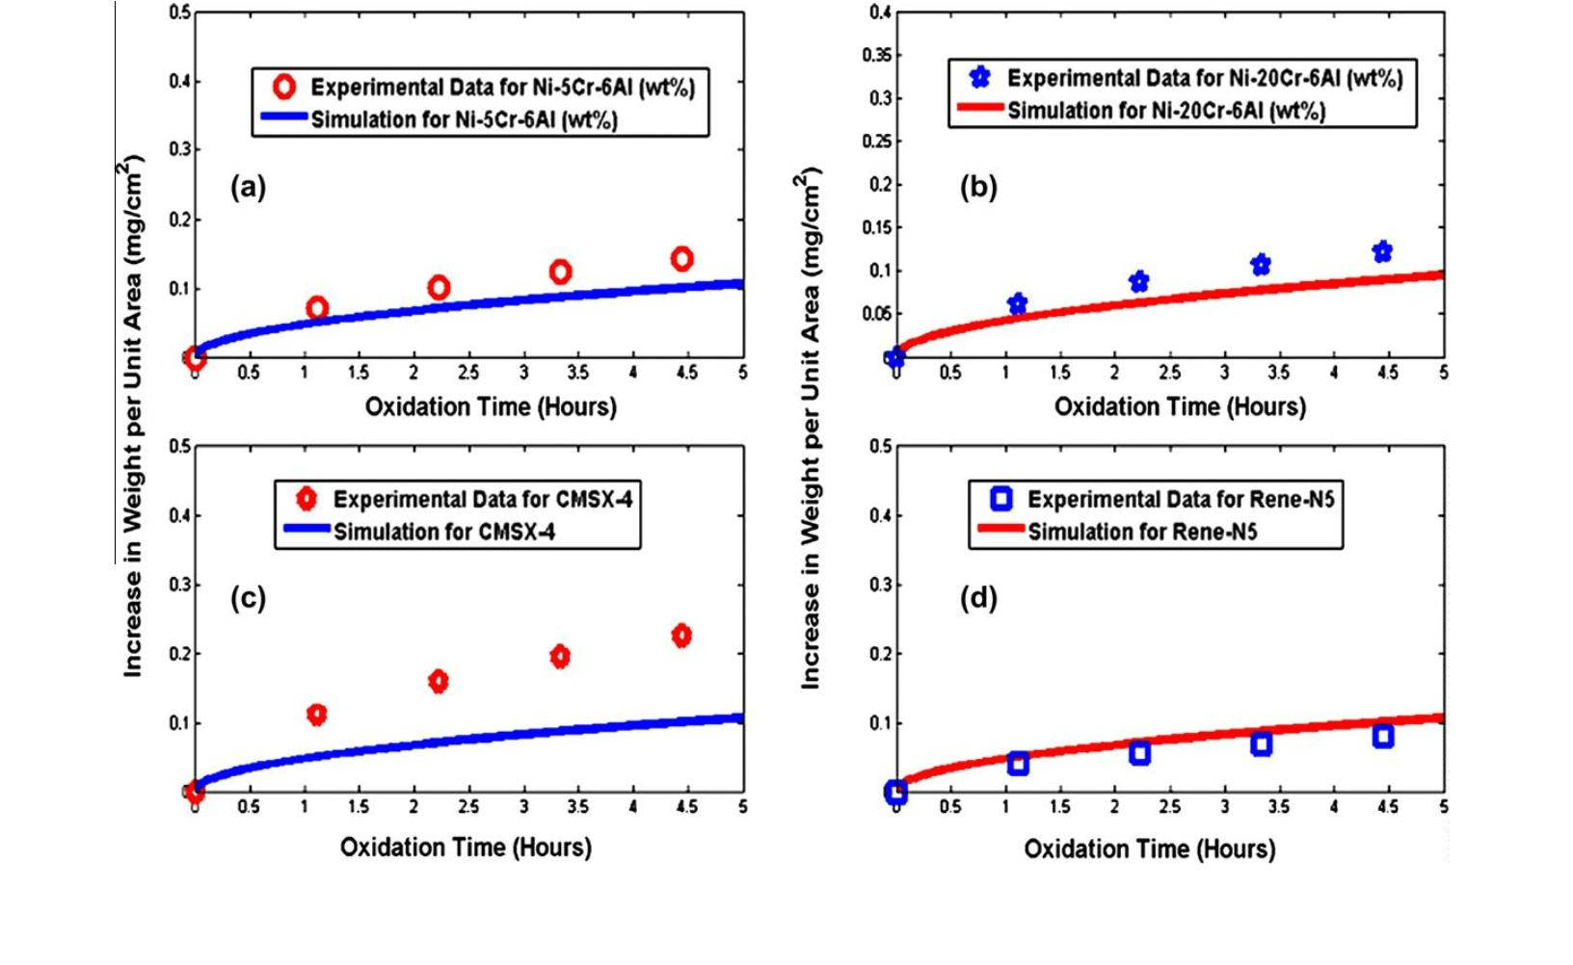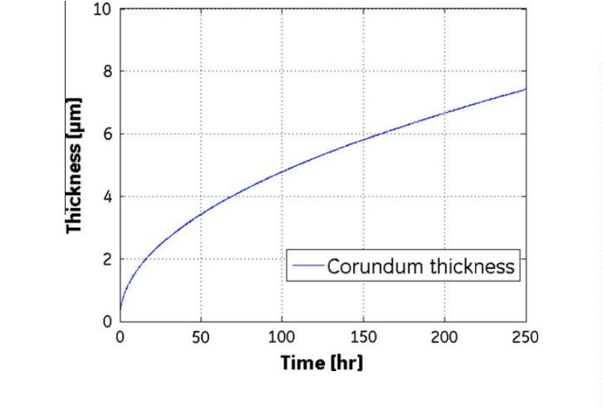

8

18

A. Chatterjee et al. / Computational Materials Science 50 (2011) 811–819

Fig. 4. Computed (from DICOSM model) cyclic oxidation rate of Ni–5Cr–6Al, CMSX-4 and Rene’ N5 at 1173 K. The spall area fraction (FA) for these computations was 0.0025.

4

. Conclusions

Two new approaches have been presented for the prediction of

the oxidation rates of multi-component Ni-base alloys by combin-

ing thermodynamic and kinetic modeling. One based on the

solution of the elemental diffusion equations under mass balance

constraints and thermodynamically computed boundary condi-

tions, and the other based on a modiﬁed Wagner’s equation with

the limiting equilibrium oxygen partial pressured derived by ther-

modynamic modeling. In this study, we have considered the oxide

phase to be a solid solution of Al2O3 and Cr O . Hence, diffusivities

2

3

of elements in both Chromia and Alumina have been considered.

Optimized values of diffusivities of Cr, Al and O in the mixed oxide

phase (Al2O3 and Cr O ) and their oxygen partial pressure and tem-

2

3

perature dependences have been derived. Next, those are used for

the prediction of oxidation rates and elemental concentration pro-

ﬁle in the oxide phase. The oxygen partial pressure dependence

was found to correspond to Cr3+ interstitials diffusion in the oxide

phase. Even though both these approaches can predict the oxida-

tion rates, the solution of the elemental diffusion equations was

found to over-predict the oxidation rates. The modiﬁed Wagner’s

equation was found to predict the oxidation rate of the multi-com-

ponent alloys tested in this study well.

Fig. 5. Calculated concentration proﬁles of Cr, Al and O in the corundum phase at

373 K for Rene’ N5 after 250 h of oxidation.

1

equation and solution of diffusion equation are delineated in Fig. 4.

For some of the Ni–Cr–Al–Y alloys for which cyclic oxidation data

were available, it was found that the model predictions are close to

the experimental values at FA = 0.0025. Experimental cyclic oxida-

tion rates for these alloys were not available to make a comparison.

The elemental concentration proﬁles of Cr, Al and O were calcu-

lated at 1373 K for Rene’ N5 using the diffusion equations and the

initial and boundary conditions. These are shown in Fig. 5. Exper-

imental information on the concentration proﬁle in the oxide scale

for these alloys is not available in the literature for comparison.

Please note that the concentrations have been normalized. Also,

the oxide phase is considered as solution and only the mobile spe-

cies participate in the diffusion, and subsequent oxidation, process.

Thus the variation of oxygen species from 0.55 (at the oxide–air

interface) to 0 (at the oxide–alloy interface) is represented by the

mobile oxygen atoms, which participate in the alloy oxidation pro-

cess. Fig. 5 gives a snapshot of the concentration proﬁle of the mo-

bile species after 250 h of oxidation. A steady-state concentration

proﬁle will have a discreet change at the oxide-air interface and

alloy–oxide interface.

Acknowledgement

The authors will like to acknowledge Kelly Fletcher, GE Global

Research, for funding this work. Useful discussions with Michael

Gigliotti, GE Global Research, as well as with Andrew Elliott and

Stephen Balsone of GE Energy are also acknowledged.

References

[1] J.L. Smialek, Acta Mater. 51 (2003) 469–483.

[

2] P. Saltykov, O. Fabrichnaya, J. Golczewski, F. Aldinger, J. Alloys Comp. 381

(2004) 99–113.

3] C. Wagner, J. Electrochem. Soc. 99 (1952) 369–380.

[

[4] V.J.D. Tretjakow, H. Schmalzried, Ber. Bunsengesellschafr Phys. Chem. 69

(1965) 396–402.

[

5] F. Gesmundo, Mater. Sci. Eng. 87 (1987) 243–250.

[

6] R. Dieckmann, J. Phys. Chem. Solids 59 (1998) 507–525.

[7] T.J. Nijdam, L.P.H. Jeurgens, W.G. Sloof, Acta Mater. 51 (2003) 5295–5307.

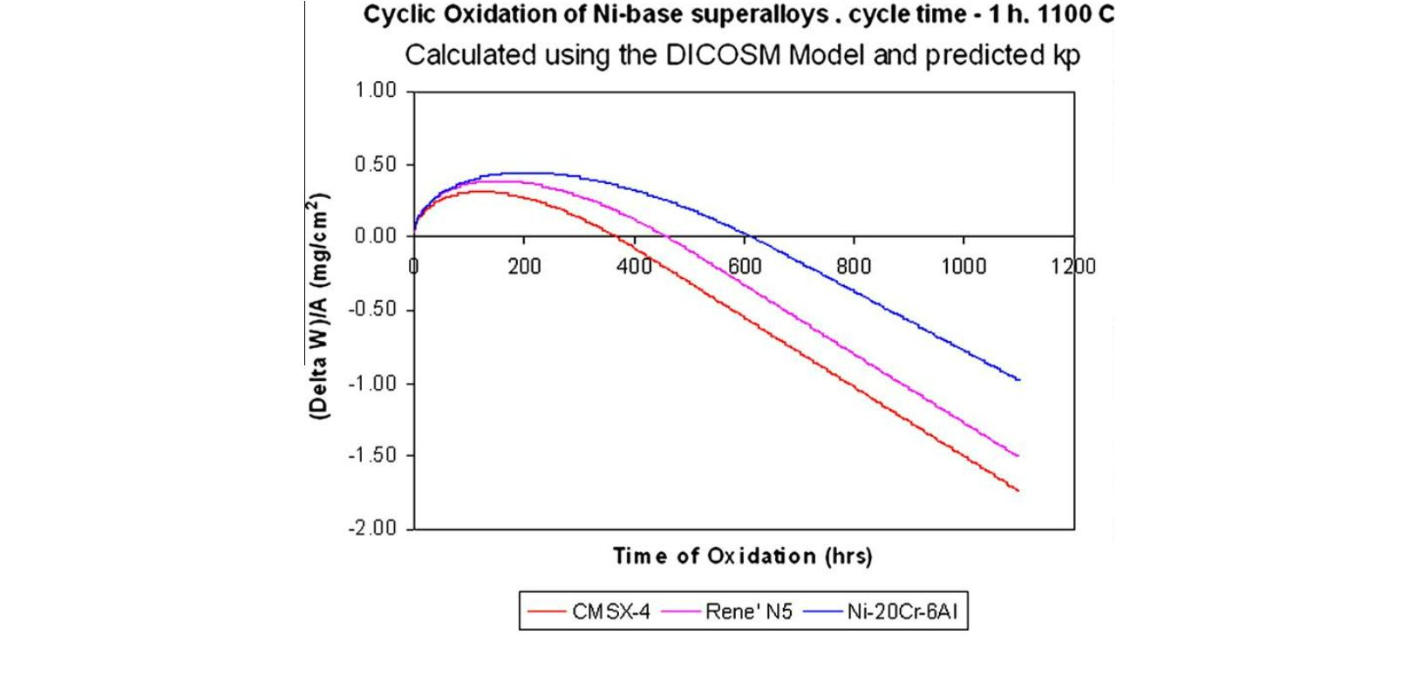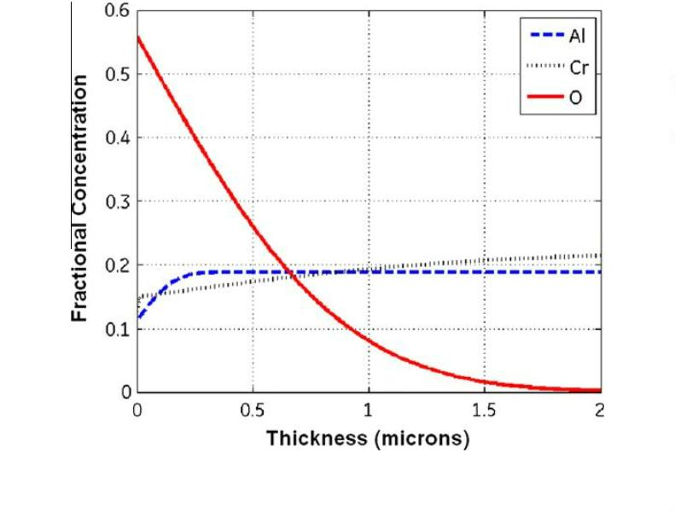

A. Chatterjee et al. / Computational Materials Science 50 (2011) 811–819

819

[

[

8] T.J. Nijdam, L.P.H. Jeurgens, W.G. Sloof, Acta Mater. 53 (2005) 1643–1653.

9] THERMOCALC™ Software URL. <<http://www.thermocalc.com/>>.

[26] V.K. Price, M.R. Storn, A.J. Lampinen, Differential Evolution:

Approach to Global Optimization, Springer, Berlin, 2005.

[27] C.S. Giggins, F.S. Pettit, J. Electrochem. Soc. 118 (11) (1971) 1782–1790.

[28] N. Mu, J. Liu, J.W. Bycon, Y.H. Sohn, Y.L. Nava, Surf. Coat. Technol. 188–189

(2004) 27–34.

A

Practical

[

[

10] J.L. Smialek, Metall. Trans. 9A (1978) 309–320.

11] C.E. Lowell, J.L. Smialek, C,A. Barrett, Cyclic oxidation of superalloys, in: R.A.

Rapp (Ed.), High Temperature Corrosion, Houston, TX-NACE, 1983, pp. 219–

2

26.

[29] P. Choqueta, C. Indrigoa, R. Mevrel, Mater. Sci. Eng. 88 (1987) 97–101.

[30] G.F. Chen, H.Y. Lou, Mater Lett. 45 (2000) 286–291.

[31] S.C. Choi, H.J. Cho, Y.J. Kim, D.B. Lee, Oxid. Met. 46 (1996) 51–72.

[32] S. Han, D.J. Young, Mater. Res. 7 (2004).

[

12] C.E. Lowell, C.A. Barrett, R.W. Palmer, J.V. Auping, H.B. Probst, Oxid. Met. 36

(1991) 81–112.

13] J.L. Smialek, J.V. Auping, Oxid. Met. 57 (2002) 559–581.

14] F.A. Kroger, Defects and transport in SiO2, Al2O3 and Cr2O3, in: R.A. Rapp (Ed.),

High Temperature Corrosion, NACE 6, National Association of Corrosion

Engineers, Houston, 1983, pp. 89–94.

15] H. Hindam, D.P. Whittle, Microstructure, adhesion and growth kinetics of

protective scales on metals and alloys, Oxid. Met. 18 (1982) 245–284.

16] A. Atkinson, Rev. Mod. Phys. 57 (1985) 437–470.

[

[

[33] B. Wang, J. Gong, A.Y. Wang, C. Sun, R.F. Huang, L.S. Wen, Surf. Coat. Technol.

149 (2002) 70–75.

[34] Y.J. Zhang, X.F. Sun, Y.C. Zhang, T. Jin, C.G. Deng, H.R. Guan, Z.Q. Hu, Mater. Sci.

Eng. A 360 (2003) 65–69.

[35] N.S. Miller, G. Simkovich, E.J. Whitney, J. Mater. Sci. Lett. 19 (2000) 1657–

1659.

[

[

[

[

[

[

[

17] W.C. Hagel, A.U. Seybolt, J. Electrochem. Soc. 108 (1961) 1146–1152.

18] W.C. Hagel, J. Am. Ceram. Soc. 48 (1965) 70–75.

19] Y. Oishi, W.D. Kingery, J. Chem. Phys. 33 (1960) 480–486.

20] S.C. Tsai, A.M. Huntz, C. Dolin, Mater. Sci. Eng. A212 (1996) 6–13.

21] R.E. Lobnig, H.P. Schmidt, K. Hennesen, H.J. Grabke, Oxid. Met. 37 (1992) 81–

[36] J. Zurek, D.J. Young, E. Essuman, M. Hänsel, H.J. Penkalla, L. Niewolak, W.J.

Quadakkers, Mater. Sci. Eng. A 477 (2008) 259–270.

[37] B.A. Pint, Surf. Coat. Technol. 188–189 (2004) 71–78.

[38] J.M. Brossard, J. Balmain, F. Sanchette, G. Bonnet, Oxid. Met. 64 (2005) 43–61.

[39] H.L. Tsai, P.C. Tsai, Surf. Coat. Technol. 71 (1995) 53–59.

[40] M.H. Li, X.F. Sun, J.G. Li, Z.Y. Zhang, T. Jin, H.R. Guan, Z.Q. Hu, Oxid. Met. 59

(2003) 591–605.

[41] M.H. Li, X.F. Sun, T. Jin, H.R. Guan, Z.Q. Hu, Oxid. Met. 60 (2003) 195–210.

[42] B.A. Pint, P.F. Tortorelli, I.G. Wright, Oxid. Met. 58 (2002) 73–101.

[43] X. Zhang, C. Gao, L. Wang, Y. Niu, Trans. Nonferrous Met. Soc. China 17 (2007)

171–174.

9

3.

[

[

22] A.E. Paladino, W.D. Kingery, J. Chem. Phys. 37 (5) (1962) 957–962.

23] V.K. Tolpygo, D.R. Clarke, Microstructural evidence for counter-diffusion of

aluminum and oxygen during the growth of alumina scales, in: 5th

International Conference on the Microscopy of Oxidation, University of

Limerick, Republic of Ireland, 2002 (26–28 August).

[

[

24] J.S. Armijo, Oxid. Met. 1 (1969) 171–198.

25] H. Schmalzried, Prog. Chem. Solid State 2 (1965) 265–303.

[44] <<http://www.calphad.com/dictra.html>>.

[45] <<http://www.surmet.com/docs/Test_Data_ALON%20Coating.pdf>>.