30 An Effective Duplicate Removal Algorithm for Text Documents 271

1. Proposed Duplicate Removal Technique

A simple and new approach has been used to design the data cleaning system, especially for duplicate detection and removal which is shown in Fig. 1.

* 1. ***Duplicate Removal Algorithm***

The data from the text file is read word by word and stored in the array list. The length of the array is calculated. In the process, each word/character in the array is compared with all other words/characters to detect the duplicates. If the duplicate is found, it is deleted and the count is maintained for the repeated number of words/characters. The modified array along with the duplicate information is saved.

* Read the data from the file and store it into the ArrayList.
* Calculate the length of ArrayList.
* Initialize variable *i*, *j,* and *c* with 0.
* Check the length of ArrayList
  + If length > *i*, go to step *v,* else
  + store the original ArrayList in file and go to step xi.

*y i* 1

• = +

While (*j* < length-1), go to step vii, else go to step x.

•

Compare value of *a*[*i*] with *a*[*j*], if yes go to step viii, else increment *j* by 1 and go to step vi.

•

Add duplicate element in new ArrayList and Delete duplicate element from the original ArrayList. Count the duplicate element by incrementing the value of *c* by 1.

•

Increment value of *j* by 1.

•

Calculate the new length of updated ArrayList and increment the value of *i* by 1 and goto step iv.

•

* End.

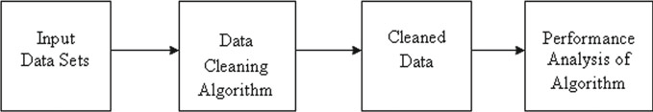

**Fig. 1** Block diagram of the system