LAB Logbook

Lab 1

<https://github.com/Addict07/Machine-Learning-In-Finance_2025-26/blob/main/LabLogbook_Week_1.ipynb>

Lab 2

<https://github.com/Addict07/Machine-Learning-In-Finance_2025-26/blob/main/LabLogbook_Week_2.ipynb>

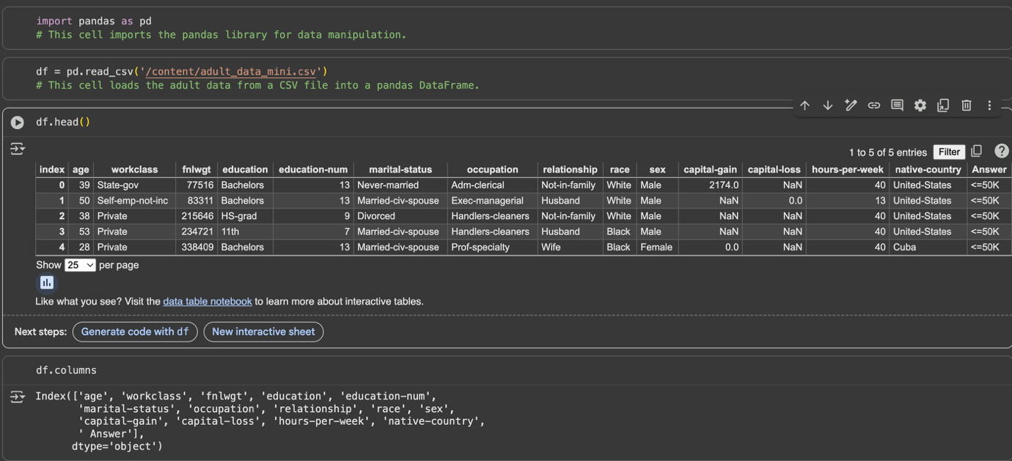

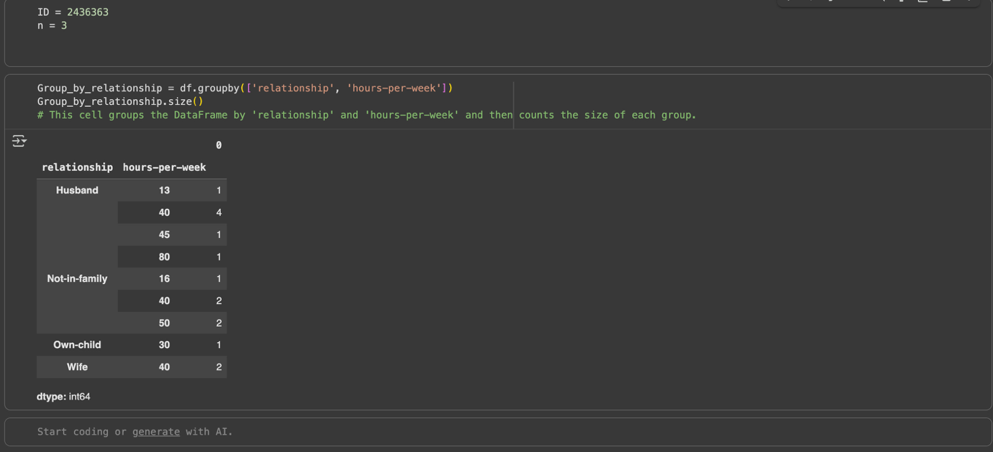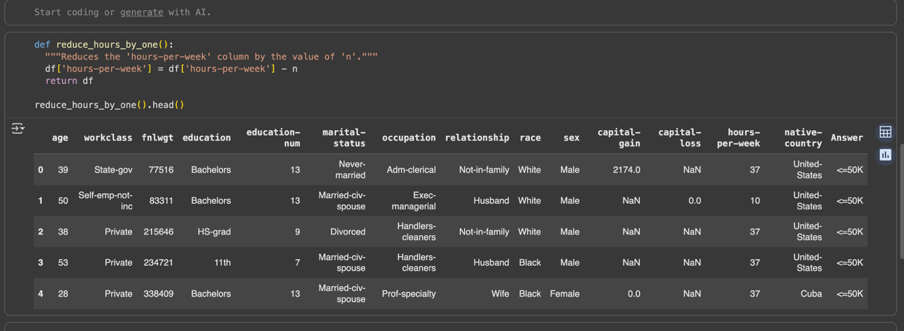

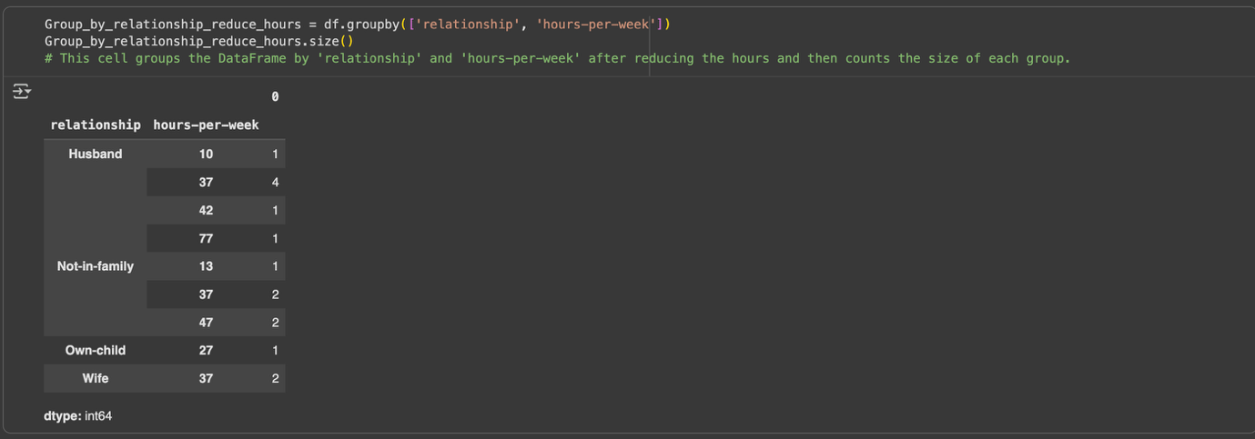

Lab 3

https://github.com/Addict07/Machine-Learning-In-Finance_2025-26/blob/main/LabLogbook_Week_3.ipynb

Lab 4

Lab 5

Lab 6

Lab 7

Lab 8

Lab 9

Lab 10

Lab 11

Lab 12