LAB Logbook

Lab 1
https://github.com/Addict07/Machine-Learning-In-Finance_2025-26/blob/main/LabLogbook_Week_1.ipynb

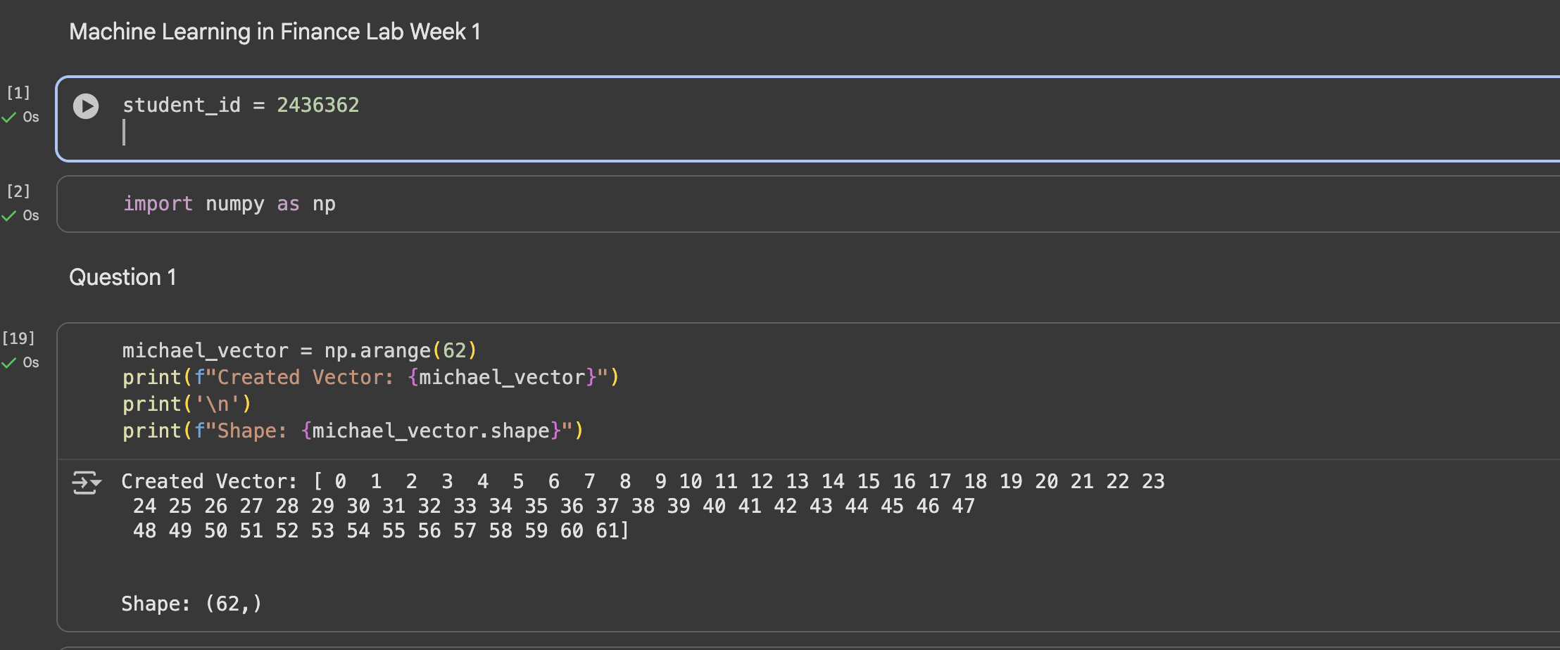
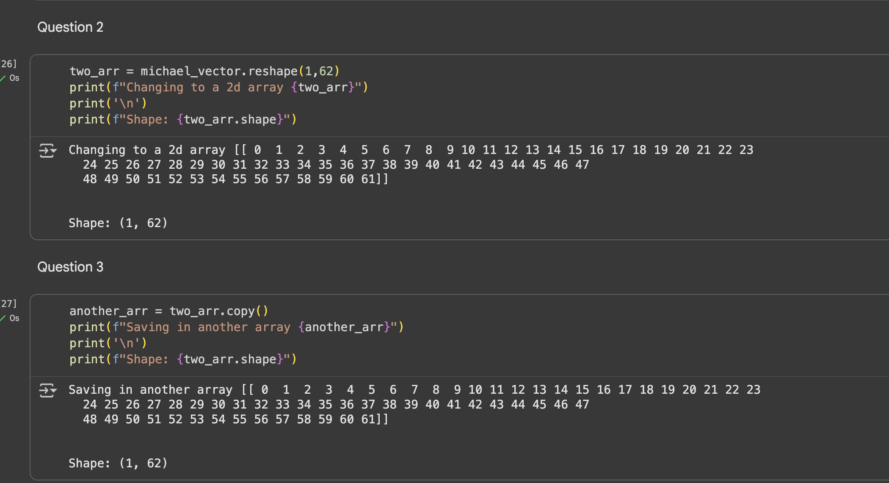

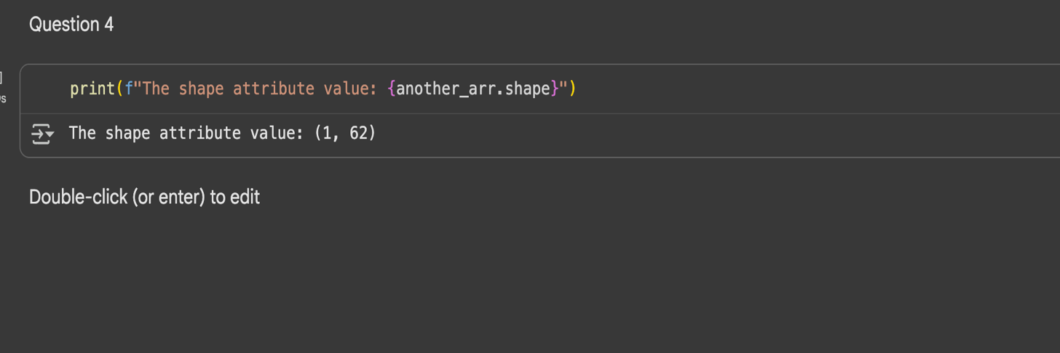

Lab 2
https://github.com/Addict07/Machine-Learning-In-Finance_2025-26/blob/main/LabLogbook_Week_2.ipynb

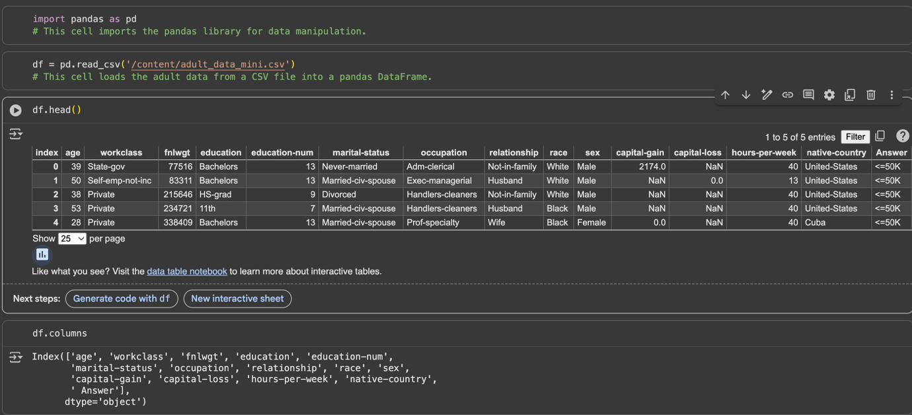
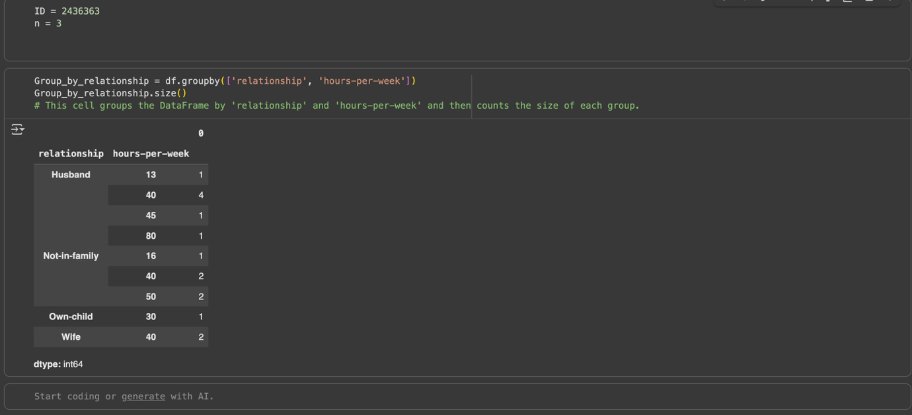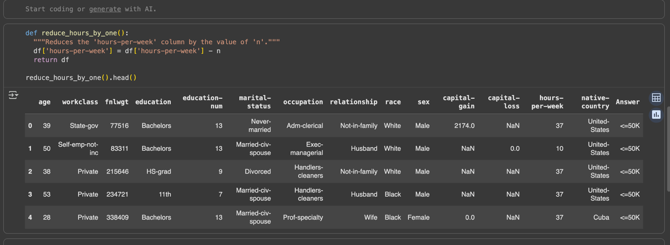

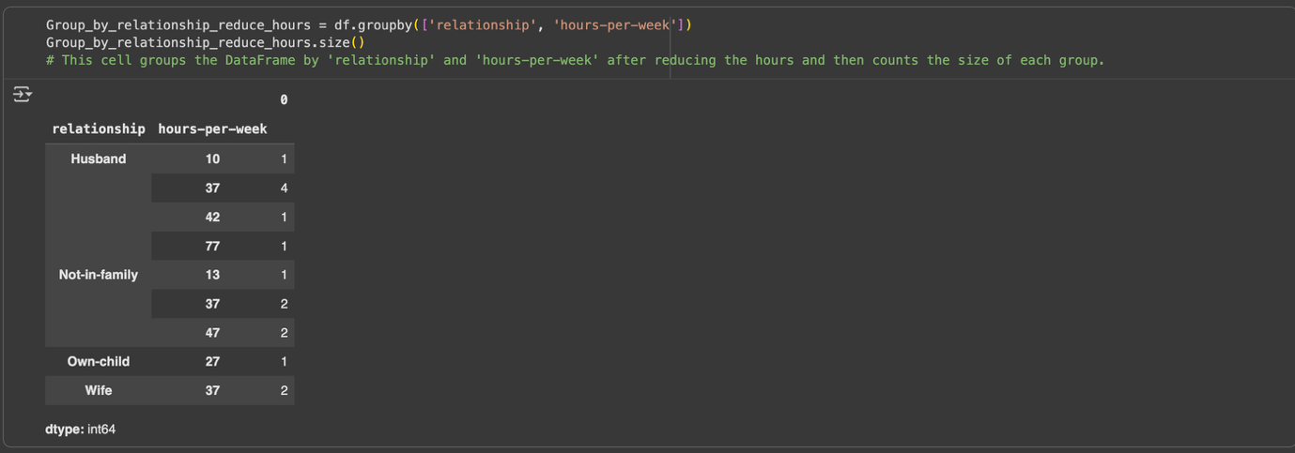

Lab 3
https://github.com/Addict07/Machine-Learning-In-Finance_2025-26/blob/main/LabLogbook_Week_3.ipynb
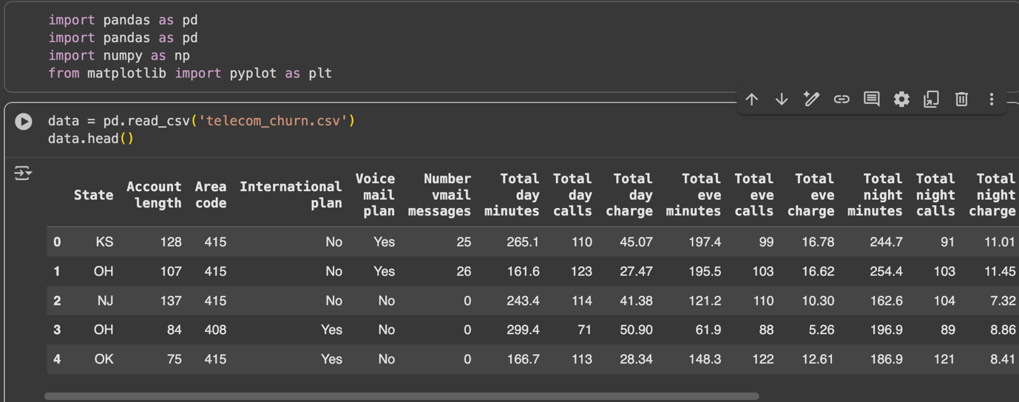
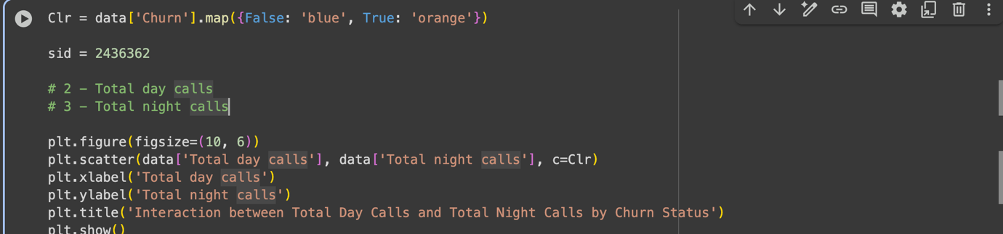
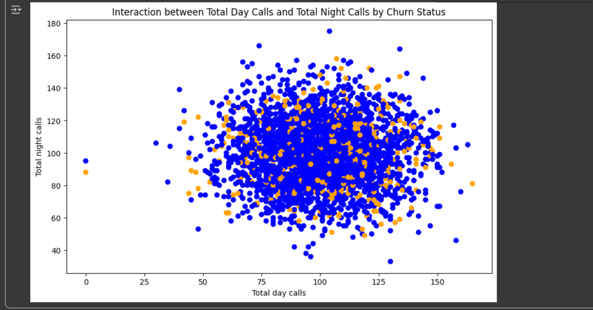

Lab 4
https://github.com/Addict07/Machine-Learning-In-Finance_2025-26/blob/main/LabLogbook_Week_4.ipynb
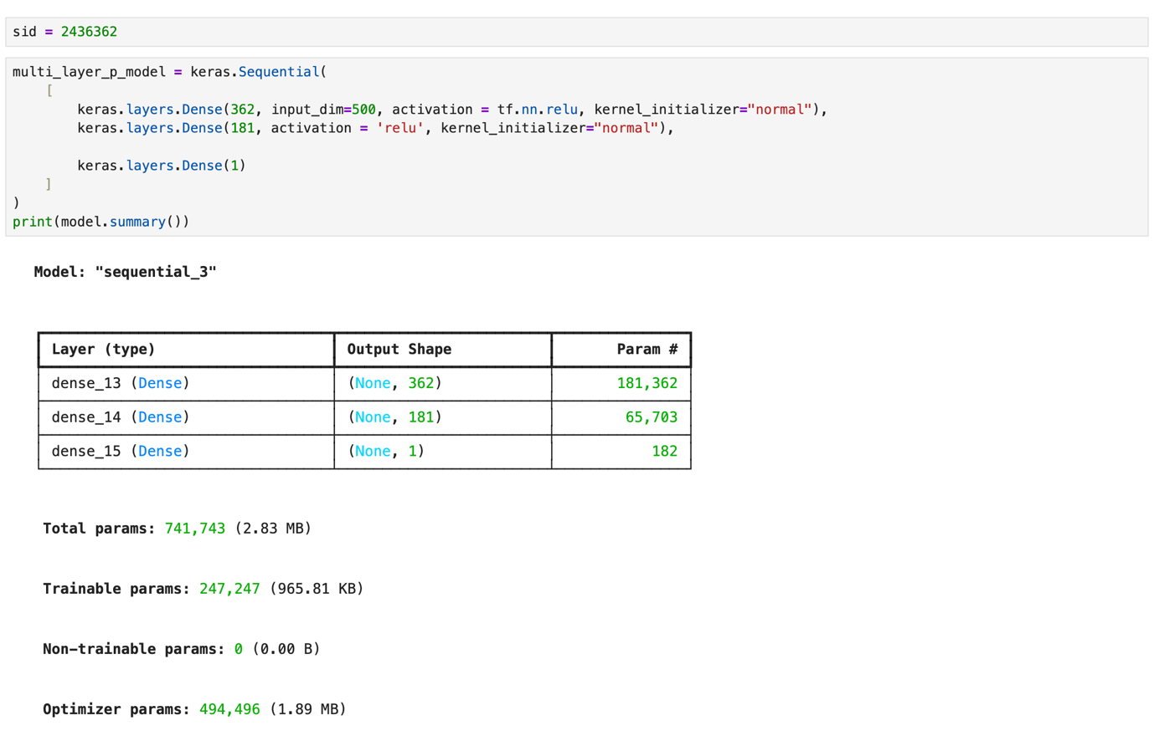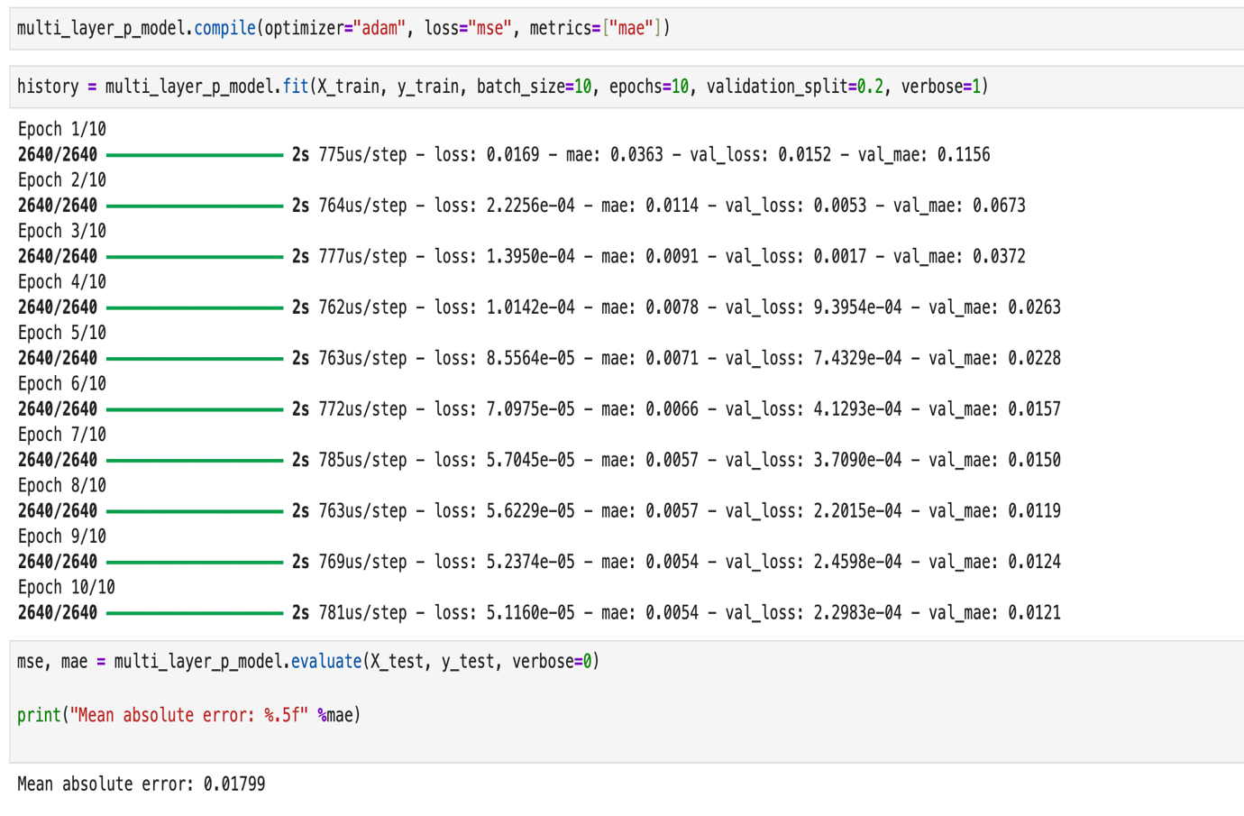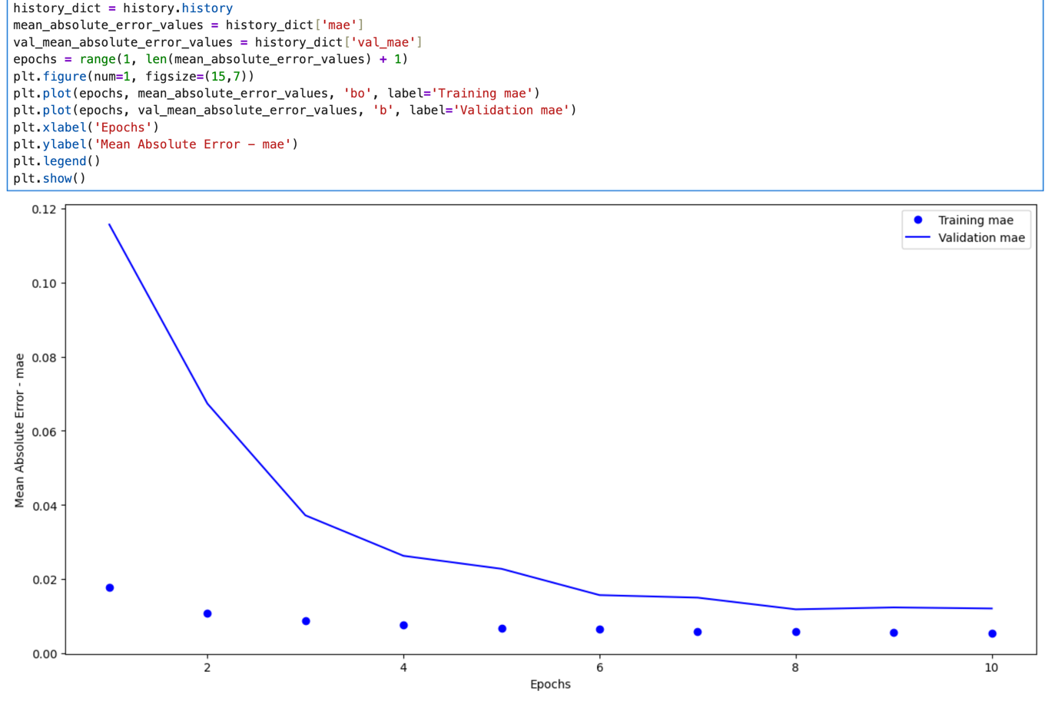

Lab 5
https://github.com/Addict07/Machine-Learning-In-Finance_2025-26/blob/main/LabLogbook_Week_5.ipynb
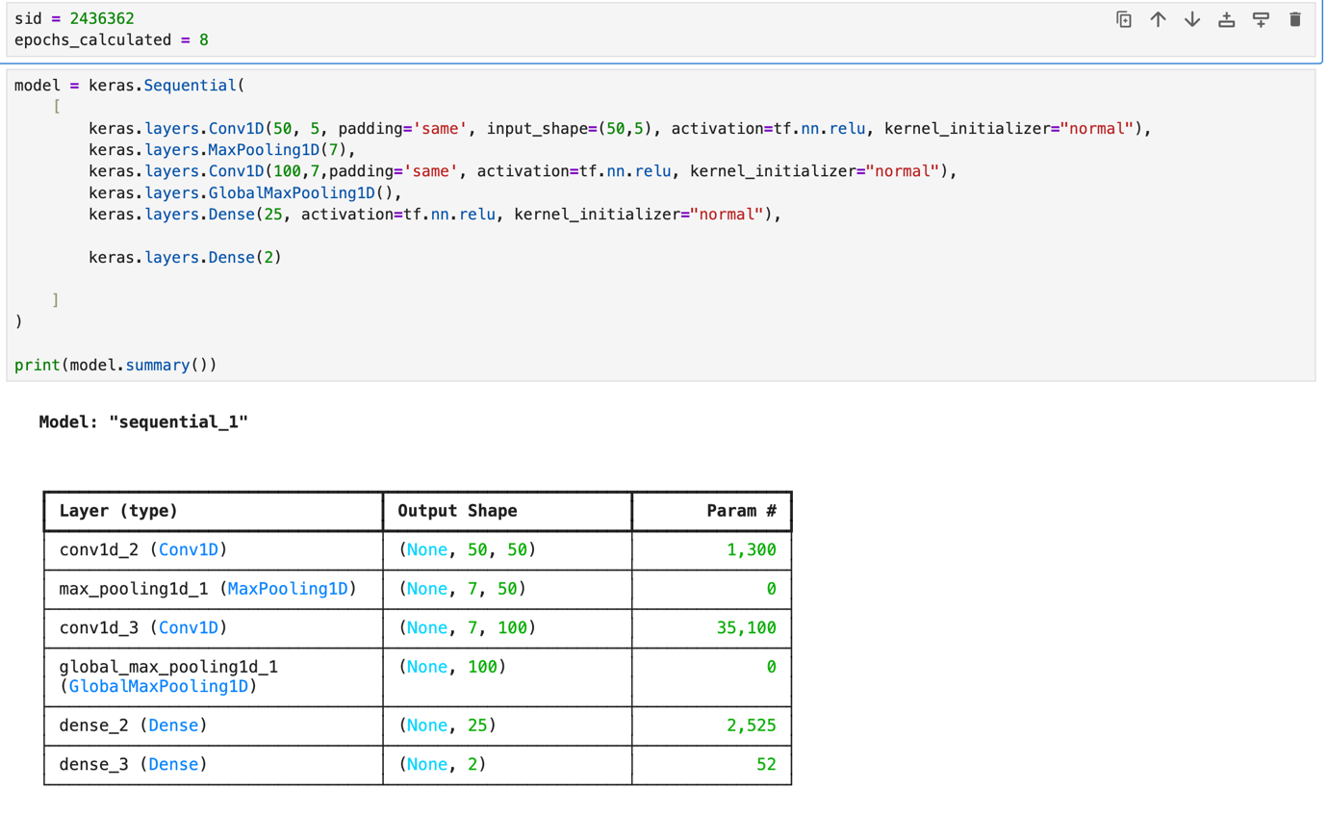
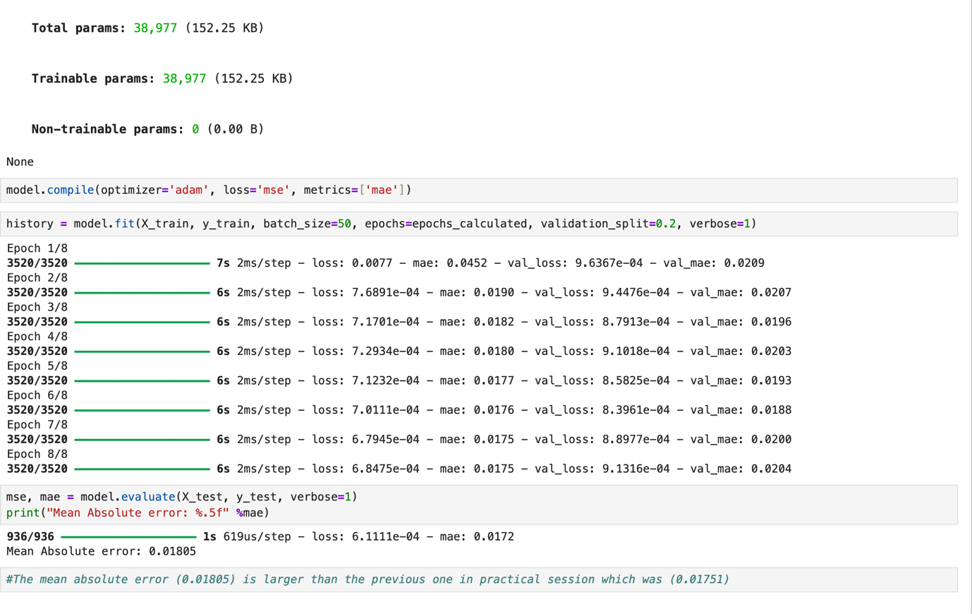
Lab 6
https://github.com/Addict07/Machine-Learning-In-Finance_2025-26/blob/main/LabLogbook_Week_6.ipynb
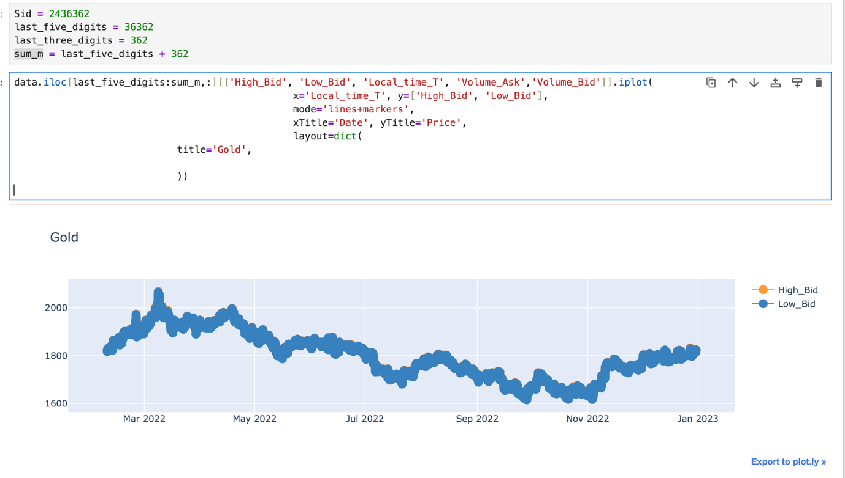

Lab 7
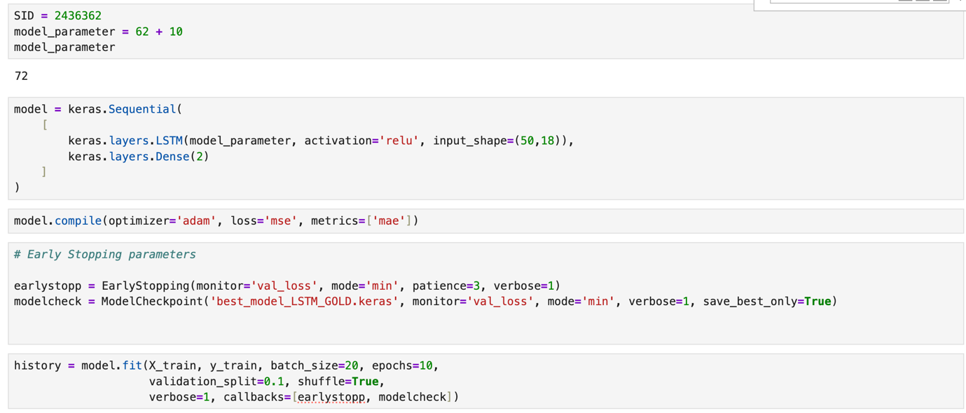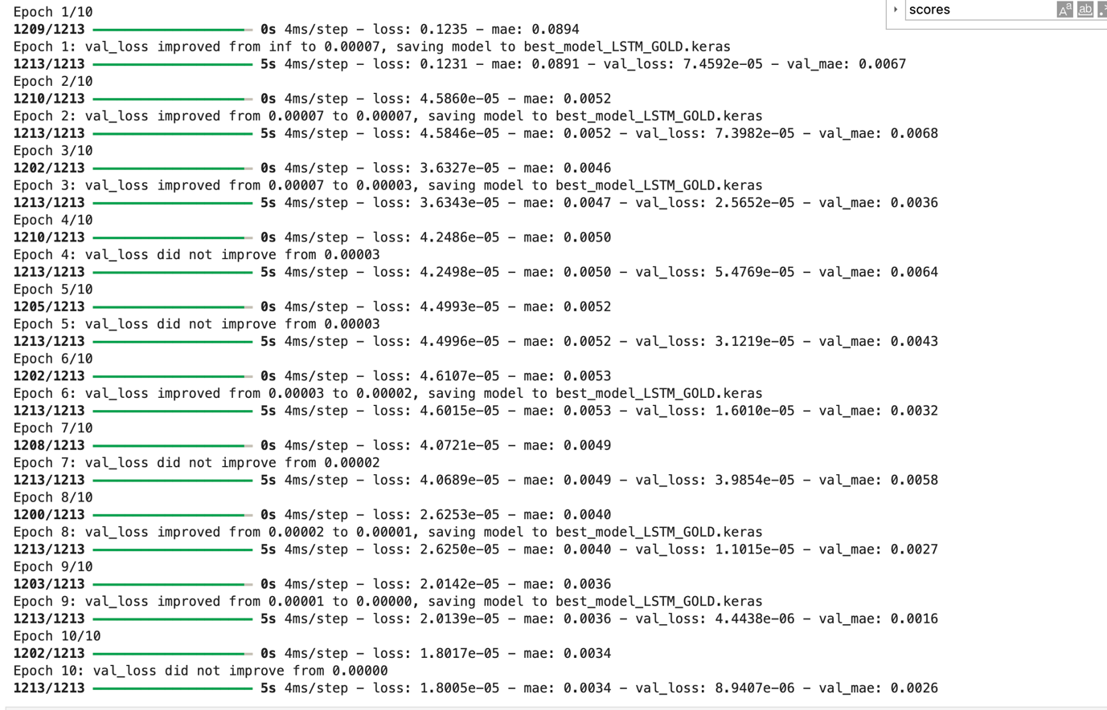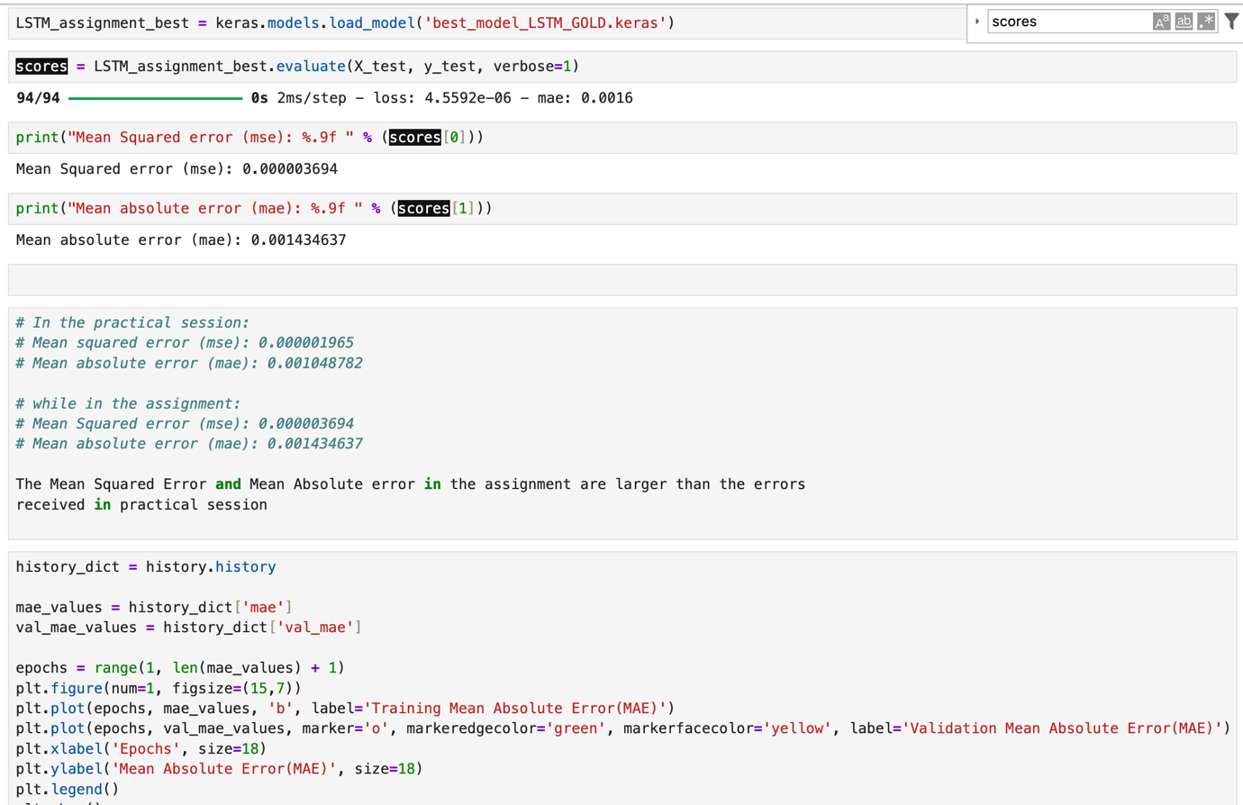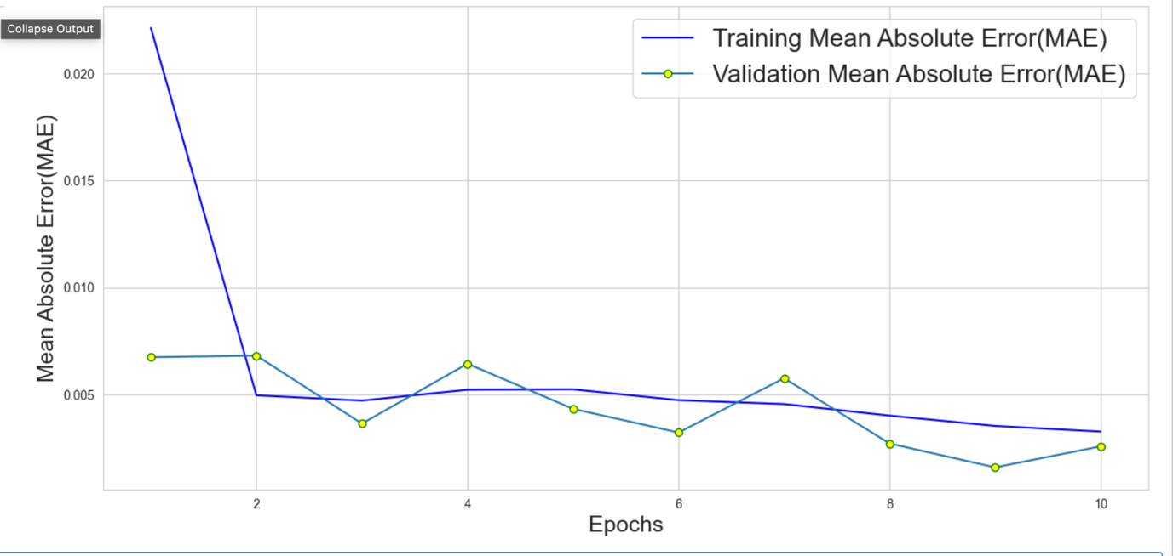

Lab 8

Lab 9

Lab 10

Lab 11

Lab 12

