**Person Re-Identification**

**By SDGML**

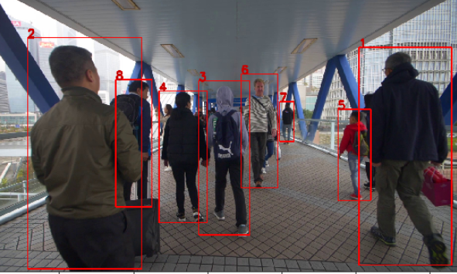

**Index**

**Problem Statement**

**Our Approach**

**Methods**

**How to use?**

**Resources**

* **Dataset**
* **Research Papers**
* **Github Repositories**

**Problem statement**

Person re-identification is associating images of the same person taken from different cameras or from the same camera in different occasions. In other words, assigning a stable ID to a person in multi-camera setting. Usually the re-identification is constrained to a small time period and a small area covered by cameras. Humans are easily able to Re-ID others by leveraging descriptors based on the person’s face, height, and build, clothing, hair style, walking pattern, etc but this seemingly easy problem is extremely difficult for a machine to solve.

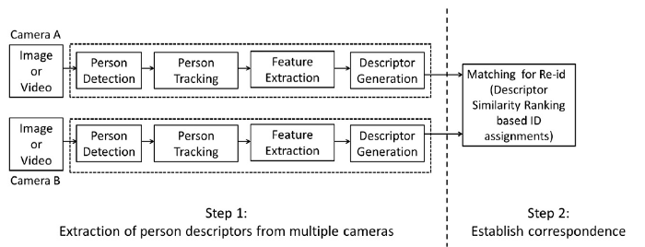Figure : A general Re-id System

**Our Approach**

To tackle the stated problem, we used combination of two approaches:

**Person Re-identification using feature mapping:**

* A resnet50 model is trained on openly available Market 1501 dataset
* Trained on 12186 images
* Validated on 751 images
* Trained for 15 epochs
* Pytorch framework used at the backend
* We use the model to generate the feature map of each individual present on the image and store the feature map in the database after assigning the id.
* This model returns a vector of size (1, 512)

**Person Re-identification by Attribute-Assisted Appearance**

* Trained a resnet50 model on RAP v2.0 (Richly Annotated Dataset for Pedestrian Attribute Recognition) having 84929 well annotated images
* Rap v2.0 is not freely available and we had to sign an agreement to use this dataset
* The author of the paper https://www.researchgate.net/publication/301817457_A_Richly_Annotated_Dataset_for_Pedestrian_Attribute_Recognition, Dangwei Li helped us with the dataset
* We trained our model to identify 82 attributes as follows:
* [Female, AgeLess16, Age17-30, Age31-45, Age46-60, BodyFat, BodyNormal, BodyThin, Customer, Employee, hs-BaldHead, hs-LongHair, hs-BlackHair, hs-Hat, hs-Glasses, ub-Shirt, ub-Sweater, ub-Vest, ub-TShirt, ub-Cotton, ub-Jacket, ub-SuitUp, ub-Tight, ub-ShortSleeve, ub-Others, ub-ColorBlack, ub-ColorWhite, ub-ColorGray, up-ColorRed, ub-ColorGreen, ub-ColorBlue, ub-ColorSilver, ub-ColorYellow, ub-ColorBrown, ub-ColorPurple, ub-ColorPink, ub-ColorOrange, ub-ColorMixture, ub-ColorOther, lb-LongTrousers, lb-Skirt, lb-ShortSkirt, lb-Dress, lb-Jeans, lb-TightTrousers, lb-ColorBlack, lb-ColorWhite, lb-ColorGray, lb-ColorRed, lb-ColorGreen, lb-ColorBlue, lb-ColorSilver, lb-ColorYellow, lb-ColorBrown, lb-ColorPurple, lb-ColorPink, lb-ColorOrange, lb-ColorMixture, lb-ColorOther, shoes-Leather, shoes-Sports, shoes-Boots, shoes-Cloth, shoes-Casual, shoes-Other, attachment-Backpack, attachment-ShoulderBag, attachment-HandBag, attachment-Box, attachment-PlasticBag, attachment-PaperBag, attachment-HandTrunk, attachment-Other, action-Calling, action-Talking, action-Gathering, action-Holding, action-Pushing, action-Pulling, action-CarryingByArm, action-CarryingByHand, action-Other]
* We trained a resnet50 model and got a MAP (Mean Average Precision of 71%)
* Trained on 67,433 images
* Validated on 16,589 images
* Trained for 100 epochs
* Model returns a vector of size (1, 82)
* Pytorch framework used at the backend

**Result of the above two approaches:**

* First model extract feature vector and another model extract attribute vector
* We use two Python Pandas Dataframes:
  + **all_frame_df** stores feature vector, attribute score and previously assigned Id for all the individuals
  + **unique_id_df** stores only unique feature vector, attribute score and previously assigned Id for every individual
* Whenever a person comes in an image, we extract the feature vector and the attribute vector for it and compare with feature vectors and attribute vectors present in the **unique_id_df**
* For comparison we use Spatial Cosine distance between the vectors and assign the same identity if the similarity result crosses the threshold value or else assign a new identity.

**Methods**

We used the combinations of two above defined approaches in two ways:

**Method 1**

* First model extract feature vector and another model extract attribute vector
* We use two python pandas data frames:
  + **all_frame_df** stores feature vector, attribute score and previously assigned Id for all the individuals
  + **unique_id_df** stores only unique feature vector, attribute score and previously assigned Id for every individual
* Whenever a person comes in an image, we extract the feature vector and the attribute vector for it and compare with feature vectors and attribute vectors present in the **unique_id_df**
* For comparison we use Spatial Cosine distance between the vectors and assign the same identity if the similarity result crosses the threshold value or else assign a new identity.

**Drawbacks of Method 1:**

* Model assigns the same id only if the image of individual crosses both the threshold value (Feature threshold and Attribute threshold) at the same time otherwise it assigns a different ID
* Hence if an image crosses only one of the threshold values then it assigns a different ID.

**Method 2**

* To overcome the limitations of method1 we came up with method2
* First model extract features and other attribute vectors
  + First model (Feature Model) recommends two most similar already seen person, crossing the feature similarity threshold value
  + Second model (Attribute Model) recommends only one most similar already seen person, crossing the attribute similarity threshold value
* We then compare the 3 recommended ids if any and take the decision as follows:
  + Return the most frequent id
  + Or the one with highest similarity score in case they are different
  + Assign new Id if above conditions are not fulfilled

**Drawbacks of Method 2:**

* Model assigns the same id for person who enter the scene from different corners. The reason is as corners are sometime have low illumination, the model recognizes them as same person and then the same id propagates even when the person walks to the center.
* The solution would be to train a classifier model that can classify person coming from the corners and assign a different unique ID or wait for 2-3 seconds from the moment it starts appearing in the frame and then assign an ID. We thought of doing it but fell short on time due to competition deadline, but we are committed to make it more accurate in the future.

**How to use?**

Pre-requisites:

* Python 3.0 or above
* Jupyter Notebook
* Pytorch
* Install the packages inside requirements.txt (pip install -r requirements.txt)

Steps:

* For method1, run evaluation_method1.ipynb notebook
* For method2, run evaluation_method2.ipynb notebook
* Update the image folder and the csv file with coordinates at the top cell of each notebook
* We have already executed the notebooks with our test data images and csv files. (Images present in ‘data/’ folder and coordinates in ‘coordinates.csv’)
* Notebooks are self-explanatory
* In case of any query(s) please feel free to reach out to us anytime.

**Resources**

**Dataset**

**Market 1501:**

The Market-1501 dataset is a dataset for person re-identification, which was collected in front of a supermarket in Tsinghua University. A total of six cameras are used, including 5 high-resolution cameras, and one low-resolution camera. Overlap exists among different cameras. Overall, this dataset contains 32,668 annotated bounding boxes of 1,501 identities. Each annotated identity is present in at least two cameras, so that cross-camera search can be performed.

<http://188.138.127.15:81/Datasets/Market-1501-v15.09.15.zip>

**RAP V2.0 (Richly Annotated Dataset for Pedestrian Recognition):**

Richly Annotated Pedestrian (RAP) V2.0 is taken from real multi-camera surveillance scenarios with long term collection, where data samples are annotated with not only fine-grained human attributes but also environmental and contextual factors. RAP has in total 84,929 pedestrian samples, each of which is annotated with more than 150 attributes as well as viewpoints, occlusions, body parts information. To our knowledge, the RAP dataset is the largest pedestrian attribute dataset, which is expected to greatly promote the study of large-scale attribute recognition systems.

This dataset is not freely available hence we contacted the authors of the paper <https://www.researchgate.net/publication/301817457_A_Richly_Annotated_Dataset_for_Pedestrian_Attribute_Recognition> and signed an agreement to keep the confidentiality of the dataset.

**Research Papers:**

* **http://jankautz.com/publications/JointReID_CVPR19.pdf**
* [**https://www.researchgate.net/publication/301817457_A_Richly_Annotated_Dataset_for_Pedestrian_Attribute_Recognition**](https://www.researchgate.net/publication/301817457_A_Richly_Annotated_Dataset_for_Pedestrian_Attribute_Recognition)
* [**https://paperswithcode.com/paper/alignedreid-surpassing-human-level**](https://paperswithcode.com/paper/alignedreid-surpassing-human-level)
* [**https://paperswithcode.com/paper/a-strong-baseline-and-batch-normalization**](https://paperswithcode.com/paper/a-strong-baseline-and-batch-normalization)

**Github Repositories:**

* <https://github.com/layumi/Person_reID_baseline_pytorch>
* <https://github.com/dangweili/pedestrian-attribute-recognition-pytorch>
* <https://github.com/wangxiao5791509/Pedestrian-Attribute-Recognition-Paper-List>
* <https://github.com/hyk1996/Person-Attribute-Recognition-MarketDuke>
* <https://github.com/yuange250/MARS-Attribute>