COMPUTER FUNDAMENTALS
bHADERWAH CAMPUS OF JAMMU UNIVERSITY

2025

PROJECT FILE
PRACTICAL FILE
BASED ON
COMPUTER FUNDAMENTAL
BCA (DATA SCIENCE)

SUBMITTED TO UNIVERSITY OF JAMMU, BHADERWAH CAMPUS BCA-1ST SEMESTER

SUBMITTED TO MR. CHANDER DEEP

SUBMITTED BY ADIL IQBAL

DEPT. OF CS & IT ROLL NO. 113040002

UNIVERSITY OF JAMMU, BHADERWAH CAMPUS

Acknowledgement

I wish to express my sincere appreciation for the invaluable support and guidance that has contributed to the completion of this practical file.
Foremost, I extend my heartfelt thanks to Mr. Chander Deep our Computer Fundamental teacher, for his dedicated guidance and supervision. his expertise and encouragement have been pivotal in enhancing my understanding of “MS Office” concepts and making this practical file a meaningful learning experience.
Additionally, I want to acknowledge the self-driven effort I have put into this project. Undertaking this task has been both challenging and rewarding, allowing me to strengthen my “MS Office” skills.
While this project largely represents an individual effort, I recognize the importance of the learning community that surrounds me. The exchange of ideas and the supportive environment have played a role in shaping my approach to this practical file.
In conclusion, I extend my gratitude to Mr. Chander Deep and to the learning community for the inspiration and support. This practical file stands as a testament to the dedication and commitment invested in the pursuit of knowledge.
Thank you.

S. No. | Program
1. | Select your document using select all option and change the font size of your document underline the word using underline option, draw a line through the middle of the selected text using stripe through option. Create a small no. below the text base line of the word using subscript create a small number above the text based line using superscript.
2. | Using the insert and break option insert a page break in your document insert page number at the bottom of the page using page number option. Insert a table like. Draw the border of the table using draw table option. Select the last row of the table and delete the entire row. Insert some more columns to the right in the table.
3. | Insert header and footer using the header and footer option. Draw a text box and insert the following text. Insert excel worksheet using object option in insert menu. Create a hyperlink and attach a file to the hyper link. Insert bookmark using book mark option.
4. | Make the word at the water mark of the document. Select the background colour of the document as red using page colour option. Change the border of the page using page option. Choose the indents tab. Change the spacing between paragraphs by adding spaces above the paragraph.
5. | Type This Paragraph and Check The Spelling and Grammar Using Spelling And Grammar Tool. View This Document in Full Screen Using Full Screen Read Option. View the Document as draft using draft tool. View the screen in full mode and zoom mode. Add a bibliography of a document.
6. | Choose a paper size for the document using size option. Split the text in three columns by using column options. Type the following line and give numbers to that line using line number option.
7. | Add a table of content to the document Update the Table of content insert foot note to the document insert an end note to the document insert an index into the document create labels to the document.
8. | Use mail merge to send an official initiation to the employs of the Company to attend a workshop
9. | Create a macro to insert a formatted table with previously defined rows and columns and with appropriate headings.
10. | Perform arithmetic on five sets of two number Number 1 Number 2 Add Sub Mul Div.
11. | Consider the problem of a stationery order for month of march. The description quantity and cost per item if to be calculated & the final cost per item involve a add tax of two percent over the total cost. The graph total & net total are to be displayed. Description Quantity Cost per item.
12. | Let us consider problem of finding the total and average of three subject marks for five students in a class in board exam.
13. | In a problem you are given the name, gender, attendance, assignment, mid-term & find grade of five students. Find the total of the assignment marks. Student who pass need to have a total score greater than or equal to 50. Display the word pass or fail under a column called description.
14. | You are given a file containing the name and age of people. You have to count no of people in each category as minor major 18-25. Middle age 26-40, above middle age 40-60, & senior citizen 61-100. Using the single function, for each scenario & create the font pertaining to the condition.
15. | Consider a table containing the consignments of different fruits from different suppliers as show below. Product Supplier Quantity
16. | Calculate the first name, last name, email id of the full name of the employee.
17. | Use Vlookup to search name of employee by their customer ID
19. | Use Vlookup to extract the info from multiple tables.
20. | Use H-look up to search the name of employee by their customer id.
- Select your document using select all option and change the font size of your document underline the word using underline option, draw a line through the middle of the selected text using stripe through option. Create a small no. below the text base line of the word using subscript create a small number above the text based line using superscript.

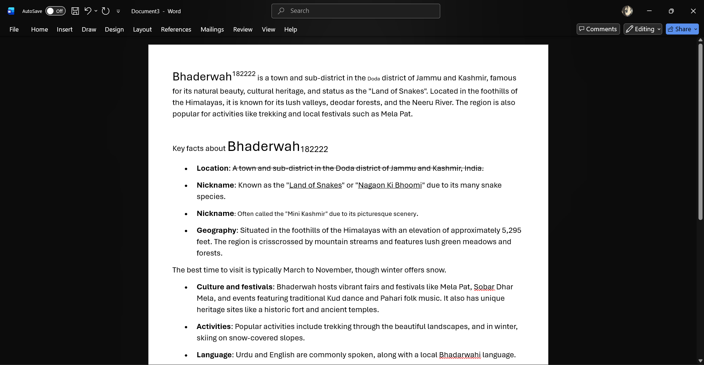

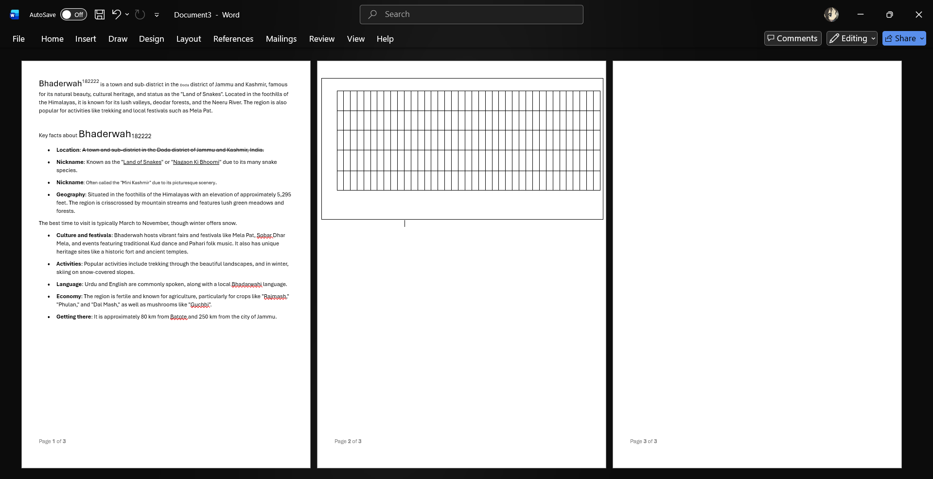
- Using the insert and break option insert a page break in your document insert page number at the bottom of the page using page number option. Insert a table like. Draw the border of the table using draw table option. Select the last row of the table and delete the entire row. Insert some more columns to the right in the table. some more columns to the right in the table.

- Insert header and footer using the header and footer option. Draw a text box and insert the following text. Insert excel worksheet using object option in insert menu. Create a hyperlink and attach a file to the hyper link. Insert bookmark using book mark option.

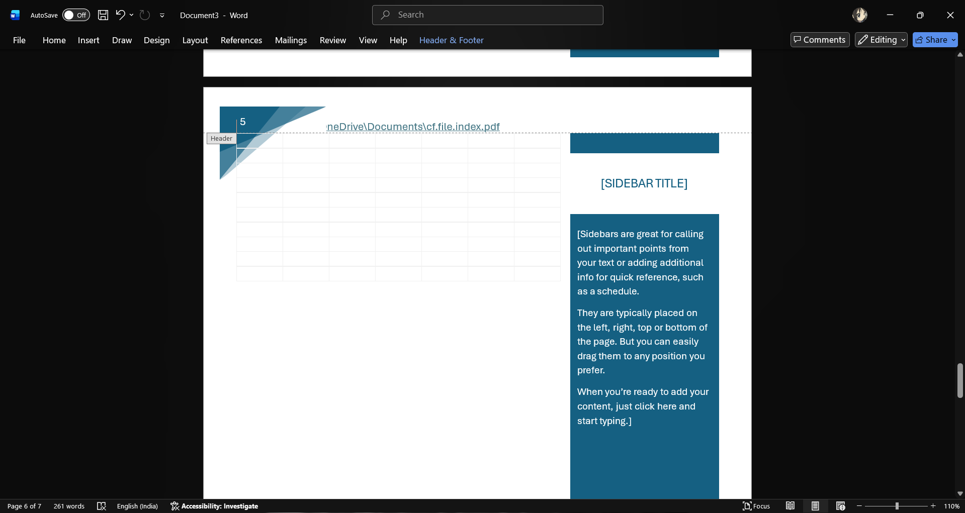

- Make the word at the water mark of the document. Select the background colour of the document as red using page colour option. Change the border of the page using page option. Choose the indents tab. Change the spacing between paragraphs by adding spaces above the paragraph.
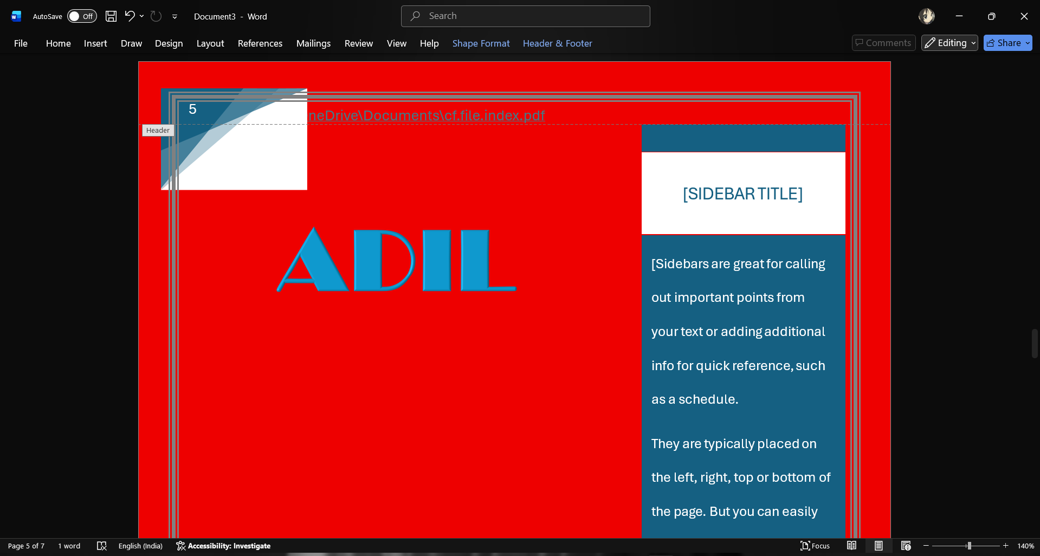
- Type This Paragraph and Check The Spelling and Grammar Using Spelling And Grammar Tool. View This Document in Full Screen Using Full Screen Read Option. View the Document as draft using draft tool. View the screen in full mode and zoom mode. Add a bibliography of a document.
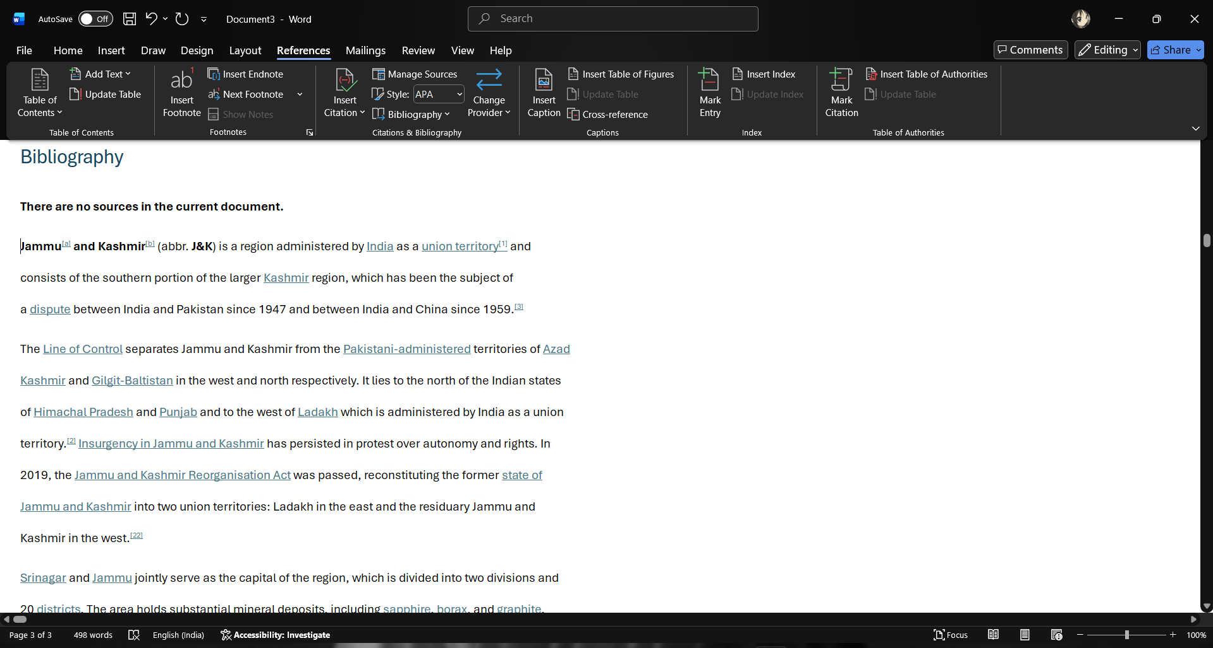

- Choose a paper size for the document using size option. Split the text in three columns by using column options. Type the following line and give numbers to that line using line number option.
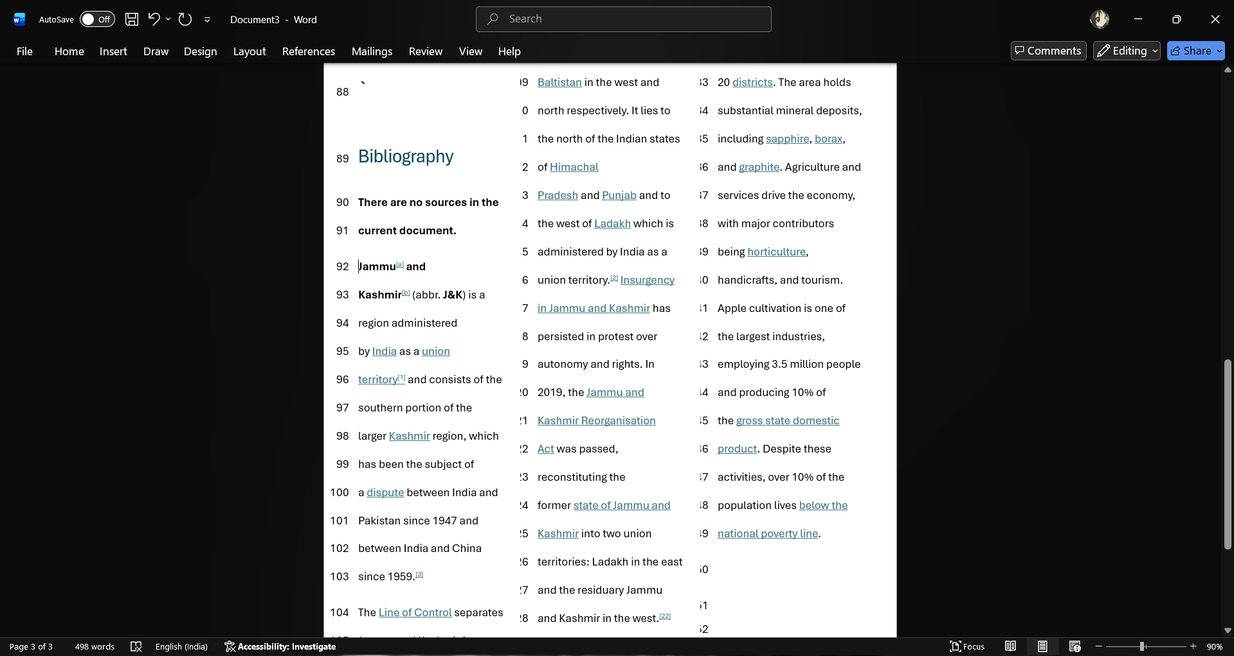

- Add a table of content to the document Update the Table of content insert foot note to the document insert an end note to the document insert an index into the document create labels to the document.
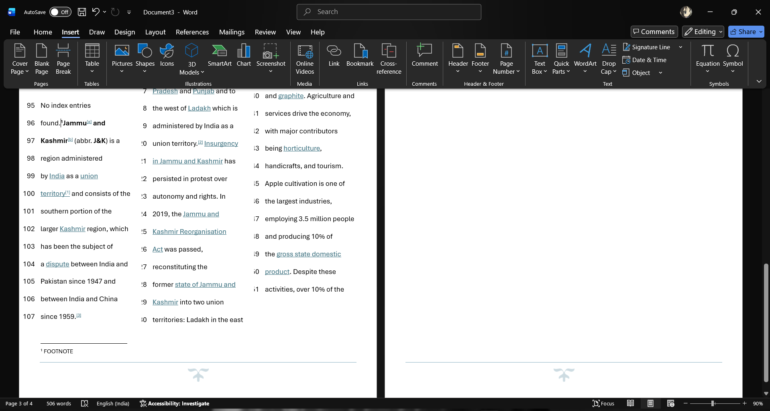
- Use mail merge to send an official initiation to the employs of the Company to attend a workshop.
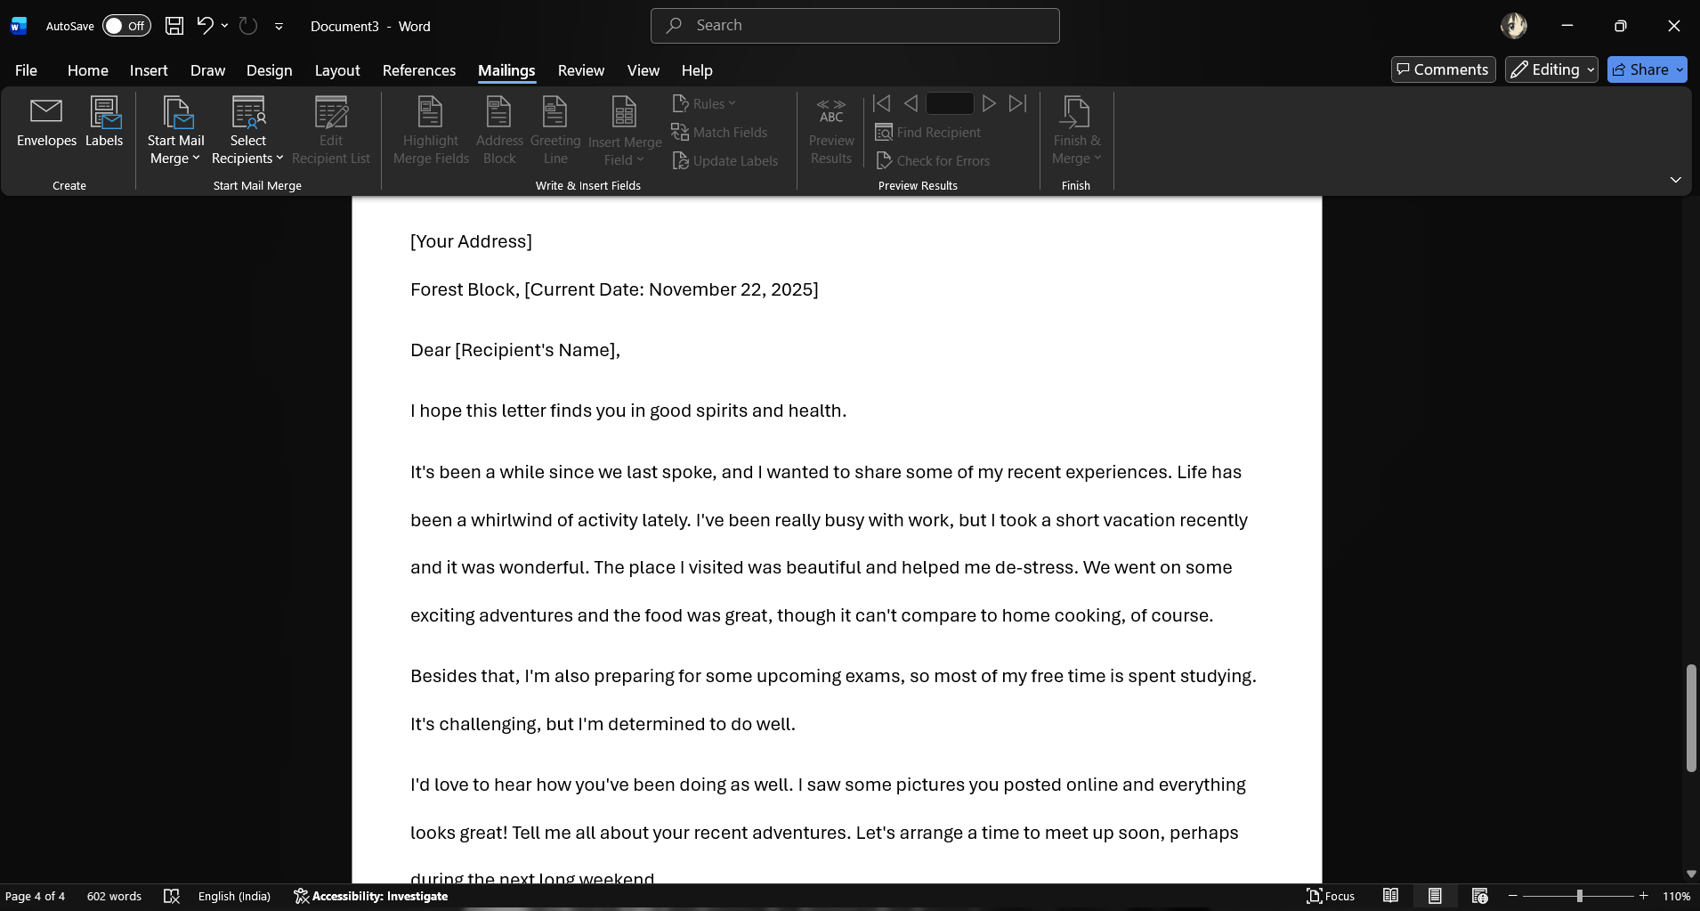

- Create a macro to insert a formatted table with previously defined rows and columns and with appropriate headings.
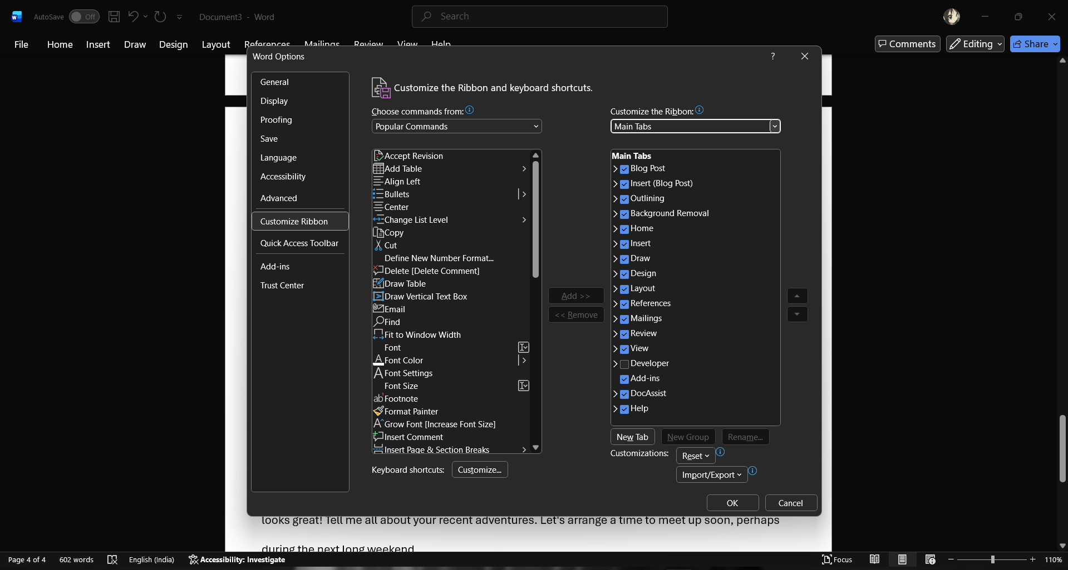

- Perform arithmetic on five sets of two number Number 1 Number 2 Add Sub Mul Div.
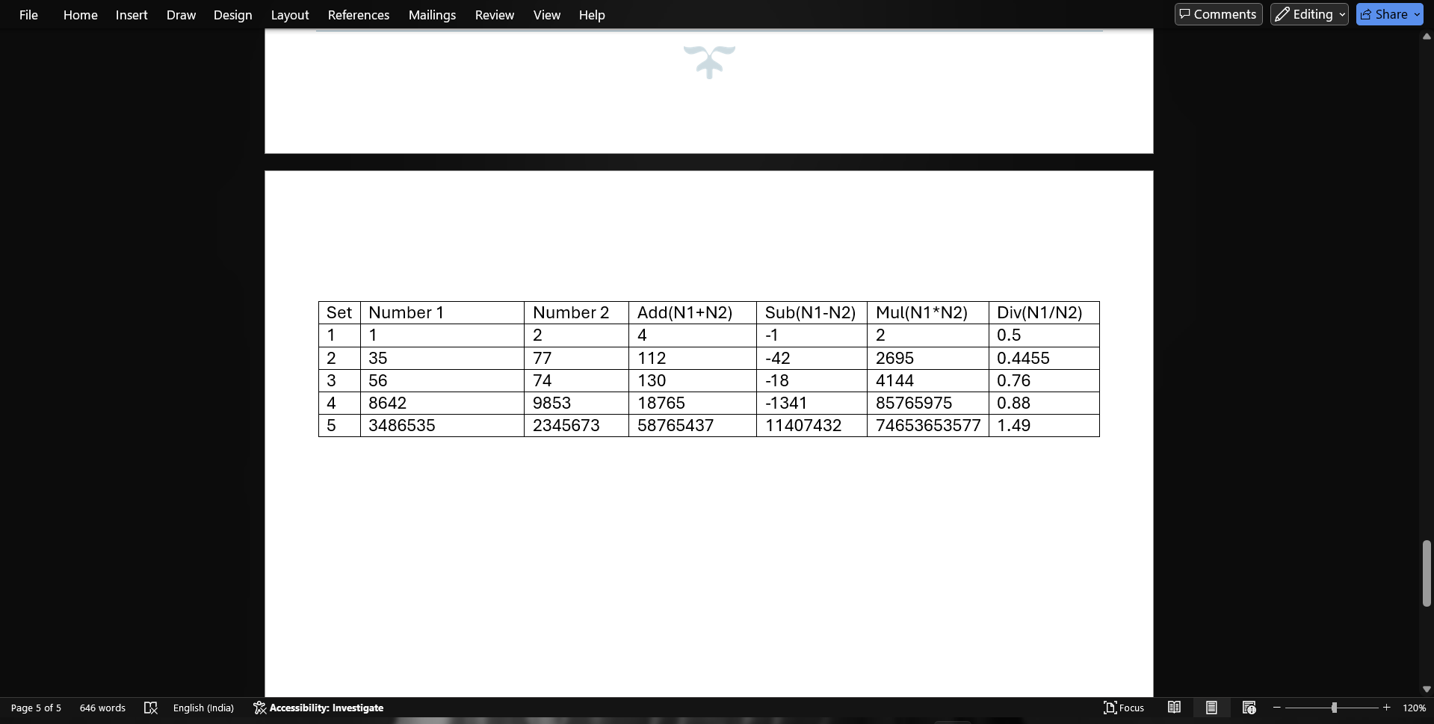
- Consider the problem of a stationery order for month of march. The description quantity and cost per item if to be calculated & the final cost per item involve a add tax of two percent over the total cost. The graph total & net total are to be displayed. Description Quantity Cost per item.
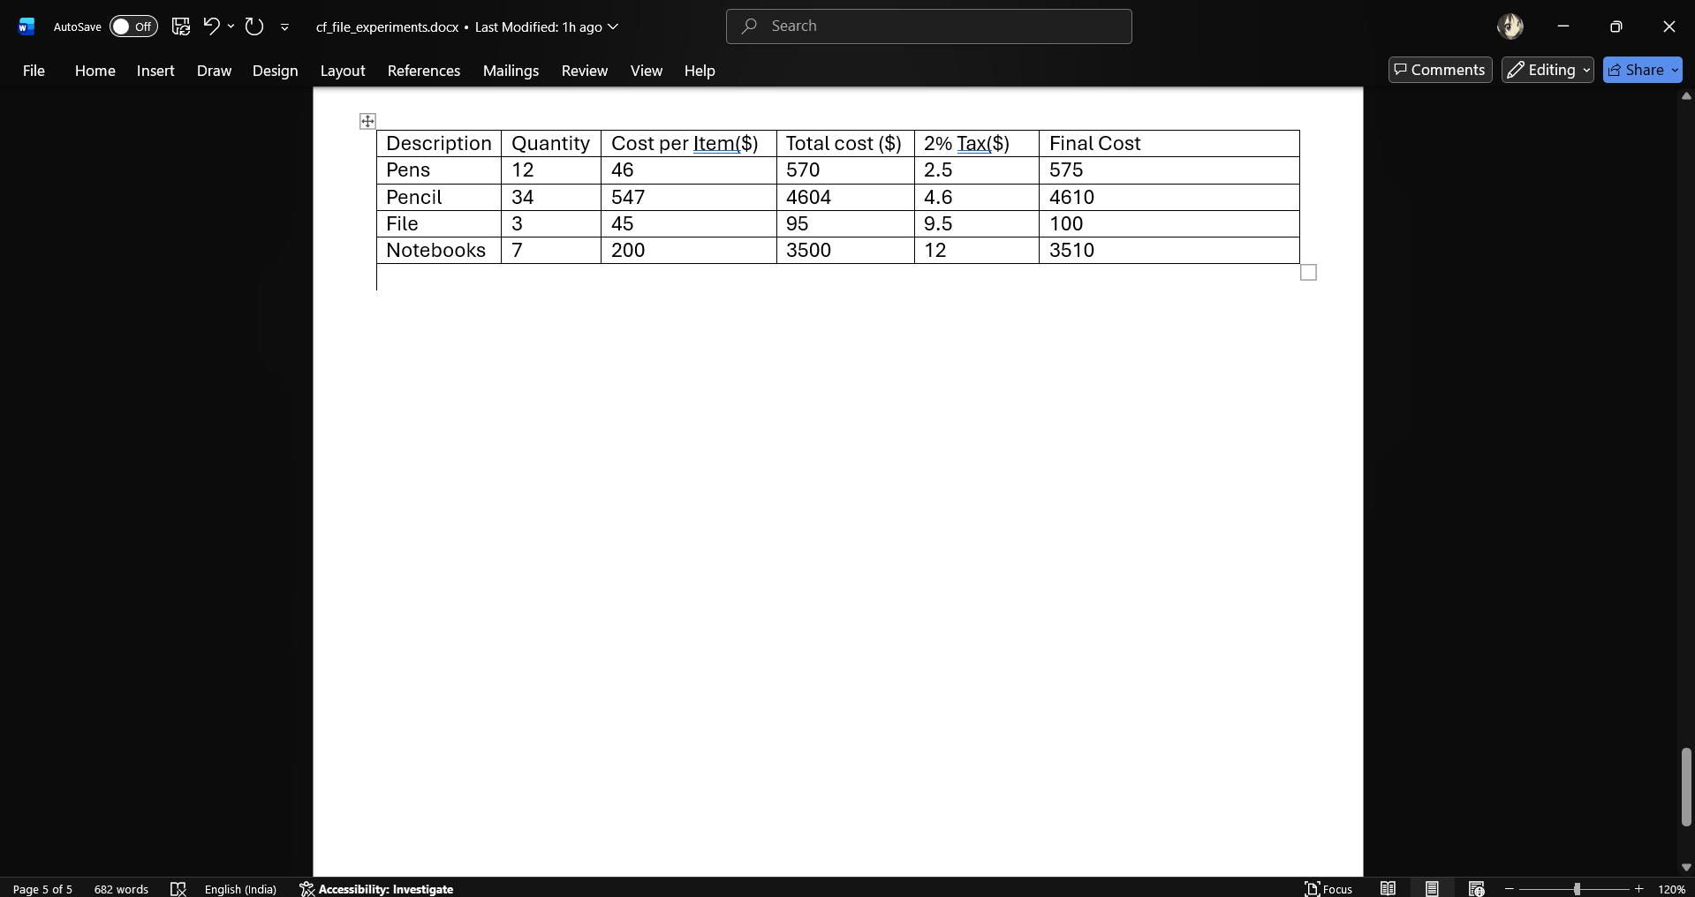
- Let us consider problem of finding the total and average of three subject marks for five students in a class in board exam.
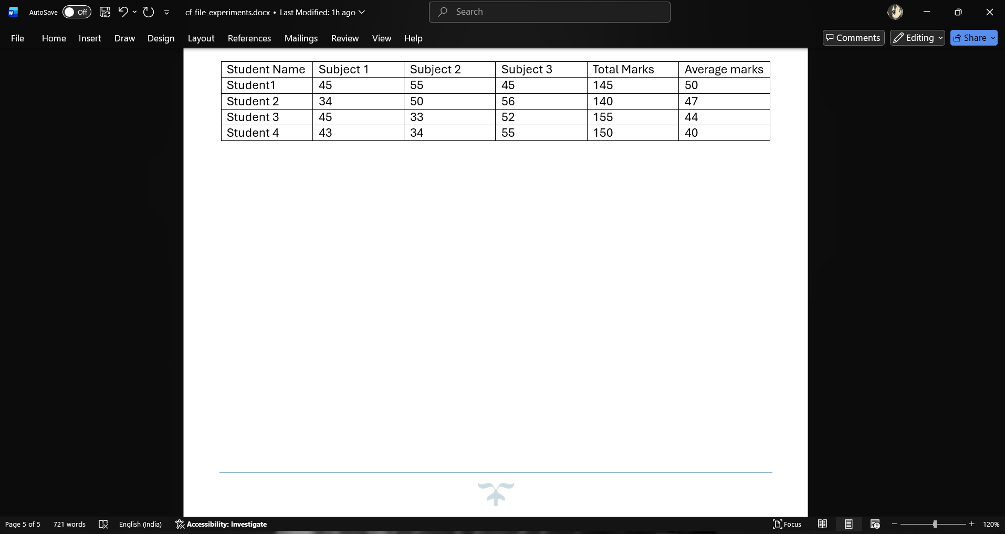

- In a problem you are given the name, gender, attendance, assignment, mid-term & find grade of five students. Find the total of the assignment marks. Student who pass need to have a total score greater then or equal to 50. Display the word pass or fail under a column called description.
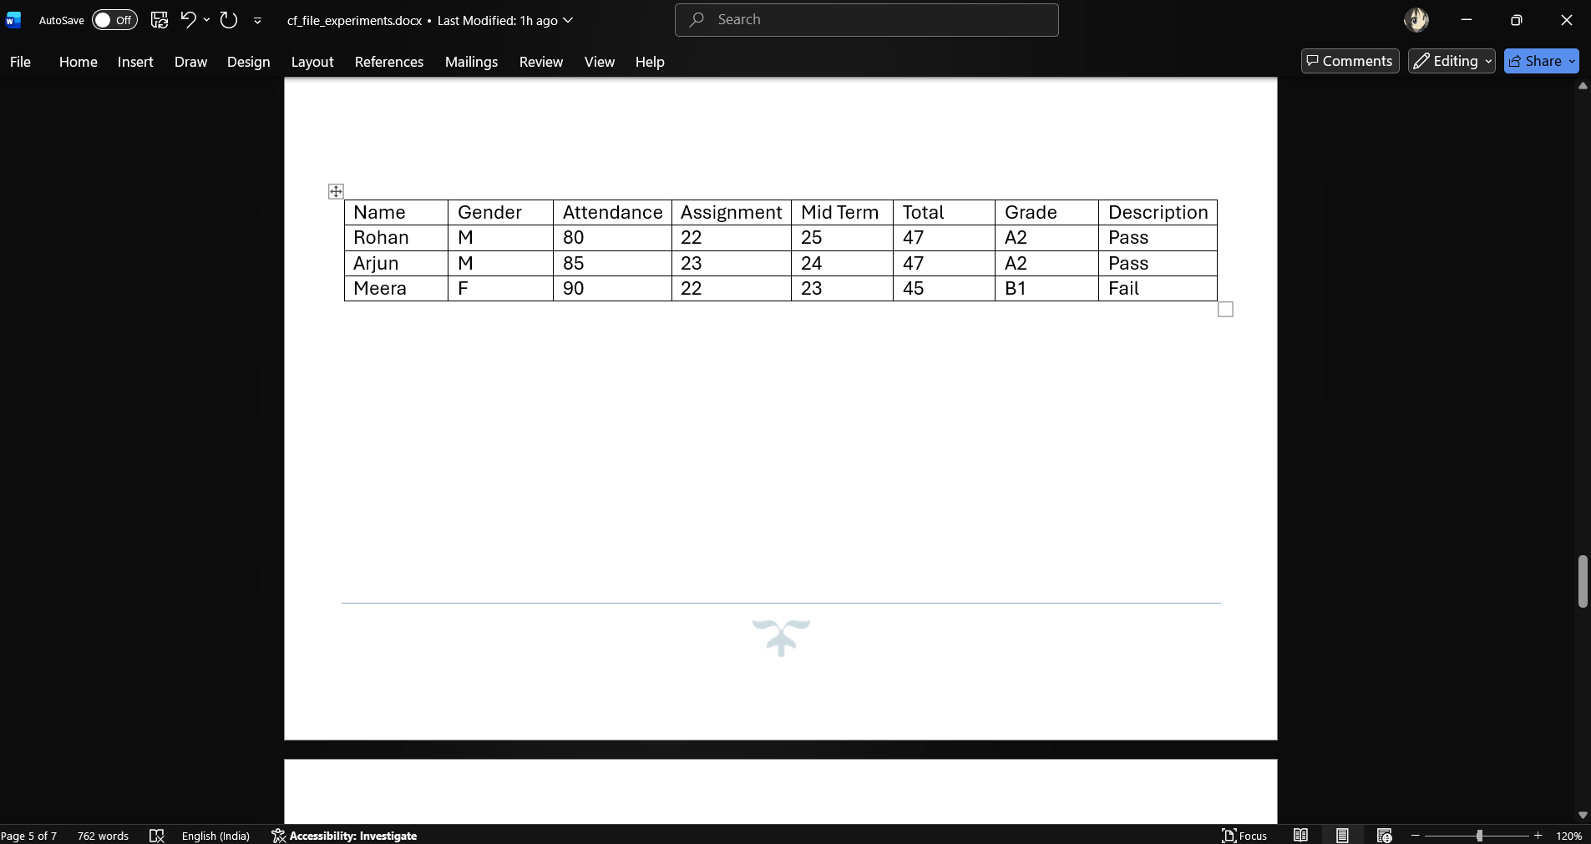
- You are given a file containing the name and age of people. You have to count no of people in each category as minor major 18-25. Middle age 26-40, above middle age 40-60, & senior citizen 61-100. Using the single function, for each scenario & create the font pertaining the condition.
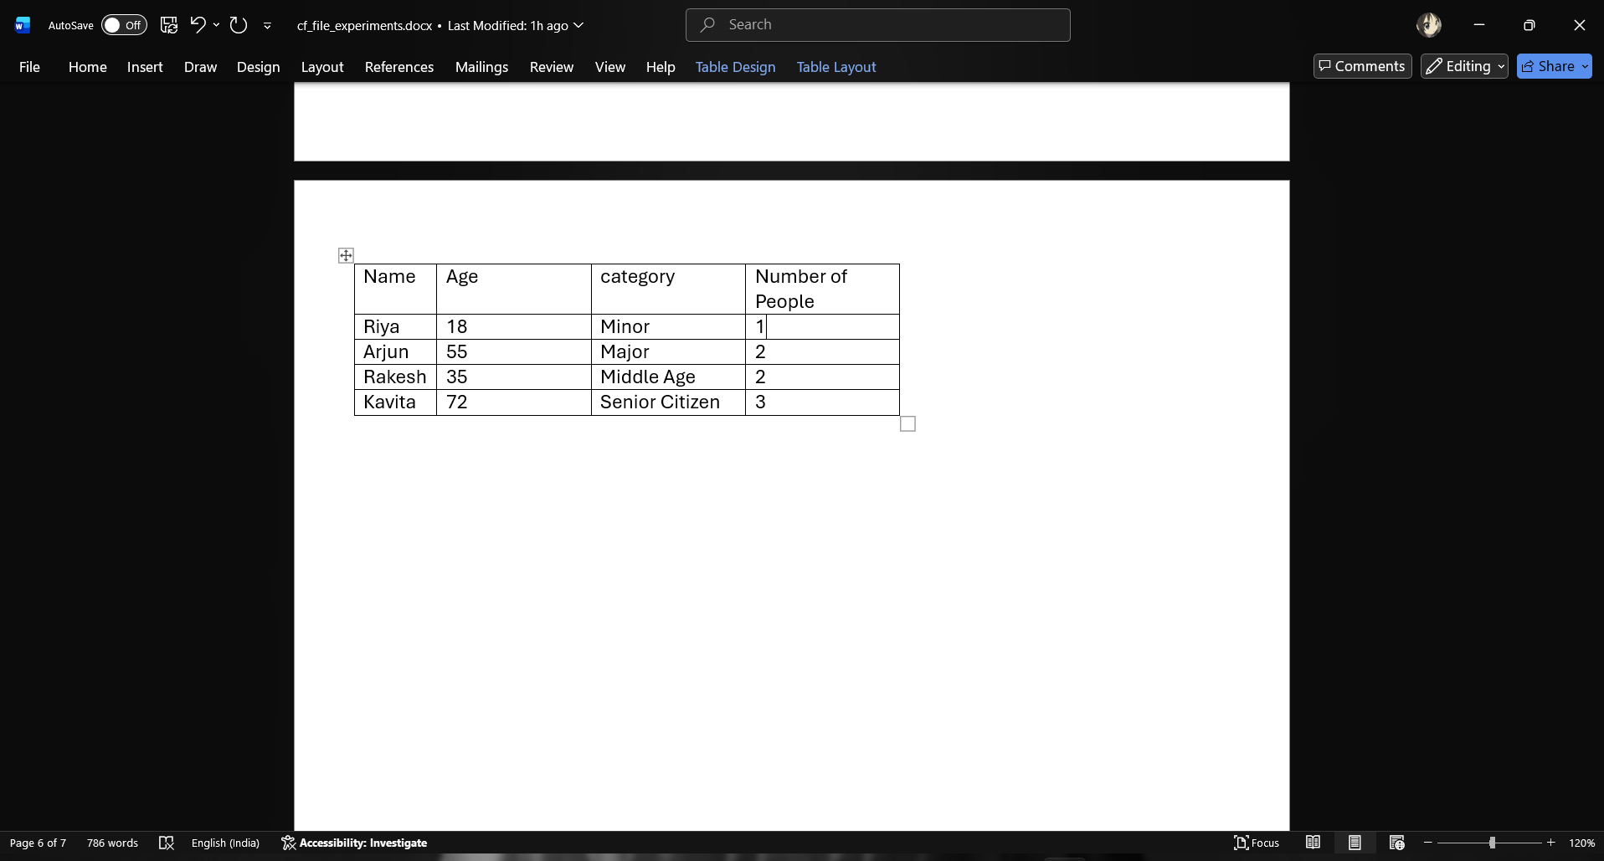

- Consider a table containing the consignments of different fruits from different suppliers as show below. Product Supplier Quantity.
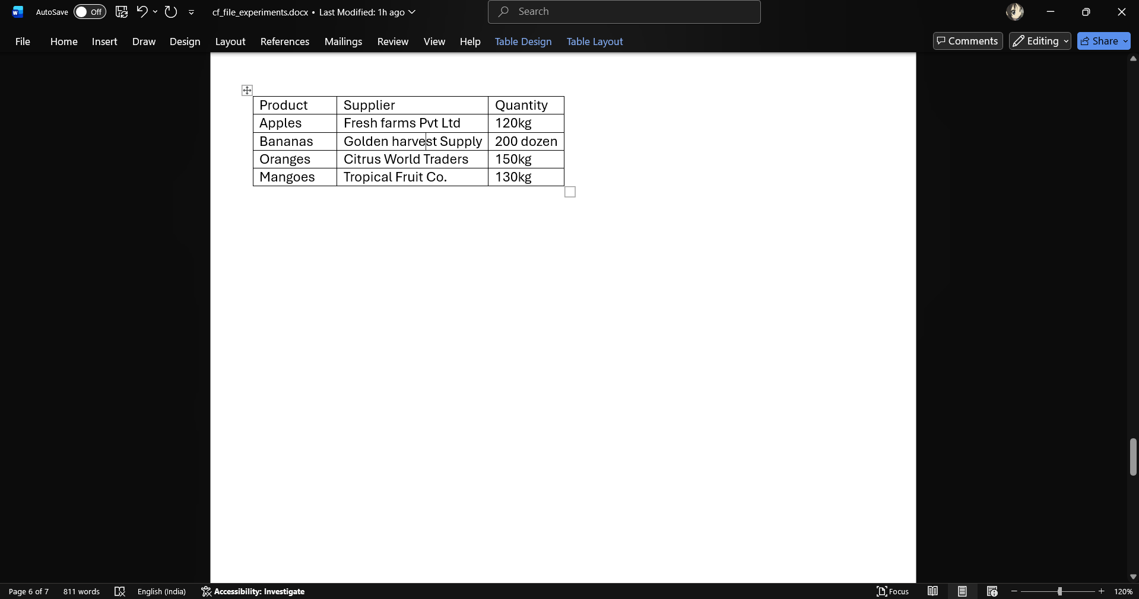

- Calculate the first name, last name, email id of the full name of the employee.

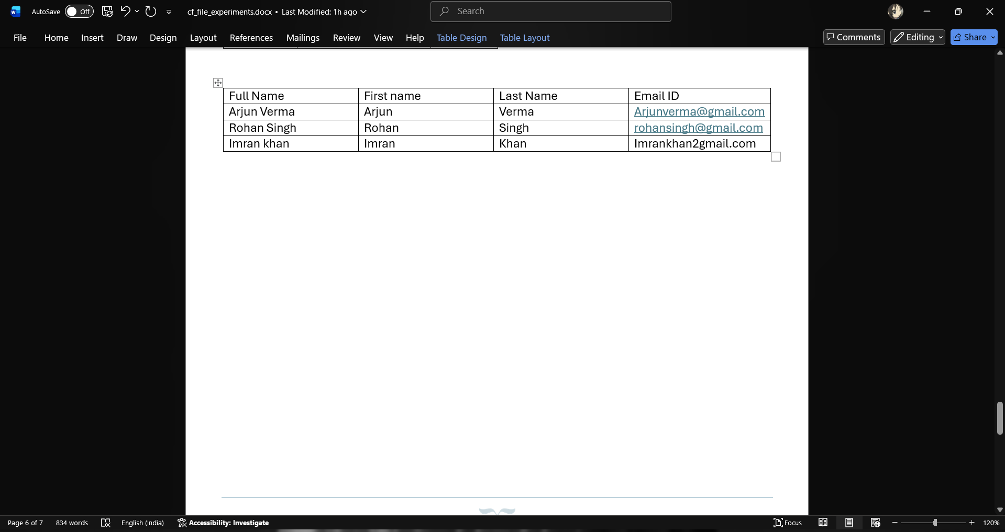
- Use Vlookup to search name of employee by their customer ID.
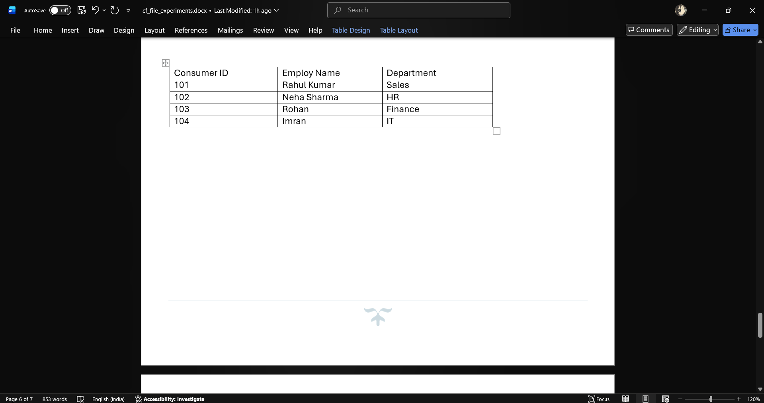

- Use Vlookup to extract the info from multiple tables.
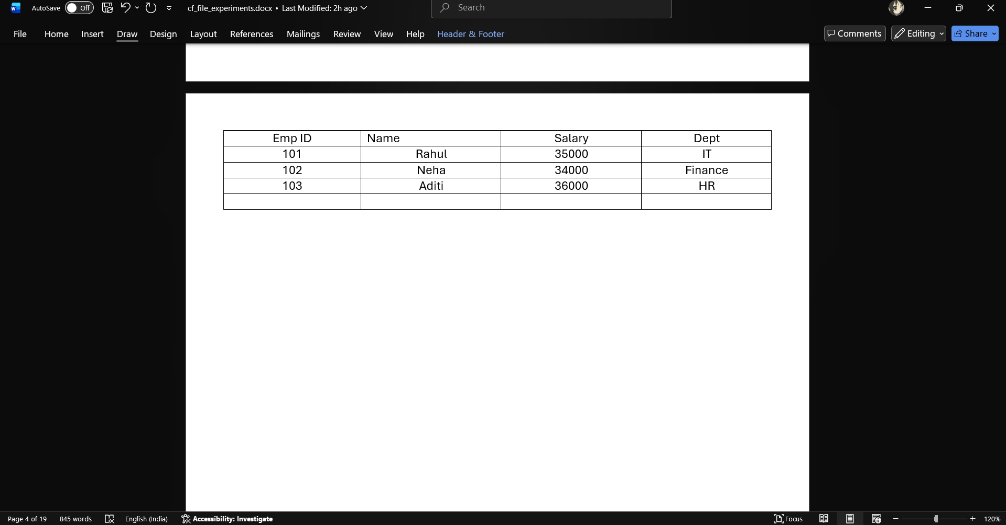

- Use H-look up to search the name of employee by their customer id.
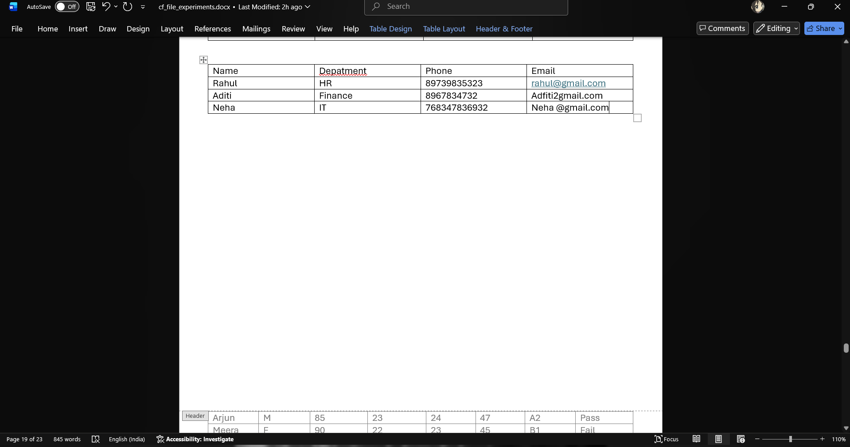

- Calculate the first name, last name, email id of the full name of the employee.

