Dev Catalyst student: Addison Blair

Dev Catalyst class: Hardware class

README

My name is Addison Blair, I am 15, and I live near Newton, Iowa, on a farm with lots of chickens, horses, cats, dogs, racoons, rabbits, mice, deer, skunks, coyotes, foxes, birds, squirrels, ducks, opossums, etc. I am homeschooled, so my home is actually a home and a school too. When I do my school on a farm you might think I do a lot of my schoolwork on agriculture and soybeans, but that’s not the case on our farm. I do my school more on science and math.

But enough about my farm and more about my Swirling LED Blender. I created this project called the Swirling LED Blender because I wanted to create something fascinating and new. My Swirling LED Blender includes the following hardware parts: blender, resistors, paint stick, LEDs, 3 AAA Batteries, 4 AAA battery holder (which I modified to 3 to create the right voltage by soldering a wire in place of one battery), wires, jumper wires, a dimmer switch, and last but not least, my Raspberry Pi Zero W. I used 16 different tools and two dozen other parts to make this amazing project into what it is now. I learned a lot using these uniquely different tools, and I now know far more than I did when I first started.

My original project idea was to use the spinning LEDs to make shapes and pictures, but I soon learned that the Raspberry Pi Zero W was not capable of controlling my GPIO pins inputs and outputs that fast. So I stuck to making some pretty cool LED combinations that spin around in a 360 degree circle. The original LED color that I was going to use was red, but I switched the LED colors to green, red, blue, white, and amber for more creativity.

To start the project I first drilled 5 evenly separated holes into one end the paint stick for the LEDs to fit through. Next I glued each LED into the paint stick with Gorilla glue, and then soldered five 10k Ohm resistors to the end of each LED leg. Later while I was testing my project I found out that the amber LED was too dim, so I soldered a 1k Ohm resistor over its 10k Ohm resistor, and the LED was then much brighter. In case you’re wondering how I got the paint stick to spin in a circle, I attached the stick to a old blender that my dad bought at the Salvation Army, screwed on two picture hangers which are hooked onto the 2 remaining blender blades (thanks to the help of a grinding wheel and a rotary cutting tool), and used rubber bands to make sure to keep tight the trusty paint stick onto the dulled blender blades.

One of my main challenges in this project was trying to get the blender blades to stop flying off with the paint stick. Many times in early attempts the stick would be unbalanced and would wobble and then fly off. But I soon dealt with that by cutting off (thanks to the help of a hacksaw) the bottom of the original plastic cup that was made to fit the blender, and used the part that I sawed off to screw over the blades so that the blender blades would stay in the blender and not fly off.

Besides that problem, the AAA batteries in the battery pack that are used to power up my Raspberry Pi Zero W kept dying (or to put it in a different way, kept losing voltage.) This issue hasn’t really been dealt with yet (besides replacing the batteries, but that means that the batteries in the battery pack -- which is hot glued to the paint stick and then zip tied on -- has to be removed and then put back on, which is an annoying process.)

One of my achievements was using a great app called VNC Real Viewer to wirelessly connect to my Raspberry Pi Zero W from my Raspberry Pi 4 so that I could run the Python code from there. The code that I created In Python now enables me to switch the LED combination with the simple press of a keyboard key while the LEDs are spinning.

I achieved a great amount because I successfully wrote the code called ***Swirling LED Blender-Final****,* completed the paint stick, and successfully attached the paint stick to the blender blades to complete my functional Swirling LED Blender.

I also have two pictures shown on this page. The first picture is my Swirling LED Light Display Blender, and the other is a small part of my project diagram.

My project (as seen from the top):

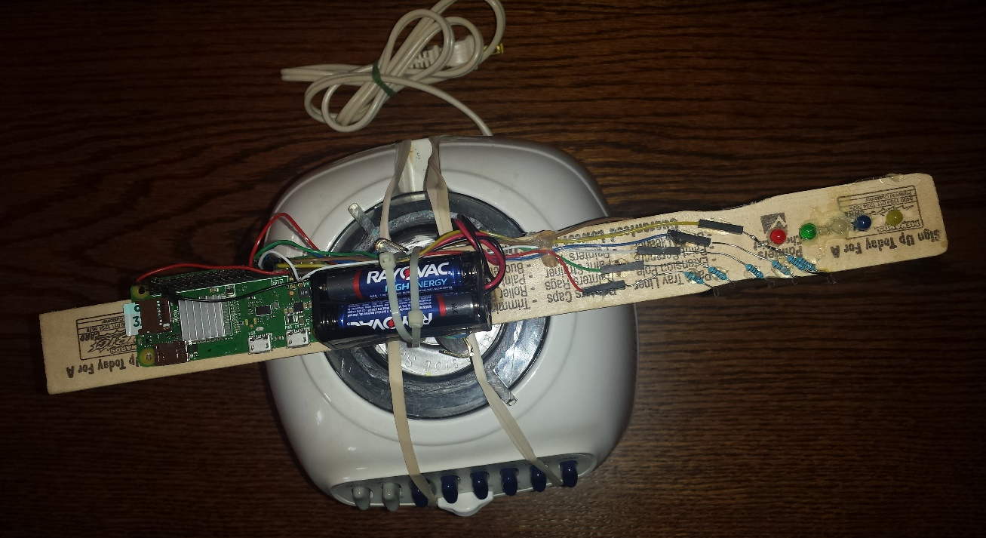

My schematic diagram of a portion of my project.

