**Hong Kong Institute of Vocational Education**

**Department of Information Technology**

**Higher Diploma in Data Science and Analytics**

**ITP4887 Big Data Management**

**Assignment**

**Group Project**

Project title: Review from research of renting post in UK

Table of Contents

Introduction 3

Setting and Utilization of Github 5

Roles 7

Product Backlog items 8

Sprint Backlog items 9

Answering the client's concerns 10

# Introduction

The trending of Immigration to British is rising in recent years. To immigrate to British,the most important thing is knowing the renting transactions so that you can choose and rent your desire house in UK. A housing agency employed us to have a study on the circumstances of renting transactions in the UK. My report is required to answer the following questions:

1. Generate (5 to 10 rows) processed renting post records.

1. What kind of property is having the most number of the bathroom on average?
2. What is the contribution of house type in the record? What is the most common type of property in the UK?
3. What is the value distribution of the number of Reception between the semi-detached house and terraced house?
4. What kind of property is contain the second most turnover?

6. Is there any relationship between the number of bedrooms, the number of bathrooms and the average price of a different property?

# Setting and Utilization of Github

The link of my Github project: <https://github.com/AddisonLO/dl32432/tree/main/4887_project>

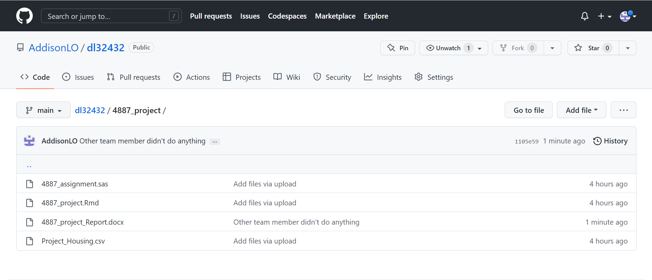

# Roles

Member list

|  |  |  |
| --- | --- | --- |
| Name | Role | Responsibilities |
| Lo Ho Him | Developer,Product Owner, Scrum Master | Doing every project related activities. For example coding, data visualization and create report. |

# Product Backlog items

|  |  |  |  |  |
| --- | --- | --- | --- | --- |
| **Sprint** | **Task** | **Category** | **priority** | **status** |
| 1 | Uploading data to R | DATA | LOW | Under Review |
| 1 | Data Cleansing | DATA | HIGH | Under Review |
| 2 | Visualize cleaned data and answer all concern provided by agency | Modelling | Middle | Under Review |

# Sprint Backlog items

# Answering the client's concerns

**Generate (5 to 10 rows) processed renting post records.**

**What kind of property has the most number of bathrooms on average?**

As with the graph shown, shared house has the most bathrooms on average. Mostly because shared houses are given to those families that can’t afford a house but still wanted to live in British. An independent bathroom for different family is very important in shared house because this is more hygienic.

Also, detached house has the second highest number of bathroom. That mean customers can consider detached house if they are afford to detached house.

**What is the contribution of house type in the record? What is the most common type of property in the UK?**

In the graph we can see flat is the most common renting house in UK. There are almost 6000 renting house in UK are flat. That mean the supply of flat house very

High, agents can recommend flat house to customers first and don’t need to worry about the supply of flat renting house.

**What is the value distribution of the number of Reception between the semi-detached house and terraced house?**

Above pie chart shown the value distribution of the number of Reception. We can see semi-detached and terraced house has 1390 and 1580 receptions respectively and these two kind of house is the second and third highest value distribution.

This mean semi-detached and terraced are popular types of renting house in UK. Agent can consider recommending these two kinds of house to customer as an alternate choice of flat house.

**What kind of property is contain the second most turnover?**

This bar chart show the total turnover of different kinds of renting house. Just like I stated in other concerns, flat house has the highest turnover. The second highest turnover is terraced, about 1E9 turnover, which is about 1 billion dollars.

**Is there any relationship between the number of bedrooms, the number of bathrooms and the average price of a different property?**

Above scatterplot show the relationship between Bed,Bath and avg. We can see most of renting houses have lower that 10 Bed and the average price is mainly between 0 to 3000000. There are few outliners in the Bed-avg scatter graph there are a large property with 60 beds, this property may be a department which have a lot of small flat in a building.

The relationship of Bath and avg is not obvious because there are a amount of property don’t a bathroom. However, we can see most of property have 2 bathroom in a house and the avg price of those houses are higher than property without bathroom marginally.