C#.net and Oracle 11g Database connection:
username:system
password:admin

Step 1: Create all required tables in Oracle:
Step1:
Login oracle 11g using the above username and password
create ur own database.(eg: username:mm password:mm)
Logout
Step2:
login with ur database -> create all tables ( eg. Info ( id prim key , name) )
log out

TABLES USED IN THE PROJECT
1.LOGIN TABLE:
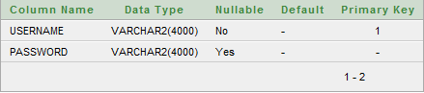
- LAB TABLE
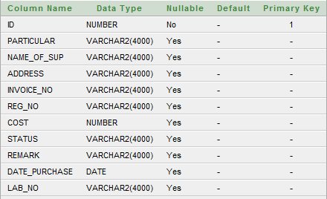

Step 2.Design the forms for the projects and link them with each other

Step 3.CONNECTION TO THE DATABASE
Step 1.add ref-> C:\oraclexe\app\oracle\product\11.2.0\server\odp.net\bin\2.x\OracleDataAccess.ddl
(From the solution explorer in .net)

Step 2.data->add data source->database->connection string
copy the connection string n paste in notepad( for later use)

Step 3.tools->connect to database->add connection->mention server name->username,password->test connection

Step 4. check the database

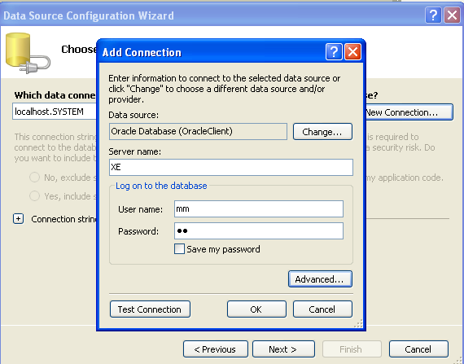

Step 4.CODES AND SNAPSHOTS:
1.Pass values from form1 to form2:
Form1:
Public Class Form1
Dim f2 As Form2
Dim s1 As String

Private Sub Button1_Click(ByVal sender As System.Object, ByVal e As System.EventArgs) Handles Button1.Click
s1 = TextBox1.Text
f2 = New Form2(s1)
f2.Show()
Me.Hide()

End Sub
End Class

Form2:
Public Class Form2
Dim ValueFromParent As String
Public Sub New(ByVal initialValue As String)
MyBase.New()
'This call is required by the Windows Form Designer.
InitializeComponent()
ValueFromParent = initialValue
Label1.Text = ValueFromParent

End Sub
Private Sub Form2_Load(ByVal sender As System.Object, ByVal e As System.EventArgs) Handles MyBase.Load

End Sub
End Class

- LOGIN PROCESS:
LOGIN PAGE: (FORMS: LOGIN,REGISTER,LOGINBAR)
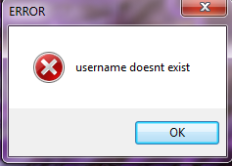
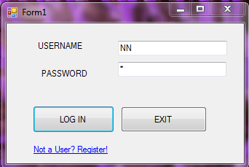
REGISTRATION FORM:
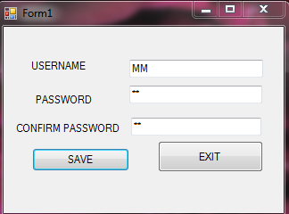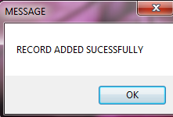
AFTER SUCCESSFUL REGISTRATION:
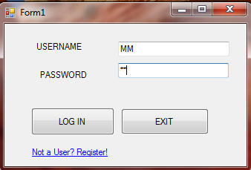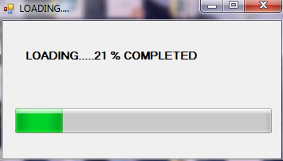
LOGIN FORM:
using Oracle.DataAccess.Client;
namespace MyLab_cs
{
public partial class LOGIN : Form
{
LOGINBAR L = new LOGINBAR();
OracleConnection CON1;
OracleCommand CMD;
string QUERY;
//int TEMP;
OracleDataReader RDR;

public LOGIN()
{
InitializeComponent();
CON1 = new OracleConnection("Data Source=XE;User ID=m;password=m ");
}

private void Button1_Click(object sender, EventArgs e)
{
if ((TextBox1.Text == " " )|| (TextBox2.Text == ""))
{
MessageBox.Show("Enter the username and password");
}

else
{

int FLAG = 0;
string STR="";

QUERY = "select * from login where username ='" + TextBox1.Text + "' ";
CMD=new OracleCommand(QUERY,CON1);

CON1.Open();
RDR = CMD.ExecuteReader();
while( RDR.Read())
{
STR=(string)RDR["password"];
FLAG=1;
}
RDR.Close();

CON1.Close();
if (FLAG==0)
{
MessageBox.Show(" username doesnt exist");
clearform();

}
else if (TextBox2.Text == STR)
{
LOGINBAR op = new LOGINBAR ();
op.Show();
Hide();
}
else
{
MessageBox.Show("Username and Password doesnt match.Please enter correct username and Password");
TextBox2.Text = " ";
TextBox2.Focus();
}

}

}

private void LOGIN_Load(object sender, EventArgs e)
{
TextBox1.Focus();

}

private void LinkLabel1_LinkClicked(object sender, LinkLabelLinkClickedEventArgs e)
{
REGISTER R =new REGISTER ();
R.Show();
Hide();

}

private void Button2_Click(object sender, EventArgs e)
{
Application.Exit();
}

void clearform()
{
TextBox1.Text = "";
TextBox2.Text = "";
TextBox1.Focus();
}

}
}

REGISTER FORM:
using Oracle.DataAccess.Client;
namespace MyLab_cs
{
public partial class REGISTER : Form
{
OracleConnection CON1;
OracleCommand CMD;
string QUERY;
int TEMP,I;
OracleDataReader RDR;
public REGISTER()
{
InitializeComponent();
CON1 = new OracleConnection("Data Source=XE;User ID=m;password=m ");
}

private void Button1_Click(object sender, EventArgs e)
{

if (TextBox1.Text == "" || TextBox2.Text == "" || TextBox3.Text == "")
{
MessageBox.Show("Enter All the Details ");
}
else
if (TextBox2.Text == TextBox3.Text)
{
I = 0;

QUERY = "select * from login where username='" + TextBox1.Text + "' ";
CON1.Open();
CMD = new OracleCommand(QUERY, CON1);

RDR = CMD.ExecuteReader();

while (RDR.Read())
{
if (RDR["username"] == TextBox1.Text)
I = 1;
else
I = I;
}
RDR.Close();
CON1.Close();

if (I == 1)
{
MessageBox.Show(" username exists");
TextBox1.Text = " ";
TextBox1.Focus();
}
else
{
CON1.Open();
QUERY = "Insert into login values('" + TextBox1.Text + "','" + TextBox2.Text + "')";
CMD = new OracleCommand(QUERY, CON1);
CMD.CommandType = CommandType.Text;
TEMP = CMD.ExecuteNonQuery();
if (TEMP > 0)

MessageBox.Show(" RECORD ADDED SUCESSFULLY");
else
MessageBox.Show("INSERT OPERATION FAILED ");

TextBox1.Text = "";
TextBox2.Text = "";
TextBox3.Text = "";
}

}
else
{
MessageBox.Show("PASSWORDS DO NOT MATCH");
TextBox2.Text = "";
TextBox3.Text = "";
TextBox2.Focus();
}
}

private void Button2_Click(object sender, EventArgs e)
{
LOGIN L = new LOGIN();
L.Show();
Hide();

}
}
}

LOGINBAR FORM:
namespace MyLab_cs
{
public partial class LOGINBAR : Form
{
OPTIONFRM op = new OPTIONFRM();
public LOGINBAR()
{
InitializeComponent();
}

private void LOGINBAR_Load(object sender, EventArgs e)
{
ProgressBar1.Step = 21;
ProgressBar1.Value = 0;

Timer1.Enabled = true ;

}

private void Timer1_Tick(object sender, EventArgs e)
{
ProgressBar1.PerformStep();
string s = " ";
s= " LOADING....." + Convert.ToString( ProgressBar1.Value) + " % COMPLETED";
Label1.Text = s;
if (ProgressBar1.Value >= ProgressBar1.Maximum)
{
Timer1.Enabled = false ;

op.Show();
Hide();
}
}
}
}

OPTION FORM:
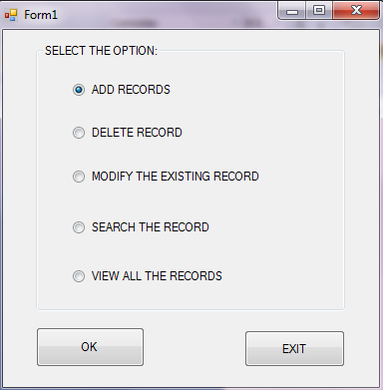
namespace MyLab_cs
{
public partial class OPTIONFRM : Form
{
ADD ADD1 =new ADD();
SEARCH SFRM = new SEARCH(); ** SEARCH FRM HAS DIFF CONSTRUCTORS(CALLIN 1ST CONSTRUCTOR **)
VIEW VFRM = new VIEW();
DELETE DFRM = new DELETE();

public OPTIONFRM()
{
InitializeComponent();
}

private void Button1_Click(object sender, EventArgs e)
{
if( RadioButton1.Checked == true )
{
ADD1.Show();
Hide();
}

if( RadioButton2.Checked == true )
{
SFRM.Show();
Hide();
}
if( RadioButton3.Checked == true )
{
SFRM.Show();
Hide();
}

if( RadioButton4.Checked == true )
{
SFRM.Show();
Hide();
}

if (RadioButton5.Checked == true)
{
VFRM.Show();
Hide();
}

}

private void Button2_Click(object sender, EventArgs e)
{
Application.Exit();
}
}
}
ADD PROCESS: ( ADD FORM)
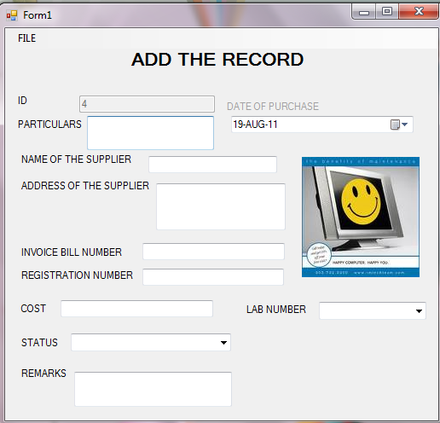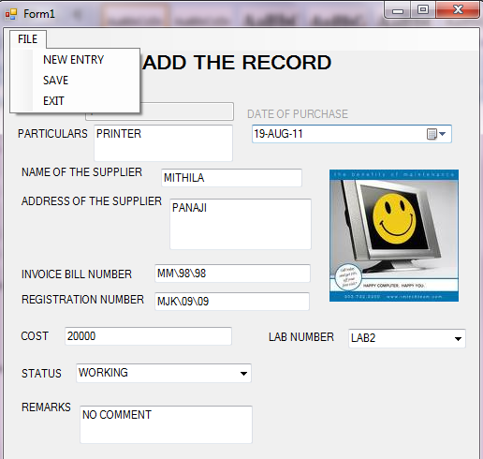
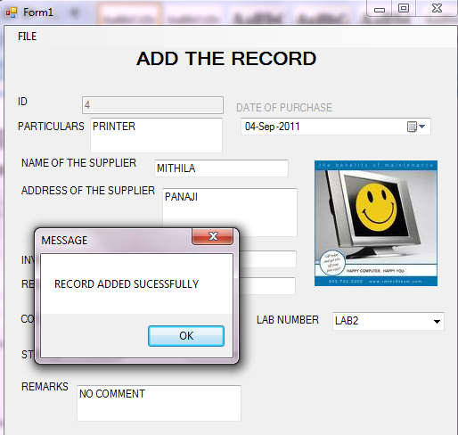

using Oracle.DataAccess.Client;

namespace MyLab_cs
{
public partial class ADD : Form
{
OracleConnection con1;
OracleCommand cmd;
string query;
int temp, I;
//OracleDataReader rdr;

public ADD()
{
InitializeComponent();
con1 = new OracleConnection("Data Source=XE;User ID=m;password=m ");
}

private void ADD_Load(object sender, EventArgs e)
{
con1 = new OracleConnection("Data Source=XE;User ID=m;password=m");

NEWRECORD();
CLEARFORM();
DateTimePicker1.Format = DateTimePickerFormat.Custom;
DateTimePicker1.CustomFormat = " dd-MMM-yyyy ";

}

public void CLEARFORM()
{
TextBox2.Text = "";
TextBox3.Text = "";
TextBox4.Text = "";
TextBox5.Text = "";
TextBox6.Text = "";
TextBox7.Text = "";

TextBox8.Text = "";

ComboBox1.SelectedIndex = 0;
ComboBox2.SelectedIndex = 0;
DateTimePicker1.Text =Convert.ToString(System.DateTime.Now);
DateTimePicker1.Format = DateTimePickerFormat.Custom;
DateTimePicker1.CustomFormat = " dd-MMM-yyyy ";
TextBox2.Focus();
}

public void NEWRECORD()
{
string query2,ID;

query2 = "Select max(id) from LAB";
con1.Open();
cmd = new OracleCommand(query2, con1);
cmd.CommandText = query2;
ID = Convert.ToString(cmd.ExecuteScalar());
if (ID.Equals(""))
TextBox1.Text = Convert.ToString(1);
else
{
int s;
s = Convert.ToInt16(ID) + 1;
TextBox1.Text = Convert.ToString(s);
}
con1.Close();
}

private void EXITToolStripMenuItem_Click(object sender, EventArgs e)
{
OPTIONFRM OP = new OPTIONFRM();
OP.Show();
Hide();
}

private void NEWENTRYToolStripMenuItem_Click(object sender, EventArgs e)
{
NEWRECORD();
CLEARFORM();
}

private void SAVEToolStripMenuItem_Click(object sender, EventArgs e)
{
if (TextBox1.Text == "" || TextBox2.Text =="" || TextBox3.Text =="" || TextBox4.Text == "" || TextBox5.Text== "" || TextBox6.Text == "" || TextBox7.Text== "" ||ComboBox1.Text == "SELECT STATUS" || TextBox8.Text == "" || DateTimePicker1.Text== "" || ComboBox2.Text == "SELECT LAB")

MessageBox.Show("Enter All the Details", "ERROR", MessageBoxButtons.OK, MessageBoxIcon.Error );

else
{

DateTimePicker1.Format = DateTimePickerFormat.Custom;
DateTimePicker1.CustomFormat = " dd-MMM-yyyy ";

try
{

con1.Open();
query = "Insert into LAB values('" + Convert.ToInt16(TextBox1.Text) + "','" + TextBox2.Text + "','" + TextBox3.Text.ToUpper() + "','" + TextBox4.Text + "','" + TextBox5.Text + "','" + TextBox6.Text + "','" +Convert.ToInt16( (TextBox7.Text)) + "','" + ComboBox1.Text + "','" + TextBox8.Text + "','" + DateTimePicker1.Text + "','" + ComboBox2.Text + "')";
cmd = new OracleCommand(query, con1);
cmd.CommandType = CommandType.Text;
temp = cmd.ExecuteNonQuery();
if( temp > 0 )
{
MessageBox.Show("RECORD ADDED SUCESSFULLY.", "Important", MessageBoxButtons.OK, MessageBoxIcon.Asterisk);

CLEARFORM();
}
else
MessageBox.Show (" INSERT OPERATION FAILED", "ERROR", MessageBoxButtons.OK, MessageBoxIcon.Error );

}
catch(Exception ex)
{
MessageBox.Show (ex.Message);
}

con1.Close();
NEWRECORD();
}
}
}
}

SEARCHING, DELETION AND MODIFYING PROCESS: ( SEARCH FORM AND SEARCHBAR FORM)
- SEARCH:
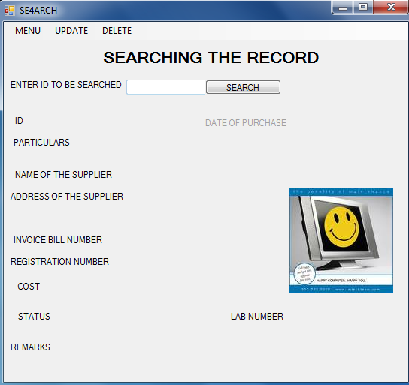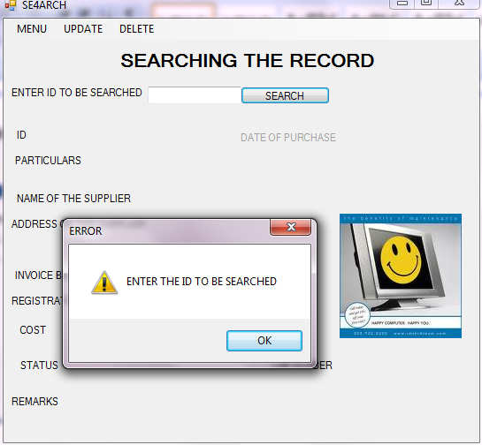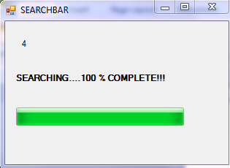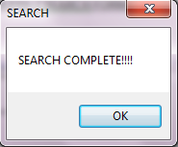
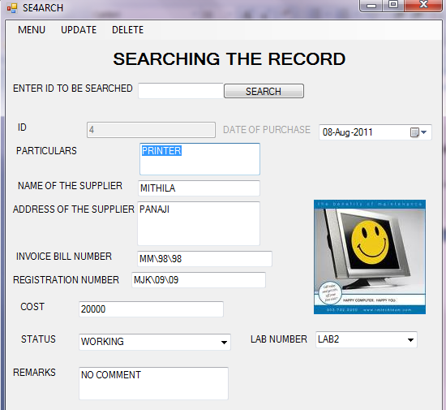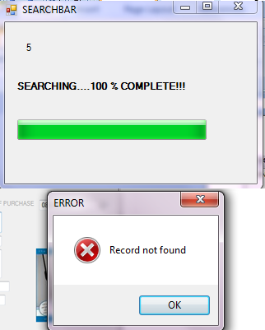
SEARCH FORM:
using Oracle.DataAccess.Client;

namespace MyLab_cs
{
public partial class SEARCH : Form
{
OracleConnection con1;
OracleCommand cmd;
string query;
int temp, I ;
OPTIONFRM op;
OracleDataReader reader2;
public SEARCH() **Constructor 1 of search frm
{
InitializeComponent();
NSEARCH();
TextBox9.Focus();

}
public SEARCH(string str1) **constructor 2 of search frm
{
InitializeComponent();
TextBox1.Visible = true;
TextBox2.Visible = true;
TextBox3.Visible = true;
TextBox4.Visible = true;
TextBox5.Visible = true;
TextBox6.Visible = true;
TextBox7.Visible = true;
TextBox8.Visible = true;
ComboBox1.Visible = true;
ComboBox2.Visible = true;
DateTimePicker1.Visible = true;
DateTimePicker1.Format = DateTimePickerFormat.Custom;
DateTimePicker1.CustomFormat = " dd-MMM-yyyy ";
TextBox9.Text = str1;
string search = " ";
int flag = 0;
con1 = new OracleConnection("Data Source=XE;User ID=m;password=m");
search = "select * from LAB where ID='" + TextBox9.Text + "' ";
cmd = new OracleCommand(search, con1);
con1.Open();
reader2 = cmd.ExecuteReader();

while (reader2.Read())
{
TextBox1.Text = Convert.ToString(reader2["ID"]);
TextBox2.Text = Convert.ToString(reader2["PARTICULAR"]);
TextBox3.Text = Convert.ToString(reader2["NAME_OF_SUP"]);
TextBox4.Text = Convert.ToString(reader2["ADDRESS"]);
TextBox5.Text = Convert.ToString(reader2["INVOICE_NO"]);
TextBox6.Text = Convert.ToString(reader2["REG_NO"]);
TextBox7.Text = Convert.ToString(reader2["COST"]);
TextBox8.Text = Convert.ToString(reader2["REMARK"]);
ComboBox1.Text = Convert.ToString(reader2["STATUS"]);
ComboBox2.Text = Convert.ToString(reader2["LAB_NO"]);
DateTimePicker1.Text = Convert.ToString(reader2["DATE_PURCHASE"]);
flag = 1;
}
if (flag == 0)
{
MessageBox.Show(" Record not found", "ERROR", MessageBoxButtons.OK, MessageBoxIcon.Error);
NSEARCH();

}
reader2.Close();
con1.Close();
TextBox9.Text = " ";
TextBox9.Focus();
}

private void NSEARCH()
{
TextBox1.Visible = false;
TextBox2.Visible = false;
TextBox3.Visible = false;
TextBox4.Visible = false;
TextBox5.Visible = false;
TextBox6.Visible = false;
TextBox7.Visible = false;
TextBox8.Visible = false;
ComboBox1.Visible = false;
ComboBox2.Visible = false;
DateTimePicker1.Visible = false;
}

private void Button1_Click(object sender, EventArgs e)
{
SEARCHBAR SBAR;
if (TextBox9.Text == "" || TextBox9.Text == " ")
MessageBox.Show("ENTER THE ID TO BE SEARCHED", "ERROR", MessageBoxButtons.OK, MessageBoxIcon.Error);

else
{
SBAR = new SEARCHBAR(TextBox9.Text); **uses constructor 2 of searchbar frm
SBAR.Show();
Hide();
}
}

private void SEARCH_Load(object sender, EventArgs e)
{
DateTimePicker1.Format = DateTimePickerFormat.Custom;
DateTimePicker1.CustomFormat = " dd-MMM-yyyy ";
}

private void NEWSEARCHToolStripMenuItem_Click(object sender, EventArgs e)
{
NSEARCH();
}

private void EXITToolStripMenuItem_Click(object sender, EventArgs e)
{
op = new OPTIONFRM();
op.Show();
Hide();
}

private void MODIFYToolStripMenuItem_Click(object sender, EventArgs e)
{
if (TextBox1.Visible == false)

MessageBox.Show("SEARCH THE RECORD", "WARNING", MessageBoxButtons.OK, MessageBoxIcon.Exclamation);

else
{
DialogResult dr;
dr = MessageBox.Show("ARE YOU SURE YOU WANT TO MODIFY THE RECORD?", "WARNING", MessageBoxButtons.YesNo, MessageBoxIcon.Question);
if (dr == DialogResult.Yes)
{
query = "Update LAB Set PARTICULAR='" + TextBox2.Text + "',NAME_OF_SUP='" + TextBox3.Text.ToUpper() + "',ADDRESS='" + TextBox4.Text + "',INVOICE_NO='" + TextBox5.Text + "',REG_NO='" + TextBox6.Text + "',COST='" + Convert.ToInt16(TextBox7.Text) + "',REMARK='" + TextBox8.Text + "',STATUS='" + ComboBox1.Text + "',LAB_NO='" + ComboBox2.Text + "',DATE_PURCHASE='" + DateTimePicker1.Text + "' Where ID='" + TextBox1.Text + "'";

cmd = new OracleCommand(query, con1);
cmd.CommandType = CommandType.Text;
try
{
con1.Open();
cmd.ExecuteNonQuery();
MessageBox.Show("Record updated successfully", "MESSAGE");
}
catch (Exception er)
{
MessageBox.Show(er.Message);
}

finally
{ con1.Close();

}
}
con1.Close();

}

NSEARCH();

}

private void DELETEToolStripMenuItem_Click(object sender, EventArgs e)
{
if (TextBox1.Visible == false)

MessageBox.Show("SEARCH THE RECORD", "WARNING", MessageBoxButtons.OK, MessageBoxIcon.Exclamation);

else
{
DialogResult dr;
dr = MessageBox.Show("ARE YOU SURE YOU WANT TO DELETE THE RECORD?", "WARNING", MessageBoxButtons.YesNo, MessageBoxIcon.Question);
if (dr == DialogResult.Yes)
{

I = 0;
query = "select * from LAB where ID='" + TextBox1.Text + "' ";
con1.Open();
cmd = new OracleCommand(query, con1);
reader2 = cmd.ExecuteReader();
while (reader2.Read())
{
string c2 = " ";
decimal c1;
c1 =(decimal) reader2["ID"];
c2 = TextBox1.Text;
if ( c2 == Convert.ToString(c1) )
I = 1;
else
I = I;

}
reader2.Close();
con1.Close();

if (I == 0)
{
MessageBox.Show(" Record not found", "ERROR", MessageBoxButtons.OK, MessageBoxIcon.Error);
TextBox1.Text = " ";
}
else
{
con1.Open();
string del = "";
del = "delete from LAB where ID='" + TextBox1.Text + "' ";
cmd = new OracleCommand(del, con1);
I = cmd.ExecuteNonQuery();
MessageBox.Show("Item Successfully Deleted");
TextBox1.Text = "";

con1.Close();

}
}

else
TextBox1.Text = "";

NSEARCH();

}

}
}
}

SEARCHBAR FORM:
namespace MyLab_cs
{
public partial class SEARCHBAR : Form
{
SEARCH SFRM;
public SEARCHBAR() ** constructor 1
{
InitializeComponent();
}
public SEARCHBAR(string i) ** constructor 2
{
InitializeComponent();
Label1.Text = i;
}

private void SEARCHBAR_Load(object sender, EventArgs e)
{
ProgressBar1.Step = 21;
ProgressBar1.Value = 0;

Timer1.Enabled = true ;
}

private void Timer1_Tick(object sender, EventArgs e)
{
ProgressBar1.PerformStep();
Label2.Text = "SEARCHING...." + Convert.ToString(ProgressBar1.Value) + " % COMPLETE!!!";
if (ProgressBar1.Value >= ProgressBar1.Maximum )
{
Timer1.Enabled = false;
MessageBox.Show("SEARCH COMPLETE!!!!", "SEARCH");
SFRM = new SEARCH(Label1.Text); **constructor 2 of search frm
SFRM.Show();
Hide();
}
}

}
}

DISPLAYING THE RECORDS IN THE DATA GRID: (VIEW FORM)
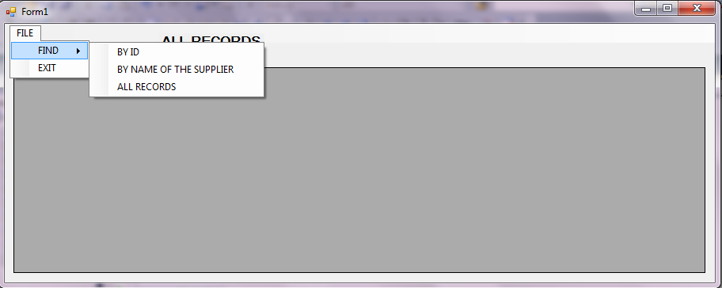
VIEW ALL RECORDS:
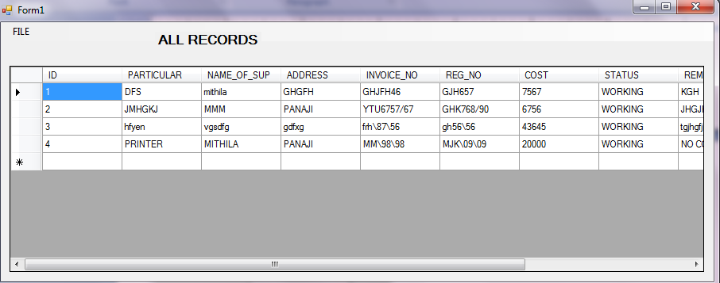
VIEW RECORD: SEARCHIN BY ID:
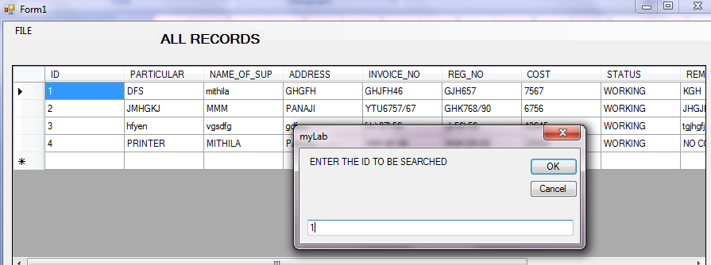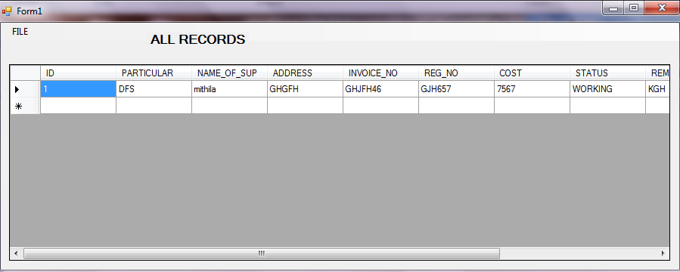
VIEW RECORD: SEARCHING BY NAME OF SUPPLIER:
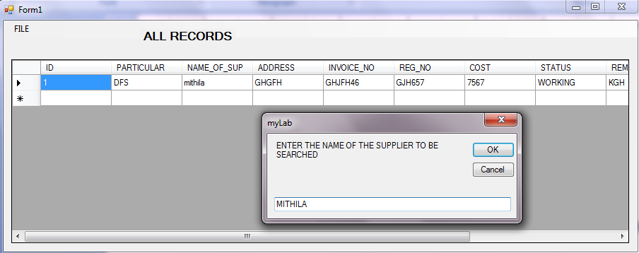
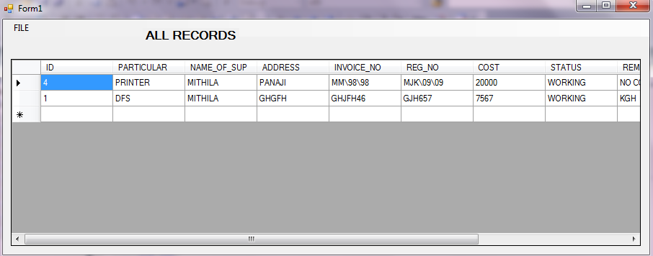
Set the Datagrid properties as follows
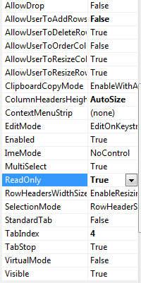
VIEW FORM CODE:
using Oracle.DataAccess.Client;
using Microsoft.VisualBasic; ** used to use inputbox(prompt box)

namespace MyLab_cs
{
public partial class VIEW : Form
{
OracleConnection con1;
OracleCommand cmd;
OracleDataAdapter da;
DataSet d;
string query;
int temp, I;
public VIEW()
{
InitializeComponent();
con1 = new OracleConnection("Data Source=XE;User ID=m;password=m ");

}

private void BYIDToolStripMenuItem_Click(object sender, EventArgs e)
{
string s="";
s= Microsoft.VisualBasic.Interaction.InputBox("ENTER id to be searched:","SEARCH");

if (s != "")
{
MessageBox.Show(s);
query = "select * from LAB WHERE ID= '" + s + " '";
cmd = new OracleCommand(query, con1);
try
{
con1.Open();
da = new OracleDataAdapter(query, con1);
d = new DataSet();
da.Fill(d, "test");
DataGridView1.DataSource = d.Tables[0];
}
catch (Exception er )
{ MessageBox.Show(er.Message);

}

con1.Close();
}
else
{
MessageBox.Show("ID not matched");
}
}

private void BYNAMEOFTHESUPPLIERToolStripMenuItem_Click(object sender, EventArgs e)
{
string s = "";
s = Microsoft.VisualBasic.Interaction.InputBox("ENTER THE NAME OF THE SUPPLIER TO BE SEARCHED", "SEARCH");

if (s != "")
{
MessageBox.Show(s);
query = "select * from LAB WHERE NAME_OF_SUP LIKE '" + s.ToUpper() + "%'";
cmd = new OracleCommand(query, con1);

try
{
con1.Open();
da = new OracleDataAdapter(query, con1);
d = new DataSet();
da.Fill(d, "test");
DataGridView1.DataSource = d.Tables[0];
}
catch (Exception)
{

}

con1.Close();
}
else
{
MessageBox.Show("Name not matched");
}
}

private void ALLRECORDSToolStripMenuItem_Click(object sender, EventArgs e)
{

query = "select * from LAB " ;
cmd = new OracleCommand(query, con1);

try
{
con1.Open();
da = new OracleDataAdapter(query, con1);
d = new DataSet();
da.Fill(d, "test");
DataGridView1.DataSource = d.Tables[0];
con1.Close();
}
catch (Exception er)
{
MessageBox.Show(er.Message);
}
finally
{
con1.Close();
}

}

private void EXITToolStripMenuItem_Click(object sender, EventArgs e)
{
OPTIONFRM OP = new OPTIONFRM();
OP.Show();
Hide();
}

}
}

C#, does it have a prompt box?
There is no problem with C#. You only add reference -the Microsoft.VisualBasic.dll and then you can use the function. The Microsoft.VisualBasic.dll is core assembly in .NET Framework, so it's allways available.

Add reference to Microsoft.VisualBasic and use this into your C# code:
string input = Microsoft.VisualBasic.Interaction.InputBox("Prompt","Title", "Default", 0, 0);

using Microsoft.VisualBasic;

namespace TEST1
{
public partial class Form1 : Form
{
string i = "";
public Form1()
{
InitializeComponent();
}

private void button1_Click(object sender, EventArgs e)
{
i= Microsoft.VisualBasic.Interaction.InputBox("ENTER");
MessageBox.Show(i);
if (i != "")
label1.Text = i;
else
label1.Text = " Value not entered";
//= " ";

}
}
}
2. dialog box
private void button2_Click(object sender, EventArgs e)
{
if( MessageBox.Show(" are u sure", "warning", MessageBoxButtons.YesNo, MessageBoxIcon.Question)== DialogResult.Yes)

{
MessageBox.Show("ok");
}

DialogResult dialogResult = MessageBox.Show("Sure", "Some Title", MessageBoxButtons.YesNo);
if(dialogResult == DialogResult.Yes)
{
//do something
}
else if (dialogResult == DialogResult.No)
{
//do something else
}

