BIOL 806 FINAL PROJECT

**By: Joshua Addo & Julia Oliveira Barreiro De Jesus**

[**https://github.com/AddoJosh/BIOL_806_PROJECT.git**](https://github.com/AddoJosh/BIOL_806_PROJECT.git)

# Title: *Screening for Resistance of cucurbit Genotypes to Cucurbit Powdery Mildew*

## INTRODUCTION

Cucurbit Powdery Mildew (CPM) poses a significant threat to cucurbits (Squash and Pumpkin) globally, affecting them in both field and greenhouse environments (Caligiore-Gei et al., 2022). It is mainly caused by two erysiphaceous ectoparasites, namely Podosphaera xanthii and Erysiphe cichoracearum (Lebeda et al., 2015). The former pathogen has a worldwide distribution than the later pathogen (McGrath, 2022). The disease poses a significant production problem, leading to a decrease in the quantity and quality of yields, mainly through a decrease in the size or number of fruit or a shortened harvest period, premature senescence of infected leaves, sunburn on fruit, premature or incomplete ripening, and poor storability (e.g., winter squash), low soluble solids, resulting in poor flavor (e.g., melon), poor rind color (e.g., pumpkin) and shriveled, discolored handles (pumpkin), and makes plants more susceptible to other diseases, particularly gummy stem blight (McGrath, 2022).

CPM characteristics consists of conspicuous whitish talcum‐like colonies of the pathogen on both sides of the leaves (Figure 1), petioles and vines (Pérez-García et al., 2009; Caligiore-Gei et al., 2022). The pathogens cannot survive without a host, and under favorable conditions, CPM develops fast and the time between infection and symptoms can be as short as three days, and spores are rapidly produced. Some reasons that can make infection favorable are high density of plants, low amount of light during cucurbits cycle, high doses of nitrogen fertilizers and high humidity (University of Massachusetts Amherst, 2021). Even though resistant varieties have been developed and improved worldwide to reduce the incidence of CPM disease, fungicides have remained the primary form of disease control (Del Pino et al., 2002). However, the use of these fungicides comes with ongoing challenges compassing prolonged exposure posing risks to human health, harm to non-target species (pollinators and natural predators), soil and water quality, pathogen resistance and also can be expensive, and their accessibility may be limited for some farmers (Cullen et al., 2019; Brauer et al., 2019; Ons et al., 2020).

In view of this challenges posed by overuse of fungicides and wanting a more sustainable methods of CPM control and management, research is being conducted in University of New Hampshire to evaluate different squash genotypes for a possible resisitant gene against CPM. Therefore, the objective of this study seeks to contribute to the development of resilient crops that can withstand CPM, ultimately promoting sustainable agricultural practices through the identification of resistant squash varieties.

## METHODOLOGY

### (A) Field screening

The field trial was carried out during the summer of 2023 at the Woodman Farm (43°08′58″ N, 70°56′28″ W and Elevation 41.59 m) to test the resistance of 7 squash accessions (comprising 3 cultivars and 4 breeding lines) (Table 1) to Cucurbit CPM (CPM). The trial was designed in complete randomized blocks, with 3 replications, each replication consisting of 4 plants. Summer Squash were planted around the fields and innoculated with CPM before the test squash accessions were planted. This summer squash served as a source of inoculum of the causal agent (CPM).

*Susceptible to CPM

## (B) Disease assessment

The assessment of resistance/tolerance/susceptible was made 60 days after planting when the disease was fully established in the field. Each plant was carefully evaluated and rated for severity on the 4th and 5th leaves, 4th and 5th petioles, and vines (main stem) using the scale developed by Caligiore-Gei *et al.* (2022) based on the percentage of leaf covered by CPM colonies as shown in Table 2 and Figure 1.

The mean severity score was calculated for leaves (4th and 5th leaves), petiole (4th and 5th petioles) and vine for each squash accession. Based on the mean leave severity score, the squash accessions were categorized as resistance/tolerance/susceptible using the following scale in Table 3.

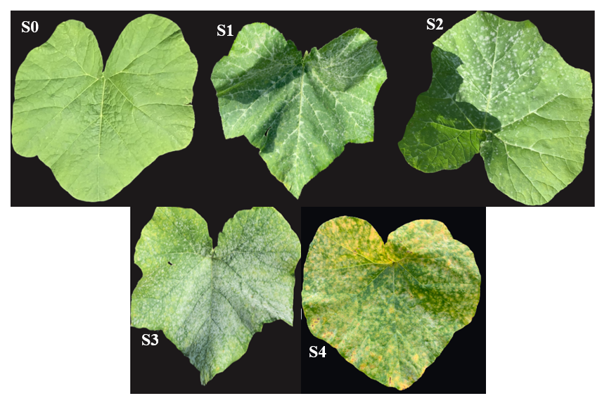

**Figure 1**: Schematic figure to guide the indexing of cucurbit CPM severity on leaves

## (C) Data Analysis

For the analysis of the field screening data, we conducted our analyses using the programming software, R v 4.3.1 (2023.06.2 Build 561). The data obtained from the field trial, including severity scores for leaves, petioles, and vines of each squash accession, were subjected to a series of statistical analyses. (i) Descriptive statistics, such as mean severity scores, standard deviation, and range, were calculated to provide a summary of the overall disease severity in the field trial. (ii) Analysis of Variance (ANOVA) were performed to assess whether there are any significant differences in disease severity among the squash accessions. This helped identify if there are varieties that demonstrate statistically significant resistance or susceptibility. Tukey’s HSD were conducted to identify specific pairs of squash accessions that differ significantly in disease severity using the stats and TukeyC packeges. (iii) Regression analyses (both linear model and generalized linear models) were conducted to explore potential relationships between severity scores on leaves, petioles, and vines using tidyverse and ggplot packages. This provided insights into whether the disease manifested similarly across different parts of the plant.

# RESULTS

### *Testing Normality of the data*

The skewness for the leave severity was approximately 0.808 and Kurtosis was approximately 2.537 indicating that more values are concentrated around the center with heavier tails compared to a normal distribution, a possible suggestion that most of the squash accession may be tolerant (lying between susceptible and resistant). The Shapiro-Wilk statistic was 0.87069 (Pr < W = < 4.023e-07) confirming that leave severity scores were not following a normal distribution (Appendix 1).

### *Construction of Box plot*

Box plot was constructed to visualize the distribution of CPM score on leave, petiole, and vine of the various squash accessions. On leave, CPM severity score ranged from 0 to 3 (Figure 2). The squash accession, OSA and PM_2 recorded the least severity score where as WBN-1-88 had the highest rating. CPM severity score petiole and vine had a mean value of 0.0698 and 0.0930, respectively (summary data).

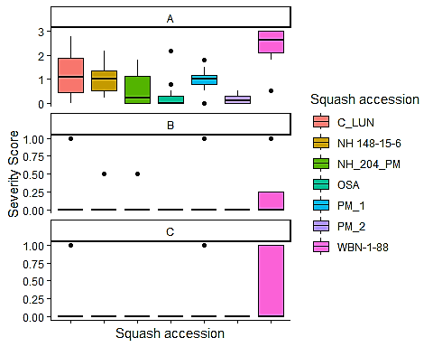

***Figure 2:*** *Box plot distribution of CPM severity on leave (A) petiole (B) and vine (C) of the various squash accessions*

### *Analysis of Variance to determine the effect of CPM on squash accessions*

To determine the effect of CPM among the various squash accessions, ANOVA was performed.

The analysis of CPM severity on leaves among the various squash accessions showed significant variations in susceptibility levels. An analysis of variance (ANOVA) revealed a significant effect of CPM on leave scores (F(6, 79) = 16.26, p < 0.001), indicating notable differences among the squash accessions. WBN-1-88 cultivar had the highest mean leave score, signifying a heightened susceptibility level (Mean = 2.425). Following closely, C_LUN breeding line displayed a substantial mean leave score (Mean = 1.183). NH 148-15-6 and PM_1 breeding lines showed similar mean leave scores (Mean ≈ 1.042 and 0.936, respectively), implying a moderate susceptibility level. OSA cultivar and PM_2 breeding line demonstrated relatively lower mean leave scores of 0.308 and 0.175, respectively, indicating a lower susceptibility. Also post hoc analysis showed that leave score of OSA and PM_2 were not different from each other (Figure 3).

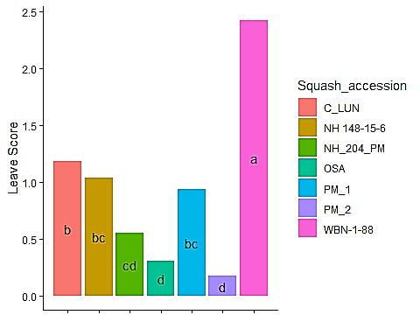

***Figure 3****: CPM severity score on leaves of Squash accessions. Different letters indicate significant differences among squash accessions (p < 0.05)*

Analysis of variance (ANOVA) of the influence of CPM on petiole scores among the different squash accessions, resulted in a non-significant effect (F (6, 79) = 1.526, p = 0.18). However, distinct patterns emerged upon examining petiole severity scores across the various accessions. WBN-1-88 recorded the highest mean petiole score (Mean = 0.250).This was followed by C_LUN with a mean petiole score of 0.083. Conversely, PM_1, NH 148-15-6 and NH_204_PM breeding lines recorded mean petiole scores of 0.071 and 0.042, 0.042, respectively. OSA cultivar, and PM_2 breeding line recorded no CPM symptoms on the petioles (Figure 4).

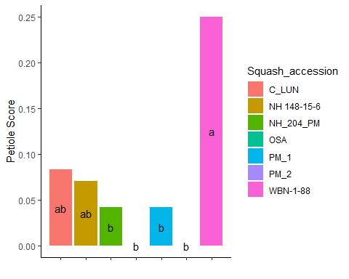

***Figure 4:*** *CPM severity score on petioles of Squash accessions. Different letters indicate significant differences among squash accessions (p < 0.05)*

Analysis of variance (ANOVA) of the influence of CPM among the different squash accessions, varied significantly differences (F(6, 79) = 4.166, p = 0.00109). Again, WBN-1-88 demonstrated the highest severity on vines (Mean = 0.417). This was followed by C_LUN (Mean = 0.167), while PM_1, NH 148-15-6, NH_204_PM, OSA, and PM_2 showed similar mean severity score (0.000). Pairwise comparisons indicated no distinct differences among the latter squash accessions in terms of vine CPM severity (Figure 5).

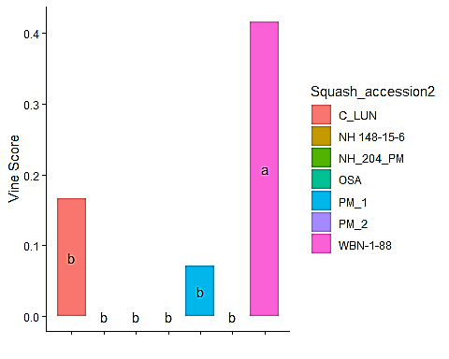

***Figure 5:*** *CPM severity score on vines of Squash accessions. Different letters indicate significant differences among squash accessions (p < 0.05)*

### *Categorizing squash accessions based on severity score on leaves*

Based on the severity score on leaves of the various squash accessions, they were categorised into three groups, namely, resistant (mean score of 0.0), tolerant (mean score of 0.1-0.9) and susceptible (mean score of >1.0). The results demonstrated that none of the squash accessions were immune to CPM infection, two (C_LUN and WBN-1-88) were categorized as susceptible and five (PM_1, NH 148-15-6, NH_204_PM, OSA, and PM_2) were categorized as tolerant (Table 4).

## *Regression analysis and Model to show relationship between severity scores on leaves, petioles and vines*

A generalized linear regression model run on mean leaves severity score and petiole severity score of all squash accessions (Figure 6) indicated that there was significant prediction between CPM infection on leaves and petioles (p <0.05) (Appendix 3).

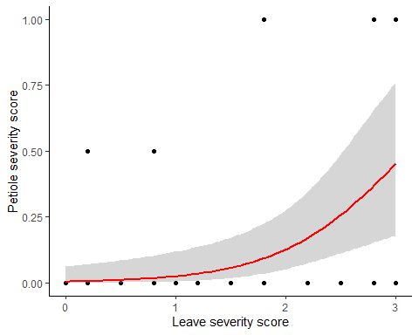

***Figure 6:*** *Relationship between mean leave severity score and petiole severity scores, including best fit line*

Figure 7 shows that the intercept value as -5.6902, indicating the log-odds of the response variable when the predictors are zero. The leaves score explains that for each unit increasing, there is an estimated increase of 2.0685 in the log-odds of the vine score. There was significant prediction (p < 0.05) between CPM infection on leaves and vine score due to infection by CPM. Model Fit shows that it fits well, due to the low deviance of 53.230 and a small AIC of 32.119 (Appendix 4)

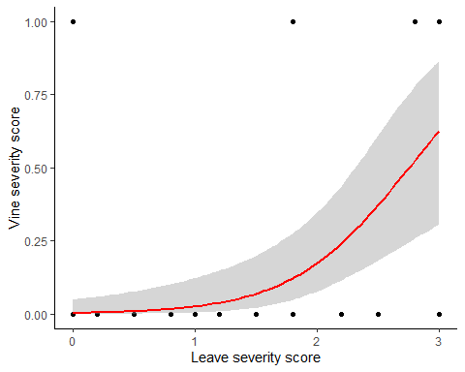

***Figure 7:*** *Relationship between mean leave severity score and vine severity scores, including best fit line*

The relationship between leave severity score and vine severity score is represented by Figure 8. The model shows that the intercept is estimated as -3.6902 and it represents the log-odds of the response when predictors are zero. Leave score shows that for each unit increasing, there will be an estimated increase of 5.8488 in the log-odds of the response. The significance shows a strong impact of leave score on vine score because p < 0.001. The model fit shows that it fits well due to low residual deviance (53.230) and AIC value as 32.347, considered moderate (Appendix 5)

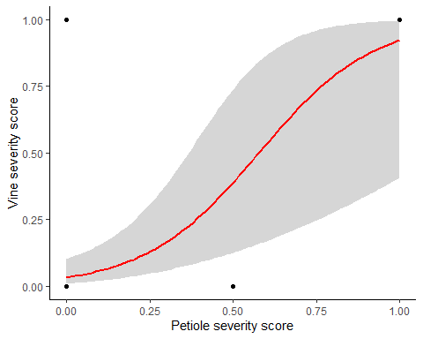

***Figure 8:*** *Relationship between mean petiole severity score and vine severity scores, including best fit line*

# DISCUSSION

The information provided by Figures 2-8 represents the analyses of CPM severity among seven squash accessions. Skewness and kurtosis measurs suggested a distribution with bigger results compared to normal, this can be due to concentration of values around the center and a prevalence of tolerant squash accessions. The Shapiro-Wilk statistic supports the deviation from a normal distribution, and the box plot graphics clearly represent the distribution of CPM scores on leaves, petioles, and vines across the seven different squash accessions. The boxplot analysis grouped C_LUN and WBN-1-88 in the leave severity score of 1-3 (Figure 2), an indication that both two squash accessions are susceptible (Table 4). All the other five squash accessions (PM_1, NH 148-15-6, NH_204_PM, OSA, and PM_2) had a leave score range between 0 and 1 (Figure 2), hence categorical analysis indicated that they were tolerant to CPM (Table 4). These analyses revealed that none of the squash accessions are immune to CPM infection. Even though categorical analysis showed that five squash accessions were tolerant to CPM, ANOVA analysis shows significant variation in their tolerant levels to CPM infection (Figures 3-5).

Generalized linear regression analysis indicated that leaves severity score is a good predicator of both petiole and vine severity scores of all squash accessions (Figures 6 -8). This possibly indicates that there could be shared genetic mechanisms or closely related genetic factors governing resistance or susceptibility to CPM across different parts of the plant. Genes responsible for resistance or susceptibility might be similarly expressed or regulated in both leaves, petioles, and vines. The identified prediction is valuable for the breeding of squash varieties resistant or tolerant to CPM. Genes or markers associated with resistance in one tissue (e.g., leaves) might also indicate resistance in other parts (e.g., petioles), aiding in the selection and development of more resilient squash cultivars.

However, further genetic analyses, such as genome-wide association studies (GWAS) or transcriptomic profiling, could elucidate specific genes, pathways, or molecular mechanisms underlying the observed correlation. Identifying and characterizing these genes could provide insights into potential targets for crop improvement strategies or genetic modifications aimed at enhancing resistance to CPM.

# CONCLUSION

Descriptive and categorical analysis concluded that C_LUN and WBN-1-88 as susceptible squash accessions while identifying the other five accessions (PM_1, NH 148-15-6, NH_204_PM, OSA, and PM_2) as tolerant to CPM infection. The strong predictive relationship between leaf severity scores and severity in petioles and vines across all squash accessions suggests shared genetic mechanisms governing resistance or susceptibility to CPM across different plant parts, potentially indicating common gene expressions or regulations. Genes or markers associated with resistance in one tissue might signal resistance in others, facilitating the selection and development of more robust cultivars.

# BIBLIOGRAPHY

McGrath, M.T. (2022). Cucurbit Powdery Mildew | Cornell Vegetables.. <https://www.vegetables.cornell.edu/pest-management/disease-factsheets/cucurbit-powdery-mildew/>

Pérez-García, A., Romero, D., Fernández-Ortuño, D., López-Ruiz, F., De Vicente, A., & Torés, J. A. (2009). The powdery mildew fungus Podosphaera fusca (synonym Podosphaera xanthii), a constant threat to cucurbits. Molecular plant pathology, 10(2), 153–160. <https://doi.org/10.1111/j.1364-3703.2008.00527.x>

Cullen, M. G., Thompson, L. J., Carolan, J. C., Stout, J. C., & Stanley, D. A. (2019). Fungicides, herbicides and bees: A systematic review of existing research and methods. PloS one, 14(12), e0225743. <https://doi.org/10.1371/journal.pone.0225743>

Ons, L., Bylemans, D., Thevissen, K., & Cammue, B. P. A. (2020). Combining Biocontrol Agents with Chemical Fungicides for Integrated Plant Fungal Disease Control. Microorganisms, 8(12), 1930. <https://doi.org/10.3390/microorganisms8121930>

Brauer, V. S., Rezende, C. P., Pessoni, A. M., De Paula, R. G., Rangappa, K. S., Nayaka, S. C., Gupta, V. K., & Almeida, F. (2019). Antifungal Agents in Agriculture: Friends and Foes of Public Health. Biomolecules, 9(10), 521. <https://doi.org/10.3390/biom9100521>

Lebeda, A., Křístková, E., Sedláková, B., McCreight, J. D., & Coffey, M. D. (2015). Cucurbit powdery mildews: methodology for objective determination and denomination of races. European Journal of Plant Pathology, 144(2), 399–410. <https://doi.org/10.1007/s10658-015-0776-7>

Caligiore-Gei, P. F., Della-Gaspera, P., Benitez, E., & Tarnowski, C. (2022). Cucurbit Powdery Mildew: First Insights for the Identification of the Causal Agent and Screening for Resistance of Squash Genotypes (Cucurbita moschata (Duchesne ex Lam.) Duchesne ex Poir.) in Mendoza, Argentina. Plant Pathology Journal (Suwon), 38(4), 296–303. <https://doi.org/10.5423/ppj.oa.01.2022.0002>

University of Massachusetts Amherst. (2021, September 6). Cucurbits, powdery mildew. Center for Agriculture, Food, and the Environment. <https://ag.umass.edu/vegetable/fact-sheets/cucurbits-powdery-mildew>

Del Pino, D., Olalla, L., Pérez-Garcı́A, A., De Rivera, M. E. S. D., García, S. M., Moreno, R., De Vicente, A., & Torés, J. A. (2002). Occurrence of races and pathotypes of cucurbit powdery mildew in southeastern Spain. Phytoparasitica, 30(5), 459–466. <https://doi.org/10.1007/bf02979750>

# APPENDIX

APPENDIX 1: *Testing Normality of the data*

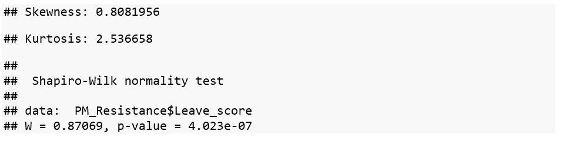

APPENDIX 2: *Analysis of Variance to determine the effect of CPM on squash accession (A)Leave (B) Petiole and (C) Vine*

A



B

C

APPENDIX 3: *Model summary of GLM of severity score and petiole severity scores, including best fit line*

APPENDIX 4: *Model summary of GLM of leave severity score and vine severity scores*

APPENDIX 5: *Model summary of GLM of petiole severity score and vine severity scores*

