DTEN ETHICAL HACKING ESSENTIALS
TASK 1: RECONNAISSANCE & FOOTPRINTING REPORT
Daryl Tech & Educational Network (DTEN) – 2026 Internship
Prepared by: RICHMOND ADDO – DTEN-L297AZBJ
Date: September 2026

1. Executive Summary
This report documents a reconnaissance and footprinting exercise performed against an authorized laboratory target hosted on a Windows machine. The target environment contained an intentionally deployed OWASP Juice Shop application. The assessment was conducted from Kali Linux using Nmap, WhatWeb and cURL. The objective was to identify exposed network ports, running services and web technologies without performing exploitation.

2. Scope and Authorization
The assessment was limited to the user's authorized personal laboratory environment. The target IP address identified during the exercise was 172.20.10.6. Testing was restricted to reconnaissance and service identification of the laboratory host and its intentionally deployed OWASP Juice Shop application.

3. Lab Environment
Component | Description
Attacker | Kali Linux (ASUS PC)
Target | Windows laboratory machine (Lenovo L590 laptop)
Target IP | 172.20.10.6
Web application | OWASP Juice Shop
Web port | TCP/3000

4. Methodology
- Performed an initial TCP port scan with Nmap to identify exposed ports.
- Performed service/version detection with Nmap (-sV).
- Used WhatWeb to identify web application and technology information on TCP/3000.
- Used cURL to retrieve HTTP response headers from the web application.
- Reviewed the results and documented the exposed attack surface and observable security controls.

5. Tools Used
- Nmap – network port and service discovery
- WhatWeb – web technology fingerprinting
- cURL – HTTP header and response inspection
- Kali Linux – assessment platform

6. Port and Service Discovery
Port | Protocol | Observed Service | Security Observation
135 | TCP | Microsoft Windows RPC | Windows RPC service exposed on the laboratory host.
139 | TCP | Microsoft Windows NetBIOS-SSN | NetBIOS/SMB-related service exposed.
445 | TCP | Microsoft Windows SMB | SMB service exposed and should be restricted where unnecessary.
3000 | TCP | HTTP | Web application accessible; identified as OWASP Juice Shop.
3306 | TCP | MySQL | Database service exposed on the laboratory host.
The exposed ports represent the network attack surface observed during reconnaissance. Because this was an authorized lab environment, the findings were documented rather than exploited.

7. Web Application Fingerprinting
WhatWeb was used against http://172.20.10.6:3000. The response returned HTTP 200 OK and identified the page title as 'OWASP Juice Shop'. HTML5 and JavaScript-related information was also observed. This confirmed that TCP/3000 was hosting the intended vulnerable practice application.

8. HTTP Header Enumeration
Header/Result | Observed Value | Interpretation
HTTP status | 200 OK | The web application responded successfully.
Access-Control-Allow-Origin | * | Allows cross-origin requests broadly; configuration should be reviewed in a real deployment.
X-Content-Type-Options | nosniff | Provides protection against MIME-type sniffing.
X-Frame-Options | SAMEORIGIN | Restricts framing by other origins and helps mitigate some clickjacking scenarios.
Feature-Policy | 'self' | Browser feature restrictions were observed.
X-Recruiting | /#/jobs | Application-specific header exposing a recruiting route.
Content-Type | text/html; charset=UTF-8 | The response contains HTML content.
The presence of a header or configuration is not by itself proof of vulnerability. Further testing would be required to determine exploitability or business impact.

9. Security Observations
- Multiple Windows network services were reachable from the assessment host.
- SMB was exposed through TCP/445 and NetBIOS-related functionality through TCP/139.
- A MySQL service was reachable through TCP/3306.
- The OWASP Juice Shop web application was reachable through TCP/3000.
- The HTTP response included several security-related headers, including X-Content-Type-Options and X-Frame-Options.
- Access-Control-Allow-Origin: * was observed and should be reviewed against the application's actual cross-origin requirements in a production environment.

10. Recommendations
- Restrict Windows RPC, NetBIOS and SMB exposure to trusted networks where these services are required.
- Disable unnecessary services and closed unused ports.
- Do not expose database services such as MySQL directly to untrusted networks unless there is a documented requirement and appropriate access controls.
- Use network segmentation and host-based firewall rules to limit access to administrative and database services.
- Review CORS configuration and permit only trusted origins where broad cross-origin access is not required.
- Keep Windows, applications and security software patched and updated.
- Continue security testing in an isolated and authorized lab environment before applying lessons to production systems.

11. Evidence
Figure 1 – Initial Nmap port scan
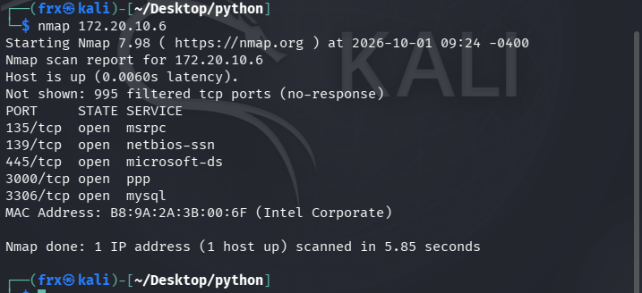

Figure 2 – Nmap service/version detection
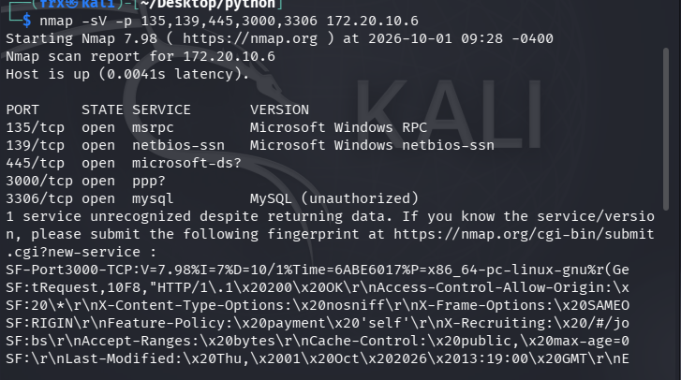
Figure 3 – WhatWeb web technology fingerprinting
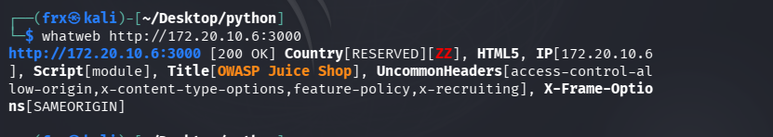

Figure 4 – HTTP header enumeration using cURL
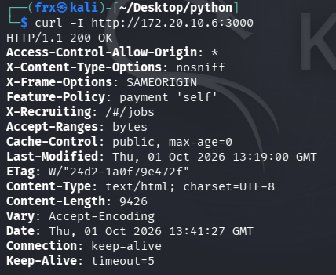
Figure 4: cURL response headers from the OWASP Juice Shop HTTP service.

Figure 5 – OWASP Juice Shop displayed in the browser
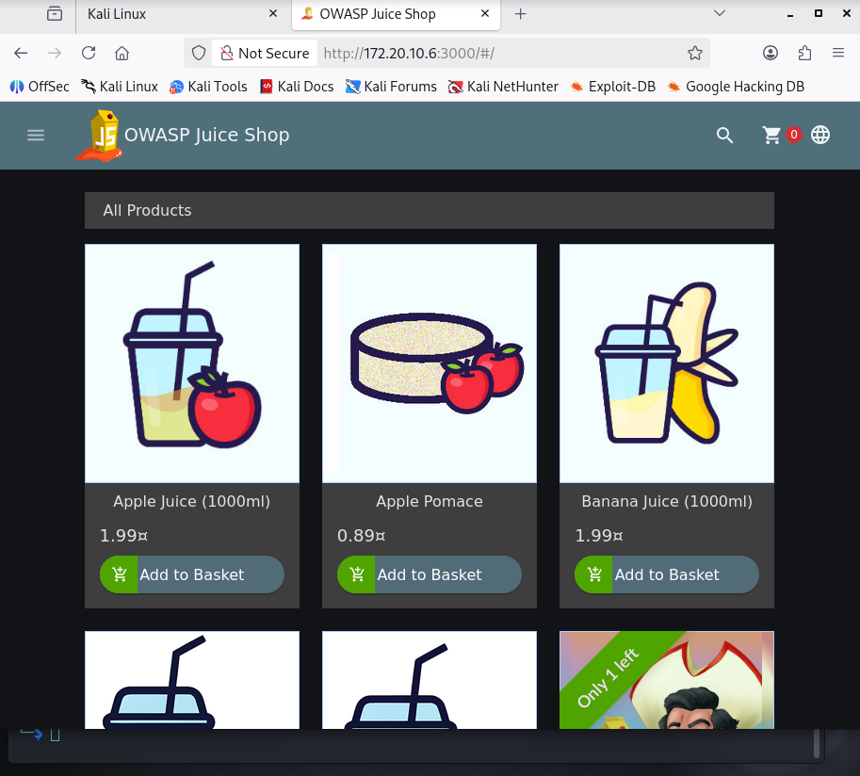

12. Conclusion
The reconnaissance exercise successfully identified the principal network services and technologies exposed by the authorized laboratory target. The assessment confirmed that the host exposed Windows RPC, NetBIOS/SMB, MySQL and an HTTP service hosting OWASP Juice Shop. The findings provide a documented view of the target's attack surface and establish a basis for further controlled security testing in the laboratory.

13. Commands Used
nmap <TARGET_IP>
nmap -sV -p 135,139,445,3000,3306 <TARGET_IP>
whatweb http://<TARGET_IP>:3000
curl -I http://<TARGET_IP>:3000

