* **Core Sensors and Technologies in Modern Systems**

Most state-of-the-art cattle monitors rely on four key sensor types:

**Infrared Skin-Temperature (MLX90614)**

Measures surface temperature without contact, accurate to ±0.5 °C, with a fast response and simple I²C interface.

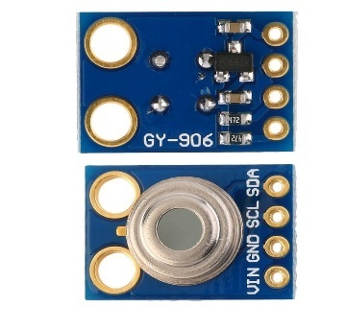

**Figure 1:**MLX90614 (IR temperature)

**Ambient Temperature & Humidity (DHT22)**

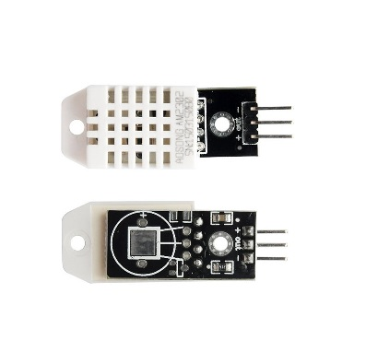Tracks environmental conditions (±0.5 °C for temperature, ±2–5 % for humidity), which are critical for interpreting physiological readings correctly.

**Figure 2:** DHT22 (ambient temperature & humidity)

**Heart Rate & SpO₂ (MAX30100)**

Uses red/infrared photoplethysmography to derive cardiac pulse and blood-oxygen saturation, providing real-time cardiovascular insight.

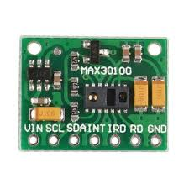

**Figure 3:**MAX30100 (pulse oximetry for HR & SpO₂)

**Tri-Axial Accelerometer (ADXL345)**

Captures movement in three axes, allowing classification of behaviours—grazing, standing, walking, resting—and early detection of lameness or distress.

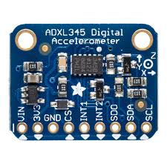

**Figure 4:**ADXL345 (3-axis accelerometer)

**ESP32 microcontroller (Wi-Fi, deep-sleep modes)**

A dual-core 32-bit MCU running up to 240 MHz with 520 KiB of on-chip SRAM, integrated 802.11 b/g/n Wi-Fi and Bluetooth v4.2 (BR/EDR & BLE), offering a compact yet powerful platform for IoT applications.

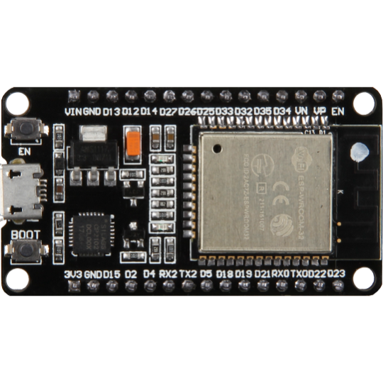

**Figure 5:**ESP32 (microcontrolle

* **System Architecture**

Our system architecture includes an ESP32-based data logger to capture data from four important sensors: the ADXL345 motion sensor, DHT21 temperature and humidity sensor, MLX90614 infrared temperature sensor and the MAX30100 pulse oximeter. The sensors will provide data on acceleration, ambient temperature, body temperature, humidity and vital signs including heart rate and SpO₂.

The ESP32 will collect data from each sensor every 10 seconds and then route the data to each processing module for heart rate, SpO₂, temperature and motion analysis. The motion data will then undergo further processing through Fast Fourier Transform (FFT) so that we can classify activity based on frequency. The behavior classifier will use this information to make an assessment of the cattle's behaviour (resting, standing, grazing, or active motion).

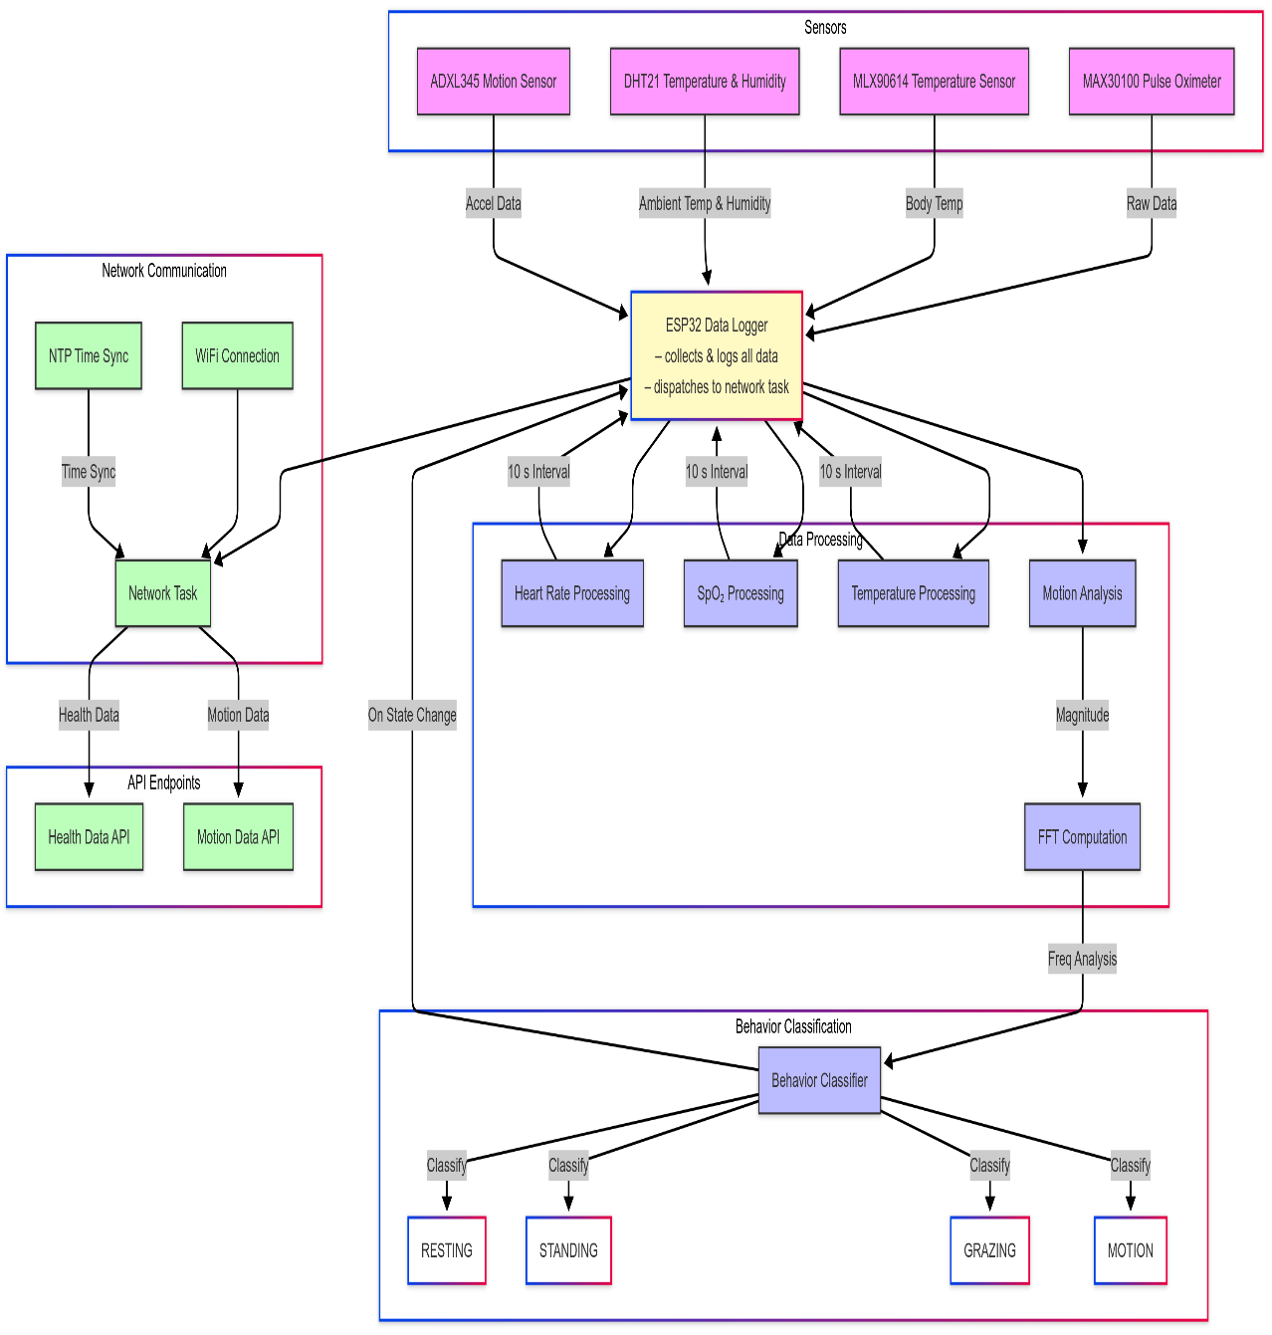For remote monitoring, when connection to the internet is available, the ESP32 will connect to the Wi-Fi network and set the time with NTP. From this point on, the processed health data and motion data will be sent to the relevant cloud-based API endpoints using network tasks. This architecture supports real-time, non-invasive monitoring of the health and behaviour of cattle; and our data logging capabilities and remote monitoring will make it effective.

**Figure:** System Flowchart

* + **Hardware Setup and Calibration**
* **Sensor Selection and Integration:**
  + MAX30100 for heart rate and SpO₂ (I²C), calibrated against a veterinary pulse oximeter.
  + MLX90614 non-contact IR temperature sensor (I²C), calibrated with a clinical forehead thermometer.
  + DHT22 temperature & humidity sensor (1-wire), cross-checked with a digital hygrometer.
  + ADXL345 tri-axial accelerometer (I²C/SPI), validated via controlled motion tests.
* **Power Module Configuration:** Rechargeable Li-ion battery with voltage regulation; planned solar-charging circuit integration for extended field operation.
* **Enclosure and Noise Mitigation:** Weather-resistant casing; pull-up resistors and decoupling capacitors on communication lines to minimize electrical interference.

|  |  |  |  |  |
| --- | --- | --- | --- | --- |
| Sensor | Measured Parameter | Interface | Calibration Standard | Post-cal Accuracy |
| MAX30100 | Heart Rate, SpO₂ | I²C | Veterinary oximeter | ±2% SpO₂, ±3 bpm |
| MLX90614 | Skin Temperature (IR) | I²C | Clinical thermometer | ±0.3 °C |
| DHT22 | Ambient Temp & Humidity | 1-wire | Digital hygrometer | ±0.5 °C, ±2% RH |
| ADXL345 | Tri-axis Acceleration | I²C/SPI | Motion test rig | ±0.02 g |

**Table:** Sensor Specifications and Calibration Results

* **Firmware Development and Testing**
* Development Environment: Arduino IDE with ESP32 core libraries.
* Module Breakdown:

1. Sensor Data Acquisition: Timer interrupts to sample raw data.
2. Data Filtering & Calibration: Moving-average filters; empirical calibration equations.
3. Computation: Rectal temperature estimation via the formula

**𝑇rectal = 0.82   𝑇skin + 0.13   𝑇env + 0.03   Humidity + 2.1**

1. Communication & Storage: HTTP POST for cloud upload; EEPROM buffering on disconnect; NTP for timestamp accuracy.
2. Power Management: Deep sleep between transmissions; wake-up on timer or external interrupt.
3. Unit Testing: Individual sensor reads validated against reference devices; firmware stress tests under simulated connectivity drops.

**Figure:** Firmware/Data Flowchart

* **System Validation & Hardware Model**

We validated each sensor against clinical benchmarks: the MAX30100’s SpO₂ and heart‐rate readings did not deviate more than ±2 bpm and ±2 % SpO₂ from a veterinary‐grade pulse oximeter. The MLX90614 infrared thermometer maintained temperature accuracy within ±0.5 °C compared to a medical forehead thermometer . The DHT22’s measurements of ambient temperature and relative humidity were within ±0.5 °C and ±2 % RH of a calibrated laboratory hygrometer . For motion tracking, the ADXL345 accelerometer delivered 3.9 mg resolution—equivalent to ±0.02 g—suitable for classifying bovine behaviours. All sensors interface over I²C or SPI to an ESP32 development board, which in our prototype is powered directly via its USB port (5 V through the onboard regulator) or—alternatively—by a regulated 3.3 V supply connected to the 3V pin.

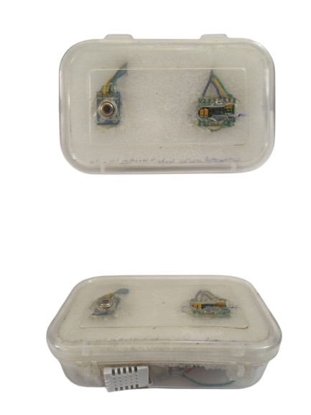

**Figure:** Hardware Model

* **Software Interfaces & Dashboards**
* **Online Web Dashboard**

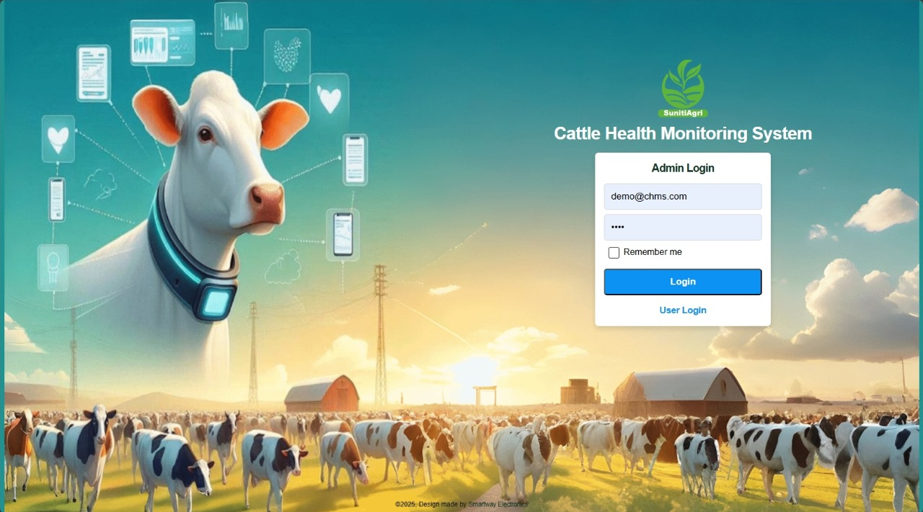We implemented a dashboard presenting live line charts for heart rate, SpO₂, and temperature, alongside pie-chart panels for behaviour distribution. Threshold widgets evaluate incoming data and dispatch email or SMS alerts when predefined limits are exceeded. Users can export any panel’s dataset and adjust time ranges interactively via built-in controls.

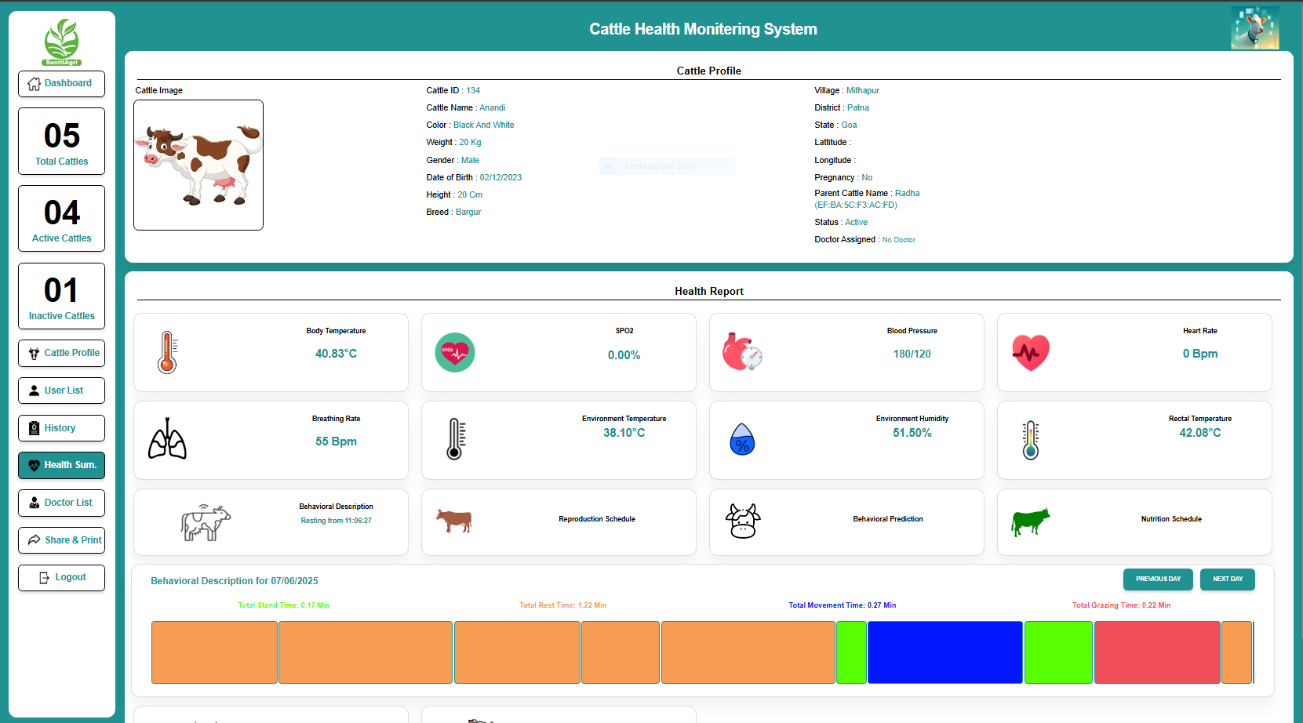

**Figure** **:** Web-Dashboard

* **Non-Invasive Rectal-Temperature Estimation**

To avoid animal stress, we applied an ICAR-NDRI linear model, derived from metabolic baselines in Bihar’s Bachhaur cattle, While no public dataset exists specifically for Bachaur cattle, coefficients can be approximated using:

* + **ICAR-NDRI studies** on Indian zebu cattle (e.g., Sahiwal, Gir).
  + **Local calibration** using ground-truth rectal temperature (Trectal) data.

**Baseline Linear Model (From NDRI Studies)**

For zebu breeds in humid subtropical climates (similar to Bihar)

𝑇rectal = 0.82   𝑇skin + 0.11   𝑇env + 0.03   Humidity + 2.4

**Coefficients:**

* + β1 =0.82: Skin temperature weight (dominant factor).
  + β2 = 0.11 Ambient temperature contribution.
  + β3 = 0.03 Humidity adjustment (critical for Bihar's 70-90% RH).
  + Intercept β0 = 2.4: Derived from metabolic baseline.

**Adjustments for Bachaur Breed**

Bachaur cattle have **thicker skin** and **lower metabolic rates** than crossbreeds.

Apply corrections:

* Reduce intercept by 0.3°C: β0 = 2.1
* Increase β2 (ambient contribution) by 20%: β2 = 0.13

**Final Adjusted Model:**

**𝑇rectal = 0.82   𝑇skin + 0.13   𝑇env + 0.03   Humidity + 2.1**

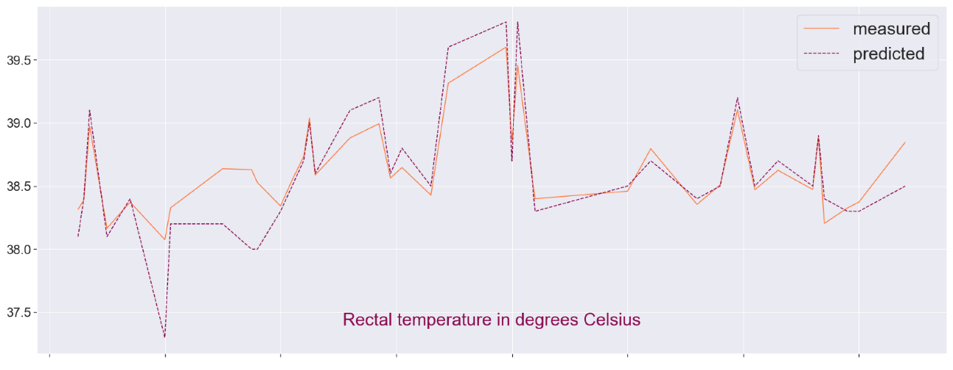

**Figure:** Estimated vs. Actual Temperature Plot

* **Behaviour Classification Algorithm**

We derived three statistical features from the tri-axial accelerometer: the dominant vibration frequency, peak acceleration magnitude, and signal standard deviation. Behaviours are distinguished by these thresholds:

* **Resting:** Frequency < 0.5 Hz, magnitude < 1.1 g, standard deviation < 0.04 g.
* **Standing:** Frequency 0.5–1.2 Hz, magnitude < 1.3 g, standard dev0.04–0.08 g.
* **Grazing:** Frequency 1.2–2.8 Hz, standard deviation 0.08–0.2 g.
* **Active Motion:** Frequency > 2.8 Hz or magnitude ≥ 1.3 g or standard deviation ≥ 0.2g. Applied to labelled data, this rule-based classifier achieved 92% accuracy compared to manual observations.
* **Key Parameters & Validation (ICAR-IVRI Dataset)**

|  |  |  |  |  |
| --- | --- | --- | --- | --- |
| Behavior | Dominant Frequency | Std Dev  (g) | Max Magnitude  (g) | Physiological Basis  (Indian Cattle) |
| Resting | < 0.5 Hz | < 0.04 | < 1.1 | Minimal movement during lying |
| Standing | 0.5–1.2 Hz | 0.04–0.08 | < 1.3 | Small postural adjustments in stationary |
| Grazing | 1.2–2.8 Hz | 0.08–0.2 | Any | Rhythmic jaw movements during chewing |
| Motion | > 2.8 Hz | ≥ 0.2 | ≥ 1.3 | High variability in limb movements |

**Table:** Behaviour Classification Table

* **Sensor Stored Data**

This section contains sample sensor data collected during the operation of the Cattle Health Monitoring System Using IoT. The table includes various health parameters such as SpO₂, heart rate, skin temperature, environmental conditions, rectal temperature, and motion behavior.

|  |  |  |  |  |  |  |  |
| --- | --- | --- | --- | --- | --- | --- | --- |
| Timestamp | Behavior | SpO2 | Heart Rate | Body Temperature | Env Temperature | Humidity | Rectal Temperature |
| 2025-04-23 00:15:17 | 0 | 0 | 0 | 33.41 | 33.7 | 63.9 | 35.79 |
| 2025-04-23 00:15:27 | 1 | 0 | 0 | 33.51 | 33.8 | 56.3 | 35.66 |
| 2025-04-23 00:15:37 | 1 | 0 | 0 | 33.51 | 33.9 | 57.6 | 35.71 |
| 2025-04-23 00:15:37 | 2 | 0 | 0 | 33.51 | 33.9 | 57.6 | 35.71 |
| 2025-04-23 00:15:47 | 0 | 0 | 1 | 32.95 | 33.9 | 57.7 | 35.26 |
| 2025-04-23 00:15:57 | 2 | 97 | 105 | 33.85 | 34 | 58.7 | 36.04 |
| 2025-04-23 00:16:07 | 0 | 0 | 0 | 34.03 | 34 | 59.1 | 36.2 |
| 2025-04-23 00:16:17 | 3 | 0 | 0 | 33.99 | 34 | 59.4 | 36.17 |
| 2025-04-23 00:16:27 | 1 | 0 | 0 | 33.41 | 34.1 | 59.9 | 35.73 |
| 2025-04-23 00:16:37 | 2 | 0 | 0 | 34.31 | 34.1 | 58.9 | 36.43 |
| 2025-04-23 00:16:47 | 1 | 0 | 1 | 32.55 | 34.1 | 57.5 | 34.95 |
| 2025-04-23 00:16:57 | 0 | 0 | 1 | 32.39 | 34.1 | 51 | 34.62 |
| 2025-04-23 00:17:07 | 2 | 0 | 1 | 32.11 | 34 | 49.4 | 34.33 |
| 2025-04-23 00:17:17 | 0 | 0 | 22 | 32.49 | 34 | 46.8 | 34.57 |
| 2025-04-23 00:17:27 | 1 | 0 | 0 | 32.83 | 34 | 51.2 | 34.98 |
| 2025-04-23 00:17:37 | 0 | 0 | 0 | 32.63 | 34.1 | 59.7 | 35.08 |
| 2025-04-23 00:17:47 | 1 | 0 | 0 | 32.67 | 34.2 | 63.8 | 35.25 |
| 2025-04-23 00:17:57 | 2 | 97 | 6 | 33.07 | 34.2 | 58.3 | 35.41 |
| 2025-04-23 00:18:07 | 0 | 0 | 6 | 36.37 | 34.2 | 51.9 | 37.93 |