**Department of Computer Engineering Academic Term: First Term 2023-24**

**Class: T.E /Computer Sem – V / Software Engineering**

| **Practical No:** | **5** |
| --- | --- |
| **Title:** | **Estimating project cost using COCOMO Model** |
| **Date of Performance:** | 31-08-2022 |
| **Roll No:** | 9595 |
| **Team Members:** | Atharva Dalvi |

**Rubrics for Evaluation:**

| **Sr. No** | **Performance Indicator** | **Excellent** | **Good** | **Below Average** | **Total Score** |
| --- | --- | --- | --- | --- | --- |
| 1 | On time Completion & Submission (01) | 01 (On  Time ) | NA | 00 (Not on Time) |  |
| 2 | Theory Understanding(02) | 02(Correct  ) | NA | 01 (Tried) |  |
| 3 | Content Quality (03) | 03(All used) | 02 (Partial) | 01 (rarely followed) |  |
| 4 | Post Lab Questions (04) | 04(done well) | 3 (Partially Correct) | 2(submitted) |  |

**Signature of the Teacher:**

**Department of Computer Engineering Academic Term: First Term 2022-23**

**Class: T.E /Computer Sem – V / Software Engineering**

**Signature of the Teacher:**

## EXPERIMENT NO. 3

**COST ESTIMATION USING COCOMO MODEL**

### Aim

To estimate project cost using COCOMO Model for Placement Predictor.

### Description

The table for constants for **Basic COCOMO mode**l is as follows:

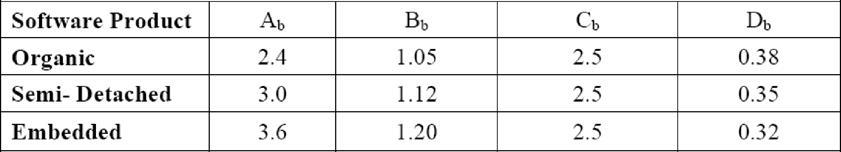

E = a(KLOC)b

Function Point of project : 78.1 for average LOC/FP for Java : 63 LOC = 63 x 78.1 = 4920

KLOC = 4920/1000 = 4.920

Software Project is taken to be **Organic** type taking values of a = 2.4 and b = 1.05

substituting all values in the equation E = 2.4(4.920)1.05

= 2.4 x 5.327

= 12.784

### Effort for basic COCOMO model = 12.784

D(Time) = c(E)d

= 2.5 x (12.784)0.38

= 2.5 x 2.63

## D = 6.575

**Average Staff Size : E/T = 12.784/6.575 = 2**

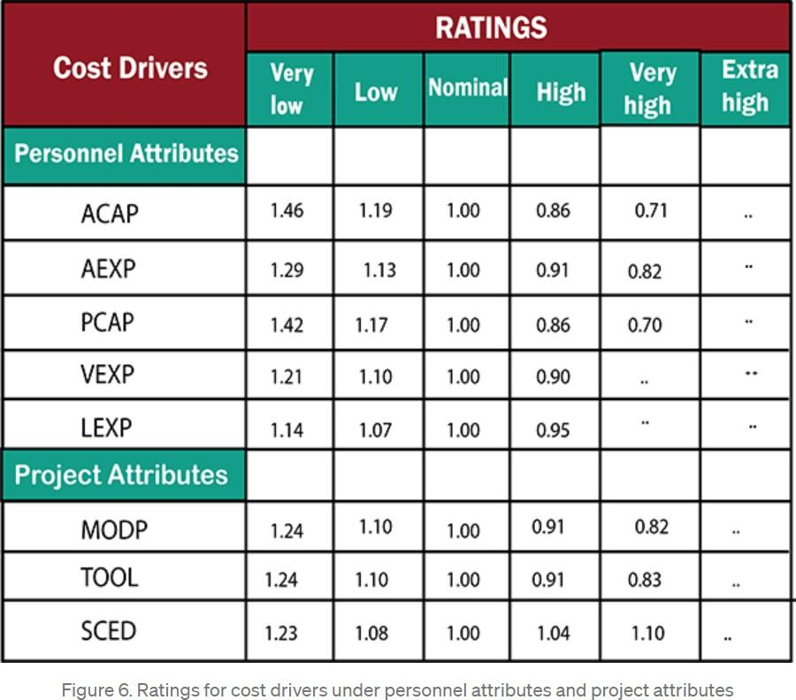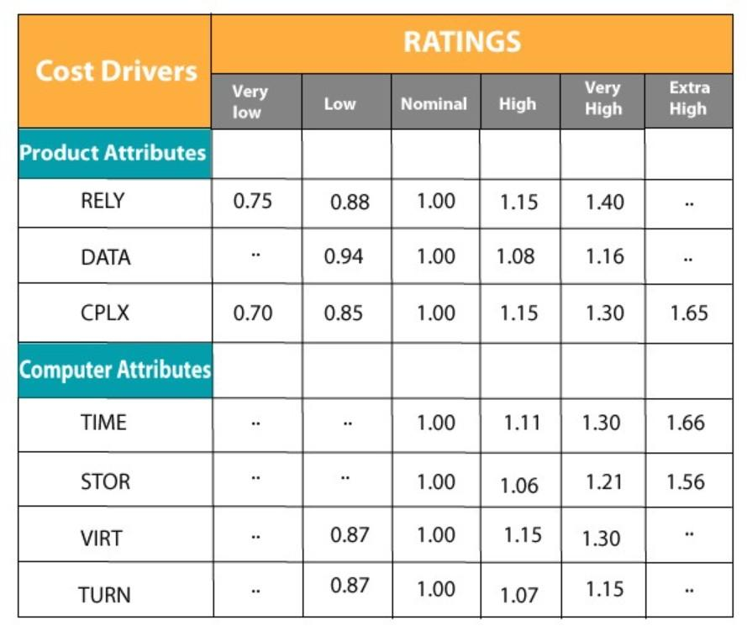

# For intermediate COCOMO model

E = a(KLOC)b * (EAF) COST DRIVERS:

Personal attributes:

Analyst Capability (ACAP) , Low = 1.19 Application Experience (AEXP), Nominal = 1.00

Software Engineering capability (PCAP), Low = 1.17 Experience using VM (VEXP), Nominal = 1.00 Programming language experience (LEXP), High = 0.95

Project attributes:

Applications of Software Eng Methods (MODP), Nominal = 1.00 Applications of Software Tools (TOOL), High = 0.91

Required Development Schedule (SCED), Nominal = 1.00

Product attributes:

Required Software reliability (RELY), HIgh= 1.15 Database size (DATA), High = 1.08

Product Complexity (CPLX), Very High = 1.30

Computer attributes:

Execution time constraints (TIME), High = 1.11 Main storage constraints (STOR), High = 1.06 Virtual Machine Volatility (VIRT), Nominal = 1.00 Required turnaround time (TURN), High = 1.07

### Calculating EAF:

EAF = ACAP x AEXP x PCAP x VEXP x LEXP x MODP x TOOL x SCED x RELY x DATA x CPLX x TIME x STOR x VIRT x TURN)

= 1.19 x 1.00 x 1.17 x 1.00 x 0.95 x 1.00 x 0.91 x 1.00 x 1.15 x 1.08 x 1.30 x 1.11

x 1.06 x 1.00 x 1.07

## EAF =2.446

### Calculating E:

substituting values in the equation:

E = 12.784 x 2.446

## E = 31.269

### Effort for intermediate COCOMO model = 31.269

**Time Required:**

D=c(E)d

D= 2.5(31.269)0.38

## D= 9.24

**Average Staff Size : E/T = 31.269/9.24 = 3**

# For Detailed COCOMO model:

Ep = μp * E DP = τP * D

It is a **Organic small** model

For Plan and Requirements: Ep = 0.06 x 31.269 = **1.876**

DP = 0.10 x 9.24 = **0.924**

For System Design:

Ep = 0.16 x 31.269 = **5.003**

DP =0.19 x 9.24 = **1.755**

For Detailed Design:

Ep = 0.26 x 31.269 = **8.129**

DP =0.24 x 9.24 = **2.217**

For Module Code and Test: Ep = 0.42 x 31.269 = **13.132**

DP =0.39 x 9.24 = **3.603**

For Integration and Test: Ep = 0.16 x 31.269 = **5.003**

DP =0.18 x 9.24 = **1.663**