

A Project Report on

“**Scrap-Up**”

Submitted By: -

Anish Karlekar 204550307031

Adnan Kureshi 204550307049

Harsh Vyas 204550307006

Jay Sangani 204550307014

Under The Guidance Of Guide :-

Mrs. Richa Bhadauria.

***In partial fulfillment for the award of the degree***

***Of***

DIPLOMA ENGINEERING

IN

COMPUTER ENGINEERING



Gujarat Technological University, Ahmedabad

2021-2022

C:\Users\UI_1\AppData\Local\Microsoft\Windows\INetCache\Content.Word\clg logo.png

DEPARTMENT OF COMPUTER ENGINEERING

**CERTIFICATE**

This is to certify that the Project entitled “ScrapUp” has been carried out by Anish Karlekar bearing Enrollment Number 204550307031 under my guidance in the fulfillment for the degree of Diploma Engineering in Computer Engineering, 5th Semester of Gujarat Technological University, Ahmedabad during the academic year 2022-23.

Date:

Place:

Prof. Richa Bhadauria

**Internal Guide Head of the Department**

C:\Users\UI_1\AppData\Local\Microsoft\Windows\INetCache\Content.Word\clg logo.png

DEPARTMENT OF COMPUTER ENGINEERING

**CERTIFICATE**

This is to certify that the Project entitled “ScrapUp” has been carried out by Harsh Vyas bearing Enrollment Number 204550307006 under my guidance in the fulfillment for the degree of Diploma Engineering in Computer Engineering, 5th Semester of Gujarat Technological University, Ahmedabad during the academic year 2022-23.

Date:

Place:

Prof. Richa Bhadauria

**Internal Guide Head of the Department**

C:\Users\UI_1\AppData\Local\Microsoft\Windows\INetCache\Content.Word\clg logo.png

DEPARTMENT OF COMPUTER ENGINEERING

**CERTIFICATE**

This is to certify that the Project entitled “ScrapUp” has been carried out by Adnan Kureshi bearing Enrollment Number 204550307049 under my guidance in the fulfillment for the degree of Diploma Engineering in Computer Engineering, 5th Semester of Gujarat Technological University, Ahmedabad during the academic year 2022-23.

Date:

Place:

Prof. Richa Bhadauria

**Internal Guide Head of the Department**

C:\Users\UI_1\AppData\Local\Microsoft\Windows\INetCache\Content.Word\clg logo.png

DEPARTMENT OF COMPUTER ENGINEERING

**CERTIFICATE**

This is to certify that the Project entitled “ScrapUp” has been carried out by Jay Sangani bearing Enrollment Number 204550307014 under my guidance in the fulfillment for the degree of Diploma Engineering in Computer Engineering, 5th Semester of Gujarat Technological University, Ahmedabad during the academic year 2022-23.

Date:

Place:

Prof. Richa Bhadauria

**Internal Guide Head of the Department**

INDEX

TOPICS PAGE NO.

INDEX

LIST OF TABLES

LIST OF FIGURES

ACKNOWLEDGEMENT

ABSTRACT

CHAPTER 1: INTRODUCTION

1.1 Problem Summary

1.2 Aim and Objectives of the project

1.3 Problem Specification

1.4 Brief Prior Art Search or Case Study

1.5 Plan of your work

1.6 Materials or Tool requirement

1.6.1 Hardware Requirement

1.6.2 Software requirement

CHAPTER 2: SYSTEM ANALYSIS

2.1 Study of existing system

2.2 Proposed system

2.2.1 Roles and responsibility of each modules

2.3 Advantages of the purpose system

2.4 Feasibility study

2.5 Requirements of New system

2.5.1 User Requirements

2.5.2 System Requirements

2.5.3 Functional Requirements

2.5.4 Non-functional Requirements

CHAPTER 3: SYSTEM DESIGN

3.1 Use Case diagram

3.2 Database design

3.2.1 Entity-Relationship diagram

3.2.2 Data dictionary

3.3 Activity diagram

3.4 Sequence diagram

CHAPTER 4: SYSTEM IMPLEMENTATION

4.1 Architectural design

4.2 Development frame

CHAPTER 5: SUMMARY

REFERENCES

LIST OF TABLES

LIST OF FIGURES

**ACKNOWLEDGEMENT**

We have taken efforts in this project. However, it would not have been possible without the kind support and help of many individuals and organizations. We would like to extend our sincere thanks to all of them. It is our privilege to express our sincerest regards to our project coordinator, Mrs. Richa Bhadauria, for their valuable inputs, able guidance, encouragement, whole-hearted cooperation and constructive criticism throughout the duration of our project.

We deeply express our sincere thanks to our Head of Department Mr. for encouraging and allowing us to present the project. We take this opportunity to thank all our friends and colleagues who started us out on the topic and provided extremely useful review feedback and for their all-time support and help in each and every aspect of the course of our project preparation. We are grateful to our college Apollo Institute of Engineering and Technology, for providing us all required resources and good working environment.

**ABSTRACT**

Our website name is ”ScrapUp”. ScrapUp is an ecommerce resell platform focused on reducing the quantity of waste products or unrequired products by successfully promoting recycling of products no longer required for their prior use or by prior user.

We promote creativity, art and innovation through our special creator module which focuses on making sustainable products from unrequired products which can be reused for an entirely new purpose or for same purpose with better results. During which generating new employment opportunities and saving our home planet.

* 1. **PROBLEM SUMMARY**

When someone wants to resell or recycle their products, the one who requires it or values it is hard to find, which leads to wastage of products and rising needs of those same products.

* 1. **AIM AND OBJECTIVES OF THE PROJECT**

We aim on finding buyers for sellers and vice versa, during which recycling products and providing employment via our special creator module.

* 1. **PROBLEM SPECIFICATIONS**

People get rid from there unwanted items by throwing them as waste, because they simply cannot find buyers for them. Some creators who can create better from worse remain unemployed due to lack of opportunities.

* 1. **BRIEF PRIOR RESEARCH OR CASE STUDY**

E-Bay: Unnecessary products are sold at high price due to bidding.

OLX: Only provides platform for selling old products.

Amazon: Only provides platform for selling new products and refurbished products only.

* 1. **PLAN OF THE PROJECT**

There are many factors to consider when it comes to composing a proper work plan ― goals, strategy, objectives, tactics, responsibilities, etc.

**TIMELINE DIAGRAM**

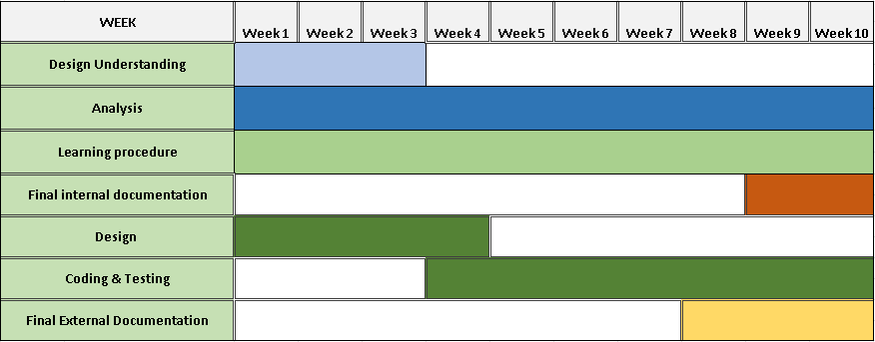

* 1. **MATERIALS OR TOOLS REQUIRED**

The basic requirement for developing website is shown below:

1.6.1 Hardware requirements

RAM: minimum 4 GB

Processor: Intel i3 2nd gen/ AMD Ryzen 3200u or better

OS: Windows Xp (Equivalent) or better

1.6.2 Software requirements:

Frontend: a. CSS

b. HTML

c. JavaScript

d. Bootstrap

Back-end:

a. MY SQL

b. PHP

**2.1 STUDY OF EXISTING SYSTEM**

There are number of resell websites and e-commerce websites which sell products but they do not give special privileges of employment to creators who work hard and make an existing product better, there are some websites owned by creators to showcase their own products where one cannot sell their individual product.

**2.2 PURPOSE OF THE SYSTEM**

The driving force behind our project is our purpose to save earth from pollution caused due to waste products in the meantime providing employment to the creators.

**2.2.1 ROLES AND RESPONSIBILITIES OF MODULES**

The overall project module is divided into three parts. They are as shown below:

* Admin
* Buyer/Seller
* Creator

**2.2.1.1 ROLES OF ADMIN**

* Registration
* Login
* Manage Buyer/Seller
* Manage Creator
* Manage Category
* Manage Products
* Manage Orders
* Manage Payments
* Manage Deliveries
* Logout

**2.1.1.2 ROLES OF BUYERS/SELLERS**

* Registration
* Login
* Manage profile
* Sell/Buy Product
* Edit Products
* Remove Product
* Track Order
* Logout

**2.2.1.3 ROLES OF VISITOR**

* Registration
* Login
* Manage Creator profile
* Manage Creator portfolio
* Sell/Buy Product
* Edit Products
* Remove Product
* Track Order
* Logout

**2.3 ADVANTAGE OF THE PROPOSED SYSTEM**

* Sustainable and eco-friendly products/services at affordable cost.
* Creating dignified employment for underprivileged skilled artisans.
* Contribute in waste management of India.
* Ethically handcrafted products at best prices.
* Enables the creators to give this creativity & innovation a shape, a platform.

**2.4 FEASIBILITY STUDY**

* Feasibility study is the study of to system to check whether the system made is feasible or not. It is very useful to check whether the system work as per the requirement or not.
* Feasibility study is highly dependent on the type of developer, the end-user and the application on other hand.

**2.5 REQUIREMENTS OF NEW SYSTEM**

* The purpose of the system is to develop website that can help and reduce the search of buyers for the products and providing creators a easy to access platform.

**2.5.1 USER REQUIREMENTS**

* Recyclable products and eco-friendly handcrafted products to sell.

**2.5.2 FUNCTIONAL REQUIREMENTS**

These are the requirements that the end user specifically demands as basic facilities that the system should offer. All these functionalities need to be necessarily incorporated into the system as a part of the contract.

* Password Hashing
* Payment Interface
* Secure Database
* Mobile-Friendliness
* Ease of access
* Payment History
* Filters
* Grand Total Calculator

**2.5.4 NON-FUNCTIONAL REQUIREMENTS**

* Non-functional requirements describe how the system works. A non-functional requirement is a requirement that specifies criteria that can be used to judge the operation of a system, rather than specific behaviors.

1. **SECURITY:**

* Only authorized person can view and modify confidential details.
* Each user has his/her own access rights and lower level user here have restrictions of using some of the system components.
* One user can’t access other user’s account or information.

1. **PRIVACY:**

* Any person will be not able to change or modify information from application. It is only altered by admin.

1. **SCALABILITY:**

* Performance of the system should not be degraded when many customers are logged in and accessing the database at the same time.
* The system must be scalable enough to be able to add any additional functionality even after the project is developed once.

1. **RELIABILITY:**

* The database of various modules like users, Arts maintained by system should be correct maintained up to date.

**3.1 USE CASE DIAGRAM**

In the Unified Modeling Language (UML), a use case diagram can summarize the details of your system's users (also known as actors) and their interactions with the system. To build one, you'll use a set of specialized symbols and connectors. An effective use case diagram can help your team discuss and represent:

* Scenarios in which your system or application interacts with people, organizations, or external systems
* Goals that your system or application helps those entities (known as actors) achieve
* Use case defines the scope of your system.

Fig: Use Case Diagram Symbols

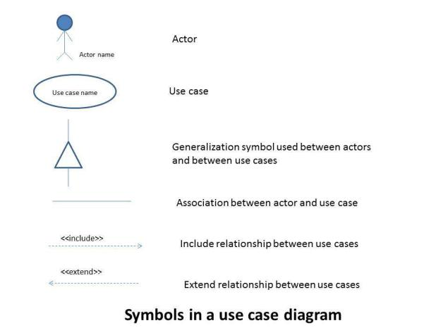

**USE CASE DIAGRAM COMPONENTS**

* **Actors:** The users that interact with a system. An actor can be a person, an organization, or an outside system that interacts with your application or system. They must be external objects that produce or consume data.
* **System:** A specific sequence of actions and interactions between actors and the system. A system may also be referred to as a scenario.
* **Goals:** The end result of most use cases. A successful diagram should describe the activities and variants used to reach the goal.

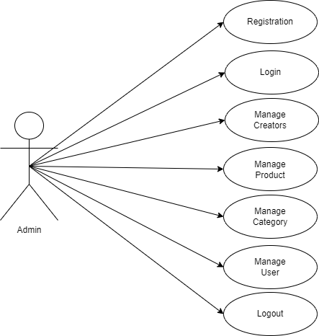

**Fig:Admin Use Case**

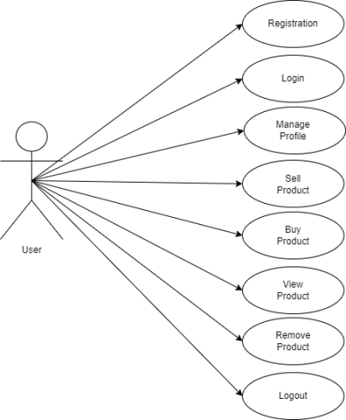

**Fig: User Use Case**

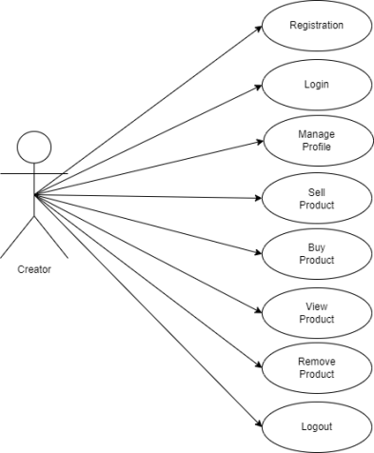

**Fig: Creator Use Case**

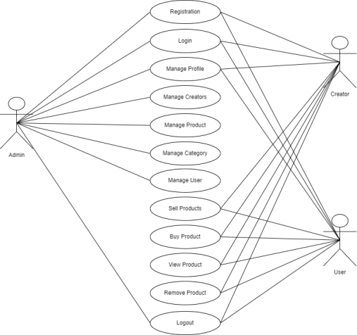

**Fig: System Use Case**

* 1. DATABASE DESIGN

Database design is the process of producing a detailed data model of the database. This data model contains all the needed logical and physical design choices and physical storage parameters needed to generate a design in a data definition language, which can be used to create a database.

The main objectives of database deigning are to produce logical and physical designs model of the proposed database system. . The logical model concentrates on the data requirements and the data to be stored independent of physical considerations. It does not concern itself with how the data will be stored or where it will be stored physically.

The physical data design model involves translating the logical design of the database onto physical media using hardware resources and software systems such as database management systems (DBMS).

3.2.2.1 Feature of Data Dictionary

The volume of data in most information system is substantial more than a single analyst can easily keep track of the same. When the teams of analyst work on assistance the task of co-coordinating data definition becomes more complex.

Individual depends on the information provided by others with their assumption and the specification made by them.

Data dictionary is integral component of structured analysis. Since dataflow diagram by them do not fully describe the subject of the investigation. The data dictionary provides additional information about system.

ACTIVITY DIAGRAM

Activity diagram is another important behavioral diagram in UML diagram to describe dynamic aspects of the system. Activity diagram is essentially an advanced version of flow chart that modeling the flow from one activity to another activity.

Activity Diagrams describe how activities are coordinated to provide a service which can be at different levels of abstraction. Typically, an event needs to be achieved by some operations, particularly where the operation is intended to achieve a number of different things that require coordination, or how the events in a single use case relate to one another, in particular, use cases where activities may overlap and require coordination. It is also suitable for modeling how a collection of use cases coordinate to represent business workflows

Identify candidate use cases, through the examination of business workflows

Identify pre- and post-conditions (the context) for use cases

Model workflows between/within use cases

Model complex workflows in operations on objects

Model in detail complex activities in a high level activity Diagram

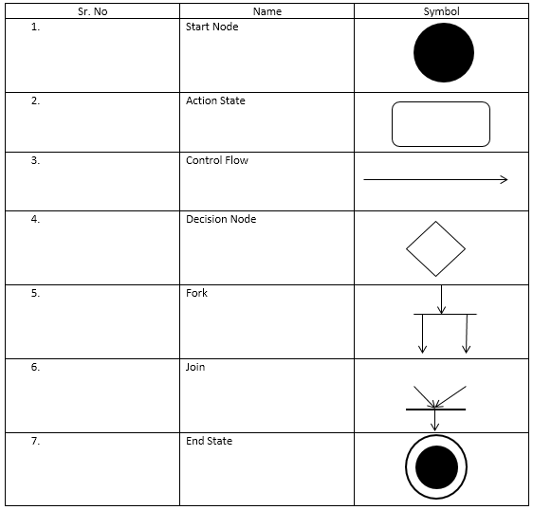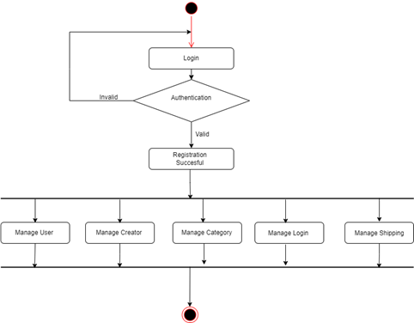

Fig: Activity Diagram for Admin

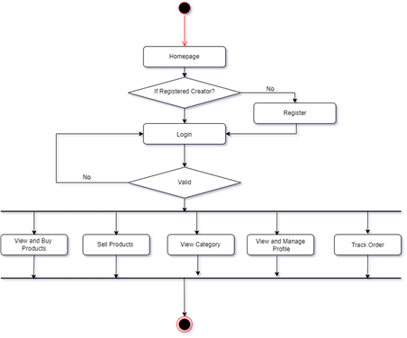

Fig: Activity Diagram for Creator

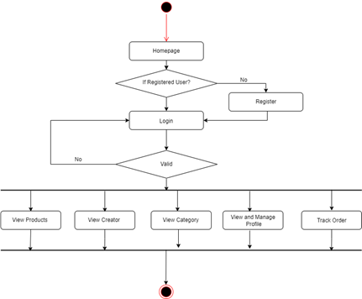

Fig: Activity Diagram for Buyer/Seller

* 1. **SEQUENCE DIAGRAM**

Sequence Diagrams – A sequence diagram simply depicts interaction between objects in a sequential order i.e. the order in which these interactions take place. We can also use the terms event diagrams or event scenarios to refer to a sequence diagram. Sequence diagrams describe how and in what order the objects in a system function. These diagrams are widely used by businessmen and software developers to document and understand requirements for new and existing systems.

**Uses of sequence diagrams:**

* Used to model and visualize the logic behind a sophisticated function, operation or procedure.
* They are also used to show details of UML use case diagrams.
* Used to understand the detailed functionality of current or future systems.
* Visualize how messages and tasks move between objects or components in a system.

## **2.3 Process Model**

Iterative process starts with a simple implementation of a subset of the software requirements and iteratively enhances the evolving versions until the full system is implemented. At each iteration , design modifications are made and new functional capabilities are added. The basic idea behind this method is to develop a system through repeated cycles (iterative) and in smaller portions at a time (incremental).

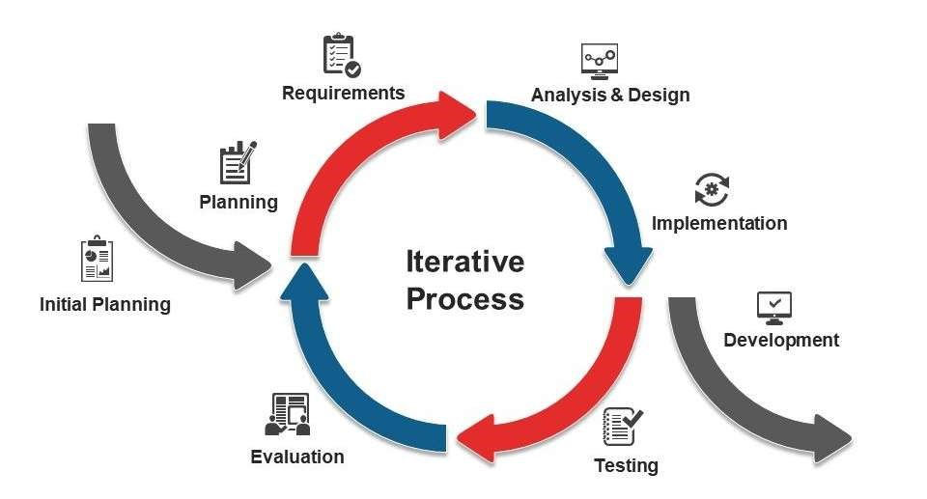

Fig 2.3.1 Iterative Process Model

Consider an iterative life cycle model which consists of repeating the following four phases in sequence: Requirements Phase: In the requirements phase of software development, the system related information is gathered and analyzed. The collected requirements are then planned accordingly for developing the system.

Design Phase: In the Design phase, the software solution is prepared to meet the necessities for the design. The system design may be a new one or the extension of a previous build one. Implementation and Test: In the implementation as well as a test phase, the system is developed by coding and building the user interface and modules which is then incorporated and tested.

Review Phase: The review phase is where the software is estimated and checked as per the current requirement. Then, further requirements are reviewed, discussed and reviewed to propose for an update in the next iteration. Iterative model is used in the following purposes:

* Here, the system requirements can be classified and understood.
* Primary necessities of the system can be defined; at the same time, some system's working can be improved with the development process.
* If a new technology needs prior understanding, this model can be helpful to know the latest technology and increment or update the model accordingly.
* This model is also useful when there are high risks in the system characteristic and goals.
* Situations where resources with required skill sets are not accessible, and the system needs to be developed on a contract basis, choosing this model is a suitable decision. Advantages of Iterative Model
* Produces working system rapidly and before time throughout the software development life

cycle

* Provides more and more flexible and enhance based on requirements.
* Simple to test as well as repair as small iteration.

**4.2 DEVELOPMENT FRAMEWORK**

**PHP:**

* PHP personal Home Page
* PHP is an acronym for "PHP: **Hypertext Preprocessor"**
* PHP invent in 1994 by Rasmus Lerdorf.
* PHP is a widely-used, open-source server-side scripting language
* PHP can generate dynamic page content.
* PHP is a powerful tool for making dynamic and interactive Web pages.
* PHP scripts are executed on the server.
* PHP is free to download and use.
* PHP files can contain text, HTML, CSS, JavaScript, and PHP code.
* PHP files have extension ".php".

**What is new in PHP 7 ?**

* PHP 7 is much faster than the previous popular stable release (PHP 5.6).
* PHP 7 has improved Error Handling.
* PHP 7 supports stricter Type Declarations for function arguments.
* PHP 7 supports new operators (like the spaceship operator: <=>)

**2) PHP features?**

* Simple
* Interpreted
* Faster
* Open Source
* Platform Independent
* Case Sensitive
* Speed Comparison of ASP PHP JSP
* Simplicity
* More frameworks & CMS