Assignment 1 Report

Aditya Sharma

PROG10004

September 25th, 2022

Part 1: Program Inception

This is python based text game which allows player to experience adventures of harry potter world. In this game one can relive the Thrilling fights in harry potter by entering many different kind of spells.

**BACKGROUND STORY**

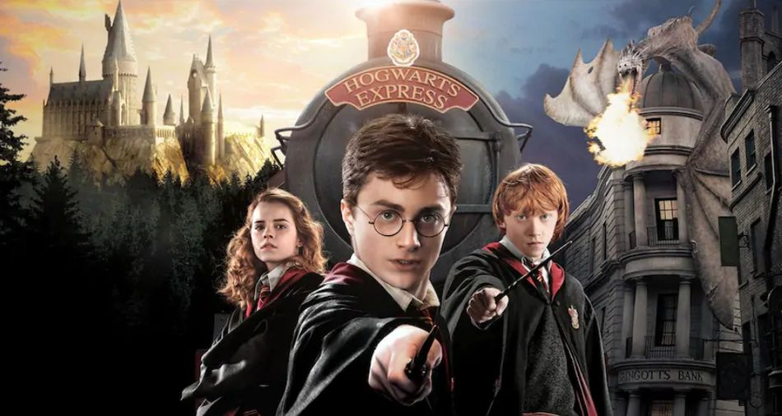

Harry potter is a seven series fiction novel written by J.K.Rowling. The novels chronicle the lives of a young wizard, Harry Potter, and his friends Hermoine Granger and Ron Weasly. The main story arc concerns Harry's struggle against Lord Voldemort, Dark Wizard who intends to become immortal, overthrow the wizard governing body known as the ministry of magic and subjugate all wizards and muggles.

**Characters**

* Harry potter
* Hermoine
* Draco Malfoy
* Albus
* Rupert
* Rubeus

**The gameplay rules:**

1. After rolling dice You can choose the characters from character list only
2. This game consists of 2 types of difficulty that the player can choose accordingly
3. It also consists of many spells that player can use to defeat the enemy and all the spells should be used according to difficulty.
4. **FOR EASY** mode you get to choose spells between Bat-Bogey Hex, Incarcerou , Confringo , Bombarda , Expulso , Petrificus Totalus , Levicorpus ,Rictusempra, Sectumsempra, Stupefy, Enneverate, Episkey, Rennervate, Expelliarmus, Enneverate, Episkey, Liberacorpus,
5. **FOR DIFFICULT** you can choose spells from Bat-Bogey Hex, Incarcerous , Confringo, Bombarda, Expulso, Petrificus Totalus, Levicorpus , Rictusempra , Sectumsempra , Stupefy, Enneverate, Episkey, Liberacorpus, Rennervate, Expelliarmus, Impedimenta, Langlock, Protego, Imperio, Crucio, Avada-Kedavara
6. **TO ATTACK** spells that you can use are Bat-Bogey Hex, Incarcerous, Confringo, Bombarda, Expulso, Petrificus Totalus, Levicorpus,Rictusempra , Sectumsempra, Stupefy.
7. In this game you can also use **HEALING SPELLS** to heal your character. Healing spells you can use are Enneverate , Episkey, Liberacorpus, Rennervate.
8. In some conditions when your player is dealing with heavy damage done. Player can also use defensive spells Expelliarmus, Impedimenta , Langlock, Protego.
9. Player can also use **UNFORGIVABLE CURSES** in the middle of the game. But do **NOTE** that in some modes enemy can also use unforgivable curses.

**(IF SOMEONE IS NEW TO HARRY POTTER AND DOESN’T KNOW ALL THE SPELLS THEY CAN USE SIMPLE STEPS FROM BELOW)**

1. Enter any key from 1 to 10 for Attack spells

['Bat-Bogey Hex', 'Incarcerous', 'Confringo', 'Bombarda', 'Expulso', Totalus', 'Levicorpus', 'Rictusempra', 'Sectumsempra', 'Stupefy'] 'Petrificus

1. Press any key from A,B,C,D to heal yourself.

['Enneverate', 'Episkey', 'Liberacorpus', 'Rennervate']

1. Press any key from E,F,G,H to protect/shield yourself.

['Expelliarmus', 'Impedimenta', 'Langlock', 'Protego']

1. Each key contains a different spell. So don't be afraid to press different keys.

IF someone tries to use the spell and the spelling is wrong the game wont detect the spell. Try to use spells according to difficulty for example if player in playing in easy mode and try to use a spell from hard mode then the spell wont work.

Win/Lose Criteria:

Part 2: Program Structure

There are total 10 files, six of which are the character files, an “Application” file and a “Game” file. The purpose and content of each file will be demonstrated below:

* Two files “dice.py” and “ report for_(dice_game_assignment).docx”:
* Six character file “Albus.py”, “Harry.py”, “rubeus.py”, “Hermoine.py”, “Dracomalfoy.py” and “rupert.py”:
* “App.py”: This file contains all the inputs and print(import not working for this file).
* “Game.py”: This folder contains the main part of the game with all the inputs and spells.

 This Python based text adventure game has been in my mind since my high school and I wanted to make this game in c++ but Python is more suitable at it is more user friendly than other languages. This game is based in Harry potter world which is my favorite novel/movie series. This novel/movie by J.K.Rowling inspired me to make a game of my own where a user can enter spells from a book like in the movie and can do damage to enemy and likewise.

My favorite part of the game was deciding the spells and how to use them so it can damage the enemy and enemy can also fight back. Once this part was clear to me the other difficulty, I faced was deciding the character, So I chose my top 6 favorite character form the series. Once this part was completed I moved on to dice roll, in this I wanted to go for a different approach I wanted to actually display the dice in terminal but this was not clear to me because I have very less experience in python so I searched many youtube tutorials on how to print a dice roll (<https://youtu.be/FW4Of6o_k28> )this video was able to clear many of my doubts but best possible way I could think to print dice was using “0” and “-“ to make a shape of dice this was very time consuming but after I got the gist of it was pretty easy and results were also convincing. Then I proceeded to make a welcome text where I wanted to try out something fancy so I used a online text converter(<https://www.texttool.com/ascii-font#p=display&f=Graffiti&t=Type%20Something%20> ) to create fancy text which welcomes the player to game and makes it more intriguing, this text convertor converts text into a ascii art. Managing the spell and classifying them were very time consuming I had to create different variables which were comp_spells_easy, comp_spells_hard, attack_spells, healing_spells, defense_spells, unforgivable_curses and for enemy and player health were user_health and comp_spell.

This is the part where it got very confusing and rough for me I wanted to make player interactions and fights with enemy more fun so I used the variables I made to decrease and increase the health of enemy as well as player this part was lengthy but after I was able to run few tests some of which were not perfect, But after fixing some errors all the statements were working fine. IF and ELSE statements were extensively used in the programming of this game. Main problem where I faced the issue was that I wanted this game to look more graphically pleasing and smooth and wanted to add many more ideas of my own such as adding text to speech option, which when tried was not functioning properly because I didn’t have much knowledge about it. The audio in the game would’ve made it more fun. Second problem with this game was I was not able to import a lot of stuff from other files. Third and last issue is that smoothness, This game lacks smoothness because I think I clustered a lot of stuff together which may made it slow but if someone wants to get into harry potter world or is already a big fan of it this game may make their experience even better.