Project3 Rmarkdown

Faith Adeyemi Allen

2024-12-13

## Project Overview

# Title: Predicting Weight Based on Height and Gender

In this project, we will develop a predictive model to estimate weight using height and gender as predictors. This will demonstrate how machine learning can be applied to gain insights from data.  
  
Using the "height and weiht" data from project 1 and 2, we will follow the following steps to achive our goal for this project.

## Step 1: Load Libraries

library(tidyverse)  
library(caret)

## Step 2: Load the Data

dataset <- read.csv("C:/Users/HP/OneDrive/Documents/Portfolio/Project3_PredictiveModel/data/cleaned_height_weight_data.csv")  
head(dataset)

## Gender Height_in_inchies Weight_in_pound  
## 1 Male 64 128  
## 2 Female 66 124  
## 3 Female 62 136  
## 4 Male 70 153  
## 5 Male 68 144  
## 6 Female 64 116

## Step 3: Split the Data

set.seed(123) # For reproducibility  
training_index <- createDataPartition(dataset$Weight_in_pound, p = 0.8, list = FALSE)  
training_data <- dataset[training_index, ]  
testing_data <- dataset[-training_index, ]

## Step 4: Train the Model

model <- lm(Weight_in_pound ~ Height_in_inchies + Gender, data = training_data)  
summary(model)

##   
## Call:  
## lm(formula = Weight_in_pound ~ Height_in_inchies + Gender, data = training_data)  
##   
## Residuals:  
## Min 1Q Median 3Q Max   
## -10.444 -5.889 -2.500 6.389 14.222   
##   
## Coefficients:  
## Estimate Std. Error t value Pr(>|t|)  
## (Intercept) 37.389 116.589 0.321 0.759  
## Height_in_inchies 1.361 1.820 0.748 0.483  
## GenderMale 13.944 8.767 1.591 0.163  
##   
## Residual standard error: 9.768 on 6 degrees of freedom  
## Multiple R-squared: 0.5822, Adjusted R-squared: 0.4429   
## F-statistic: 4.18 on 2 and 6 DF, p-value: 0.07295

## Step 5: Evaluate the Model

predictions <- predict(model, newdata = testing_data)  
mse <- mean((predictions - testing_data$Weight_in_pound)^2)  
r_squared <- 1 - (sum((predictions - testing_data$Weight_in_pound)^2) /   
 sum((testing_data$Weight_in_pound - mean(testing_data$Weight_in_pound))^2))  
  
cat("Mean Squared Error:", mse, "\\n")

## Mean Squared Error: NaN \n

cat("R-squared:", r_squared, "\\n")

## R-squared: NaN \n

## Step 6: Visualize Results

### Predicted vs Actual

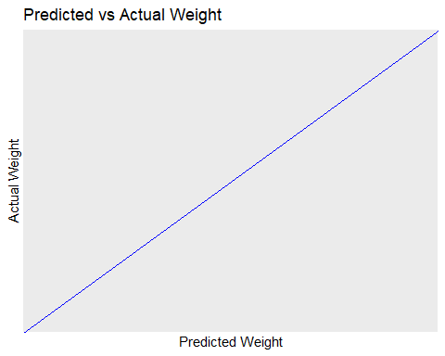

### Residual Plot

