Adeyemi Taiwo
Cloud Pathway Project

Task 1: Set IAM User Account Password Requirements

This is the default IAM User Account Requirements on the AWS IAM Dashboard
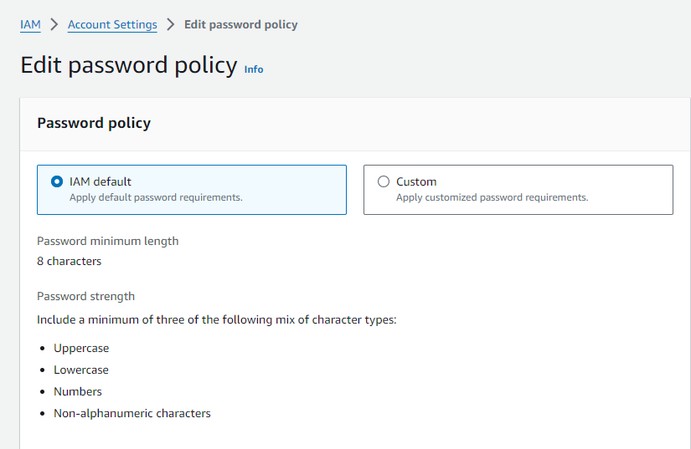

Next step: I will customise the password policy to the new requirements.

IAM Account Settings showing the customised User Account Password Requirements
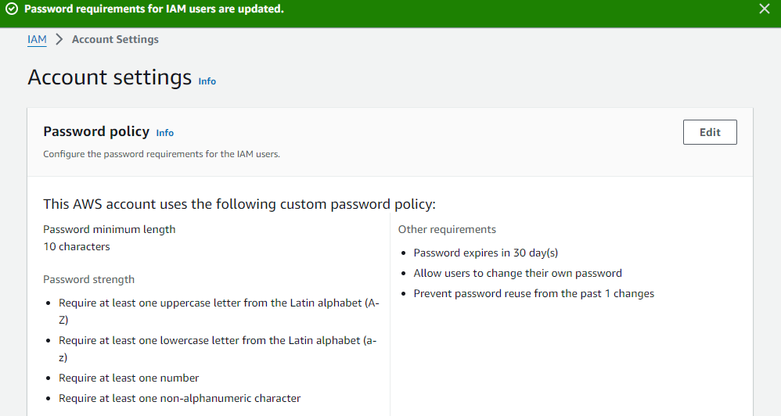

Task 2: Create Administration Users (with full Admin permissions)

These are the two users with full administrative permissions
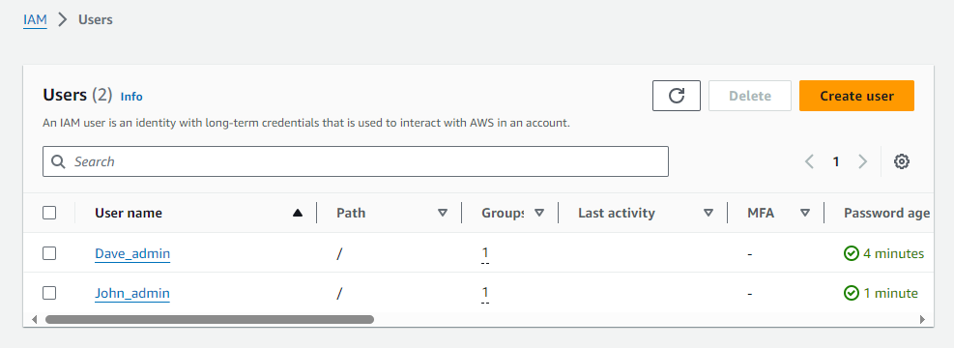

The two users are placed in a group named “admin” that gives them the required permissions
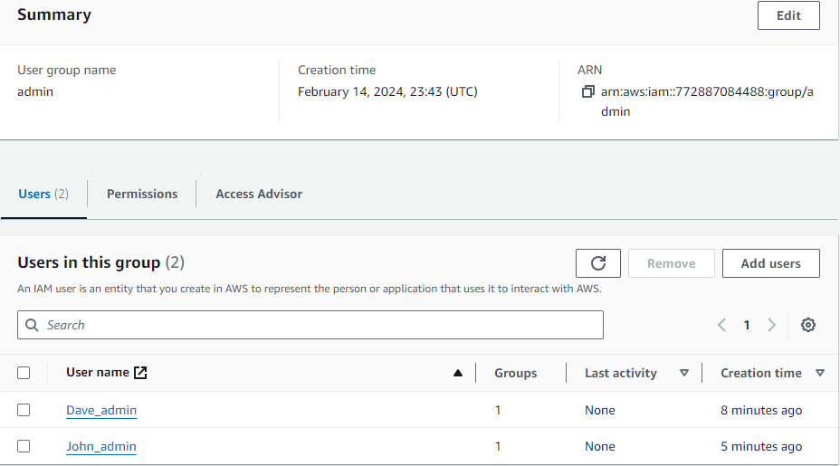

The permissions assigned to the two users in the group
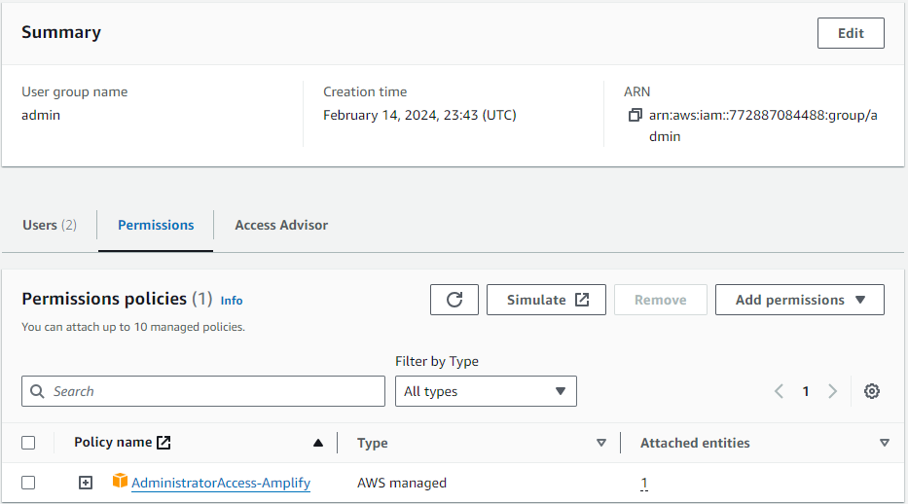

Task 3: Create Billing Users

The two users are placed in a group named “FinanceGroup” that gives them the required permissions
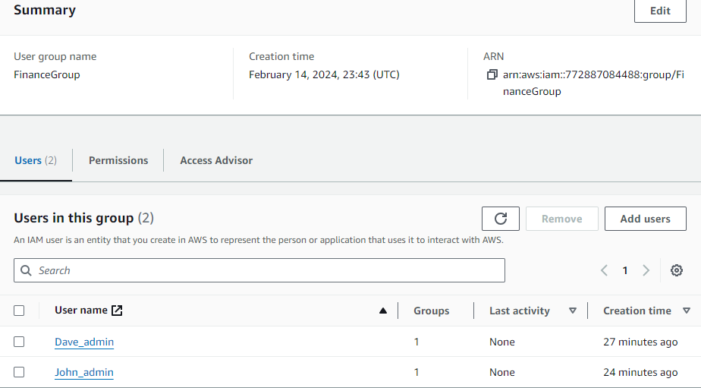

The permissions assigned to the two users in the group
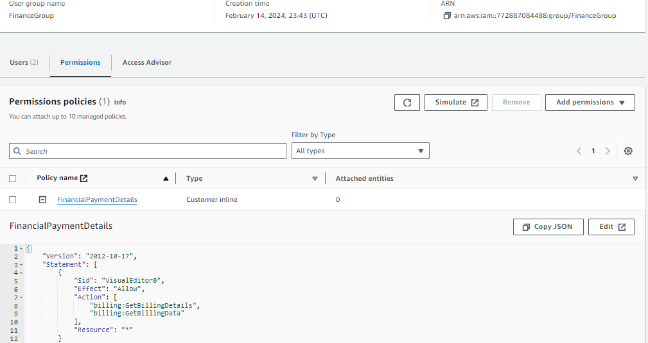

Task 7: Use Managed Services

I deployed Linux Server with a WordPress instance on Lightsail
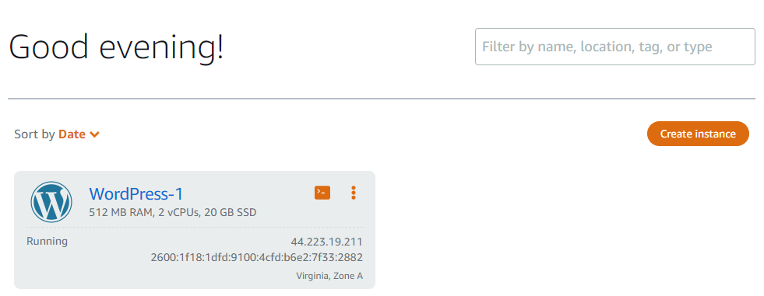

I assessed the WordPress website via the IP address created with the WordPress instance. Then I retrieved the Wordpress website password.

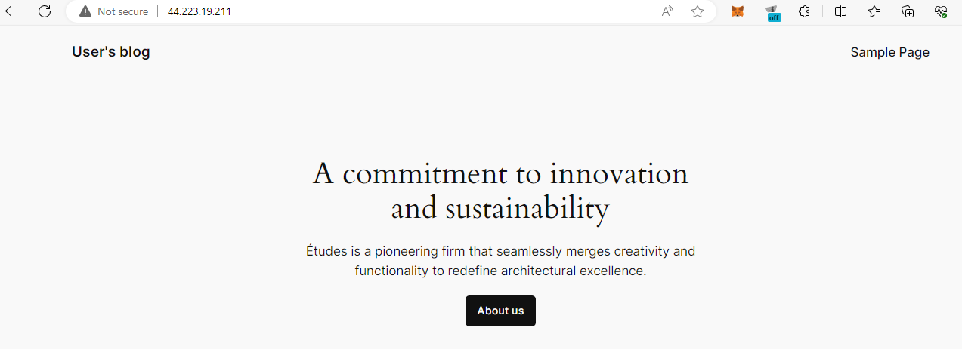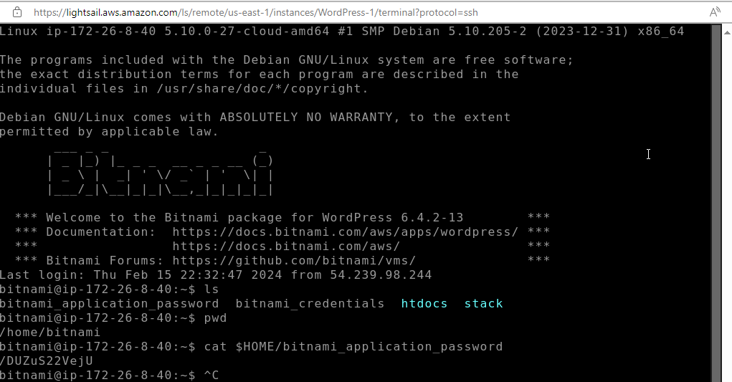

I logged in on the WordPress website and added a post, “Hello World … This is my WordPress instance!”
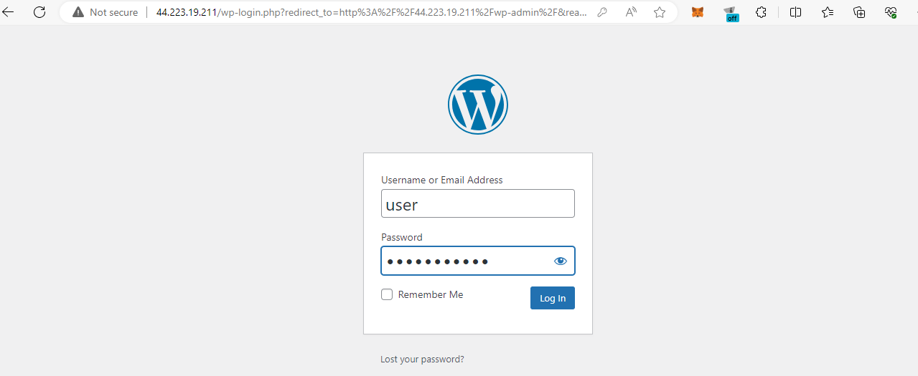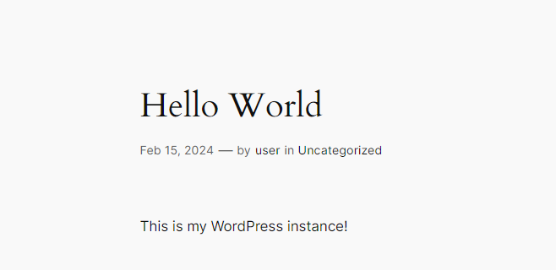

Task 8: Deploy a Windows Virtual Desktop

The first step is the creation of directory, which I did below:
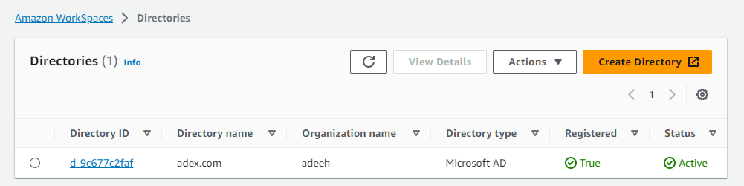

The next step is to create a workspace

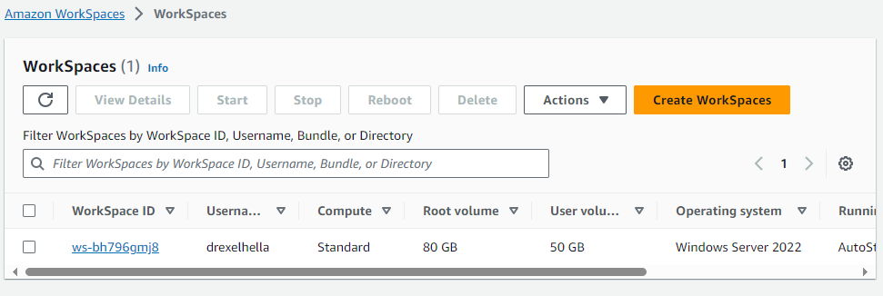

After creating the workspace, an email is sent to the email address I used for the user. I clicked on the link in the email and I was directed to a Virtual Desktop

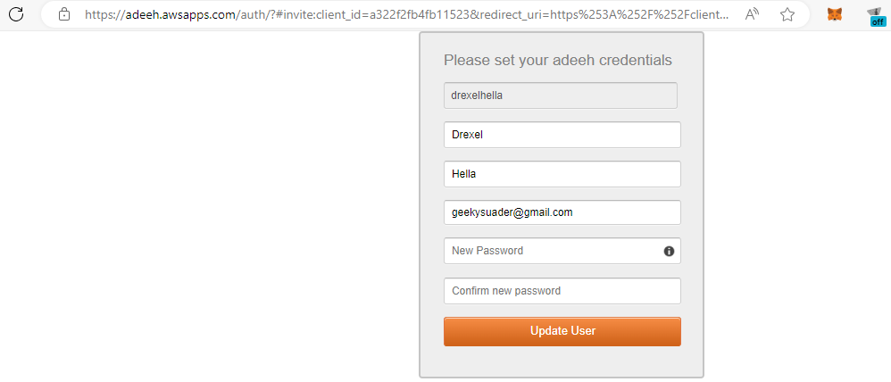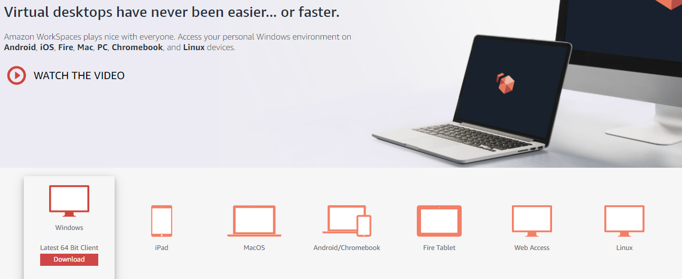

I clicked on the windows icon to download the Window Virtual Desktop. After installing and running the Window Virtual Desktop, I used the registration code sent in the initial email that was sent to the user email address. Then I logged in with my username and password.


Task 10: Create an Elastic Web Hosting Environment

Access the Amazon Elastic Beanstalk and create application. Once that is done, the next step is to create an environment.
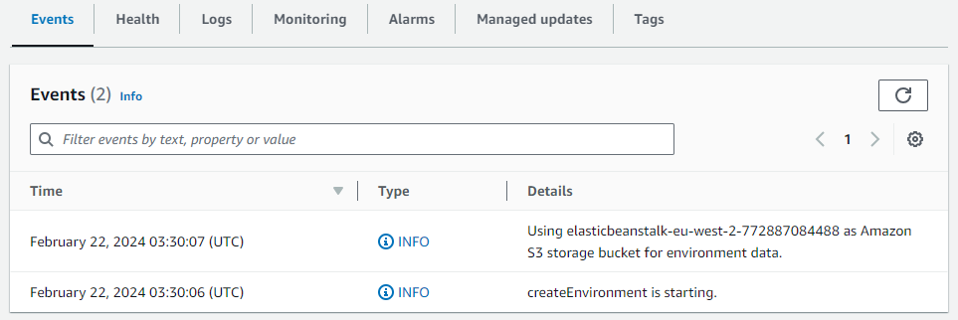

I had to abandon this because my AWS Elastic Beanstalk keep getting terminated

Task 12: Chat Bot with Conversational Features

The first step is to create bot on Amazon Lex. Bot created with intent:
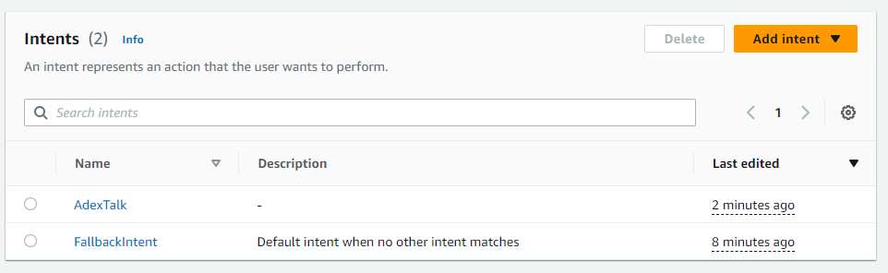

The next step is to add slot types. Slot Type created.
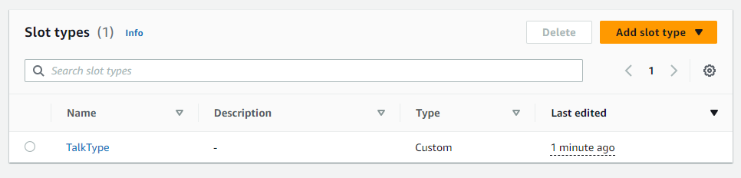

Task 15: Speech to Text

The first step is to create Transcription Jobs in Amazon Transcribe on the AWS Console.
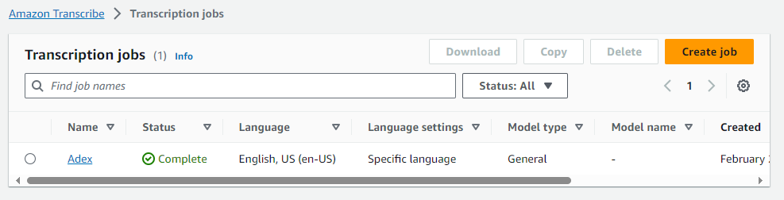

Next, I created an s3 bucket, added a video file and used the url of the video file for the Transcription job.
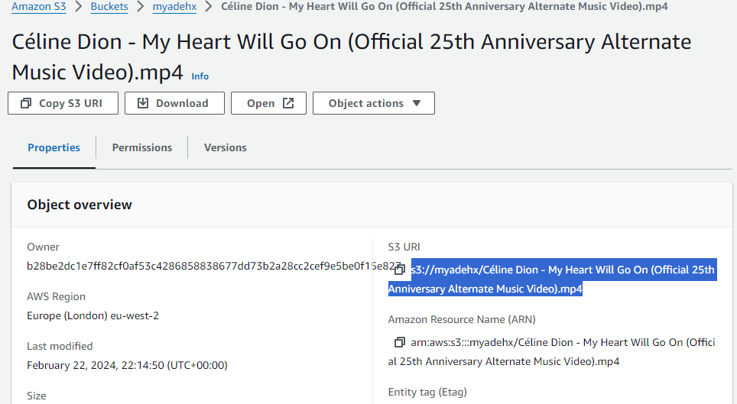

Finally, I clicked on the Transcription Job I created and the speech in the video file in my s3 bucket has been converted to text as shown below:
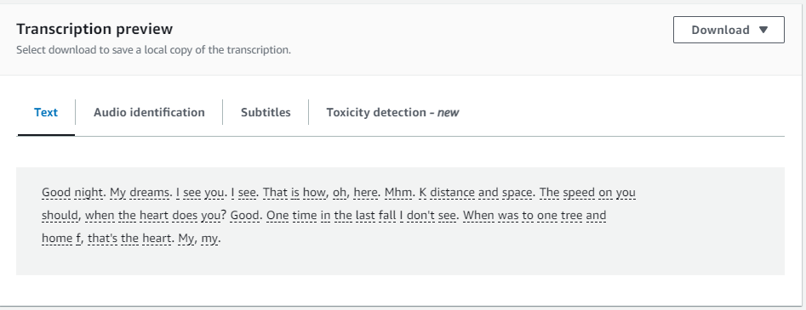

Alternatively, I can use real time transcription by clicking on the start streaming button in Amazon Transcribe on the AWS Console. And with this, every word I say into the microphone is automatically converted to text as shown below:
