**Benefit Hub Product Guide**

Table of Contents

Benefit Hubs Overview 2

User Access 2

Navigation 2

Benefit Hub Functionality 5

Issues or Error Messages: 10

Incorrect Information or Missing Content 10

Broken Link 10

Benefit Hub Technical Issue 10

# Benefit Hubs Overview

VA.gov provides information on different benefits. Each benefit type has it’s own introduction page that acts as the hub for all the information related to that benefit. Currently, VA.gov has eleven benefit hubs:

* Health care
* Disability
* Education and training
* Careers and employment
* Pension
* Housing assistance
* Burials and memorials
* Life insurance
* Records
* Service member benefits
* Family member benefits

## User Access

Any user on VA.gov account can access these benefit hubs and the information on them. **You do not need an account to access benefit hubs.** However, the benefit hubs do link to some tools and features that may require a VA.gov account.

## Navigation

**Direct urls:**

* Health care: <https://www.va.gov/health-care/>
* Disability: <https://www.va.gov/disability/>
* Education and training: <https://www.va.gov/education/>
* Careers and employment: <https://www.va.gov/careers-employment/>
* Pension: <https://www.va.gov/pension/>
* Housing assistance: <https://www.va.gov/housing-assistance/>
* Burials and memorials: <https://www.va.gov/burials-memorials/>
* Life insurance: <https://www.va.gov/life-insurance/>
* Records: <https://www.va.gov/records/>
* Service member benefits: <https://www.va.gov/service-member-benefits/>
* Family member benefits: <https://www.va.gov/family-member-benefits/>

Users can also access any benefit hub page using the main menu found in the VA.gov header:

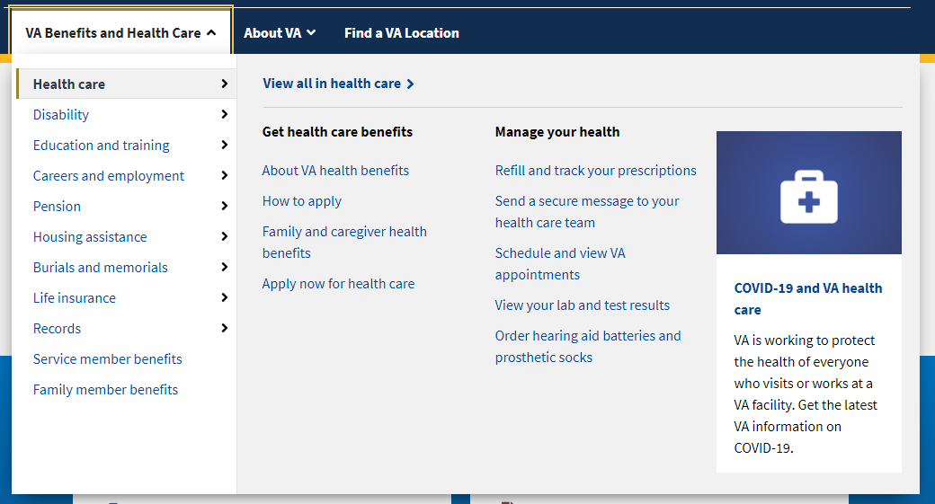

There are also links on the main page that will take a user to specific benefit tools or features but these don’t take users directly to the main benefit hub page:

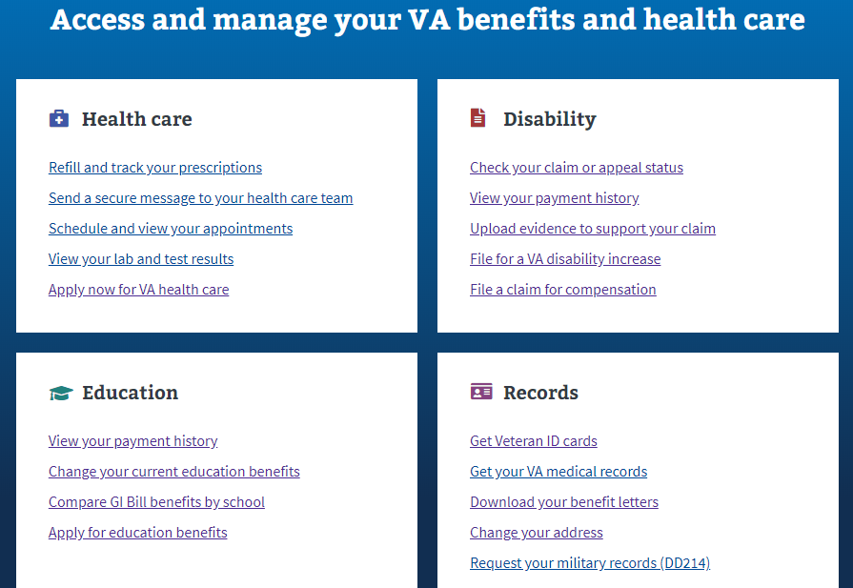

# Benefit Hub Functionality

Benefit hubs are simply content pages that provide helpful information about the specific benefit. For the most part, benefit hubs are structured in a similar way to help make navigation simple no matter what benefit hub a veteran is using.

Each benefit hub begins with a short overview of the benefit that outlines what types of actions they can do:

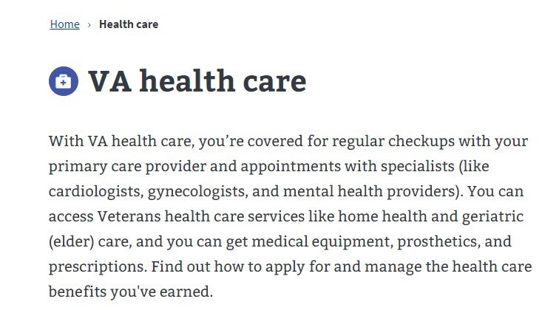

Below that, there will be an “on this page” section that provides jump links to specific sections of the page. This let’s a user navigate directly to a section they are interested in without having to read the whole page:



From there, the benefit hub page will provide more information about the different features, tools, or information that will help a veteran access that benefit:

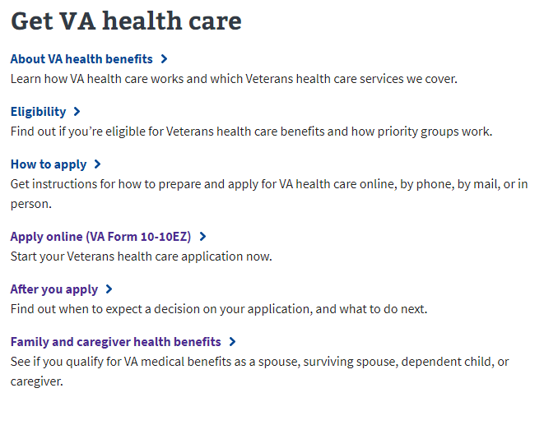

Next the benefit hub will list out information and links about how to manage this benefit:

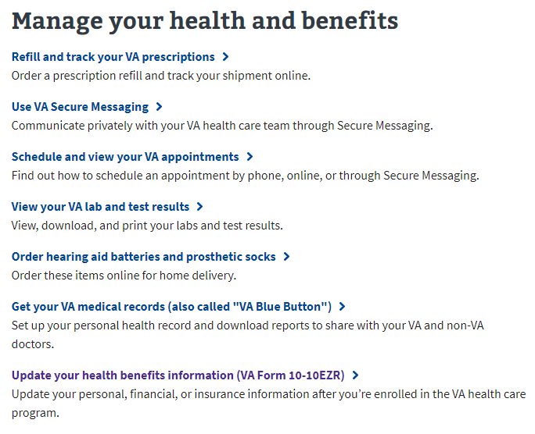

Next there will be a more information and resources section:

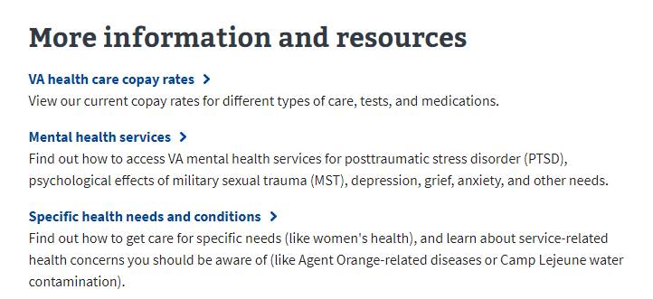

At the end there is a “other VA benefits and services” section with links to other benefit hubs:

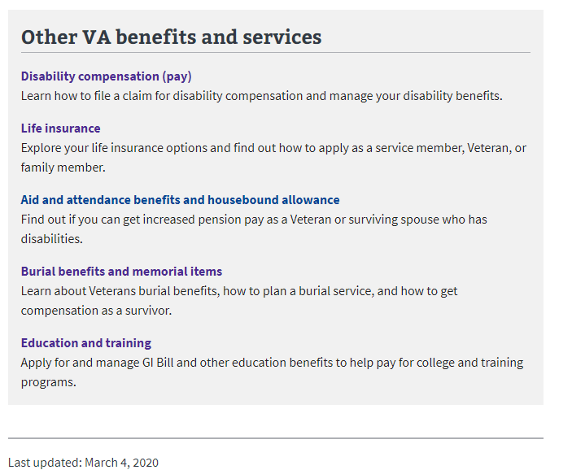

On the right-hand side of a benefit hub page, there is a “Ask questions” and “Connect with us” section. This provides phone numbers to contact centers that can provide assistance for this particular benefit as well as email newsletter and social media information.

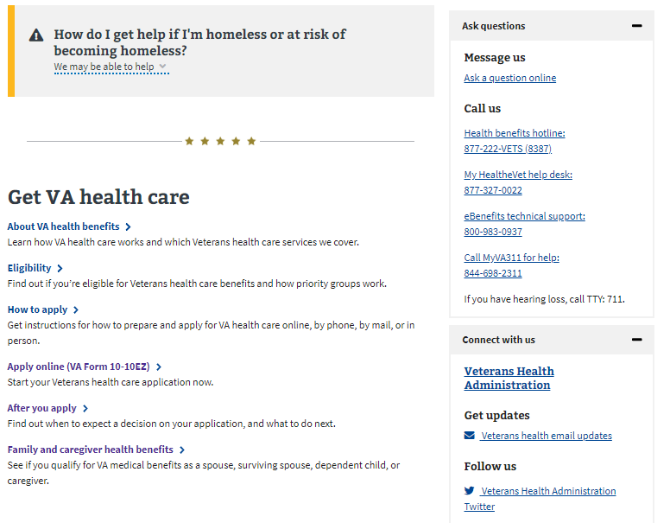

If a user selects any of the links provided on the benefit hub home page, they will be taken to a new page. This new page is still considered part of the benefit hub. You can tell which benefit hub a user is in by the navigation at the top of the page:

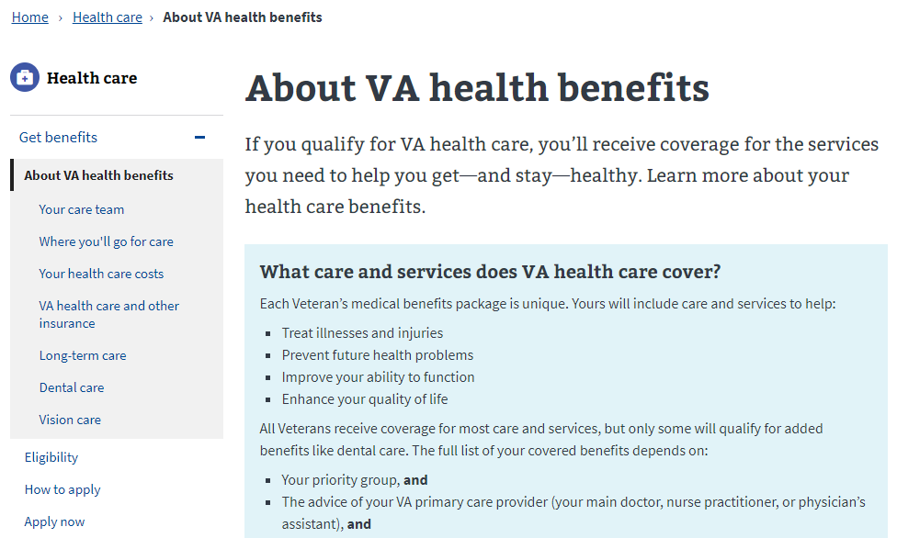

Topics with a lot of information, will also have a sidebar navigation that shows what other pages are under this topic. A user can navigate directly to pages using the sidebar links:



# Issues or Error Messages:

### Incorrect Information or Missing Content

The biggest issue for benefit hubs is when a user thinks there is missing information, or the information provided is not accurate. This type of issue is automatically Tier 3 as it needs to be reviewed by the VA.gov public website team to determine if the feedback is correct.

### Broken Link

Sometimes a user discovers that one of links provided on a benefit hub page no longer works or it directs the user to the incorrect page. These are Tier 3 issues as they must be addressed by the VA.gov public website time who can fix the broken link or determine what page a user should be sent to.

### Benefit Hub Technical Issue

Because the benefit hubs are content pages with limited functionality, a user should not experience any specific technical issues on these pages.