**Post-9/11 GI Bill Statement of Benefits**

Table of Contents

GI Bill School Feedback Overview 1

User Access 2

Who can access this application? 2

Navigation 2

GI Bill School Feedback Tool Functionality 5

Application Information 5

Education Benefits 9

School Information 10

Feedback Information 12

Review Application 14

# 

# GI Bill Statement of Benefits Overview

If a user was awarded Post-9/11 GI Bill education benefits, they can use the GI Bill Statement of Benefits tool to see how much of their benefits they’ve used and how much they have left to use for education or training.

## User Access

### Who can access this application?

The only users who can access this tool are veterans who are signed into an LOA3 account (identity proofed). This tool is not available for users who are not signed in or only have an LOA1 account (not identity proofed). Additionally, the user’s LOA3 account must be matched with MVI, meaning the user’s identity has been verified as a veteran in the VA’s records.

## Navigation

**Direct url:**​ <https://www.va.gov/education/gi-bill/post-9-11/ch-33-benefit/>

**Or** the link for the education application can be found on the ​**VA.gov**​ homepage.

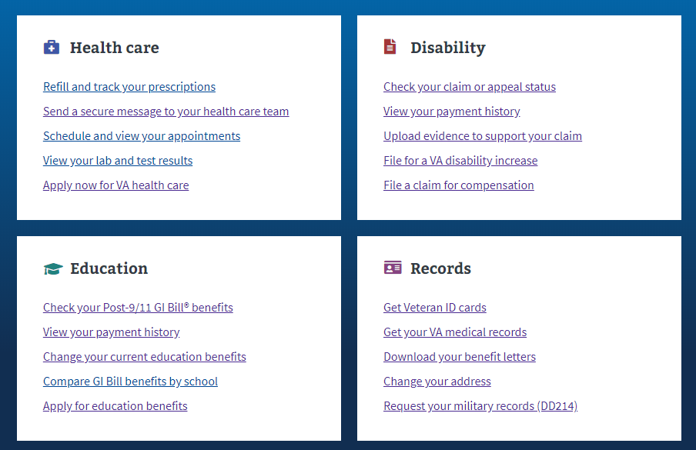

**Or** in the main menu drop down:

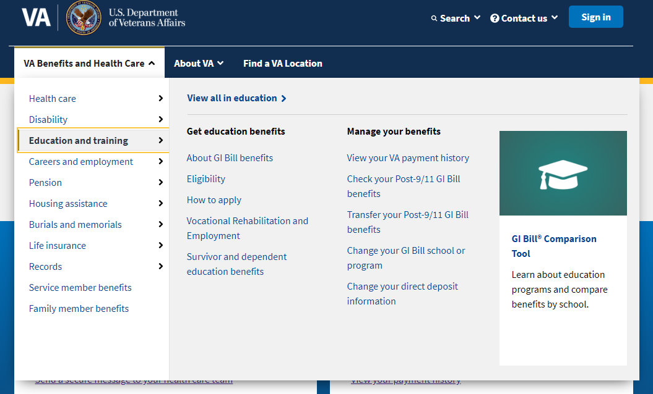

**Or** on the Education Hub Page under “Manage your Veterans education benefits”: <https://www.va.gov/education/>

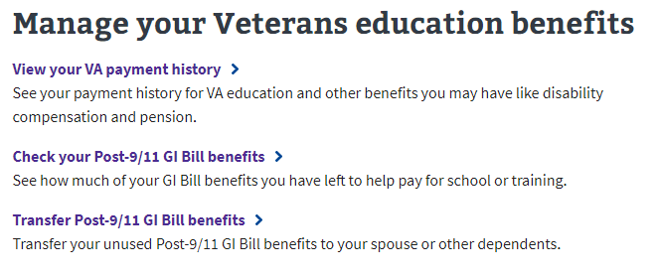

# GI Bill Statement of Benefits Functionality

## Not Signed In

If a user goes to the GI Bill Statement of Benefits page and is not signed into an account, they will see the following information:

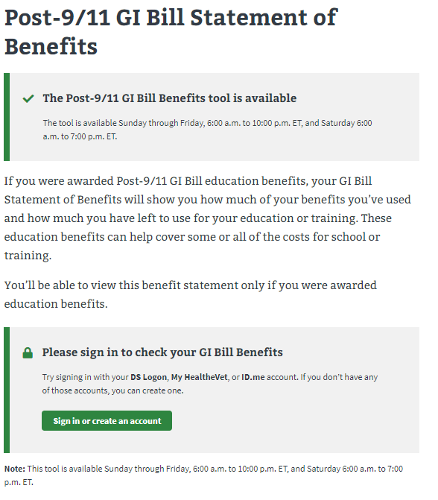

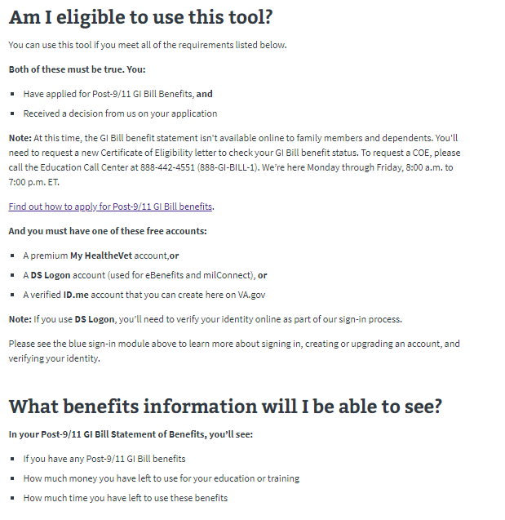

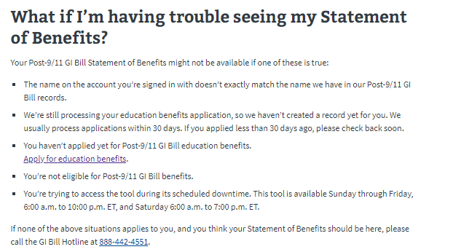

The message with information about the availability of the tool is always present on this page. This is because this tool has certain hours it is not available. The tool is available Sunday through Friday, 6:00 am to 10:00 pm and Saturday 6:00 am to 7:00 pm ET.

## Signed In to an LOA1 Account or LOA3 Account but not verified in MVI

If a user is signed into an LOA1 account (not identity proofed) or are signed into an LOA3 account (identity proofed) but have not been verified in MVI, they will see the following screen when they go to the tool:

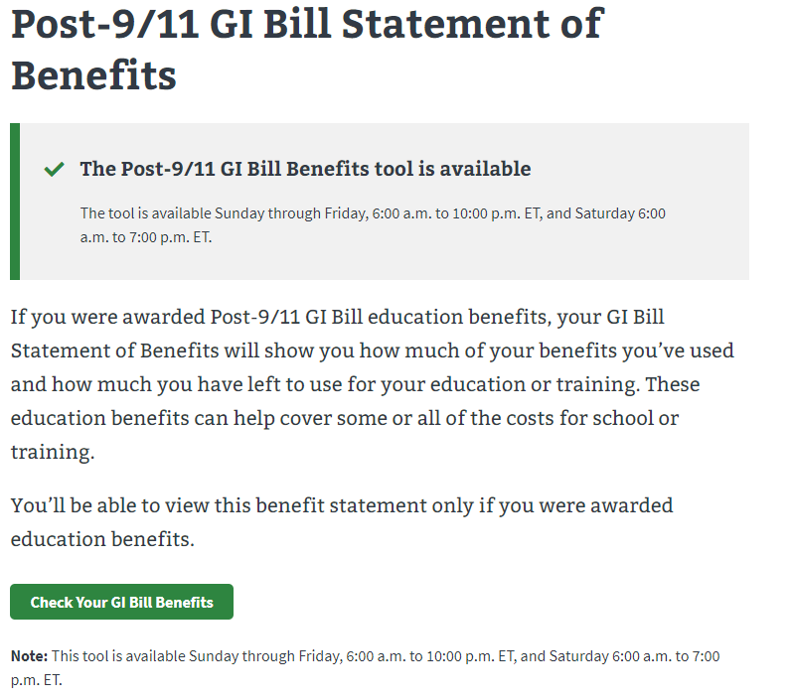

When the user selects the “Check Your GI Bill Benefits” button, they will see the following information on the screen:

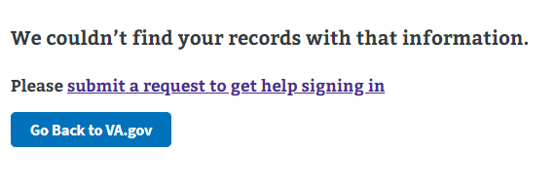

## Signed In to an LOA3 Account AND verified in MVI

If a user is signed into an LOA3 account (identity proofed) and has been verified in MVI, they will see the following screen when they go to the tool:



And they will see the following screen after selecting “Check Your Gil Bill Benefits”

