**Health Care Application**

**Product Guide**

Table of Contents

Claims and Appeal Status Overview 2

Who can use the claims and appeals status tool? 2

Claims and Appeal Status Tool Navigation 3

Logged out and LOA1 users: 6

Logged in users: LOA3 6

Using the Claims Status Tool 6

Claims Status Tab 8

Claims Status Definitions 9

Claims Files Tab 10

Additional Evidence 11

Documents Filed 13

Claims Details Tab 13

Claims Status Tool Issues 14

Questions about the content of the application: 14

Application is pre-filled with incorrect information: 15

User can’t move forward in their application: 15

User can’t upload a document: 15

User is having trouble upgrading their LOA1 account to an LOA3 account 16

# 

# Claims and Appeal Status Overview

Users with an LOA3 (identity verified) VA.gov account can check the status of their claims and appeals on VA.gov. Using the claims status tool, a user can track the following claims and appeals:

* Disability compensation (including claims based on special needs like an automobile or clothing allowance)
* Veterans or Survivors Pension benefits
* Special monthly compensation (such as Aid and Attendance)
* Dependency and Indemnity Compensation (DIC)
* Burial allowance to help pay for a Veteran’s burial and funeral expenses

**You can also use this tool to check the status of a claim or appeal for other benefits like these:**

* VA health care
* GI Bill or other education benefits
* Vocational rehabilitation and employment
* A home loan Certificate of Eligibility (COE)
* A Specially Adapted Housing (SAH) or Special Housing Adaptation (SHA) grant
* Life insurance
* A pre-need determination of eligibility to be buried in a VA national cemetery

You can find more information about the claim/appeal status tool here: <https://www.va.gov/claim-or-appeal-status/>

## Who can use the claims and appeals status tool?

To use this tool, you’ll need to have an LOA3 (identity verified account) VA.gov. The following are all the types of LOA3 account a user could use to sign into VA.gov and access the claims status tool

* A Premium My HealtheVet account, or
* A Premium DS Logon account (used for eBenefits and milConnect), or
* A verified ID.me account that you can create on VA.gov

If a user is signed in with an LOA1 (not identity verified account) they will not be able to see the status of their claims or appeals using this tool.

## Claims and Appeal Status Tool Navigation

Once a user is signed into their LOA3 (identity verified) VA.gov account, they can find the claims and appeals status tool in the following locations: [www.va.gov/track-claims/your-claims](http://www.va.gov/track-claims/your-claims)

* On the homepage: [www.va.gov](http://www.va.gov)

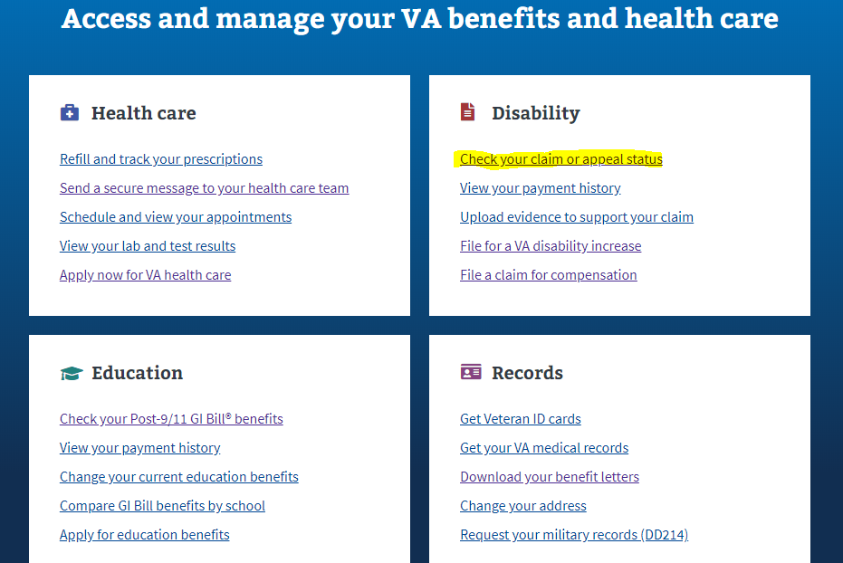

* In the main menu dropdown

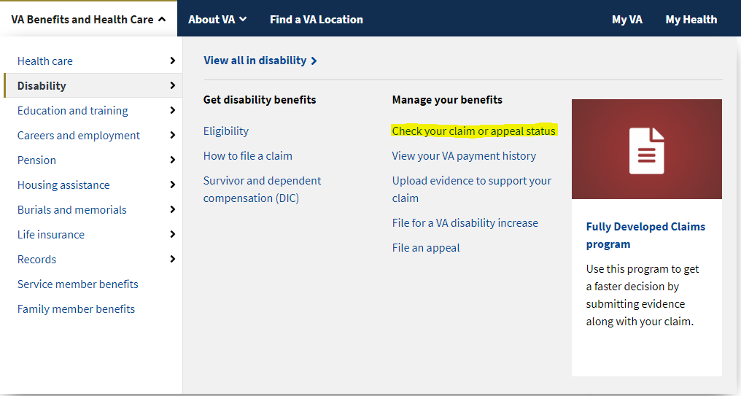

* In the disability benefit hub: <https://www.va.gov/disability/>

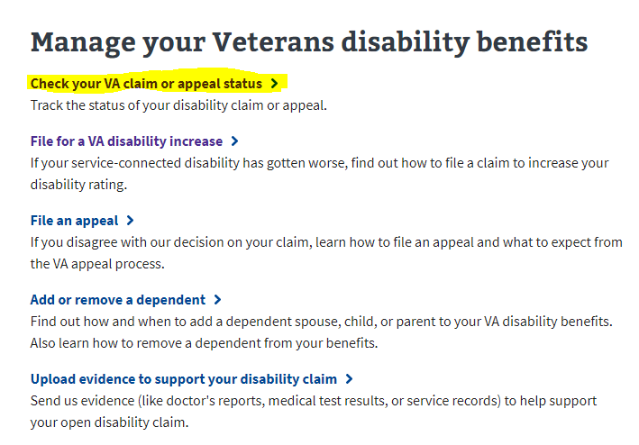

* In the My VA dashboard

Go to your “My VA” dashboard found in the top right corner of the page once a user is signed in:

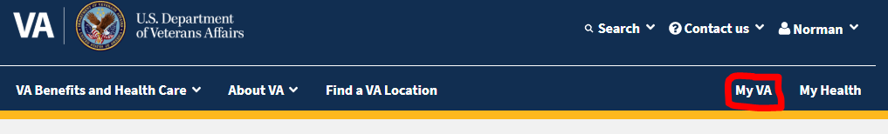

Scroll down to the “Track Claims” section. There will be a summary of the latest status information for any open claims or appeals for a user:

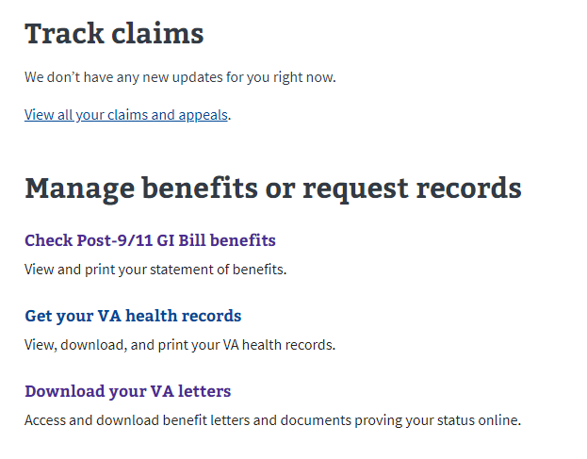

## Logged out and LOA1 users:

If a user is not logged into a VA.gov account or are signed into a LOA1 account (not identity verified), and try to use the claim status tool, they will be taken to this webpage and be prompted to sign in: <https://www.va.gov/claim-or-appeal-status/>

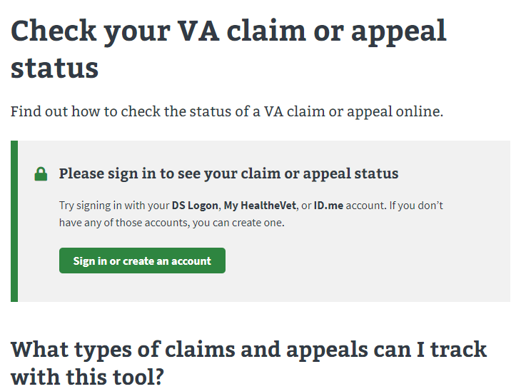

## Logged in users: LOA3

If a user is signed into an LOA3 (identity verified) account, they will be taken directly to the claims status tool.

# Using the Claims Status Tool

When a user is signed into their LOA3 account goes to the claims status tool, they will see their submitted claims and appeal listed.

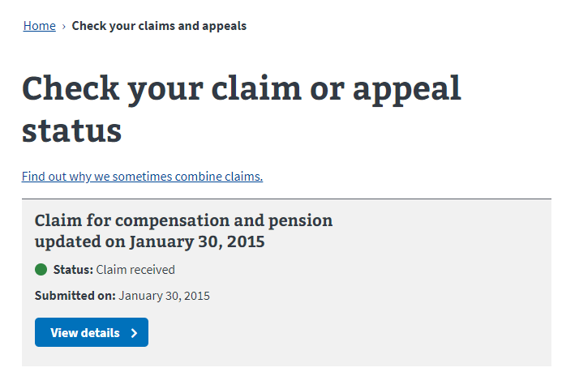

## Claims Status Tab

A user can select the “view details” button to view more information about the claim processing.

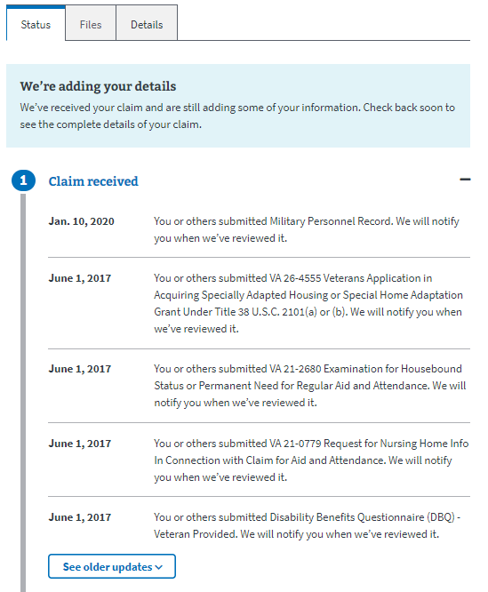

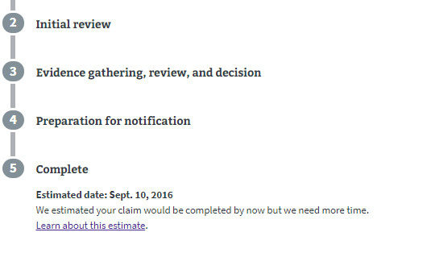

### Claims Status Definitions

The claim status tool has 5 different statuses that can be shown to the user. You can find details on the five different statuses below or on this webpage: <https://www.va.gov/disability/after-you-file-claim/>

1. **Claim received:** Notification the VA has received the user’s disability glaim
   1. If you file your claim online, you’ll get an on-screen message from us after you submit the form.
   2. If you file your claim on eBenefits, you’ll see a notice from us in your claims list within about one hour of applying.
   3. If you mail your application, we’ll send you a letter to let you know we have your claim. You should get this letter about one week, plus mailing time, after we receive your claim.

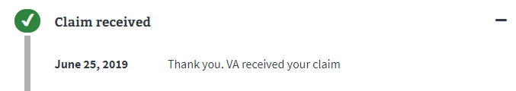

1. **Initial review:** A Veterans service representative (VSR) will review your claim. It’ll move to step 3 if we don’t need any more evidence to support it.

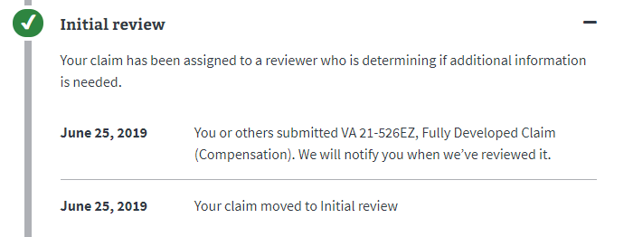

1. **Evidence gathering, review, and decision:** During this step, the VSR will do 3 things:
   1. Ask for evidence from the user
   2. Review the evidence – if more evidence is needed, the claim may return to this step more than once.
   3. Make a decision

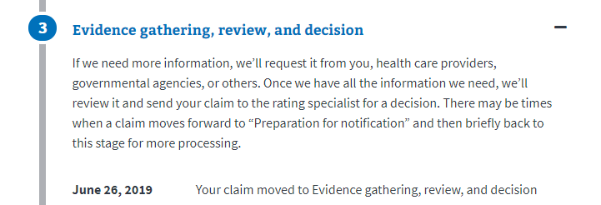

1. **Preparation for notification:** The user’s entire claim decision packet is ready to be mailed
2. **Claim complete:** The packet has been mailed and includes details on the decision of the claim.

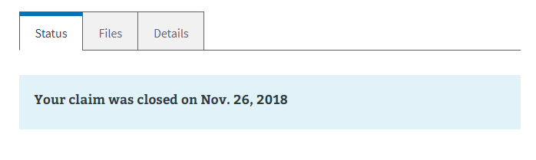

## Claims Files Tab

The files tab is where a user can review the evidence they have already submitted and upload any additional evidence. Under the “File requests” section, the user will see information for additional evidence needed by the VA to process the request.

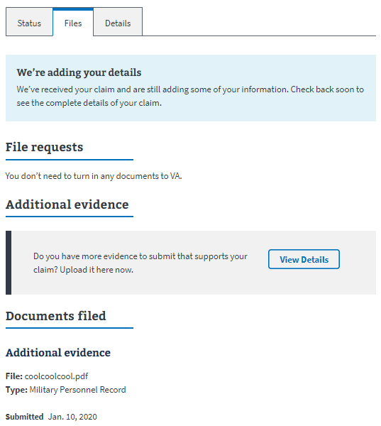

### Additional Evidence

If the user wants to submit additional evidence to their claim, they can do this by selecting the “View details” button in the “Additional evidence” section.

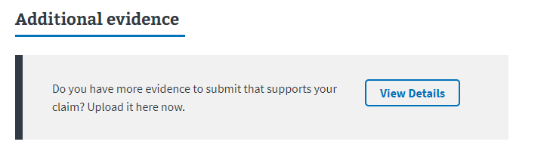

If the user selects the “View details” button, they will see the below information

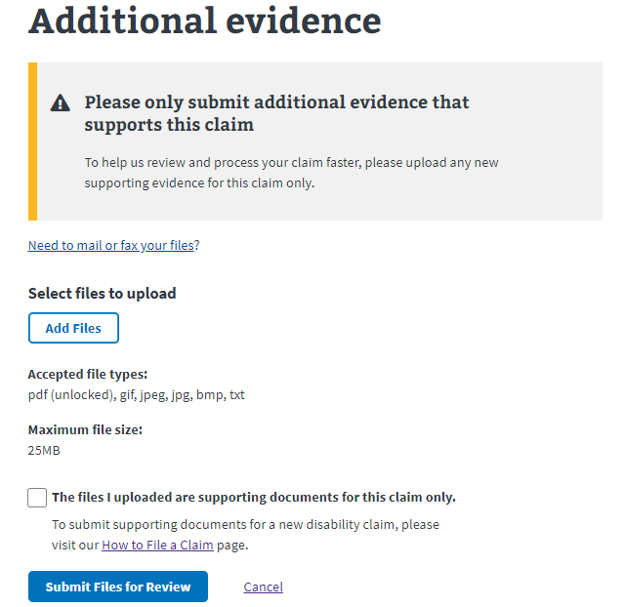

### Documents Filed

The documents filed section of the Files tab lists out all the evidence uploaded and submitted by the user, unless the evidence was submitted by fax or mail. Documents cannot be view, changed, or removed in this section.

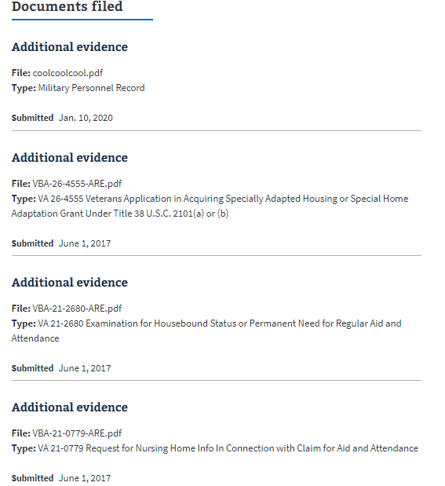

## Claims Details Tab

This tab is where the user can go to see the details of their claims. The information in this tab can’t be updated or changed on the website.

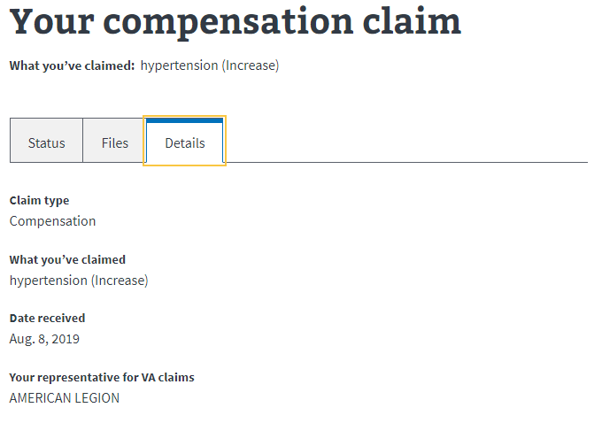

# Claims Status Tool Issues

## Appeals or claims status is unavailable:

VA.gov pulls the claims and appeals status from different VA.gov systems. Sometimes there are issues with these systems and therefore the status cannot be displayed. If this happens, the agent should encourage the user to try back later. If the issue persists, this issue should be escalated to the VA.gov technical support team.

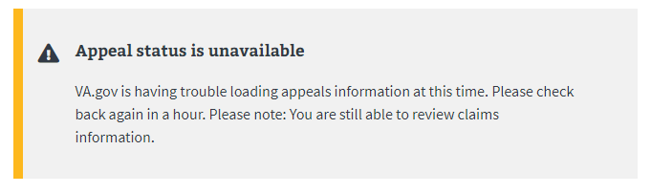

## How do I upload additional evidence?

A user must go to the file tab of their claim to upload additional documents. In the file tab, there is a “View Details” button. They must click on that button to upload documents.

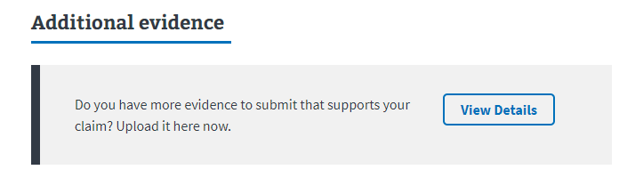

If the user is having issues uploading a document, walk through the requirements of the documents to make sure they are uploading a file type and size accepted by VA.gov:

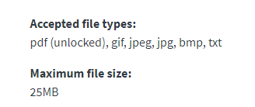

Finally, the user must select a check box stating the files they are uploading are supporting documents for the specific claim. They user will not be allowed to submit the documents unless they click on this check box.

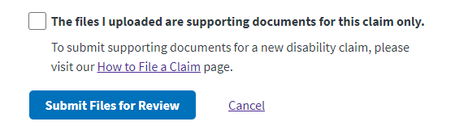

## User says their claims and/or appeals information is missing or incomplete:

If a user states the claims status tool is missing their claims, first make sure there aren’t multiple pages of claims.

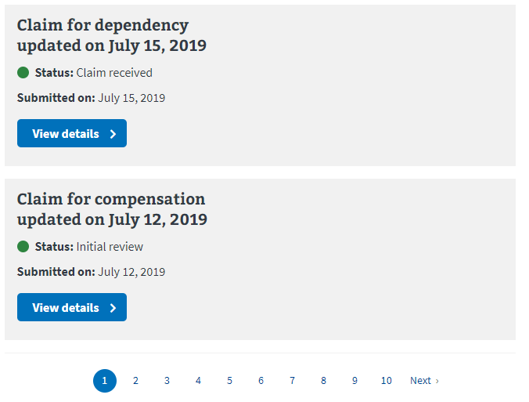

If this isn’t the issue, instruct the user they will need to contact the NCC (800-827-1000) to verify their claim information. If NCC verifies there is a discrepancy between what they have on file for claims and what the claims status tool states, this issue will need to be escalated to the VA.gov technical support team.