**VA COVID-19 Chatbot Product Guide**

Table of Contents

COVID-19 Chatbot Overview 2

User Access 2

Navigation 2

VA COVID-19 Chatbot Functionality 4

Starting a Chat 4

Asking Another Question 6

My current COVID-19 Symptoms (CDC self-checker tool 7

Getting more help or ending the Chatbot 7

Issues or Error Messages: 9

Unexpected Path Error Message 9

Outdated Internet Browser 9

# COVID-19 Chatbot Overview

In conjunction with the Office of Connected Care and Veterans Experience Office, the VA Office of the CTO has developed a COVID-19 FAQ interactive “chatbot” tool to better serve Veterans’ increased demand for information and services during the COVID-19 pandemic.

## User Access

Any user on VA.gov account can use the COVID-19 chatbot functionality. **You do not need an account to access the chatbot.** The Chatbot will work on the latest versions of all major web browsers.

## Navigation

**Direct url:**​ [www.va.gov/coronavirus-chatbot](http://www.va.gov/coronavirus-chatbot)

For the initial launch of the COVID-19 Chatbot, a user will be able to access it from **the VA.gov COVID-19 FAQ page** and **the facility locator page.** Each page will have a link that will take the user to a new page where the chatbot is located.

*COVID-19 FAQ Page*

<https://www.va.gov/coronavirus-veteran-frequently-asked-questions/>

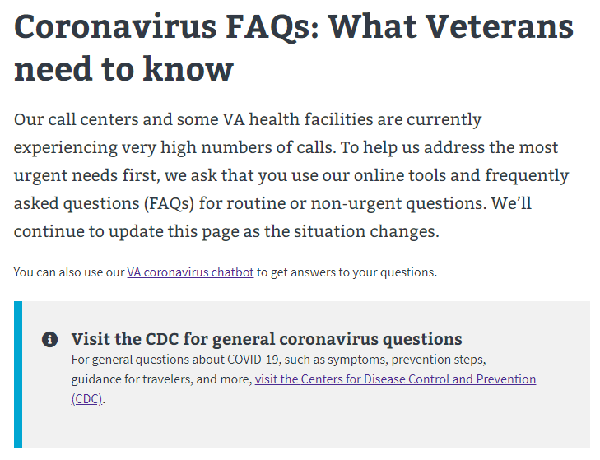

*VA.gov Facility Locator*

<https://www.va.gov/find-locations>

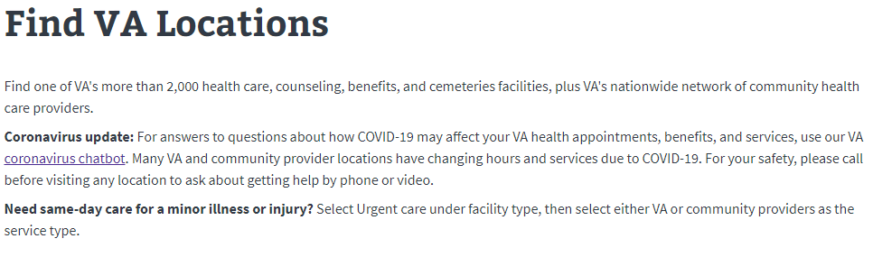

# VA COVID-19 Chatbot Functionality

### Starting a Chat

When the user reaches the Chatbot page they will see the following:

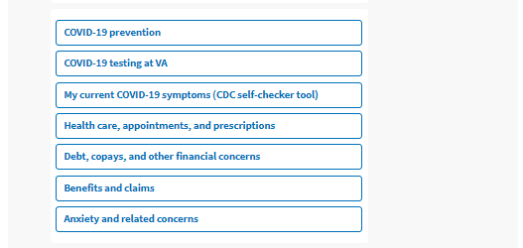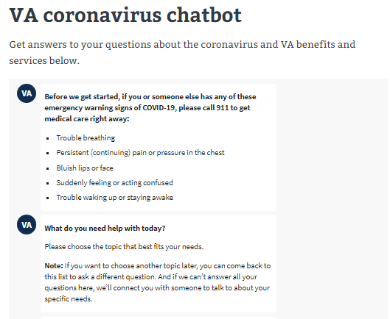

The user is first instructed to call 911 if they are experiencing any emergency warning signs. From there, the user can start the Chatbot experience by selecting a topic they need help with. When the user selects a topic they might be provided with additional topics to select from or they might be taken directly to an answer. In the below example, the user selected “COVID-19 testing at VA.”

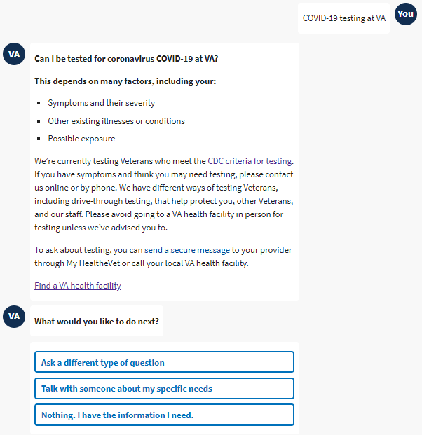

The chatbot returned an answer for the user as well as another question asking what they would like to do next.

### Asking Another Question

If the user selects “Ask a different type of question” they will be shown the original suggested topics they saw at the beginning and can continue using the chatbot for finding answers.

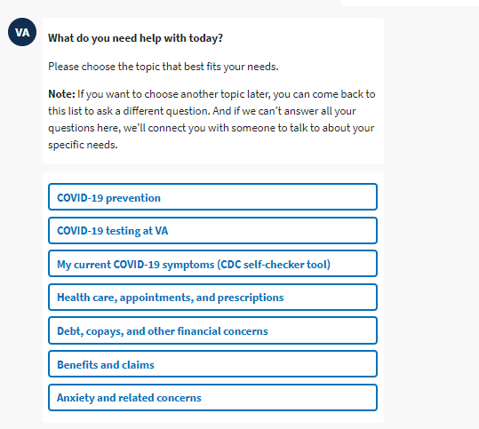

### My current COVID-19 Symptoms (CDC self-checker tool

If the user selects the option for symptoms, the tool will switch over functionality to the CDC symptom checker tool. With this tool, CDC’s chatbot guide, “**Clara**,” will help the user to decide when to seek medical care. If the user would like to go back to the VA COVID-19 chatbot to choose another topic, they can refresh the page to start over.

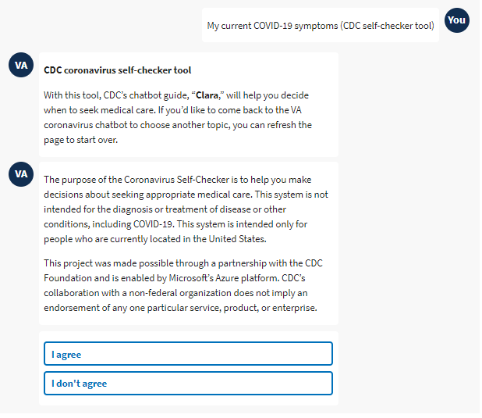

### Getting more help or ending the Chatbot

When the Chatbot asks “what would you like to do next” the user can select “talk with someone about my specific needs”



When they select this option, they will be shown a list of phone numbers they can call or links to helpful resources or tools.

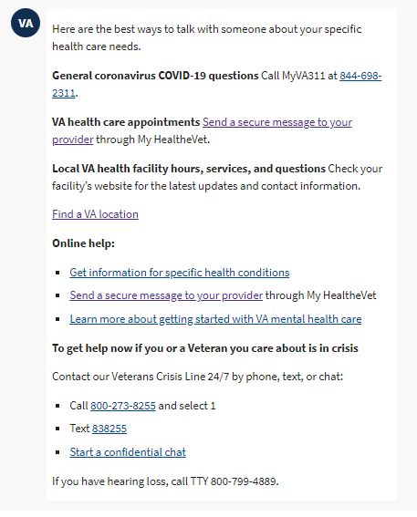

A user can also tell the chatbot they do not need more information by selecting “Nothing. I have the information I need.” If they select this, they will see the below message:

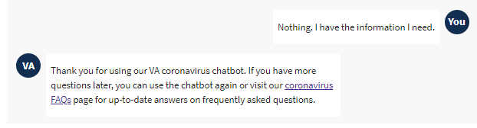

# Issues or Error Messages:

### Unexpected Path Error Message

If the Chatbot functionality experiences an issue because of an unexpected action, they will see the following error message. They should be able to refresh the page and start over or select one of the suggested links.

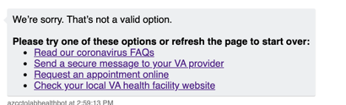

### Outdated Internet Browser

Users who are not using an updated version of their browser, might experience problems using the chatbot functionality. If this is the case, the user will need to update the version of their internet browser or try using the chatbot on another device with more up to date internet browser versions.