**FEATURE GUIDE**

**Compensation & Pension Direct Deposit on VA.gov**

# Current Functionality

Currently, all direct deposit functionality at the VA is managed on [eBenefits](https://www.ebenefits.va.gov/ebenefits/about/feature?feature=direct-deposit-and-contact-information).

# Updated Functionality

Going forward, we will moving direct deposit functionality over to VA.gov **for compensation and pension benefits only**. Direct deposit functionality for education benefits will remain on eBenefits.

# Direct Deposit Location

<https://www.va.gov/profile>

# Who Can Access Direct Deposit

**Veterans must receive compensation & pension payments from the VA**.

First and foremost, the direct deposit feature is only visible to people who receive compensation & pension payments from the VA.

If a user receives compensation & pension payments, they will see this in their profile:

If a user does not receive compensation & pension payments from the VA, they will not see the direct deposit functionality in their profile:

The following also must be true for people who receive compensation & pension payments to see the direct deposit feature in the profile:

**Veterans must be logged in to view direct deposit**

The direct deposit feature is located in the VA.gov user profile. The user profile is only visible to logged in users, so only logged in users can update their direct deposit information.

**Veterans must be LOA3 to view direct deposit**

Veterans who are LOA1 (have not verified their identities on VA.gov) can not view the VA.gov user profile, which is where the direct deposit feature lives. In order to view the profile, VA.gov users have to be identity verified (LOA3). Logged in LOA1 users will see this when they go to the VA.gov profile:

**Veterans need to have 2-factor authentication set up**

Veterans who are logged in and LOA3 also need to have set up 2-factor authentication on VA.gov to view direct deposit. When they go to the VA.gov profile, they will see a prompt to add 2-factor authentication if they have not done so already:

*What LOA3 users who receive compensation & pension will see if they go to the VA.gov profile if they have not set up 2-factor authentication*

# How to Access and Update Direct Deposit for Compensation & Pension

This is how direct deposit works for Veterans who have access to it. Remember, a user must receive compensation & pension payments, be signed in to VA.gov, be LOA3, and have 2-factor authentication set up to access this feature.

1. Sign in to VA.gov (<https://www.va.gov/>).

1. Click the **personalized menu** in the upper right corner of the screen (the user’s name) and select **Profile**.

1. On the Profile (<https://www.va.gov/profile>), either click the **Direct deposit information** jump link (<https://www.va.gov/profile/#direct-deposit>) at the top of the page, or scroll down to **Direct deposit information for disability compensation and pension benefits**.

* 1. If a user needs to add 2-factor authentication, they will see the prompt below. They should add 2-factor authentication and then come back to the profile in order to access direct deposit.

1. To update the direct deposit information, click **Edit**.

If someone has not added direct deposit information yet, they will see this instead. They can click any of the links that start **“Please add…”** to open the direct deposit form:

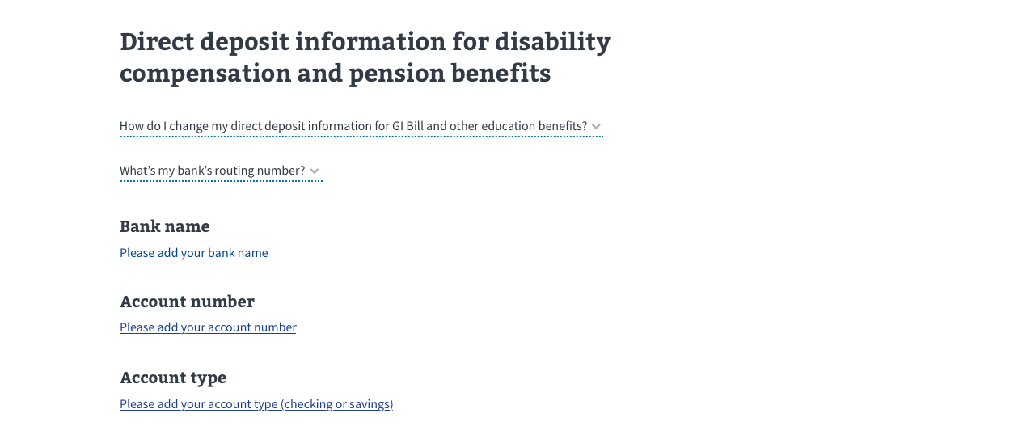

1. Once the form opens, update the Routing number, Account number, and Account type. Then click **Update**.

1. After clicking update, the form will close and show the updated information.

1. After someone’s direct deposit information has been updated, they should receive an automatically generated confirmation email from VA.gov. This is a no-reply address and any emails sent to this address will not be received by our team or anyone else.

# Errors

There are a few errors that users may see when they are interacting with the direct deposit feature:

# Required Errors

If a user tries to submit the direct deposit form without filling out any/all of the fields, they will receive “required” errors that correspond with the fields they have left blank. Below is a screenshot of what this would look like if all the fields were left blank:

If a user reports these errors, explain to them that they need to fill in all required information in order to add or update their direct deposit.

# Routing number can’t be found

If a user submits an invalid bank routing number, we will return the error below. This error would likely occur if someone accidentally mistyped their bank’s routing number:

If a user reports this error, ask the user to try typing their bank routing number again. If that does not work, you might suggest that they double check they are entering the correct information.

# Backend system is down/generic error

If someone tries to update their direct deposit information and the backend system is down, they will see this error. There may be other scenarios in which a user sees this error, but they would all be caused by issues with the backend system. There isn’t anything the user can do to resolve this. They should just come back and try again later:

# If a user reports this error, recommend that the user come back and try again later. If they are still having issues, recommend trying on different browsers or devices (if possible). Explain that if after 48 hours the error still appears, they should call back to report the error so we can escalate to the VA.gov triage team.

# Payment information won’t load

If we can’t retrieve someone’s direct deposit information, they will see this error. This is cause by issues with the backend system, and there isn’t anything the user can to do resolve it. They should just come back and try again later:

# If a user reports this error, recommend that the user come back and try again later. If they are still having issues, recommend trying on different browsers or devices (if possible). Explain that if after 48 hours the error still appears, they should call back to report the error so we can escalate to the VA.gov triage team.

# Fraud error

In the event that someone reports suspicion of fraud to the VA and the VA finds that there is a credible threat, they will suspend the ability for the associated account to update their direct deposit information until the fraud issue is resolved. This would be an extremely rare use case, but in the even that it happens, a user would see if this If they tried to update their direct deposit information:

If a user reports this error, tell them to follow the directions shown on the screen and to call the National Call Center (1-800-827-1000) to have their questions answered and unlock their account.

# Mailing address errors

Some people may not be able to update their direct deposit information because of an issue with the mailing address that is on file for them. If we detect that their mailing address is “invalid” — either incomplete or an address which the US Postal system may not recognize — the update of the direct deposit information will fail. The technical specifics are not important to convey to the end user — just that this has something to do with how direct deposit data and mailing addresses are coupled in the backend database.

If someone sees this error, then they should update their mailing address in the VA.gov profile, and then try to update their direct deposit again. Once they are successfully able to save a new and valid mailing address, then their direct deposit information should be able to be saved **unless** there are issues with their phone numbers on file (see the next section for more information on phone number errors).

The flow will look like this:

1. A user tries to update their direct deposit information in the VA.gov profile. They may get this error saying their mailing address is invalid:

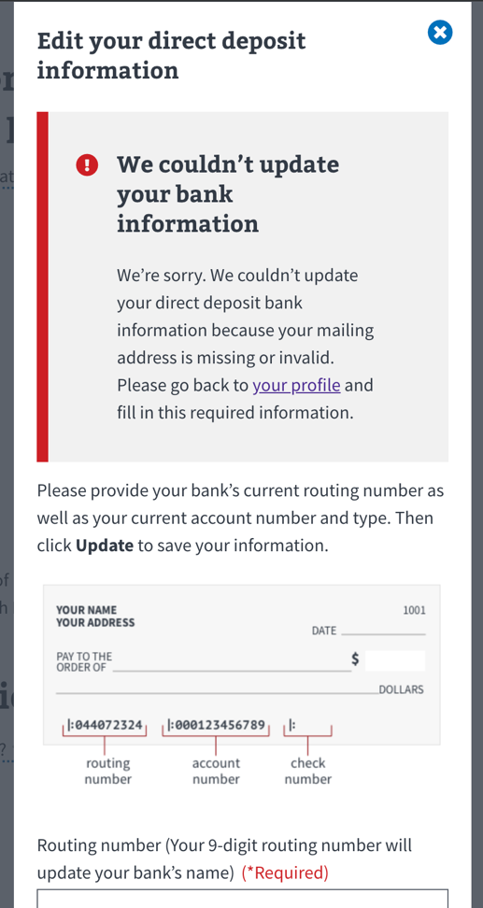

1. From here, they should leave the direct deposit screen and go to the Contact Information section of the profile. Under there, they will see an option to update their mailing address. They should click **Edit** to update their mailing address.

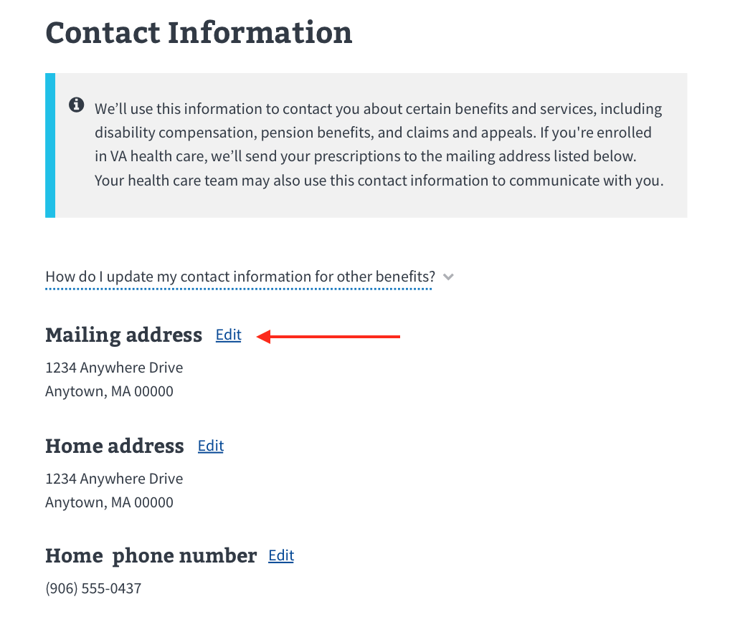

1. In the mailing address form, have them enter their current mailing address and click **Update**.

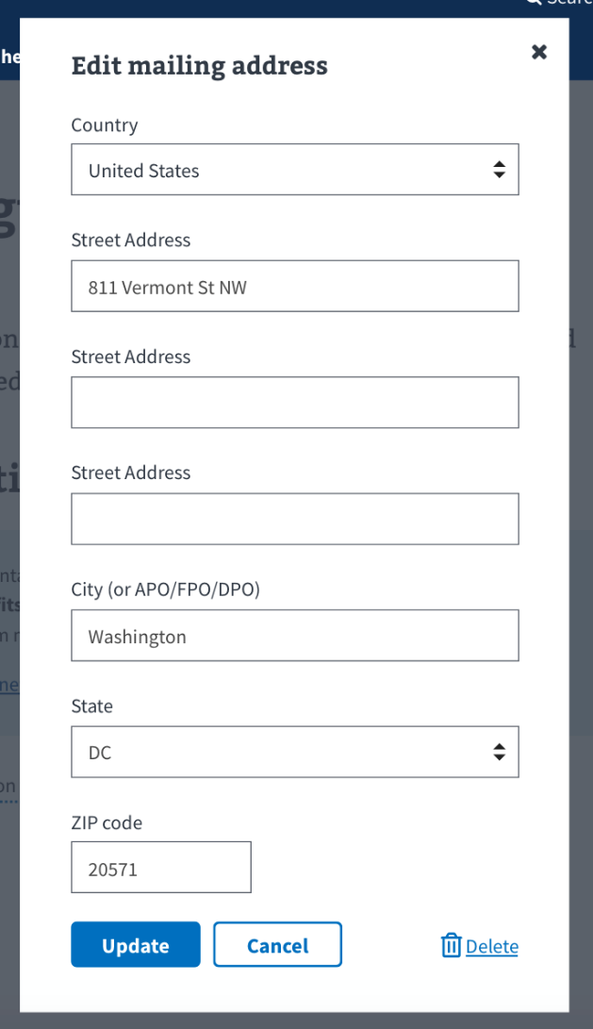

1. Once they update their mailing address, they should try to update their direct deposit information again. It should work this time.
   1. **Note**: This is unlikely, but it is possible that someone will get another error related to changing their phone number after they’ve fixed their mailing address (see the next section below for more information). This is unlikely but it is possible. Once they fix their phone number(s), they should be all set to update their direct deposit information.

# Phone number errors

Similar to the error above, some people may not be able to update their direct deposit information because of an issue with the home or work phone number that is on file for them. If we detect that their home or work phone number is invalid, the update of the direct deposit information will fail. Like with the mailing address error, the technical specifics are not important to convey to the end user — just that this has something to do with how direct deposit data and home or work phone numbers are coupled in the backend database.

If someone sees this error then they should update their home or phone number in the VA.gov profile, and then try to update their direct deposit again. Pleasenote that the error message will specify whether they need to update the home OR the work phone number.

Once they are successfully able to save a new home or work phone number, then their direct deposit information should be able to be saved **unless** there are issues with their mailing address on file (see the previous section for more information on mailing address errors) **or** there are issues with a different phone number (eg. they had to fix their home number and then got a different error that they need to fix their work phone number).

For the end user, the flow will look like this:

1. A user tries to update their direct deposit information in the VA.gov profile. They may get an error saying their home or work phone number is invalid (**Note**: the error will specify which phone number they need to update):

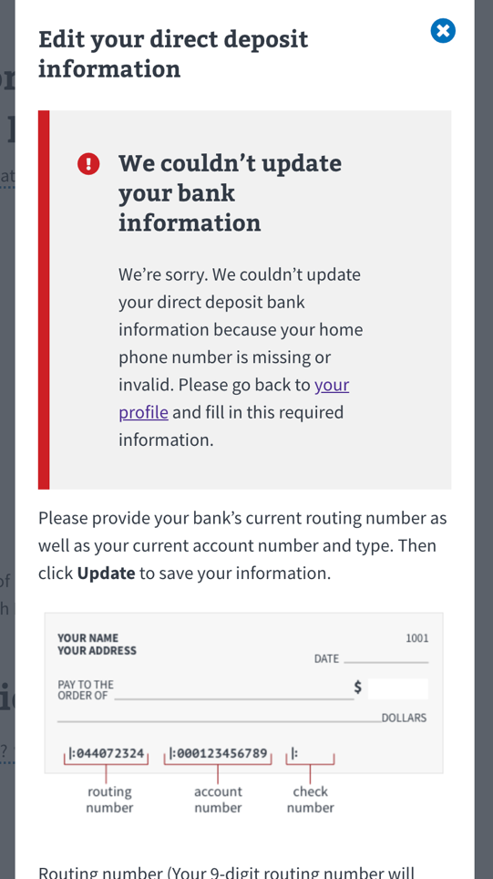

1. From here, they should leave the direct deposit screen and go to the Contact Information section of the profile. Under there, they will see an option to update their home or work phone number. They should click **Edit** next to whichever phone number they need to update.

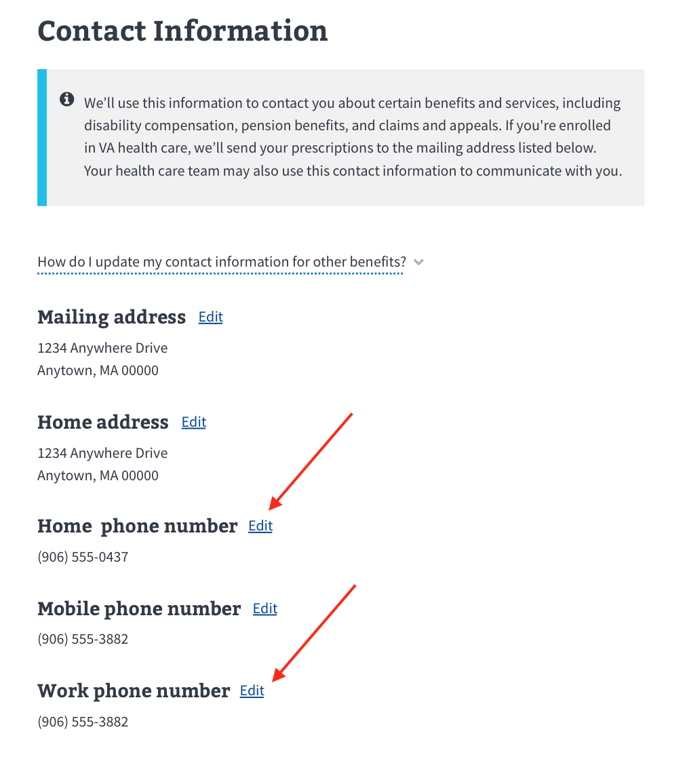

1. In the phone number form, have them enter their current home or work phone number and click **Update**.

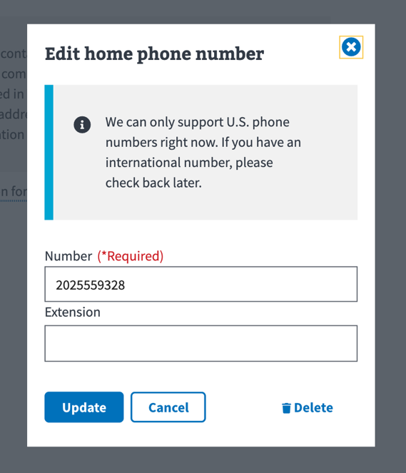

1. Once they update their home or work phone number, they should try again to update their direct deposit information. It should work this time.
   1. **Note**: This is unlikely, but it is possible that someone will get another error related to changing a different phone number **or** to changing their mailing address (see Mailing Address section above) after they’ve fixed their phone number. This is unlikely but it is possible. Once they fix their phone number(s) and/or mailing address, they should be able to update their direct deposit information.

**Additional Information on Direct Deposit for Compensation & Pension**

There is additional content that users can read and bookmark on direct deposit. This content can be found at <https://www.va.gov/change-direct-deposit/>.

**For people who want to switch from paper checks to direct deposit**

People can **switch from paper checks to direct deposit from their VA.gov profile**. That is outlined in the “How to Access and Update Direct Deposit for Compensation & Pension” starting on page 4 above (step 4 in the process).

However, if people do not want to do this online, they can:

* Fill out VA Form 24-0296 and submit this to a regional office
  + <https://vbaw.vba.va.gov/bl/20/cio/20s5/forms/VBA-24-0296-ARE.pdf>.
* **Or** this change can be done over the phone by the National Call Center.
* **Or** they can make this change in person at their regional office.

**For people who want to switch from direct deposit to paper checks, or change the address their paper checks are sent to**

They can:

* Fill out VA Form 21-572 and submit this to a regional office
  + <https://vbaw.vba.va.gov/bl/20/cio/20s5/forms/VBA-20-572-ARE.pdf>.
* **Or** this change can be done over the phone by the National Call Center.
* **Or** they can make this change in person at their regional office.