**Education Benefits Application (VA Form 22-1990)**

Table of Contents

Education Benefits Application Overview 3

User Access 3

Who can access this application? 3

Navigation 4

Education Application Wizard 6

Education Benefits Application 11

Part 1: Application Information 11

Benefits Eligibility 13

Military History 18

Service Periods 18

Active Duty: 19

ROTC History: 20

Contributions: 22

Education History 23

Employment History 25

School Selection 26

Personal Information 28

Secondary Contact 30

Direct Deposit: 31

Review Application 32

# Education Benefits Application Overview

There are seven different education forms/applications available on VA.gov. These applications are accessed through the same education application wizard in addition to having separate URLS. Below is a list of the education forms available on VA.gov:

1. Education Benefits Application (22-1990)
2. Education Benefits Transfer Application (22-1990E)
3. Education Change of Program or Training Application (22-1995)
4. Education Benefits for National Call to Service Application (22-1990N)
5. Education Benefits for Eligible Dependents (22-5490)
6. Education Change of Program or Training Application under FRY or DEA (22-5495)
7. VET TEC Application (22-0994)

This product guide covers the Education Benefits Application (22-1990)

## User Access

### Who can access this application?

Veterans do not need to be signed into complete this application. However, if they aren’t signed in, the application will not be prefilled with their information and the veteran will not be able to save their application in progress. You can reference the below screenshot for more information on this:

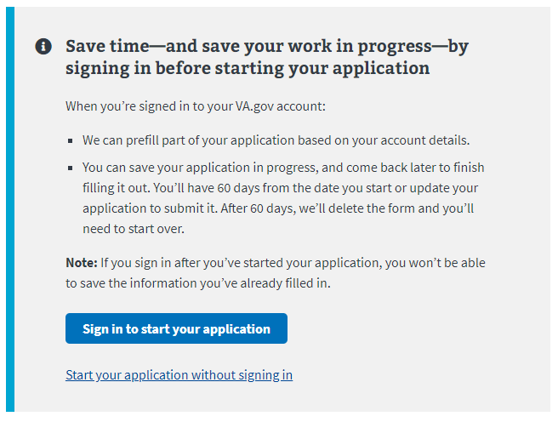

## Navigation

**Direct url:**​ https://www.va.gov/education/apply-for-education-benefits/application/1990/introduction/

**Or** the link for the education application can be found on the ​**VA.gov**​ homepage.

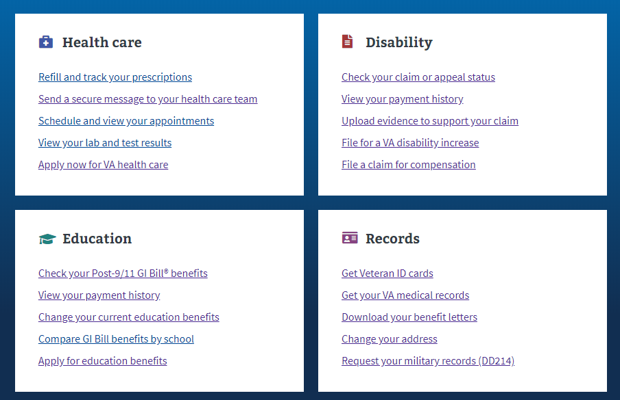

**Or** the link can be found in the dropdown menu:

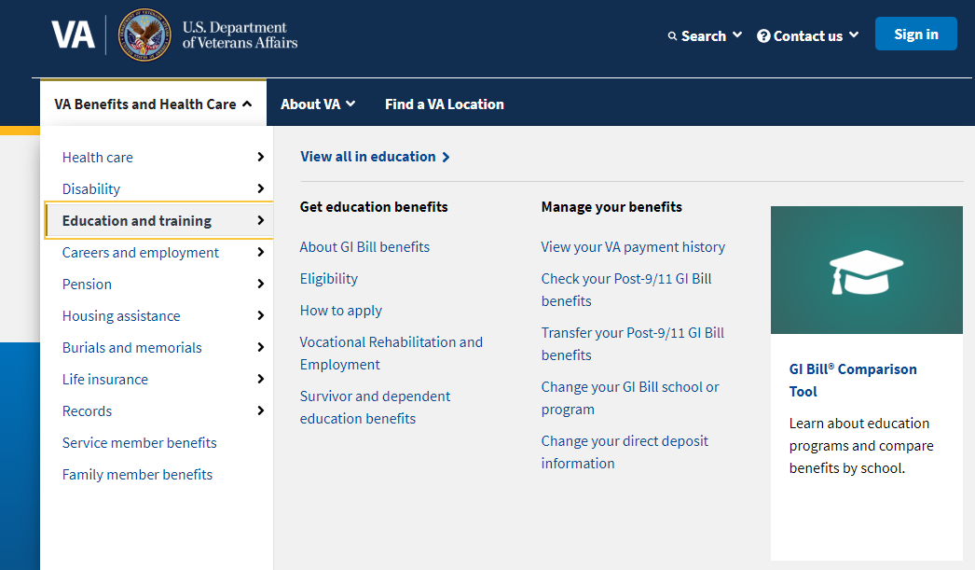

**Or** on the Education Hub Page: <https://www.va.gov/education/>



# Education Application Wizard

<https://www.va.gov/education/>

Instead of providing links to the different education applications, VA.gov uses an education application wizard to determine which application/form a user should fill out and submit. . This wizard asks the veteran several questions and based on their answers, the veteran will be taken to the correct form.

For the Education Benefits Application (VA-Form 22-1990) the user must answer the education application wizard in the following way:

* Are you applying for a benefit or updating your program or place of training?
  + Applying for a new benefit
* Are you a veteran or service member claiming a benefit based on your own service?
  + Yes
* Are you claiming a National Call to Service education benefit?
  + No
* Are you applying for Veteran Employment Through Technology Education Courses (VET TEC)
  + No

See screenshot below for what the wizard looks like:

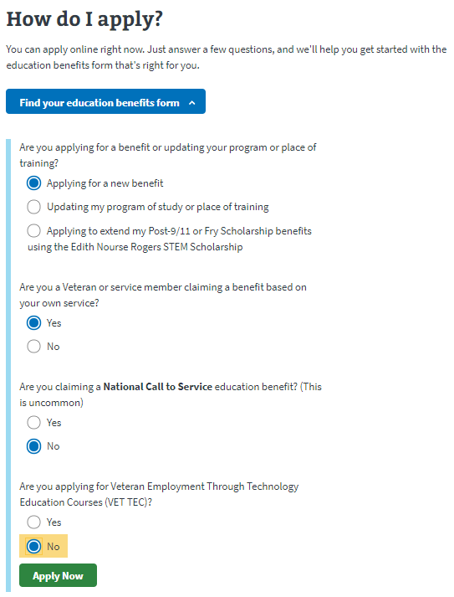

After selecting “Apply Now” the veteran will see the next page. The screenshot below is what the user will see if they are signed into an LOA1 (not identity verified) OR an LOA3 (identity verified account) and outlines application and review process:

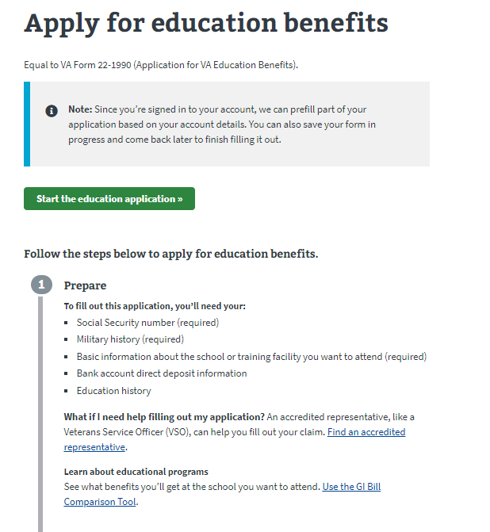

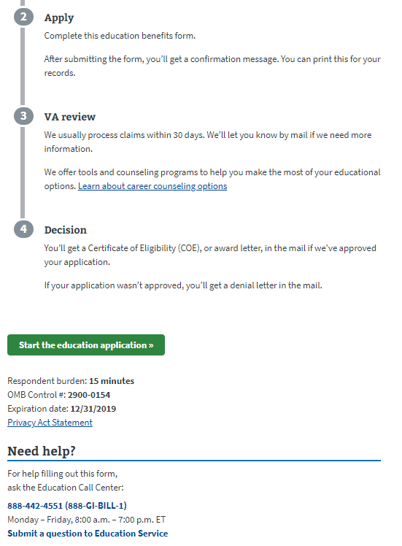

If the user is not signed in, they will see the below message about the advantages of signing in or creating an account before completing the application:

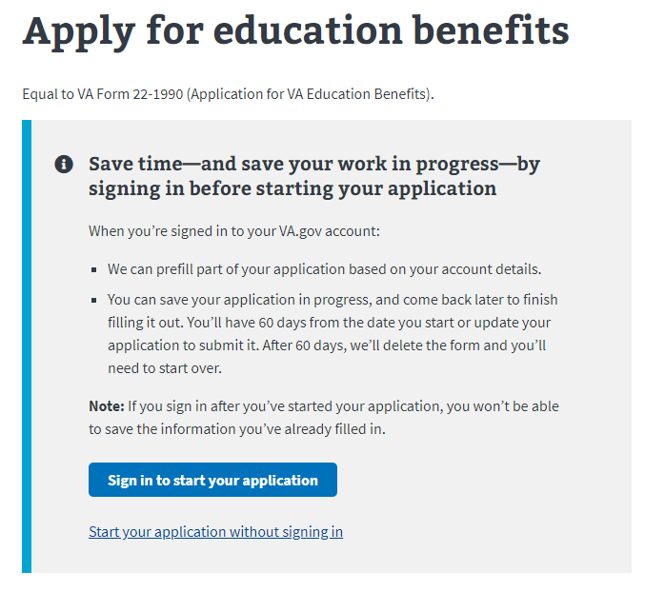

# Education Benefits Application­

## Application Information

First, the user will be asked to fill in general personal information. If they are signed in, the application will be pre-filled but the veteran can also change this information. If they are not signed in, they will need to add the information.

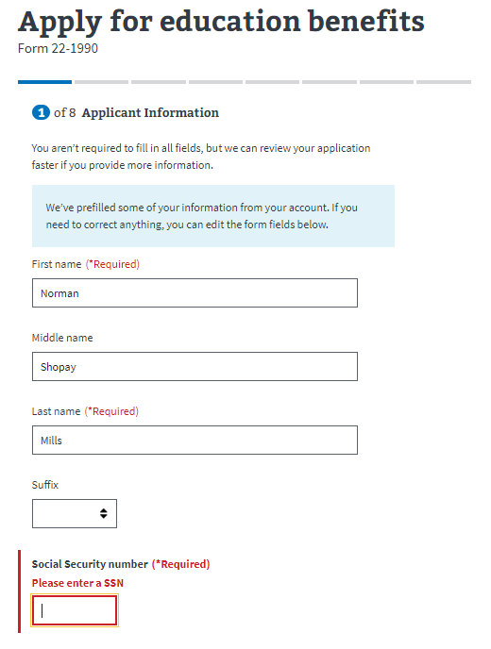

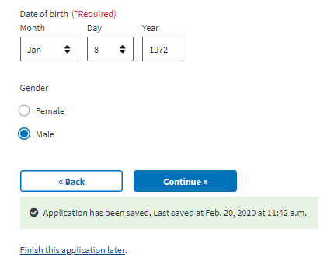

The application will tell the veteran what must be filled in. If they do not enter all the required information, they will not be allowed to move on to the next page.

## Benefits Eligibility

The next section will ask the veteran about the benefits they are eligible for. The veteran will be asked to select the benefit that is the best match for them. The veteran can click on the “Learn more” link for each benefit and a new browser tab will open with information. The veteran can also select more than one benefit.

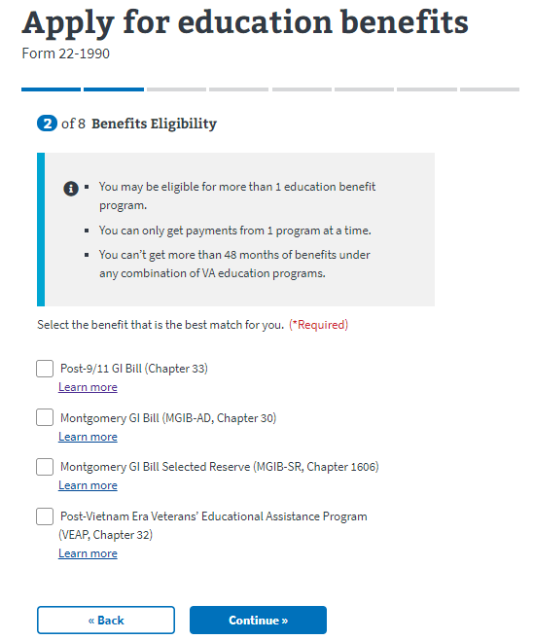

If the user DOES NOT select the Post-9/11 GI Bill Benefit, they will be taken to the Military History portion of the application.

If the veteran selects the Post-9/11 GI Bill benefit, a dropdown will appear that explains the veteran will have to give up 1 other benefit they may be eligible for if they choose to apply for this particular benefit.

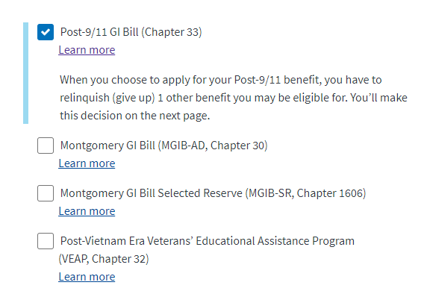

If they select to continue with the Post-9/11 GI Bill benefit, the veteran will be shown the following page:

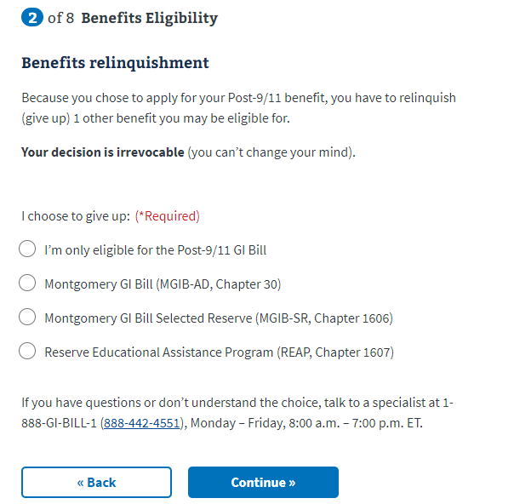

If the veteran selects “I’m only eligible for the Post-9/11 GI Bill, they can continue to the next page of the application.

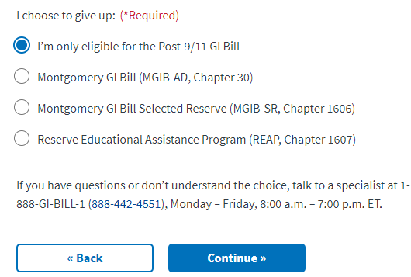

If the veteran selects “Montgomery GI Bill (MGIB-AD, Chapter 30), the below dropdown will appear and they must fill out the information to continue:

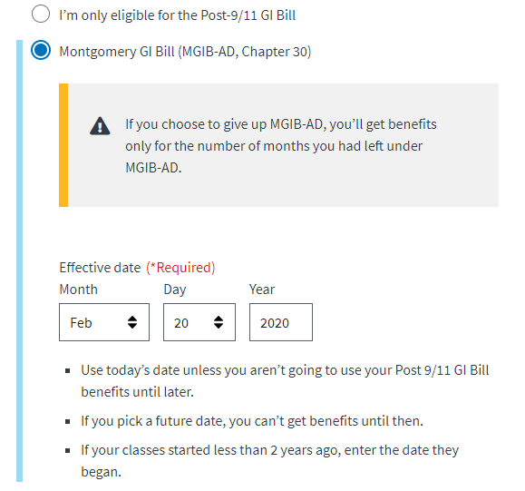

If the veteran selects “Montgomery GI Bill Selected Reserve (MGIB-SR, Chapter 1606), the below dropdown will appear and they must fill out the information to continue:

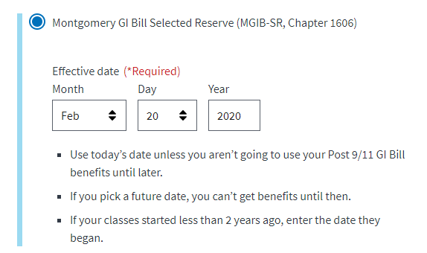

If the veteran selects “Reserve Educational Assistance Program (REAP, Chapter 1607), the below dropdown will appear and they must fill out the information to continue:

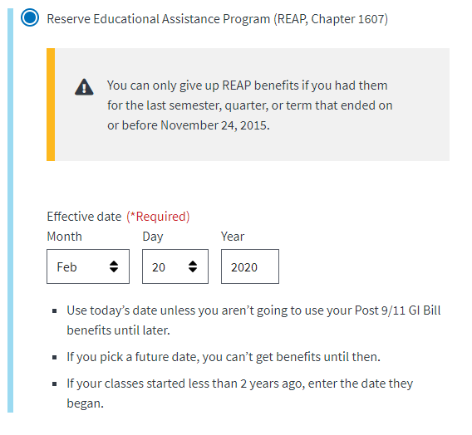

If the user is confused by this information, there is a help number provided where they can call to get more information:



## Military History

### Service Periods

Next, the veteran will be asked to enter all of their periods of service. If they are signed in, this should be pre-filled. But they can edit and add more if they need to:

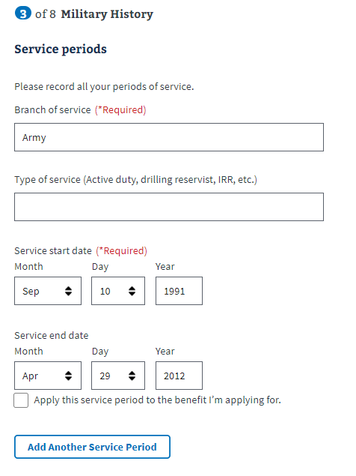

­

### Active Duty:

Next they will be asked if they received a commision from a military service academy and they year they graduated. They will also be asked if they are on active duty now. If they select no, they can continue to the next page:

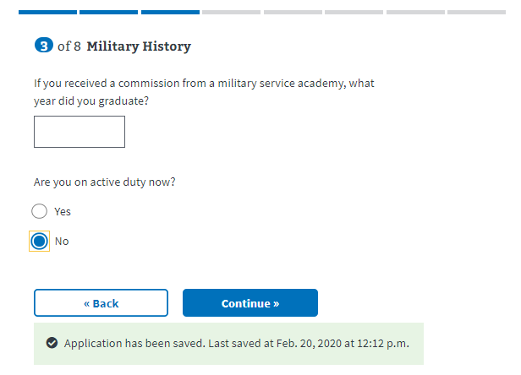

If they select yes, a dropdown will appear with an additional question about terminal leave.

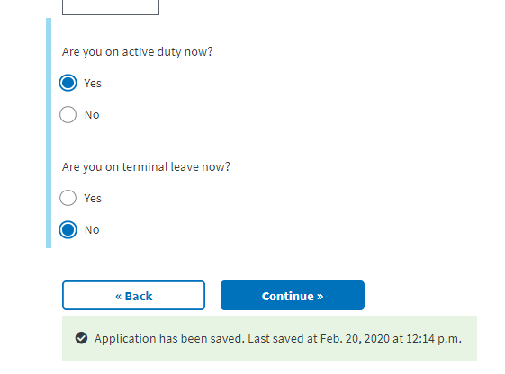

### ROTC History:

Next the veteran will be asked about any ROTC history they might have.

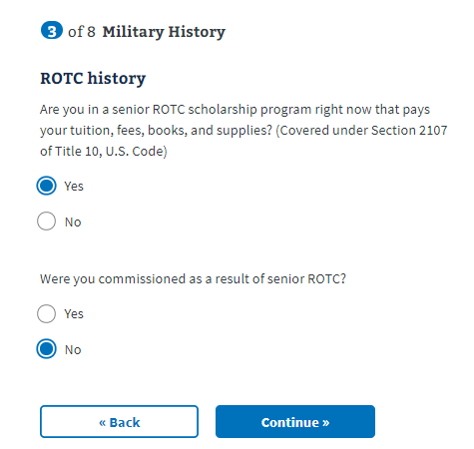

They will continue onto the next page, unless they select YES for the question about commissioning as a result of senior ROTC. If they select YES, a drop down will appear with additional questions.

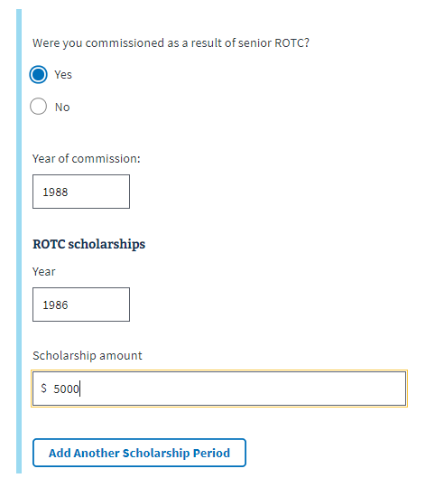

The veteran can select “Add Another Scholarship Period” if they have more than one.

### Contributions:

Next the veteran will be asked to select all the contributions that apply.

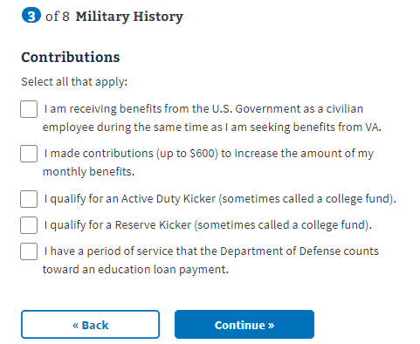

If they select the last contribution (“I have a period of service that the Department of Defense counts toward an education loan payment”) a dropdown will appear with additional questions:

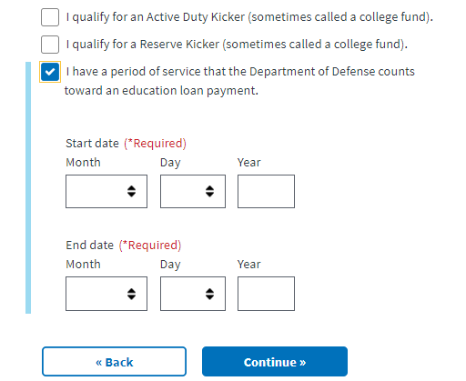

## Education History

Next the veteran will move into the Education History section. On the first page, they will be asked general questions about their education, starting with high school:

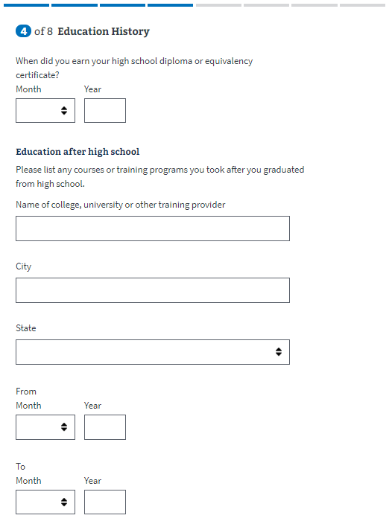

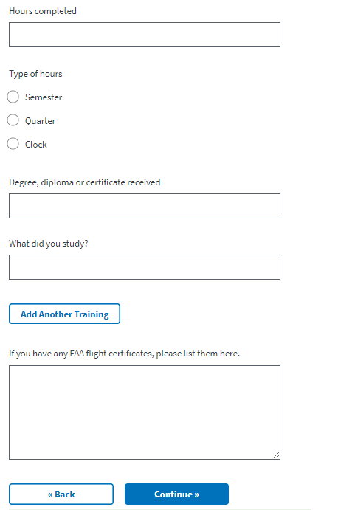

## Employment History

Next the veteran will answer questions about their employment history.

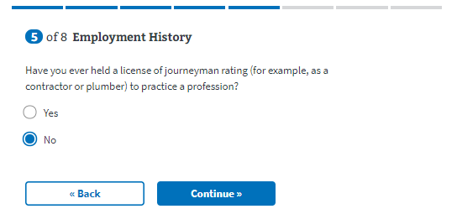

If the veteran has not held a license of journeyman rating to practice a profession, they will move on to the next page. If they answer yes, a dropdown will appear with additional questions. They will be able to add multiple employment periods if necessary:

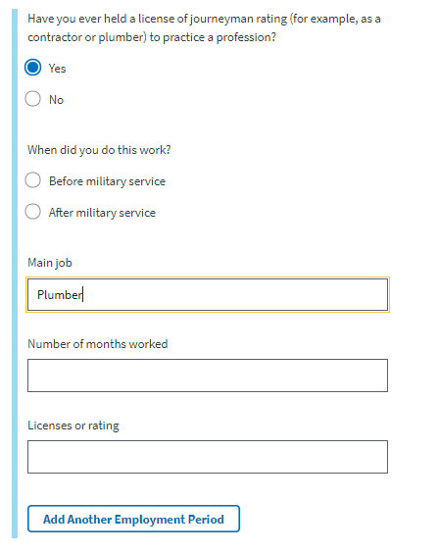

## School Selection

Next, the veteran will be asked for details about the school they have selected:

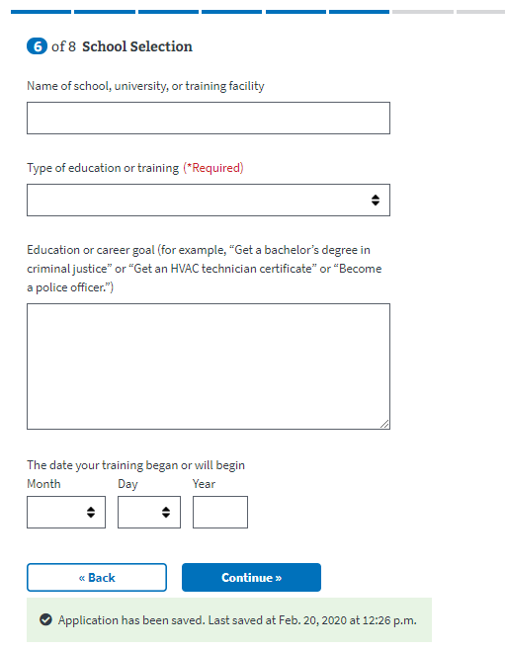

For the type of education or training dropdown, certain fields produce a dropdown that must be filled in to move on to the next page of the application. They are the following:

* College, university, or other educational program, including online courses
* Correspondence
* Apprenticeship or on-the-job training
* Vocational flight training

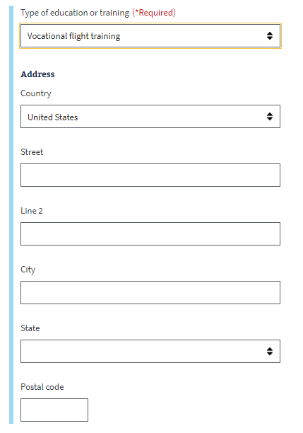

## Personal Information

Next the veteran will be asked to enter personal information about how they should be contacted if there are questions about their application:

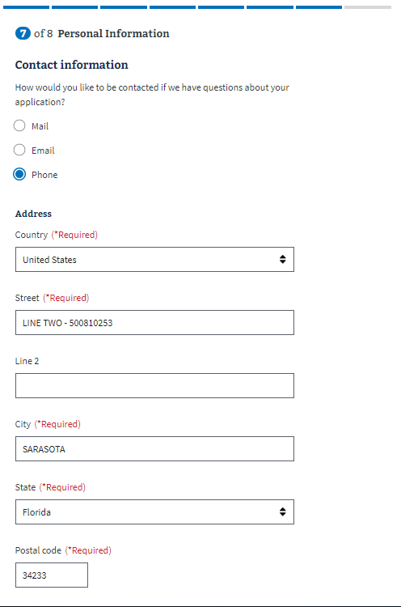

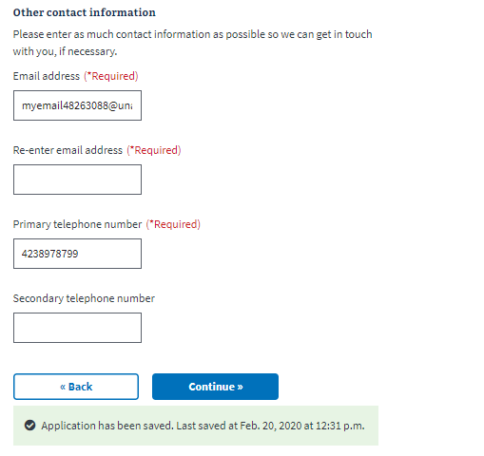

### Secondary Contact

Next they will be asked to enter contact information for a secondary contact:

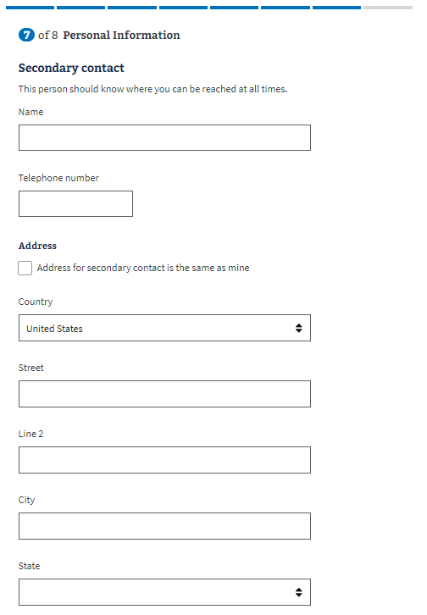

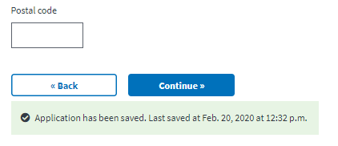

### Direct Deposit:

Next the user will be asked to enter direct deposit information:

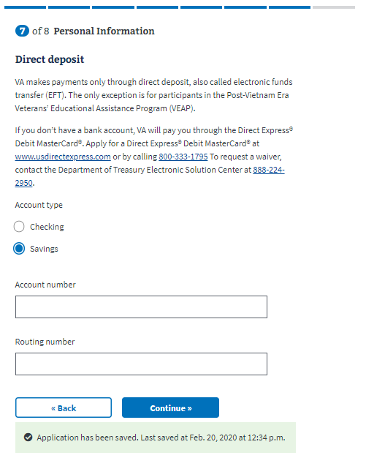

## Review Application

The last step is the review application page. Here the veteran can review the information they’ve entered by clicking on the plus signs next to a section:

­ 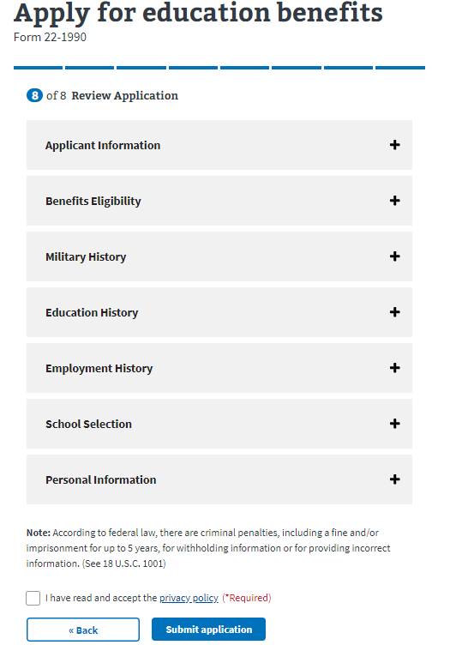

If the veteran clicks on the plus sign, the section will open and show what the user entered. If something looks wrong, the veteran can select the “edit” button, and will be able to make edits on the information:

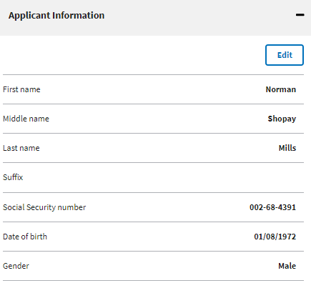

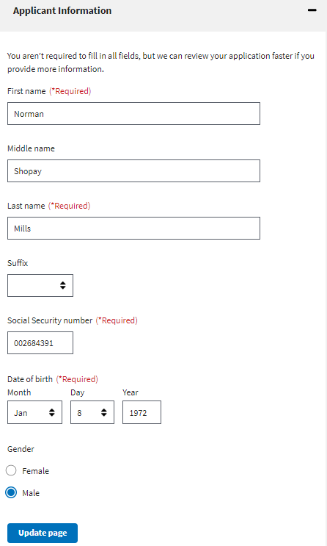

Once the user has reviewed the information and made any changes, they can select to submit the application. They can only successfully submit the application after selecting the “I have read and accept the privacy policy” check box:

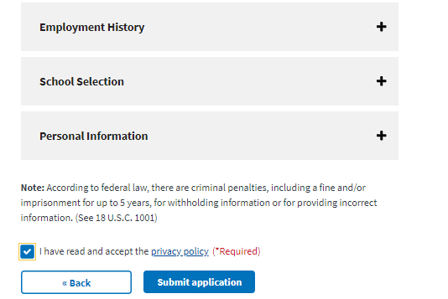

After selecting “submit application” the user will be shown the below page which contains a summary of the information, as well as additional information links that can help the veteran understand the process for their education claim:

