**Education Benefits for National Call to Service Application**

**(VA Form 22-1990N)**

Table of Contents

Education Benefits Application Overview 2

User Access 3

Who can access this application? 3

Navigation 3

Education Application Wizard 5

Education Benefits for National Call to Service Application 11

Application Information 11

Additional Benefits: 12

Applicant Service 13

Benefit Selection 16

School Selection 17

Personal Information 18

Direct Deposit: 20

Review Application 21

# Education Benefits Application Overview

There are seven different education forms/applications available on VA.gov. These applications are accessed through the same education application wizard in addition to having separate URLS. Below is a list of the education forms available on VA.gov

1. Education Benefits Application (22-1990)
2. Education Benefits Transfer Application (22-1990E)
3. Education Change of Program or Training Application (22-1995)
4. Education Benefits for National Call to Service Application (22-1990N)
5. Education Benefits for Eligible Dependents (22-5490)
6. Education Change of Program or Training Application under FRY or DEA (22-5495)
7. VET TEC Application (22-0994)

This product guide covers the Education Benefits for National Call to Service Application (22-1990N)

## User Access

### Who can access this application?

Veterans do not need to be signed into complete this application. However, if they aren’t signed in, the application will not be prefilled with their information and the veteran will not be able to save their application in progress. You can reference the below screenshot for more information on this:

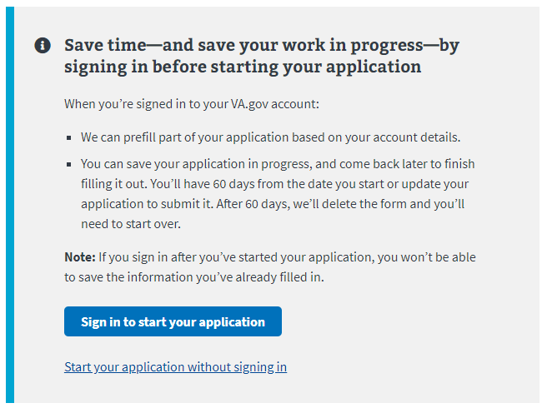

## Navigation

**Direct url:**​ <https://www.va.gov/education/apply-for-education-benefits/application/1990N/introduction>

**Or** the link for the education application can be found on the ​**VA.gov**​ homepage.

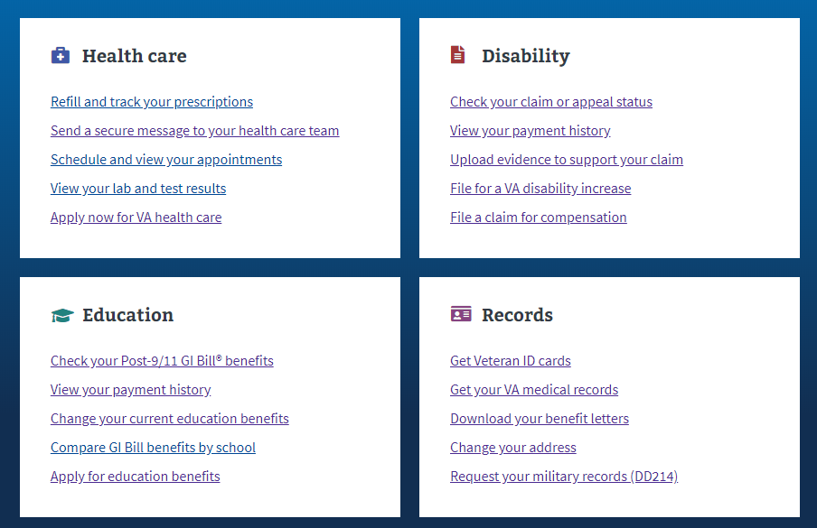

**Or** the link can be found in the dropdown menu:

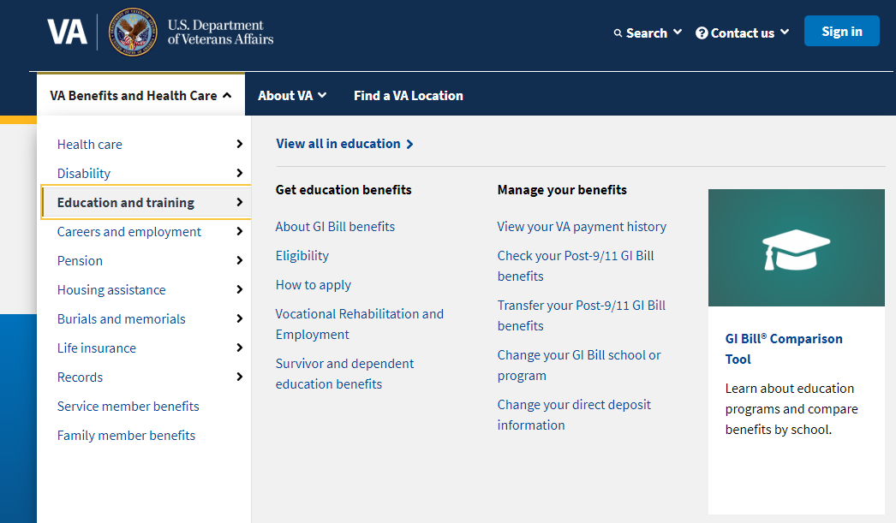

**Or** on the Education Hub Page: <https://www.va.gov/education/>

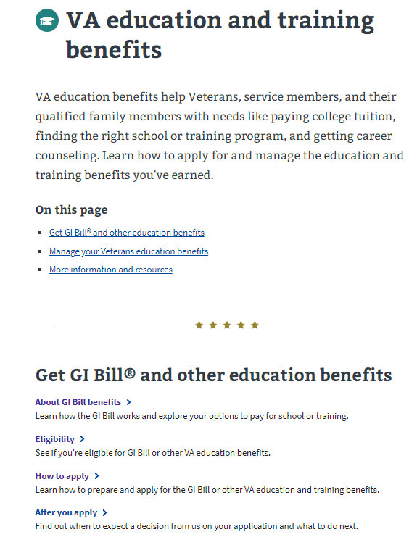

# Education Application Wizard

<https://www.va.gov/education/>

Instead of providing links to the different education applications, VA.gov uses an education application wizard to determine which application/form a user should fill out and submit. . This wizard asks the veteran several questions and based on their answers, the veteran will be taken to the correct form.

For the Education Benefits for National Call to Service Application (VA-Form 22-1990N) the user must answer the education application wizard in the following way:

* Are you applying for a benefit or updating your program or place of training?
  + Applying for a new benefit
* Are you a veteran or service member claiming a benefit based on your own service?
  + Yes
* Are you claiming a National Call to Service education benefit?
  + Yes

See screenshot below for what the wizard looks like. You will notice the wizard has some messages for the 22-1990N. These are meant to help veterans be sure they are filling in the right education benefit form.

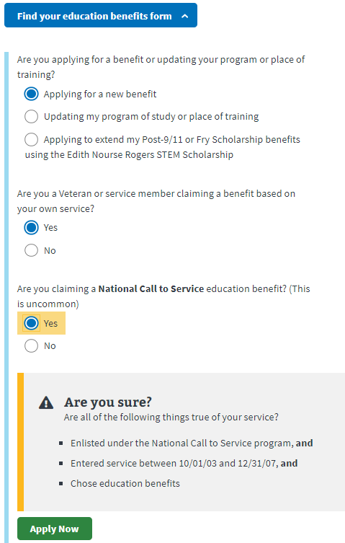

After selecting “Apply Now” the veteran will see the next page. The screenshot below is what the user will see if they are signed into an LOA1 (not identity verified) OR an LOA3 (identity verified account) and outlines application and review process:

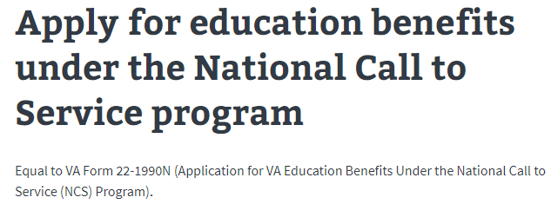

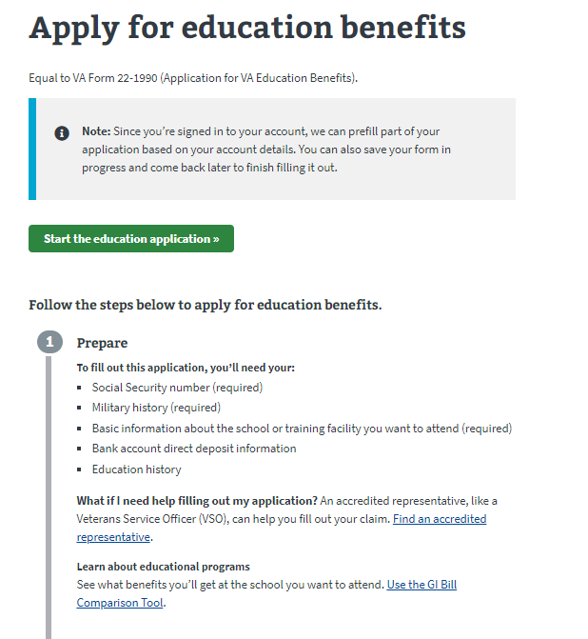

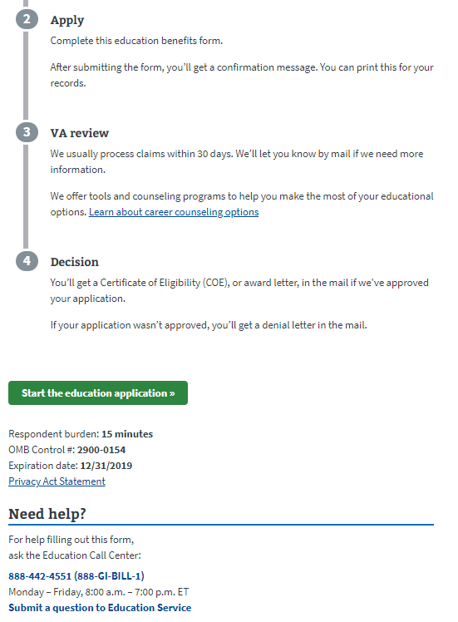

If the user is not signed in, they will see the below message about the advantages of signing in or creating an account before completing the application:

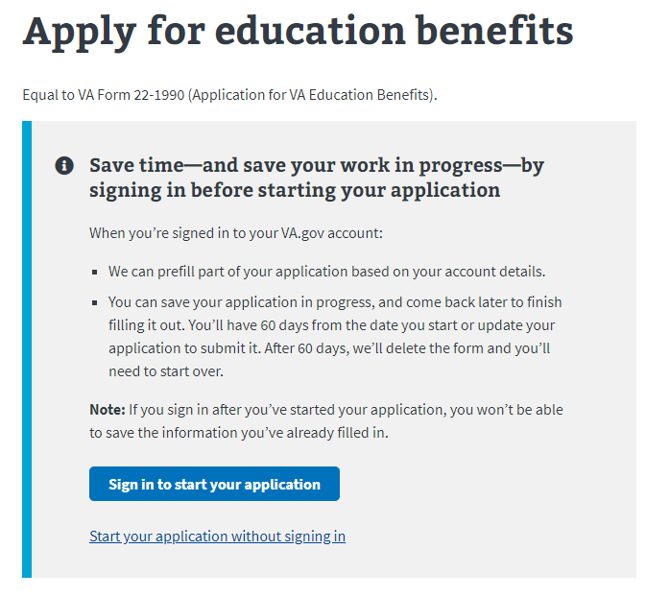

# Education Benefits for National Call to Service Application­

## Application Information

First, the user will be asked to fill in general personal information. If they are signed in, the application will be pre-filled but the veteran can also change this information. If they are not signed in, they will need to add the information.

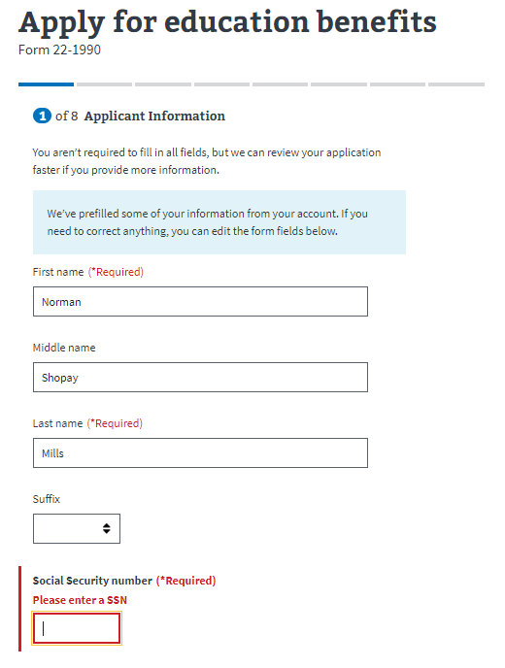

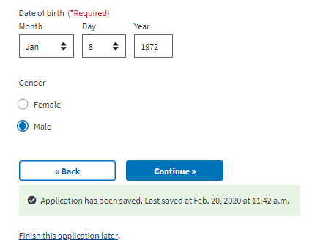

The application will tell the veteran what must be filled in. If they do not enter all the required information, they will not be allowed to move on to the next page.

### Additional Benefits:

Next the veteran will be asked about any additional benefits they might be receiving.

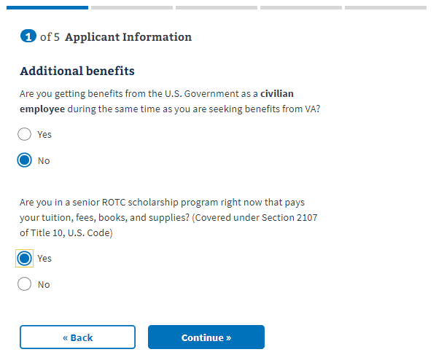

If the veteran answers Yes to the “are you getting benefits from the U.S. Government as a civilian employee during the same time as you are seeking benefits from the VA?” a dropdown will appear with an additional question:

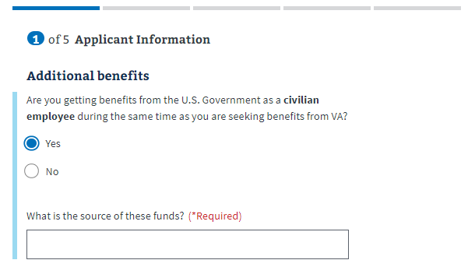

### Applicant Service

Next, the veteran will be asked to enter all their periods of service. If they are signed in, this should be pre-filled. But they can edit and add more if they need to:

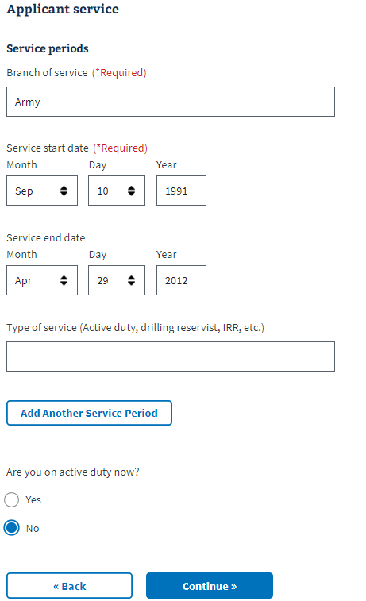

If the user selects Yes on the “Are you on active duty now?” question, a dropdown will appear with additional questions:

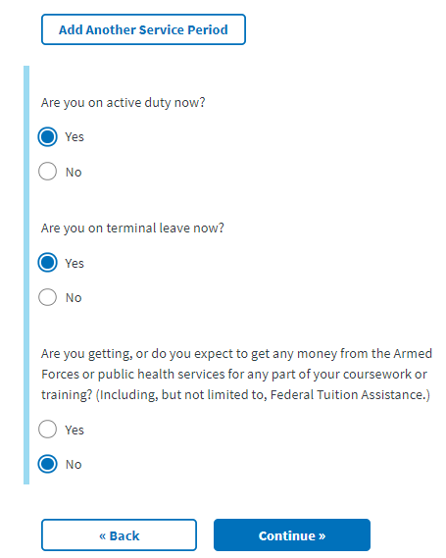

## Benefit Selection

Next the veteran will be shown a statement about authorizing the VA to pay the benefit with the highest monthly rate if the veteran is eligible for more than one benefit. The checkbox will be automatically selected but the veteran can uncheck the box.

­ 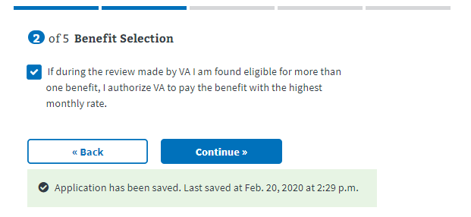

## School Selection

Next the veteran will enter information about the school or program where they want to apply their benefits.

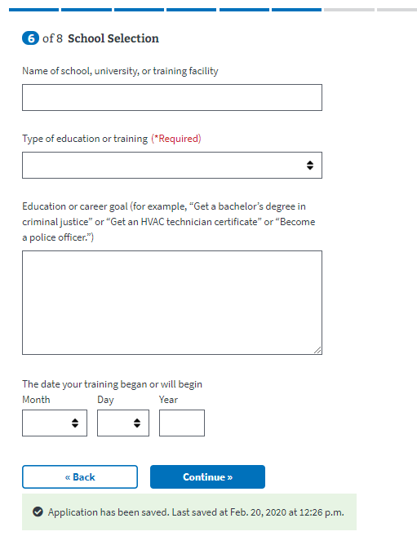

For the “Type of Education or Training Dropdown”, certain fields produce a dropdown that must be filled in to move on to the next page of the application. They are the following:

* College, university, or other educational program, including online courses
* Correspondence
* Apprenticeship or on-the-job training
* Vocational flight training

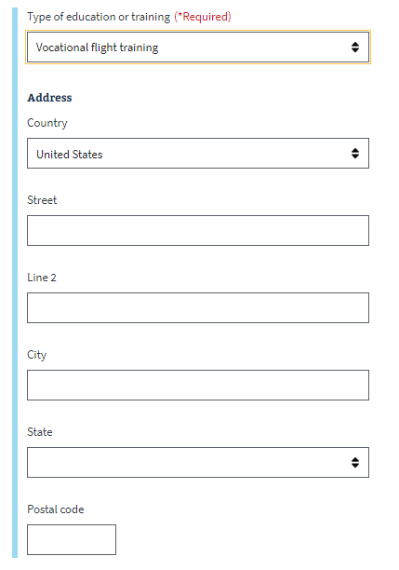

## Personal Information

Next the veteran will be asked to enter personal information about how they should be contacted if there are questions about their application:

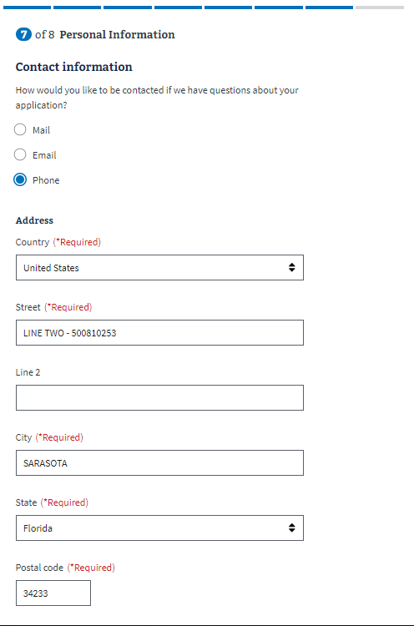

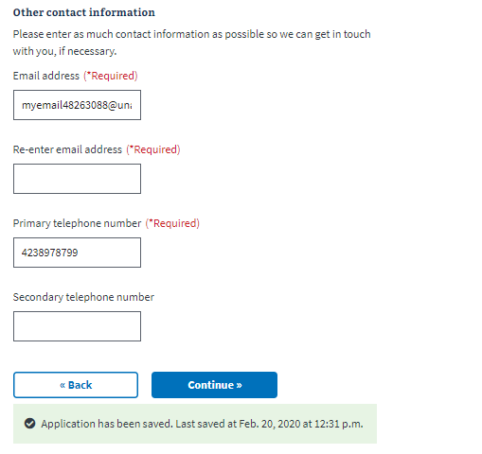

### Direct Deposit:

Next the user will be asked to enter direct deposit information:

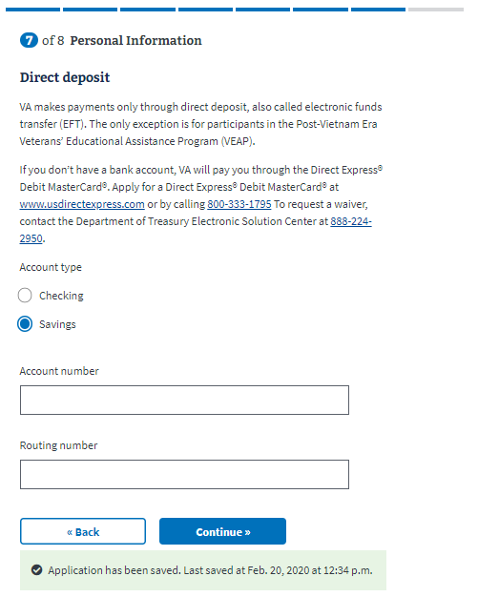

## Review Application

The last step is the review application page. Here the veteran can review the information they’ve entered by clicking on the plus signs next to a section:

­ 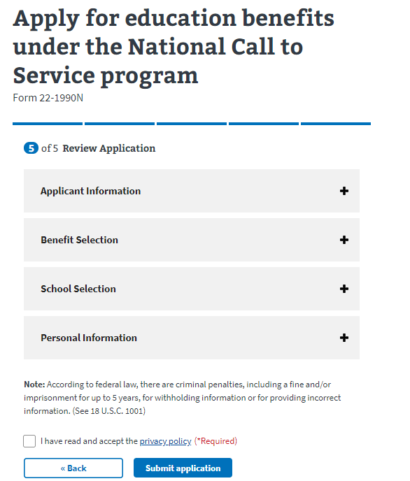

If the veteran clicks on the plus sign, the section will open and show what the user entered. If something looks wrong, the veteran can select the “edit” button, and will be able to make edits on the information:

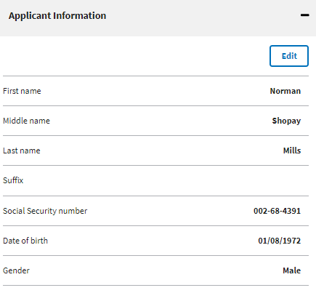

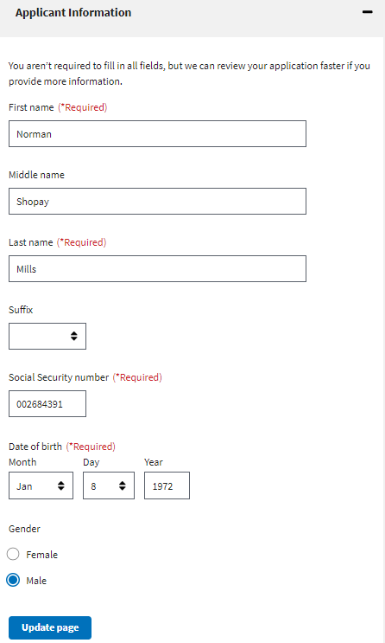

Once the user has reviewed the information and made any changes, they can select to submit the application. They can only successfully submit the application after selecting the “I have read and accept the privacy policy” check box:

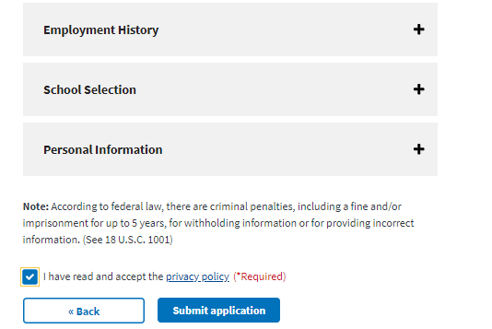

After selecting “submit application” the user will be shown the below page which contains a summary of the information, as well as additional information links that can help the veteran understand the process for their education claim:

