**Education Change of Program or Training Application (22-1995)**

Table of Contents

Education Benefits Application Overview 1

User Access 2

Who can access this application? 2

Navigation 2

Education Application Wizard 4

Scenario 1 5

Scenario 2 5

Scenario 3 6

Education Change of Program or Training Application 10

Application Information 10

Education Benefit 11

Military History 14

School Selection 16

Last Attended Schooling 18

Personal Information 20

Direct Deposit: 22

Review Application 24

# Education Benefits Application Overview

There are seven different education forms/applications available on VA.gov. These applications are accessed through the same education application wizard in addition to having separate URLS. Below is a list of the education forms available on VA.gov:

1. Education Benefits Application (22-1990)
2. Education Benefits Transfer Application (22-1990E)
3. Education Change of Program or Training Application (22-1995)
4. Education Benefits for National Call to Service Application (22-1990N)
5. Education Benefits for Eligible Dependents (22-5490)
6. Education Change of Program or Training Application under FRY or DEA (22-5495)
7. VET TEC Application (22-0994)

This product guide covers the Education Change of Program or Training Application (22-1995)

## User Access

### Who can access this application?

Veterans do not need to be signed into complete this application. However, if they aren’t signed in, the application will not be prefilled with their information and the veteran will not be able to save their application in progress. You can reference the below screenshot for more information on this:

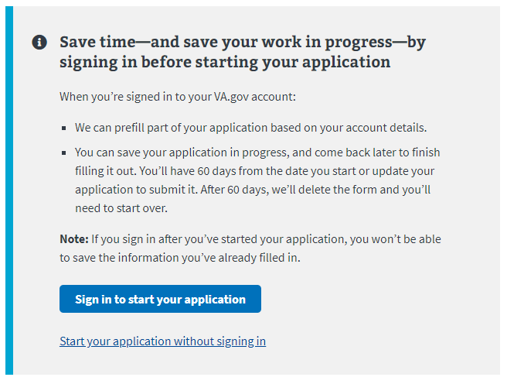

## Navigation

**Direct url:**​ <https://www.va.gov/education/apply-for-education-benefits/application/1995>

**Or** the link for the education application can be found on the ​**VA.gov**​ homepage.

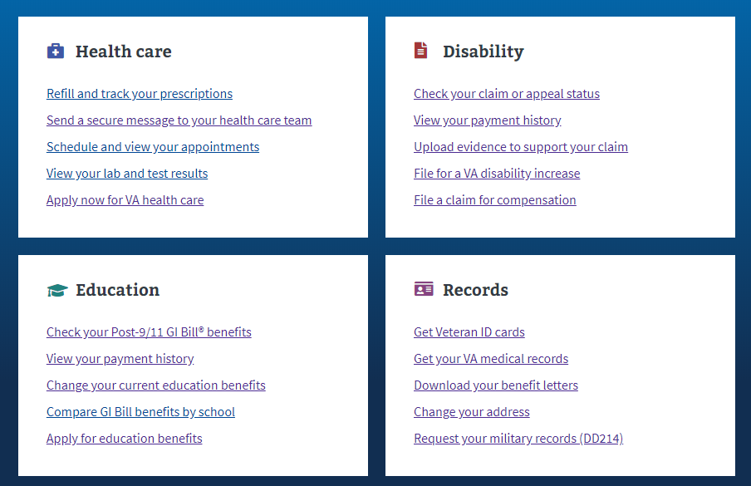

**Or** the link can be found in the dropdown menu:

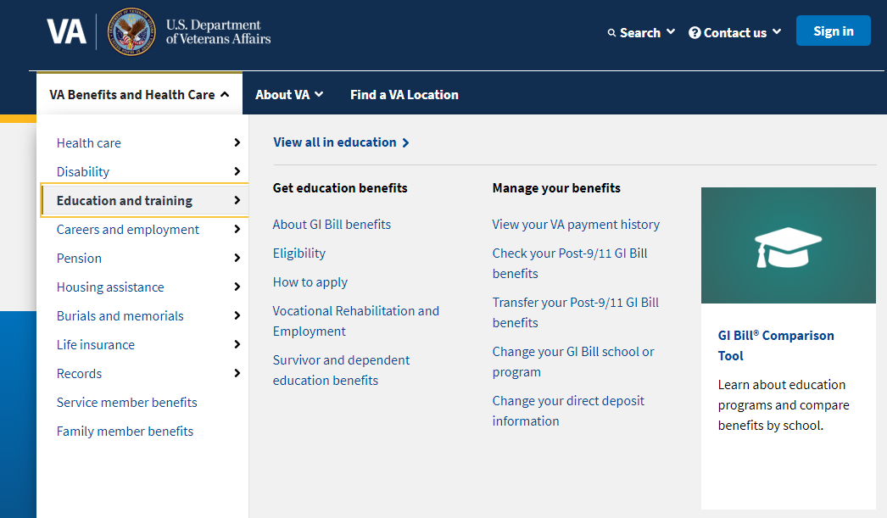

**Or** on the Education Hub Page: <https://www.va.gov/education/>

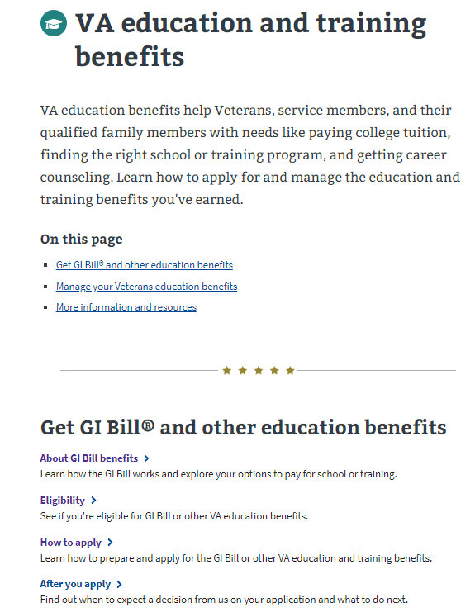

# Education Application Wizard

<https://www.va.gov/education/>

Instead of providing links to the different education applications, VA.gov uses an education application wizard to determine which application/form a user should fill out and submit. This wizard asks the veteran several questions and based on their answers, the veteran will be taken to the correct form.

There are three different ways for the VA-Form 22-1995 to be shown to the user when using the education application wizard.

### Scenario 1

* Are you applying for a benefit or updating your program or place of training?
  + Updating my current education benefits
* Are you receiving education benefits transferred to you by a sponsor Veteran?
  + No, I’m using my own benefits

See screenshot below for what the wizard looks like:

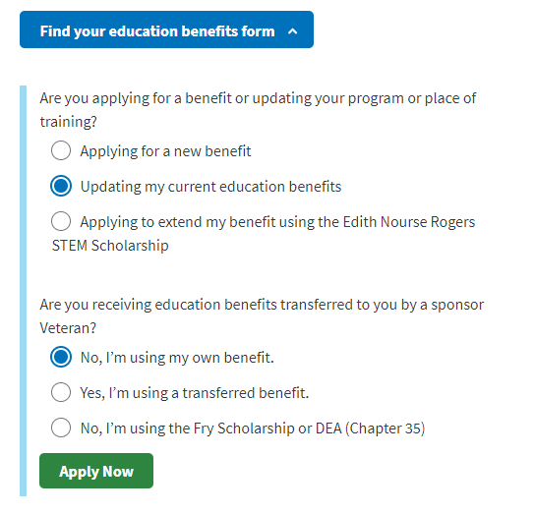

### Scenario 2

* Are you applying for a benefit or updating your program or place of training?
  + Updating my current education benefits
* Are you receiving education benefits transferred to you by a sponsor Veteran?
  + Yes, I’m using a transferred benefit.

See screenshot below for what the wizard looks like:

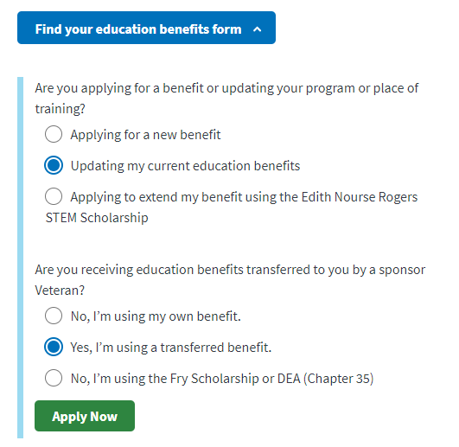

### Scenario 3

* Are you applying for a benefit or updating your program or place of training?
  + Applying to extend my benefit using the Edith Nourse Rogers Stem Scholarship

See screenshot below for what the wizard looks like:

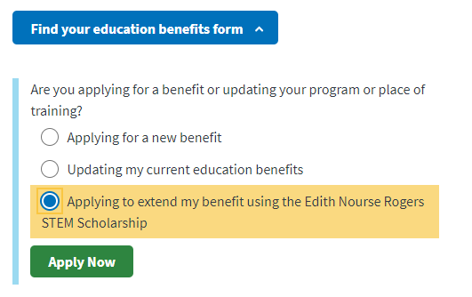

After selecting “Apply Now” the veteran will see the next page. The screenshot below is what the user will see if they are signed into an LOA1 (not identity verified) OR an LOA3 (identity verified account) and outlines application and review process:

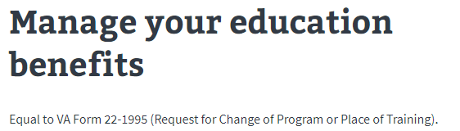

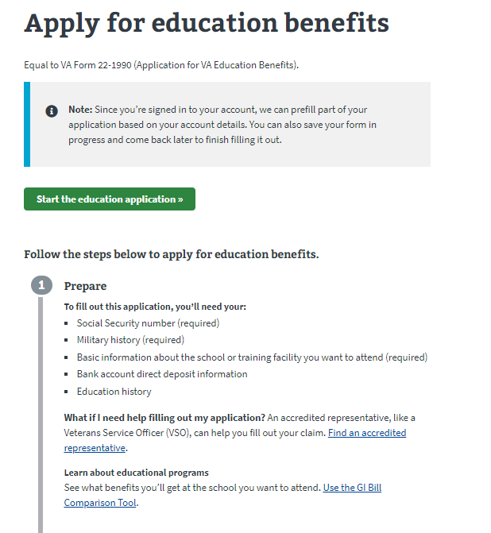

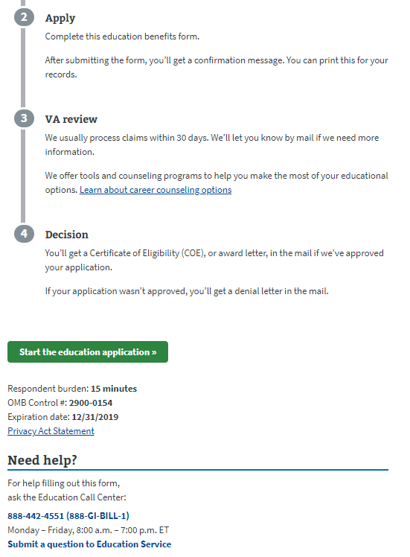

If the user is not signed in, they will see the below message about the advantages of signing in or creating an account before completing the application:

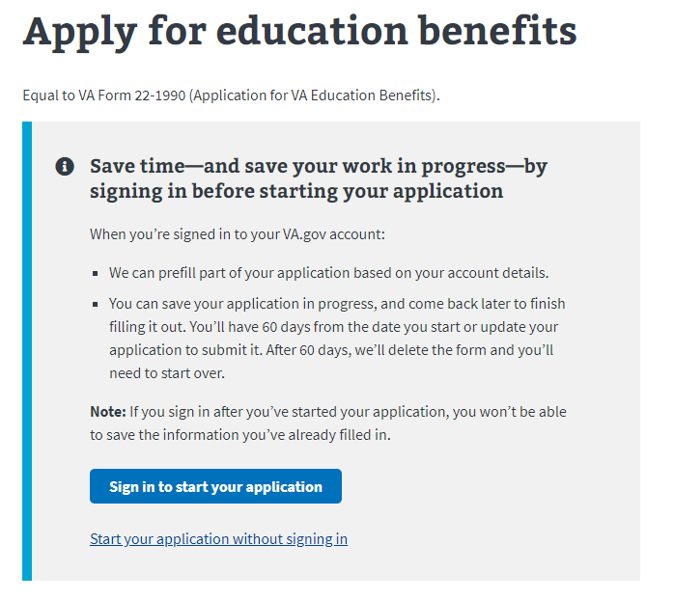

# Education Change of Program or Training Application

## Application Information

First, the user will be asked to fill in general personal information. If they are signed in, the application will be pre-filled but the veteran can also change this information. If they are not signed in, they will need to add the information.

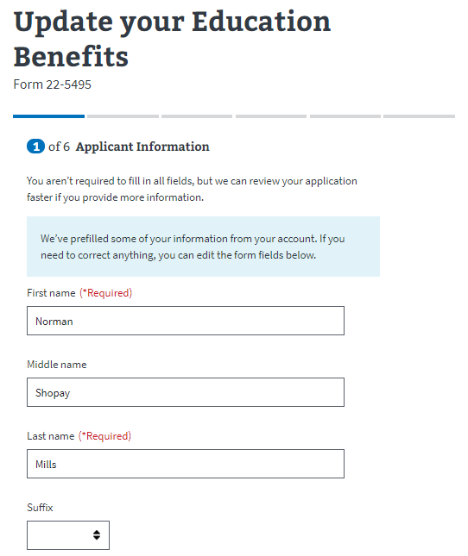

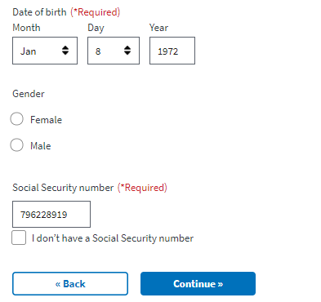

The application will tell the veteran what must be filled in. If they do not enter all the required information, they will not be allowed to move on to the next page.

## Education Benefit

The next section will ask the veteran about the benefits they are currently using or have used most recently. The user can click on the “learn more” links to open a new tab in their browser and find more information about the benefit.

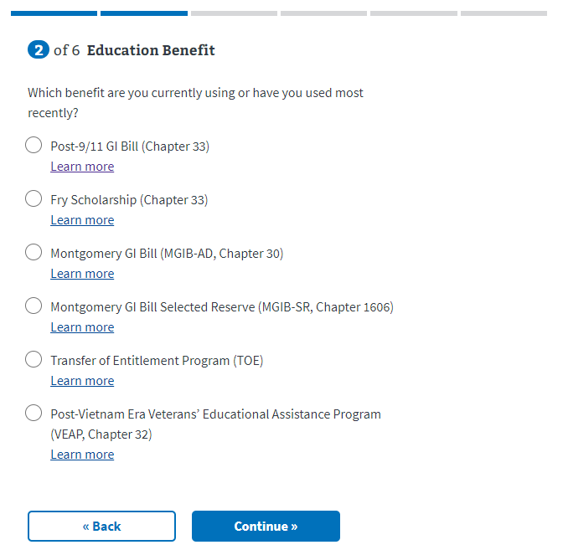

On the next page, the user will be asked if they are applying for the Edith Nourse Rogers STEM scholarship

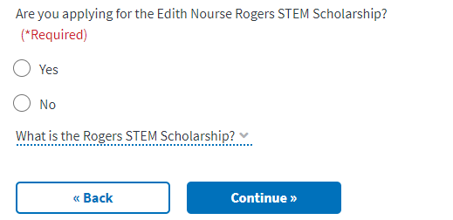

If the user selects no, they can continue onto the next page. If the user says yes, a dropdown will appear with an additional question:

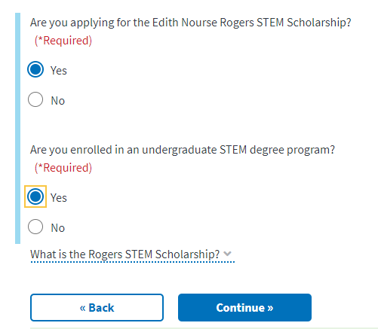

If the user selects no for the second question (are you enrolled in an undergraduate STEM degree program?) another dropdown question will appear.

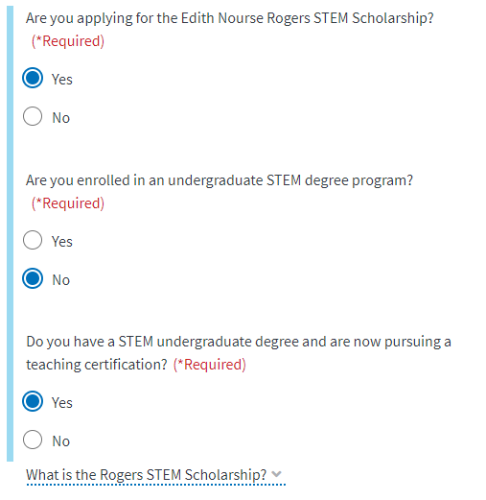

This page also has an inline FAQ that the user can reference for more information about the Rogers STEM Scholarship:



## Military History

Next, the user will be asked if they have any new periods of service to record since they last applied for education benefits.

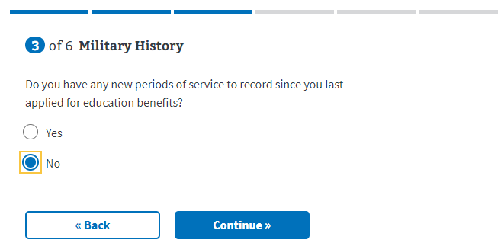

If they answer yes, a dropdown will appear where they can enter multiple periods of service:

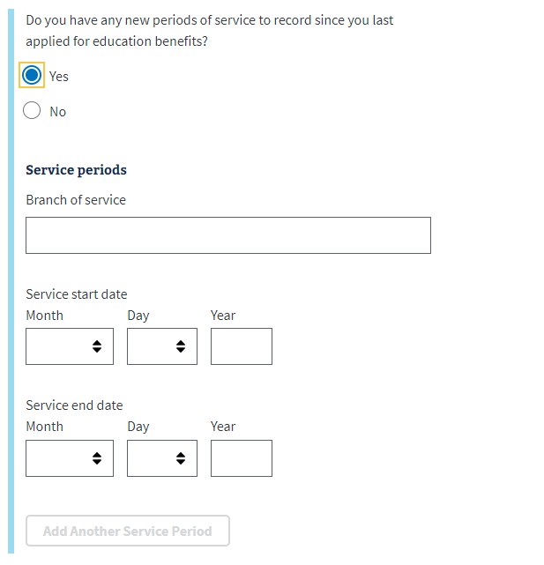

Next the user will be asked if they have an periods of service that began before 1978:

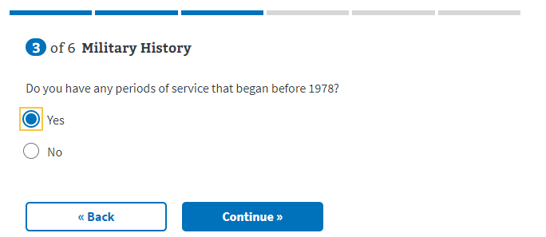

## School Selection

Next, the veteran will be asked for details about the school they have selected:

­­­­ 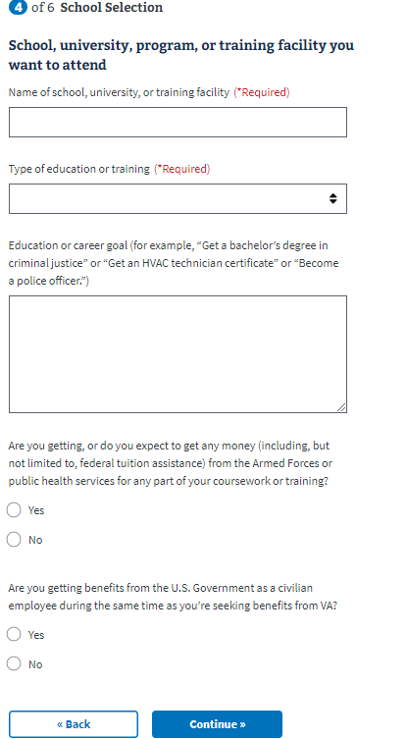

For the type of education or training dropdown, certain fields produce a dropdown that must be filled in to move on to the next page of the application. They are the following:

* College, university, or other educational program, including online courses
* Correspondence
* Apprenticeship or on-the-job training
* Vocational flight training

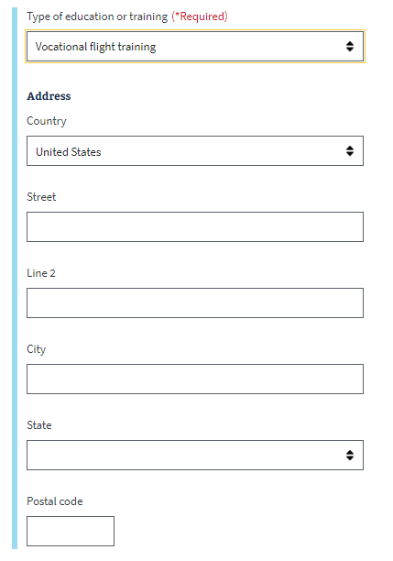

### Last Attended Schooling

Next, the user will be asked to enter information about the program or school they last attended:

­ 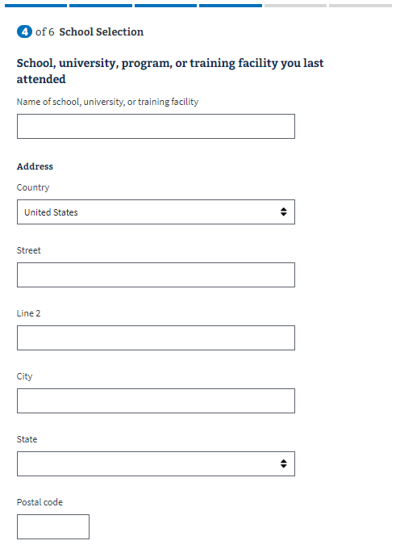

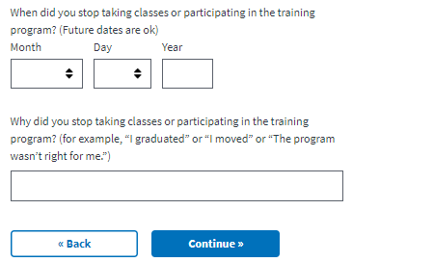

## Personal Information

Next the veteran will be asked to enter personal information about how they should be contacted if there are questions about their application:



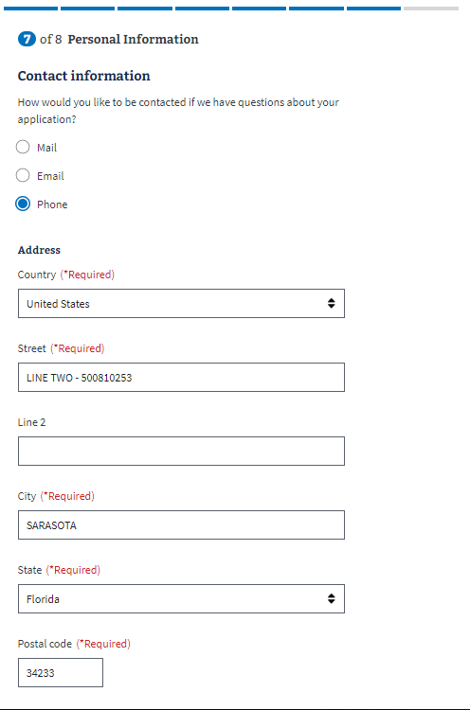

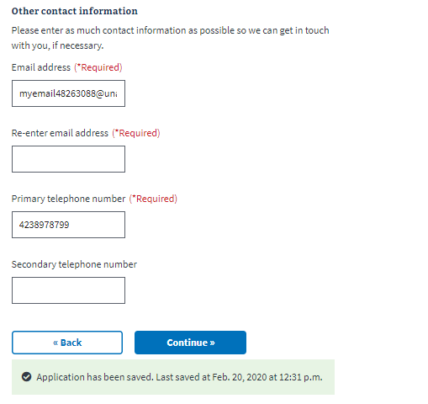

Next, the user will answer a few personal questions:

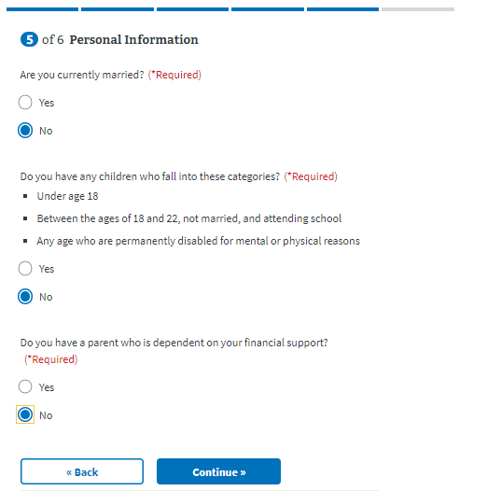

### Direct Deposit:

Next the user will be asked to enter direct deposit information:

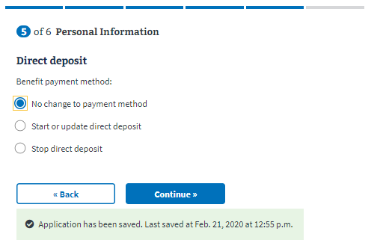

If the user selects “start or update direct deposit” a dropdown will appear with the fields to enter direct deposit account information:

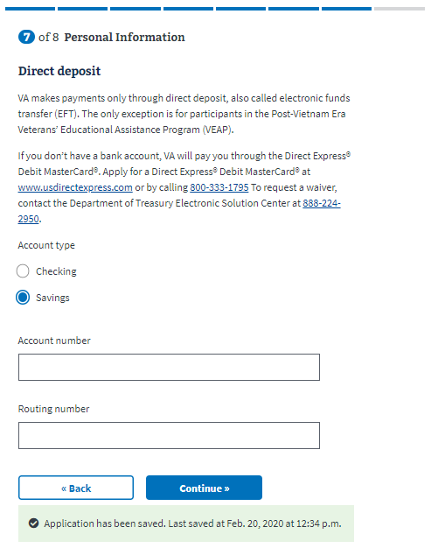

If the user selects “Stop direct deposit” a dropdown will appear explaining what you need to do if you can’t set up a direct deposit:

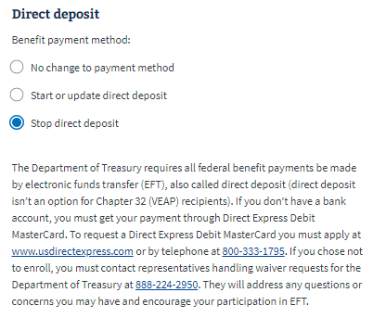

## Review Application

The last step is the review application page. Here the veteran can review the information they’ve entered by clicking on the plus signs next to a section:

­ 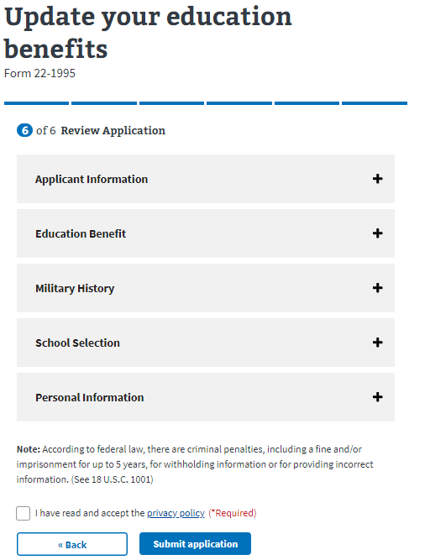

If the veteran clicks on the plus sign, the section will open and show what the user entered. If something looks wrong, the veteran can select the “edit” button, and will be able to make edits on the information:

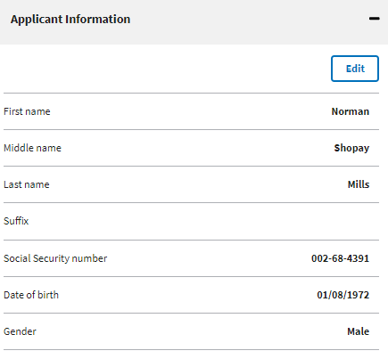

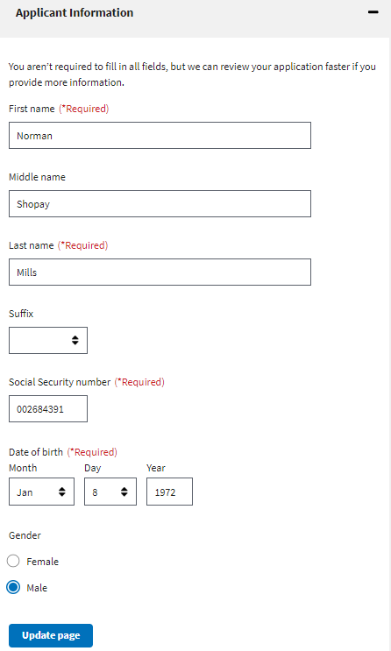

Once the user has reviewed the information and made any changes, they can select to submit the application. They can only successfully submit the application after selecting the “I have read and accept the privacy policy” check box:

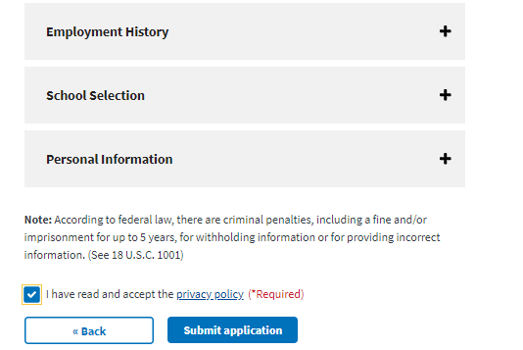

After selecting “submit application” the user will be shown the below page which contains a summary of the information, as well as additional information links that can help the veteran understand the process for their education claim:

