**Education Benefits as an Eligible Dependent**

**(VA Form 22-5490)**

Table of Contents

Education Benefits Application Overview 3

User Access 3

Who can access this application? 3

Navigation 5

Education Application Wizard 7

Education Benefits Transfer Application 12

Application Information 12

Additional Benefits: 14

Applicant Service 15

Benefits Eligibility 17

Benefits History 19

Sponsor Information 21

Sponsor Service 23

Education History 24

Employment History 28

School Selection 29

Personal Information 32

Secondary Contact 34

Direct Deposit: 36

Review Application 37

# Education Benefits Application Overview

There are seven different education forms/applications available on VA.gov. These applications are accessed through the same education application wizard in addition to having separate URLS. Below is a list of the education forms available on VA.gov:

1. Education Benefits Application (22-1990)
2. Education Benefits Transfer Application (22-1990E)
3. Education Change of Program or Training Application (22-1995)
4. Education Benefits for National Call to Service Application (22-1990N)
5. Education Benefits for Eligible Dependents (22-5490)
6. Education Change of Program or Training Application under FRY or DEA (22-5495)
7. VET TEC Application (22-0994)

This product guide covers the Education Benefits as an Eligible Dependent (22-5490)

## User Access

### Who can access this application?

Veterans do not need to be signed into complete this application. However, if they aren’t signed in, the application will not be prefilled with their information and the veteran will not be able to save their application in progress. You can reference the below screenshot for more information on this:

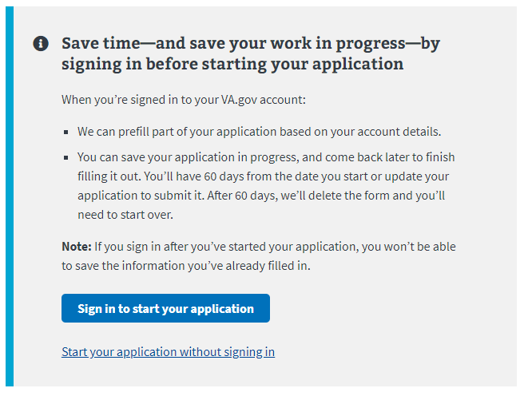

## Navigation

**Direct url:**​ <https://www.va.gov/education/apply-for-education-benefits/application/5490/introduction>

**Or** the link for the education application can be found on the ​**VA.gov**​ homepage.

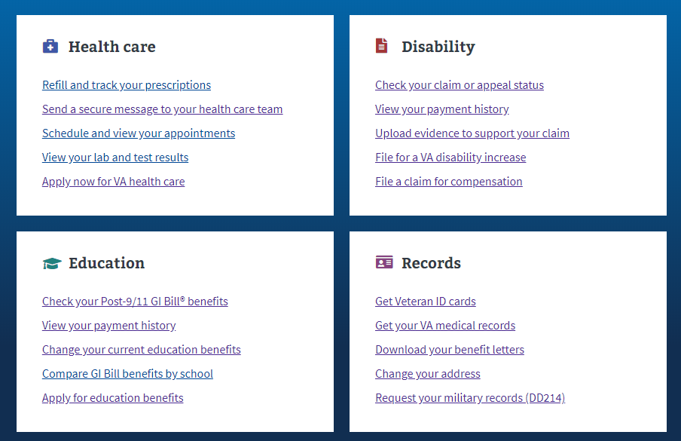

**Or** the link can be found in the dropdown menu:

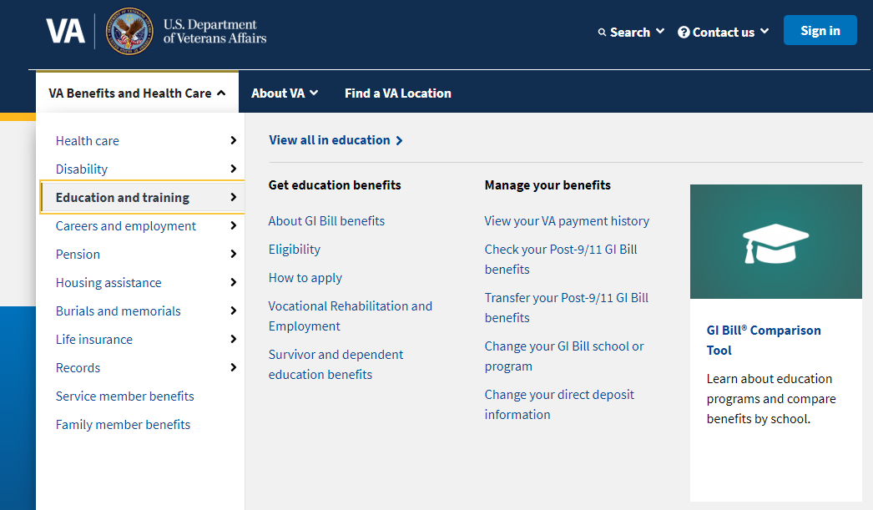

**Or** on the Education Hub Page: <https://www.va.gov/education/>

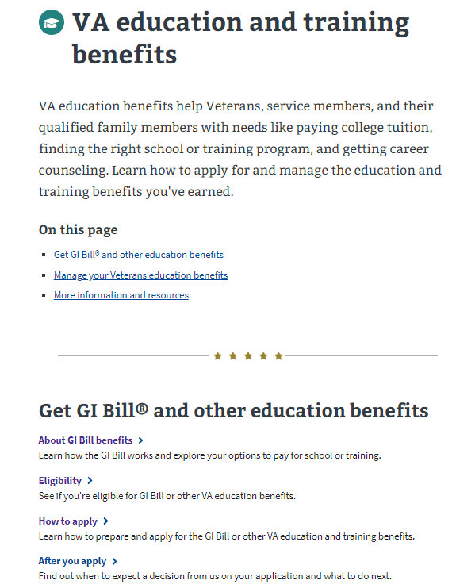

# Education Application Wizard

<https://www.va.gov/education/>

Instead of providing links to the different education applications, VA.gov uses an education application wizard to determine which application/form a user should fill out and submit. This wizard asks the veteran several questions and based on their answers, the veteran will be taken to the correct form.

For the Education Benefits as an Eligible Dependent (VA-Form 22-5490) the user must answer the education application wizard in the following way:

* Are you applying for a benefit or updating your program or place of training?
  + Applying for a new benefit
* Are you a veteran or service member claiming a benefit based on your own service?
  + No
* Is your sponsor deceased, 100% permanently disabled, MIA, or a POW?
  + Yes

See screenshot below for what the wizard looks like:

­ 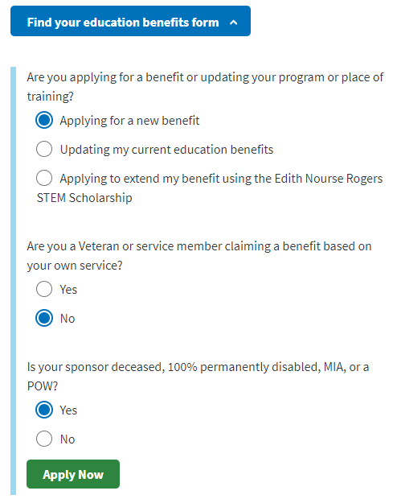

After selecting “Apply Now” the veteran will see the next page. The screenshot below is what the user will see if they are signed into an LOA1 (not identity verified) OR an LOA3 (identity verified account) and outlines application and review process:

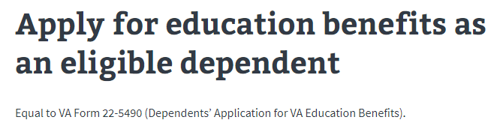

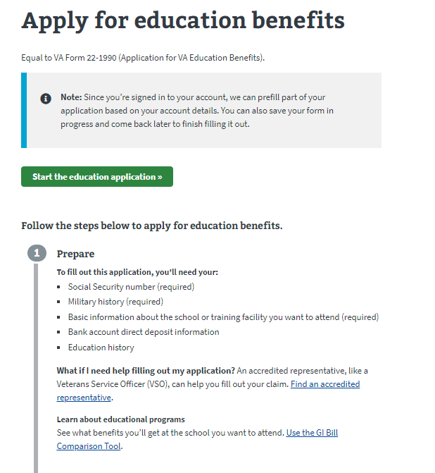

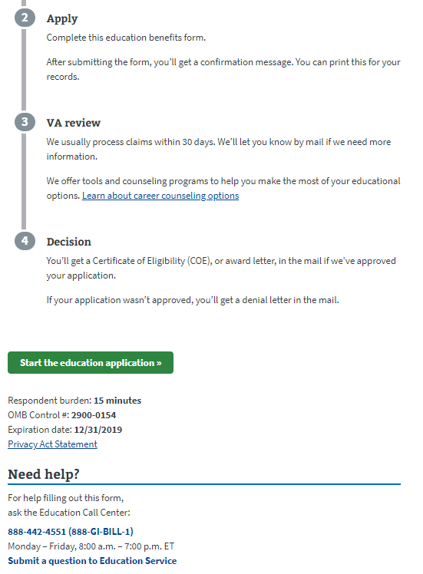

If the user is not signed in, they will see the below message about the advantages of signing in or creating an account before completing the application:

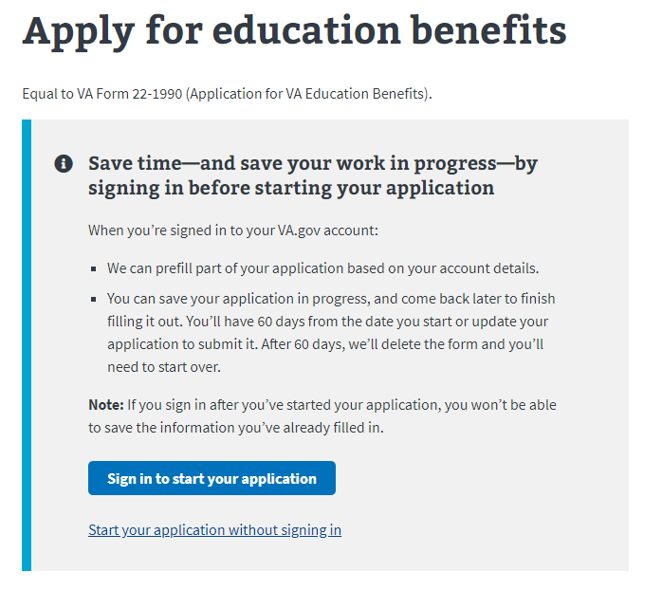

# Education Benefits Transfer Application­

## Application Information

First, the user will be asked to fill in general personal information. If they are signed in, the application will be pre-filled but the veteran can also change this information. If they are not signed in, they will need to add the information.

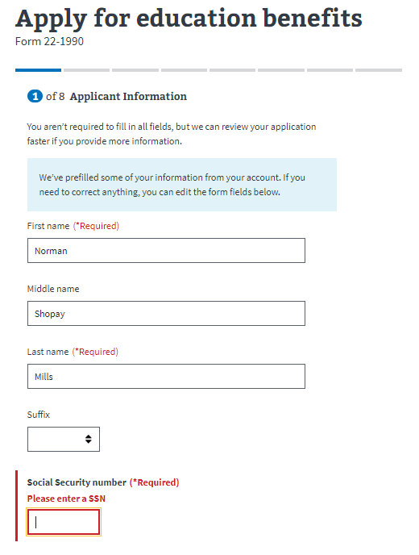

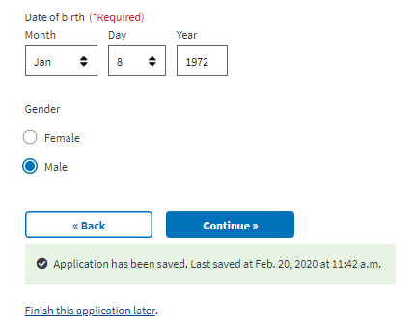

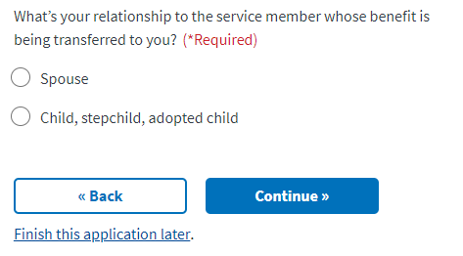

The application will tell the veteran what must be filled in. If they do not enter all the required information, they will not be allowed to move on to the next page.

### Additional Benefits:

Next the user will be asked if they are receiving any additional benefits.

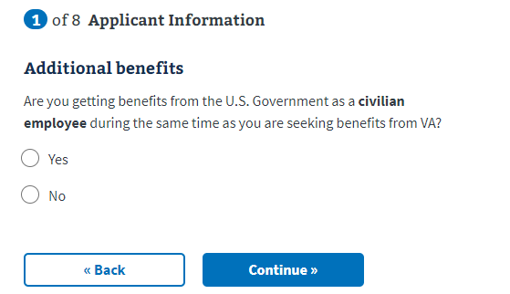

If the user answers yes to the above question, a dropdown will appear asking the source of these funds:

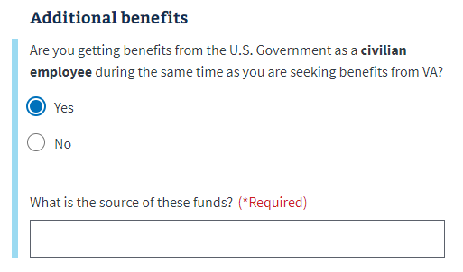

### Applicant Service

Next the user will be asked whether they have ever served on active duty in the armed forces.

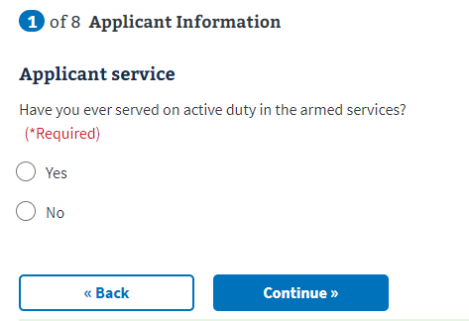

If the user answers no, they can continue to the next page. If they answer yes, a dropdown will appear with additional questions. The user can enter multiple periods of service.

­ 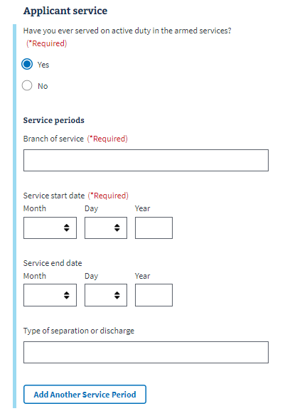

## Benefits Eligibility

The next section will ask the user about the benefits they are eligible for. The user will be asked to select the benefit that is the best match for them:

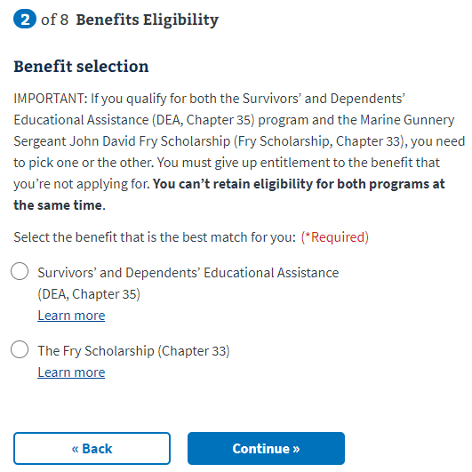

A dropdown will appear when the user selects one of the available benefits. The dropdowns are informational and do not require additional information to be answered:

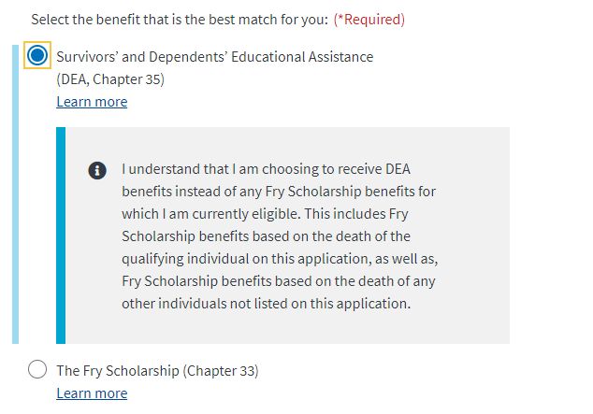

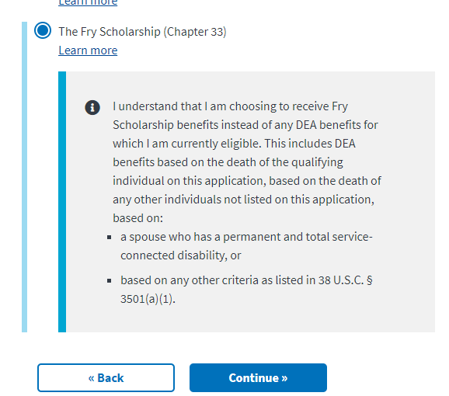

### Benefits History

Next, the user will be asked if they have ever applied for or received any VA benefits:

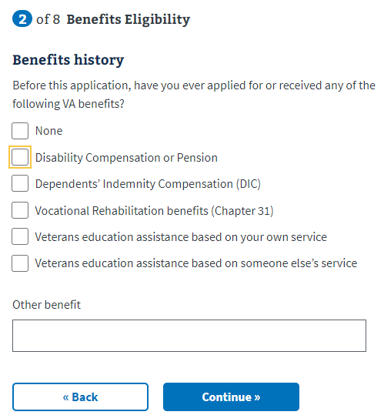

Dropdowns will appear for the last and second to last options:

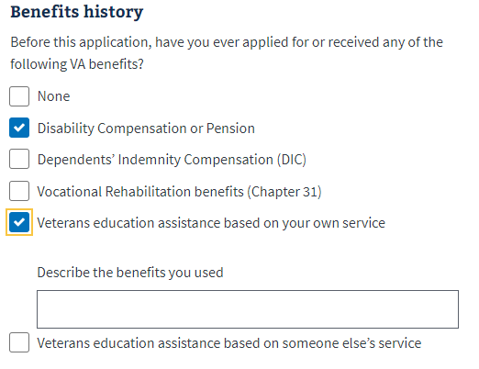

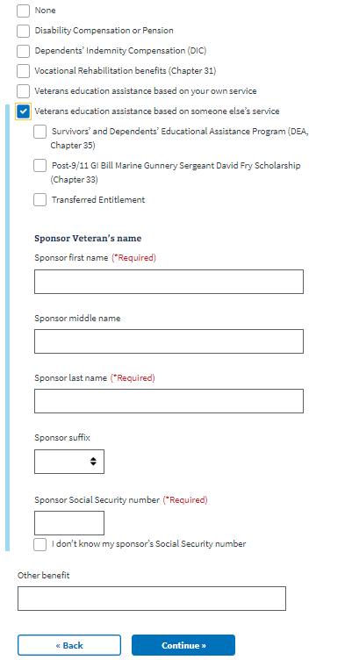

## Sponsor Information

Next the user will be asked to enter information about their sponsor information. ­

­ 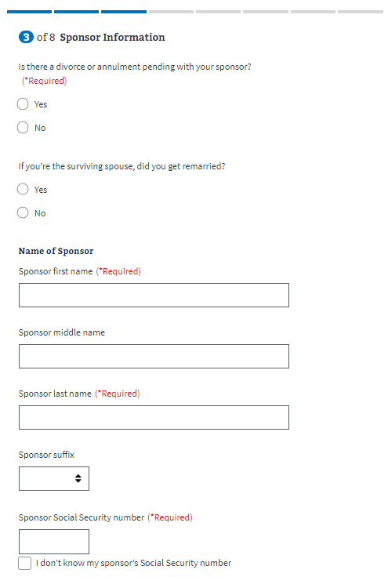

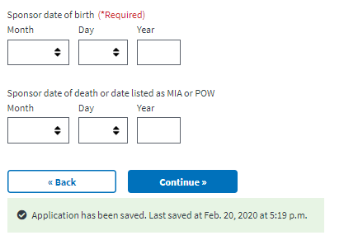

If the user answers Yes to “If you’re the surviving spouse, did you get remarried?” a dropdown will appear with additional questions:

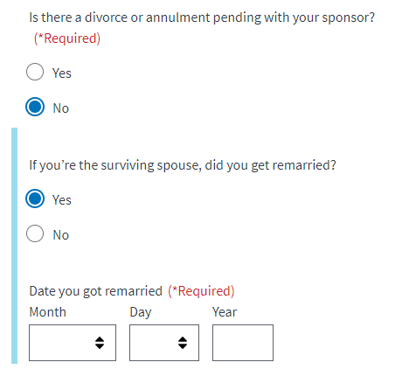

### Sponsor Service

Next, the user will be asked about their sponsor’s military service

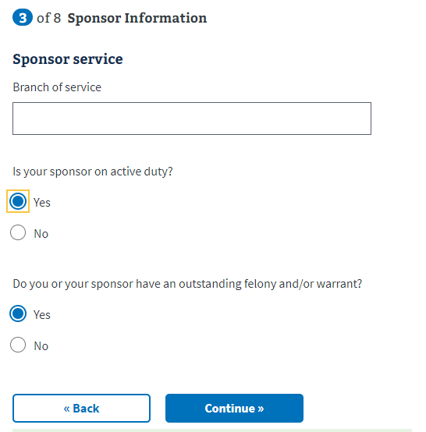

## Education History

Next the user will move into the Education History section. On the first page, they will be asked general questions about their education, starting with high school:

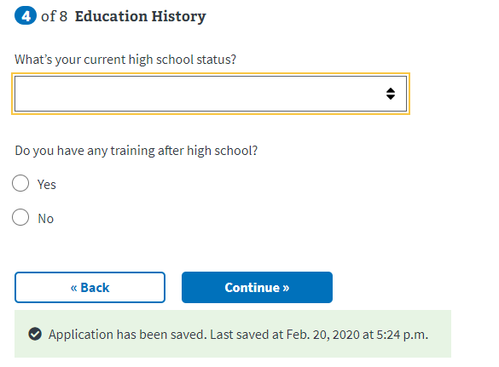

Depending on which dropdown option the user selects from the “What’s your current high school status field?”, additional information will appear that can be answered:

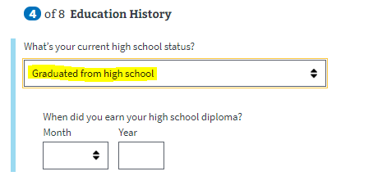

­ 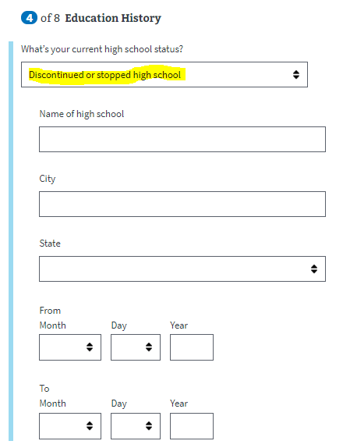

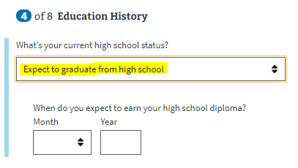

If the user selects yes for the “Do you have any training after high school?” question, the following information will appear. The user can add multiple training/education periods.

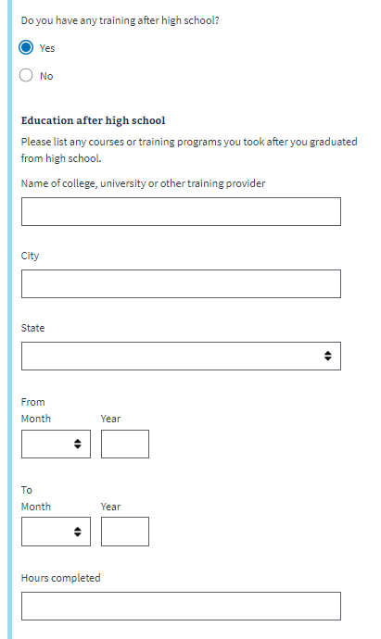

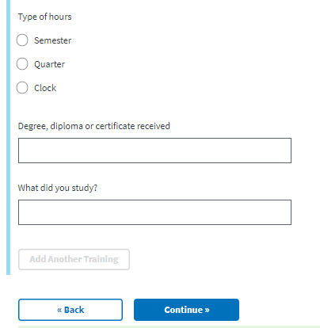

## Employment History

Next the user will answer questions about their employment history.

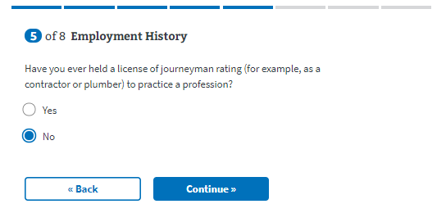

If the veteran has not held a license of journeyman rating to practice a profession, they will move on to the next page. If they answer yes, a dropdown will appear with additional questions. They will be able to add multiple employment periods if necessary:

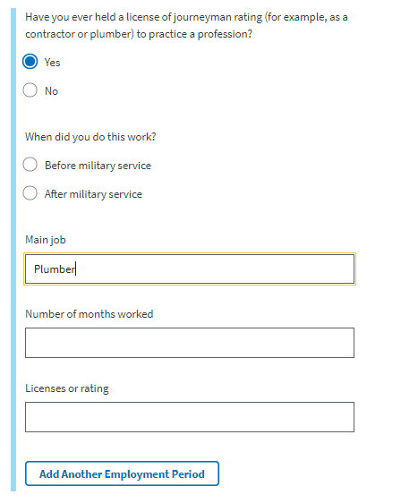

## School Selection

Next, the veteran will be asked for details about the school they have selected:

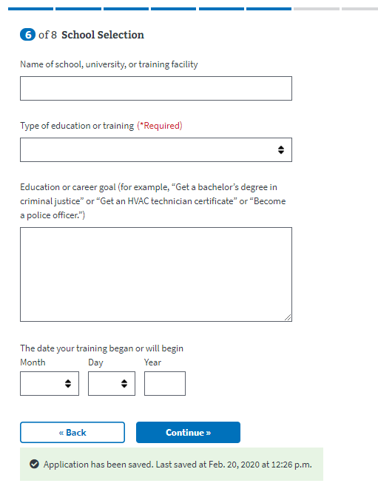

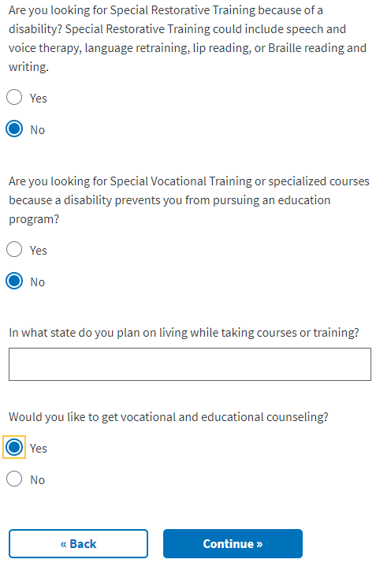

For the type of education or training dropdown, certain fields produce a dropdown that must be filled in to move on to the next page of the application. They are the following:

* College, university, or other educational program, including online courses
* Correspondence
* Apprenticeship or on-the-job training
* Vocational flight training

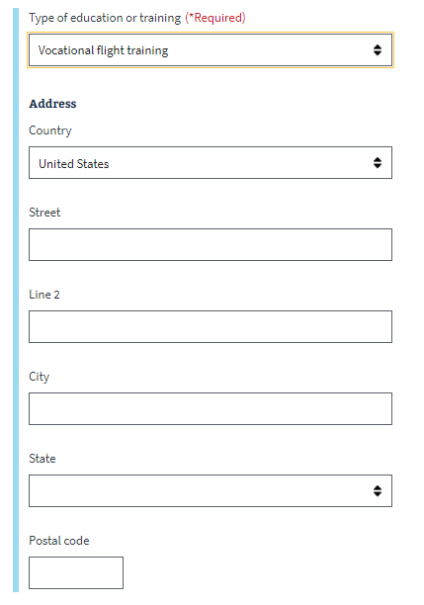

## Personal Information

Next the veteran will be asked to enter personal information about how they should be contacted if there are questions about their application:

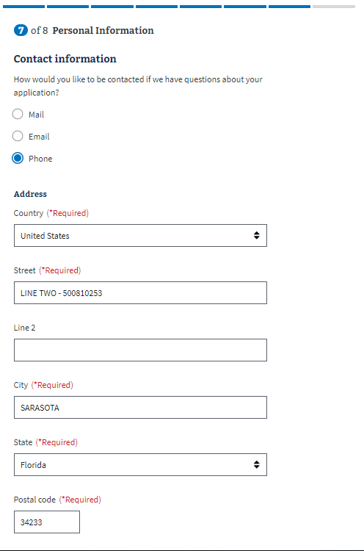

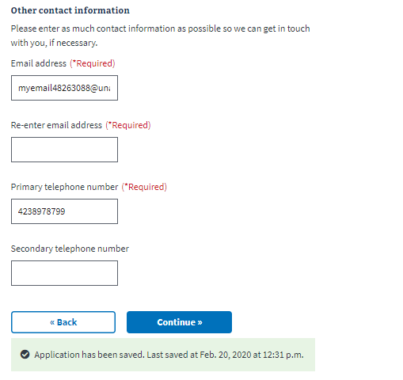

### Secondary Contact

Next they will be asked to enter contact information for a secondary contact:

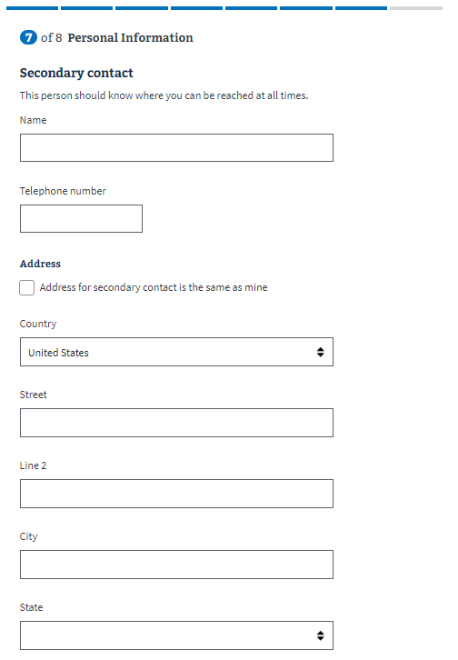

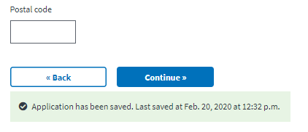

### Direct Deposit:

Next the user will be asked to enter direct deposit information:

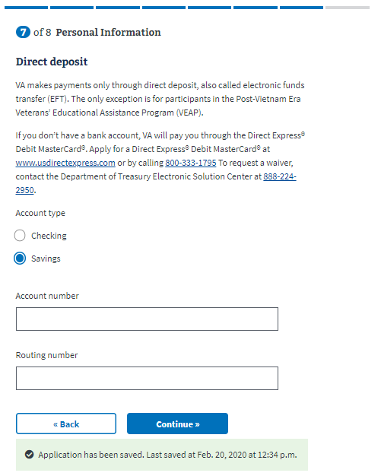

## Review Application

The last step is the review application page. Here the veteran can review the information they’ve entered by clicking on the plus signs next to a section:

­ 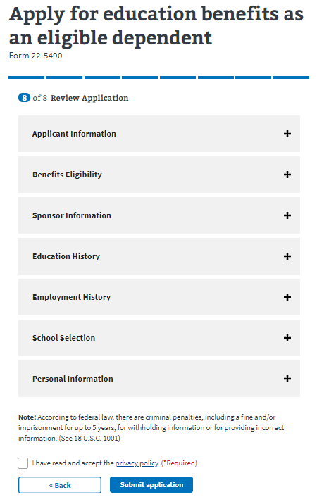

If the veteran clicks on the plus sign, the section will open and show what the user entered. If something looks wrong, the veteran can select the “edit” button, and will be able to make edits on the information:

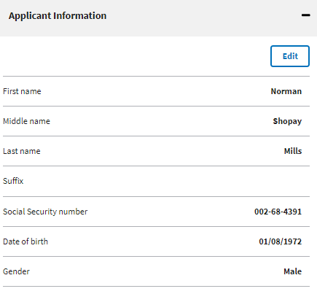

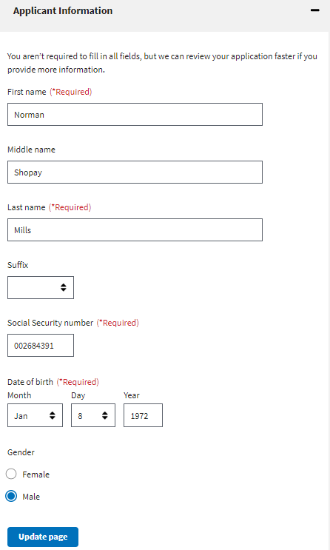

Once the user has reviewed the information and made any changes, they can select to submit the application. They can only successfully submit the application after selecting the “I have read and accept the privacy policy” check box:

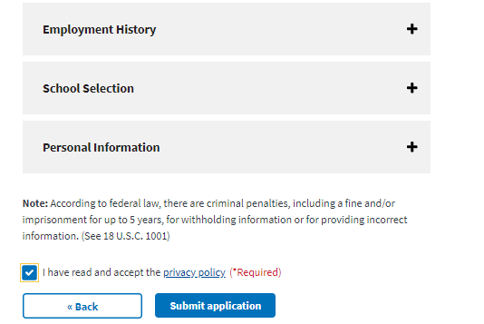

After selecting “submit application” the user will be shown the below page which contains a summary of the information, as well as additional information links that can help the veteran understand the process for their education claim:

