**Veteran Employment Through Technology Education Courses – VET TEC (VA Form 22-0994)**

Table of Contents

Education Benefits Application Overview 2

User Access 2

Who can access this application? 2

Navigation 3

Education Application Wizard 5

VET TEC Application 9

Part 1: Application Information 9

Military Service 12

Education History 13

Work Experience: 14

Program Selection: 17

Personal Information: 19

Review Application 22

# Education Benefits Application Overview

There are seven different education forms/applications available on VA.gov. These applications are accessed through the same education application wizard in addition to having separate URLS. Below is a list of the education forms available on VA.gov:

1. Education Benefits Application (22-1990)
2. Education Benefits Transfer Application (22-1990E)
3. Education Change of Program or Training Application (22-1995)
4. Education Benefits for National Call to Service Application (22-1990N)
5. Education Benefits for Eligible Dependents (22-5490)
6. Education Change of Program or Training Application under FRY or DEA (22-5495)
7. VET TEC Application (22-0994)

This product guide covers the VET TEC Application (22-0994).

## User Access

### Who can access this application?

To access this application, a veteran must be signed in with the highest level of identity verification on VA.gov (LOA3) and be found in the Master Veteran Index (MVI).

Users can sign in using their DS Logon Premium, MHV Premium, or ID.me accounts. They need to be registered as LOA3 users and found in MVI.

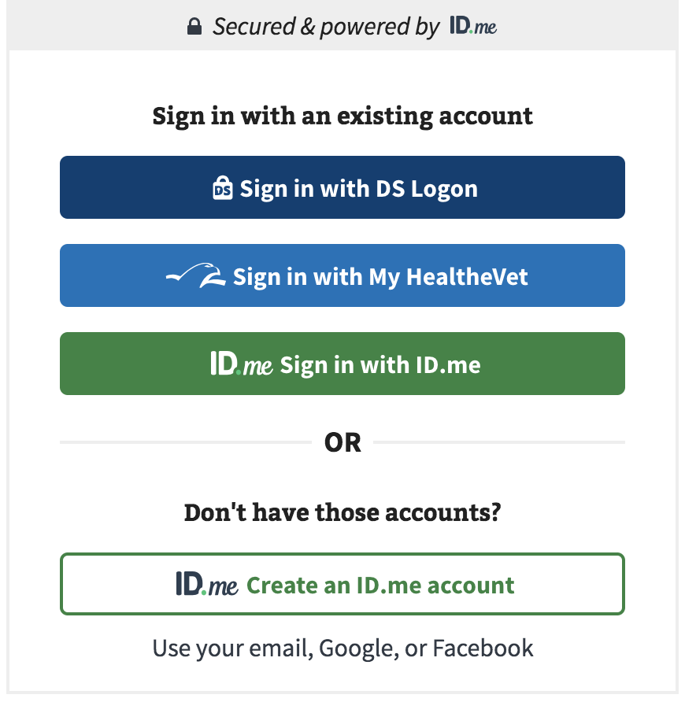

## Navigation

**Direct url:** <https://va.gov/education/apply-for-education-benefits/application/0994/introduction>

**Or** the link for the education application can be found on the ​**VA.gov**​ homepage.

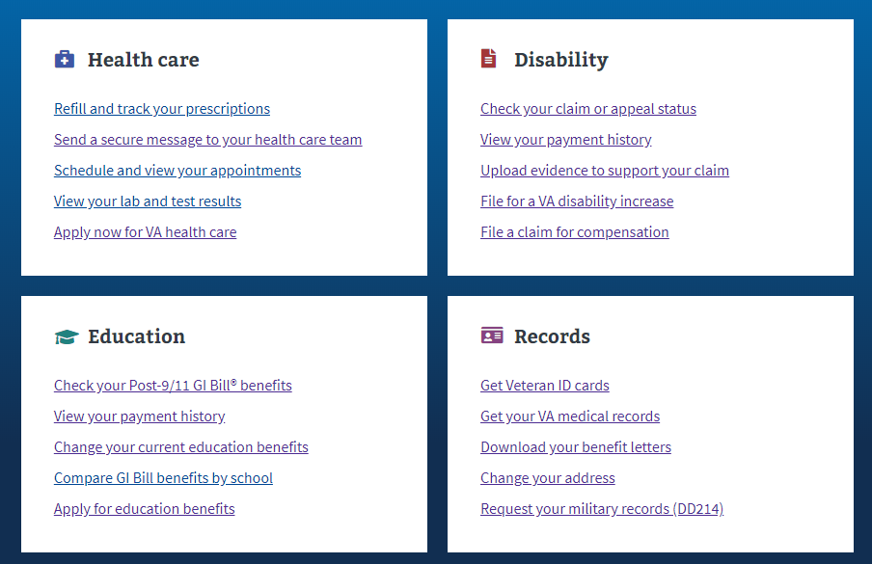

**Or** the link can be found in the dropdown menu:

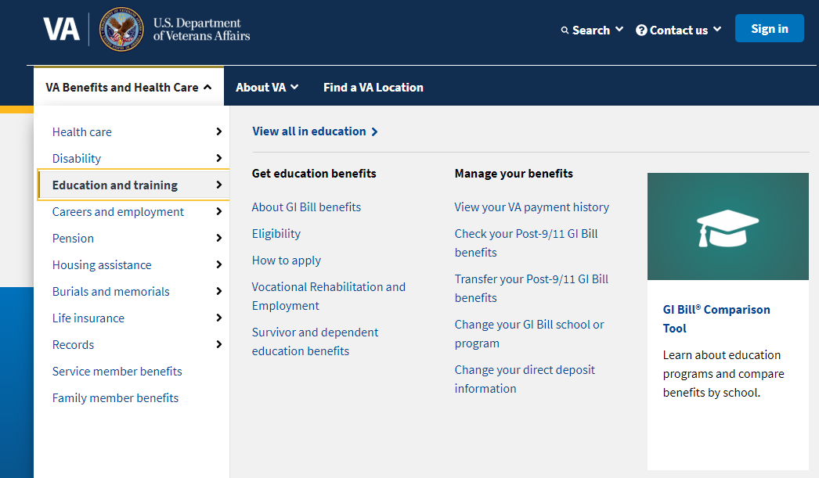

**Or** on the Education Hub Page: <https://www.va.gov/education/>



# Education Application Wizard

<https://www.va.gov/education/>

Instead of providing links to the different education applications, VA.gov uses an education application wizard to determine which application/form a user should fill out and submit. . This wizard asks the veteran several questions and based on their answers, the veteran will be taken to the correct form.

For the Education Benefits Application (VA-Form 22-1990) the user must answer the education application wizard in the following way:

* Are you applying for a benefit or updating your program or place of training?
  + Applying for a new benefit
* Are you a veteran or service member claiming a benefit based on your own service?
  + Yes
* Are you claiming a National Call to Service education benefit?
  + No
* Are you applying for Veteran Employment Through Technology Education Courses (VET TEC)
  + Yes

See screenshot below for what the wizard looks like:

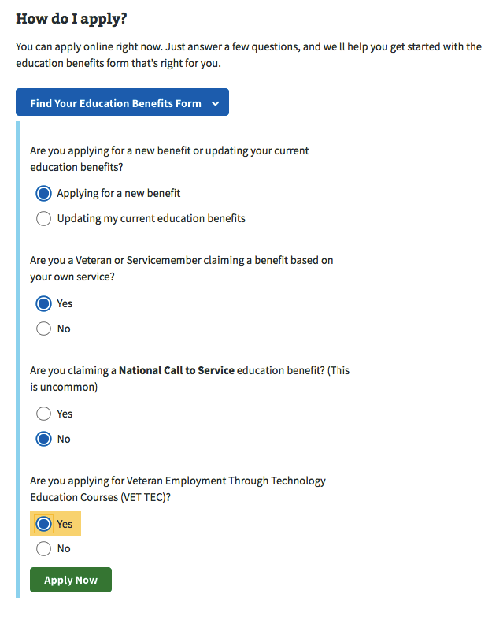

The next screen is a brief introduction for the Veteran. It explains a little more about the VET TEC application process and what is needed in order to complete it online. If they are signed into an identity verified account (LOA3) and are found in MVI, they will be able to start the application.

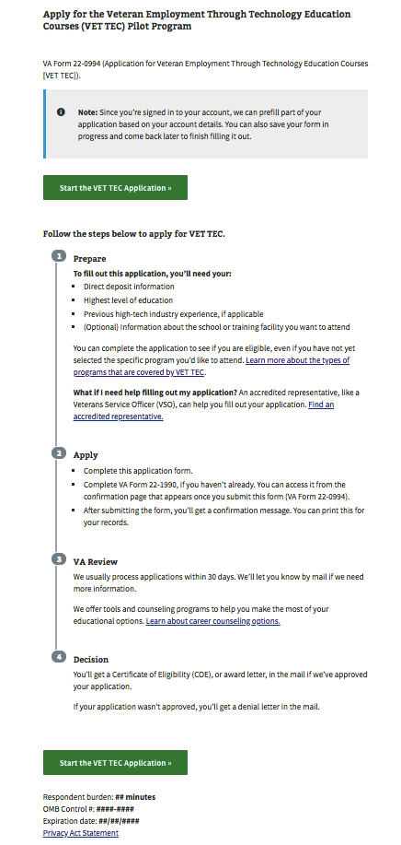

If the user is not signed in, they will see the below message explaining the must be signed in to complete this application.

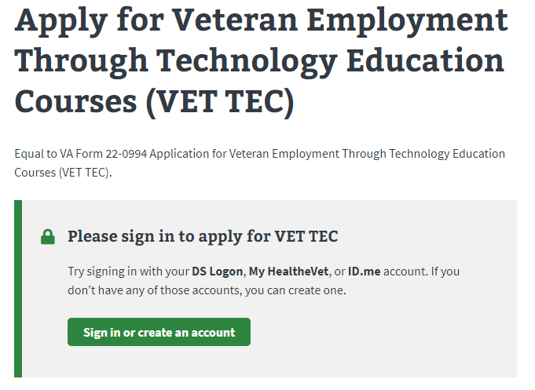

If the user is only signed into a non-identity verified account (LOA1) they will see the below message:

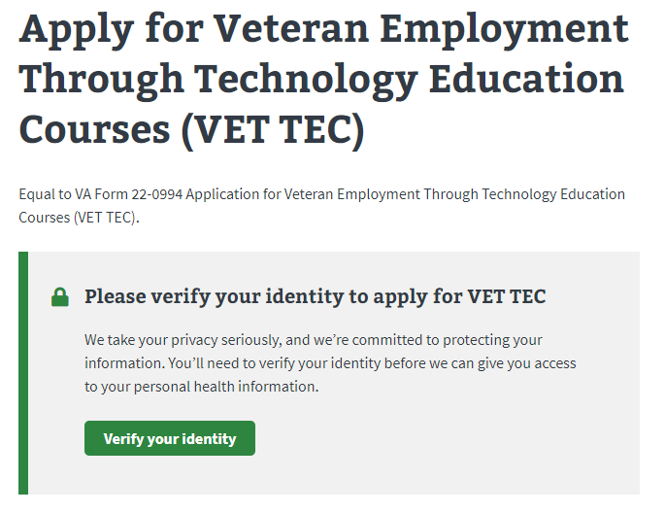

# VET TEC Application­

## Application Information

First, the user will be asked to fill in general personal information. Because the veteran has to be signed in, the application will be pre-filled but the veteran can also change this information. 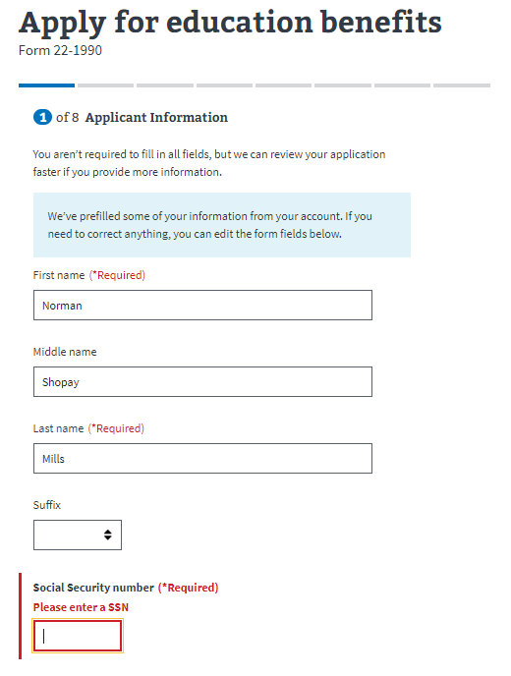

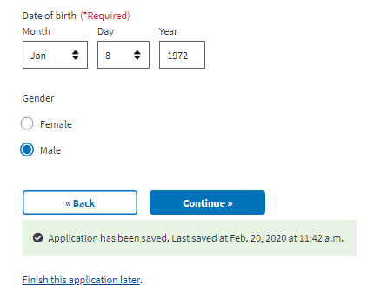

The application will tell the veteran what must be filled in. If they do not enter all the required information, they will not be allowed to move on to the next page.

The next page will ask the veteran if they have applied for VA Education benefits in the past?

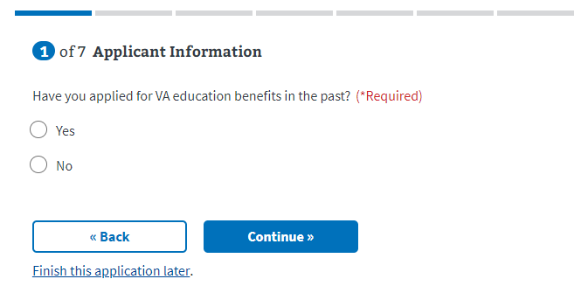

If the veteran selects no, they will see a message appear that explains they will need to complete an application for VA Education Benefits (VA From 22-1990). VA.gov will remind the veteran once they’ve completed this application that they must do this:

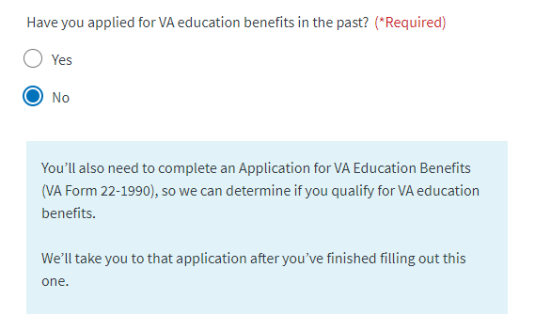

## Military Service

Next the Veteran is asked about their Military Status because if they are on Active Duty then they may not be eligible for VET TEC benefits at this time

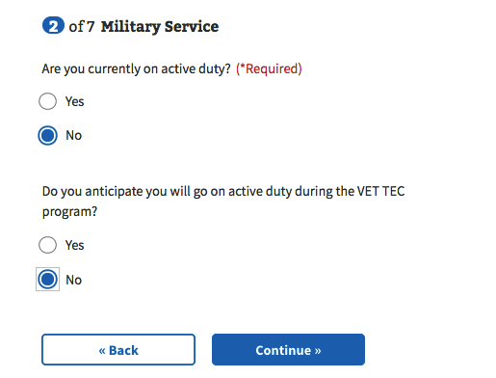

If the veteran answers yes to “are you currently on active duty” a message will appear that VET TEC is only available to veterans:

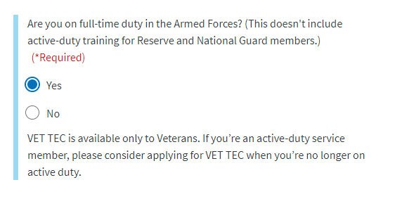

## Education History

After that the Veteran is asked about the highest level of education they have completed

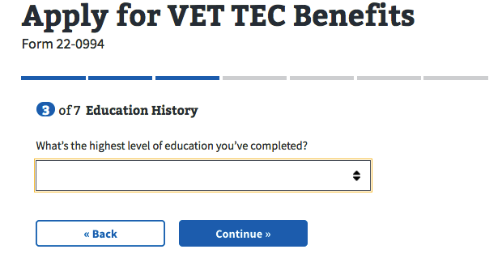

## Work Experience:

In the next section, the veteran will be asked about their experience in the high-tech industry.

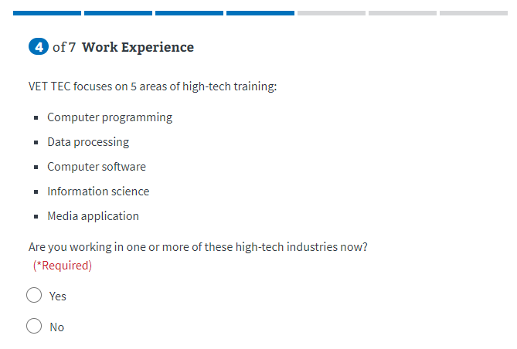

If the user answers yes, a dropdown will appear with additional questions.

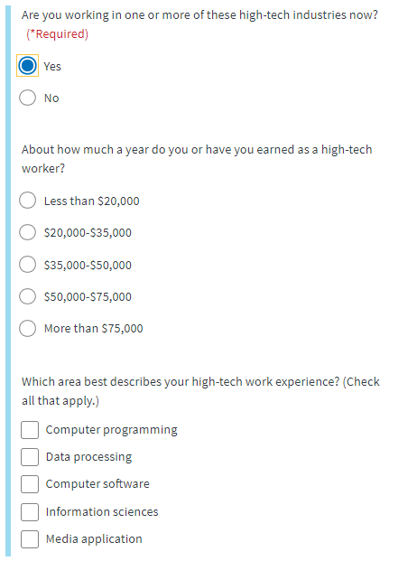

If the veteran answers no, another question will appear asking if they have worked in one of these industries in the past:

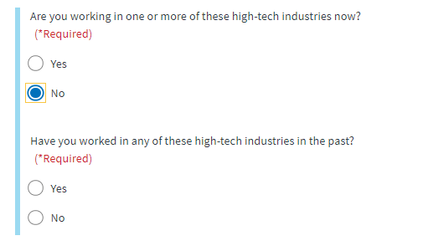

If the veteran answers no, they will be taken to the next page. If they answer yes, they have worked in one of these industries in the past, a dropdown will appear with additional questions:

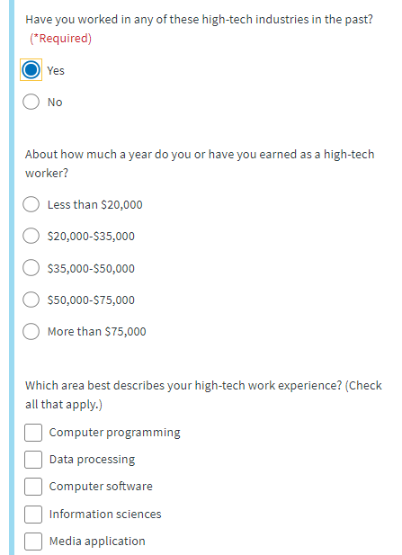

## Program Selection:

Next the Veteran is asked about the programs they would like to attend using VET TEC benefits. The user is able to add up to 3 programs. If the user answers no, they will be taken to the “Personal Information” section of the application.

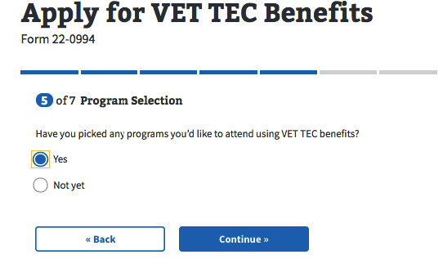

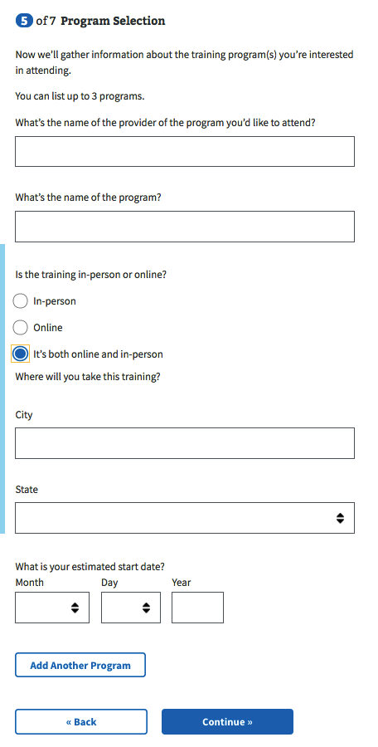

## Personal Information:

Next, the Veteran is asked about their contact information. 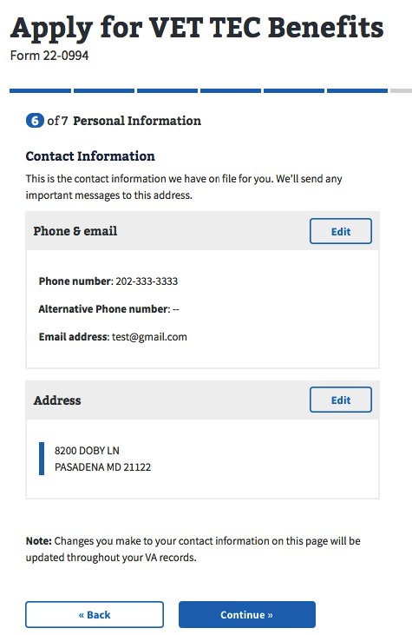

The veteran can edit this information by selecting the “edit” button.

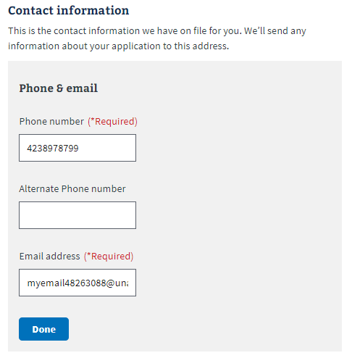

Next, the Veteran is asked to review/enter their banking information. They can update this information by selecting the “New account” button. This screen also provides helpful information about what happens when a user updates their account or what to do if they don’t have a bank account.

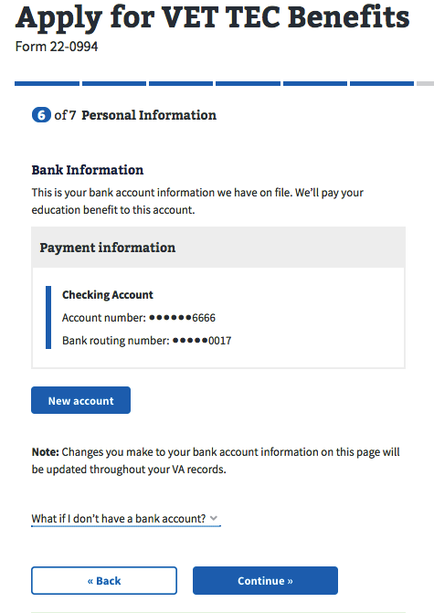

­

## Review Application

The last step is the review application page. Here the veteran can review the information they’ve entered by clicking on the plus signs next to a section:

­ 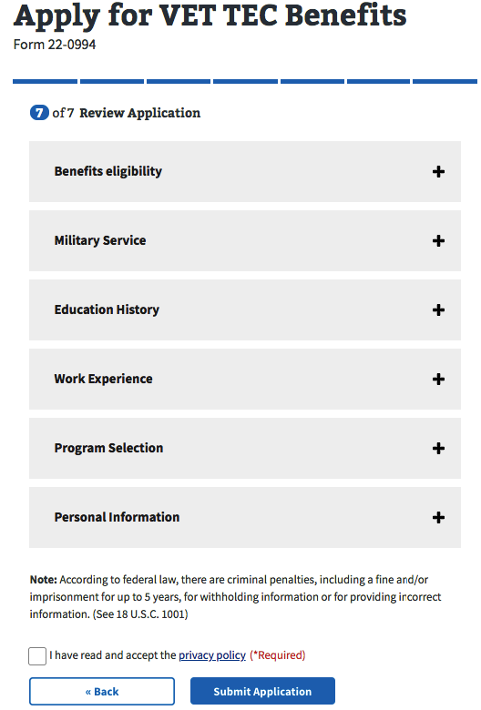

If the veteran clicks on the plus sign, the section will open and show what the user entered. If something looks wrong, the veteran can select the “edit” button, and will be able to make edits on the information:

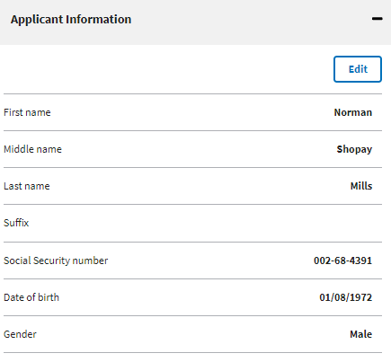

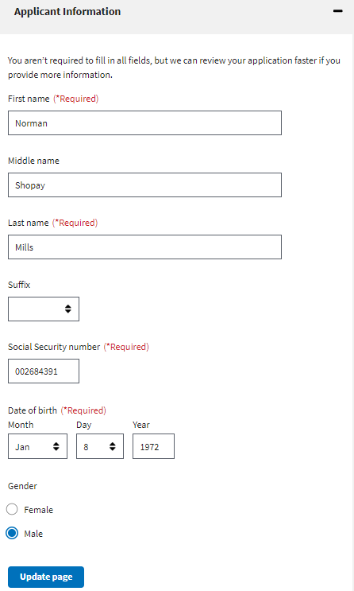

Once the user has reviewed the information and made any changes, they can select to submit the application. They can only successfully submit the application after selecting the “I have read and accept the privacy policy” check box:

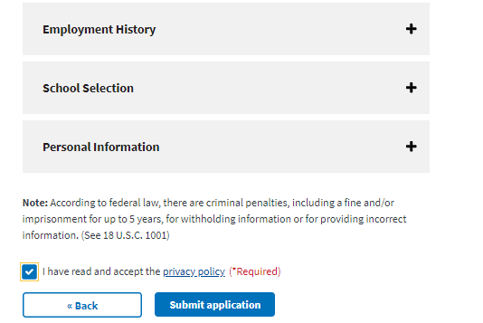

After selecting “submit application” the user will be shown the below page which contains a summary of the information, as well as additional information links that can help the veteran understand the process for their education claim:

