**GI Bill School Feedback Tool**

Table of Contents

GI Bill School Feedback Overview 1

User Access 2

Who can access this application? 2

Navigation 2

GI Bill School Feedback Tool Functionality 5

Application Information 5

Education Benefits 9

School Information 10

Feedback Information 12

Review Application 14

# 

# GI Bill School Feedback Overview

If a user has an issue or complaint about a school or training facility that’s eligible to receive GI Bill benefits, they can submit feedback to VA using the GI Bill School Feedback tool.

The user can choose to submit their feedback anonymously or on behalf of someone else.VA shares all information with the school, but if you submit feedback anonymously VA won’t share the name with the school.

## User Access

### Who can access this application?

Veterans do not need to be signed into complete this application. However, if they aren’t signed in, the application will not be prefilled with their information and the veteran will not be able to save their application in progress. You can reference the below screenshot for more information on this:

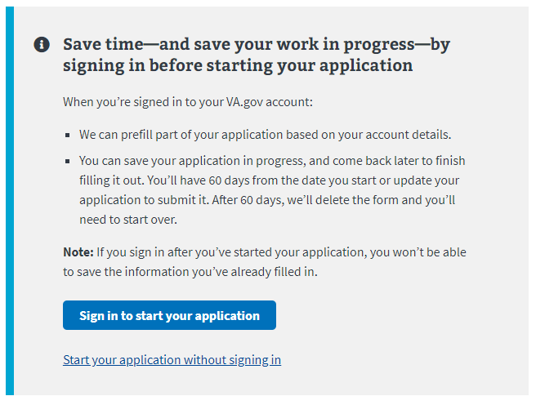

## Navigation

**Direct url:**​ <https://www.va.gov/education/submit-school-feedback/introduction>

**Or** the link for the education application can be found on the ​**VA.gov**​ homepage.

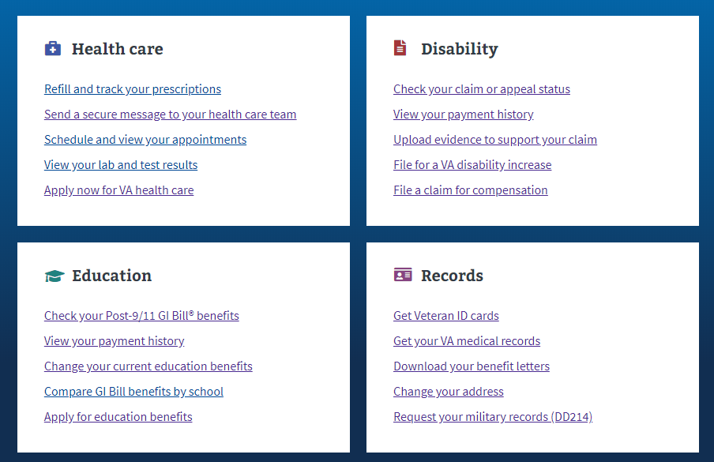

**Or** on the Education Hub Page under “More information and resources”: <https://www.va.gov/education/>

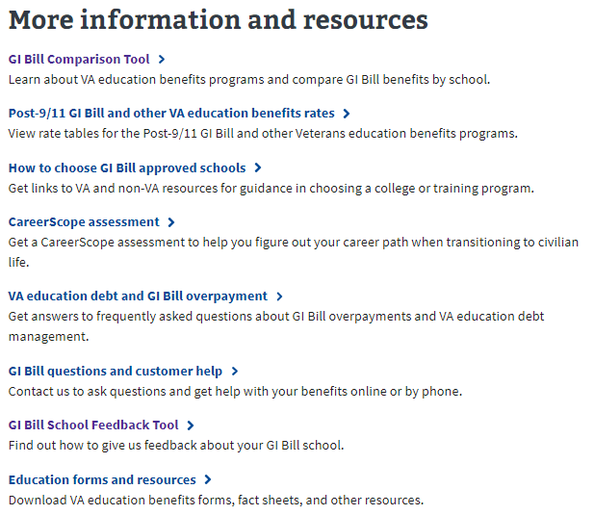

# GI Bill School Feedback Tool Functionality

## Application Information

The feedback tool is structured like an application. In the first section the user will be asked on whose behalf they are submitting the feedback.

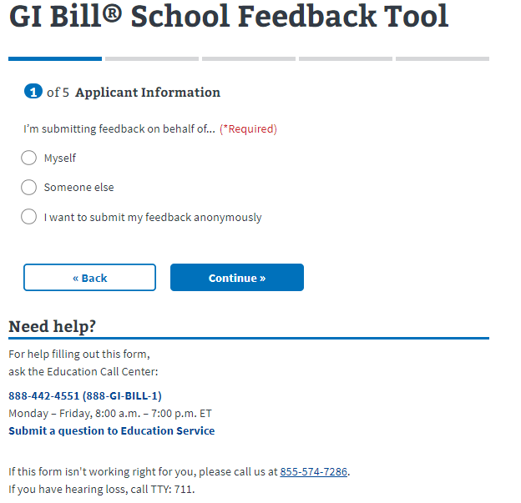

The use can only select one option. When the user selects an option, a dropdown appears clarifying what information will be shared with the school:



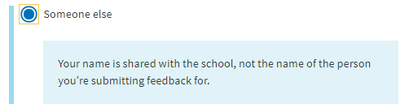

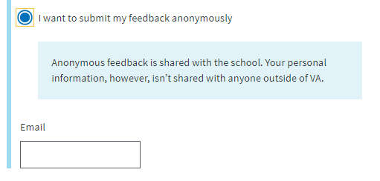

If the user selects they want to submit the feedback anonymously, they will skip to section 2 of the application. If they pick one of the other two options, they will be taken to the next page.

On this page, the user must fill in their personal information. If they are signed into their account, this information might come pre-filled. Any field that has required next to it, must be entered before the user can continue on to the next part of the application.

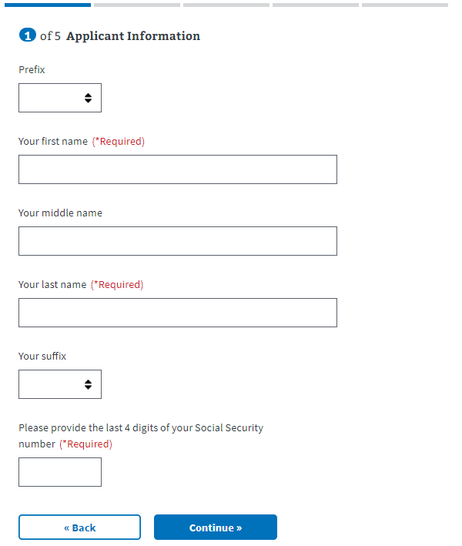

On the next page, the user will enter address information:

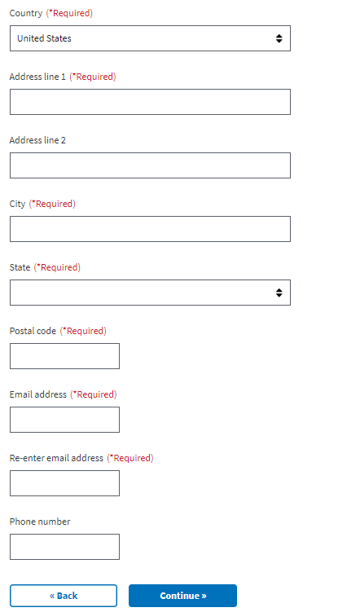

## Education Benefits

In the next section, the user will be asked which education benefits they have used. They can select all that apply, meaning they can select more than one. They are also asked, which military tuition assistance benefits have they used and if they have used any other benefits.

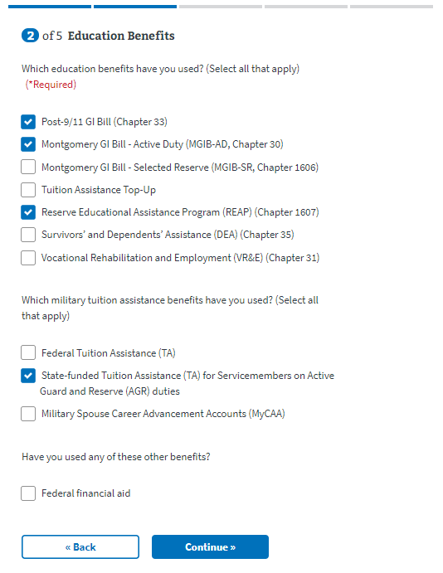

## School Information

Next the user will be instructed to select the school they want to submit feedback to.

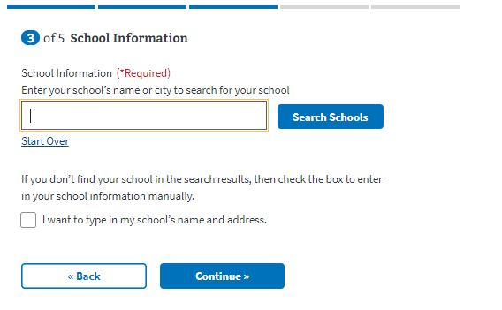

The user can enter the name of the school and select “Search Schools” and pick from the listed results:

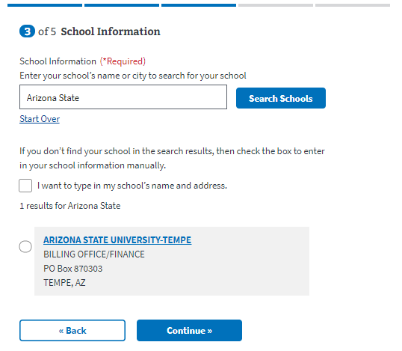

If the user does not see the right information for the school they are submitting feedback to, they can select to type in the school’s name and address manually:

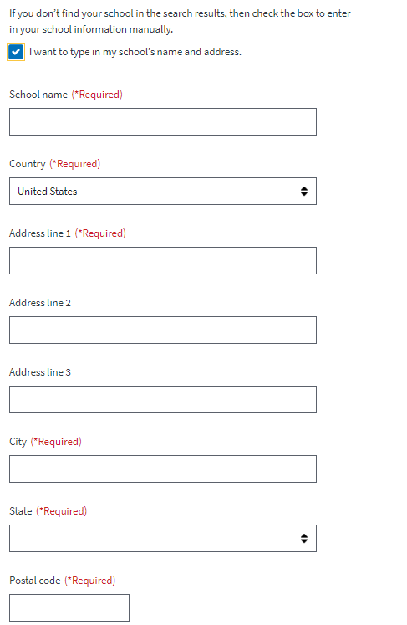

## Feedback Information

Next the user will select the best topic(s) that describes their feedback and then can enter the actual feedback and what they think would be a fair way to resolve the issue. These two questions are free text and have character limits:

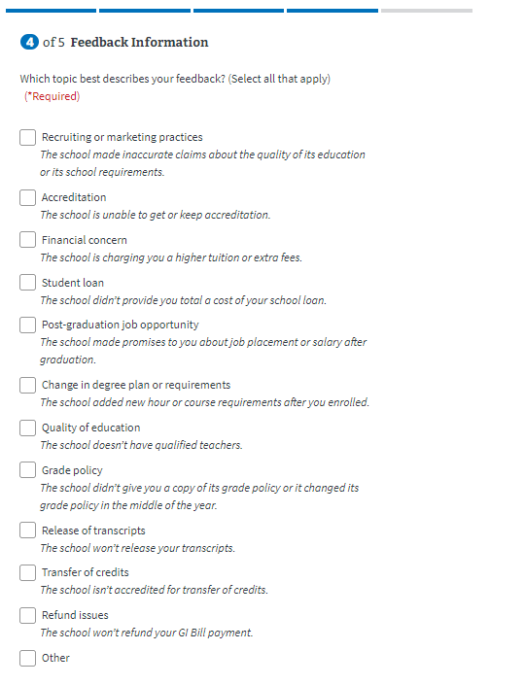

­ 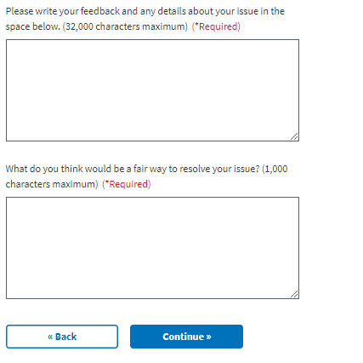

## Review Application

The last step is the review application page. Here the veteran can review the information they’ve entered by clicking on the plus signs next to a section:

­ 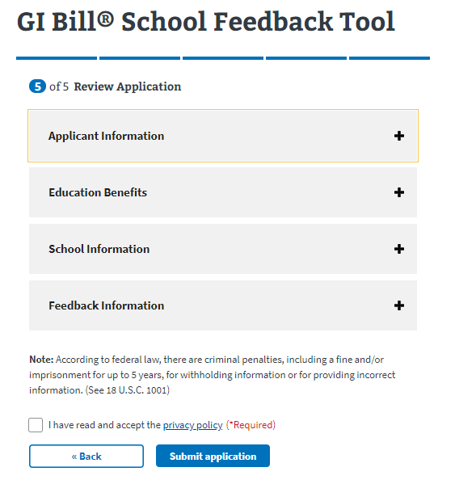

If the veteran clicks on the plus sign, the section will open and show what the user entered. If something looks wrong, the veteran can select the “edit” button, and will be able to make edits on the information:

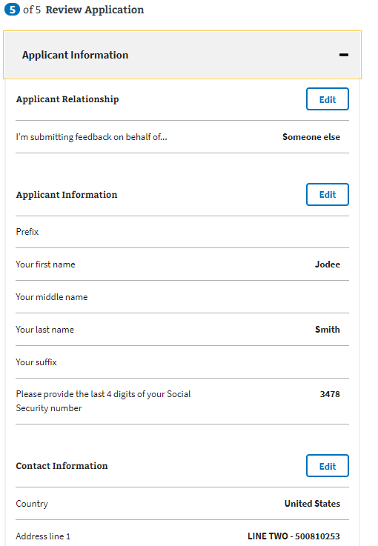

Once the user has reviewed the information and made any changes, they can select to submit the application. They can only successfully submit the application after selecting the “I have read and accept the privacy policy” check box:

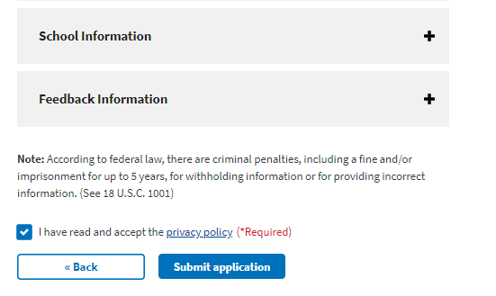

After selecting “submit application” the user will be shown the below page which contains a summary of the information, as well as additional information links that can help the veteran understand the process for their education claim:

