**Health Care Application**

**Product Guide**

Table of Contents

Healthcare Application Overview and Navigation 3

Healthcare Application Introduction Page 5

Logged out users: 5

Logged in users: LOA1 9

Logged in users: LOA3 10

Filling out the Healthcare Application 13

Veteran Information 15

Veteran Information Page 1: Names 15

Veteran Information Page 2: Birth Date and Location 16

Veteran Information Page 3: Demographic Information 17

Veteran Information Page 4: Address 18

Veteran Information Page 5: Email and Phone Number 19

Military Service 20

Military Service Page 1: Branch of Service and Dates of Service 20

Military Service Page 2: Service History 21

Military Service Page 3: Upload Discharge Papers 22

Military Service Page 4: Current Compensation 23

Household Information 24

Household Information Page 1: Financial Disclosure 24

Household Information Page 2: Spouse’s Information 26

Household Information Page 3: Dependents Information 28

Household Information Page 4: Annual Income 31

Household Information Page 5: Previous Calendar Year’s Deductible Expenses 32

Insurance Information 33

Insurance Information Page 1: Medicaid/Medicare 33

Insurance Information Page 2: Other Coverage 34

Insurance Information Page 3: VA Facility 35

Review Application 36

Healthcare Application Issues 40

Questions about the content of the application: 40

Application is pre-filled with incorrect information: 40

User can’t move forward in their application: 40

User can’t upload a document: 41

User is having trouble upgrading their LOA1 account to an LOA3 account 41

# 

# Healthcare Application Overview and Navigation

Users of VA.gov can apply for health care benefits by filling out the online application (VA from 10-10EZ). Users with no account, an LOA1 account (not identity verified) or an LOA3 account (identity verified) can access and complete the Healthcare Application.

A user can find the healthcare application at this URL (<https://www.va.gov/health-care/apply/application/introduction>) or at the following locations on VA.gov

* On the homepage: [www.va.gov](http://www.va.gov)

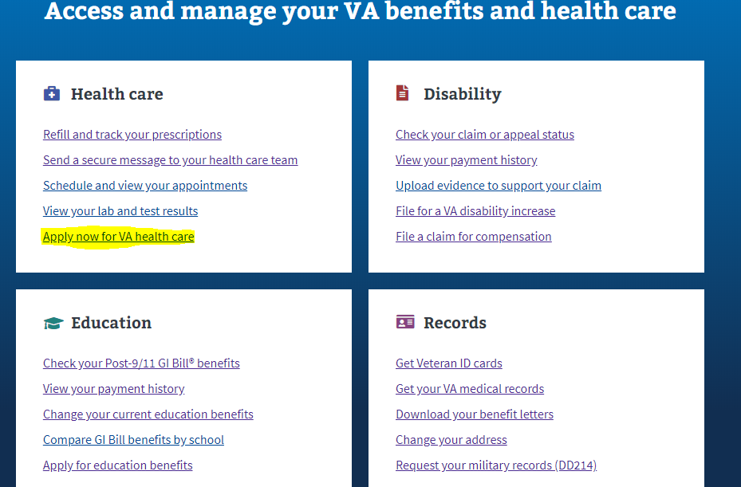

* In the main menu dropdown

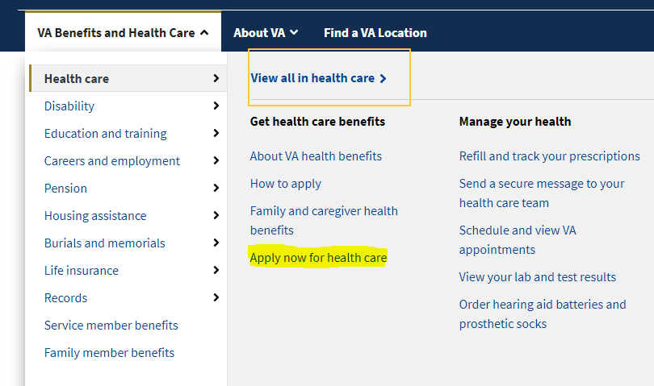

* In the Health care benefit hub: <https://www.va.gov/health-care/>

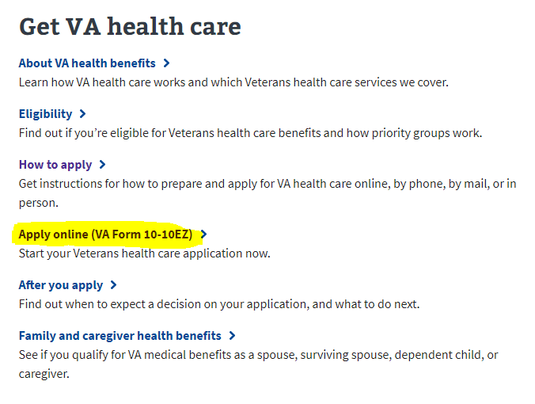

# Healthcare Application Introduction Page

Currently, the health care application is available on VA.gov (<https://www.va.gov/health-care/apply/application/introduction>) to all users who come to the site, whether they are logged in or logged out, or whether they are LOA1 or LOA3.

## Logged out users:

**Logged out application introduction page URL:** <https://www.va.gov/health-care/apply/application/introduction>.

Logged out users will access the health care application through the health care application introduction page.

On this page, we strongly encourage people to login before applying, and have a call out to previous applicants to login and check their status. These are at the top of the healthcare application introduction page, and they look like so:

**Logged out ID page URL:** <https://www.va.gov/health-care/apply/application/id-form>

Logged out users can access the health care application. However, in order to do so, they will be filtered through an ID page where they will enter some personal information that we’ll use to scan MVI and the enrollment system (ESR) for existing records. They get to the ID page by going to the health care application introduction page (pictured above) and clicking the link **Start your application without signing in**.

This link will take them to the ID page:

Once someone fills out this form and submits it, we will scan MVI and ESR for their records. Potential outcomes include:

* **User is not found in MVI or the enrollment system (ESR)** — These users will be passed through to the health care application. As part of this application, there will be a section where they can upload their DD214 or other discharge documents to help verify their service.

This is the DD214 upload page found in the application:

* **User is found in MVI but not in ESR** — These users will be passed through to the health care application but will not be asked to include a DD214 or other discharge documents.
* **User is found in MVI and in ESR** — These users will not be able to access the health care application from a logged out state because finding them in the enrollment system (ESR) means that they have applied for health care previously. They need to sign in to VA.gov in order to see their health care status before accessing the application.

These users will see the following prompt if they are found in the enrollment system (ESR):

## Logged in users: LOA1

Logged in users who are LOA1 (not identity verified) will not be able to access the health care application without first verifying their identity and becoming LOA3. This is to make sure that all users who apply are scanned through the ESR to verify whether they have or have not applied for health care previously. Since we don’t know who LOA1 users are, we can’t scan them through the ESR unless they become LOA3.

LOA1 users will see the following screen when they go to the health care application introduction page at <https://www.va.gov/health-care/apply/application/introduction>:

## Logged in users: LOA3

For logged in LOA3 users, we will automatically perform a scan on the backend for existing health care records in the enrollment system (ESR) when they go to the application introduction page at <https://www.va.gov/health-care/apply/application/introduction>.

For users who are **not** found in the enrollment system (ESR), they will be able to go straight into the health care application:

For users who **are** found in the enrollment system (ESR), they will see their current health care status. It will look something like this:

Or they may see a different status like this:

These are only two examples; in all, there are about 25 potential statuses people could see. The following is an outline of potential outcomes:

* Veteran is enrolled in VA healthcare.
* Veteran has a pending application.
* Veteran did not qualify for VA health care this time around, but they may qualify in the future if circumstances change (eg. Their income was too high, or they did not have a service connected disability at the time of application).
* Veteran did not qualify (is ineligible) for VA health care because of their service record or other circumstances.
  + There are many reasons why someone may be ineligible for health care. The most common ones are that they did not serve for 24 consecutive months of active duty, their character of service was not high enough, or their service could not be verified. We are trying to display about 12 different reasons someone may have been found to be ineligible.
* Veteran is deceased.
* Veteran had VA health care but canceled it; or they were offered it but declined it.
* Veteran had an open/incomplete application for a year, so it was closed.
* A service member has applied too early and is still on active duty.

For all veterans who have applied for health care before and see the health care status on the application introduction page, they should call the health enrollment center at 877-222-VETS ([877-222-8387](tel:+18772228387)) if they have questions.

# Filling out the Healthcare Application

There are six sections of the health care application:

1. Veteran Information
2. Military Service
3. VA Benefits
4. Household Information
5. Insurance Information
6. Application Review

Each section has multiple pages of questions that the user must enter to complete the application. On every page of the application, there is a “Finish the application later” link that allows the user to save their progress. The application also automatically saves as the user completes the application.

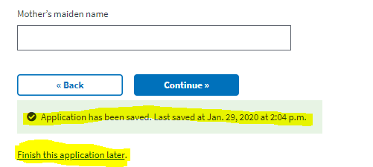

To move forward through the application, the user clicks continue. They will not be able to move forward if there is required information on the page they have not entered. To go back to a section of the application, the user can use the back button.

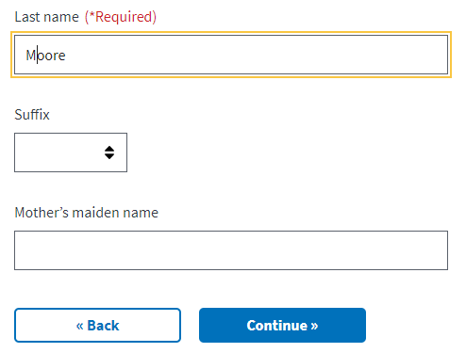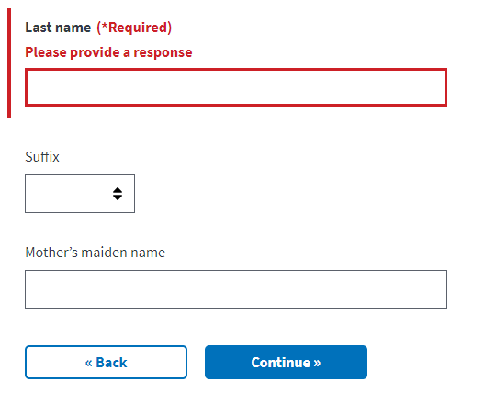

The application also has a status bar at the top of each page of the application to indicate how far along in the application a user is:

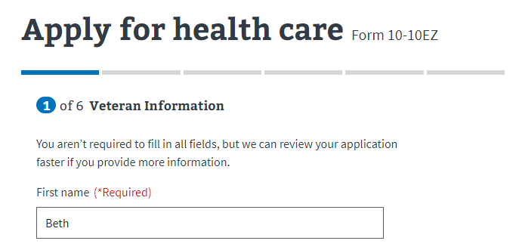

## Veteran Information

### Veteran Information Page 1: Names

When possible, the application will automatically prefill information it has received from the user. The user can edit the information as they complete the application

­ 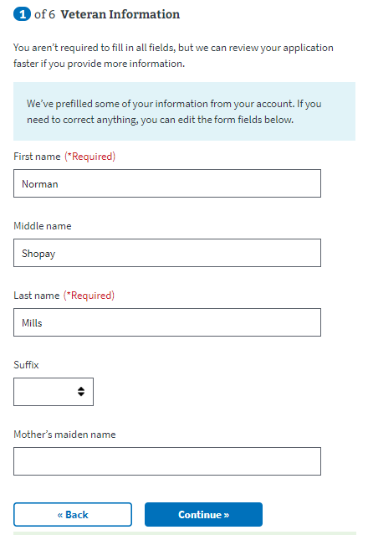

### 

### Veteran Information Page 2: Birth Date and Location

If a user has not entered a required piece of information, they will see the below message and they will not be able to continue to the next page without entering the information.

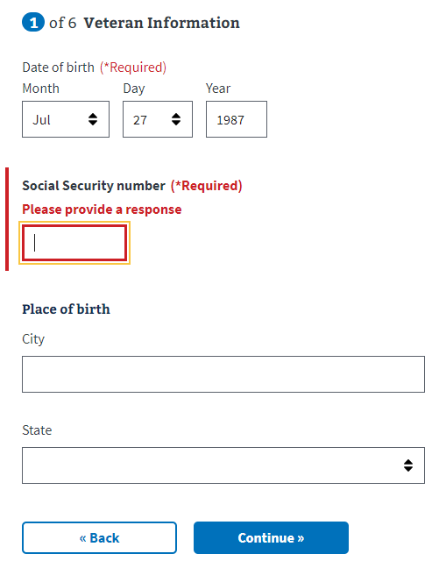

### Veteran Information Page 3: Demographic Information

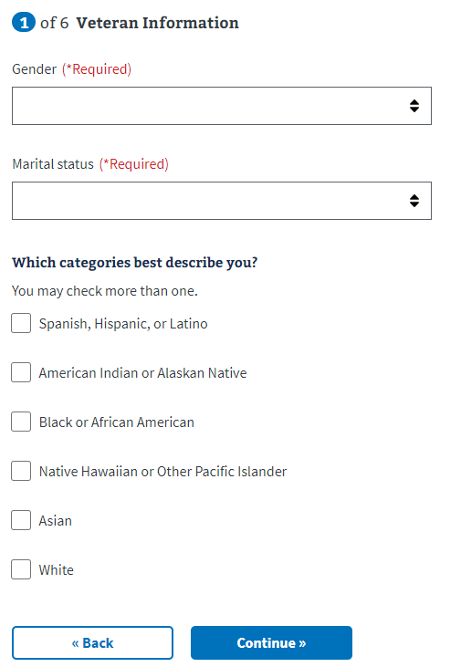

### Veteran Information Page 4: Address

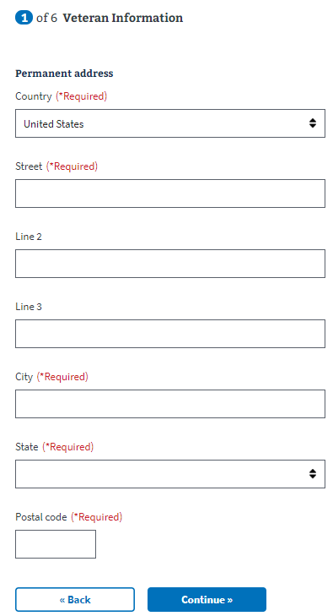

### Veteran Information Page 5: Email and Phone Number

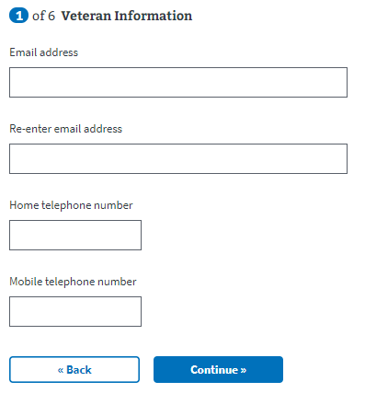

## Military Service

### Military Service Page 1: Branch of Service and Dates of Service

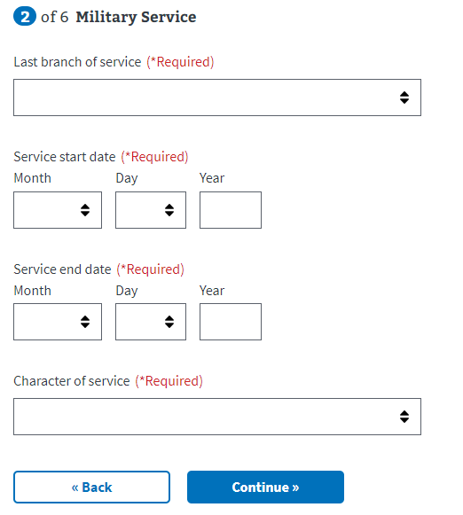

### Military Service Page 2: Service History

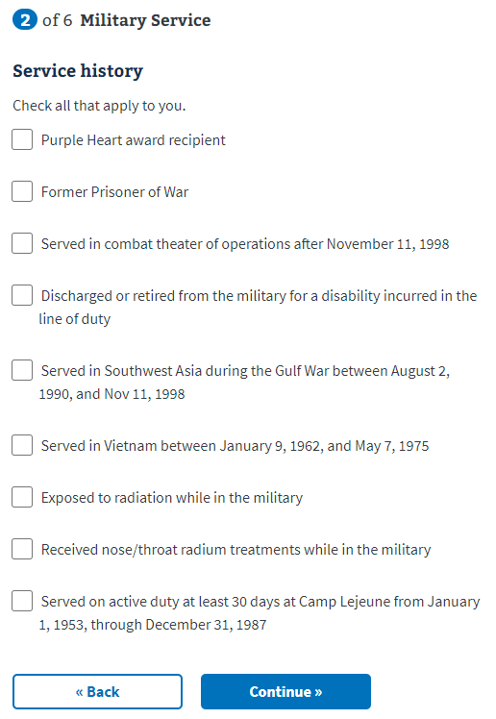

### 

### Military Service Page 3: Upload Discharge Papers

If the user is not found in MVI or the enrollment system (ESR) these users will need to upload their DD214 or other discharge documents to help verify their service. A user will not see this page if they have been verified in MVI or ESR.

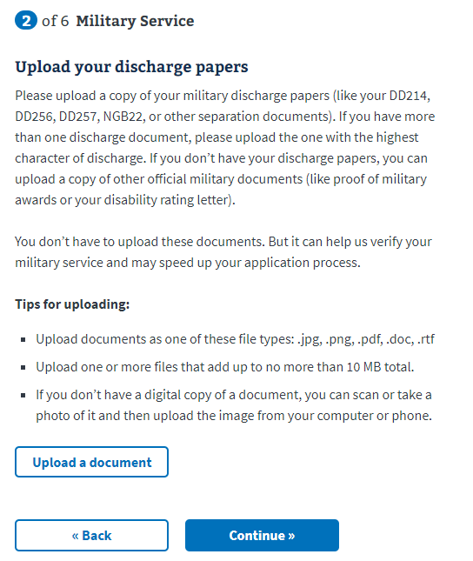

### Military Service Page 4: Current Compensation

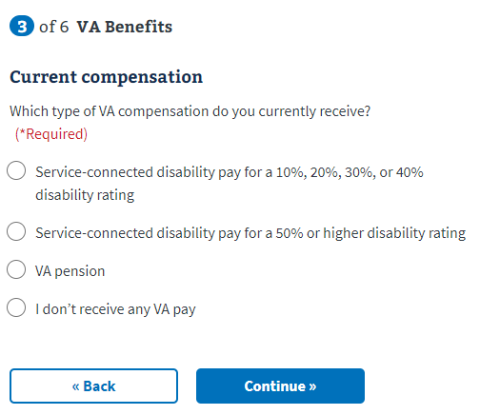

## Household Information

### Household Information Page 1: Financial Disclosure

A user can select to not disclose financial information on this page. If they do, the user will be taken directly to the insurance information section of the application.

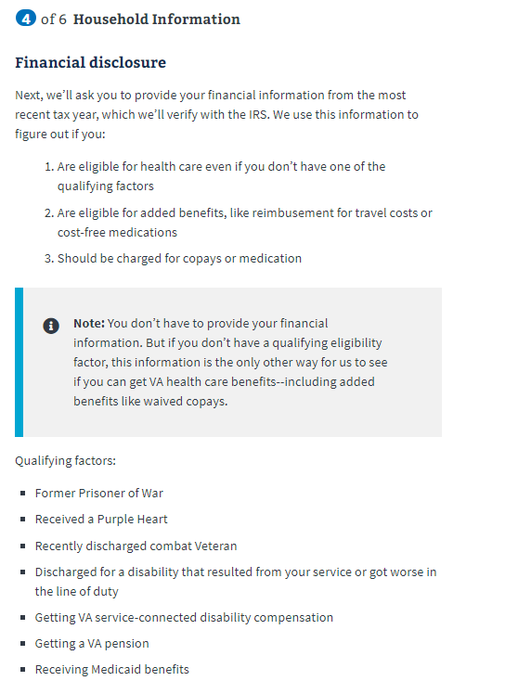

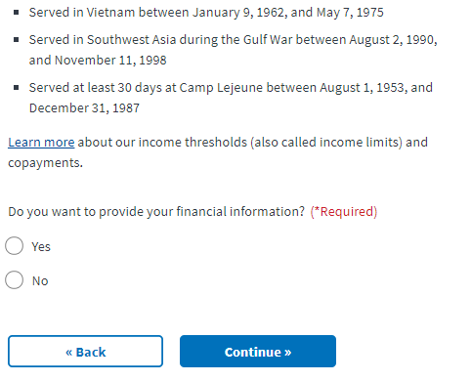

If the user selects they do not want to provide their financial information, they will be shown the below message:

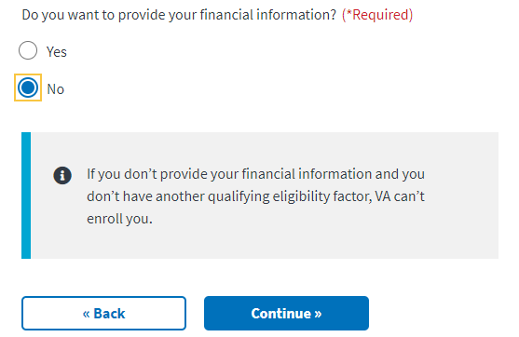

### Household Information Page 2: Spouse’s Information

If a user indicated they are married or separated they will be required to fill out their spouse’s information.

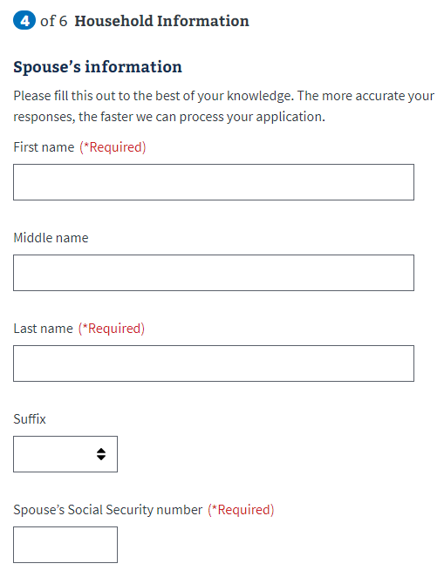

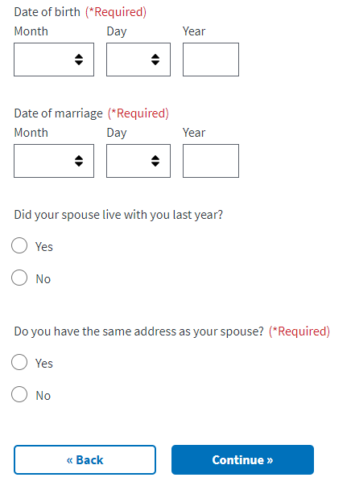

If the user entered they have never been married, widowed, or divorced, they will be taken directly to the next page in the application.

### Household Information Page 3: Dependents Information

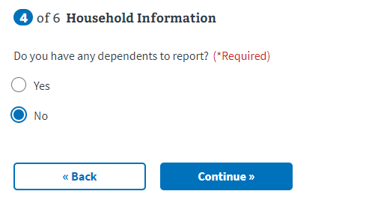

If the user does have dependents, the page will expand with the following information:

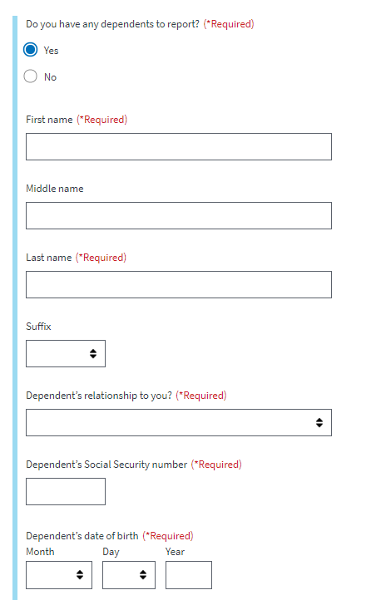

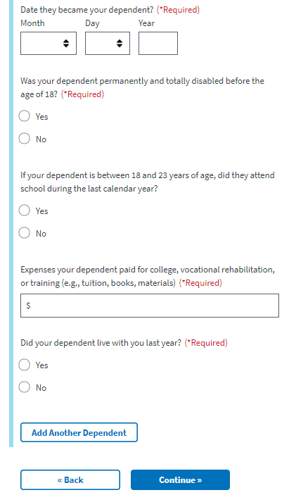

The user can add additional dependents by selecting the “Add another dependent” button at the bottom of the form.

If the user does not have dependents, they will be taken directly to the next page

### Household Information Page 4: Annual Income

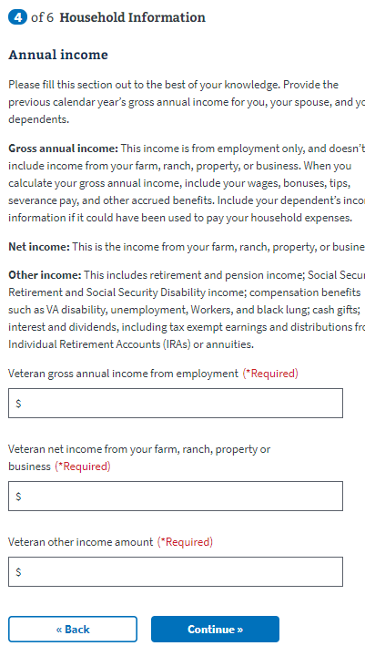

### Household Information Page 5: Previous Calendar Year’s Deductible Expenses

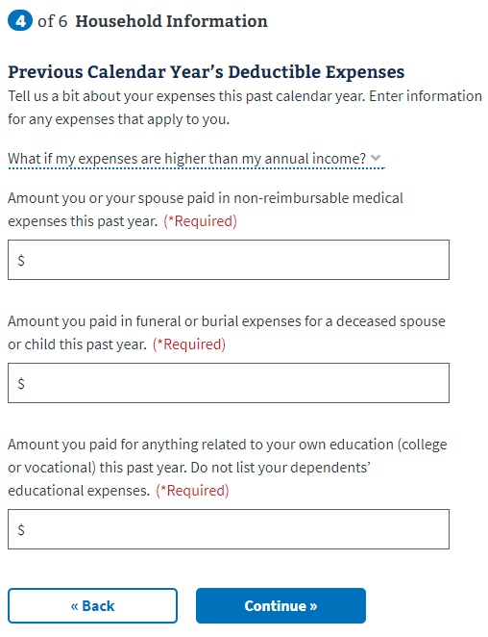

## Insurance Information

### Insurance Information Page 1: Medicaid/Medicare

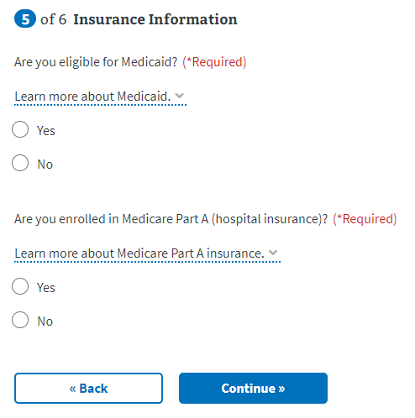

If the user selects they are enrolled in Medicare Part A, the form will expand:

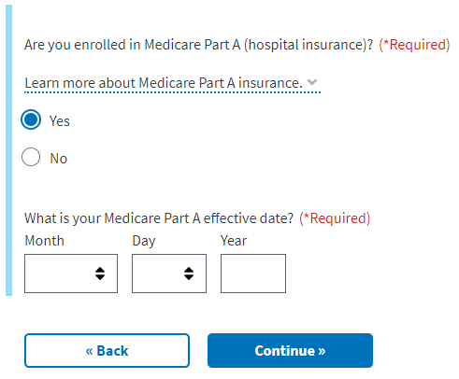

### Insurance Information Page 2: Other Coverage

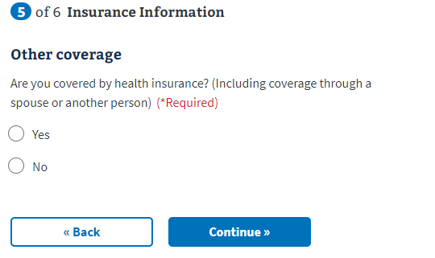

If the user selects yes, the application expands to include the below questions:

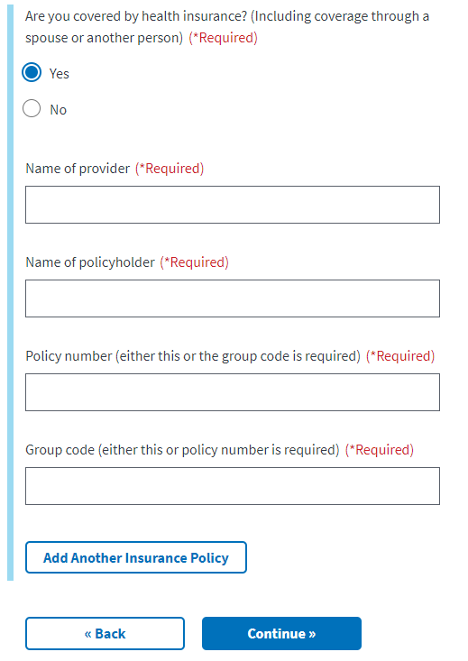

### Insurance Information Page 3: VA Facility

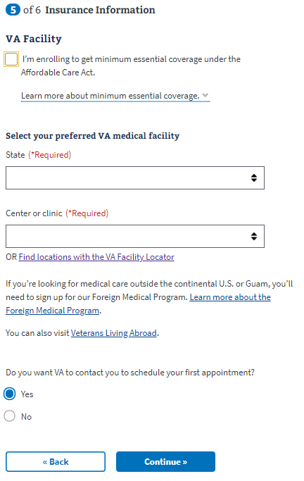

## Review Application

Once the user has completed the application, they will be shown the Review Application section. In this section, the user can open each section and see what information they entered.

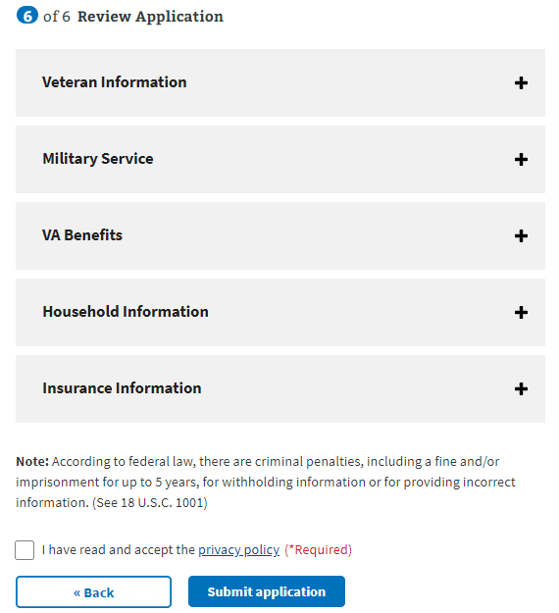

If they want to change the information shown, they can select the “edit” button and make changes to that information.

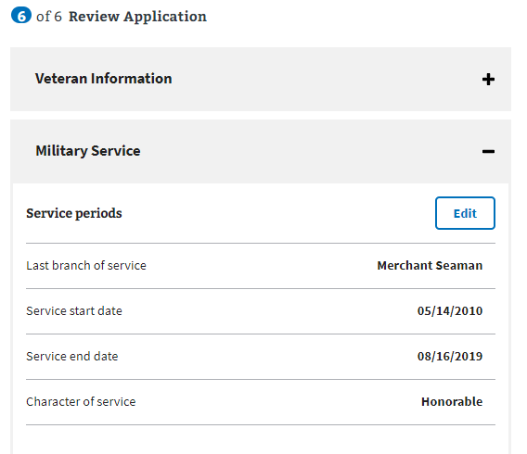

Once the user has reviewed the information and is ready to submit the application, they must select the check box indicating they have read and accepted the privacy policy:

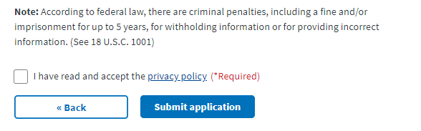

The user will be shown the following information after they submit their application:

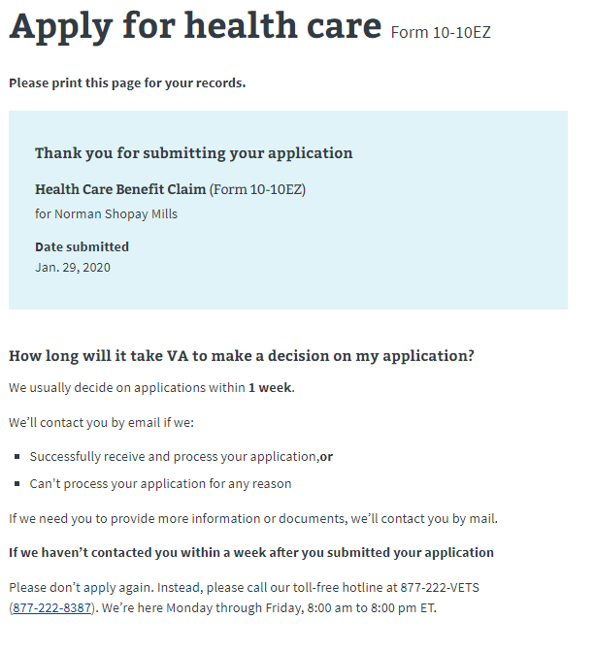

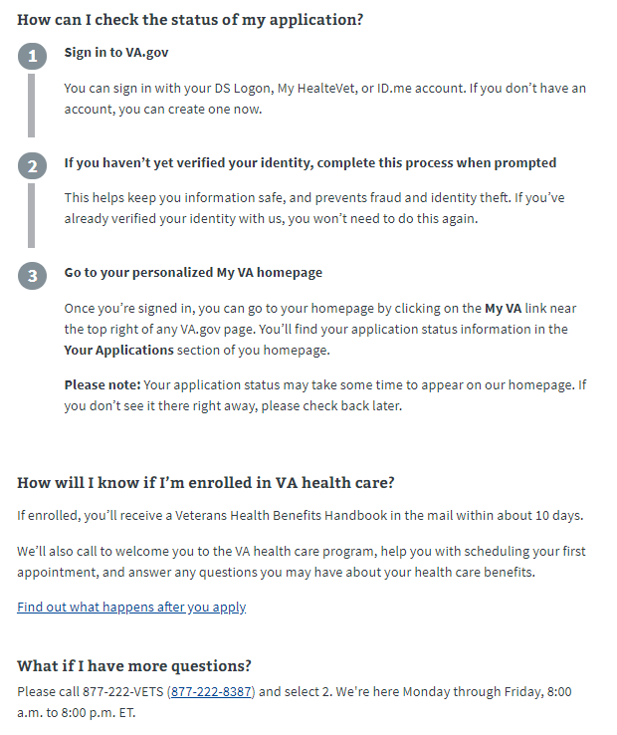

# Healthcare Application Issues

## Questions about the content of the application:

Many users will have specific questions about the content of the application because they don’t understand what the application is asking or why it needs that information. These are non-technical issues and should be directed to the Health Enrollment Center call center. Before transferring over to this call center, make sure the user does not have any questions related to the navigation or issues entering information for technical reasons.

The information for the HEC is at the bottom of every page in the Health Care Application:

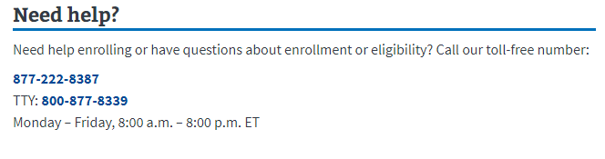

## Application is pre-filled with incorrect information:

If a user has already entered information about themselves or their account has personal, contact or military information associated with it, that information will be used to pre-fill the application. The purpose is to make it easier for the user to complete the application. Sometimes, this information is incorrect, and it will confuse the user why their application has pre-filled with the wrong information. The user can fix this by editing the information directly in the application.

## User can’t move forward in their application:

If a user is saying they can’t move on to the next page in the application, ask them to check and make sure they have filled out all the required information. The website will have a big red message indicating where it is missing required information:



## User can’t upload a document:

There are a few places where a user might be asked to upload a document to their application. If a user is having difficulty uploading a document, review the tips section below to make sure the user is following the guidelines:



## User is having trouble upgrading their LOA1 account to an LOA3 account

If a user is trying to apply for health care benefits with their LOA1 (not identity verified account) they will be required to upgrade to an LOA3 (identity verified) account. They can do this using ID.me or upgrading their My HealtheVet or DS Logon account. If they do not want to do this, you can also tell them they can apply for health care benefits signed out of their account. This is not ideal because they will have to provide more information as they fill out the application, but it is an option if they don’t want to upgrade their account to LOA3.