**Pension Benefits Application (21P-527EZ)**

Table of Contents

Pension Benefits Application Overview 2

User Access 2

Who can access this application? 2

Navigation 2

How Do I Apply 4

Pension Benefits Application 5

Application Information 5

Military History 7

Work History 12

Household Information: 16

Financial Disclosure: 18

Direct Deposit: 22

Contact Information: 23

Additional Information: 25

Review Application 28

# Pension Benefits Application Overview

This product guide covers the online application for veteran pension benefits (21P-527EZ).

## User Access

### Who can access this application?

Veterans do not need to be signed into complete this application. However, if they aren’t signed in, the application will not be prefilled with their information and the veteran will not be able to save their application in progress. You can reference the below screenshot for more information on this:

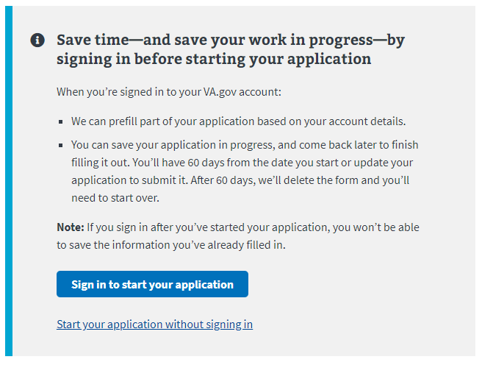

## Navigation

**Direct url:**​ <https://www.va.gov/pension/application/527EZ/introduction>

**Or** the link can be found in the dropdown menu:

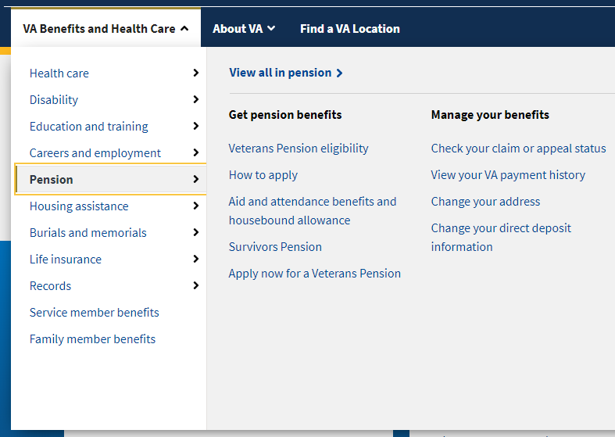

**Or** on the Pension Benefit Hub Page: <https://www.va.gov/pension/>

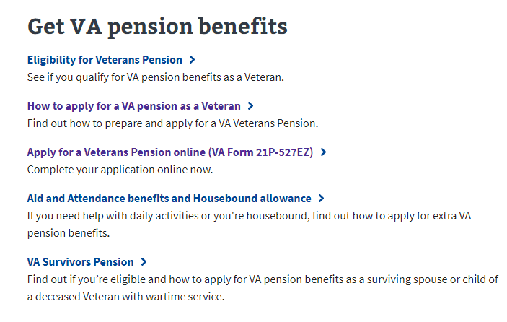

# How Do I Apply

<https://www.va.gov/pension/how-to-apply/>

This web page provides instructions on how to apply for veterans pension benefits and what information is needed to complete the application. This page also directs the user to the application once they are ready to apply:

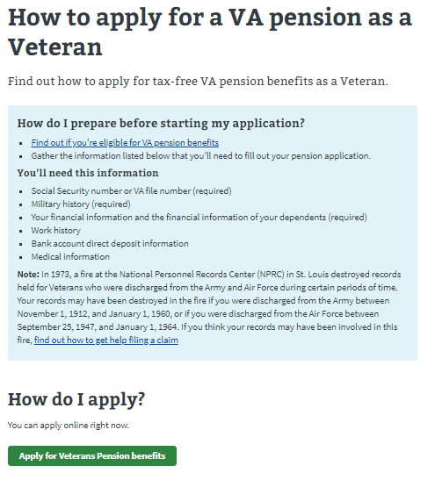

# Pension Benefits Application­

### Application Information

First, the user will be asked to fill in general personal information. If they are signed in, the application will be pre-filled but the veteran can also change this information. If they are not signed in, they will need to add the information.

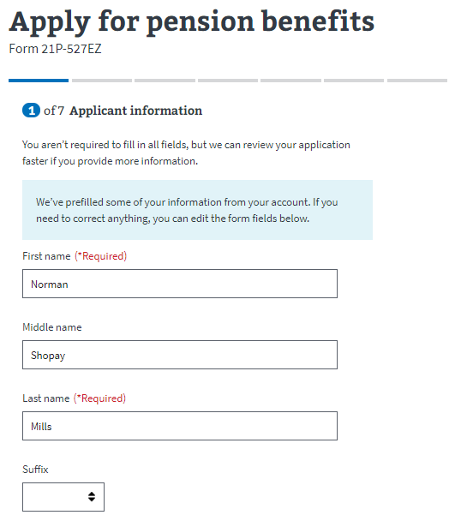

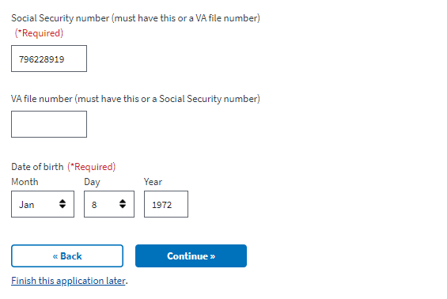

The application will tell the veteran what must be filled in. If they do not enter all the required information, they will not be allowed to move on to the next page.

### Military History

Next, the veteran will be asked to enter all of their periods of service. If they are signed in, this should be pre-filled. But they can edit and add more if they need to:

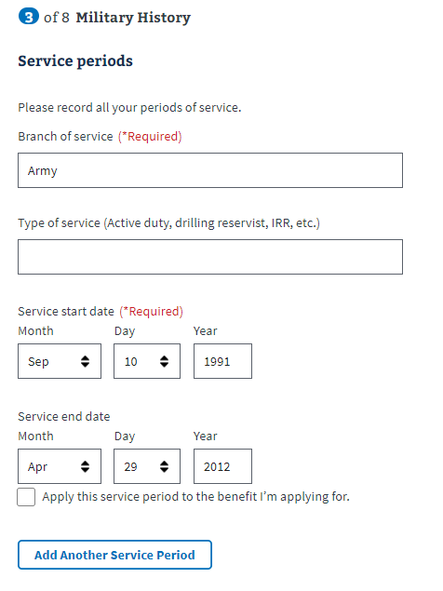

The user will be asked a few additional questions about their military history:

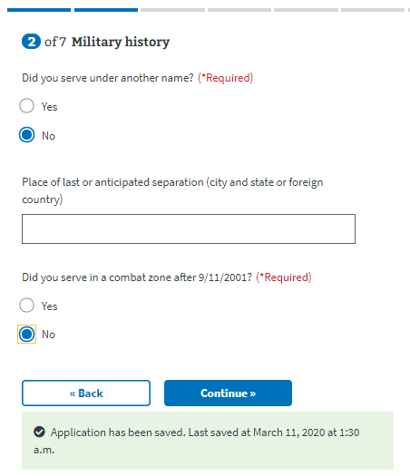

­Next, the user will be asked whether they served in the National Guard. If they say no, they will continue to the next page:

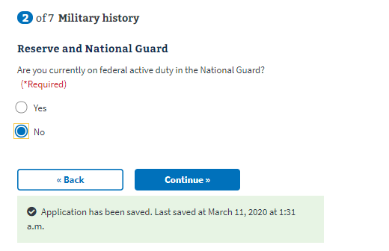

If they say yes, additional fields will appear that they must fill out to continue on to the next page:

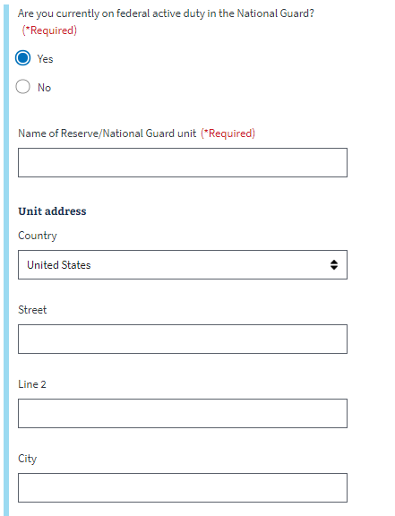

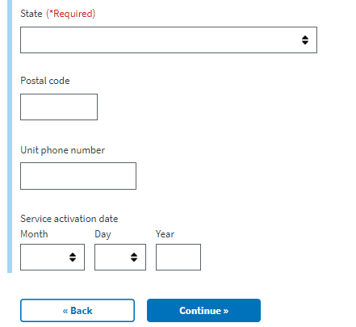

Next they will be asked about POW and severance pay

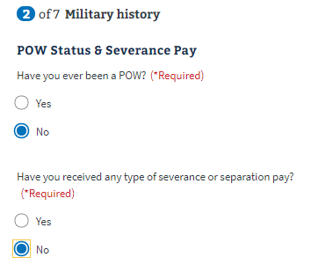

If the user says no to both of the questions, they can continue on to the next page. If they say yes, they will need to answer additional questions that appear:

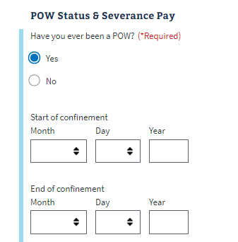

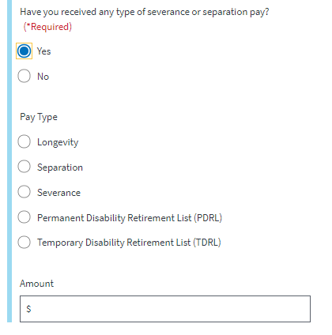

### Work History

Next they will be asked about their work history. First they will be asked what disabilities prevent the user from working.

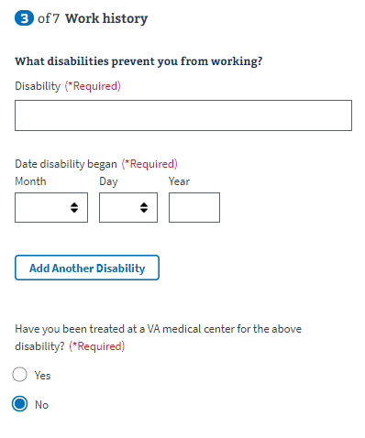

If the user selects yes, for the “Have you been treated at a VA medical center for the above disability?” a dropdown will appear with an additional questions.

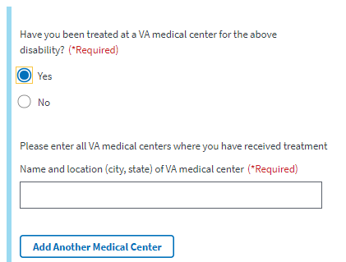

Next, they will be asked if they have had a job from 1 year before they became disabled until now.

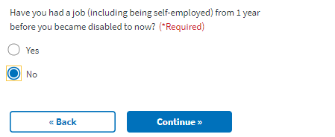

If they answer no, they can continue onto the next page. If they answer yes, they must answer additional fields that appear:

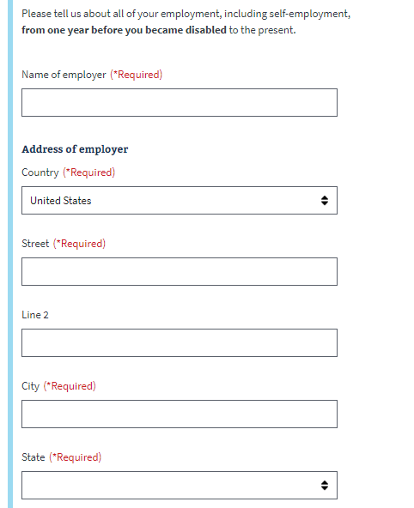

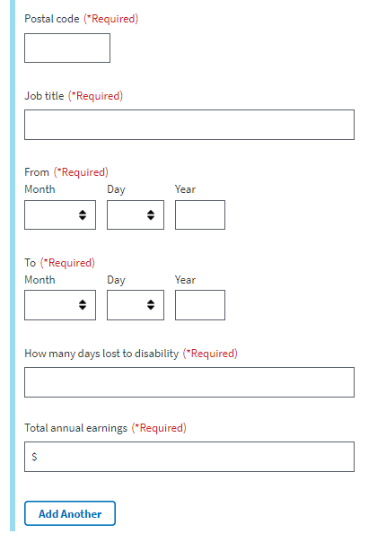

### Household Information:

Next the veteran will be asked about their marital status. If the user selects married, separated, widowed, or divorced, they will need to enter how many times they have been married:

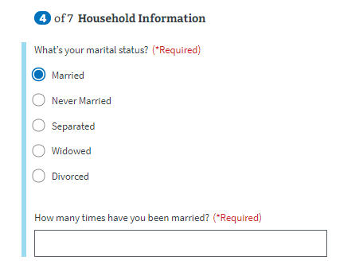

Next they will be asked about their dependent children. If they don’t have any, they can continue onto the next page. If they do, they will need to enter information about each child:

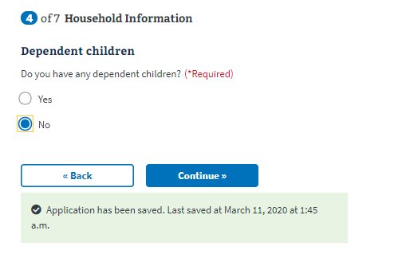

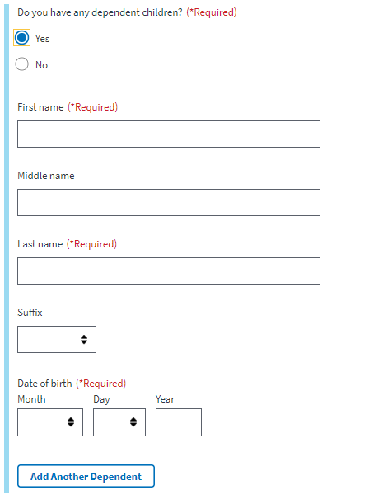

### Financial Disclosure:

Next the veteran will be asked to enter financial information. The application provides a general list of sources but if they do not cover all the sources for a veteran, they can select the “add another source” button to provide more information:

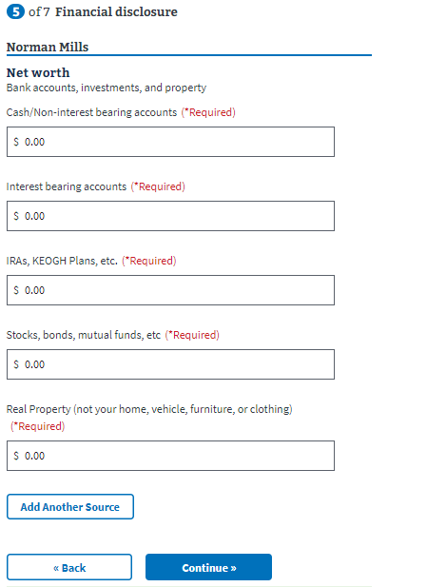

The next page looks the same as the net worth page but requires monthly income disclosure:

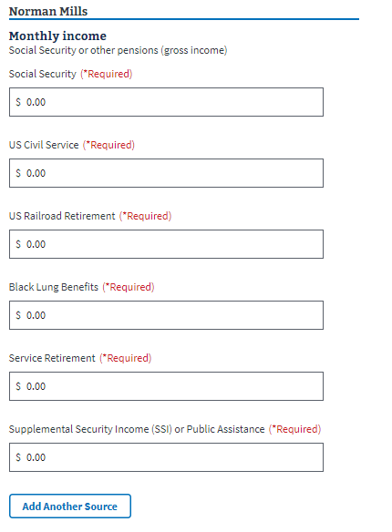

Next, the user is asked to report any expected income:

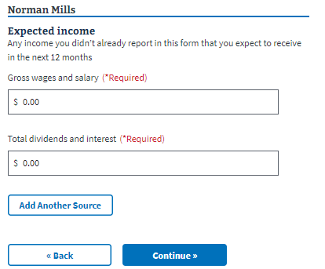

Next, the user is asked to report any unreimbursed expenses. If the user selects no, they can move on to the next page. If they select yes, they will need to answer additional questions:

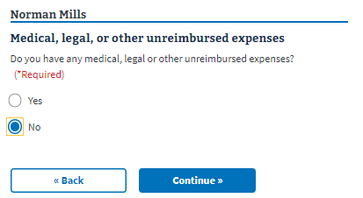

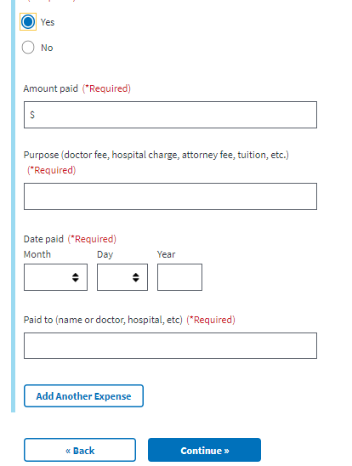

### Direct Deposit:

Next the user will be asked to enter direct deposit information:

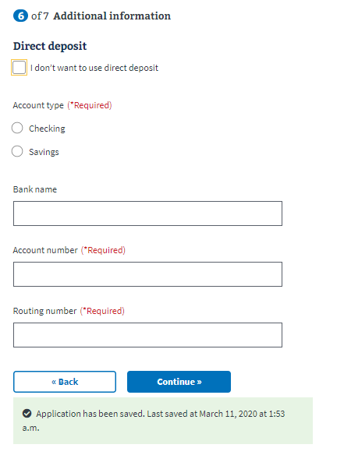

### Contact Information:

Next, they will enter their contact information:

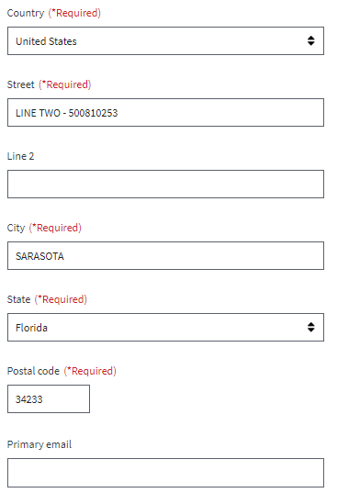

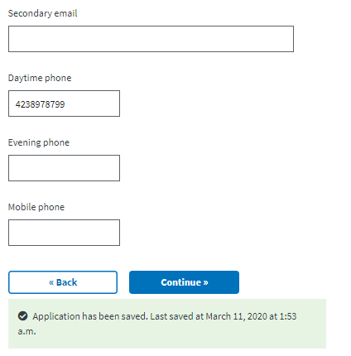

### Additional Information:

Next, the user is presented with information about Aid and Attendance and Housebound Benefits. The information outlines what they will need to provide in terms of supporting documents if they are claiming non-service connected pension benefits with Aid and Attendance benefits or if they are claiming for increased disability pension benefits based on being housebound.

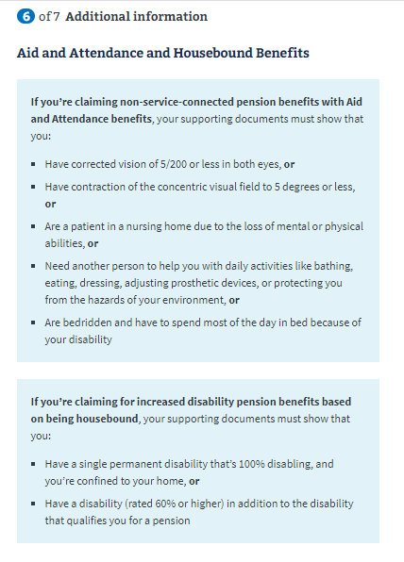

On the next page is where they can upload any supporting documents:

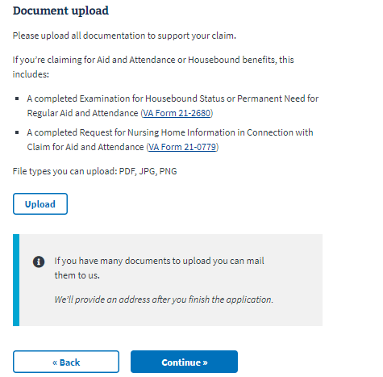

Next the user is presented with the option of applying using the fully developed claim program. The user can go through the FDC program if they have uploaded all necessary documentation. They can also learn more about the FDC program by selecting the “Learn more about the FDC program” link:

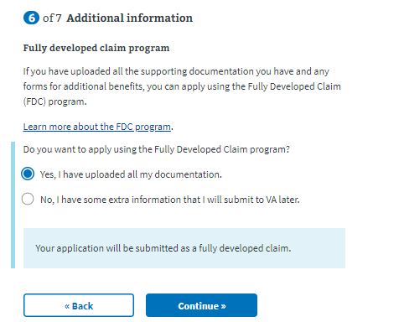

## Review Application

The last step is the review application page. Here the veteran can review the information they’ve entered by clicking on the plus signs next to a section:

­ 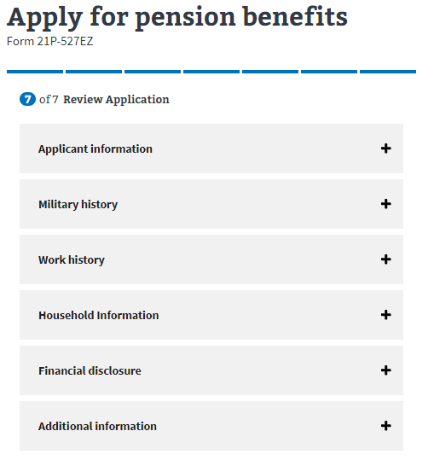

If the veteran clicks on the plus sign, the section will open and show what the user entered. If something looks wrong, the veteran can select the “edit” button, and will be able to make edits on the information:

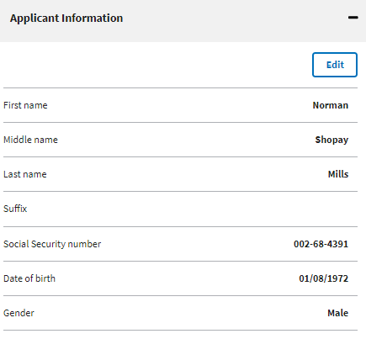

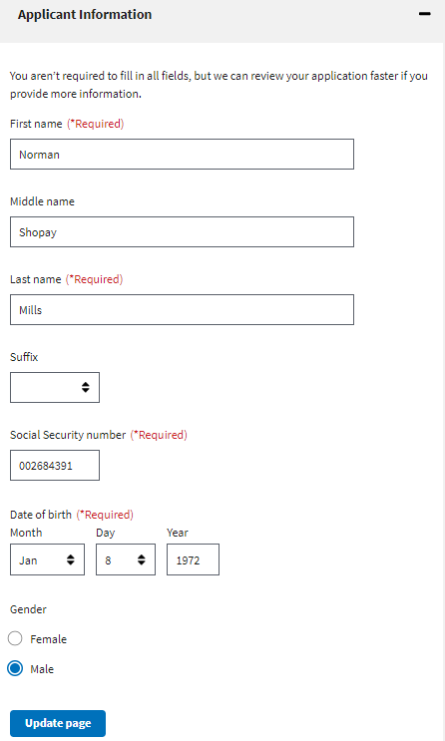

Once the user has reviewed the information and made any changes, they can select to submit the application. They can only successfully submit the application after selecting the “I have read and accept the privacy policy” check box:

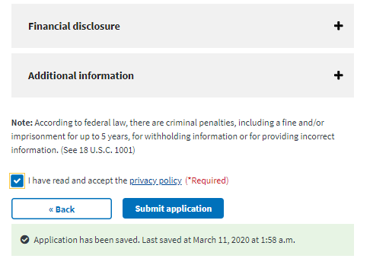

After selecting “submit application” the user will be shown the below page which contains a summary of the information, as well as additional information links that can help the veteran understand the process for their education claim:

