**Pre-Need Burial Application (40-10007)**

Table of Contents

Pre-Need Burial Application Overview 2

User Access 2

Who can access this application? 2

Navigation 3

Pre-Need Eligibility 5

Pre-Need Eligibility Application 6

Application Information 6

Military History 11

Burial Benefits 13

Supporting Documents: 15

Contact Information: 16

Review Application 20

# Pre-Need Burial Application Overview

You can apply to find out in advance if you can be buried in a VA national cemetery. This is called a pre-need determination of eligibility.

**Please note:** “Pre-need” means before the time of need. This application is for planning for your own burial in advance. Please don’t complete this form if you’re requesting burial at the time of need.

## User Access

### Who can access this application?

Veterans do not need to be signed into complete this application. However, if they aren’t signed in, the application will not be prefilled with their information and the veteran will not be able to save their application in progress. You can reference the below screenshot for more information on this:

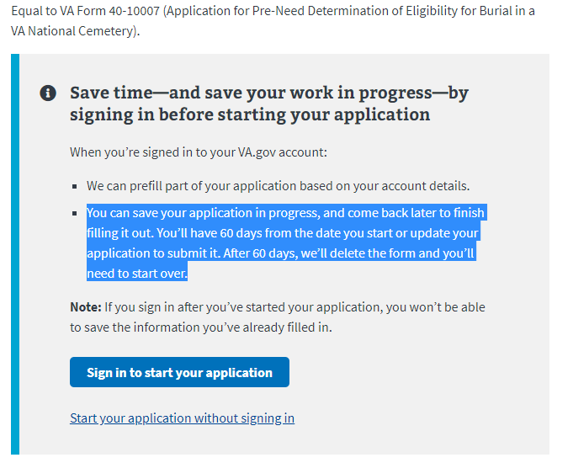

## Navigation

**Direct url:**​ <https://www.va.gov/burials-and-memorials/pre-need/form-10007-apply-for-eligibility/introduction>

**Or** the link can be found in the dropdown menu:

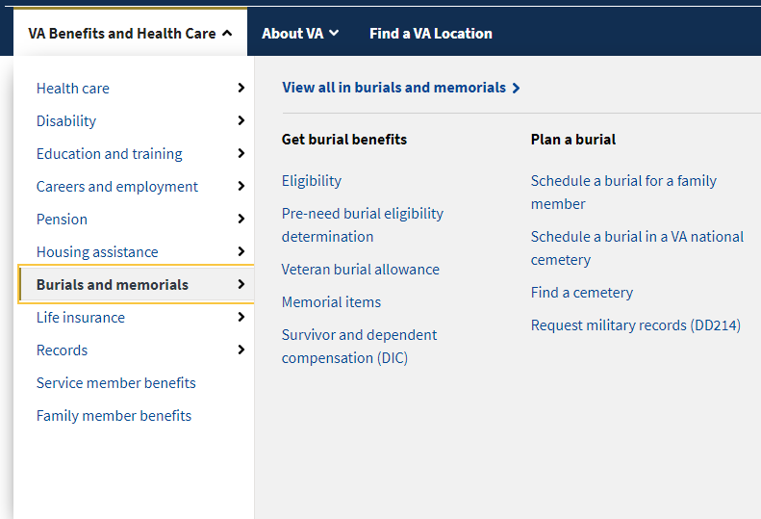

**Or** on the Burials and Memorials Benefit Hub Page: <https://www.va.gov/burials-memorials/>

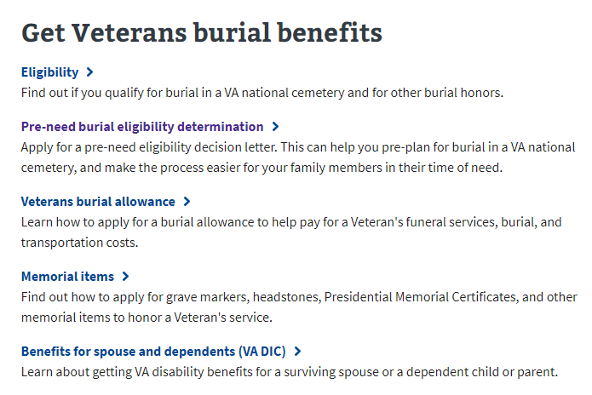

# Pre-Need Eligibility

<https://www.va.gov/burials-memorials/pre-need-eligibility/>

This web page provides instructions on to apply for pre-need eligibility and what information is needed to complete the application. This page also directs the user to the application once they are ready to apply. This is found near the bottom of the page:



# Pre-Need Eligibility Application

### Application Information

First, the user will be asked to fill in general personal information. If they are signed in, the application will be pre-filled but the veteran can also change this information. If they are not signed in, they will need to add the information.

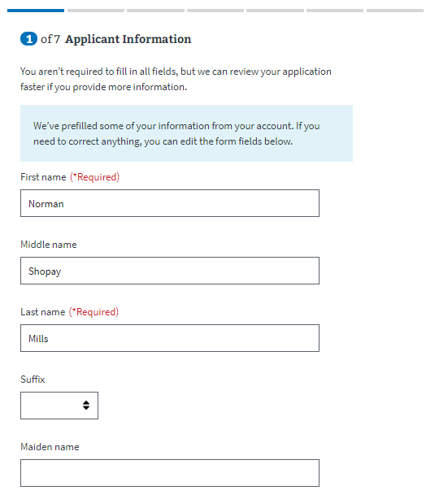

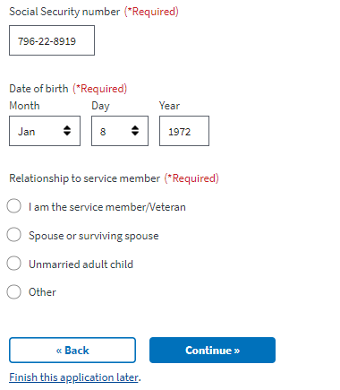

If the user answers they are the veteran/service member filling out the application, they next page will ask additional questions about the user.

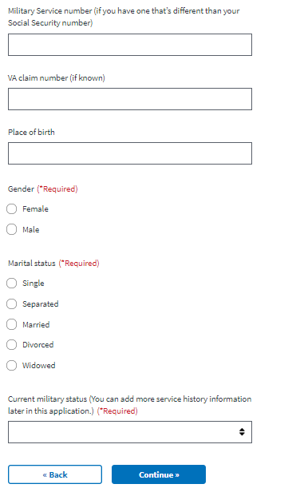

If the user selects spouse/surviving spouse or unmarried adult child, the user will have to provide additional information about their sponsor:

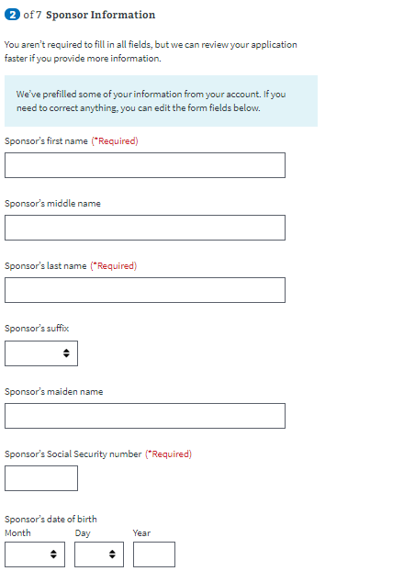

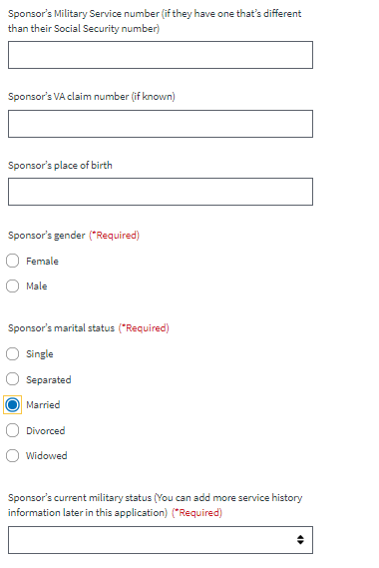

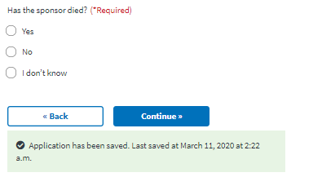

### Military History

Next, the veteran will be asked to enter all of their periods of service. If they are signed in, this should be pre-filled. But they can edit and add more if they need to:

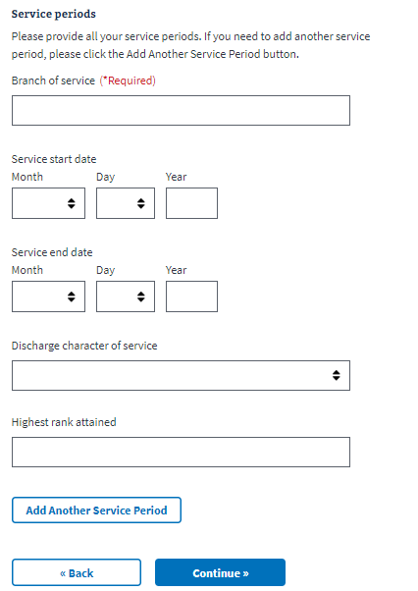

The user will be asked a few additional questions about their military history:

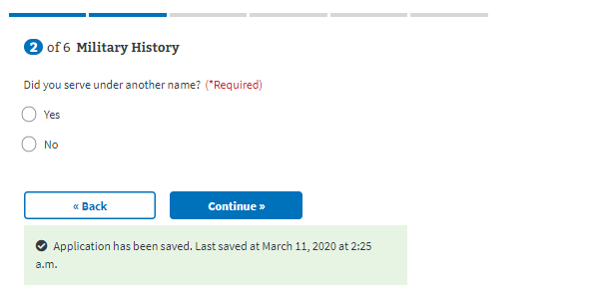

### Burial Benefits

Next they will be asked about burial benefits. When the user begins typing in the name of the VA national cemetery where they would prefer to be buried, a dropdown will appear and they must select one of the options provided.

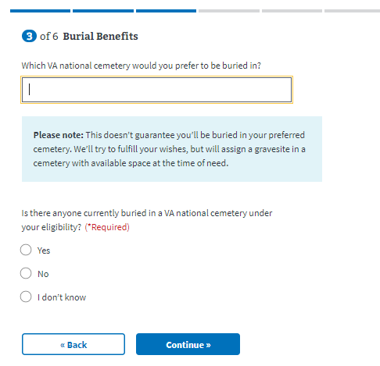

Additionally, if the user answers Yes, there is someone currently buried in a VA national cemetery under their eligibility, additional fields will appear that they will need to fill out:

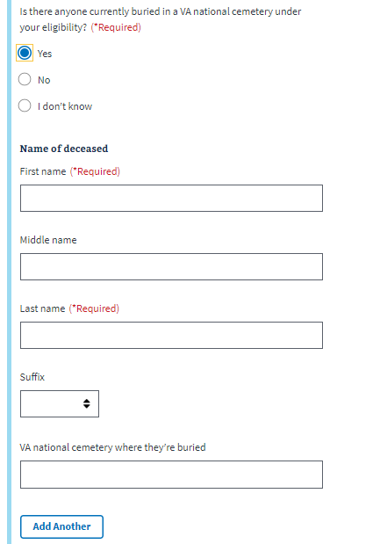

### Supporting Documents:

Next the user will be asked to upload supporting documents. There is a dropdown that provides helpful information about what type of documents the user should upload, including the DD214

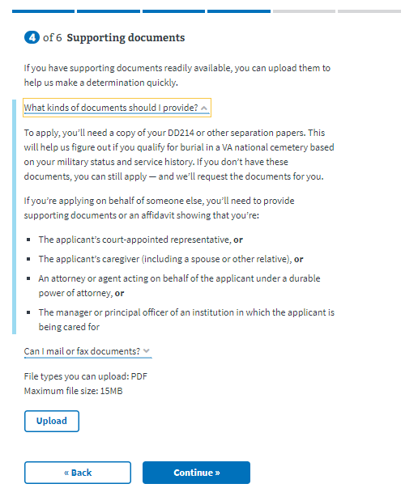

### Contact Information:

Next, they will enter their contact information:

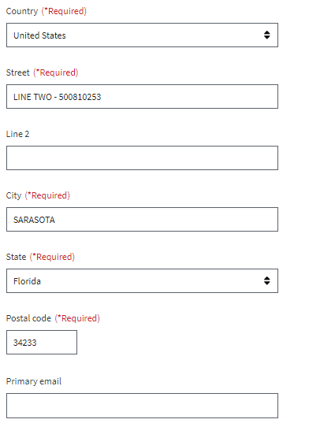

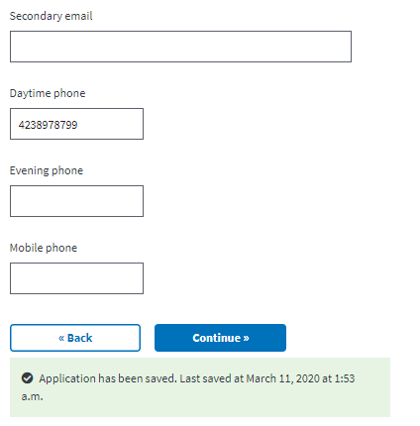

Next, they will be asked who is filling out this application. If the answer is the veteran, they will move on to the next part of the application. If it is someone else, they will need to answer additional questions:

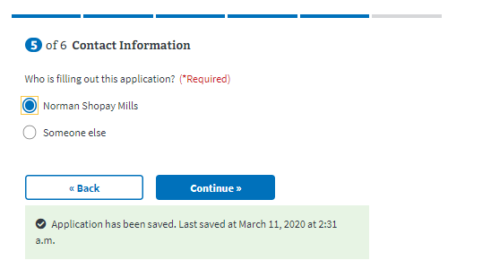

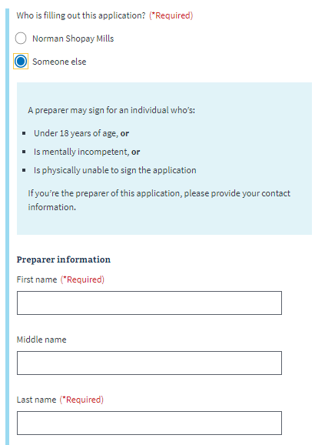

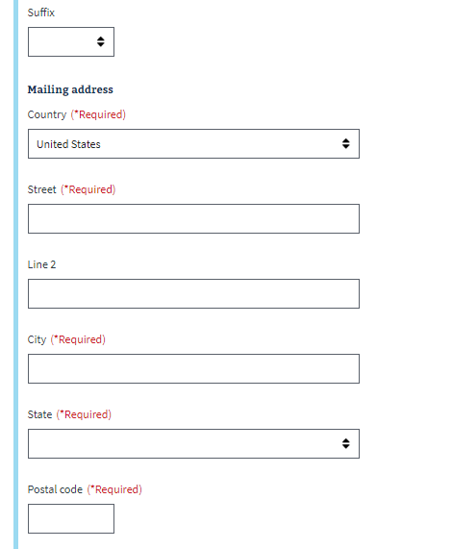

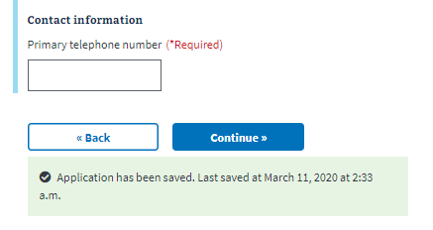

## Review Application

The last step is the review application page. Here the veteran can review the information they’ve entered by clicking on the plus signs next to a section:

­ 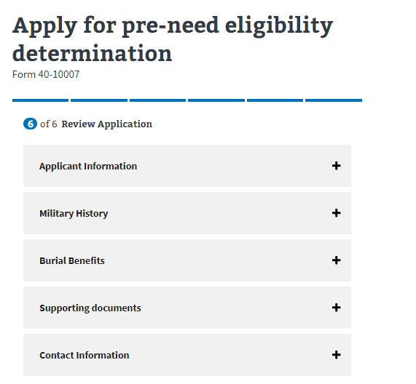

If the veteran clicks on the plus sign, the section will open and show what the user entered. If something looks wrong, the veteran can select the “edit” button, and will be able to make edits on the information:

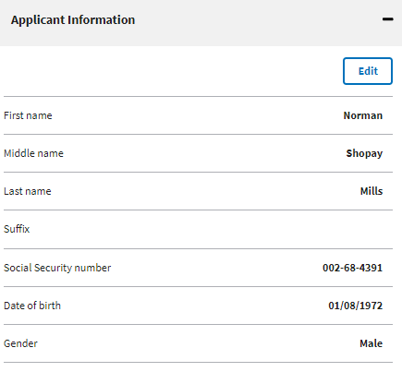

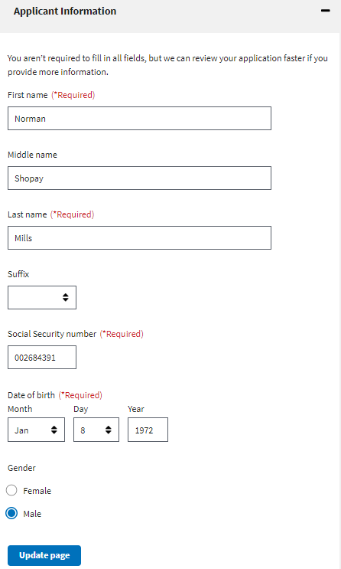

Once the user has reviewed the information and made any changes, they can select to submit the application. They can only successfully submit the application after selecting the “I have read and accept the privacy policy” check box:

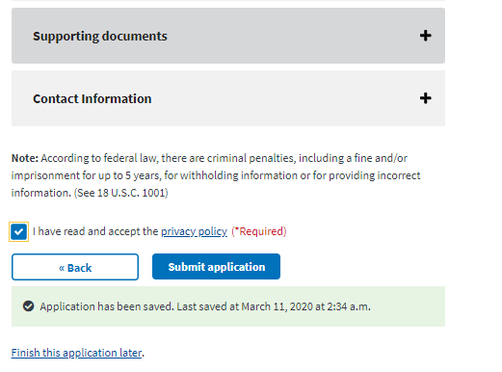

After selecting “submit application” the user will be shown the below page which contains a summary of the information, as well as additional information links that can help the veteran understand the process for their education claim:

