**VA Benefit Letters Tool**

Table of Contents

VA Benefit Letters Overview 2

User Access 2

Who can access this application? 2

Navigation 2

VA Benefit Letters Functionality 4

Not Signed In 4

Signed in to an LOA1 Account 7

Signed into an LOA3 Account (identity verified) but not verified in MVI 8

Signed into an LOA3 Account (identity verified) AND verified in MVI 9

Major Issues and Error Messages 16

Signed into an LOA3 Account (identity verified) but not verified in MVI 16

Invalid Address Error Message: 17

Unable to find information about your VA letters message: 18

# VA Benefit Letters Overview

Veterans need a letter proving their status. Veterans can access and download their VA Benefit Summary Letter (sometimes called a VA award letter) and other benefit letters and documents online.

## User Access

### Who can access this application?

The only users who can access this tool are veterans who are signed into an LOA3 account (identity proofed). This tool is not available for users who are not signed in or only have an LOA1 account (not identity proofed). Additionally, the user’s LOA3 account must be matched with MVI, meaning the user’s identity has been verified as a veteran in the VA’s records.

## Navigation

**Direct url:**​ <https://www.va.gov/records/download-va-letters/>

**Or** the link for the education application can be found on the ​**VA.gov**​ homepage.

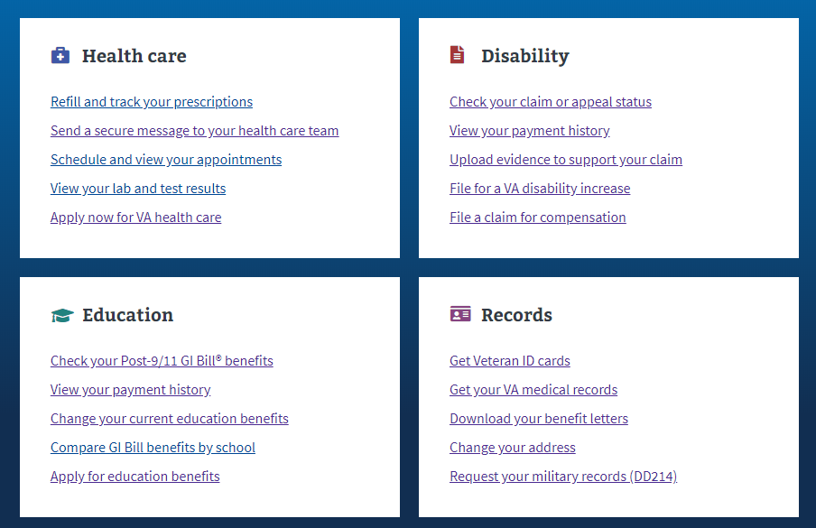

**Or** in the main menu drop down:

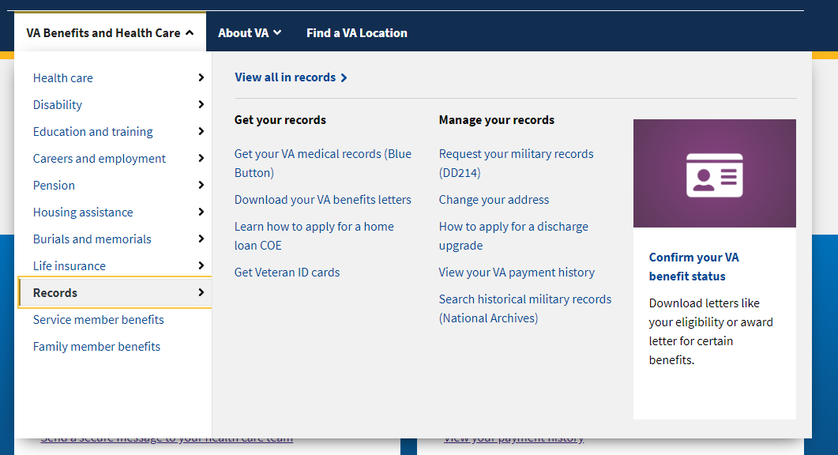

**Or** on the Education Hub Page under “Manage your Veterans education benefits”: <https://www.va.gov/education/>

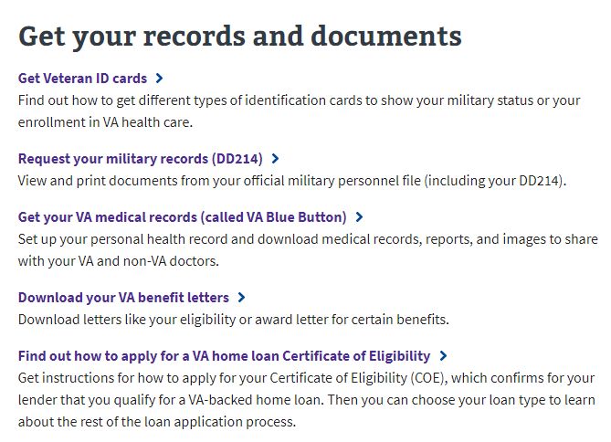

# VA Benefit Letters Functionality

### Not Signed In

If a user goes to the VA Benefit Letters Tool and is not signed into an account, they will see the following information:

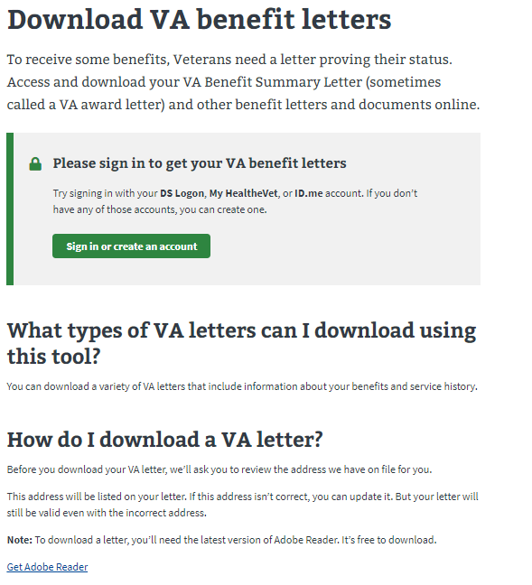

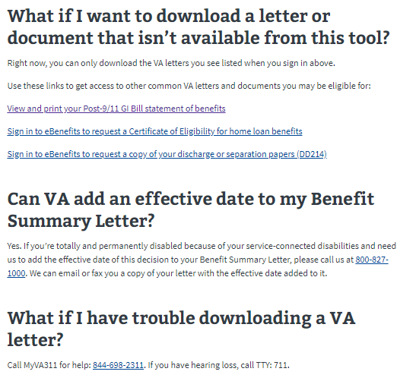

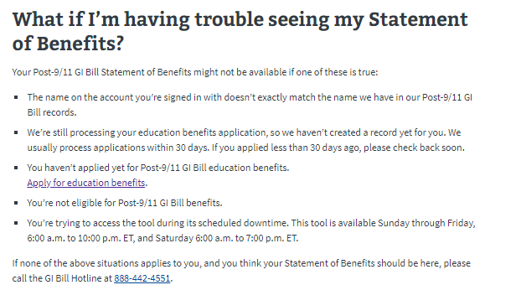

The important thing to note is that the user must create an account and sign in if they want to access their VA Benefit letters. There is also additional information that explains how to download the letters and where to download benefit letters that aren’t provided by this tool.

### Signed in to an LOA1 Account

If a user is signed into an LOA1 account (not identity proofed), they will see the following screen when they go to the tool:

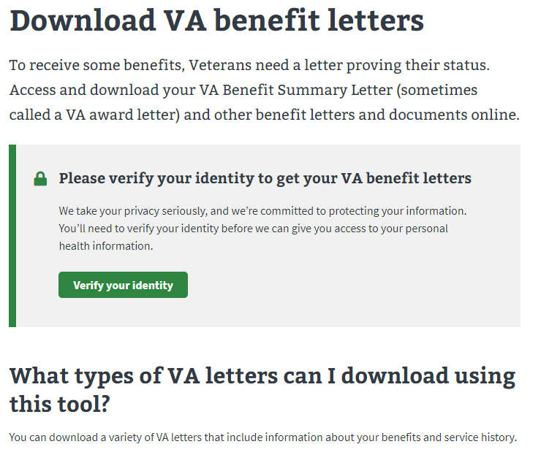

They will need to verify their identity before they are able to access the tool.

### Signed into an LOA3 Account (identity verified) but not verified in MVI

If a user is signed into an LOA3 account and is not verified in MVI, when they go to the landing page for the VA Benefit Letters tool, they will see the following screen:

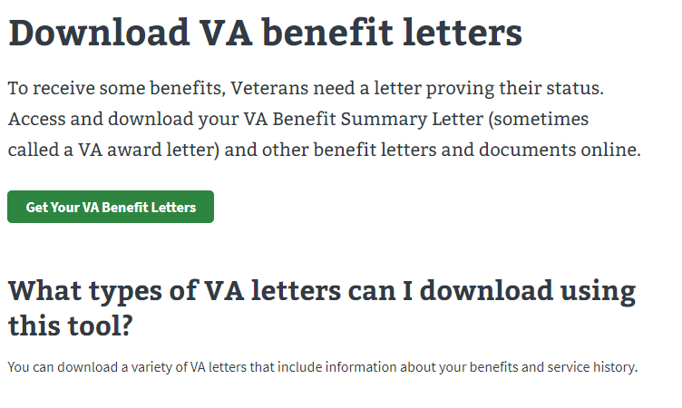

After selecting the “Get your VA Benefit Letters” button, the user will see the following messages:

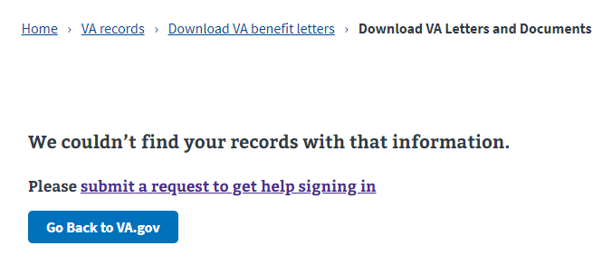

If the user sees this, they will need to go through the process of updating their VA records to verify their identity and get access to this tool.

### Signed into an LOA3 Account (identity verified) AND verified in MVI

If a user is signed into an LOA3 account and is verified in MVI, when they go to the landing page for the VA Benefit Letters tool, they will see the following screen:



After selecting the “Get your VA Benefit Letters” button, the user will see the following screen:

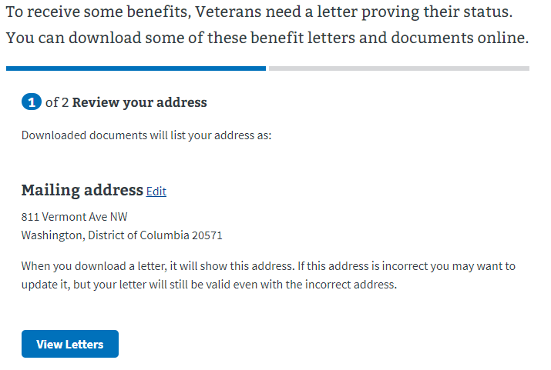

This screen shows the address on file for the veteran. It also tells the user that if the address is wrong, they can update it but that the letter is still valid, even if the address does not match their current address. The user can select to edit the address on the screen by selecting the “Edit” link.

After the user selects the “view letter” button, they are taken to the letters available to them:

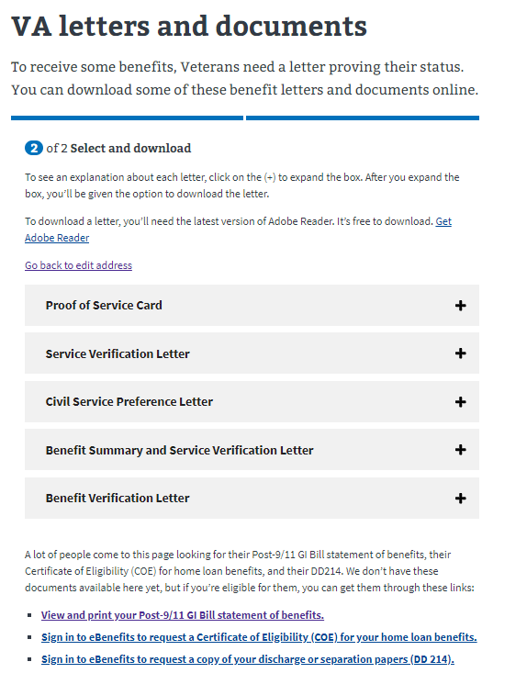

On this page, the user is warned they will need to have the latest version of Adobe Reader to download the letter. There is a link that directs them on how to get it if they don’t have it:



The user can then select the “+” signs to see an explanation about each letter and download the letter.

*Proof of Service Card:*

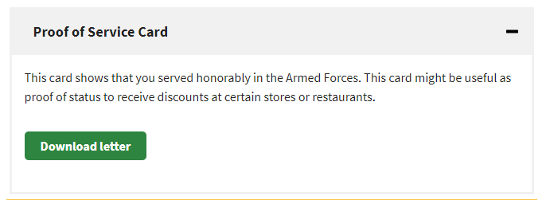

*Service Verification Letter: The user is notified they can use their Benefit Summary Letter instead of this one.*

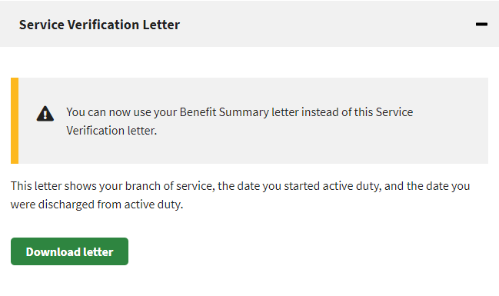

*Civil Service Preference Letter*

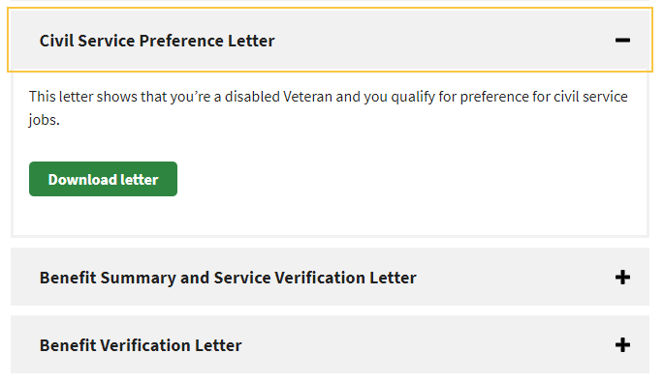

*Benefit Summary and Service Verification Letter*

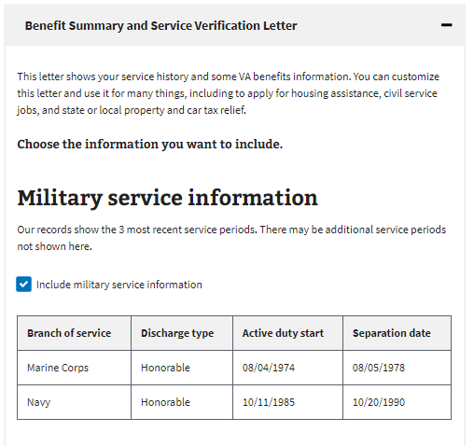

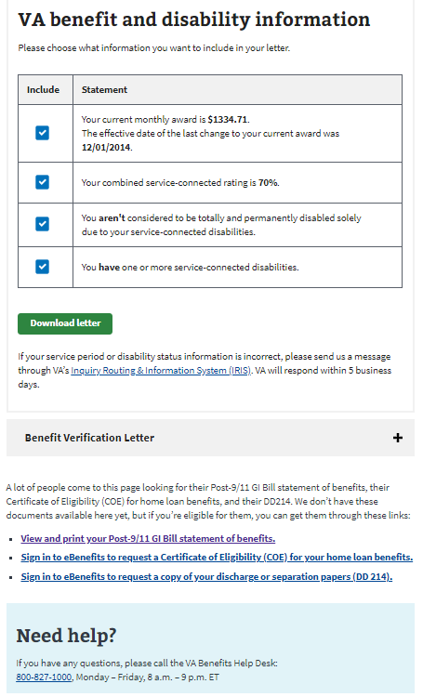

This letter typically has more information and allows the user to select what to include in the letter they download.

*Benefit Verification Letter:*

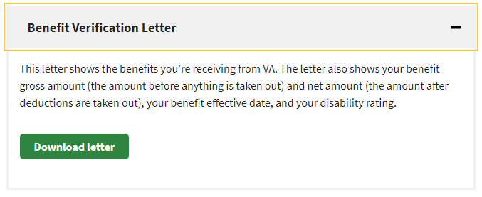

When a user selects to download a letter, they will see the below message and depending on how their computer is configured, the downloaded document will appear in their documents tab or somewhere else and the user will need to click save. Once they do that, the letter will open:

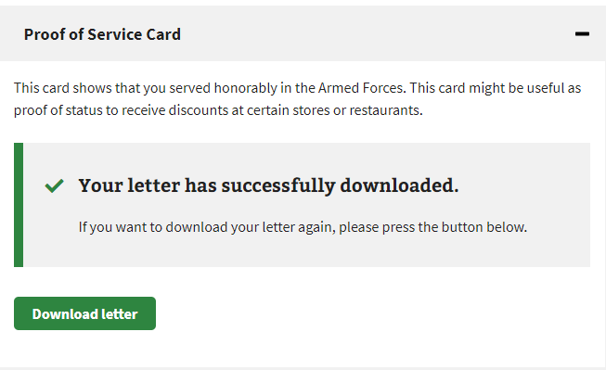

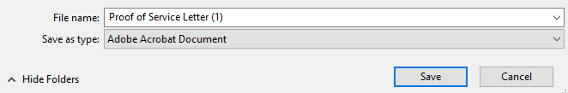

# Major Issues and Error Messages

### Signed into an LOA3 Account (identity verified) but not verified in MVI

If a user is signed into an LOA3 account and is not verified in MVI, when they go to the landing page for the VA Benefit Letters tool, they will see the following screen:



After selecting the “Get your VA Benefit Letters” button, the user will see the following messages:



If the user sees this, they will need to go through the process of updating their VA records to verify their identity and get access to this tool.

To do this, the user will need to do the following:

* Contact your nearest VA medical center and let them know you need to verify the information in your records and update it as needed.
* The operator or patient advocate can connect you with the right person.

[Find your nearest VA Medical Center](https://www.va.gov/find-locations)

### Invalid Address Error Message:

The veteran is signed into an LOA3 (identity verified) VA.gov account that is verified in MVI. They go to download their Benefit Letters.



After selecting the “Get Your VA Benefit Letters” button, they see the following message:

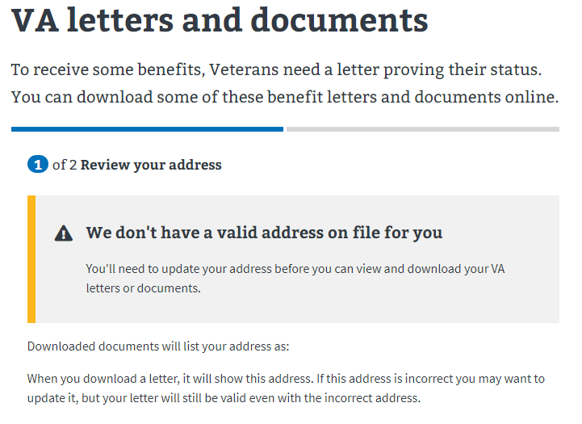

If the user sees this message, they will need to go to their VA.gov profile and update their address. The user can access their profile from the header dropdown:

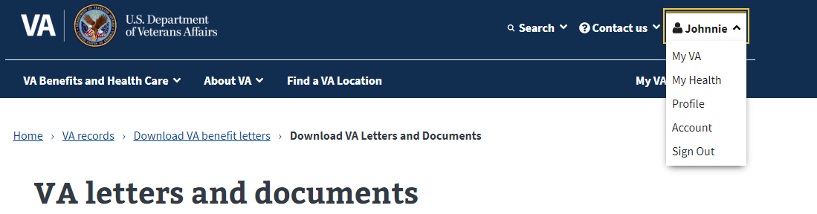

### Unable to find information about your VA letters message:

If a user is signed into an LOA3 VA.gov account and sees the below message, they should be instructed to contact the number provided to determine if they have Benefit letters.

