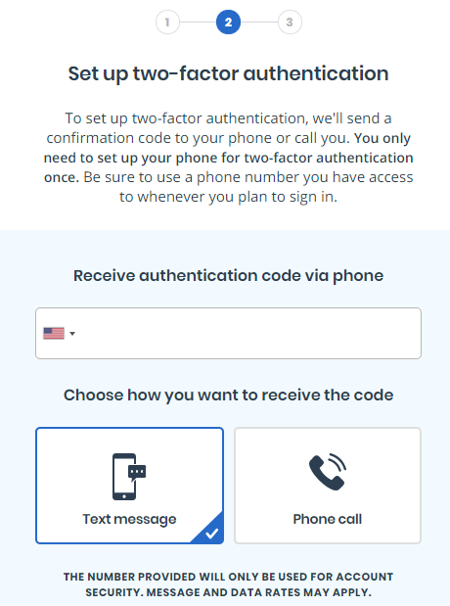

A user who is setting up two-factor authentication must enter a phone number where they can receive a text message or phone call with a 6-digit, one time use security code.

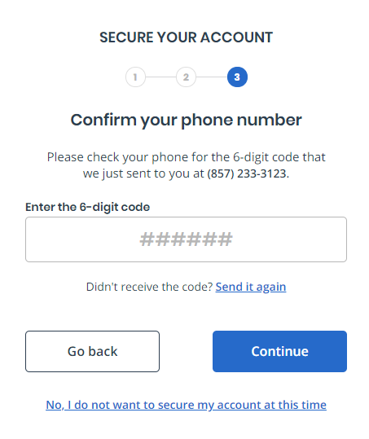

After entering the phone number, the user will receive the text message or phone call (depending on what they selected) with the 6-digit code. They must enter it and select “continue.”

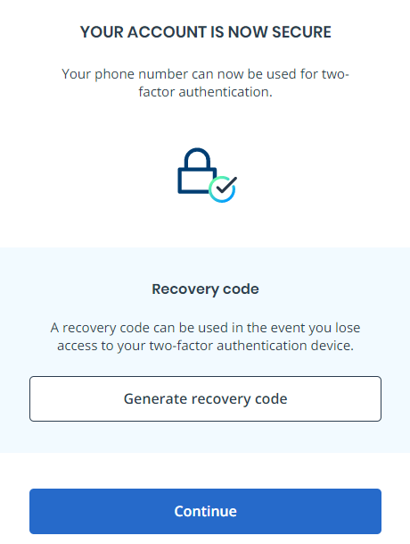

Once the user has entered the 6-digit code, they have completed setting up two-factor authentication. The user can continue to VA.gov or they can also generate a recovery code. This is a code they can save and store away in case they lose access to the phone where their 6-digit security codes are sent because from now on, whenever the user signs into VA.gov, they will be sent a 6-digit code that they must enter to access their VA.gov account.