**FEATURE GUIDE**

**VA.gov User Profile**

Table of Contents

Profile Overview and Navigation 2

Who has a VA.gov profile? 2

Profile Features 5

Contact Information Overview 6

Top Contact Information Issues and Error Messages 10

Personal Information Overview 11

Top Personal Information Issues and Error Messages 11

Military Service Information 12

Top Military Service Information Issues and Error Messages 13

Other Profile Errors and Issues 13

# Profile Overview and Navigation

The profile feature is where a user can view the contact, personal, and military information the VA has on them. Users can also use the profile to update their contact information for certain VA.gov benefits and services. Additionally, some VA.gov users may be able to view and update their direct deposit account information for compensation and pension benefits.

This is the link to a user’s profile: <https://www.va.gov/profile>. However, a user must be signed in to see their profile.

1. Sign in to VA.gov (<https://www.va.gov/>).

1. Click the **personalized menu** in the upper right corner of the screen (the user’s name) and select **Profile**.

# Who has a VA.gov profile?

Every VA.gov account has a profile. However, the functionality of a profile only exists **if a user is signed into their LOA3 (identity verified) VA.gov account.**

This is what the profile looks like when signed into an identity verified account:

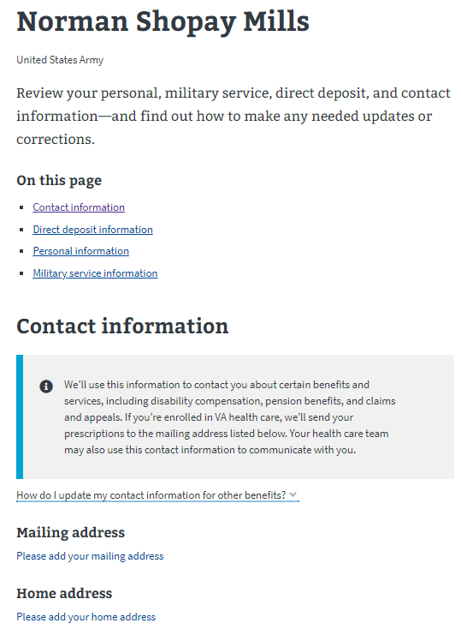

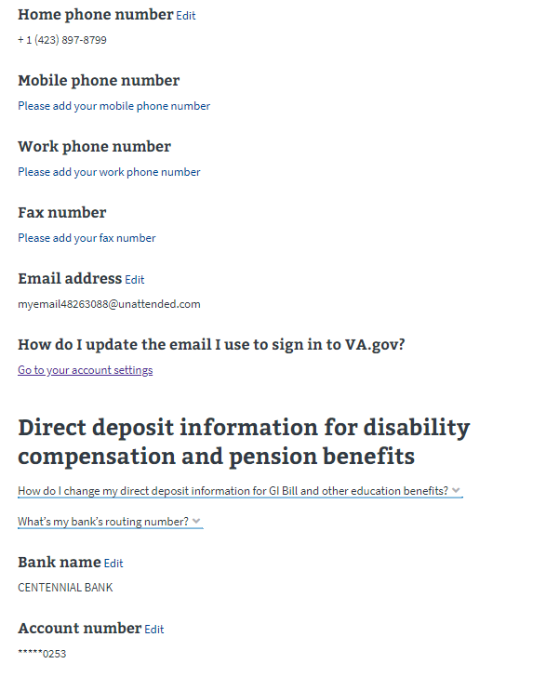

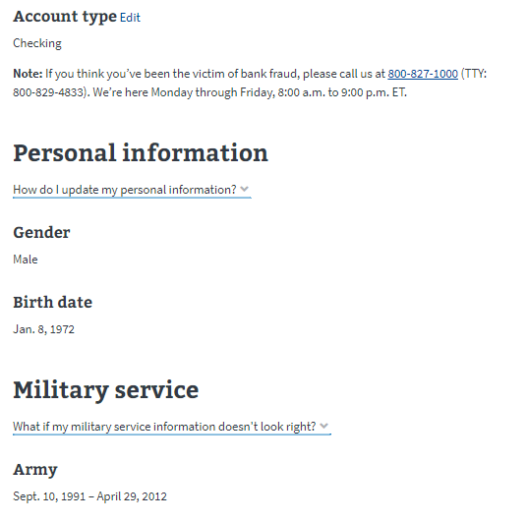

If a user has an LOA1 VA.gov (NOT identity verified), they will still have a profile in the header dropdown…

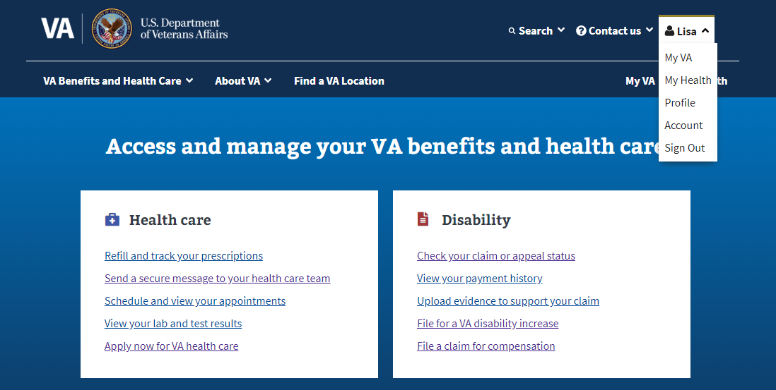

But there will be no information in their profile. Below is a picture of what a profile looks like for a user with an LOA1 (NOT identity verified) account:

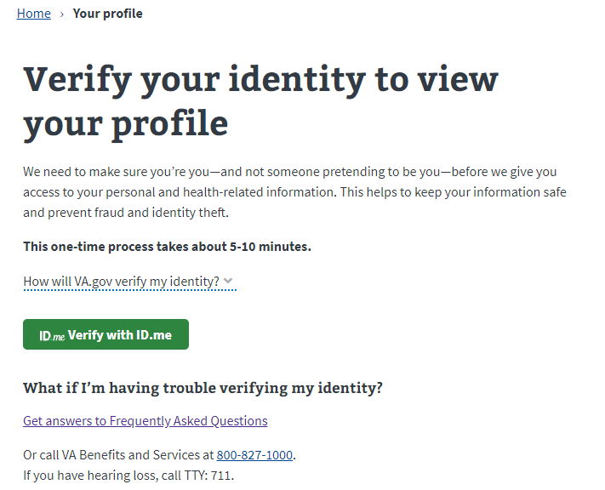

# Profile Features

There are **3** permanent features of a VA.gov profile.

1. Contact Information
2. Personal Information
3. Military Service

Some VA.gov users will also have a direct deposit feature. The direct deposit feature is only visible to people who receive compensation & pension payments from the VA and appears below the contact information section of the profile.

*Profile with Direct Deposit:*

*Profile without direct deposit*

## Contact Information Overview

The contact information feature displays the following information:

* Mailing address
* Home address
* Home phone number
* Mobile phone number
* Work phone number
* Fax number
* Email address

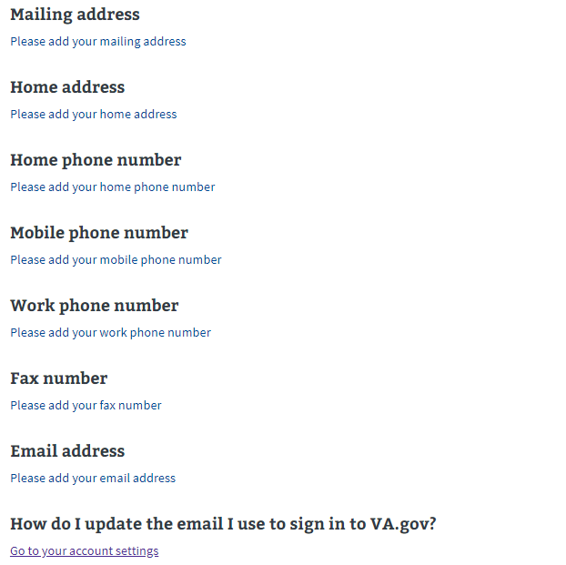

A user can update any of the fields in the contact information section of the profile and it will update immediately across the following VA benefits and services:

* VA health care (including prescriptions, appointments, reminders, lab and test results, and communications from your VA medical team)
* Disability compensation
* Pension benefits
* Claims and appeals
* Vocational Rehabilitation and Employment (VR&E)

If a user needs to update their contact information for other VA benefits and services, the profile provides that information in a dropdown answer. This webpage also provides the same information: <https://www.va.gov/change-address/>

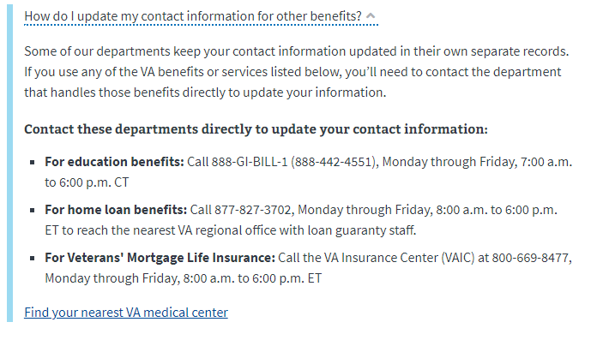

To update contact information, select the “edit” button.

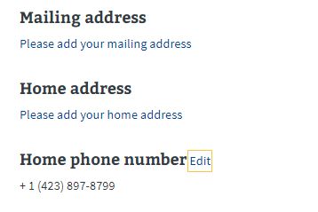

Enter updated information and select “update” button.

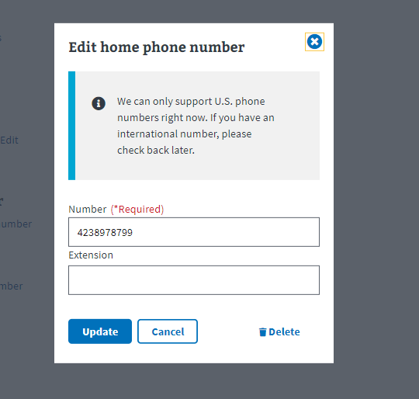

If there is no information added to a data field, there will be a “Please add your [data field] link. Select this link to open the editing pop up.



Enter your information in the provided fields and select update to save.

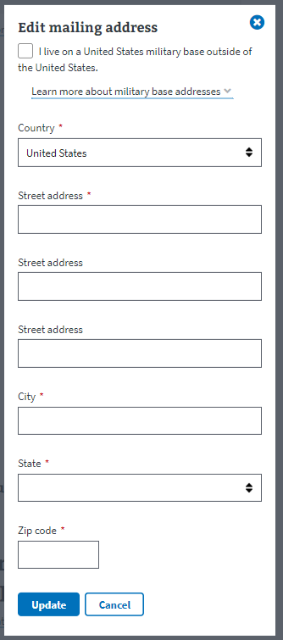

### Top Contact Information Issues and Messages

1. **Contact information is incorrect:** When a user creates an LOA3 (identity verified) account, their profile will often come pre-populated with information. If the contact information is incorrect, the user can update that information and this will update across the following systems:
   1. VA health care (including prescriptions, appointments, reminders, lab and test results, and communications from your VA medical team)
   2. Disability compensation
   3. Pension benefits
   4. Claims and appeals
   5. Vocational Rehabilitation and Employment (VR&E)

If the user needs the contact information to be updated in other systems, they can use the dropdown menu or you can refer them to this website: <https://www.va.gov/change-address/>

1. **Problems updating information:** Sometimes a user will receive the below error messages when trying to update their contact information:

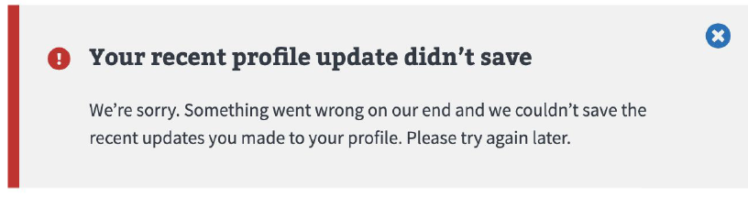

If a user reports seeing this error message, advise them to follow its instructions, and to

try again later. If they still cannot update their information after multiple times, make note that this issue should be escalated to the VA.gov contact center team.

1. **Address will not update:** Sometimes a user will receive the below error message when trying to update their mailing address:

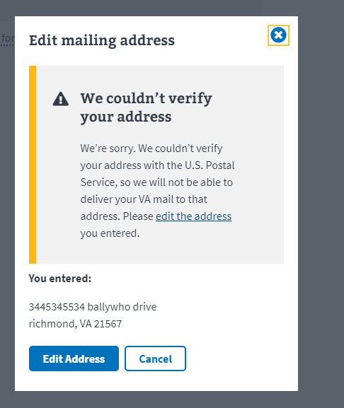

Advise the user to check the entered their address correctly. If they say it is, this issue will need to be escalated to the VA.gov contact center team.

1. **Military Base Address:** The contact information section of the VA.gov profile allows users to enter a military base for their address. Some users have difficulty with entering this information correctly. To help with this, the profile provides a check box that automatically formats portions of the address to prevent a user from entering certain information incorrectly:

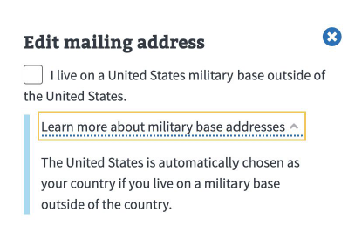

1. **Missing Information:** When updating contact information, there are required fields that must be entered to save the new information. If the user does not enter that information, the user will see the following image:

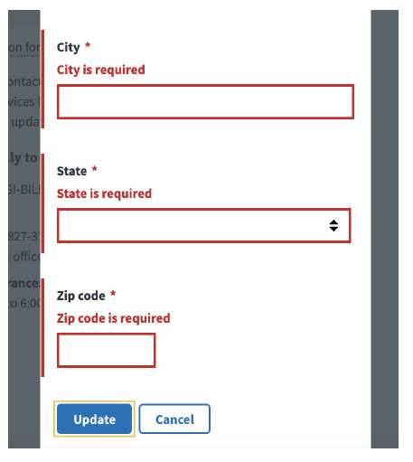

The user must enter the missing information to save the update to their contact information.

1. **No international phone numbers:** The VA.gov profile only supports domestic (U.S.) phone numbers. A user cannot enter an international phone number into any of the available phone fields (home, work, mobile, fax). If a user does enter an invalid or international number, the will see the following message:

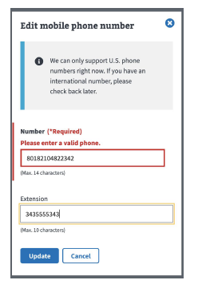

1. **Deleting Contact Information:** If a user deletes contact information, they will receive a message warning them about the consequences of deleting the information. This is shown because contact information updates across multiple systems and we want to make sure the user knows this before removing information. The user can always add the information back in if they realize the didn’t want the information taken away.

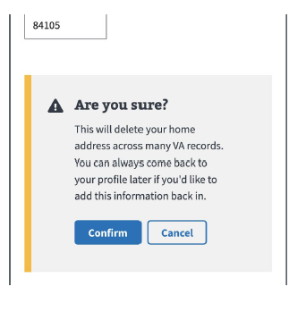

1. **Saving Message:** After a user enters new contact information, they will see the below message. This is to indicate that the process of saving the new information is happening. This message will disappear once that process has completed.

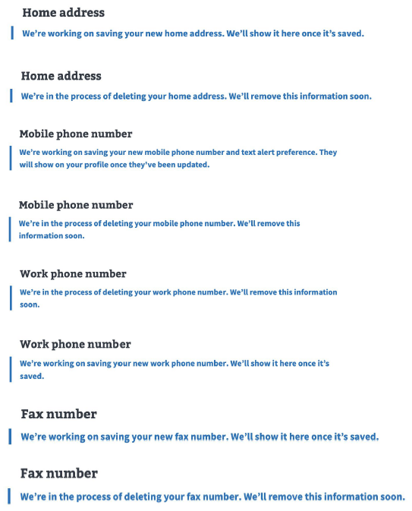

## Personal Information Overview

The personal information feature displays a veteran’s birth date and gender.



This information cannot be edited or updated on the VA.gov profile. VA.gov provides dropdown answers that explains how a veteran can update this information if it is missing or it is wrong.

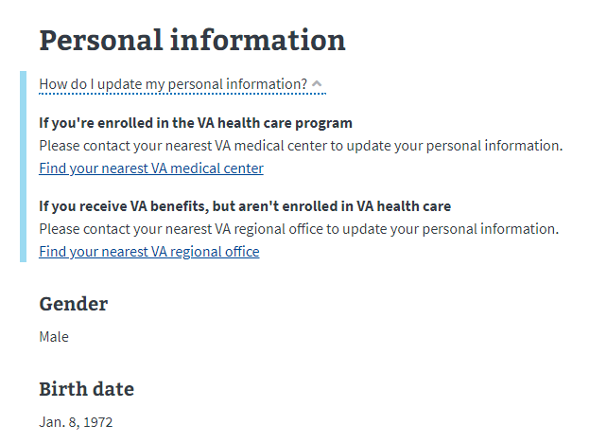

### Top Personal Information Issues and Error Messages

1. **How do I update my personal information if it is wrong or has changed?** If a user’s personal information is incorrect or needs to be updated, they will need to follow the instructions provided in the dropdown answer (see below):

**If you're enrolled in the VA health care program**  
Please contact your nearest VA medical center to update your personal information.  
[Find your nearest VA medical center](https://staging.va.gov/find-locations/?facilityType=health)

**If you receive VA benefits, but aren't enrolled in VA health care**  
Please contact your nearest VA regional office to update your personal information.  
[Find your nearest VA regional office](https://staging.va.gov/find-locations/?facilityType=benefits)

## Military Service Information

The military service information displays details about a veteran’s service. This information is pre-populated once an LOA3 (identity verified) account is created. This information cannot be changed or updated on VA.gov.



If the information in the military service section is incorrect, the user can use the dropdown answer to get information on how to change their military service information.

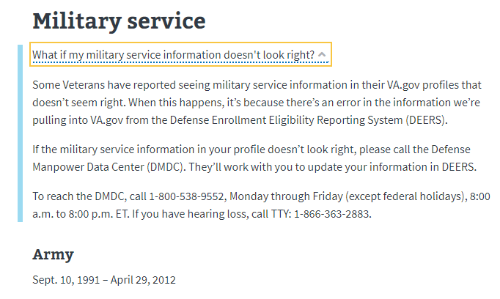

### Top Military Service Information Issues and Error Messages

1. **How do I update my military information if it is wrong?** If a user’s military service information is incorrect, they will need to follow the instructions provided in the dropdown answer (see below):

Some Veterans have reported seeing military service information in their VA.gov profiles that doesn’t seem right. When this happens, it’s because there’s an error in the information we’re pulling into VA.gov from the Defense Enrollment Eligibility Reporting System (DEERS).

If the military service information in your profile doesn’t look right, please call the Defense Manpower Data Center (DMDC). They’ll work with you to update your information in DEERS.

To reach the DMDC, call 1-800-538-9552, Monday through Friday (except federal holidays), 8:00 a.m. to 8:00 p.m. ET. If you have hearing loss, call TTY: 1-866-363-2883.

1. **We can’t access your military information:** Profiles come pre-populated with the information connected to the user. Sometimes a user’s military information won’t be uploaded into the profile. If this happens, the user will see the following message: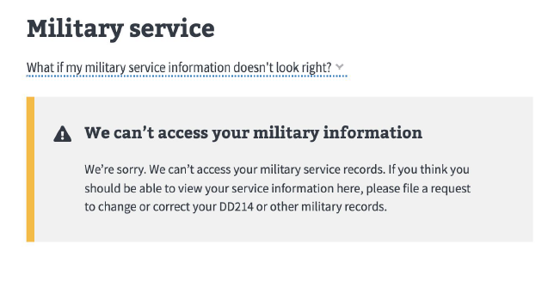

If a user sees this message, you can assist them with the process of filing a request to change or correct their DD214.

# Other Profile Errors and Issues

1. **I have created an LOA3 (identity verified) account, but I don’t have information in my profile:** Sometimes a user will successfully complete the identity verification process, but their identity does not match what the VA has in its systems. If this occurs, the user will see the below message when they go to their profile:

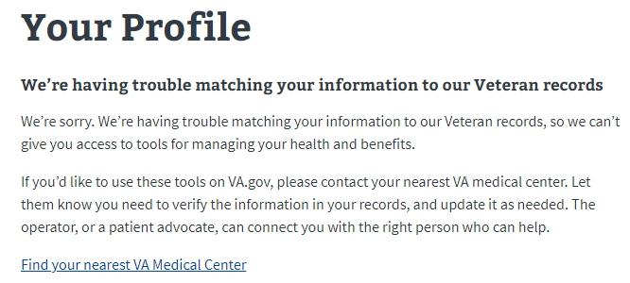

If they see this message, advise them to follow the instructions to update their records so the VA has their correct information.