**FEATURE GUIDE**

**Header and Footer Tools**

Table of Contents

Header Tools and Navigation 2

Facility Locator Overview 3

Facility Locator Issues 5

Search Overview 6

Search Issues 7

Contact Us Overview 7

Contact Us Issues 8

My VA Overview 8

Contact Us Issues 12

My Health Overview 13

My Health Issues 13

Account Overview 16

Account Issues 17

Footer Tools and Navigation 17

# Header Tools and Navigation

The VA.gov website has a permanent header that displays a set of tools, no matter what webpage a user is on. This product guide goes through the different tools that can be found in the header. Below is what the header looks like when a user is NOT signed in:

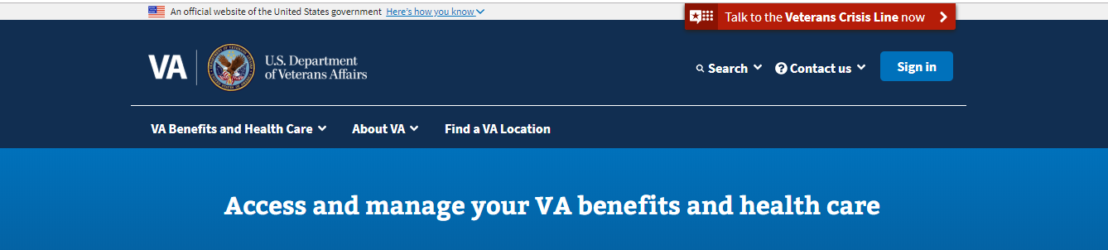

The following tools will always be in the VA.gov header, regardless of whether a user is signed in or not:

* Facility Locator
* Search
* Contact us

Below is what the header looks like when a user is signed into their account:

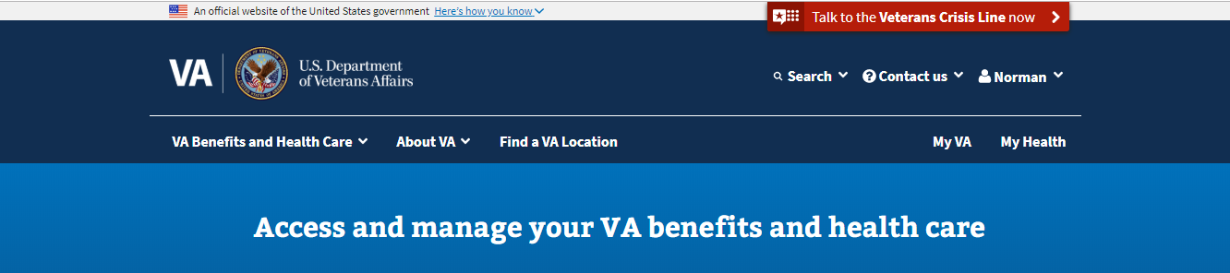

The following tools will be in the VA.gov header ONLY when a user is signed in:

* My VA
* My Health
* Account
* Profile

## Facility Locator Overview

The facility locator is a tool that is used to search for VA services near the user. Users can enter a street, zip code, city, or state and find the nearest health facilities, regional offices, cemeteries, community care providers, and other veteran services locations.

The facility locator can be found in two places on the VA.gov header.



The facility locator can also be accessed directly at this URL: <https://www.va.gov/find-locations>. Below is what the facility locator looks like:

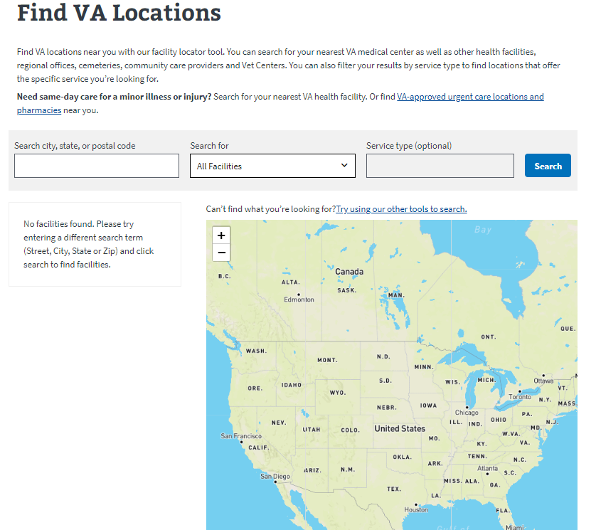

The user can enter their location and from there narrow down to the type of facility they are looking for.

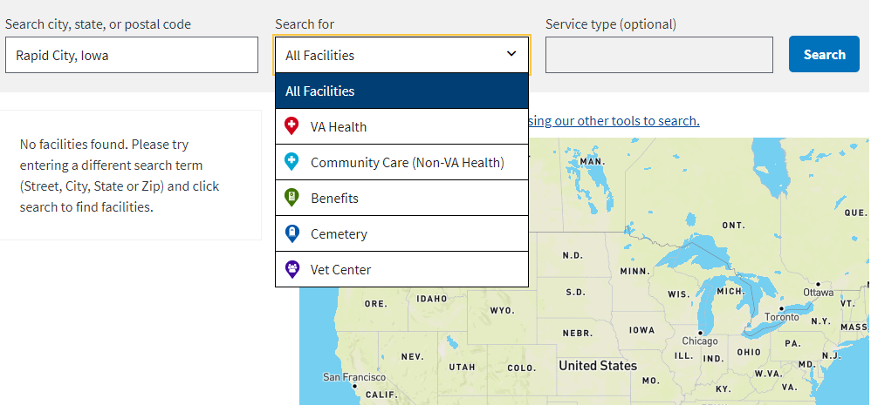

The user can also narrow down the service type after selecting a facility type.

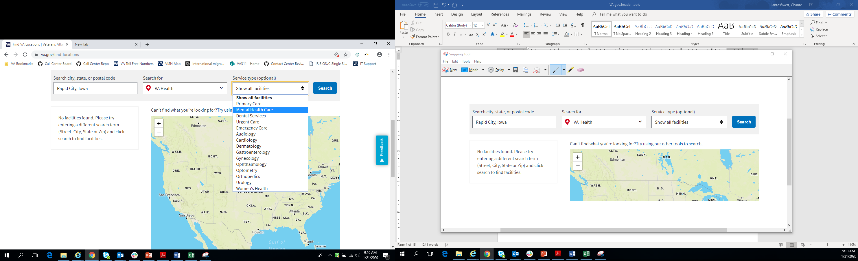

If a user is looking for a community care provider, they must type in a service type in to the search box.

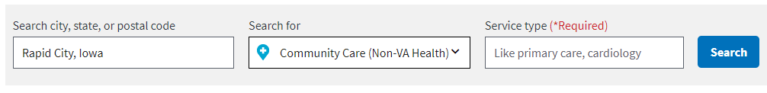

After entering in the search criteria and selecting search, the user will be presented with the results of the search. The results will be displayed on the map and on the left sidebar. The user will have to use the scroll bar to see all results in the left sidebar.

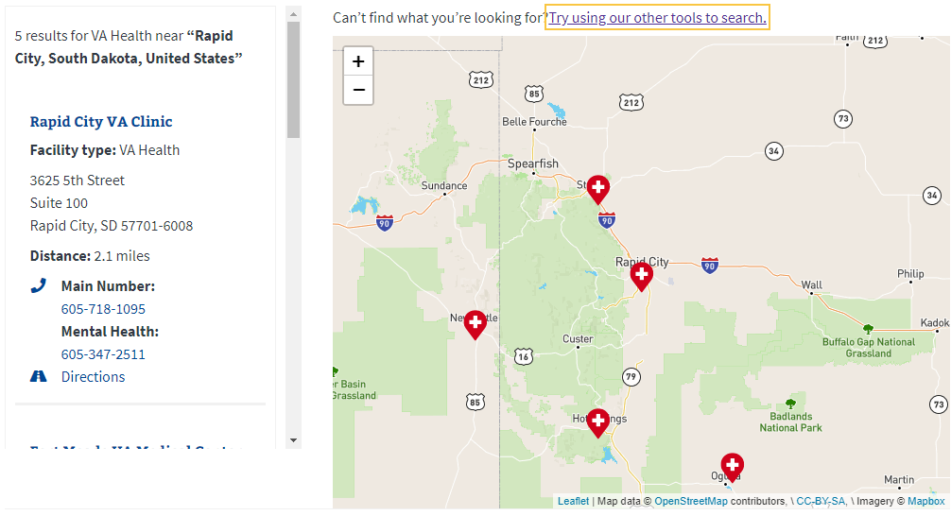

User must use the scroll bar to view all the results

### Facility Locator Issues

The main issue users have with the facility locator is problems with results being shown or generated.

1. Sometimes there is a problem with the results being retrieved. This means it takes longer than normal for the results to show and instead, the user sees the below message for a long period of time.

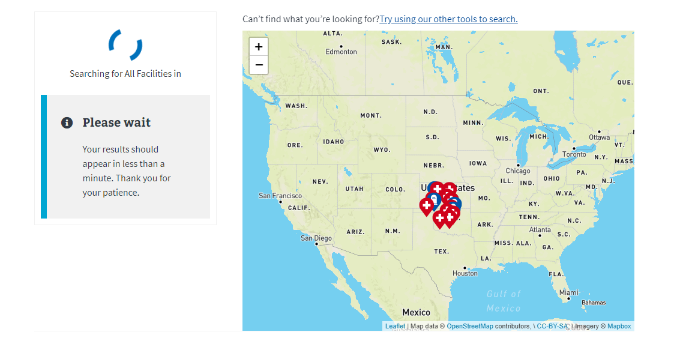

If this is occurring, recommend to the user to try refreshing the page and entering the search terms again. If the results still don’t appear, explain there might be an issue with the tool, and they should come back and try again.

You can also try doing the search for the user if the facility locator tool is working for you. If that doesn’t work, you can also suggest they try using another location finder tool: <https://www.va.gov/directory/guide/home.asp>.

## Search Overview

The search bar is a tool like any normal search bar. The user can type in terms they are looking for, select search and generate results based on that term. To do a search, the user selects the search dropdown arrow and the search box will appear:

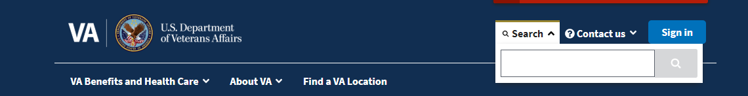

After entering a term, the page will reload with the available results

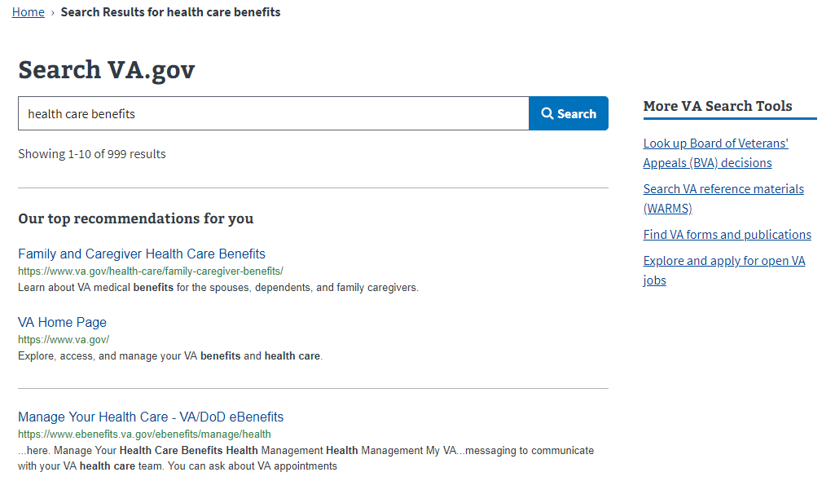

The user can see the results listed below the search box. The user can select any of the results and be taken to the website. They can also search a new term or navigate to the other search tools available on the righthand side of the page.

### Search Issues

VA.gov has not seen consistent or major technical issues for the search tool. We have heard complaints from users that the search results are not always helpful or related to the search term. If for some reason the search tool does not seem to be working and is not generating any results, this issue should be escalated so the VA.gov team can see if there is something wrong with the feature.

## Contact Us Overview

The Contact Us dropdown is where the user can find information on where to get support for their questions. The user simply clicks on the “Contact Us” text and the below options will appear.

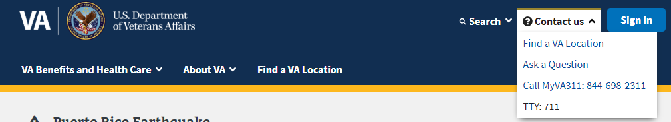

* The “Find a Location” link will take a user to the facility locator
* The “Ask a Question” link will take a user to the IRIS webform page: <https://iris.custhelp.va.gov/app/ask>

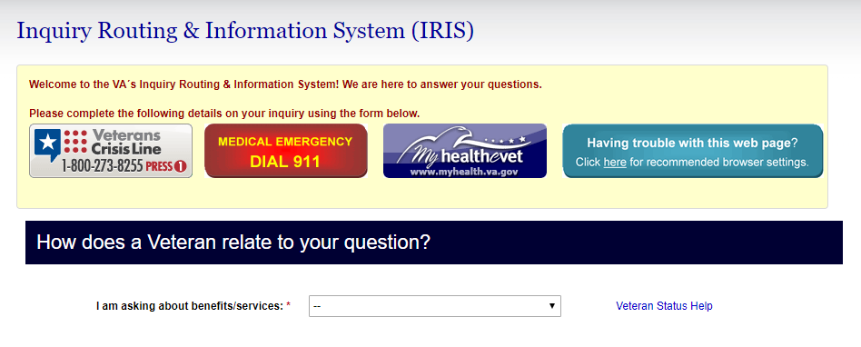

* The “Call MyVA311: 844-698-2311” is a link that will attempt to call the listed phone number. On a computer, it might try and do it through Skype. On a phone it will ask the user to start a call.

### Contact Us Issues

There have not been any reported technical issues for the Contact Us dropdown.

## My VA Overview

The My VA feature only appears in the header when a user is signed into their VA.gov account. The My VA feature can be found in two locations in the header.

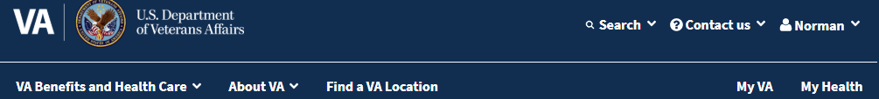

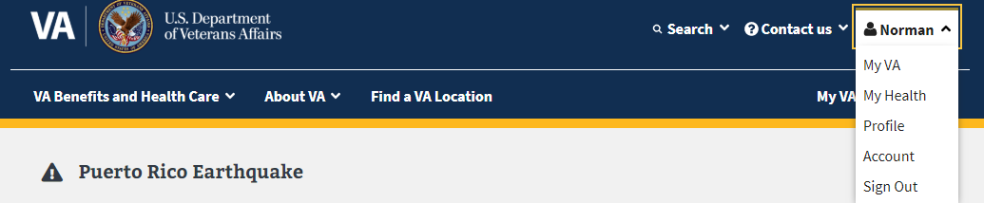

The My VA feature is a page that highlights key information about VA.gov and what the user has in progress on their VA.gov account. First, the user will see general information about VA.gov benefit tools and information available on VA.gov:

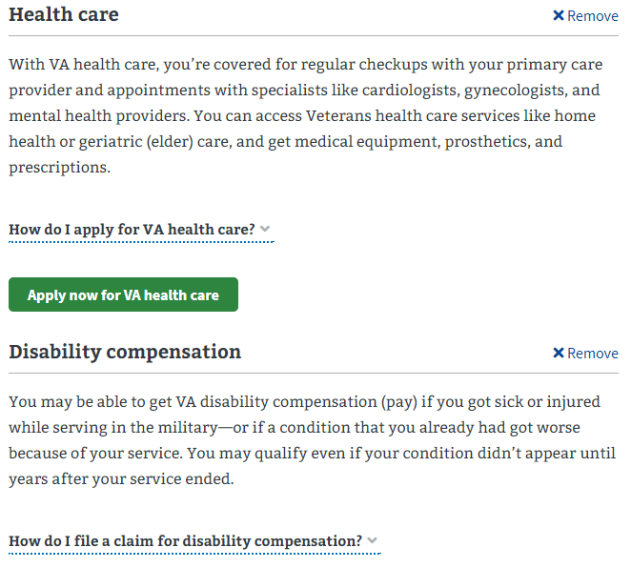

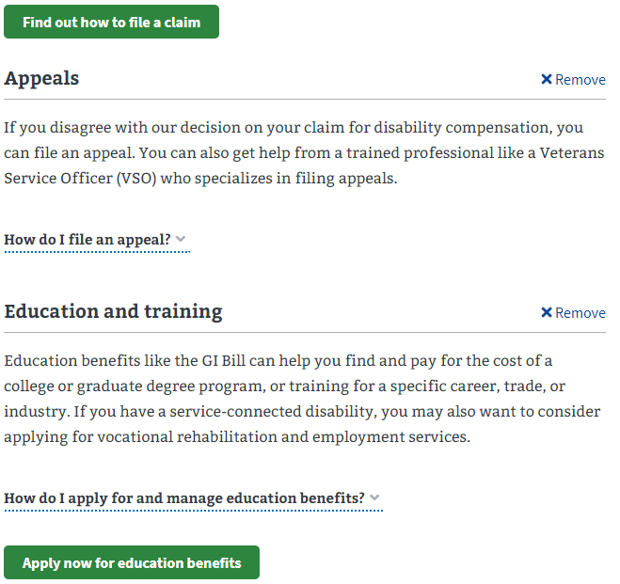

A user can manage what is shown in this section by selecting to remove a benefit overview:



A user can also manage what is shown by selecting the “Find VA benefits” button:

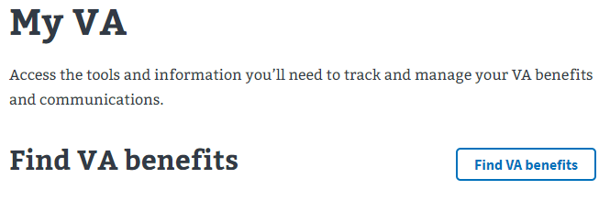

After selecting the “Find VA benefits” a user see a grid of benefits. From there, they can select which benefits to show on their My VA page:

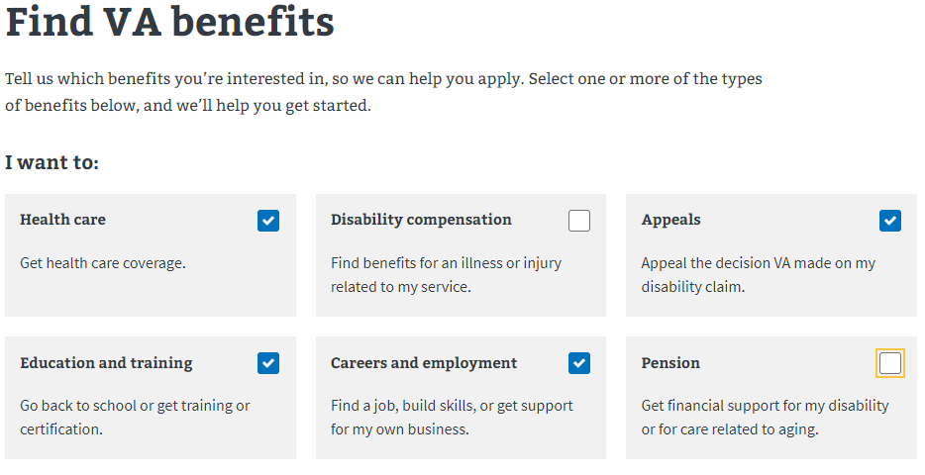

The My VA tool also shows the status of a user’s applications on VA.gov.

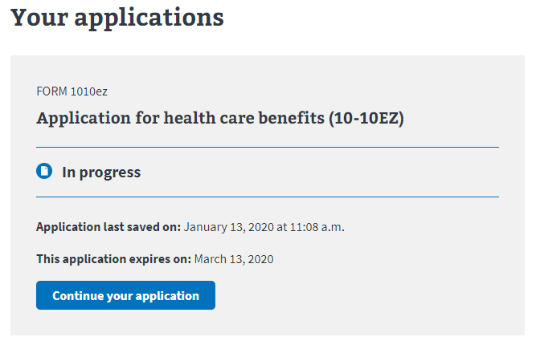

If the user selects the “Continue your application” button, they will be taken to the place in the application where they left off.

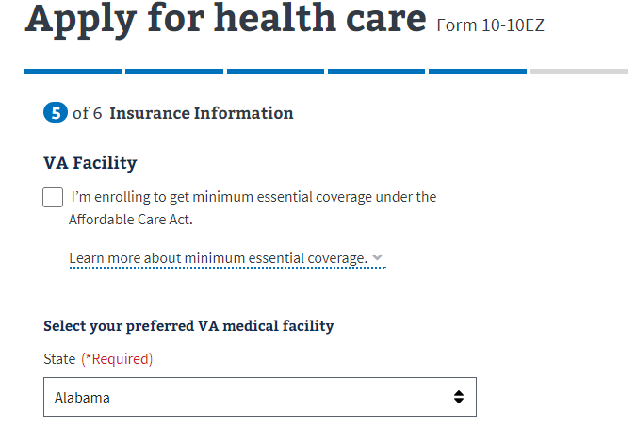

My VA also provides links to other VA.gov features such as the claims and appeals status tool, profile, account, and links to other benefit and records tools:

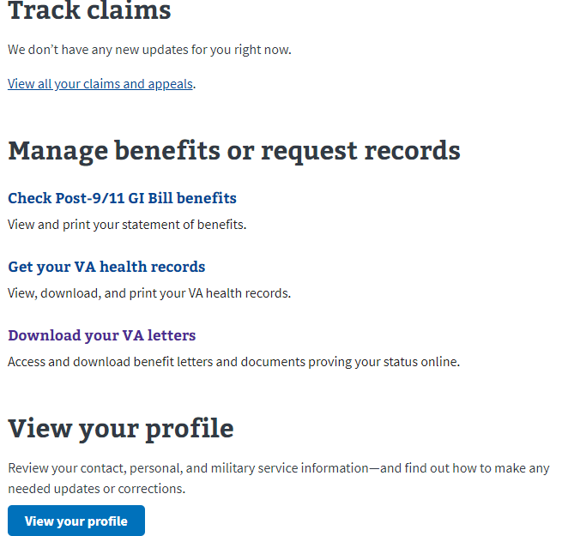

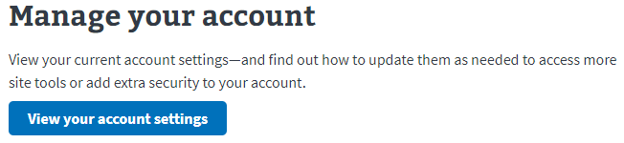

### Contact Us Issues

There have not been any reported technical issues with the My VA feature. There is sometimes confusion with the purpose of the feature. It is important to remember that the only thing a user can do on the feature is review the information, select the provided links, or manage which benefit information is shown.

## My Health Overview

The My Health feature only appears in the header when a user is signed into their VA.gov account. The My Health feature can be found in two locations in the header.



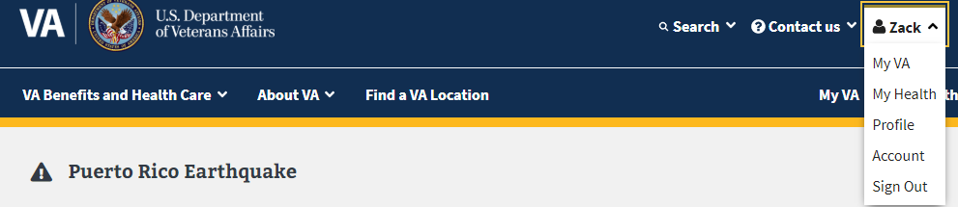

The My Health feature is not really a feature. It is a link to a user’s My HealtheVet account and will only work if the user has an LOA3 (identity verified) account that matches their VA records. If this is true, the user will see the My HealtheVet account after clicking the “My Health” button:

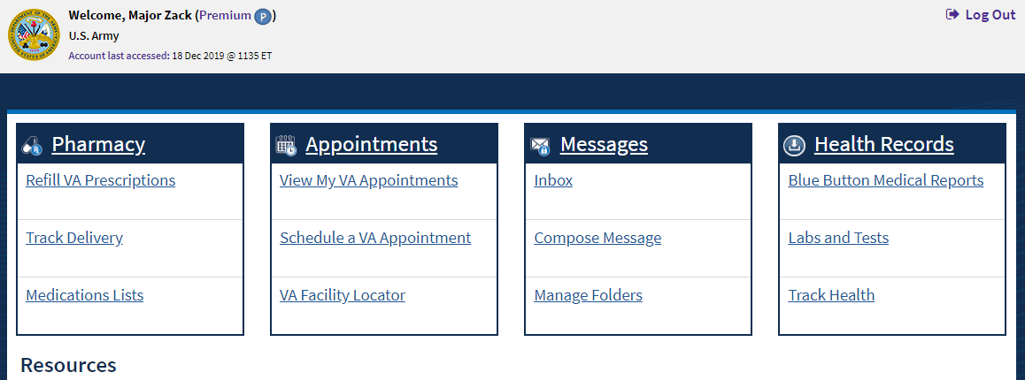

### My Health Issues

1. **“We couldn’t match your information to our VA patient records” error:** The user will see the below information if they are signed into their LOA3 (identity verified) VA.gov account but there isn’t a matching VA patient record: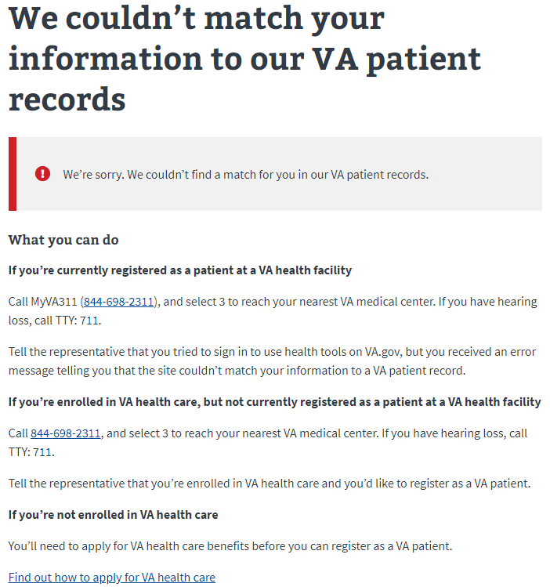
2. **“The information you provided doesn’t match our records:”** The user will see the below information if they are signed into their LOA3 (identity verified) VA.gov account but the VA’s records for the user do not match the information they used to verify their identity. To fix this issue, the user will have to follow the instructions listed below:

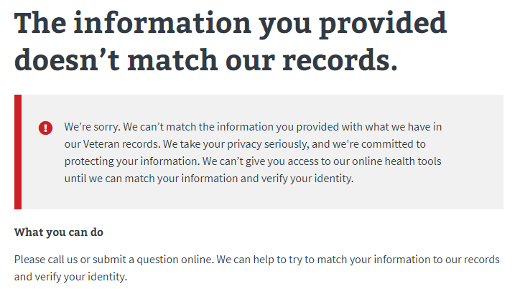

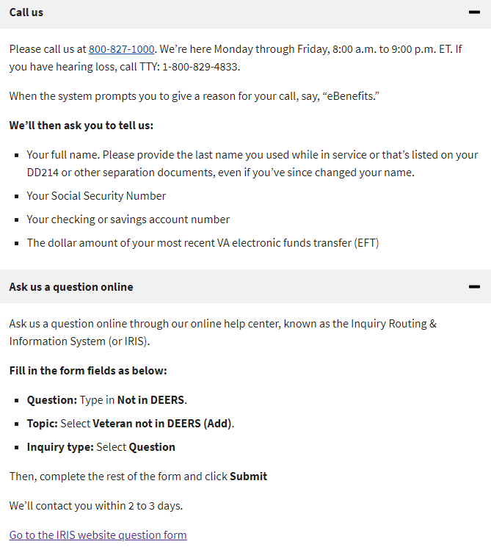

## Account Overview

The Account feature only appears in the header when a user is signed into their VA.gov account.



The Account feature is a page that summarizes a user’s account basic information. A user has to be signed in to see this feature. Below is what a user will see on an account page:

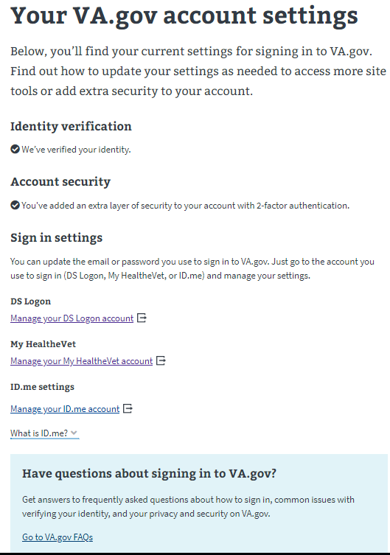

Depending on the type of account a user has, there will be different information on this page.

### Account Issues

There have not been any reported technical issues with the Account feature. There is sometimes confusion with the purpose of the feature. It is important to remember that the only thing a user can do on the feature is review the information or select the links.

# Footer Tools and Navigation

The footer is similar to the header, except that it is a permanent feature located at the bottom of every VA.gov page. The footer is primarily links to various VA programs and services. The footer also includes links to some of the tools listed in the “contact us” section in the header. The footer also includes a link to the Welcome Kit:

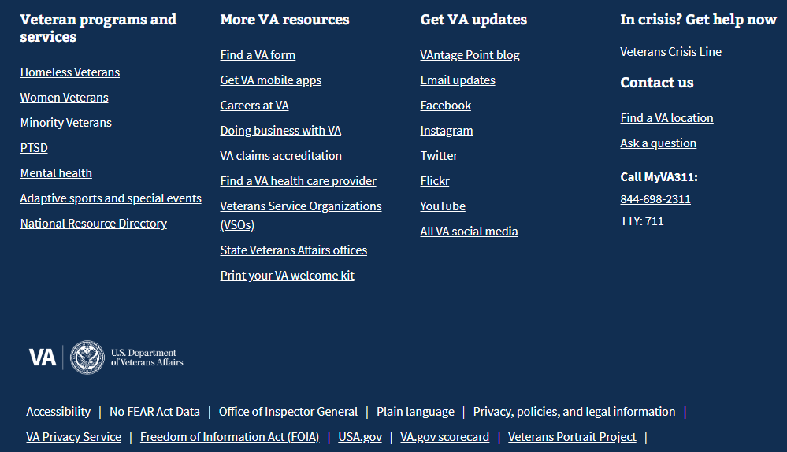

The Welcome Kit is a guide to VA benefits and services. It can be downloaded at this webpage, as well additional VA benefits and services information: <https://www.va.gov/welcome-kit/>

­­