**Veterans Identity Card (VIC) Application**

Table of Contents

Veteran ID Application Overview 2

User Access 2

Who can access this application? 2

Navigation 2

Accessing the VIC Application 6

User is not signed into an account: 6

User is signed into an LOA1 Account (their identity has not been verified) 6

User is signed into an LOA3 Account but they have not been verified by MVI 7

User is signed into an LOA3 (identity verified) account that has also been verified by MVI 8

Major Issues or Error Messages: 10

# Veteran ID Application Overview

A Veteran ID Card (VIC) is a form of photo ID you can use to get discounts offered to Veterans at many restaurants, hotels, stores, and other businesses. Find out if you’re eligible for a Veteran ID Card—and how to apply.

VA.gov does not manage the application for the veteran ID card (VIC). However, users can access the application from VA.gov if they are signed into an LOA3 (identity verified) account that is also verified by MVI.

## User Access

### Who can access this application?

Only users with an LOA3 (identity verified) account that has also been verified in MVI will be able to use VA.gov to access the VIC application.

## Navigation

**Direct url:**​ <https://www.va.gov/records/get-veteran-id-cards/vic/>

There isn’t a direct way to access the URL from the homepage or the main dropdown menu. However, there are links in these places that will direct you to the information that will get you to this URL: <https://www.va.gov/records/get-veteran-id-cards/vic/>

If the user selects this link on the home page…

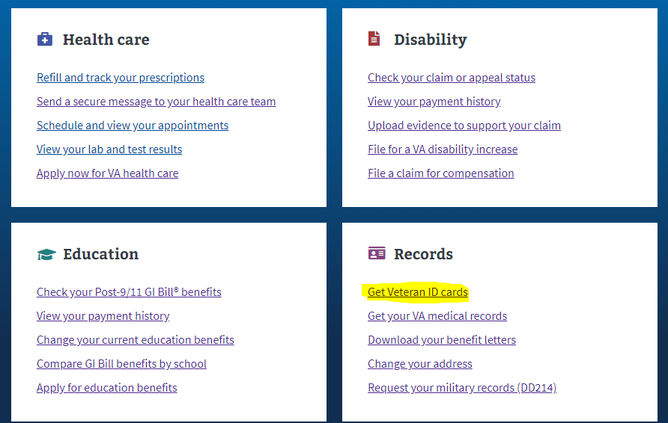

**Or** this link in the dropdown menu:

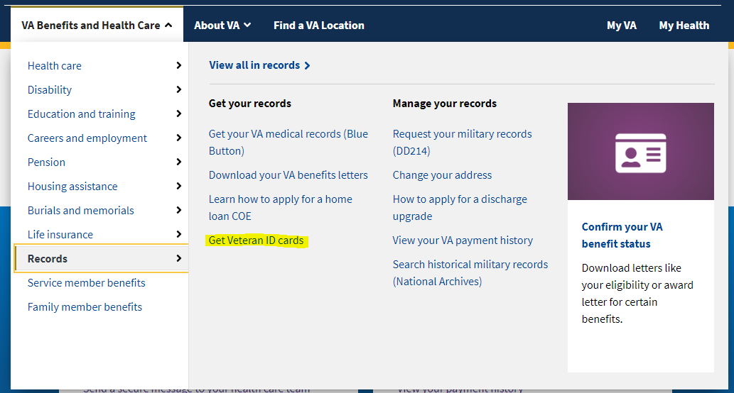

**Or** this link on the Records Hub Page: <https://www.va.gov/education/>

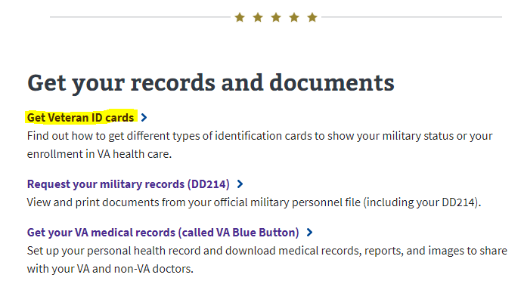

The user will be taken to this URL: <https://www.va.gov/records/get-veteran-id-cards/>

At this URL, the user will be presented with information about the different types of ID cards available to veterans.

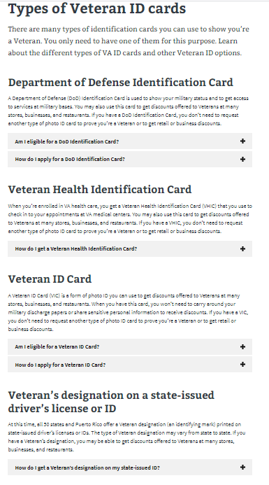

If the user selects the + button next to “How do I apply for a Veterans ID Card?” there will be linked text that will take the user to the VIC page:

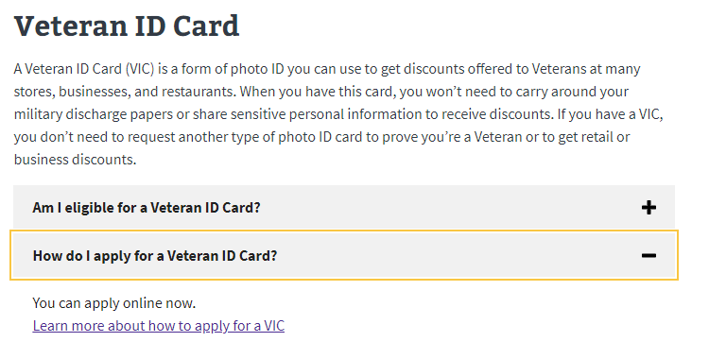

# Accessing the VIC Application

Once the user is on the VIC application page, they will see information about who is eligible for a VIC. Depending on what kind of account they are signed into, the user will see different calls to action.

### User is not signed into an account:

If a user is not signed into a VA.gov account and goes to the VIC application page, they will see the following call to action:

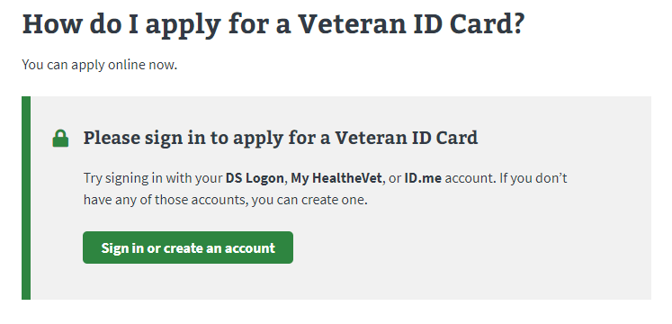

The user will have to go through the steps of creating an identity verified VA.gov account before they can access the VA.gov application.

### User is signed into an LOA1 Account (their identity has not been verified)

If a user is signed into an LOA1 VA.gov account and goes to the VIC application page, they will see the following call to action:

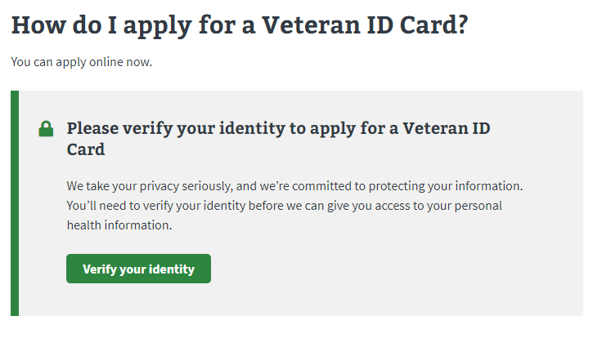

The user will have to go through the steps of upgrading their account to LOA3 (verifying their identity) before accessing the VIC application.

### User is signed into an LOA3 Account but they have not been verified by MVI

If a user is signed into an LOA3 (identity verified) VA.gov account that has not been verified by MVI and goes to the VIC application page, they will see the following call to action:

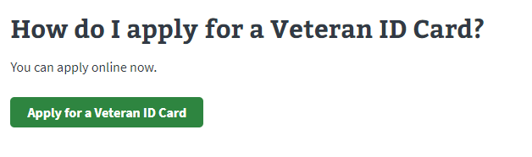

If the user selects the “Apply for a Veteran ID Card” button, they will be taken to the following page:

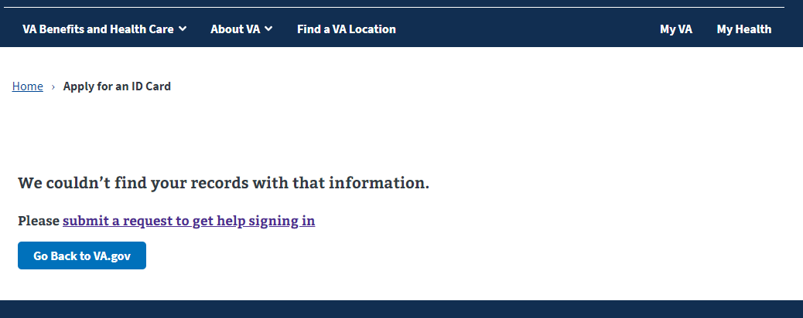

### User is signed into an LOA3 (identity verified) account that has also been verified by MVI

If a user is signed into an LOA3 (identity verified) VA.gov account that has been verified by MVI and goes to the VIC application page, they will be shown the following call to action:



If the user selects the “Apply for a Veteran ID Card” button, they will be taken to the following page:

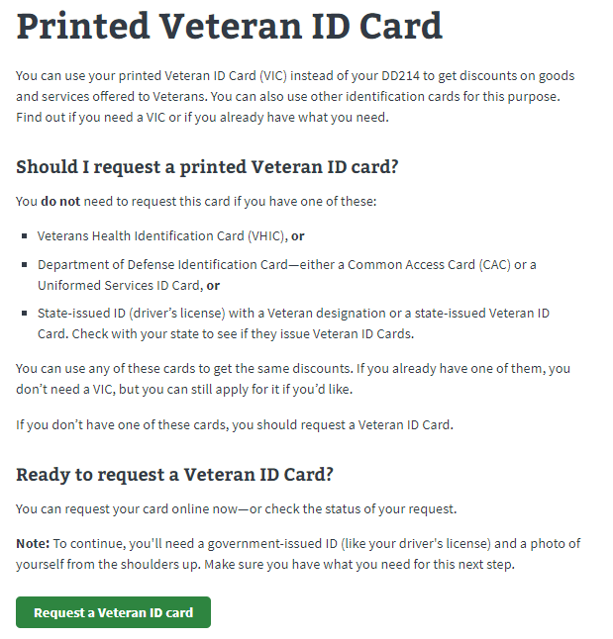

When the user selects the “Request a Veteran ID card” button, they will be redirected to a new website where the VIC application is managed.

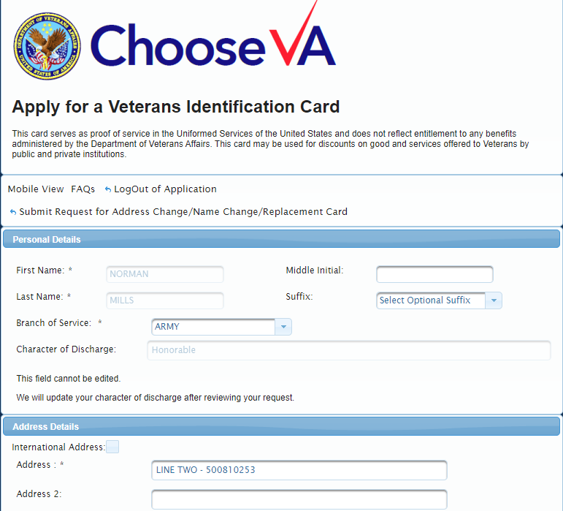

# Major Issues or Error Messages:

### We couldn’t find your records with that information:

If a user is trying to apply for a VIC and says they can’t because they are seeing the below message, they will need to go through the process of updating their records in MVI so that their verified LOA3 VA.gov account matches the VA records.



A user can fix this issue by contacting their nearest VA medical center and explaining they need to verify the information in their records and update it as needed. The operator or patient advocate can connect you with the right person. You can use the facility locator to help them locate their nearest VA Medical Center to do this: [Find your nearest VA Medical Center](https://www.va.gov/find-locations).

If this option is not ideal for the user, you can also provide the following instruction on how to access the VIC application directly:

1. Go to [AccessVA](https://eauth.va.gov/accessva/) (<https://access.va.gov>) to submit a VIC request.
2. Select the VIC icon.
3. Select **Sign in with DS Logon** or **Sign in with ID.me** to access the VIC application. Once you have successfully logged in, you can proceed with your VIC request.
4. Verify that your personal information is accurate and update if necessary.
5. Upload a copy of your DD-214 or other official military discharge document (DD-256, DD-257 or NGB-22) that reflects an Honorable or General (Under Honorable Conditions) character of discharge.
6. Upload a valid copy of your state issued (driver’s license) or federal issued (passport) ID.
7. Upload an image to appear on your card.
8. Click Preview Card
9. ClickRequest Card

If they have any questions, tell the user to contact the VIC Program Office directly at [vic@va.gov](mailto:vic@va.gov).

### Questions about the status of their VIC or filling in the application:

Because VA.gov does not manage the actual VIC application the user will have to be directed to [vic@va.gov](mailto:vic@va.gov) or the HRC helpdesk at 800-983-0937 for the following inquiries:

* What is the status of my VIC application?
* A question about the VIC application or an error occurring on the VIC application
* Questions about eligibility.