**GI Bill Comparison Tool**

Table of Contents

GI Bill Comparison Tool Overview 1

User Access 1

Navigation 2

GI Bill Comparison Tool Functionality 4

# GI Bill Comparison Tool Overview

The GI Bill Comparison Tool is a product that allows to learn about VA education benefits programs and compare benefits by school.

## User Access

Users do not need to be signed into complete this application. The full functionality of the tool is available for a user, whether or not they have a VA.gov account.

## Navigation

**Direct url:**​ <https://www.va.gov/gi-bill-comparison-tool>

**Or** the link for the education application can be found on the ​**VA.gov**​ homepage.

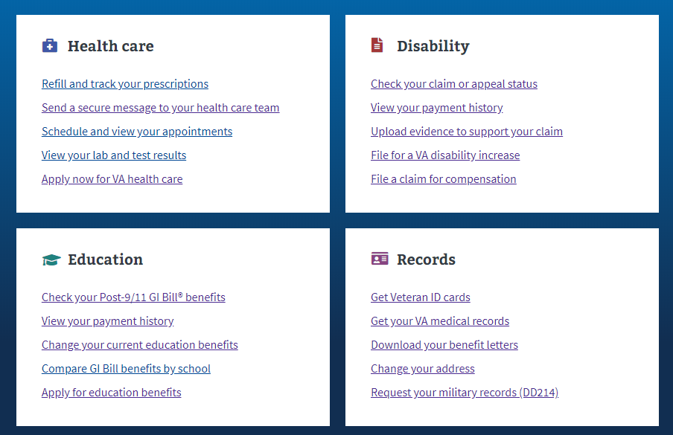

**Or** in the main menu dropdown:

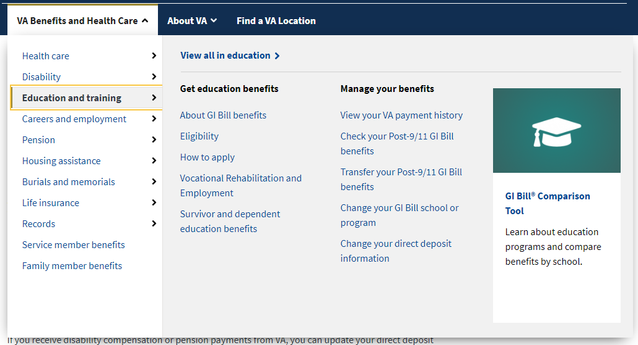

**Or** on the Education Hub Page: <https://www.va.gov/education/>

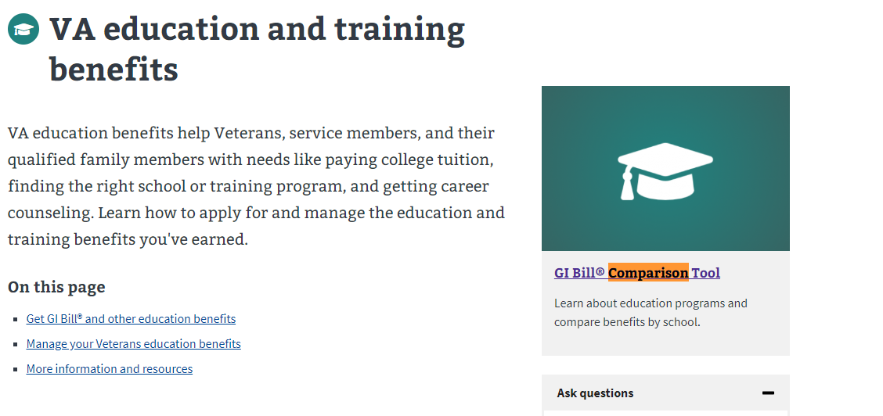

# GI Bill Comparison Tool Functionality

The GI Bill Comparison Tool, is a search tool that allows users to enter information and get results based on that criteria. When a user gets to the tool, they can enter information about their status and benefits. From there, the can select information about the type of schools or programs they want to attend and then enter a specific city, school, or employer.

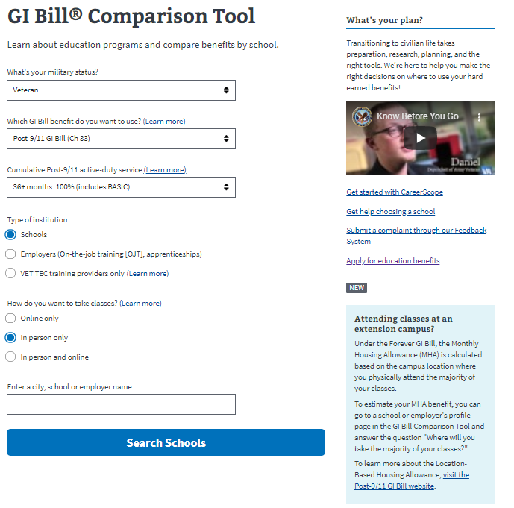

A user can search for schools in a city by entering in the city and then selecting from the dropdown. They can also search for a specific school or employet.

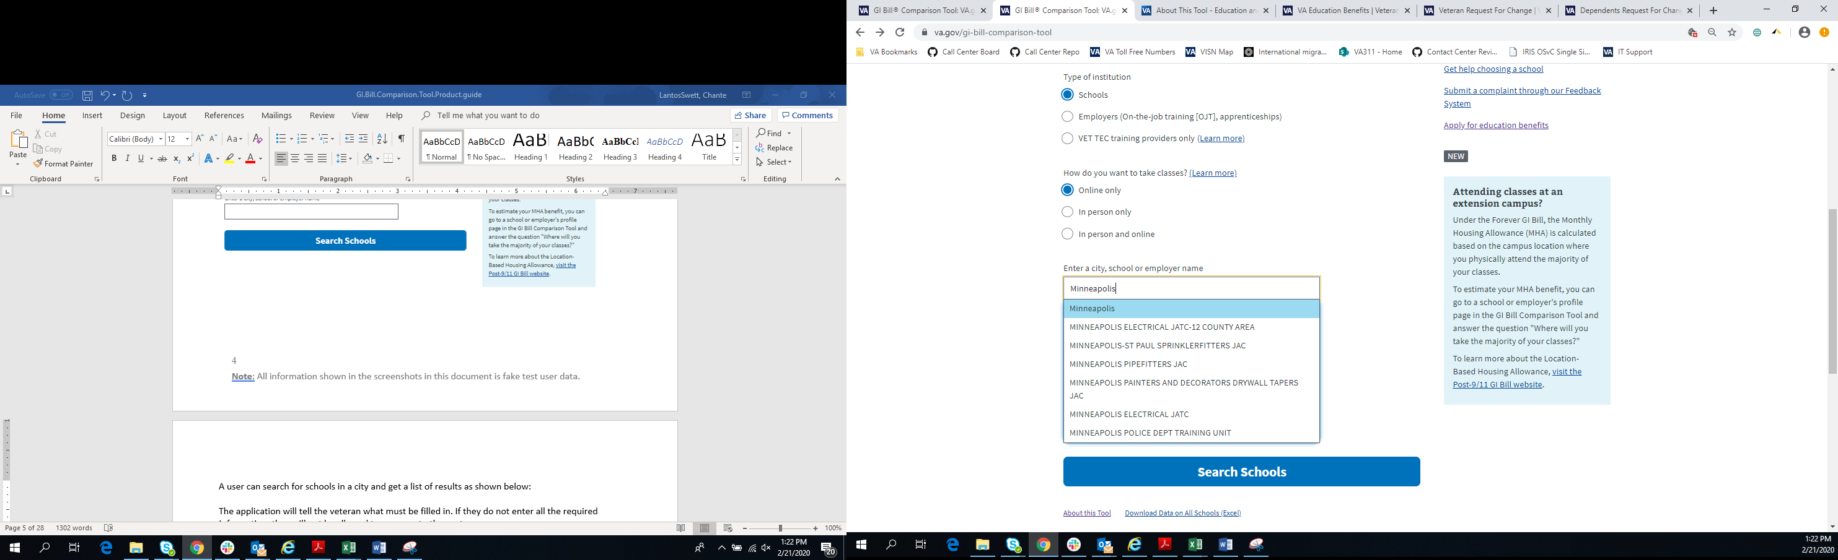

After selecting “search schools” the user will be presented with a list of results based on their search criteria:

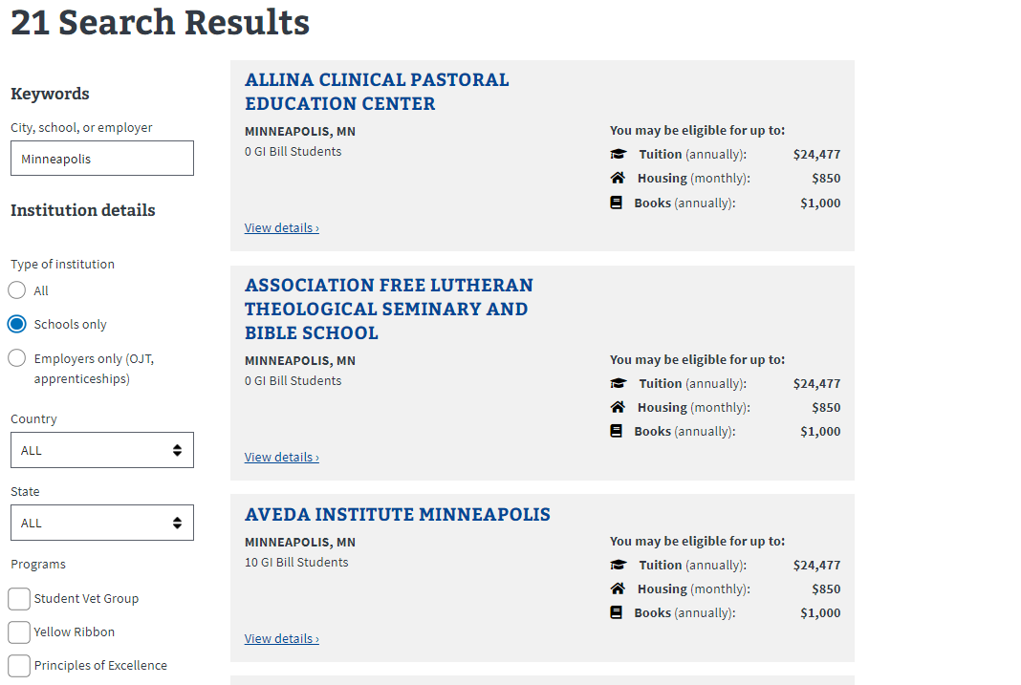

The user can refine their search by using the fields on the left to increase or narrow the scope of the results:

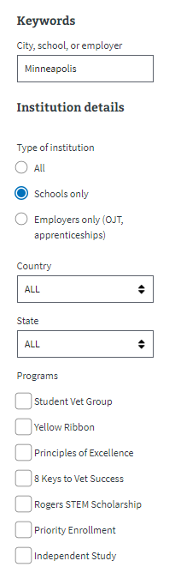

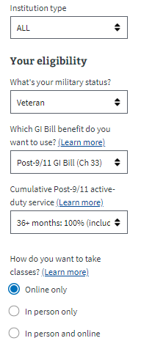

The user can click on a university to get more detailed information about what it would cost to attend the university based on their benefits. They can edit their eligibility details as well as add additional information like scholarship money to calculate what it might cost to attend this school:

The user can also learn about Veteran programs offered by the school, and see student complaints as well as additional information:

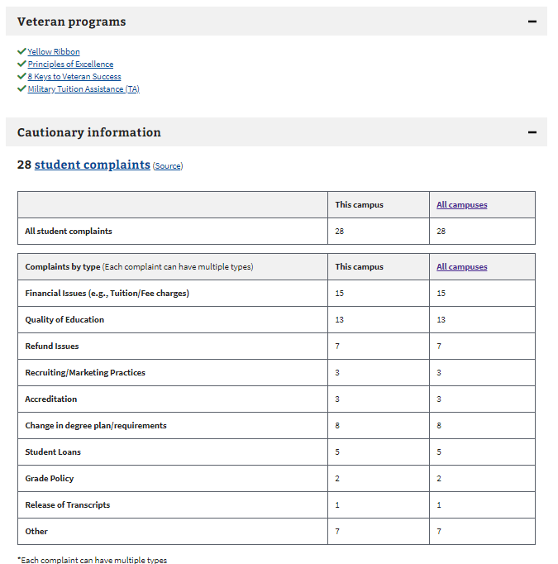

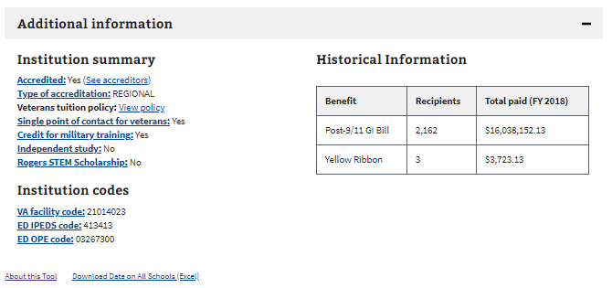

Users can also search for VET TEC training providers as well:

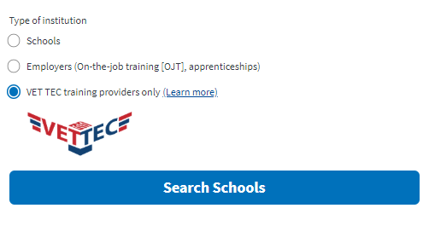

Below is an example of the results when a user searches for VET TEC providers:

