**Health Care Application**

**Product Guide**

Table of Contents

**Health Care Application Overview and Navigation** **2**

**Health Care Application Introduction Page** **4**

Logged out users: 4

Logged in users: LOA1 (not identity verified) 8

Logged in users: LOA3 (identity verified) 9

**Filling out the Health Care Application** **12**

Veteran Information 14

Veteran Information Page 1: Names 14

Veteran Information Page 2: Social Security Number. 17

Veteran Information Page 3: Date of Birth. 18

Users must select the month and day from the dropdowns. The year must be typed in. 18

Veteran Information Page 4: Place of Birth 19

Veteran Information Page 5: Mother’s maiden name 20

Veteran Information Page 6: Birth Sex 21

Veteran Information Page 7: Race, Ethnicity or Origin 22

Veteran Information Page 8: Mailing Address 23

Veteran Information Page 9: Email and Phone Number 25

VA Benefits 26

VA Benefits Page 1: Current Compensation From VA 26

VA Benefits Page 2: Current Compensation 29

Military Service 30

Military Service Page 1: Branch of Service and Dates of Service 30

Military Service Page 2: Service History 31

Military Service Page 3: Upload Discharge Papers 32

Household Information 33

Household Information Page 1: Financial Disclosure 33

Household Information Page 2: Marital Status 35

Household Information Page 3: Spouse’s Information 36

Household Information Page 4: Dependents Information 38

Household Information Page 5: Annual Income 41

Household Information Page 6: Previous Calendar Year’s Deductible Expenses 42

Insurance Information 43

Insurance Information Page 1: Medicaid 43

Insurance Information Page 2: Medicare 44

Insurance Information Page 3: Medicare Detail 45

Insurance Information Page 4: Other Coverage 46

Insurance Information Page 5: VA Facility 48

Review Application 49

**Health Care Application Issues** **55**

Questions about the content of the application: 55

Application is pre-filled with incorrect information: 55

Veteran can’t move forward in their application: 55

Veteran can’t upload a document: 56

Veteran is having trouble upgrading their LOA1 account to an LOA3 account 56

# 

# Health Care Application Overview and Navigation

Users of VA.gov can apply for health care benefits by filling out the online application (VA form 10-10EZ). Users with no account, an LOA1 account (not identity verified), or an LOA3 account (identity verified) can access and complete the Health Care Application.

A user can find the Health Care Application at this URL (<https://www.va.gov/health-care/apply/application/introduction>) or at the following locations on VA.gov

* On the homepage: [www.va.gov](http://www.va.gov)

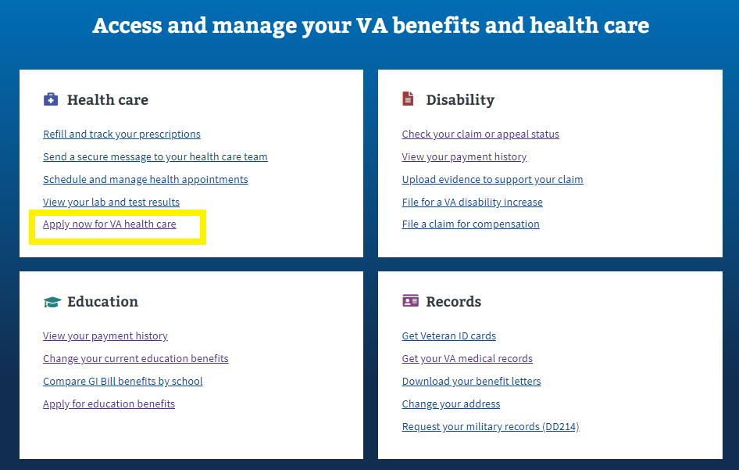

* In the main menu dropdown

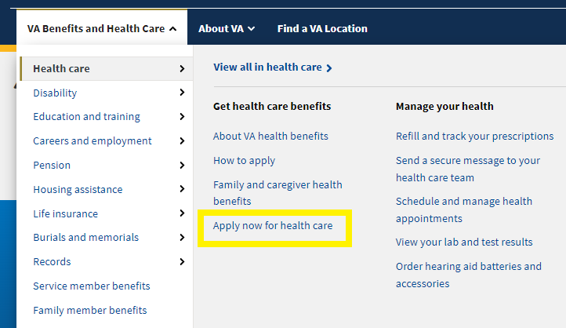

* In the Health care benefit hub: <https://www.va.gov/health-care/>

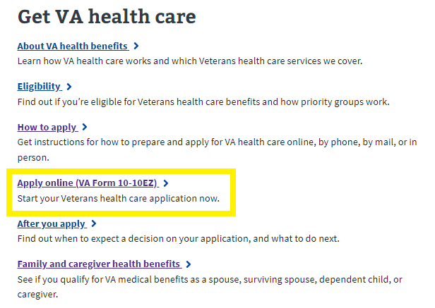

# 

# Health Care Application Introduction Page

Currently, the Health Care Application is available on VA.gov (<https://www.va.gov/health-care/apply/application/introduction>) to all users who come to the site, whether they are logged in or logged out, or whether they are LOA1 or LOA3.

## Logged out users:

Logged out application introduction page link: <https://www.va.gov/health-care/apply/application/introduction>.

Logged out users will access the health care application through the health care application introduction page.

On this page, we strongly encourage people to login before applying, and have a call out to previous applicants to login and check their status. These are at the top of the health care application introduction page:

Logged out ID page link:<https://www.va.gov/health-care/apply/application/id-form>

Logged out users can access the health care application. However, in order to do so, they will be filtered through a screener ID page where their entered personal information is used to scan the MVI (Master Veteran Index) and the ESR (Enrollment System) for existing records. They are shown the screener ID page immediately upon clicking on: **Start your application without signing in**.

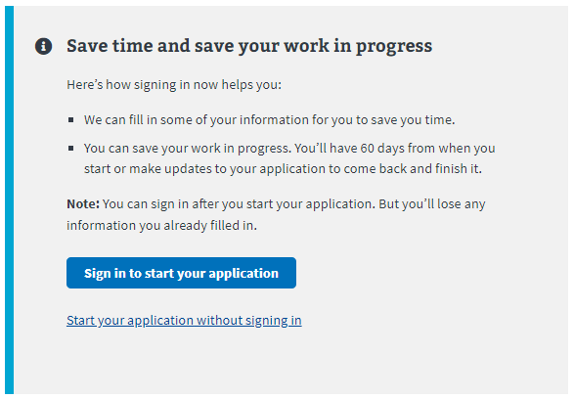

The screener ID page asks them for their First and Last name, Date of birth, and Social Security number.

Upon filling out the ID page screener and pushing the “Continue to the application” button, MVI and ESR are queried. Potential outcomes include:

* **User is not found in MVI or the ESR** — These users will be passed through to the health care application. As part of this application, there will be a section where they can upload their DD214 or other discharge documents to help verify their service.
* **User is found in MVI but not in ESR** — These users will be passed through to the health care application but will not be asked to include a DD214 or other discharge documents.
* **User is found in MVI and in ESR** — These users will not be able to access the health care application from a logged out state because finding them in the enrollment system (ESR) means that they have applied for health care previously. They need to sign in to VA.gov in order to see their health care status before accessing the application.

Users found in MVI and ESR will see the following alert that directs them to sign in to continue. They won’t be able to complete the application until they do:

## Logged in users: LOA1 (not identity verified)

Logged in LOA1 users will see the following alert when they go to the health care application introduction page at <https://www.va.gov/health-care/apply/application/introduction>: LOA1 users won’t be able to access the health care application without first verifying their identity and becoming LOA3. This is to make sure that all users who apply are scanned through the ESR to verify whether they have or have not applied for health care previously.

## 

## Logged in users: LOA3 (identity verified)

For logged in LOA3 users, we will automatically perform a scan on the backend for existing health care records in the enrollment system (ESR) when they go to the application introduction page at <https://www.va.gov/health-care/apply/application/introduction>.

For users who are **not** found in the enrollment system (ESR), they will be able to go straight into the health care application:

For users who **are** found in the enrollment system (ESR), they will see their current health care status. There are 25 potential statuses people could see. The following is an outline of potential outcomes:

* Veteran is enrolled in VA healthcare.
* Veteran has a pending application.
* Veteran did not qualify for VA health care this time around, but they may qualify in the future if circumstances change (eg. Their income was too high, or they did not have a service connected disability at the time of application).
* Veteran did not qualify (is ineligible) for VA health care because of their service record or other circumstances.
  + There are many reasons why someone may be ineligible for health care. The most common ones are that they did not serve for 24 consecutive months of active duty, their character of service was not high enough, or their service could not be verified. We are trying to display about 12 different reasons someone may have been found to be ineligible.
* Veteran is deceased.
* Veteran had VA health care but canceled it; or they were offered it but declined it.
* Veteran had an open/incomplete application for a year, so it was closed.
* A service member has applied too early and is still on active duty.

For all veterans who have applied for health care before and see the health care status on the application introduction page, they should call the health enrollment center at 877-222-VETS ([877-222-8387](tel:+18772228387)) if they have questions.

Here are 2 visual examples of the alerts:

An alert that shows that this user is already enrolled in health care:

An alert that they have applied before and didn’t qualify at that time:

# Filling out the Health Care Application

There are six sections in the health care application, but not everyone is shown the entire application:

1. Veteran Information
2. VA Benefits
3. Military Service
4. Household Information
5. Insurance Information
6. Application Review

Some users will be able to fill out a shortened version of the application, skipping some sections. Veterans will be shown the shortened form if:

* They have a Disability Rating of equal to or greater than 50%.

Please note: For authenticated users, the system will prefill the information we already have on file. The user will have the ability to review and update some of this as they complete the application.

Each section has multiple pages of questions that the user must enter to complete the application. For authenticated users the application is automatically saved as the user completes the application, and they have the option to *Finish the application later*.

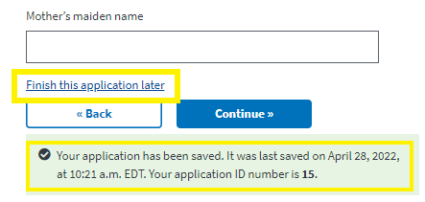

To move forward through the application, the user clicks **Continue**. They will not be able to move forward until all required information on the page is complete, an example error message is shown below. To go back to a section of the application, the user can use the back button.

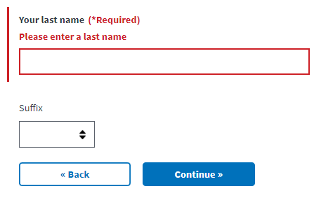

The application also has a status bar at the top of each page of the application to indicate how far along in the application a Veteran is. It progresses when a new section is complete, **not** based on the number of questions complete:

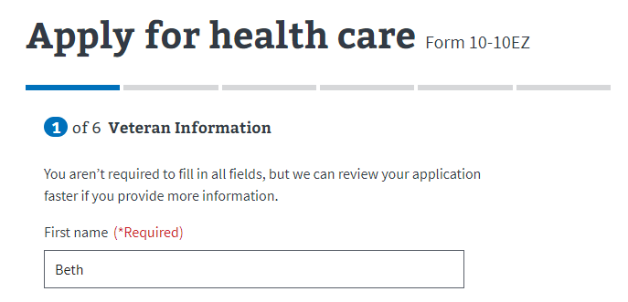

## 

## Veteran Information

### Veteran Information Page 1: Names

Authenticated users are shown their name, date of birth (DOB), and Social Security Number (SSN) in a locked state. If they need to update this information, they will need to contact the VA Benefits Hotline at 800-827-1000. Unauthenticated users will be asked to provide their name, Social Security Number (SSN), and Date of birth (DOB).

**Authenticated user**

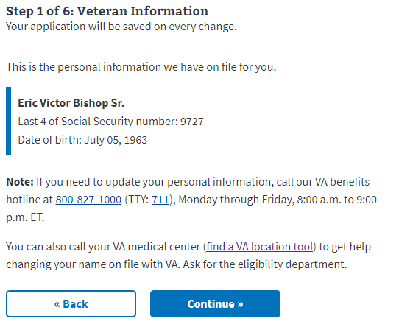

Authenticated users with information in their profile that qualifies them to have a shortened form, will be alerted to that immediately after this page. If they do not see that page, they may still possibly qualify later in the application. These users will need to input their place of birth now, and will move on to Mother’s Maiden Name.

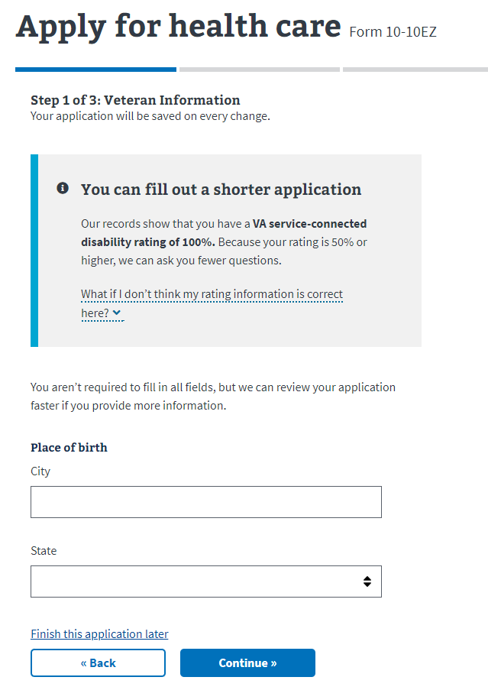

**Unauthenticated user**

The form will be prefilled with the information that the user previously entered. If there is any additional information, like a middle name or suffix, that they would like to input, they can do so here.

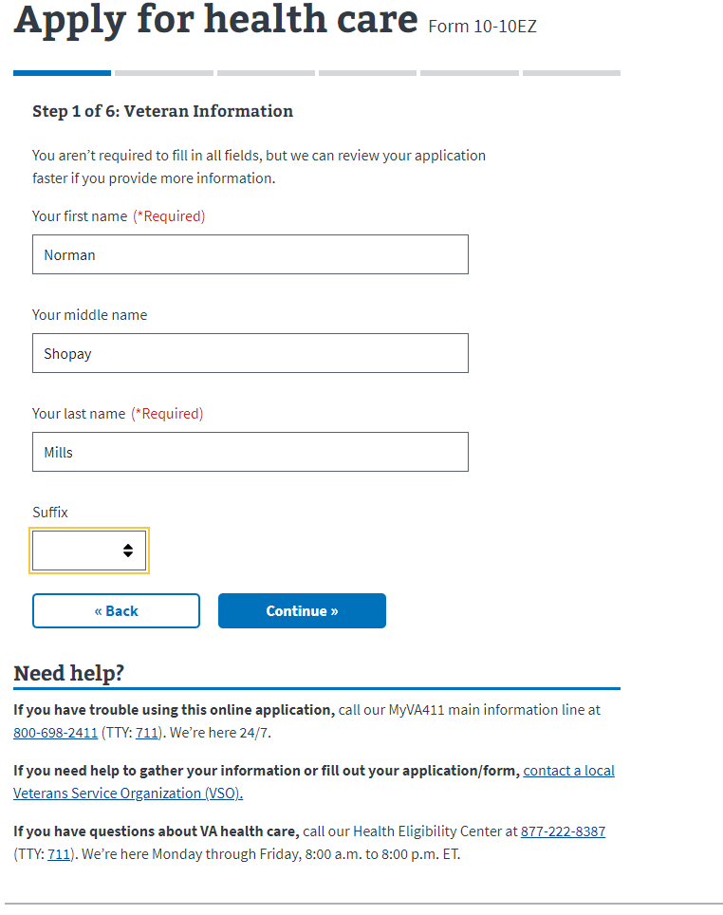

### Veteran Information Page 2: Social Security Number.

Users will need to enter their Social Security Number, with or without dashes. It must be a valid Social Security Number or an error will be triggered..

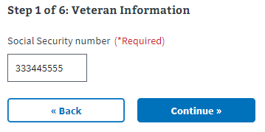

### Veteran Information Page 3: Date of Birth.

### Users must select the month and day from the dropdowns. The year must be typed in.

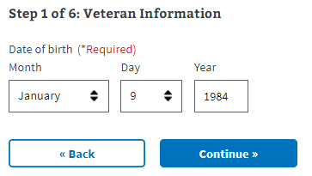

### 

### Veteran Information Page 4: Place of Birth

The user must enter the city name and select the state from the dropdown. This currently doesn’t support international locations. For those born outside the US, they can enter the city and leave the state blank.

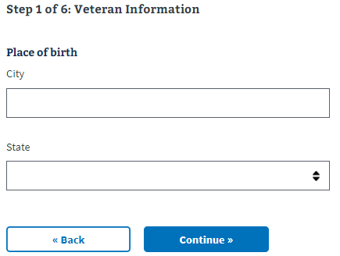

### 

### Veteran Information Page 5: Mother’s maiden name

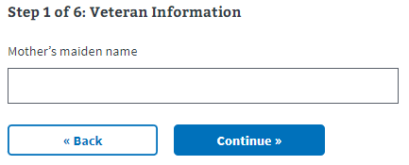

### 

### Veteran Information Page 6: Birth Sex

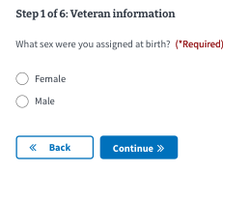

### 

### Veteran Information Page 7: Race, Ethnicity or Origin

The user may select one or more options. This is not a required question.

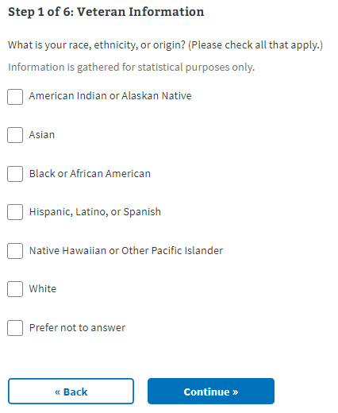

### 

### Veteran Information Page 8: Mailing Address

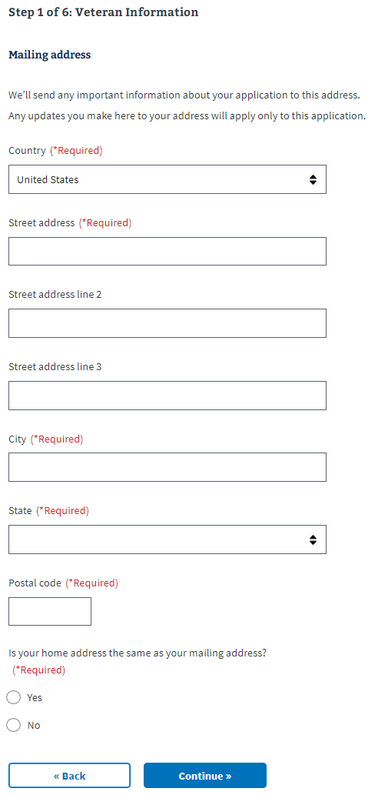

Note: If the user indicates that their mailing address is different from their home address, they will be asked to put their home address in on the following page.

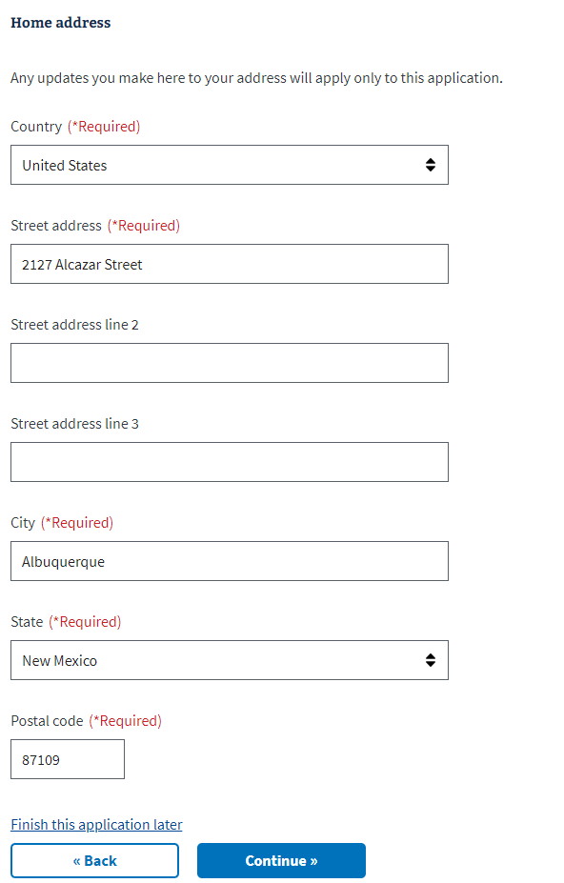

### 

### Veteran Information Page 9: Email and Phone Number

Users may choose to provide their email address and/or home/mobile telephone numbers. If the user decides to share this information, these contact methods will be used to communicate with the Veteran during the application process. If they do not provide either, all communication will be delivered to their mailing address via paper mail.

Users who are filling out the short form will be taken to the Insurance Information section after this page.

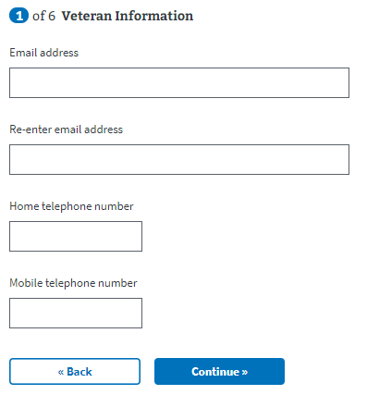

## 

## VA Benefits

### VA Benefits Page 1: Current Compensation From VA

This next section asks for the Veteran’s current compensation, based on their service-connected disability rating. The dropdown information shown here explains how we use the information. If they indicate that they receive compensation for a disability rating of up to 40%, they will move on to the next page to enter their Military Service information.

If the Veteran indicates that they do not receive any compensation, they will be asked about their VA pension.

If they indicate they receive compensation for a disability rating of 50% or higher, they will be redirected to a shortened version of the application. This shortened form skips the following sections:

1. Military Service
2. Household Information

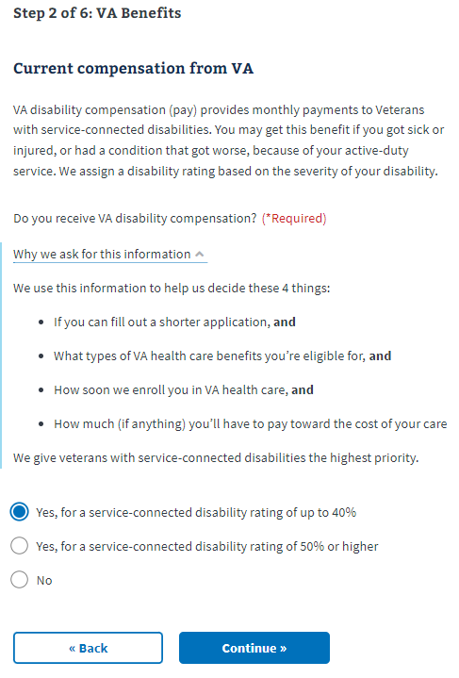

If the Veteran indicates that they have a disability rating of 50% or higher, they will be asked to confirm their selection. They will see this page, explaining why they need to confirm their selection.

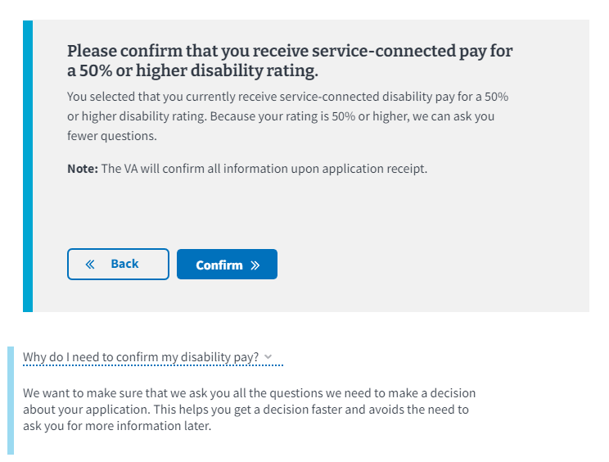

### 

Once they have confirmed they are receiving service-connected pay for a 50% or higher disability rating, they will be informed they can fill out the shortened form of the application and an explanation as to why. Please proceed to the Insurance Information section.

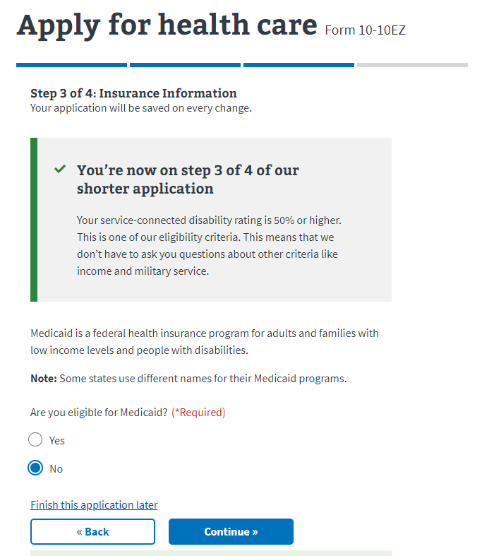

### VA Benefits Page 2: Current Compensation

This question is only shown if the user indicates **No** to the previous, VA disability compensation question.

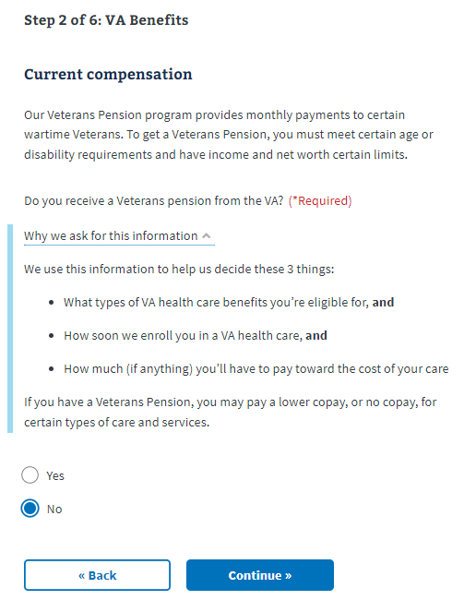

## 

## 

## Military Service

### Military Service Page 1: Branch of Service and Dates of Service

The application will check dates to ensure their validity. For example:

* Not 18 years old at input service start date
* Input service end date is before service start date

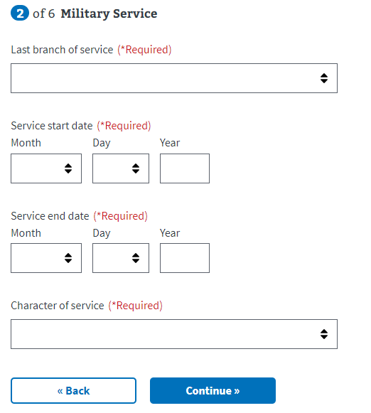

### 

### 

### Military Service Page 2: Service History

The user may select one or more options. This is not a required question.

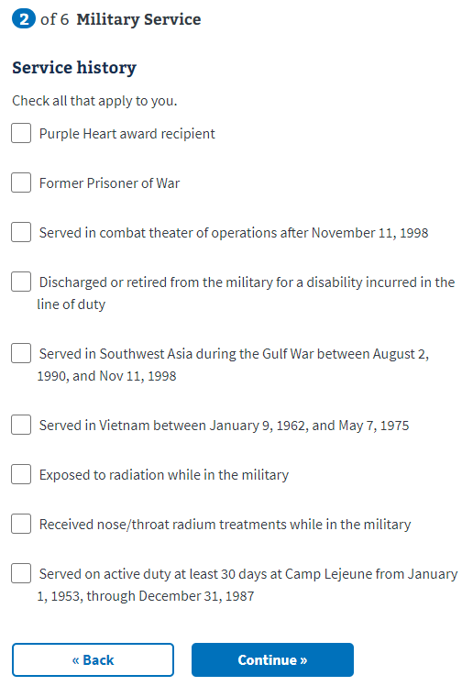

### Military Service Page 3: Upload Discharge Papers

A user who has been verified in MVI or ESR will not see this page. Users that have not been verified in these systems will need to upload their DD214 or other discharge documents to help verify their service. If the Veteran needs to request any of these documents, they can do so here: <https://www.va.gov/records/get-military-service-records/>.

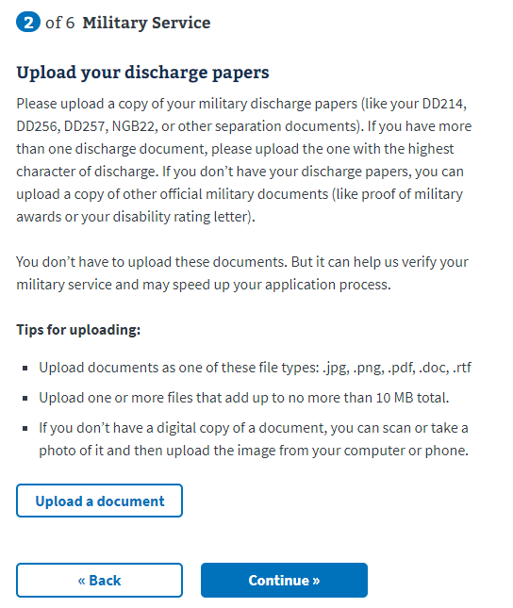

## Household Information

### 

### Household Information Page 1: Financial Disclosure

A user can choose whether or not to disclose financial information on this page; however, if they are not part of a [priority group](https://www.va.gov/health-care/eligibility/priority-groups/) based on disability or military service, they will receive a request for this information, which could delay their application processing time.

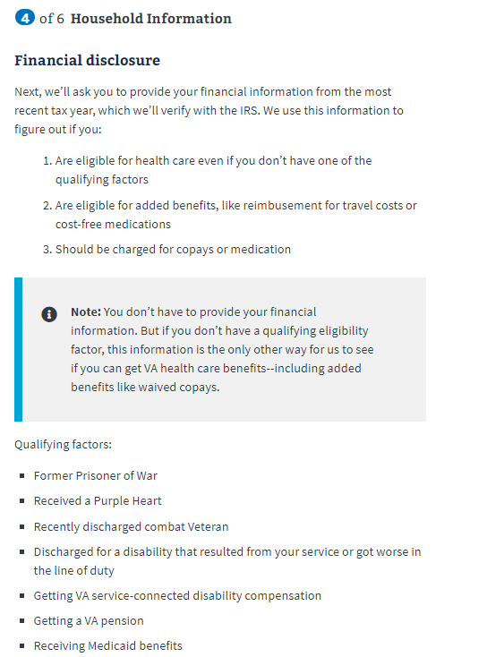

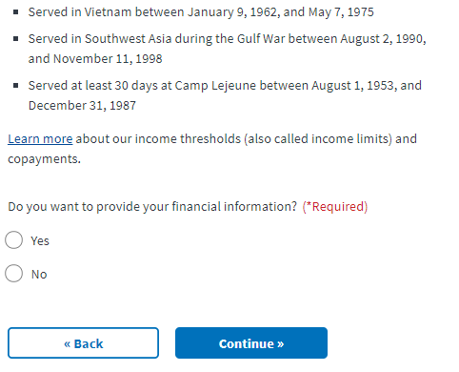

If the user selects they do not want to provide their financial information, they will be shown the below message:

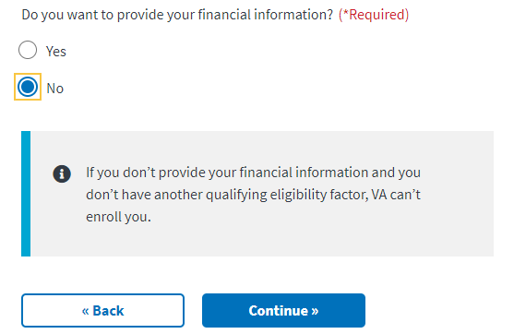

### Household Information Page 2: Marital Status

The user will now need to indicate their marital status from the dropdown.

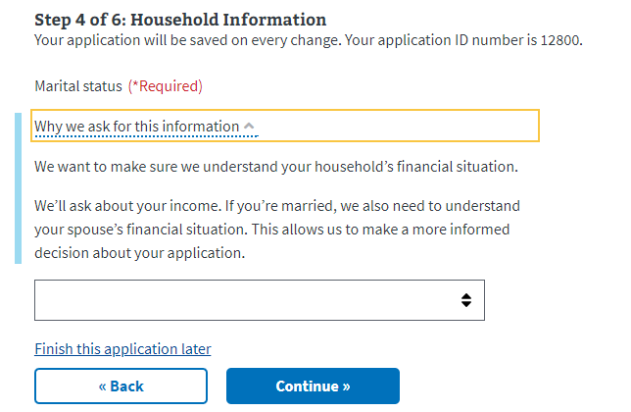

### 

### Household Information Page 3: Spouse’s Information

If the Veteran has chosen to share their financial information and indicates they are married or separated, they will be required to fill out their spouse’s information.

If they chose not to disclose their financial information, they will be taken to the Insurance Information section of the application once they’ve indicated their marital status.

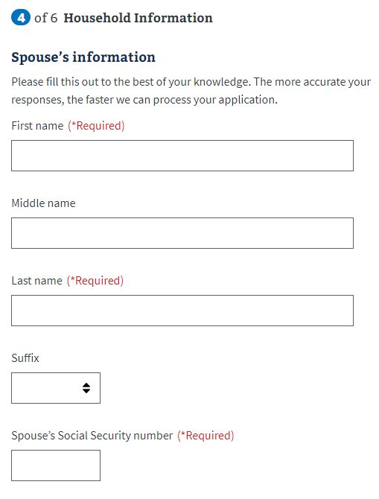

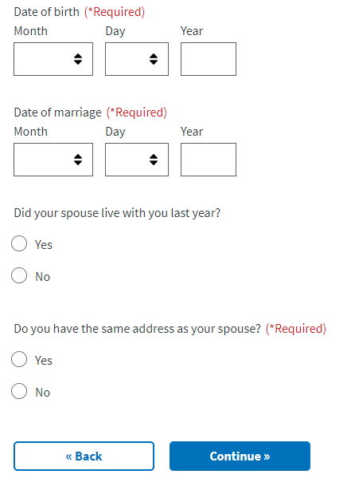

### 

### Household Information Page 4: Dependents Information

If the Veteran indicates that they have at least one dependent, the form will expand and ask them to input information about the dependent. They will have the option to enter more than one dependent.

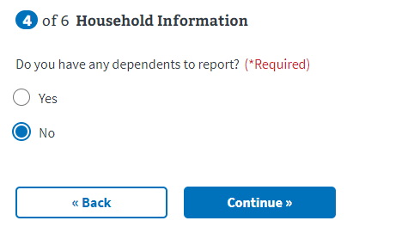

Examples of when someone becomes your dependent:

* Birth of a child
  + The date of birth would be the date on which the child became your dependent.
* Adoption
  + The official date of adoption would be the date on which the child became your dependent.

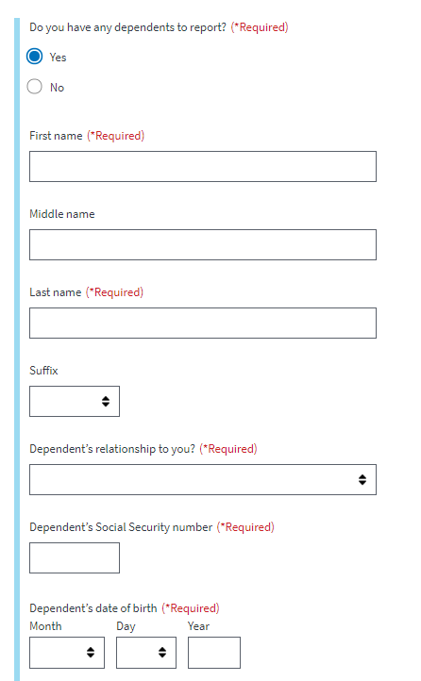

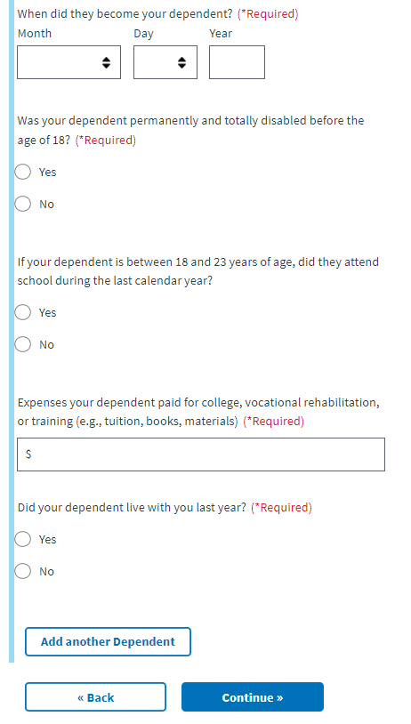

The user can add additional dependents by using the **Add another Dependent** button at the bottom of the form.

### Household Information Page 5: Annual Income

The user will need to provide the requested financial information in the following forms. The application will ask about their annual income and their previous year’s deductible expenses.

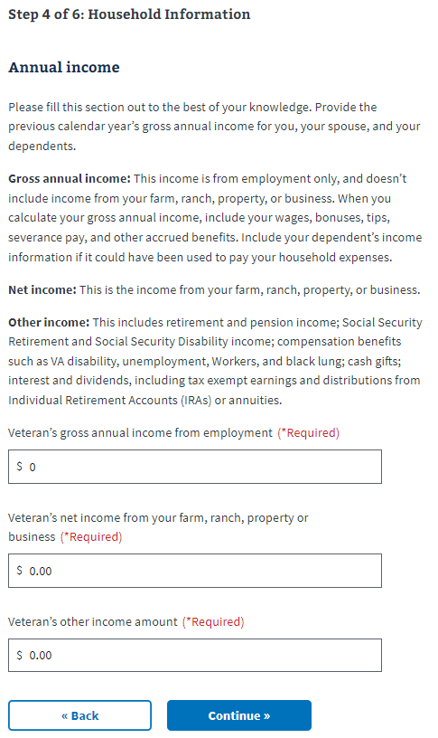

### Household Information Page 6: Previous Calendar Year’s Deductible Expenses

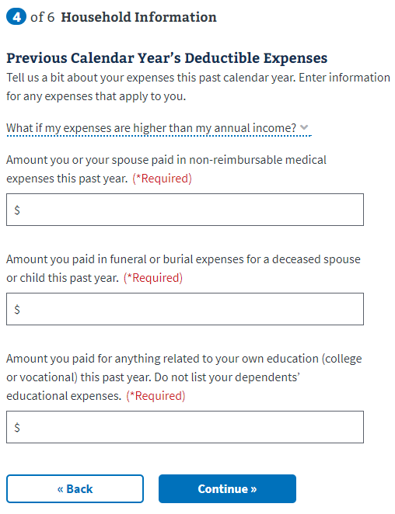

## 

## Insurance Information

### Insurance Information Page 1: Medicaid

All users are shown this page. The user needs to indicate whether they’re eligible for Medicaid. Those filling out the shortened application will see an alert on this and all remaining pages of their application that indicates that they are filling out a shortened application and why.



### 

### Insurance Information Page 2: Medicare

The user needs to indicate whether they’re enrolled in Medicare Part A. If they select **Yes**, the next page will request the effective date of their Medicare Part A coverage.

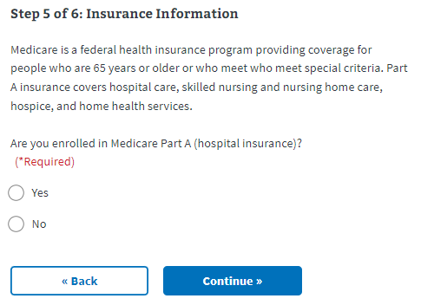

### 

### Insurance Information Page 3: Medicare Detail

The user will need to input the effective date of their Medicare Part A.

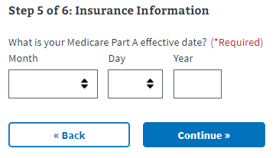

### 

### Insurance Information Page 4: Other Coverage

The user needs to indicate whether they have any additional health insurance coverage. If they do, the form will expand to allow them to input that information.

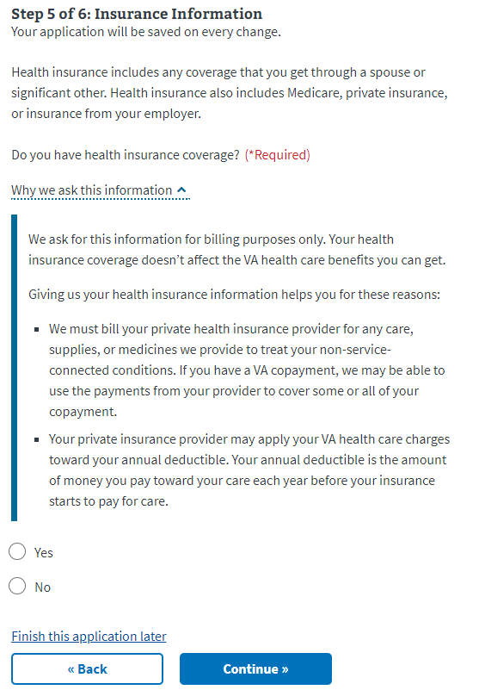

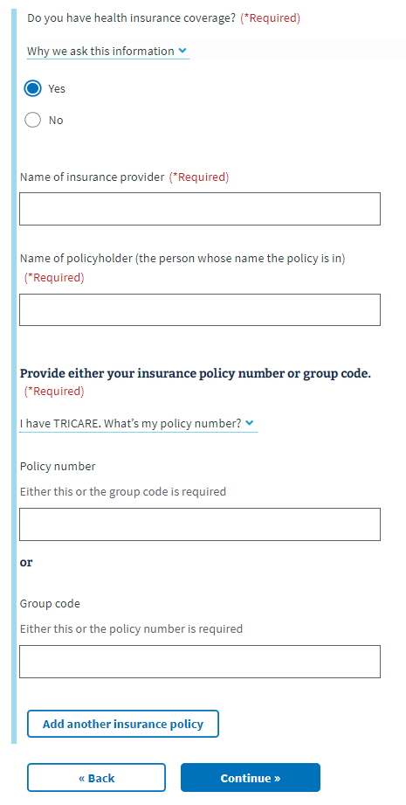

### Insurance Information Page 5: VA Facility

The user will need to indicate whether they’re applying to get minimum essential coverage under the Affordable Care Act, and then they will select their preferred VA medical facility by selecting the state that it is located in, and then the facility itself from the second dropdown menu. If they need assistance locating a facility, they can use the [VA Facility Locator](https://www.va.gov/find-locations) by clicking on the link below the *Center or clinic* dropdown.

The Veteran can indicate whether they want the VA to contact them to schedule their first appointment.

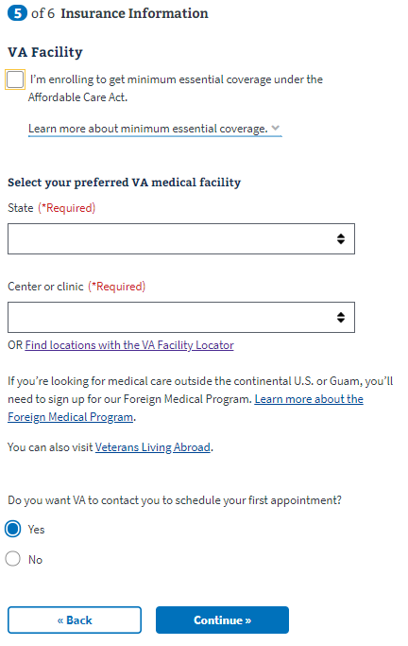

## Review Application

Once the Veteran has completed the application, they will be shown the Review Application section. In this section, the user can open each section and see what information they entered.

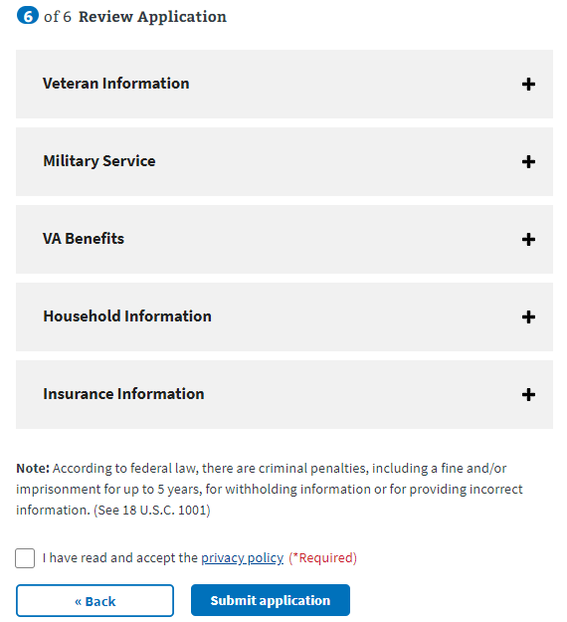

If they want to change the information shown, they can select the **Edit** button and make changes to that information.

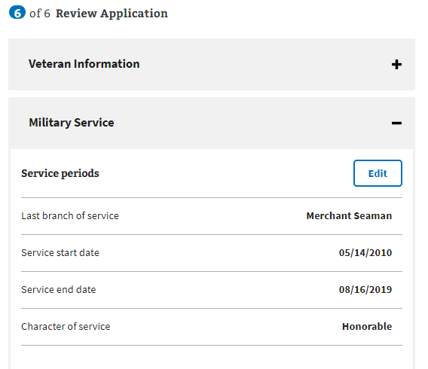

Once the **Edit** button has been pressed, the user can update the information in that section. They’ll need to make sure to press the **Update Page** button to save the changed information.

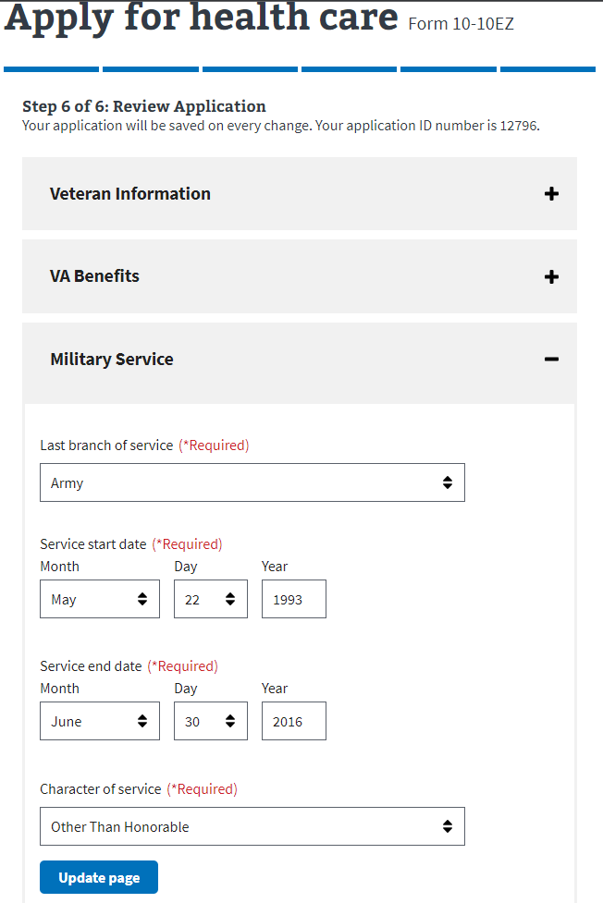

If any of the changes made remove any required information, or trigger additional questions that need to be answered, the application will draw their attention to where the update needs to be made.

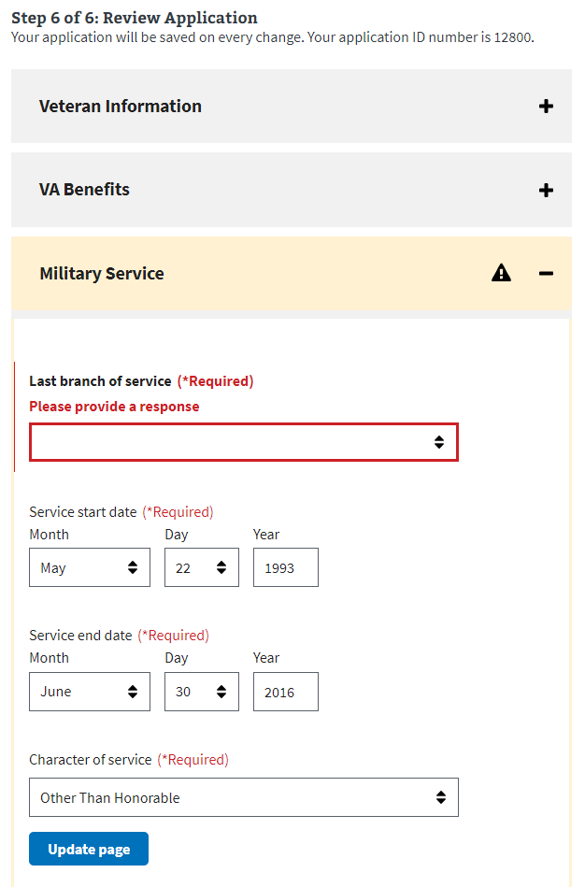

Once the user has reviewed the information and is ready to submit the application, they must select the check box indicating they have read and accepted the privacy policy. The privacy policy can be accessed via the link. This will be opened in new tab and their application won’t be interrupted:

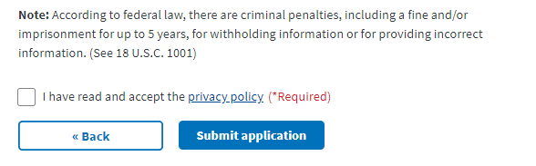

The user will be shown the following information after they submit their application:

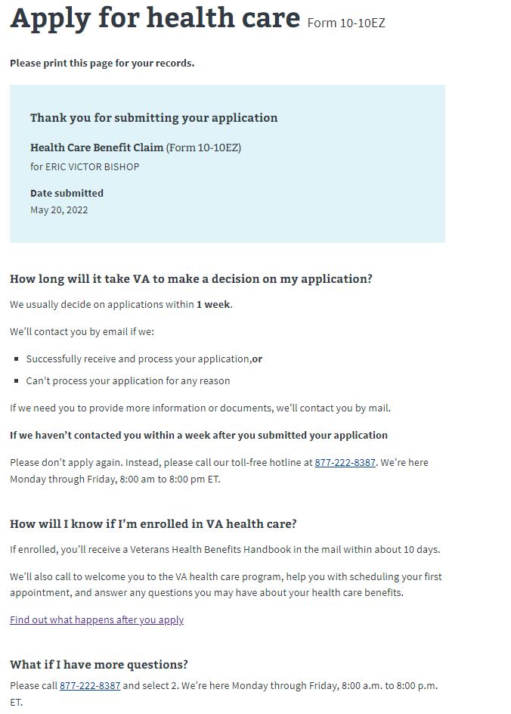

# Health Care Application Issues

## Questions about the content of the application:

Many Veterans will have specific questions about the content of the application because they don’t understand what the application is asking or why it needs that information. These are non-technical issues and should be directed to the Health Enrollment Center call center. Before transferring over to this call center, make sure the Veteran does not have any questions related to the navigation or issues entering information for technical reasons.

The information for the HEC is at the bottom of every page in the Health Care Application:

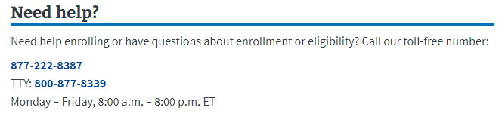

## Application is pre-filled with incorrect information:

If a Veteran has already entered information about themselves or their account has personal, contact or military information associated with it, that information will be used to pre-fill the application. The purpose is to make it easier for the Veteran to complete the application. Sometimes this information is incorrect, and it will confuse the Veteran why their application has pre-filled with the wrong information. The Veteran can fix this by editing the information directly in the application.

## Veteran can’t move forward in their application:

If a Veteran is saying they can’t move on to the next page in the application, ask them to check and make sure they have filled out all the required information. The website will have a big red message indicating where it is missing required information:

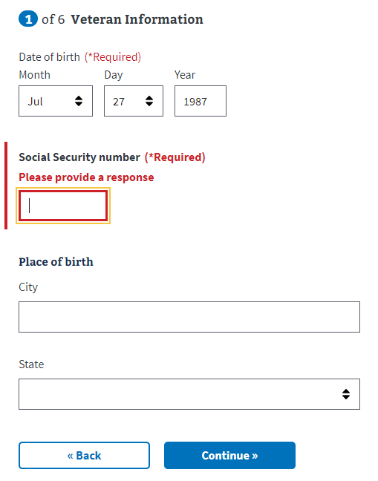

## 

## Veteran can’t upload a document:

There are a few places where a Veteran might be asked to upload a document to their application. If a Veteran is having difficulty uploading a document, review the tips section below to make sure the Veteran is following the guidelines:



## Veteran is having trouble upgrading their LOA1 account to an LOA3 account

If a Veteran is trying to apply for health care benefits with their LOA1 (not identity verified account), they will be required to upgrade to an LOA3 (identity verified) account. They can do this using ID.me, Login.gov or upgrading their My HealtheVet or DS Logon account. If the Veteran does not want to do this, you can also tell them they can apply for health care benefits when signed out of their account. This is not ideal because they will have to provide more information as they fill out the application, but it is an option if they don’t want to upgrade their account to LOA3.