**Million Veteran Program Women’s Campaign**

**Social Media Toolkit**

**Facebook Post #1:**

Did you know? Over the last 10 years, more than 75,000 Veterans have joined VA’s Million Veteran Program, now one of the largest genetics research programs in the world. Learn more and enroll today at mvp.va.gov.

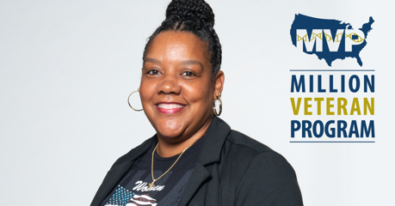

**Facebook Post #2:**

Imagine going to the doctor and getting health care designed just for you. VA’s Million Veteran Program is working on that future today, and we need your help. Learn more and enroll at mvp.va.gov.

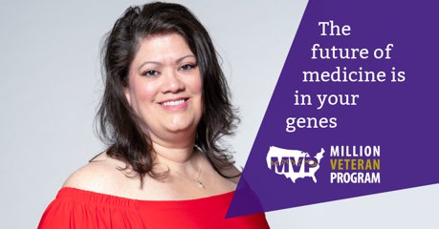

**Facebook Post #3:**

The future of medicine is in your genes. Join VA’s Million Veteran Program and help us unlock new breakthroughs and discoveries through genetics research. Learn more and enroll at mvp.va.gov.

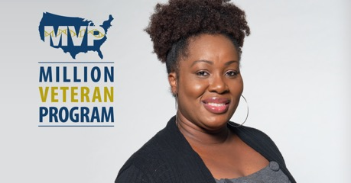

**Facebook Post #4:**

Nearly 1 million Veterans are leading the fight again, this time through research and genetics. Thanks to those in VA’s Million Veteran Program, we are unlocking the secrets of health and illness in Veterans and supporting medical discoveries for all Veterans. Learn more and enroll today at mvp.va.gov.

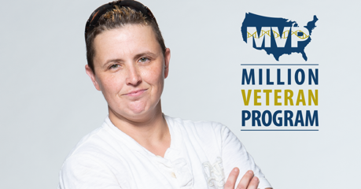

**Facebook Post #5:**

Did you know? VA is helping better predict breast cancer risk through genetics research. This is just one way VA’s Million Veteran Program is revolutionizing women’s health. Learn more and enroll today at mvp.va.gov.

**Facebook Post #6:**

Over 75,000 women Veterans have joined VA’s Million Veteran Program. By sharing their genetic and health information with researchers, they’re making sure women aren’t left out of medical breakthroughs and discoveries. You can help, too. Learn more and enroll today at mvp.va.gov.

**Facebook Post #7:**

In the past, medical research only used data on men. Not anymore. Thanks to VA’s Million Veteran Program, VA is leading the way in biomedical research focused on women for women. Learn more and enroll today at mvp.va.gov.

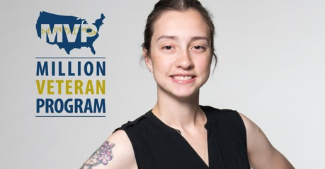

**Facebook Post #8:**

Women Veterans have always been trailblazers. Now they’re paving the way in precision medicine by joining VA’s Million Veteran Program. Learn more and enroll today at mvp.va.gov.

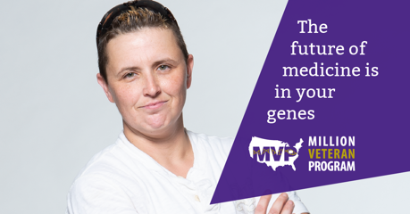

**Facebook Post #9:**

Women Veterans deserve the best care anywhere. You can help by joining VA’s Million Veteran Program. It’s the largest genetics research program in the world, working to better understand health and illness in Veterans, including women’s health. Learn more and enroll today at mvp.va.gov.

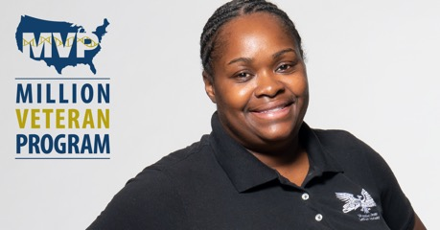

**Facebook Post #10:**

We’re on a mission to improve Veteran’s health today and tomorrow. You can help. Learn more about VA’s Million Veteran Program and enroll today at mvp.va.gov.

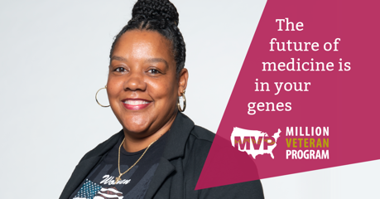

**Facebook Post #11:**

Imagine your doctor knew your breast cancer risk and the most effective treatments based on your genes, lifestyle and overall health. That research is happening today, thanks to 75,000+ women Veterans who have shared their genetic and health information with VA’s Million Veteran Program. You can help, too. Learn more and enroll today at mvp.va.gov.

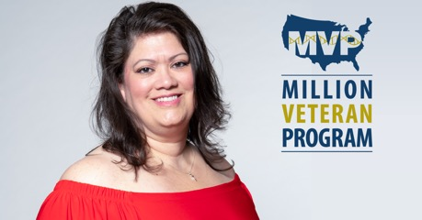

**Facebook Post #12:**

Why are some Veterans more at risk for heart disease or depression? Why do treatments work for some but not others? VA’s Million Veteran Program is using genetic, health, and lifestyle data collected from over 75,000 Veterans to support researchers’ quest for answers. You can help by joining MVP today at mvp.va.gov.

