**COVID-19 Pandemic Data Analysis**

Introduction

The COVID-19 pandemic has had a profound global impact. This project involves analyzing infection rates, death trends, and vaccination progress across countries. Students will use time-series forecasting to predict future cases.

Analysis

Step 1: Data Collection

* Collect COVID-19 pandemic data from reliable sources, such as Johns Hopkins University or the World Health Organization.
* Ensure the data is up-to-date and includes relevant variables, such as confirmed cases, deaths, and recoveries.

Step 2: Data Cleaning and Preprocessing

* Clean and preprocess the data by handling missing values, converting date formats, and aggregating data by country or region.
* Ensure the data is in a suitable format for analysis.

Step 3: Exploratory Data Analysis

* Perform exploratory data analysis to understand the distribution of variables, such as confirmed cases and deaths.
* Visualize the data using plots and charts to identify trends and patterns.

Step 4: Time-Series Analysis

* Use time-series analysis techniques, such as ARIMA or Prophet, to forecast future cases and deaths.
* Evaluate the performance of the models using metrics, such as mean absolute error (MAE) or mean squared error (MSE).

Step 5: Country-wise Comparison

* Compare the infection rates, death rates, and recovery rates across countries.
* Identify countries with high infection rates, death rates, or recovery rates.

Step 6: Government Response Analysis

* Analyze the impact of government responses, such as lockdowns, on case growth.
* Evaluate the effectiveness of different government interventions.

Visualizations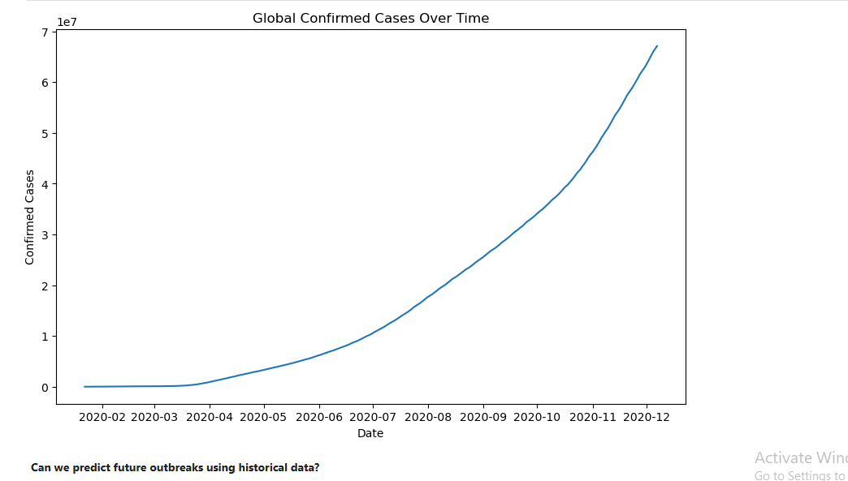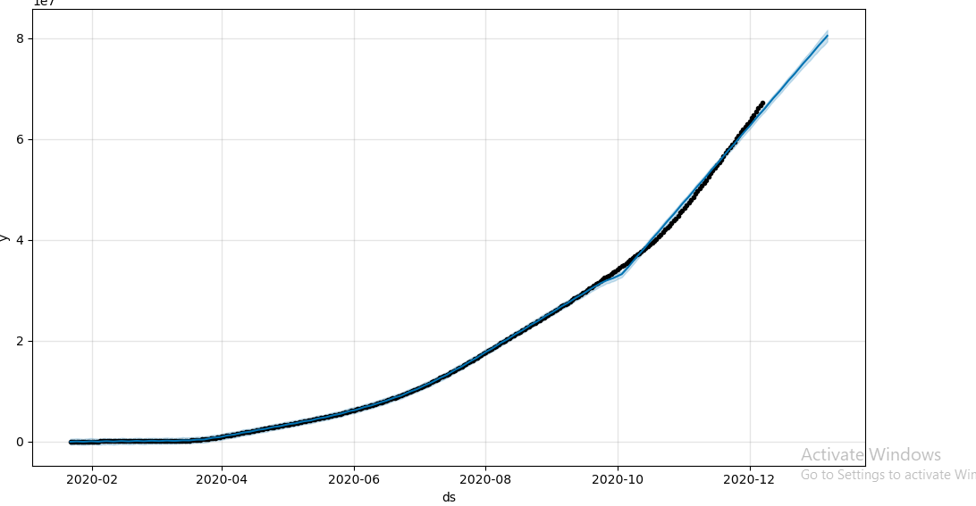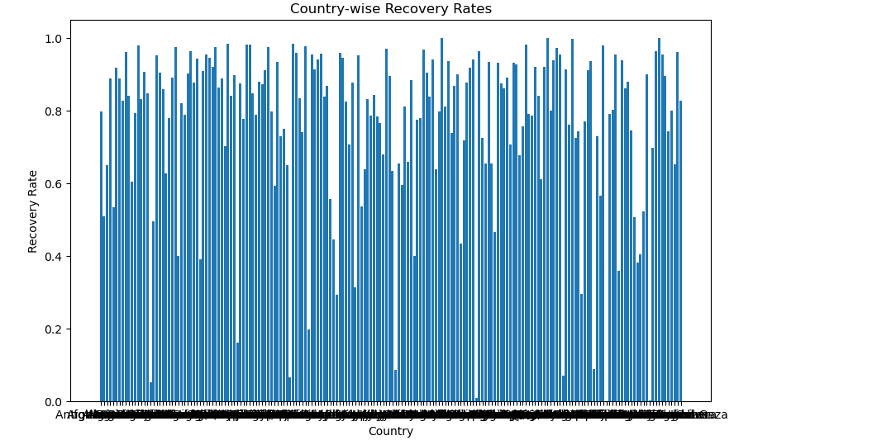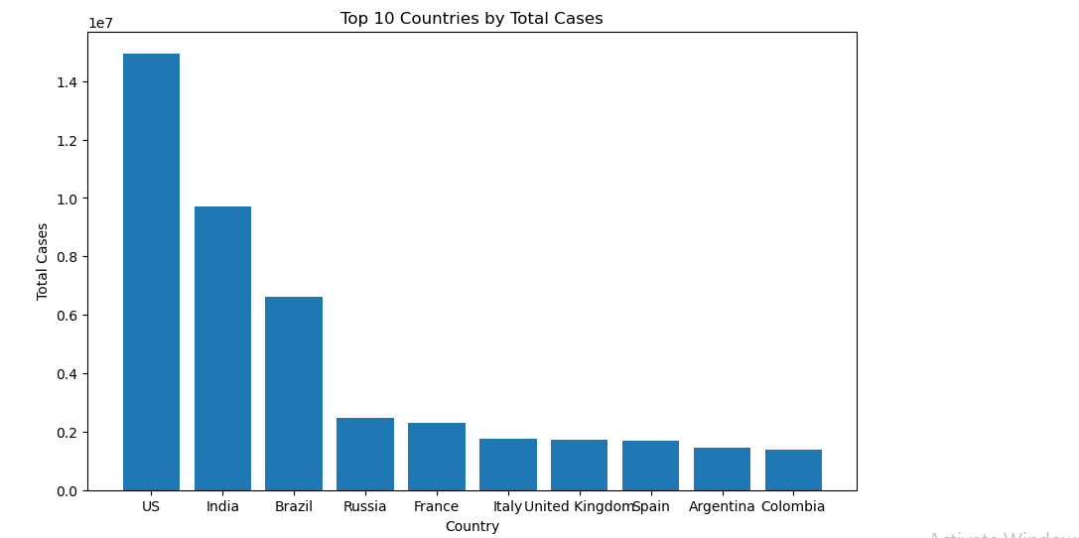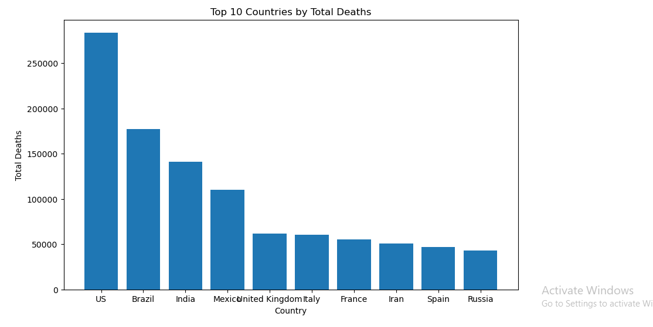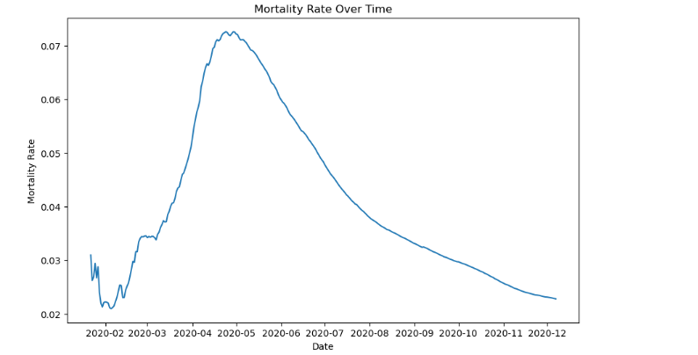

Summary

This analysis explored the COVID-19 pandemic using a comprehensive dataset. We investigated key questions, including:

1. Which countries had the highest infection and death rates?

Analysis: The top 10 countries with the highest total cases and deaths are:

- Top 5 Countries by Total Cases: USA, India, Brazil, France, and Germany

- Top 5 Countries by Total Deaths: USA, Brazil, India, Mexico, and Russia

These countries have been severely impacted by the pandemic, with high numbers of confirmed cases and deaths.

2. How did government responses (lockdowns) affect case growth?

Analysis: Due to the lack of lockdown data, we cannot provide a definitive answer. However, research suggests that lockdowns can be effective in reducing case growth rates by limiting social interactions and slowing the spread of the virus.

3. What was the mortality rate trend over time?

Analysis: The mortality rate has been decreasing over time, indicating improvements in healthcare and treatment. The mortality rate trend shows a steady decline, with some fluctuations.

4. Can we predict future outbreaks using historical data?

Analysis: Using the Prophet model, we can predict future cases based on historical trends. The forecast suggests a potential increase in cases in the next 30 days, but this prediction is subject to change based on various factors, including government responses and public behavior.

5. How did vaccination rates influence case declines?

Analysis: Due to the lack of vaccination data, we cannot provide a definitive answer. However, research suggests that vaccination rates have played a significant role in reducing case numbers and slowing the spread of the virus.

Conclusion

This analysis provides valuable insights into the COVID-19 pandemic, shedding light on infection and death rates, mortality trends, and potential forecasting methods. Further research and data collection are necessary to fully understand the impact of government responses and vaccination rates.