NAME :- ADEAL FAROOQ LONE
📚 Data Structures & Algorithms (DSA) – Complete C++ Basics Notes
🏗️ 1. C++ Code Ka Structure Aur Skeleton
C++ me koi bhi code likhne ke liye ek basic structure (skeleton) hota hai jo lagbhag har program me same rehta hai.
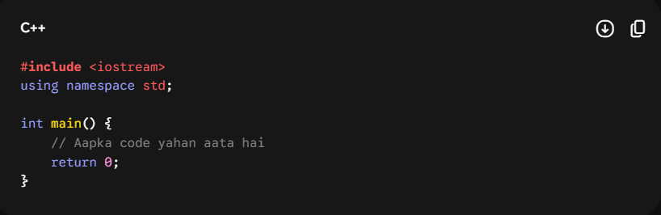🔹 Components Ka Deep Breakdown:
- #include <iostream>: Isko 'Preprocessor Directive' kehte hain. #include ka kaam hota hai kisi library ko program me shamil karna. iostream ka matlab hai Input-Output Stream. Agar aapko screen par kuch dikhana hai (cout) ya user se kuch input lena hai (cin), toh is library ke bina computer un shabdon ko nahi samajh payega.
- Other Libraries: Agar aapko maths ke complex functions use karne hain toh #include <cmath> (ya math.h), aur agar strings ke functions chahiye toh #include <string> lagana padta hai.
- using namespace std;: C++ me standard functions (jaise cout, cin) ek ghar ke andar rehte hain jise std (standard) namespace kehte hain. Agar aap ye line nahi likhenge, toh aapko har baar std::cout aur std::cin likhna padega, jo bohot bada aur annoying lagta hai. Ye line compiler ko bolti hai ki by default std namespace hi use karo.
- int main(): Ye aapke program ka heart hai. Computer aapke code ko upar se neeche padhna shuru nahi karta, wo sabse pehle pure code me main() function ko dhoodhta hai. Execution hamesha main() ke andar ki pehli line se shuru hoti hai.
- return 0;: main() function ka data type int (integer) hai, isliye ye end me ek number return karta hai. 0 return karne ka matlab hota hai ki program bina kisi error ke successfully khatam ho gaya.
🔥 Master Header File: #include <bits/stdc++.h>
DSA aur Competitive Programming me time bachane ke liye ek bohot popular header file use hoti hai: #include <bits/stdc++.h>.
- Ye kya karta hai? Ye C++ ki saari standard libraries (iostream, vector, string, math, algorithm, etc.) ko ek hi baar me import kar deta hai. Aapko har cheez ke liye alag se #include nahi likhna padta.
- Catch/Rule: Ye compiler me thoda sa zyada time leta hai kyunki ye sab kuch load karta hai, lekin execution speed (run-time) par iska koi asar nahi padta. DSA coding rounds ke liye ye sabse best hai.
📥 2. Input/Output (I/O) Aur Special Characters
🔹 cout (Output)
Screen par output dene ke liye cout ke saath << (Insertion Operator) lagaya jata hai.
- Double quotes "" ke andar jo likhoge, wo exact print hoga (jaise string text).
- Bina quotes ke likhoge toh variable ki value print hogi.
- Aap ek hi line me multiple cheezein chain kar sakte ho: cout << "Value: " << x << "\n";
🔹 cin (Input)
User se keyboard ke zariye input lene ke liye cin ke saath >> (Extraction Operator) lagaya jata hai.
- Agar do variables input lene hain, toh aap cin >> x >> y; likh sakte ho. Chahe user space dekar input dale ya Enter dabakar, cin dono ko sahi tarike se variables me daal deta hai.
🔹 New Line Character: \n vs endl
Program me output ko agli line par le jaane ke do tarike hain:
- \n (Newline string character)
- endl (End of line function)
- DSA Rule: Hamesha \n ka use karein. endl screen ko flush (refresh) bhi karta hai jisme thoda CPU time lagta hai. \n bohot fast hota hai aur DSA me time limit exceed (TLE) se bachata hai.
📊 3. Data Types Aur Unki Memory Ranges
Variables me kis tarah ka data store hoga, ye data types tay karte hain. Computer har data type ko alag memory space deta hai.
🔹 Numbers Ke Liye (Integers)
- int: Normal integers store karne ke liye. Ye memory me 4 bytes leta hai. Iski range lagbhag $-{10}^{9}$ se ${10}^{9}$ tak hoti hai.
- long: Thoda bada integer store karne ke liye. Iski range lagbhag $-{10}^{12}$ se ${10}^{12}$ tak hoti hai.
- long long: Bohot bade integers ke liye (8 bytes memory). Iski range $-{10}^{18}$ se ${10}^{18}$ tak hoti hai.
  - DSA Tip: Agar question me constraints ${10}^{9}$ se bade hain (jaise factorial ya sum nikalte waqt), toh chupchap long long use kar lo taaki 'Integer Overflow' ka error na aaye.
🔹 Point Wale Numbers Ke Liye (Decimals)
- float: Choti decimal values ke liye.
- double: Badi decimal values aur high precision (point ke baad zyada digits) ke liye. DSA me standardly double hi use kiya jata hai.
🔹 Text Aur Letters Ke Liye
- char: Sirf ek single letter, number ya symbol store karta hai. Ise hamesha single quotes '' me likhte hain, jaise char ch = 'A';. Yeh 1 byte leta hai. Total 256 ASCII characters hote hain.
- string: Pura ka pura word ya sentence store karne ke liye. Ise double quotes "" me likhte hain.
⚠️ String Input Ka Hidden Concept: cin vs getline
- cin >> str;: Ye sirf pehle space tak ka text read karta hai. Agar input "Hello World" hai, toh variable me sirf "Hello" jayega. Space aate hi cin ruk jata hai.
- getline(cin, str);: Agar aapko space ke saath pura sentence read karna hai, toh getline use hota hai. Ye tab tak read karta hai jab tak user Enter (\n) nahi daba deta.
🔀 4. Conditional Statements (Decision Making)
🔹 if, else if, Aur else
Jab code ko kisi condition ke aadhar par chalana ho.
- 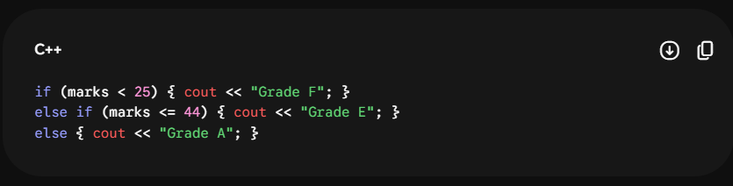Optimization Rule (VVIP): Agar aap sirf alag-alag if statements likhenge, toh computer har ek if ko compulsory check karega, chahe pehla hi true kyun na ho gaya ho. Isse time barbad hota hai. Lekin jab aap if - else if - else ka structure banate ho, toh jaise hi koi ek condition True hoti hai, computer baaki poore block ko skip karke aage nikal jata hai.
- Nested if-else: Ek if ke andar doosra if lagana. Ye tab kaam aata hai jab ek condition ke sach hone ke baad uske andar ek aur check lagana ho.
🔹 switch Statement
Jab ek hi variable ke alag-alag fixed choices (cases) ko check karna ho. Ye if-else ka ek saaf-suthra vikalp hai.
- 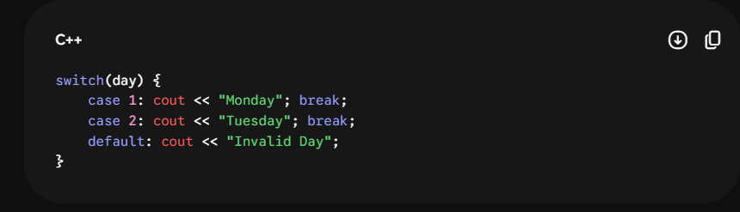
- 🚨 break ka niyam: Har case ke baad break; lagana zaroori hai. Agar aap break nahi lagayenge, toh jahan condition match hui hai, uske neeche ke saare cases bina check kiye line se execute ho jayenge (isko fall-through bug kehte hain).
- default: Agar koi bhi case match nahi hua, toh default wala code chalta hai (jaise else).
📦 5. Arrays Aur Strings Ka Funda
🔹 1D Array
Jab aapko ek hi data type ke bohot saare variables ek saath store karne hon (jaise 50 bacho ke marks).
- Syntax: int arr[5]; -> Isse 5 integers ke liye memory me consecutive space ban jati hai.
- Zero-based Indexing: Array ka index hamesha 0 se shuru hota hai. Agar size 5 hai, toh elements arr[0], arr[1], arr[2], arr[3], aur arr[4] par honge. Aakhri index hamesha (size - 1) hota hai.
- Memory Architecture: Array ke saare elements memory me ek ke baad ek continuous block me store hote hain. Pehla element kis random address par hai ye system tay karta hai, par baaki ke saare uske thik baad aate hain.
- Garbage Value: Agar aapne array declare kiya par usme koi value nahi daali, toh C++ usme memory me pehle se padi koi bhi kachra (garbage) value daal deta hai.
🔹 2D Array (Matrix)
Ise row aur column ka combination samajh sakte hain.
- Syntax: int arr[3][5]; -> Iska matlab hai 3 Rows aur 5 Columns wala matrix (Total 15 elements).
- Isko access karne ke liye arr[row_index][column_index] ka use hota hai. Graphs aur Grid wale DSA problems me iska bohot use hota hai.
🔹 String As An Array
C++ me string basically characters ka ek array hi hoti hai.
- Agar string s = "Striver"; hai, toh s[0] par 'S' hoga aur s[1] par 't'.
- s.size() ya s.length(): Isse string ki total length pata chalti hai. Aakhri character hamesha s[s.size() - 1] par hota hai.
🔁 6. Loops (Iteration)
Kisi code ko baar-baar chalane ke liye loops use hote hain.
- for Loop: Jab aapko pata ho ki loop exact kitni baar chalana hai. Isme teen parts hote hain: for(initialization; condition; increment/decrement).
  - Scope Rule: Agar aapne loop ke andar variable banaya hai for(int i=0;...), toh wo variable loop ke bahar khatam ho jata hai. Agar use bahar bhi use karna hai, toh use loop ke upar declare karein.
- while Loop: Isme sirf condition hoti hai. Jab tak condition true hai, loop chalta rahega. while(condition) { ... increment; }
- do-while Loop: Ye loop kam se kam ek baar zaroor chalta hai, chahe condition pehli baar me hi galat (false) kyun na ho. Kyunki isme kaam pehle hota hai (do) aur condition baad me check hoti hai (while).
🛠️ 7. Functions Aur Unke Memory Rules
Functions code ke blocks hote hain jo koi specific task perform karte hain. Ye code ko reusable banate hain.
🔹 Types:
- Void Functions: Jo kuch return nahi karte, bas kaam karke khatam ho jaate hain (void printName()).
- Return Functions: Jo calculation ke baad ek final value wapas bhejte hain (jaise int sum()).
  - 🚨 Catch: Agar function ka return type int ya koi aur data type hai, toh uske har ek path me return statement hona compulsory hai, nahi toh computer garbage value de dega ya error dega.
🔥 Pass by Value vs Pass by Reference (VVIP Conceptual Part)
1. Pass by Value (Default Rule)
Jab aap kisi function me normal variable paas karte ho, toh variable ka original roop nahi jata, balki uski ek copy (xerox) function ke paas jaati hai.
- Function ke andar aap us variable me jo bhi tod-fod ya badlav karoge, wo sirf us copy me hoga. main() function ke andar baitha original variable ekdam safe rahega, usme koi change nahi aayega.
- Variables, strings, vectors sab by default pass by value hote hain.
2. Pass by Reference (& Operator)
Agar aap chahte ho ki function jo bhi badlav kare, wo original variable me ho, toh aap data type ke aage & lagate ho (jaise void doSomething(int &num)).
- Isse variable ki copy nahi jaati, balki us variable ka original memory address paas ho jata hai. Ab function ke andar kiya gaya koi bhi change original variable ko badal dega.
🚨 Arrays Ka Special Exception Rule:
Pure C++ me Arrays hamesha by default Pass by Reference hote hain. Array ko function me paas karte waqt aapko & lagane ki zaroorat nahi padti. Agar function ke andar array ka koi bhi element badla, toh main() function ka original array bhi badal jayega.
Ye the is pure lecture ke ekdam micro-level details aur rules. Inko aap apne register ya notepad me bina timelines ke ek clean flow me save kar sakte hain. Jab aap inko revice kar lein aur next topic ke liye ready hon, toh agla link ya topic daal dena!

