PORTFOLIO EVIDENCE PACK
Client Onboarding Workflow
Prepared by: Adeayo Adewale
Project 2 of 2 | AI Automation Portfolio

Introduction
This evidence pack documents the build and operation of the Client Onboarding Workflow — an automated system that processes form submissions, creates client folders in Google Drive, sends personalized welcome emails, creates follow-up tasks in ClickUp, and delivers internal notifications to Slack.

The ten screenshots in this pack demonstrate the architecture, the defensive validation layer, the normalization logic, a successful end-to-end execution, and the error notification system. Together they evidence that this system was built for production conditions — not just for a demo.

Every screenshot was taken from a live, actively running scenario with real test data. No elements are mocked or simulated.

Project Summary
Trigger | Tally form submission via instant webhook
Tools connected | Tally, Google Drive, Gmail, ClickUp, Slack
Modules | 10 modules including Router, normalizer, 4 action modules, 2 Slack channels
Error handlers | Break handlers on all action modules — routes to Incomplete Executions
Security | Submission ID validation, required field checks, email format validation
Duplicate prevention | Tally native — email address as unique identifier
Error alerting | Fallback route fires #errors notification on every blocked submission
Failure modes documented | 17 across 3 categories
Documents produced | 4 — System Architecture, Failure Mode Registry, Setup Record, Operating Guide

Evidence Screenshots

Screenshot 1 — Full Scenario Canvas

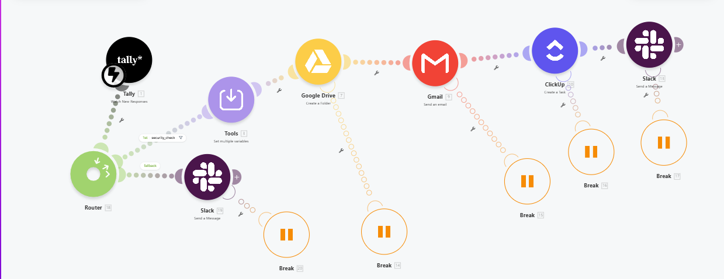
Figure 1: Complete Make scenario showing all modules, routing logic, and Break error handlers

The canvas shows the complete architecture: Tally webhook trigger, Router splitting into main and fallback routes, security_check filter, normalizer, Google Drive, Gmail, ClickUp, Slack #onboarding, Slack #errors, and Break handlers on all action modules. The routing logic — main route for valid submissions, fallback route for blocked ones — is visible in the canvas structure.

Screenshot 2a — security_check Filter — Conditions 1 to 3

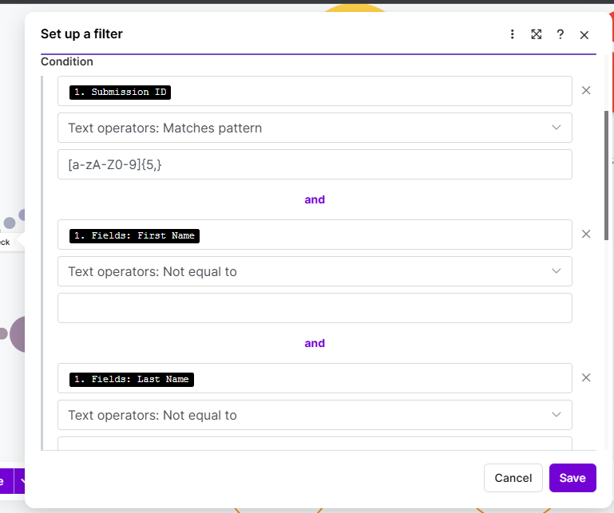
Figure 2a: Filter inspector showing Submission ID pattern match, First Name, and Last Name validation

The security_check filter sits between the Router and the normalizer on the main route. Conditions 1 to 3 validate the submission ID against a pattern requiring alphanumeric characters of at least five characters, and confirm that First Name and Last Name fields are not empty. All six conditions must pass for a submission to proceed.

Screenshot 2b — security_check Filter — Conditions 4 to 6

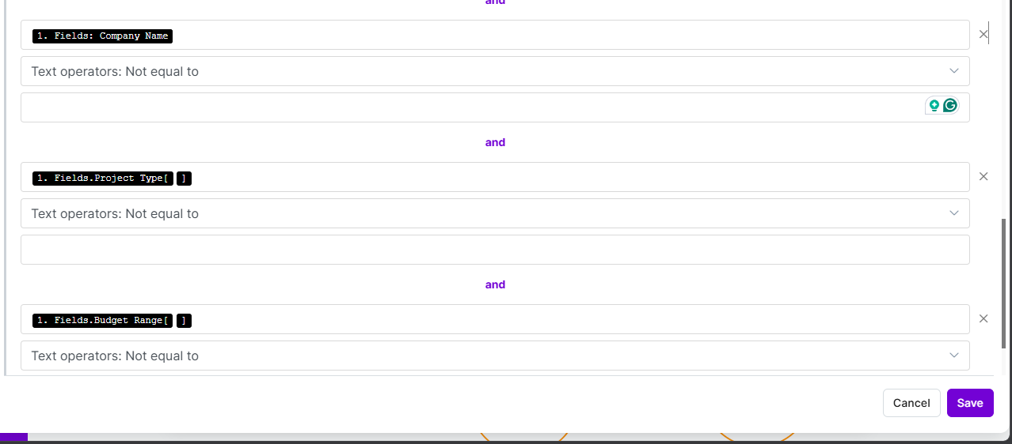
Figure 2b: Filter inspector showing Email format validation, Company Name, and Project Type checks

Conditions 4 to 6 validate the email address against a format pattern, confirm Company Name is present, and confirm Project Type is selected. The full six-condition filter is split across two screenshots for visibility. A submission that fails any single condition is routed to the fallback path and triggers an #errors notification.

Screenshot 3 — Normalizer Output — Ten Clean Variables

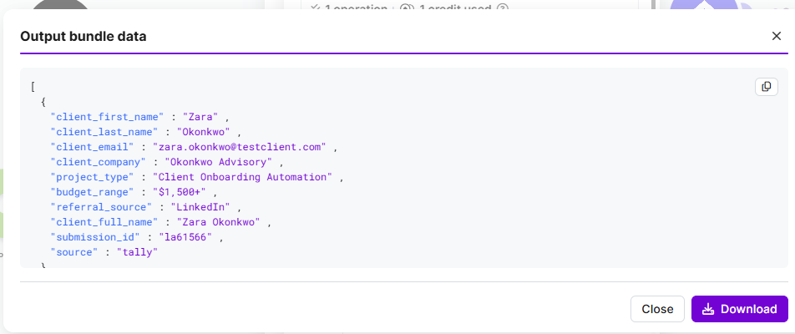
Figure 3: Set Multiple Variables module output showing all ten normalized variables populated with real test data

The normalizer converts the raw Tally payload into ten consistently named variables. Dropdown fields — project_type, budget_range, and referral_source — are correctly resolved from arrays to plain strings using index [1] referencing. The source variable is set to the literal text 'tally', ready to distinguish submissions if a second trigger source is added in the future. No downstream module touches the raw payload directly.

Screenshot 4 — Successful End-to-End Run

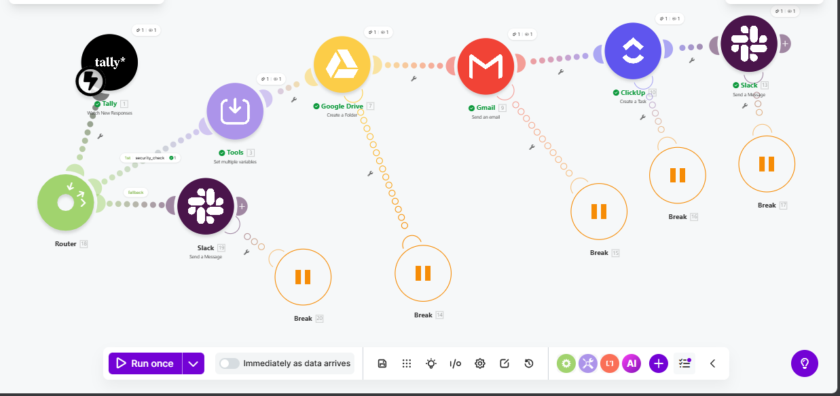
Figure 4: All modules showing green checkmarks on a live test submission

Every module in the main route executed successfully: Tally received the submission, the security_check filter passed it, the normalizer produced clean variables, Google Drive created the folder, Gmail sent the welcome email, ClickUp created the task, and Slack delivered the #onboarding notification. The run completed in seconds from form submission to Slack confirmation.

Screenshot 5 — Google Drive — Client Folders

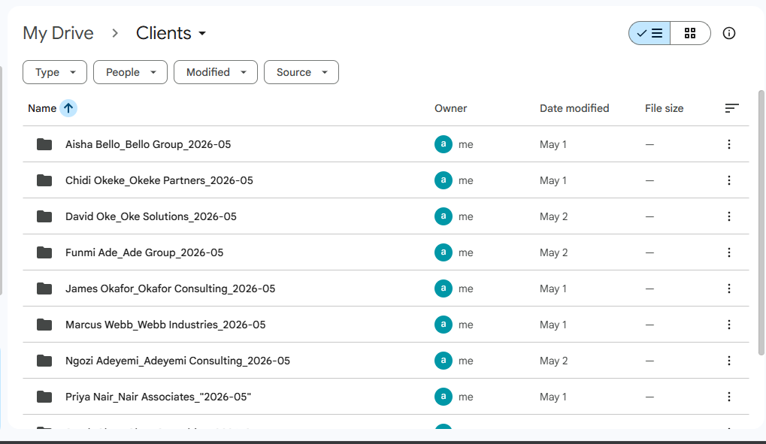
Figure 5: Google Drive Clients folder showing automatically created client folders with correct naming format

Each folder is named using the convention ClientFullName_CompanyName_YYYY-MM, generated automatically from the normalized variables and the current date. The naming format makes folders sortable by month and immediately identifiable by client. Folders are created in the Clients directory at the root of My Drive.

Screenshot 6 — Gmail — Welcome Email Received
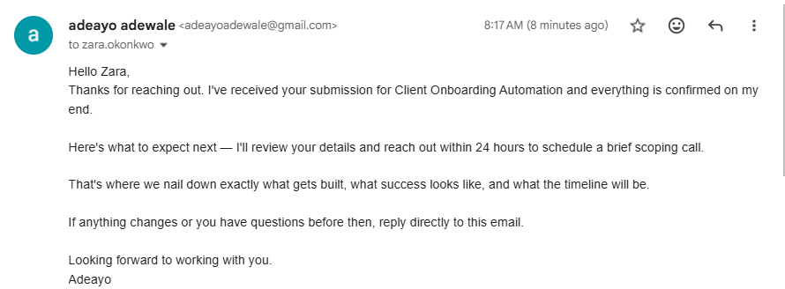

Figure 6: Welcome email in inbox showing subject line, first name greeting, project type reference, and sign-off

The welcome email uses the client's first name only, references their selected project type specifically, and is written in a conversational tone. The design decision was deliberate — automated emails that feel automated create distance before the relationship begins. This email was reviewed against one question: would a real person send this exact message?

Screenshot 7 — ClickUp — Client Onboarding Tasks
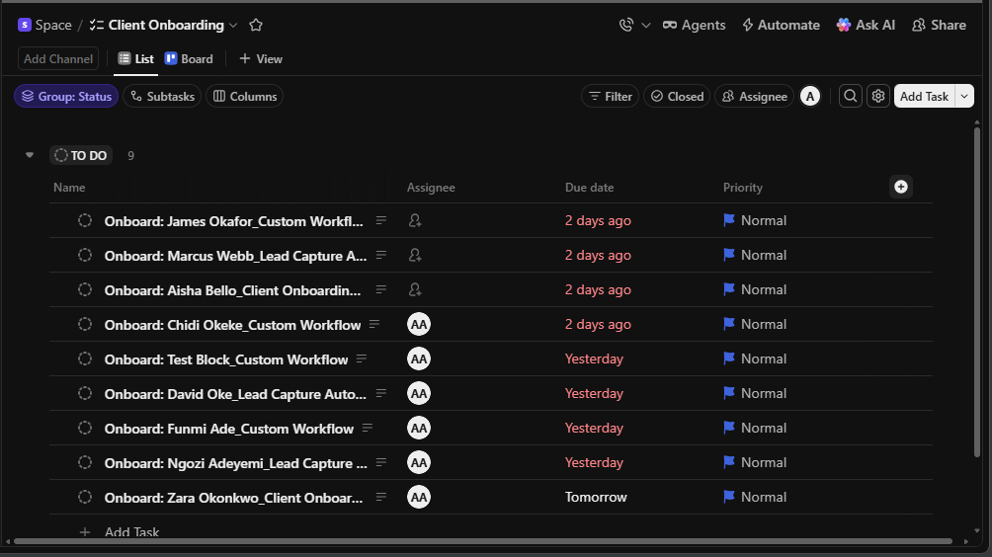
Figure 7: ClickUp Client Onboarding list showing tasks with correct naming, assignee, due date, and priority

Each task is named using the format 'Onboard: ClientFullName — ProjectType', assigned to the operator, set to Normal priority, and due the following day. The 24-hour due date enforces the follow-up commitment made in the welcome email. Tasks are created in the Client Onboarding list under the Space in Adeayo's Workspace.

Screenshot 8 — Slack #onboarding — Onboarding Bot Notification

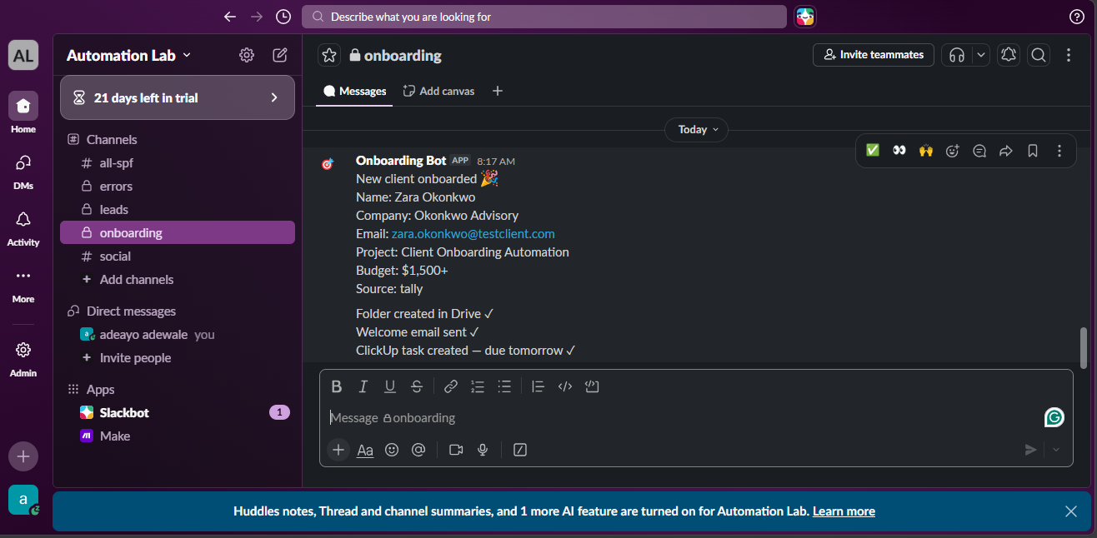
Figure 8: Onboarding Bot message in #onboarding showing full client details and three action confirmations

The Slack notification confirms that all three upstream actions completed successfully on this submission — folder created in Drive, welcome email sent, ClickUp task created and due tomorrow. This eliminates the need to check three separate tools after each onboarding. The operator sees the complete status in one message.

Screenshot 9 — Slack #errors — Error Bot Notification

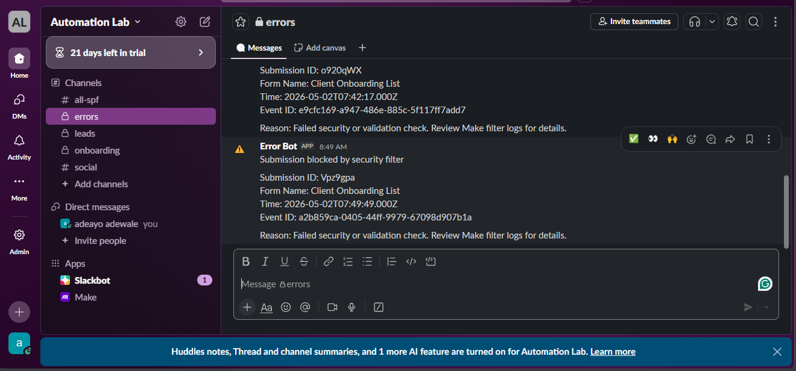
Figure 9: Error Bot message in #errors showing blocked submission details including Submission ID, timestamp, and Event ID

When a submission fails the security_check filter, the fallback route fires an immediate notification to #errors. The message includes the Submission ID, Form Name, timestamp, and Event ID — enough detail to locate the entry in Tally's Submissions tab and determine whether a legitimate submission was incorrectly blocked. No submission fails silently.

Delivery Confirmation
This portfolio evidence pack, together with the four project documents, constitutes the complete deliverable set for the Client Onboarding Workflow. The system is live, tested, and running on Immediately as data arrives mode.

Document | Status | Included
Document 1 — System Architecture | Complete | ✓
Document 2 — Failure Mode Registry | Complete | ✓
Document 3 — Setup and Configuration Record | Complete | ✓
Document 4 — Operating Guide | Complete | ✓
Portfolio Evidence Pack | Complete | ✓

Project 2 of 2 | AI Automation Portfolio | Adeayo Adewale

