PORTFOLIO EVIDENCE PACK
B2B Lead Capture Pipeline
Automated lead capture with validation, duplicate detection,
security token authentication, and full operational documentation.

Built by: Adeayo
April 2026
Version 1.0

What This Is
This document provides visual evidence of a fully built, tested, and hardened B2B lead capture automation pipeline. It accompanies four operational documents — System Architecture, Failure Mode Registry, Setup and Configuration Record, and Operating Guide.

Every screenshot in this pack was captured from a live system. Every failure mode shown was deliberately triggered to confirm the defensive architecture works as designed. This is not a demo. It is a tested system.

Business Outcomes Delivered
The following outcomes are built into the system architecture — not aspirational claims.

Business Outcome | How It Is Achieved
Zero leads lost | Every submission captured 24/7 — no human monitoring required
Clean CRM from day one | Invalid, incomplete, and duplicate records blocked before entry
Instant lead response | Personalized confirmation email within 5 seconds of submission
Immediate team alert | Slack notification fires the moment a new lead arrives
Protected against abuse | Secret token blocks unauthorized webhook access
Failures are visible | Error handlers store failed executions for manual review — nothing disappears silently
No manual data entry | Replaces the need for a person to capture, clean, and enter lead data

System Architecture Overview
The pipeline consists of eight modules connected in sequence. Every submission passes through three gates before any data is written. No module downstream of the gates ever receives incomplete, invalid, duplicate, or unauthorized data.

Pipeline sequence:

Step | Module | Job
1 | Webhook | Receives incoming submission from any form
2 | security_check | Verifies secret token — blocks unauthorized access
3 | intake_validation | Validates email, name, company, email format
4 | Airtable Search | Checks for existing record with same email
5 | check_record | Blocks submission if duplicate found
6 | Airtable Create | Writes new record to Leads table
7 | Gmail | Sends personalized confirmation to lead
8 | Slack | Notifies sales team with full lead details

Screenshot Evidence
Nine screenshots documenting the complete system — architecture, defensive gates, successful runs, blocked submissions, and live output.

# | Screenshot | What It Shows
1 | Full pipeline canvas | Complete architecture — all modules connected
2 | intake_validation filter | Five conditions — all green ticks on valid submission
3 | check_record filter | Numeric zero condition — duplicate gate
4 | Successful run — all green ticks | Clean lead processed — all modules fired
5 | Blocked submission | Red stop sign — defensive gate working
6 | Duplicate blocked | check_record stopping known lead
7 | Airtable Leads table | Five clean records — validated and unique
8 | Slack notification | Team alert with full lead details
9 | Gmail confirmation | Personalized email — lead notified instantly

Screenshot 1 — Full Pipeline Canvas
The complete scenario as built in Make.com. All eight modules are connected in sequence with both error handler Break modules visible branching from Gmail and Slack.
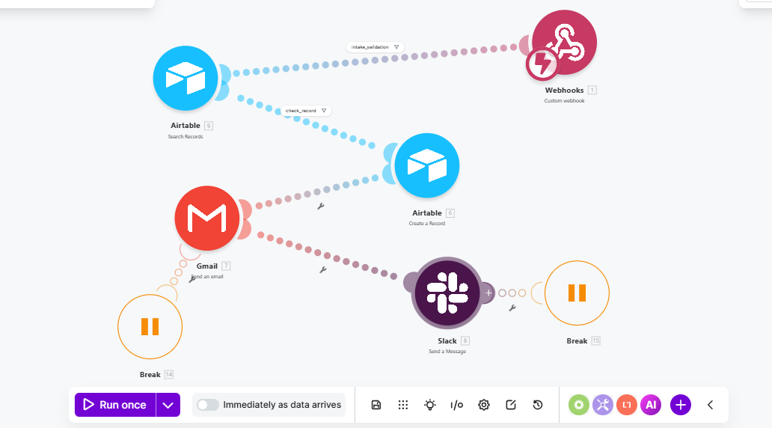
Screenshot 1 — Full Pipeline Canvas: Eight modules connected in sequence. security_check and intake_validation gates visible before any write operations. Break modules on Gmail and Slack error paths.

Screenshot 2 — intake_validation Filter
The data quality gate. Five conditions evaluated simultaneously on every submission. All five must pass for the bundle to continue. One failure blocks the entire submission at this point.

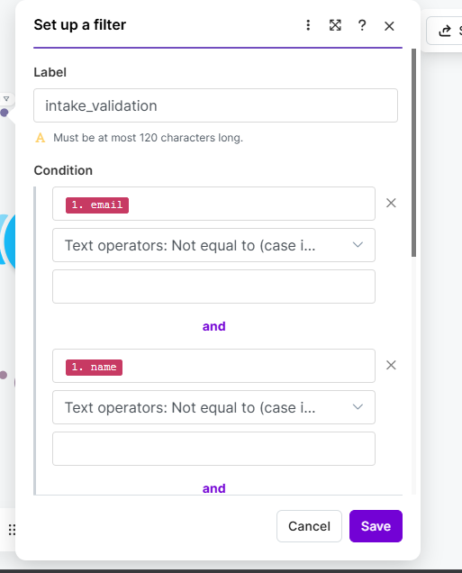
Intake Validation I
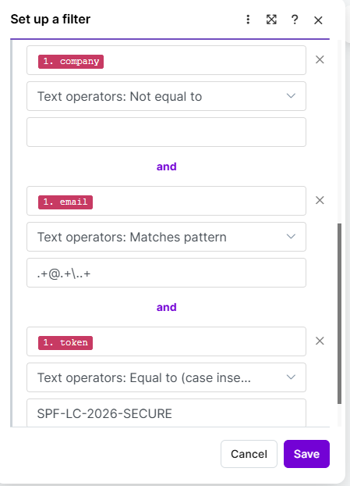
Intake Validation II
Screenshot 2 — intake_validation Filter Inspector: Five AND conditions: email not empty, name not empty, company not empty, email matches format pattern, token matches security value. All green on a valid submission.

Screenshot 3 — check_record Filter
The duplicate detection gate. Reads the output of the Airtable Search module. If any existing record with the same email was found, the bundle is stopped here. Only zero matches allows the submission through.

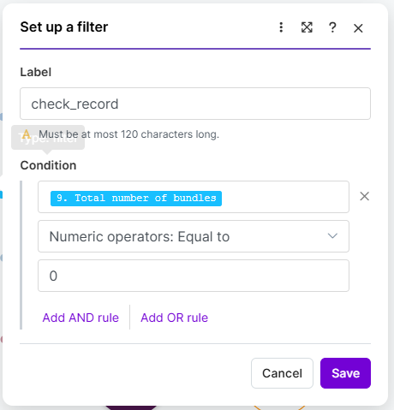
Screenshot 3 — check_record Filter Inspector: Numeric operator: Total number of bundles equal to 0. If the search returned any records the submission stops here. Prevents duplicate CRM entries and duplicate confirmation emails.

Screenshot 4 — Successful Run
A clean new lead with all required fields and correct security token passing through the complete pipeline. All eight modules fire in sequence. Green ticks confirm every step completed successfully.

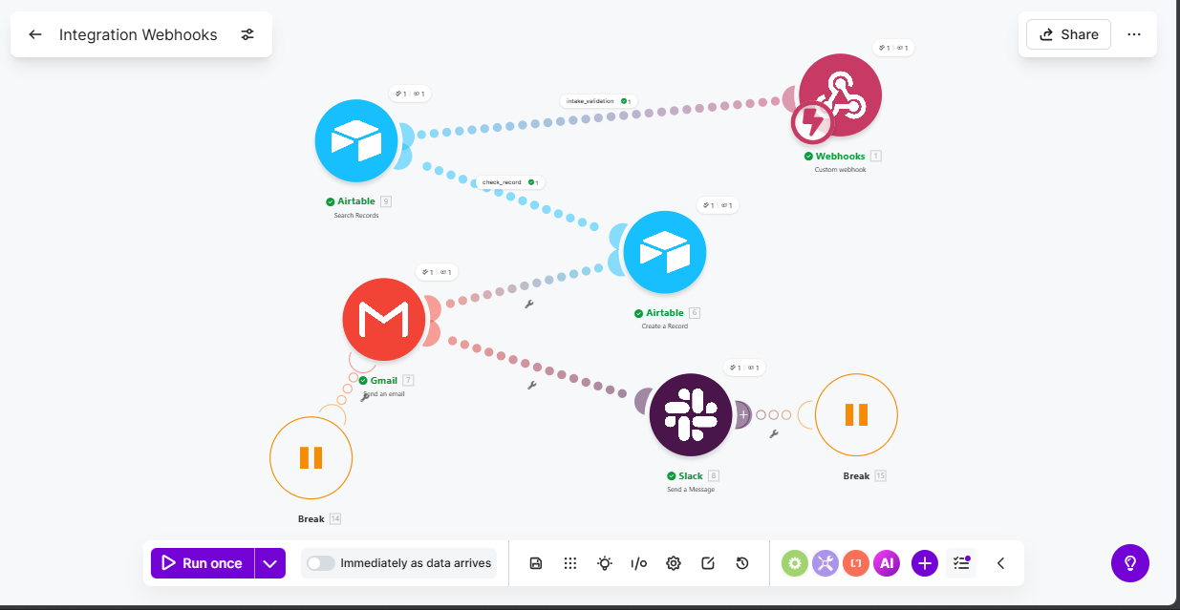
Screenshot 4 — Successful Run — All Modules: Green ticks across all eight modules. New lead passed all gates, record created in Airtable, confirmation email sent, Slack notification delivered. Total execution time under 5 seconds.

Screenshot 5 — Blocked Submission
A submission with missing or invalid data stopped at the intake_validation gate. The specific failing condition is visible in the Filter Inspector — red stop sign on the condition that failed. Nothing downstream was affected.

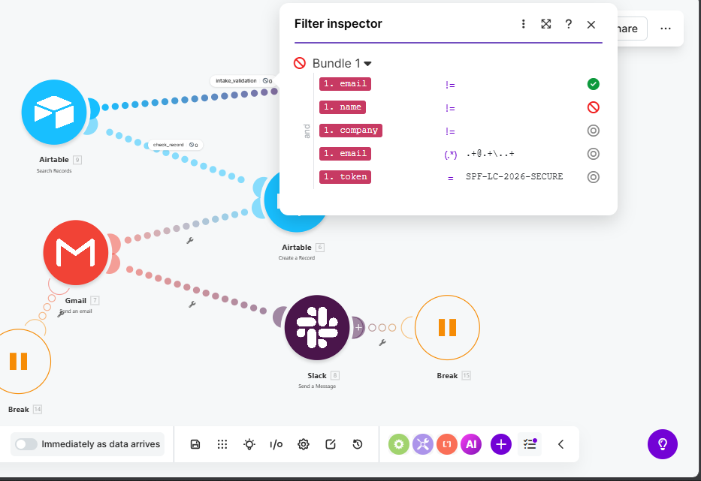
Screenshot 5 — Blocked Submission — intake_validation: Filter Inspector showing which specific condition failed. The conditions that passed show green ticks. The failing condition shows a red stop. Airtable, Gmail, and Slack were never reached.

Screenshot 6 — Duplicate Blocked
A known lead attempting to re-enter the system. The intake_validation gate passes — the submission is complete and correctly formatted. The Airtable Search finds the existing record. The check_record gate stops the bundle.

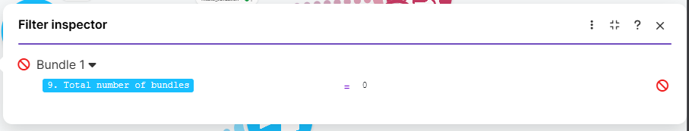
Screenshot 6 — Duplicate Blocked — check_record: The search returned one existing record. check_record evaluated total bundles as 1, not 0, and stopped the submission. No duplicate record created. No duplicate email sent. No duplicate Slack notification.

Screenshot 7 — Airtable Leads Table
The CRM database showing five validated, unique lead records. Every record arrived through the complete pipeline — all gates passed, all fields populated. No empty rows, no duplicate entries, no test contamination.

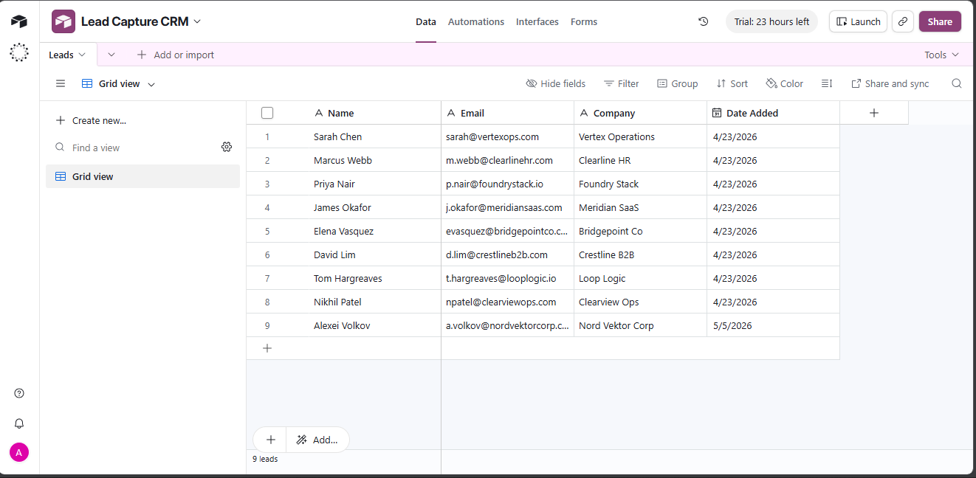
Screenshot 7 — Airtable Leads Table: Nine records: Sarah Chen, Marcus Webb, Priya Nair, James Okafor, Elena Vasquez among others. All fields populated for every record — Name, Email, Company, Date Added. No gaps, no duplicates.

Screenshot 8 — Slack Notification
The team notification delivered to the #leads channel in Slack. The message includes the lead's full details — name, email, company, and submission timestamp — and directs the team to check Airtable for the full record.

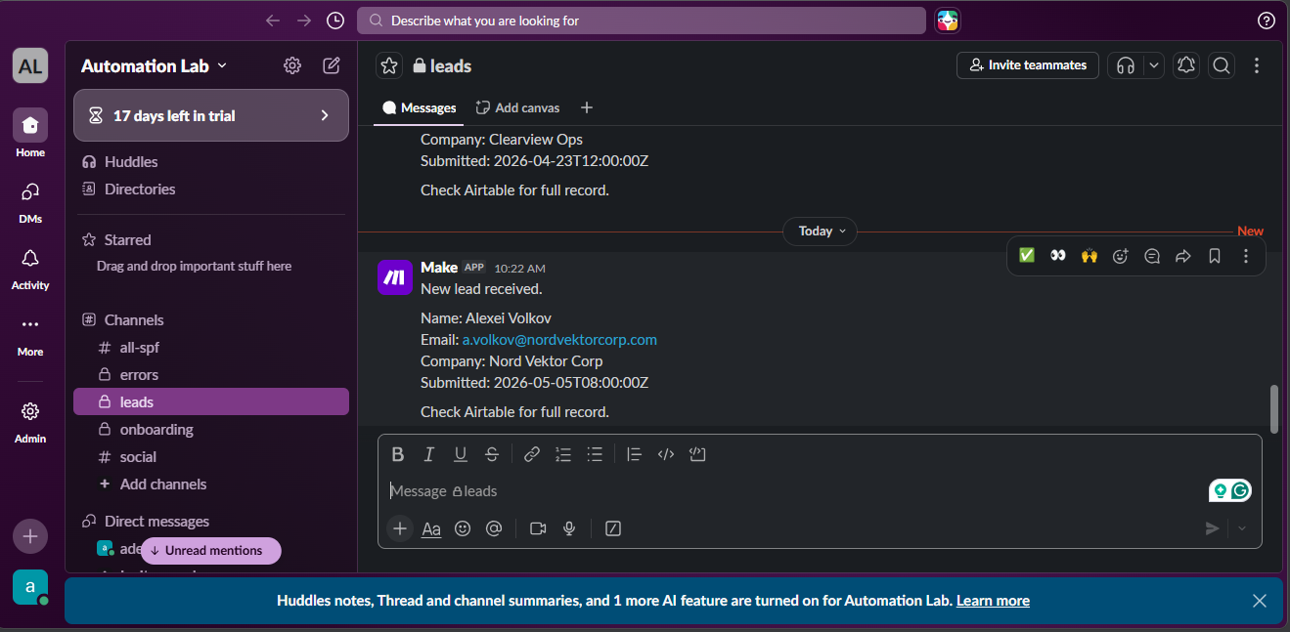
Screenshot 8 — Slack Notification — #leads Channel: Notification arrives within seconds of form submission. Includes name, email, company, and submission time. Sales team sees new lead immediately without logging into any other system.

Screenshot 9 — Gmail Confirmation Email
The personalized confirmation email sent to the lead within seconds of submission. The subject line and body are dynamically populated with the lead's name and company from the incoming data — no manual intervention required.

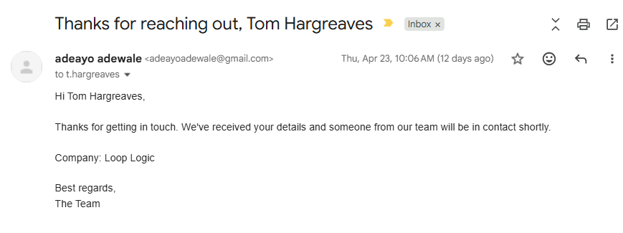
Screenshot 9 — Gmail Confirmation Email: Personalized subject line: 'Thanks for reaching out, [Name]'. Body includes lead's company name. Sent automatically within 5 seconds. Lead's first experience with the client's brand is immediate and professional.

Failure Mode Summary
Eleven failure scenarios were identified, deliberately triggered, and documented during the build process. The table below summarises each one. Full details are in the accompanying Failure Mode Registry document.

Failure Mode | Severity | Handling
Missing fields | Low | Auto
Malformed email | Low | Auto
Duplicate submission | Medium | Auto
Unauthorized access | High | Auto
Gmail failure | Medium | Partial
Slack failure | Medium | Partial
Gmail expiration | Medium | Manual
Scenario deactivated | High | Manual
Operation limit | High | Manual
Schema drift | High | Manual
Batch submission | Medium | Manual

Three failure modes are handled automatically with no human intervention. Five are partially handled with stored executions for manual review. Three require preventive action documented in the Operating Guide.

Complete Deliverables
This project delivers five documents:

Document | Purpose
Document 1 — System Architecture | What the system does, why it is built the way it is, and what business outcomes it delivers
Document 2 — Failure Mode Registry | Eleven failure scenarios with severity ratings, automatic handling status, and required human action
Document 3 — Setup and Configuration Record | Every technical decision, credential type, module configuration, and pre-handover checklist
Document 4 — Operating Guide | Day-to-day reference for the client — what healthy looks like, what broken looks like, weekly checks, and things never to do
Document 5 — Portfolio Evidence Pack | This document — nine screenshots with captions providing visual evidence of the complete system

Built by Adeayo
I build automations that run without you watching them.

