1. The mod_proxy_balancer module in Apache is a load-balancing module that distributes incoming client requests across multiple backend servers (known as "balancer members"). It is typically used to improve performance, scalability, and reliability in distributed web applications by balancing the load of client requests.

### **Key Features of mod_proxy_balancer:**

* **Load Distribution**: It distributes client requests to multiple servers based on various algorithms (e.g., by request count, load, or other custom factors).
* **Session Stickiness**: It supports sticky sessions to ensure that users maintain a consistent session with the same server.
* **Failover and Recovery**: Automatically detects and routes requests away from servers that are down or overloaded.
* **Dynamic Reconfiguration**: You can adjust and reconfigure backends without restarting the Apache server.

### **Sticky Sessions in mod_proxy_balancer**

**Sticky sessions**, also known as "session persistence," ensure that once a user is connected to a specific backend server, all subsequent requests from that user continue to be sent to the same server. This is especially useful for applications that store user session data in memory on the server rather than in a shared database or other external session store.

#### **When Sticky Sessions Are Used:**

* **Session-Dependent Applications**: Applications like e-commerce websites, where user information (e.g., shopping cart contents, preferences) is stored in-session and is critical to the user experience.
* **In-Memory Session Storage**: When the application does not have a shared or distributed session storage system (e.g., Redis, Memcached).
* **Applications Needing Consistency**: In cases where consistent interactions with the same server improve performance or simplify session handling.

### **How Sticky Sessions Work with mod_proxy_balancer**

To achieve sticky sessions with mod_proxy_balancer, the module uses a **cookie-based mechanism** where each user's browser stores a unique identifier (such as JSESSIONID for Java applications). This cookie associates the user with a specific backend server, allowing mod_proxy_balancer to route requests consistently to that server.

Example

<Proxy "balancer://mycluster">

BalancerMember "http://backend1.example.com" route=node1

BalancerMember "http://backend2.example.com" route=node2

ProxySet stickysession=JSESSIONID|jsessionid # Cookie-based stickiness

</Proxy>

ProxyPass "/app" "balancer://mycluster"

ProxyPassReverse "/app" "balancer://mycluster"

In this example:

* The sticky session directive specifies the cookie name for session persistence.
* The route parameter sets a unique identifier for each backend server, allowing Apache to identify which server to route subsequent requests to based on the session ID.

1. In Apache's mod_proxy_balancer module, several load-balancing algorithms control how traffic is distributed across backend servers. Here’s a breakdown of the primary modes: bytraffic, bybusyness, byrequests, and heartbeat.

### **1. Bytraffic (Load Balancing by Traffic)**

In **bytraffic** mode, Apache routes requests based on the amount of data (traffic) being sent to each backend server. It will direct the next request to the server with the least amount of traffic, thereby distributing requests in proportion to each server’s current load.

* **Use Case**: Ideal for scenarios where server performance may vary, such as with multimedia or data-intensive applications, as it helps maintain a balanced data load across servers.
* **How it Works**: Apache keeps track of the amount of traffic each server has handled and sends new requests to servers with lighter data loads.

### **2. Bybusyness (Load Balancing by Busyness)**

The **bybusyness** method distributes requests based on the number of active requests (busyness) each server is handling at a given moment. Apache directs new requests to the server with the fewest active connections, helping balance workloads across the backend servers.

* **Use Case**: Useful in high-concurrency environments where you want to avoid overloading any single server with too many active connections, such as applications with high concurrent traffic.
* **How it Works**: Each backend server’s "busyness" is calculated based on the number of active requests it’s currently handling, with requests sent to the least busy server.

### **3. Byrequests (Load Balancing by Request Count)**

The **byrequests** algorithm distributes requests in a round-robin manner, where each server gets an equal number of requests over time. This approach doesn’t consider server load, active connections, or traffic volume—it simply rotates requests evenly among available servers.

* **Use Case**: Best suited for environments where all servers have identical capabilities and the load per request is roughly the same, such as basic websites or APIs without significant resource demands.
* **How it Works**: Each server receives an equal share of requests, ensuring fair distribution but without adjusting dynamically based on actual load.

### **4. Heartbeat (Load Balancing by Heartbeat Monitoring)**

The **heartbeat** load-balancing method relies on real-time health checks (heartbeats) sent by each backend server. This setup works with the mod_heartbeat and mod_heartmonitor modules, which allow Apache to receive regular status updates from each server about its health and load.

* **Use Case**: Ideal for complex, highly dynamic environments where server load varies frequently, and it’s critical to have real-time data about each server’s status. This is common in larger applications where server health monitoring is necessary.
* **How it Works**: The mod_heartmonitor module collects and shares health and load information (heartbeat) from each server. Based on this data, Apache routes requests to the healthiest and least loaded servers, improving both reliability and performance

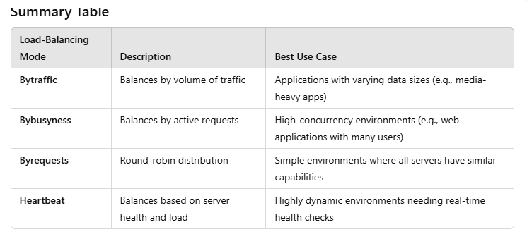

Each mode provides unique benefits, with options suited for different application requirements, from simple round-robin distribution to sophisticated health-monitor-based load balancing.