**Load Balancer Solution With Apache**

**A Load Balancer (LB) distributes clients' requests among underlying Servers and makes sure that the load is distributed optimally.**

**The diagram below shows the architecture of the solution**

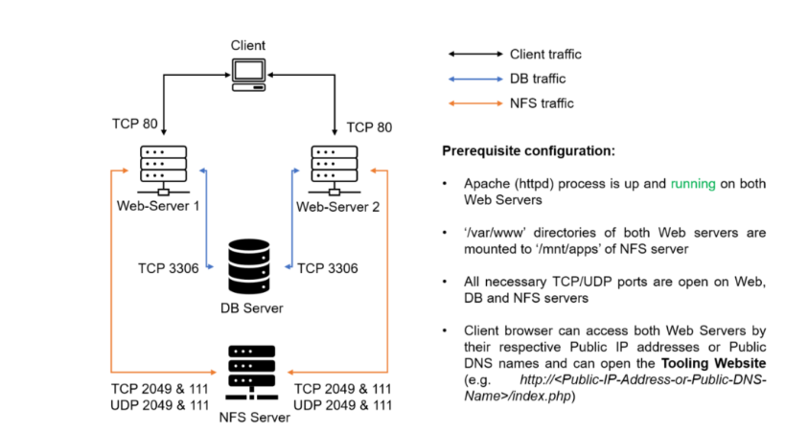

**Task**

**Deploy and configure an Apache Load Balancer for Tooling Website solution on a separate Ubuntu EC2 instance. Make sure that users can be served by Web servers through the Load Balancer.**

**Prerequisites**

**Ensure that the following servers are installed and configured already.**

**- Two RHEL9 Web Servers**

**- One MySQL DB Server (based on Ubuntu 24.04)**

**- One RHEL9 NFS Server**

**Prerequisites Configurations**

**- Apache (httpd) is up and running on both Web Servers.**

**- '/var/www' directories of both Web Servers are mounted to '/mnt/apps' of the NFS Server.**

**- All neccessary TCP/UDP ports are opened on Web, DB and NFS Servers.**

**- Client browsers can access both Web Servers by their Public IP addresses or Public DNS names and can open the 'Tooling Website' (e.g, 'http://<Public-IP-Address-or-Public-DNS-Name>/index.php')**

**Step 1 - Configure Apache As A Load Balancer**

**1. Create an Ubuntu Server 24.04 EC2 instance and name it Project-8-apache-lb**

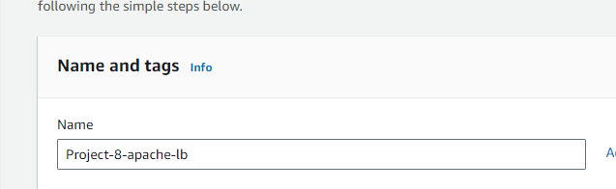

**2. Open TCP port 80 on Project-8-apache-lb by creating an Inbound Rule in the Security Group**

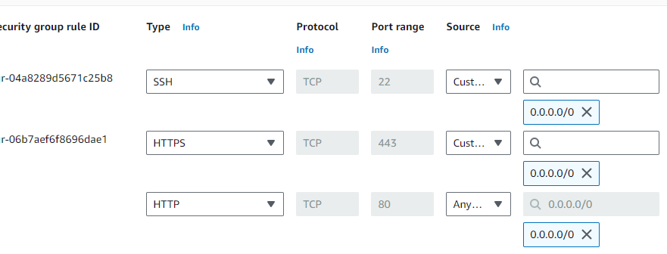

**3. Install Apache Load Balancer on Project-8-apache-lb and configure it to point traffic coming to LB to both Web Servers.**

**i. Install Apache2**

**- Access the instance**

**'**

**ssh -i "MEAN.pem" ubuntu@ec2-54-145-97-90.compute-1.amazonaws.com**

**'**

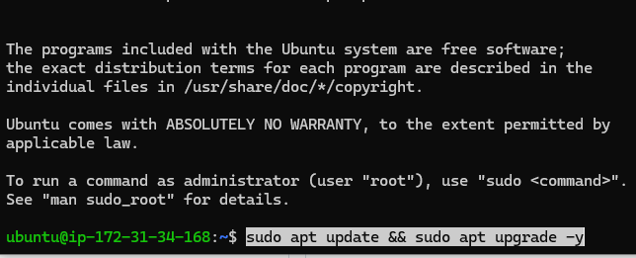

**- Update and upgrade Ubuntu**

**'**

**sudo apt update && sudo apt upgrade -y**

**- Install Apache**

**'**

**sudo apt install apache2 -y**

**'**

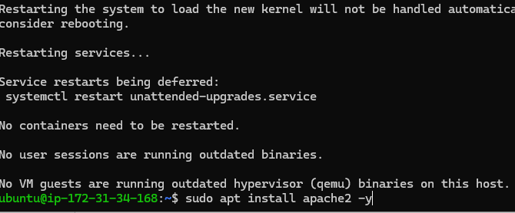

**'**

**sudo apt-get install libxml2-dev -y**

**'**

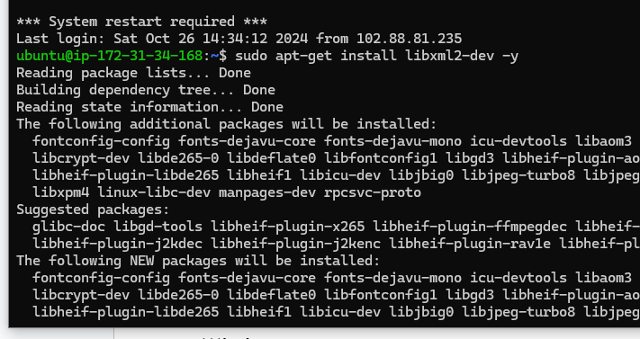

**ii. Enable the following modules**

**'**

**sudo a2enmod rewrite**

**sudo a2enmod proxy**

**sudo a2enmod proxy_balancer**

**sudo a2enmod proxy_http**

**sudo a2enmod headers**

**sudo a2enmod lbmethod_bytraffic**

**'**

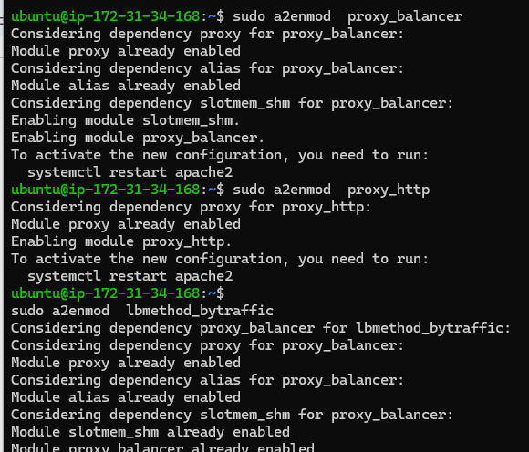

**iii. Restart Apache2 Service**

**'**

**sudo systemctl restart apache2**

**sudo systemctl status apache2**

**'**

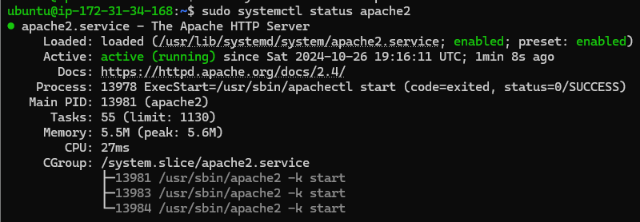

**Configure Load Balancing**

**i. Open the file 000-default.conf in sites-available**

**'**

**sudo vi /etc/apache2/sites-available/000-default.conf**

**'**

**ii. Add this configuration into the section '<VirtualHost *:80> </VirtualHost>'**

**'apache**

**<Proxy "balancer://mycluster">**

**BalancerMember http://18.209.173.19:80 loadfactor=5 timeout=1**

**BalancerMember http://54.162.250.21:80 loadfactor=5 timeout=1**

**ProxySet lbmethod=bytraffic**

**</Proxy>**

**ProxyPreserveHost on**

**ProxyPass / balancer://mycluster/**

**ProxyPassReverse / balancer://mycluster/**

**'**

**![Server config](./images/9.png)**

**iii. Restart Apache**

**'**

**sudo systemctl restart apache2**

**'**

**![Restart apache](./images/10.png)**

**'bytraffic' balancing method with distributing incoming loads between the Web Servers according to current traffic load. The proportion in which traffic must be distributed can be controlled by 'loadfactor' parameter.**

**Other methods such as 'bybusyness', 'byrequests', 'heartbeat' can also be adopted.**

**4. Verify that the configuration works**

**i. Access the website using the LB's Public IP address or the Public DNS name from a browser**

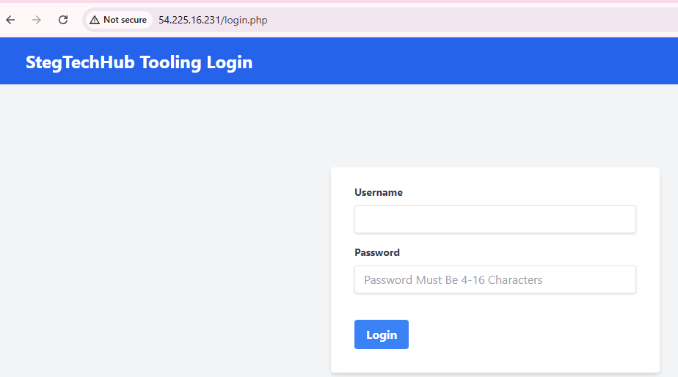

**__Note__: If in the previous project, '/var/log/httpd' was mounted from the Web Server to the NFS Server, unmount them and ensure that each Web Servers has its own log directory.**

**ii. Unmount the NFS directory**

**- Check if the Web Server's log directory is mounted to NSF**

**'**

**df -h**

**sudo umount -f /var/log/httpd**

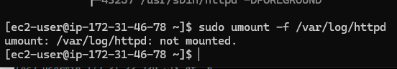

**'**

**If the directory is busy, the services using it need to be stopped first.**

**'**

**sudo systemctl stop httpd**

**sudo umount -f /var/log/httpd**

**sudo systemctl start httpd**

**df -h**

**sudo systemctl status httpd**

**'**

**- Check that the directory is unmounted**

**'**

**df -h**

**'**

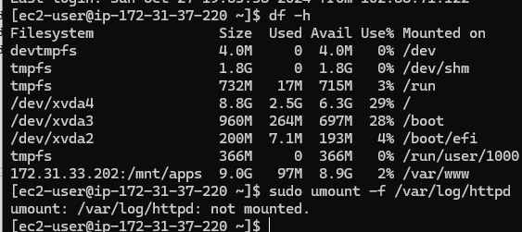

**iii. Open two ssh consoles for both Web Server and run the command:**

**'**

**sudo tail -f /var/log/httpd/access_log**

**'**

**Web Server 1 & 2 'access_log'**

**Weserver 1**

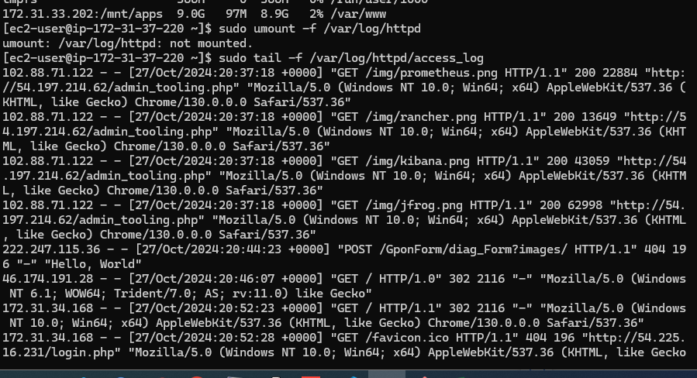

**Webserver 2**

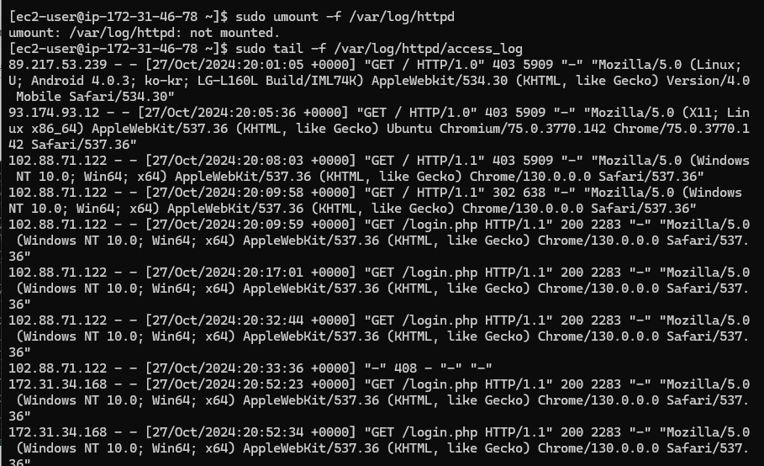

**iv. Refresh the browser page several times and ensure both Web Servers receive HTTP and GET requests. New records must apear in each web server log files. The number of request to each servers will be approximately the same since 'loadfactor' is set to the same value for both servers. This means that traffic will be evenly distributed between them.**

**After the refresh.**

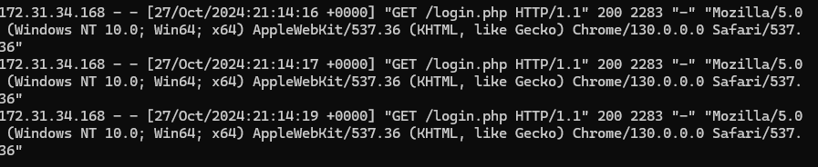

**Sometimes it is tedious to remember and switch between IP addresses, especially if there are lots of servers to manage. It is best to configure local domain name resolution. The easiest way is use '/etc/hosts' file, although this approach is not very scalable, but it is very easy to configure and shows the concept well.**

**Configure the IP address to domain name mapping for our Load Balancer.**

**Open the hosts file on your lb server**

**'**

**sudo vi /etc/hosts**

**'**

**Add two records into file with Local IP address and arbitrary name for the Web Servers**

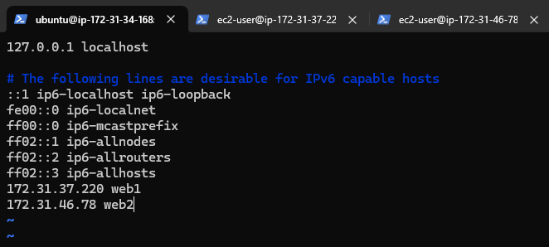

**Update the LB config file with those arbitrary names instead of IP addresses on the LB server.**

**sudo vi /etc/apache2/sites-available/000-default.conf**

**'**

**'**

**BalancerMember http://webserver1:80 loadfactor=5 timeout=1**

**BalancerMember http://webserver2:80 loadfactor=5 timeout=1**

**'**

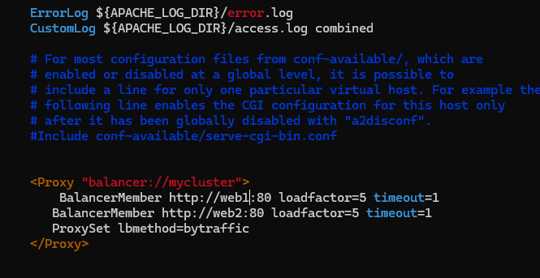

**Try to curl the Web Servers from LB locally**

**'**

**curl** [**http://web1**](http://web1)

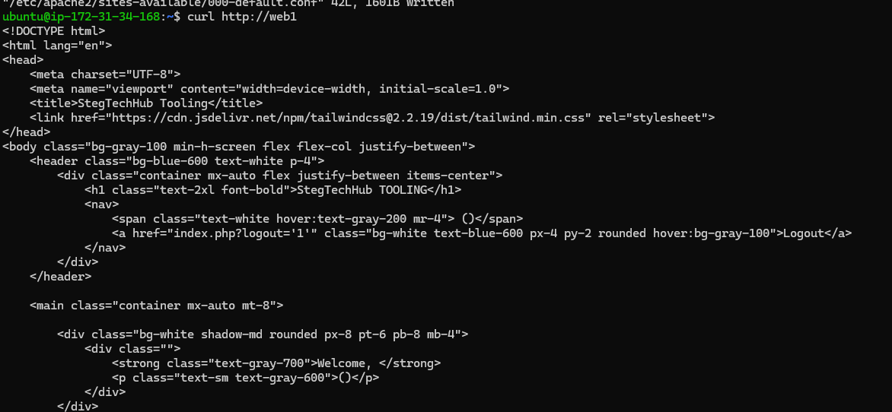

**'**

**curl http://web2**

**'**

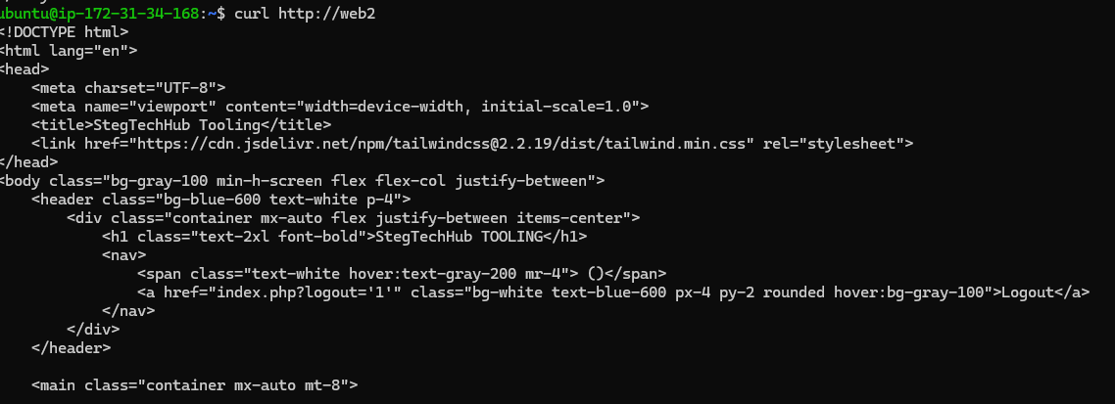

**Remember, This is only internal configuration and also local to the LB server, these names will neither be 'resolvable' from other servers internally nor from the Internet.**

Now your set up looks like this:

